Real estate data analysis

1.Write a hive query to find the city wise list all the Condos which is not less than ten thousand.

step 1 : create table and load dataset into it

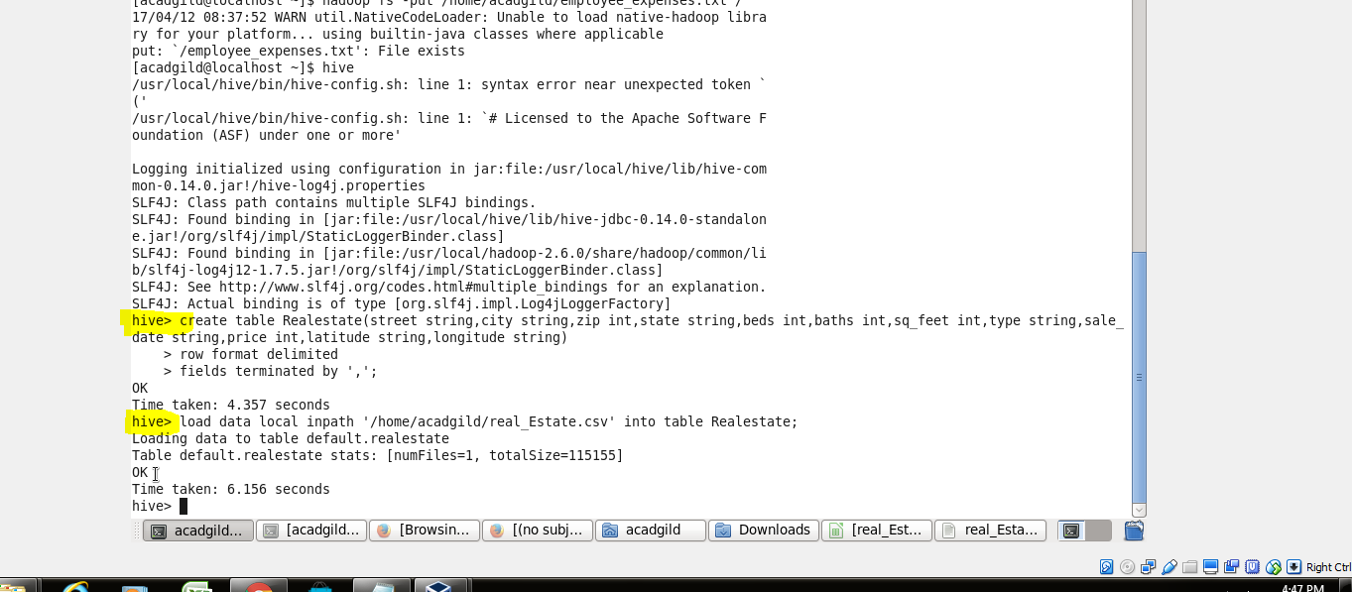

step 2: executiong query to find the city wise list all the Condos which is not less than ten thousand

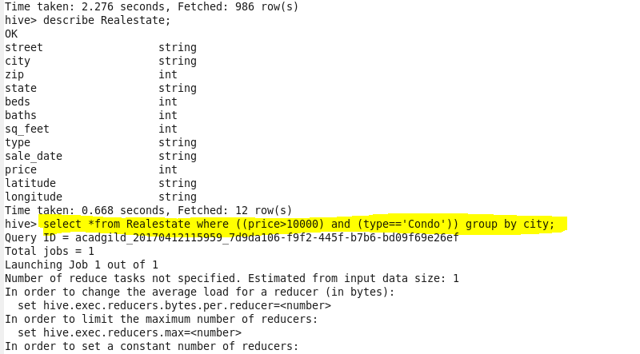

step 3: result

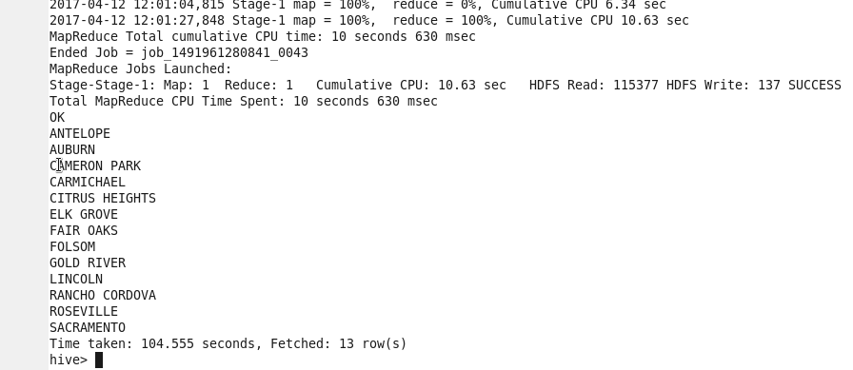

2. Write a hive query to find which is the cheapest Condo in CA. name the city,street and price for the Condo.

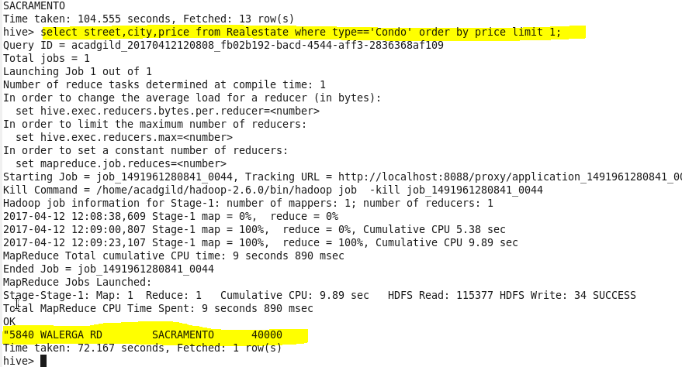

3. Write a hive query to list top 5 residency details which lie in the budget of 60000-120000, an area more than 1450, sold after 17th may, min bedroom 3 and, min bathroom 2.

it has only one result matching constraints

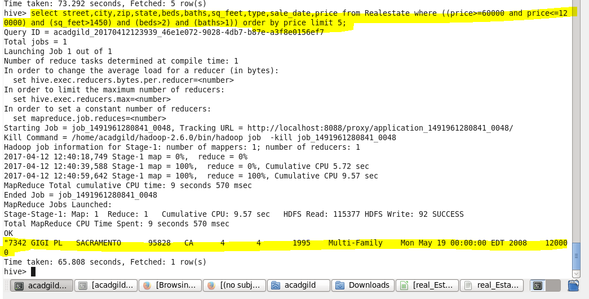

4. Write a hive query to separate list of residential apartments with more than 2 beds. Also include columns in following order City,Baths,Sq_feet,Price,flat_type,Beds respectively

step 1: creating a separate table Resident_2BHK using partitioning to separate list with >2 beds

and inserting into the table with given constraint

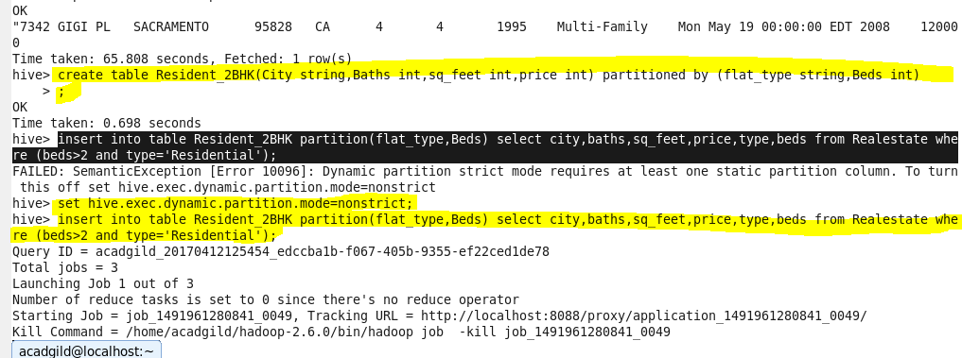

Step 2: result

