AI MENTAL HEALTH UK
Task - Baseline stats model
Duration – 1-3 May
Name – Rushay Gopani
Domain - Data Science

Objective
Build statistical model of MH prevalence rates by region. Apply confidence intervals.
To model regional prevalence of common mental disorders (CMD) using APMS 2014 data and quantify uncertainty using confidence intervals.

Data Source
- CMD prevalence: apms-2014-ch-02-tabs - Table 2.11 (Age-standardised, All adults, Any CMD)
- Sample size: apms-2014-ch-14-tabs - Table 14.2
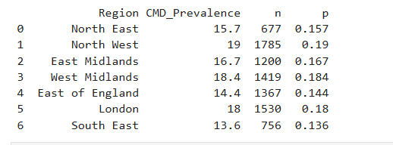

Method
- Age-standardised values used to ensure comparability
- Prevalence converted to proportions
- Wilson confidence intervals computed using regional sample sizes

Results
- Regions such as South West and West Midlands show higher CMD prevalence
- Regions like South East show lower prevalence
- Smaller sample sizes produce wider confidence intervals
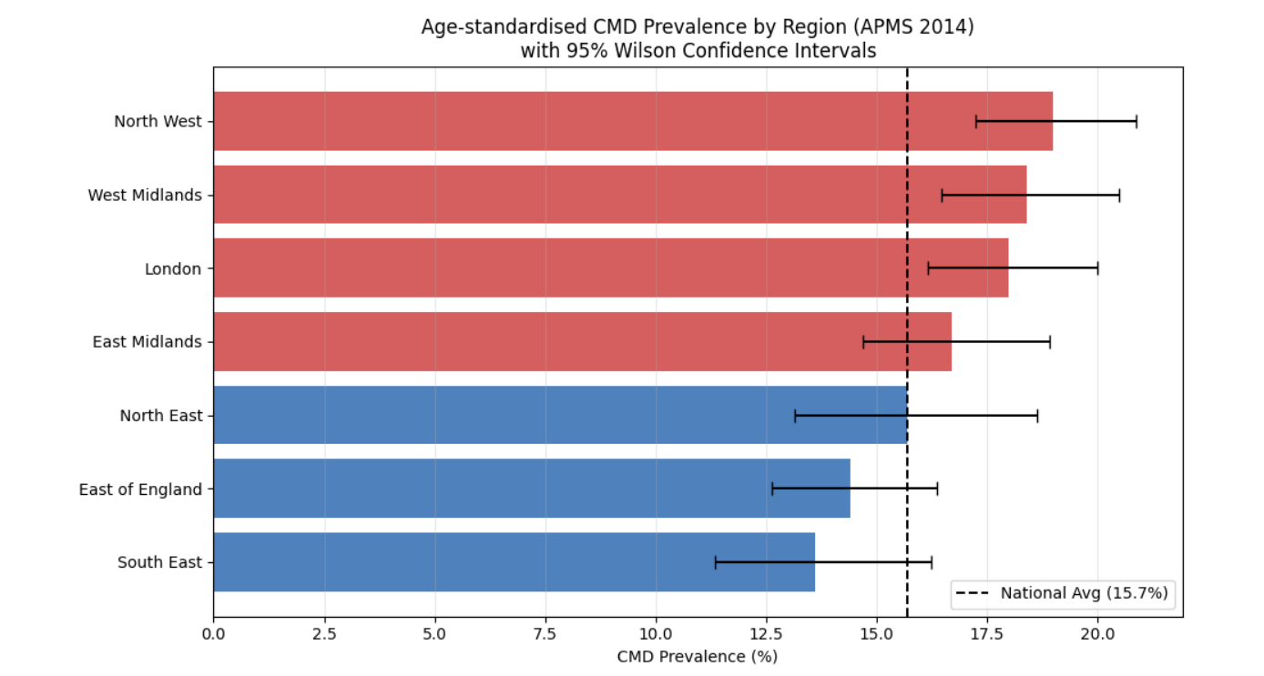

Conclusion
The model highlights meaningful regional variation in CMD prevalence while accounting for uncertainty, providing a statistically robust baseline.

