tf2 cheats chat prompts
Every prompt you sent in this chat, in order. Screenshots and files you attached with a prompt are placed under that prompt.

Prompt 1 — Retarget the template for Team Fortress 2
all below info is given to you to retarget this template for team team fortress 2:

Brand name: tf2 cheats
Short name: none
Site URL (no trailing slash): tf2cheat.com
Support email:
Checkout URL: https://zadeyo.com/go/ZAHRAN?to=%2Fproducts%2Fteam-fortress-2
Game name: team fortress 2
Anti-cheat: Valve Anti-Cheat (VAC)
Locale: en
Market: Worldwide

Currency: USD
Platforms: Windows PC

Plan 1 id: monthly
Plan 1 label: Monthly
Plan 1 price: 35$
Plan 1 duration: P30D

Plan 2 id: lifetime
Plan 2 label: Lifetime
Plan 2 price: 150$
Plan 2 duration: P99Y

Primary keyword: tf2 cheats

Keyword list:
tf2 anti cheat informational 20 0

------------------------------------------------------------------------------------------------------------------------------------

keywords are given to you implement the below stuff according to your seo knowledge
homeTitle: tf2 cheats | Aimbot, ESP and Radar
homeDescription: Buy tf2 cheats for Team Fortress 2 on Windows PC. Aimbot, silent aim, ESP, class ESP, and radar with live VAC status. Monthly $35 or lifetime $150.

featuresTitle: Team Fortress 2 Features | tf2 cheats
featuresDescription: Team Fortress 2 features for tf2 cheats — aimbot, silent aim, triggerbot, player ESP, class ESP, item ESP, and 2D/3D radar on Windows PC.

storeTitle: Team Fortress 2 Store | tf2 cheats
storeDescription: Team Fortress 2 store for tf2 cheats. Monthly access is $35 and lifetime is $150, with aimbot, ESP, radar, and instant worldwide delivery.

statusTitle: Team Fortress 2 Status | tf2 cheats
statusDescription: Team Fortress 2 VAC status for tf2 cheats. Read clear versus Updating after Steam and Valve Anti-Cheat patches before you load.

previewTitle: Team Fortress 2 Preview | tf2 cheats
previewDescription: Preview silent aim, ESP, and radar for Team Fortress 2. See how tf2 cheats group aim and visuals before you checkout.

setupTitle: Team Fortress 2 Setup | tf2 cheats
setupDescription: Learn how Team Fortress 2 cheats group aimbot, ESP, and radar, which settings matter, and what to check before you load on Windows PC.

supportTitle: Team Fortress 2 Support | tf2 cheats
supportDescription: Get support for tf2 cheats on Discord — loader setup, delivery, menu config, and Valve Anti-Cheat (VAC) status help after you purchase.

faqTitle: Team Fortress 2 FAQ | tf2 cheats
faqDescription: FAQ for tf2 cheats on Windows PC — $35 monthly and $150 lifetime, aimbot and ESP features, VAC status, setup, and Discord support.

reviewsTitle: tf2 cheats Reviews | Buyer Feedback
reviewsDescription: Read tf2 cheats reviews from buyers covering aimbot, player ESP, class ESP, radar, and VAC status before you pick monthly or lifetime.

blogTitle: Team Fortress 2 Intel | tf2 cheats
blogDescription: Team Fortress 2 intel hub for tf2 cheats — aimbot, silent aim, class ESP, radar, Windows setup, and Valve Anti-Cheat (VAC) status before you buy.

--------------------------
update the features to these:
Aimbot
Aim Assist
Silent Aim
Triggerbot
ESP
Player ESP
Box ESP
Skeleton ESP
Health ESP
Name ESP
Distance ESP
Class ESP
Team Check
Enemy Only ESP
Item ESP
Pickup ESP
Radar
2D Radar
3D Radar
This is the full brief from your first prompt (input.md lines 11–94). No photo was attached.

Prompt 2 — Replace the hero video
replce the current hero video with hero video.webm from everywhere, make sure the quality of the video stays good, delete the old hero video.
No photo was attached.

Prompt 3 — Change navbar logo and favicon
change the navbar logo and favicon to @navbar logo and favicon.webp to new logo navbar logo and favicon.jpg
Attached file: navbar logo and favicon.jpg (new logo).


Prompt 4 — Fix black borders and put video behind the navbar
why there are black borders on the bottom and the top, the video be behind the navbar aswell.
Screenshot you attached with this prompt:
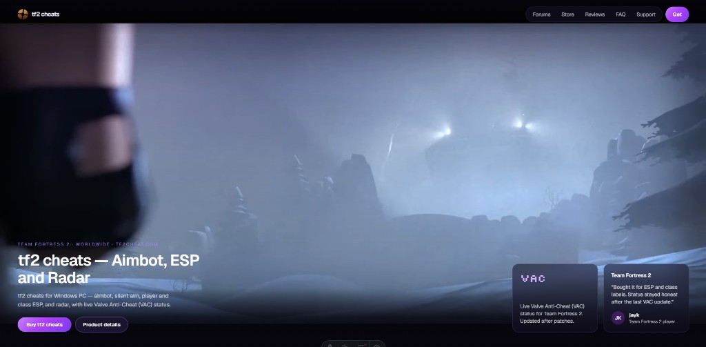

Prompt 5 — Swap gallery images to PNG
replace the image-1.webp and image-2.webp to image-1.png and image-2.png from everywhere, make sure you dont decrease the quality, remove the old image 1 and 2.
No photo was attached.

Prompt 6 — Fix the missing gallery image
fix this missing image.
Screenshot you attached with this prompt:
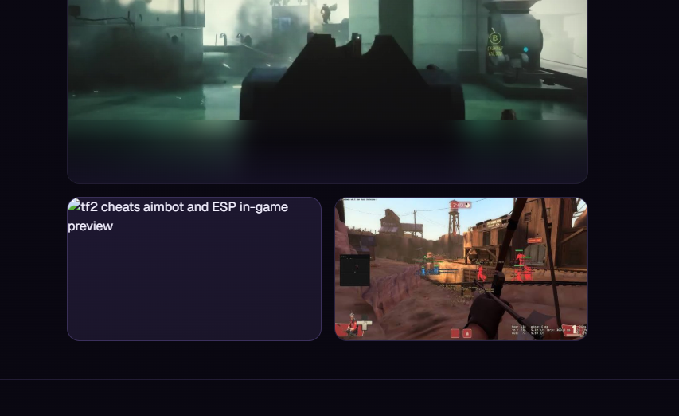

Prompt 7 — Remove preview.webm
remove preview.webm from everywhere of the website and delete it.
No photo was attached.

Prompt 8 — Replace The Finals cover with a TF2 cover from IGN
bring tf2 good cover photo from ign and implement it here.
Screenshot you attached with this prompt:
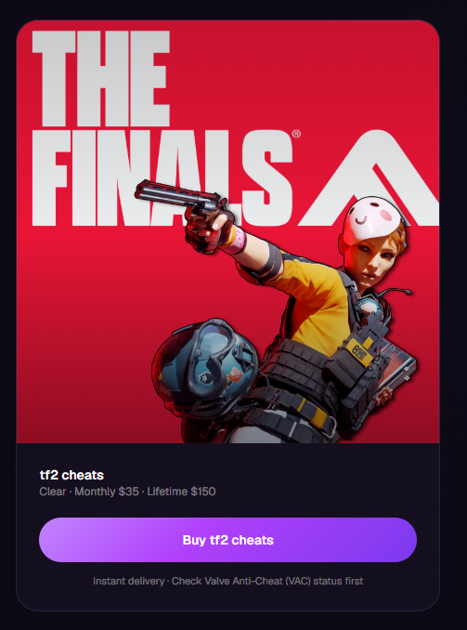

Prompt 9 — Export this chat’s prompts
make me a word file and add all the prompts that i gave you thorughout this chat, make sure to add the photos i gave you while giving a specific prompt.
No photo was attached.

Prompt 10 — Same request as a file
make me a file and add all the prompts that i gave you thorughout this chat, make sure to add the photos i gave you while giving a specific prompt.
No photo was attached.

Prompt 11 — Use the actual input.md content
insteaf of wrting input.md lines, write the actual content
No photo was attached. Prompt 1 now uses the full brief instead of a line reference.

