Weather-Based Prediction of Wind Turbine Energy Output: A Next-Generation Approach to Renewable Energy Management

Project Description:
The Weather-Based Prediction of Wind Turbine Energy project focuses on forecasting wind turbine power output using historical weather data and machine learning techniques. Wind energy generation is highly dependent on environmental factors such as wind speed, temperature, atmospheric pressure, and humidity. Accurate prediction of turbine output helps optimize energy planning, grid stability, and efficient power distribution.
In this project, weather parameters are collected and preprocessed to remove inconsistencies and handle missing values. Exploratory Data Analysis (EDA) is performed to understand patterns and relationships between weather variables and turbine energy production. Relevant features are selected and used to train machine learning regression models for predicting wind energy output.
The system is developed using Python and various data science libraries for data processing, visualization, and model building. The trained model evaluates performance using standard metrics to ensure prediction accuracy and reliability.
This project demonstrates how data-driven approaches can improve renewable energy forecasting, reduce operational uncertainty, and support sustainable energy management.

Technical Architecture:
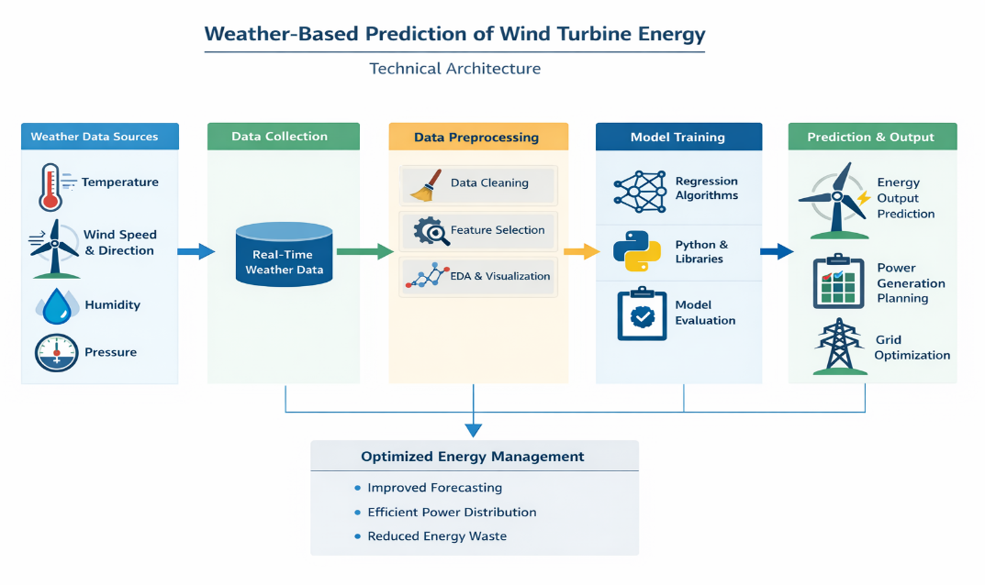
Prerequisites
In order to develop this project we need to install the following software/packages:
Step 1:Anaconda Navigator :
Anaconda Navigator is a free and open-source distribution of the Python and R programming languages for data science and machine learning related applications. It can be installed on Windows, Linux, and macOS.Conda is an open-source, cross-platform, package management system. Anaconda comes with great tools like JupyterLab, Jupyter Notebook, QtConsole, Spyder, Glueviz, Orange, Rstudio, Visual Studio Code.
For this project, we will be using Jupyter notebook and Spyder
To install Anaconda navigator and to know how to use Jupyter Notebook & Spyder using Anaconda
Watch the video: https://youtu.be/5mDYijMfSzs?si=SsFz5wHK_jrKxSK1
Step 2:To build Machine learning models you must require the following packages
Sklearn: Scikit-learn is a library in Python that provides many unsupervised and supervised learning algorithms.
NumPy: NumPy is a Python package that stands for 'Numerical Python'. It is the core library for scientific computing, which contains a powerful n-dimensional array object
Pandas: pandas is a fast, powerful, flexible, and easy to use open-source data analysis and manipulation tool, built on top of the Python programming language.
Matplotlib: It provides an object-oriented API for embedding plots into applications using general-purpose GUI toolkits
Flask: Web framework used for building Web applications.
Watch the video: https://youtu.be/akj3_wTploU?si=IthpBeOh-EIcltvy

If you are using anaconda navigator, follow the below steps to download the required packages:
- Open anaconda prompt.
- Type “pip install numpy” and click enter.
- Type “pip install pandas” and click enter.
- Type “pip install matplotlib” and click enter.
- Type “pip install scikit-learn” and click enter.
- Type “pip install Flask” and click enter.
If you are using Pycharm IDE, you can install the packages through the command prompt and follow the same syntax as above.
Prior Knowledge
One should have knowledge on the following Concepts, please refer the videos below to gain sufficient required knowledge to complete the project.
Supervised and unsupervised learning: https://youtu.be/kE5QZ8G_78c?si=ZUuWRnnE4u-G5I7v
Regression Classification and Clustering https://youtu.be/6za9_mh3uTE?si=eTRIk2kfBVgEM2gT
Random Forest: https://youtu.be/eM4uJ6XGnSM?si=vwloT4I69LV6VJTt
Flask: https://youtu.be/lj4I_CvBnt0?si=Du02Q5UY4yOeryVz
Project Objectives
By the end of this project:
- You’ll be able to understand the problem to classify if it is a regression or a classification kind of problem.
- You will be able to know how to pre-process/clean the data using different data preprocessing techniques.
- You will able to analyze or get insights into data through visualization.
- Applying different algorithms according to the dataset and based on visualization.
- You will be able to know how to build a web application using the Flask framework.
Project Flow
You will go through all the steps mentioned below to complete the project.
- User interacts with the UI (User Interface) to enter Data
- The entered data is analyzed by the model which is integrated
- Once model analyses the input the prediction is showcased on the UI
To accomplish this, we have to complete all the activities and tasks listed below
- Data Collection.
  - Collect the dataset or Create the dataset
- Data Preprocessing.
  - Import the Libraries.
  - Importing the dataset.
  - Checking for Null Values.
  - Data Visualization.
  - Taking care of Missing Data.
  - Label encoding.
  - One Hot Encoding.
  - Feature Scaling.
  - Splitting Data into Train and Test.
- Model Building
  - Training and testing the model
  - Evaluation of Model
- Application Building
  - Create an HTML file
  - Build a Python Code
Project Structure
Create a Project folder which contains files as shown below
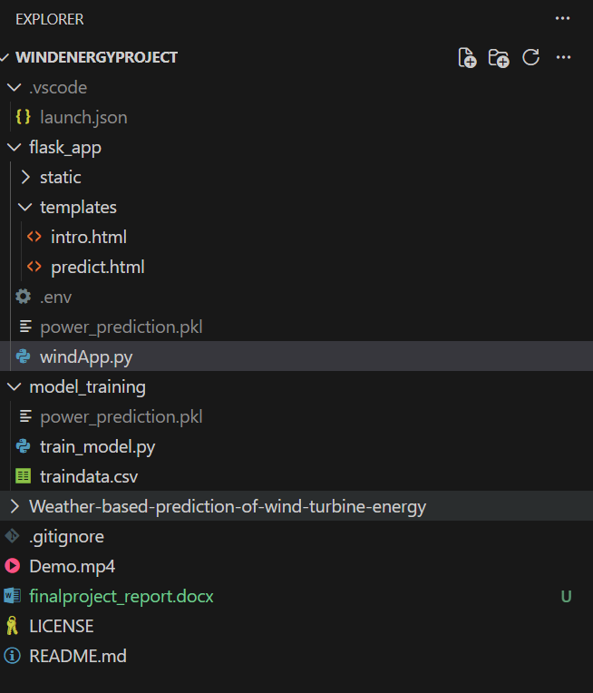
- Flask folder contains the necessary files for a web application:
- static folder contains the images for web application
- templates folder contains the HTML pages
- .sav file is the model file
- windApp.py is for server-side scripting
- .csv file is the dataset
- .py files are the training and testing files.

Milestone 1: Data Collection
ML depends heavily on data, without data, a machine can't learn. It is the most crucial aspect that makes algorithm training possible. In Machine Learning projects, we need a training data set. It is the actual data set used to train the model for performing various actions.
Activity 1: Download dataset /create dataset
The dataset for wind energy prediction is to be collected. The dataset which is considered here will have the environmental conditions. You can collect datasets from different open sources like kaggle.com, data.gov, UCI machine learning repository etc.
Milestone 2 : Data Pre-Processing
In this milestone, we will be preprocessing the dataset that is collected. Preprocessing includes:
- Processing the dataset.
- Handling the null values.
- Handling the categorical values if any.
- Normalize the data if required.
- Identify the dependent and independent variables.
- Split the dataset into train and test sets.
Activity 1: Import required libraries
The libraries can be imported using the import keyword.
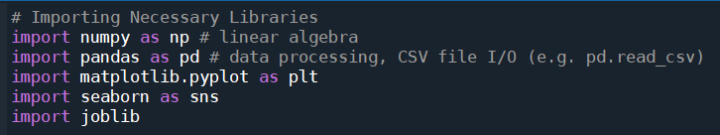
Activity 2: Analyze the datasets
Step 1: The datasets are imported as data frames using the pandas library. Rename the columns with suitable column names for better understanding.
*Dataset contains the wind speed and wind direction along with the power generated.
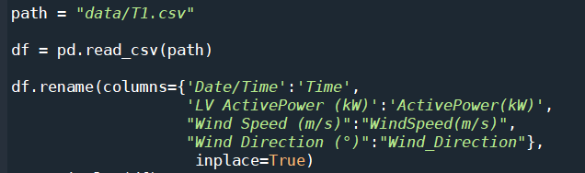
Step 2: Check the correlation between the columns for dimensionality reduction (knowing which columns are necessary and which are not)
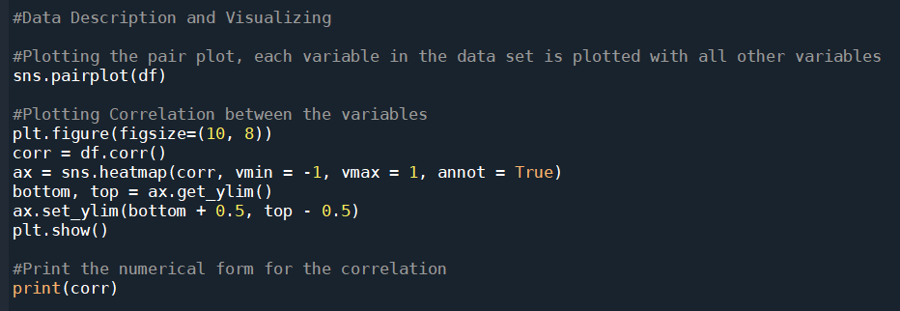
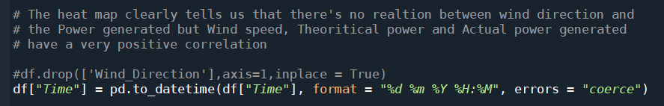
The heat map clearly tells us that there's no relation between wind direction and the Power generated but Wind speed, Theoretical power and Actual power generated to have a very positive correlation.
Activity 3: Splitting data into independent and dependent variables
In this activity, the dependent and independent variables are to be identified. The independent columns are considered as x and the dependent column as y.
After identifying the dependent and independent variables, the dataset now has to be split into two sets, one set is used for training the model and the second set is used for testing how good the model is built. The split ratio we consider is 80% for training and 20% for testing.
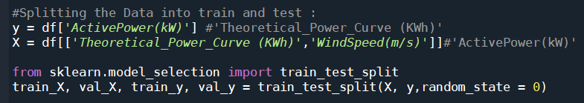

Milestone 3: Model Building
There are several Machine learning algorithms to be used depending on the data you are going to process such as images, sound, text, and numerical values. The algorithms can be chosen according to the objective. As the dataset which we are using is a Regression dataset so you can use the following algorithms
- Linear Regression
- Random Forest Regression / Classification
- Decision Tree Regression / Classification
Activity 1: Choose the appropriate model
We will be considering the Random Forest Regressor model and fit the data.
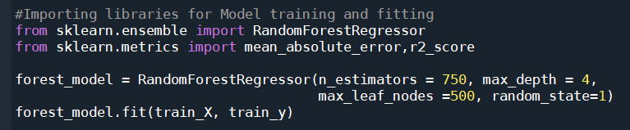
Activity 2: Check the metrics of the model
Here we will be evaluating the model built. We will be using the test set for evaluation. The test set is given to the model for prediction and prediction values are stored in another variable called y_pred. The r2 score of the model is calculated and its performance is estimated.
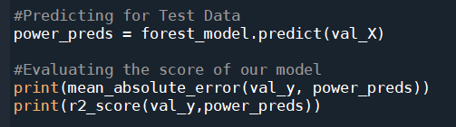

Activity 3: Save the model
The finalised model is now to be saved. We will be saving the model as a pickle or pkl file or sav file.
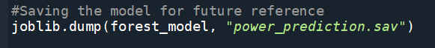
Activity 4: API Integration
Step 1: Signup for OpenWeather API for current weather forecasting. To signup click here
Step 2: After verification and subscription within 24 hours the API key will be activated.
Step 3: The API Key can be used to get the weather forecast of any of the cities known. The city is passed with parameter q and apikey is to be given with the parameter appid.
Milestone 4: Application Building
After the model is built, we will be integrating it to a web application so that normal users can also use it to predict the energy in a no-code manner. In the application, the user provides the required values and get the predictions.
Activity 1: Build the python flask app
In the flask application, the API requests, as well as energy prediction requests, are taken and the results are processed.
Step 1: Import required libraries
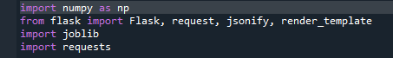

Step 2: Load the model and initialise flask app
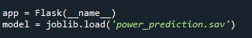

Step 3: Configure app.py for api requests
Flask file takes the city as input and hits the API to get the weather conditions and send it back to the UI.
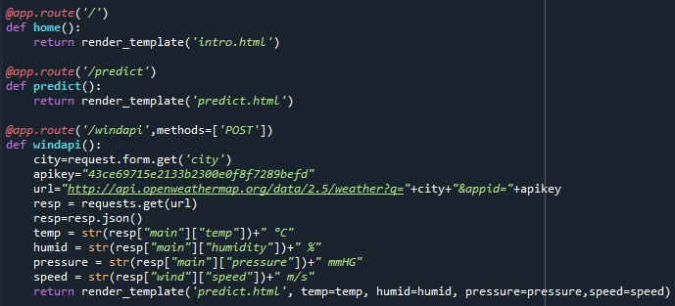
Step 4: Configure the file with predictions
It takes the inputs from the UI and passes it to the model and sends the predicted output to the UI.
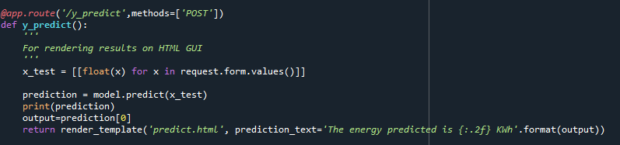
Step 5: Run the app
Enter commands as shown below
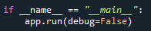
Activity 2: Build an HTML Page
We Build an HTML page to take both the API requests for weather forecasting as well as the energy prediction forms. You can get the HTML page from project folder
- Index.html [To enter]
- Predict.html [To Predict]

Activity 3: Execute and test your model

Step 1: Execute the python code and after the model is running, open localhost:5000 page and test it.
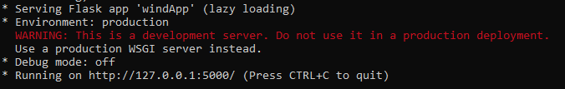

Output:
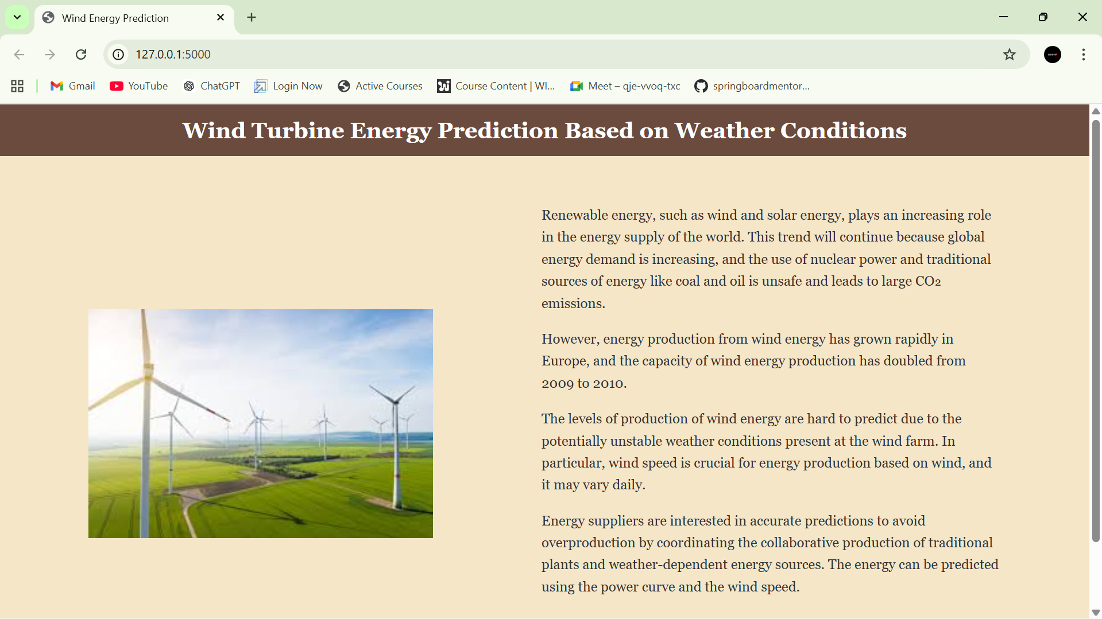

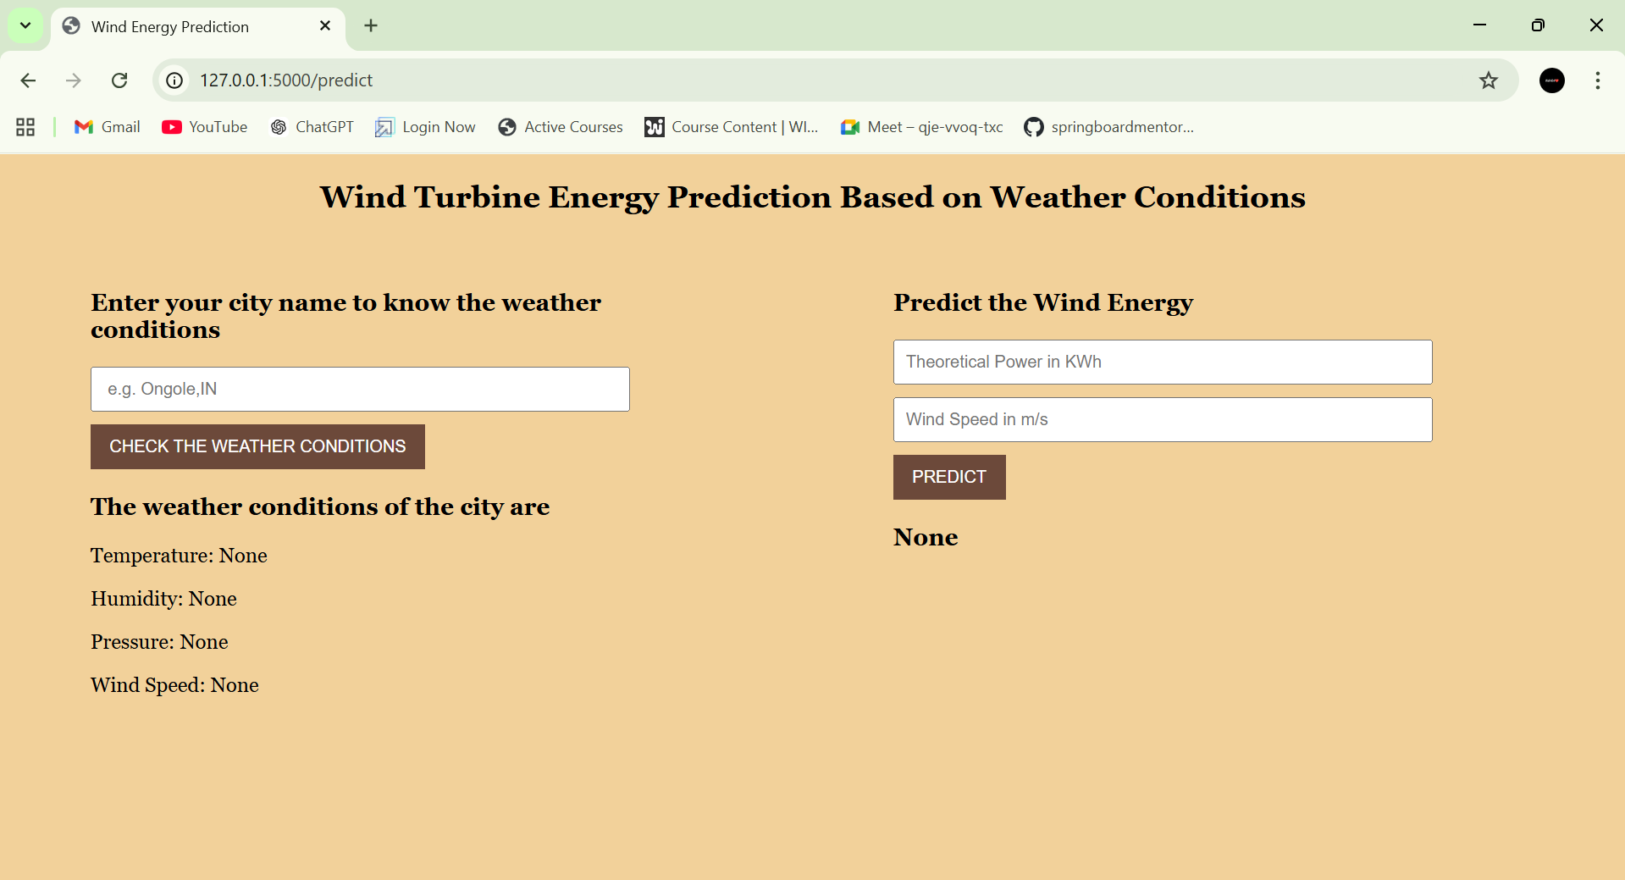

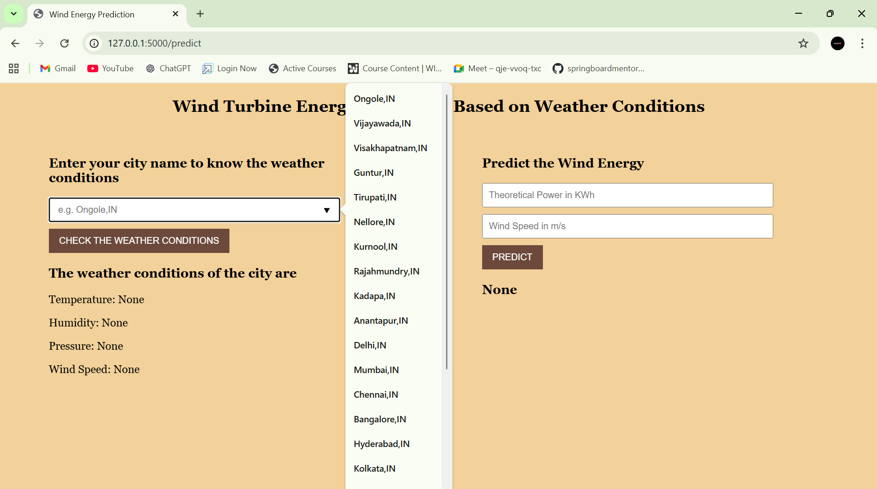

After prediction:

