DevOps Installation

1. Java 21 download and install
2. Git download and install
3. Maven download and install
4. Terraform download
5. Intellij idea download
6. 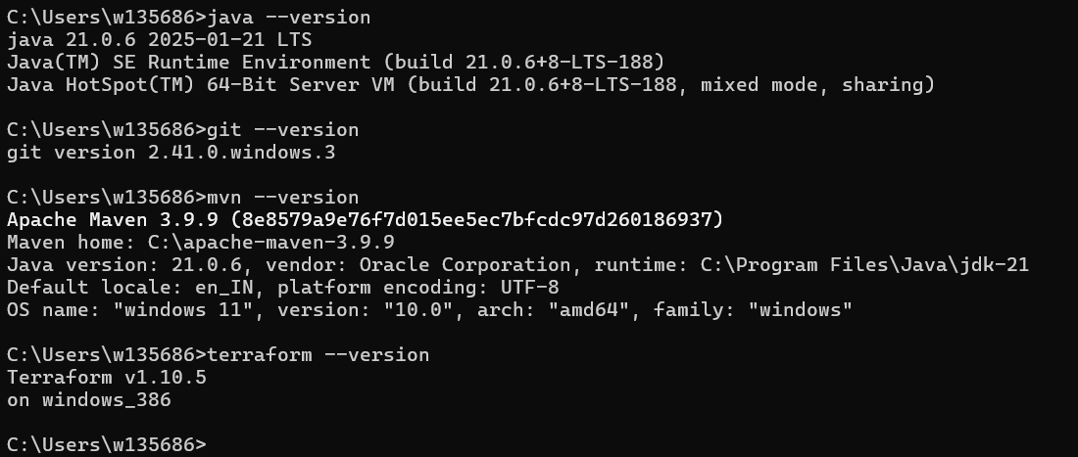

Free Account login creation –

1. Create a github account for repos.
2. Create the AWS and Azure free account