1. Write a MongoDB query to display all the documents in the collection restaurants.

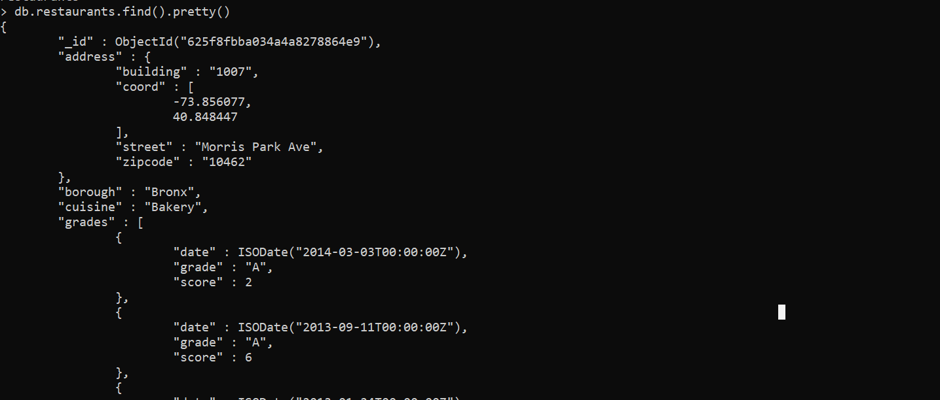

3. Write a MongoDB query to display the fields restaurant_id, name, borough and cuisine, but exclude the field _id for all the documents in the collection restaurant.

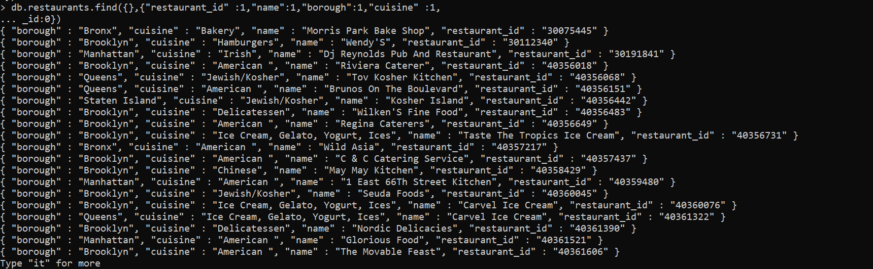

4. Write a MongoDB query to display the fields restaurant_id, name, borough and zip code, but exclude the field _id for all the documents in the collection restaurant.

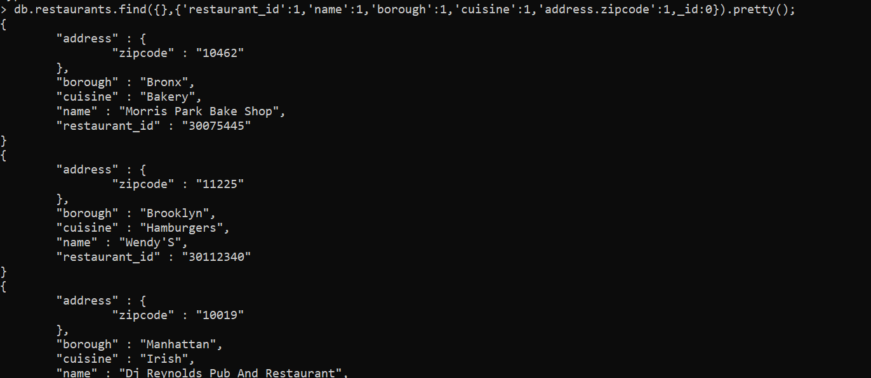

5. Write a MongoDB query to display all the restaurant which is in the borough Bronx.

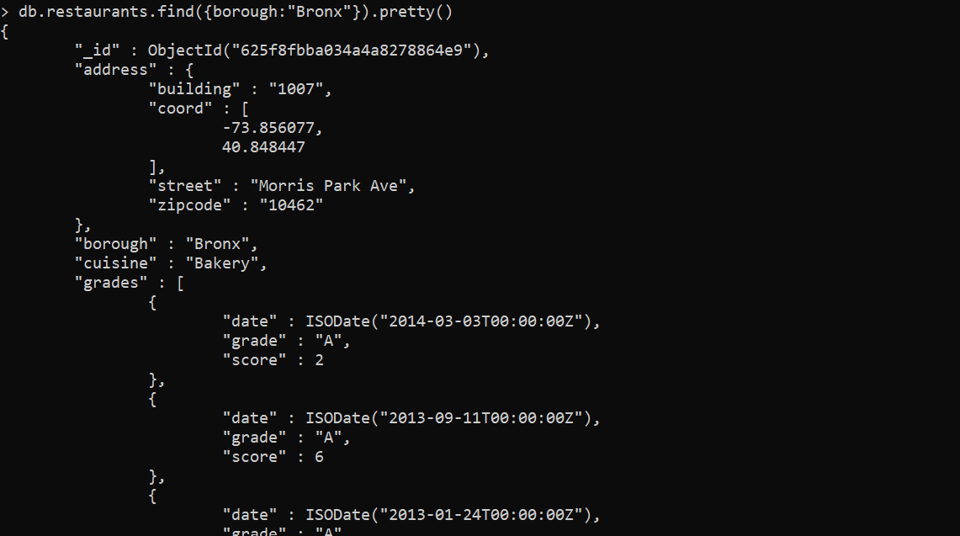

6. Write a MongoDB query to display the first 5 restaurant which is in the borough Bronx.

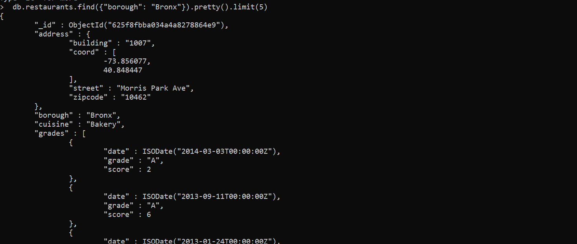

7.Write a MongoDB query to display the next 5 restaurants after skipping first 5 which are in the borough Bronx.

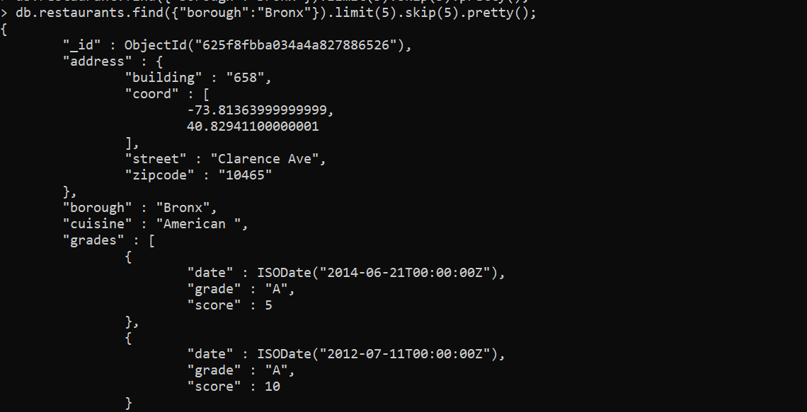

8. Write a MongoDB query to find the restaurants who achieved a score more than 90.

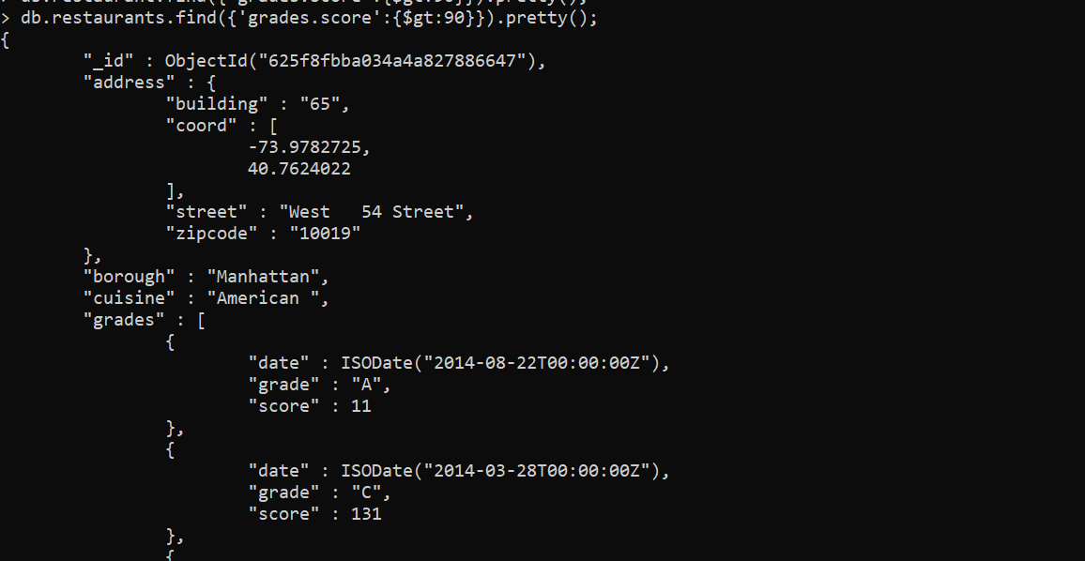

9. Write a MongoDB query to find the restaurants that achieved a score, more than 80 but less than 100. 

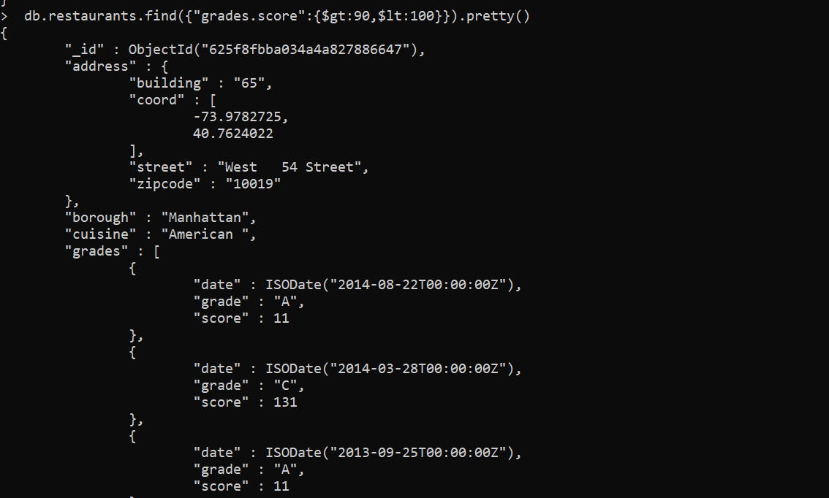

10. Write a MongoDB query to find the restaurants which locate in latitude value less than -95.754168.

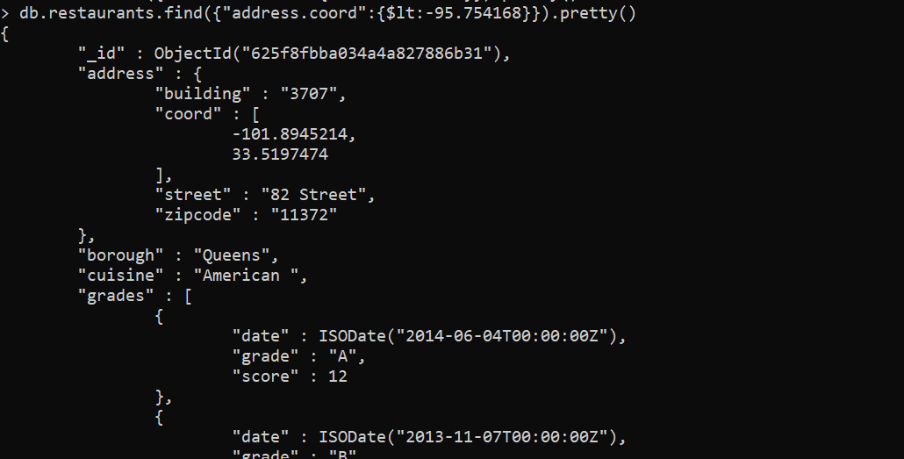

11. Write a MongoDB query to find the restaurants that do not prepare any cuisine of 'American' and their grade score more than 70 and latitude less than -65.754168.

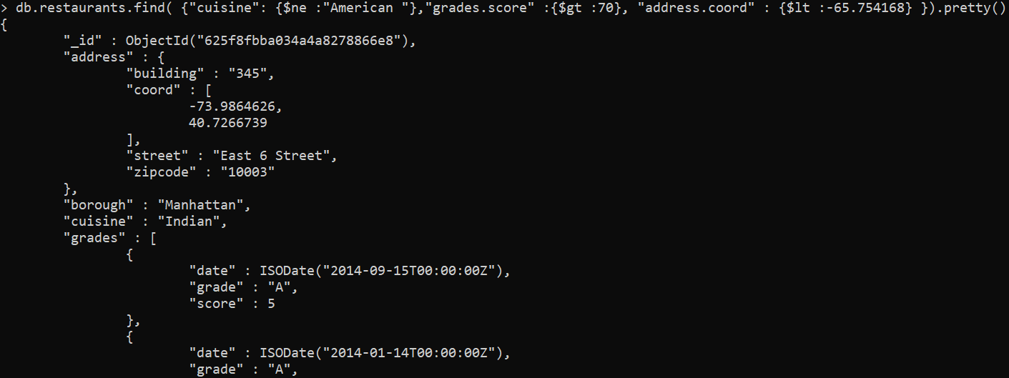

12. Write a MongoDB query to find the restaurants which do not prepare any cuisine of 'American' and achieved a score more than 70 and located in the longitude less than -65.754168.

Note : Do this query without using $and operator.

