Question-1.

1. use a command to show the current working directory

- list the directory contents in the short and long format

(with file permissions,owner,size etc,.).

Explore attributes given in long format e.g. file type, file permissions, file

size, file owner etc.

- list all files along with hidden files in current working directory.

- list only hidden files in the directory

(**Hint** : use **pwd** , **ls, echo** commands)

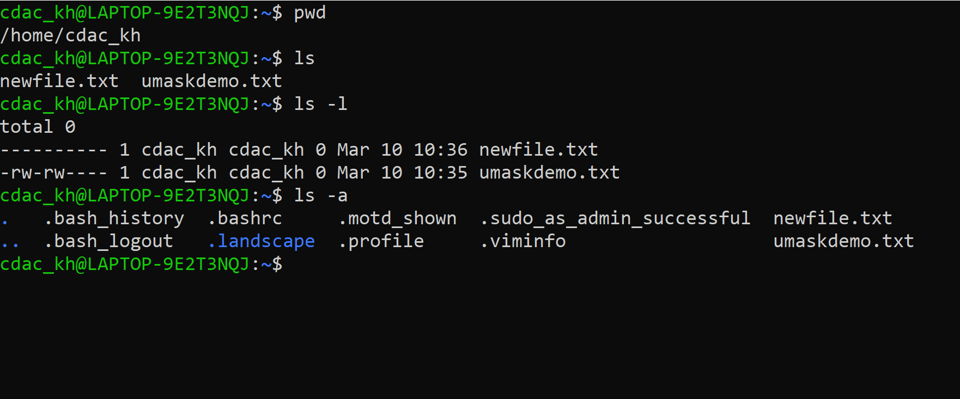

2. Make a directory and name it as **cdac-dir** and change the current working directory to the new directory.(Hint : use **mkdir,cd** commands).

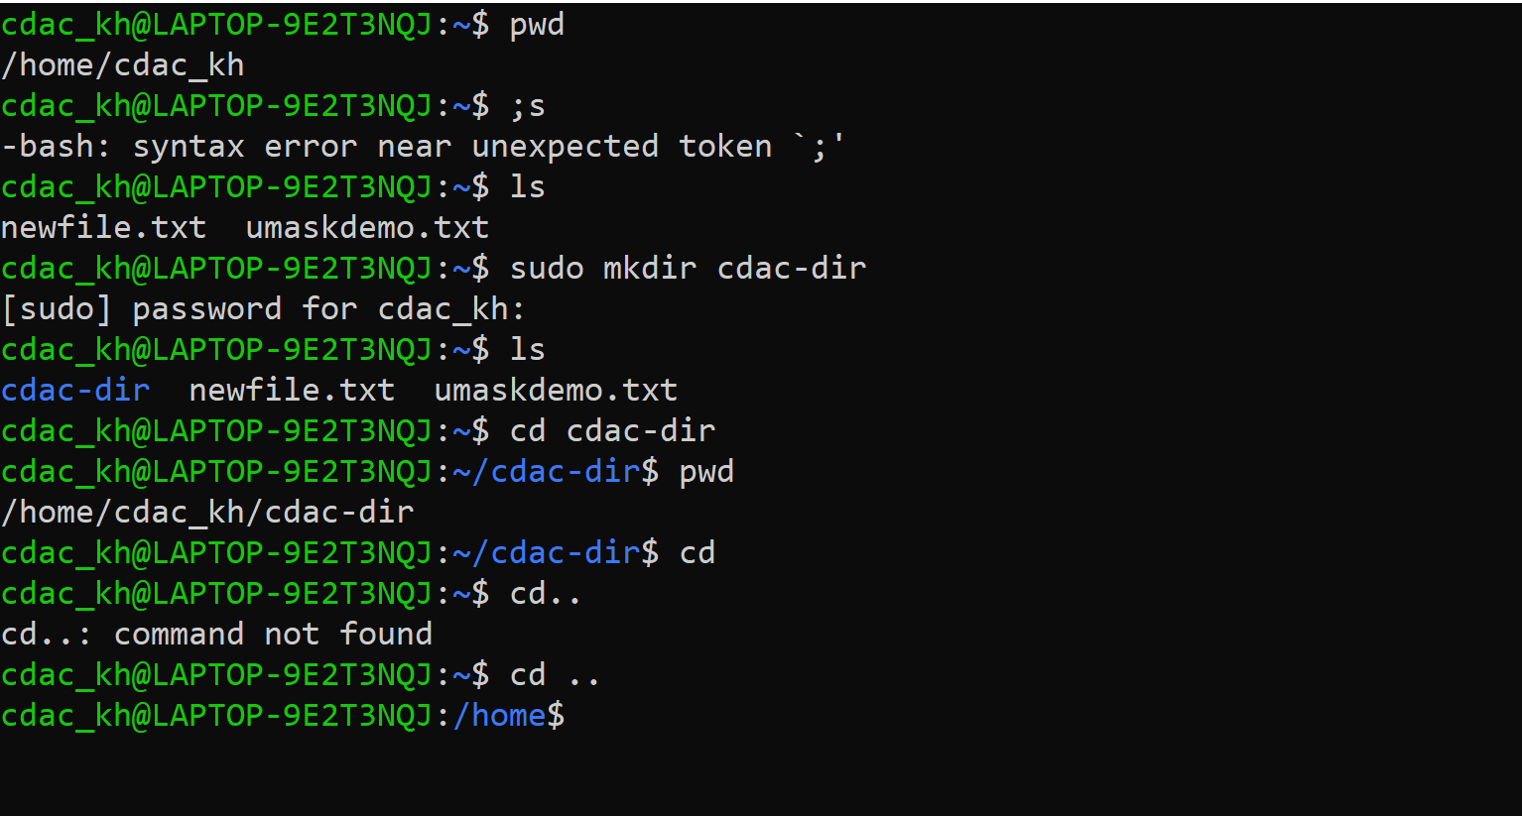

3. Createfollowing nested directories inside current directory by invoking single commandfor only one time.

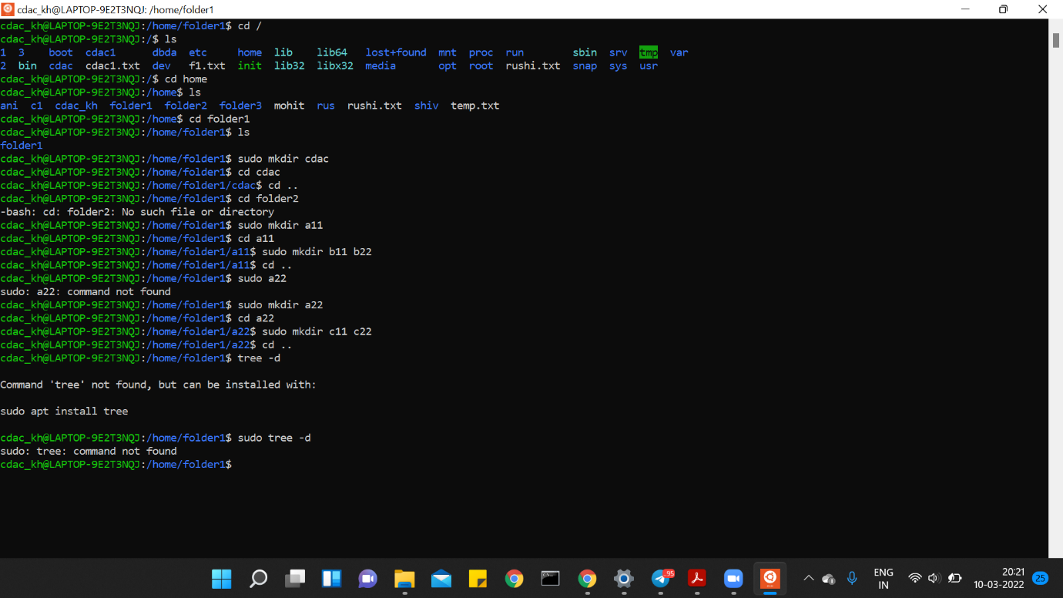

Question-2.

1. Display the **man-page** for **ls** , but redirect the output into **temp.txt** , then use

the **cat, less** , and **more** commands to display the new file.

2. Display the initial 10 lines and final 5 lines of **temp.txt** with the obvious Linux

commands.(Hint: use **head** and **tail** commands).

3. Copy **temp.txt** to another directory and rename it there.

(**Hint** : use **cp** to copy and **mv** command to rename).

4. Display the number of lines, words and characters in file using Linux

command (**Hint** : use **wc** command).

5. Use history command to display last 10 commands used.

(**Hint** : use **history** command). 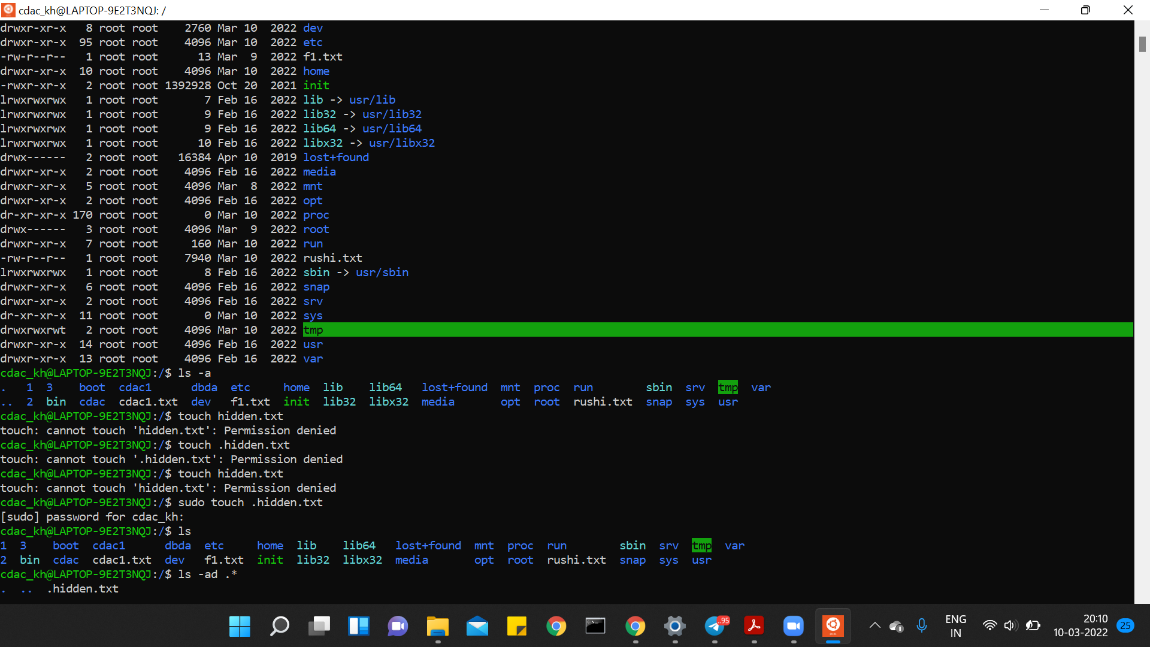

**Question-3.**

1. **Create a tar archive file of any directory present in your home directory.**

root@LAPTOP-9E2T3NQJ:/home/folder1# tar -cf file1.tar folder1

root@LAPTOP-9E2T3NQJ:/home/folder1# ls

a11 a22 cdac file1.tar folder1

**list the contents of the archive file without extracting**

root@LAPTOP-9E2T3NQJ:/home/folder1# tar tf file1.tar

folder1/

2. **Create a zip file of another directory.**

**root@LAPTOP-9E2T3NQJ:/home# gzip file.txt**

**root@LAPTOP-9E2T3NQJ:/home# ls**

**ani c1 file.sh folder1 folder3 mohit rushi.txt.gz temp.txt**

**archive.tar cdac_kh file.txt.gz folder2 leap.sh rus shiv**

**list the contents of the zip file without extracting**

**root@LAPTOP-9E2T3NQJ:/home# zcat file.txt**

hello

my name is rushikesh

i am from latur ,maharashta

i am cdac post graduate

**3.Give read, write & execute permissions to your file.**

**root@LAPTOP-9E2T3NQJ:/home# chmod 777 file.txt.gz**

**root@LAPTOP-9E2T3NQJ:/home# ls -l**

**total 64**

drwxr-xr-x 2 root root 4096 Mar 9 11:04 ani

-rw-r--r-- 1 root root 10240 Mar 13 22:43 archive.tar

drwxr-xr-x 3 root root 4096 Mar 9 16:28 c1

drwxr-xr-x 4 cdac_kh cdac_kh 4096 Jun 8 12:36 cdac_kh

-rw-r--r-- 1 root root 0 Mar 12 17:40 file.sh

-rwxrwxrwx 1 root root 95 Jun 8 12:56 file.txt.gz

drwxr-xr-x 6 root root 4096 Jun 8 12:47 folder1

drwxr-xr-x 2 root root 4096 Mar 9 15:50 folder2

**Change ownership of that file.(Hint : use chown command**

root@LAPTOP-9E2T3NQJ:/home# chown cdac_kh file.txt.gz

root@LAPTOP-9E2T3NQJ:/home# ls -l

total 64

drwxr-xr-x 2 root root 4096 Mar 9 11:04 ani

-rw-r--r-- 1 root root 10240 Mar 13 22:43 archive.tar

drwxr-xr-x 3 root root 4096 Mar 9 16:28 c1

drwxr-xr-x 4 cdac_kh cdac_kh 4096 Jun 8 12:36 cdac_kh

-rw-r--r-- 1 root root 0 Mar 12 17:40 file.sh

-rwxrwxrwx 1 cdac_kh root 95 Jun 8 12:56 file.txt.gz

drwxr-xr-x 6 root root 4096 Jun 8 12:47 folder1

**List processes running in shell, all running processes and show top processes in decreasing order of their resource utilization.**

root@LAPTOP-9E2T3NQJ:/home# ps

PID TTY TIME CMD

100 pts/0 00:00:00 sudo

101 pts/0 00:00:00 su

102 pts/0 00:00:00 bash

141 pts/0 00:00:00 ps

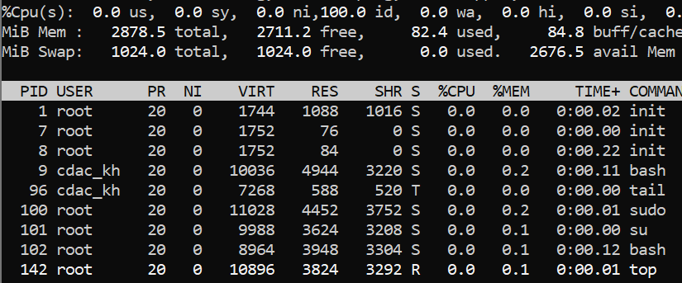

Question-4.

1. Display current time and calendar (**Hint** : use **date, cal** commands)

2. Change the current date and time of the system to following 14th

March 2017, 10:10 AM

3. Explore following commands

who, whoami, whatis, whereis, (**Hint** : use man pages).

