Name : Rushikesh Anil Khairnar
Student ID: 5115301
Roll NO: 21
Subject: Data Engineering

Practical 3: MongoDB Operations

Aim:
To perform single and multiple document insertion and retrieval using MongoDB shell (mongosh).

Step 1: Insert Single Document
Query:
db.items.insertOne({ name: "laptop", price: 999 });

Output:
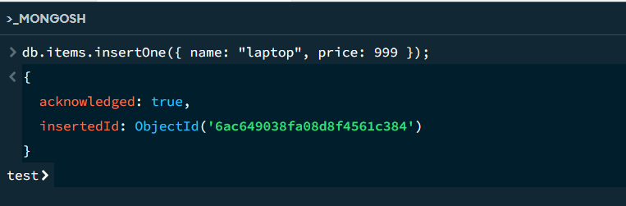

Step 2: View Inserted Document
Query:
db.items.find();

Output:
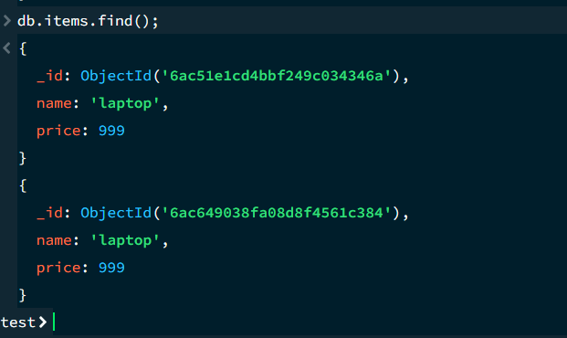

Step 3: Insert Multiple Documents
Query:
db.products.insertMany([
{ name: "phone", price: 500, stock: 10 },
{ name: "tablet", price: 300, stock: 5 },
{ name: "watch", price: 150, stock: 0 }
]);

Output:
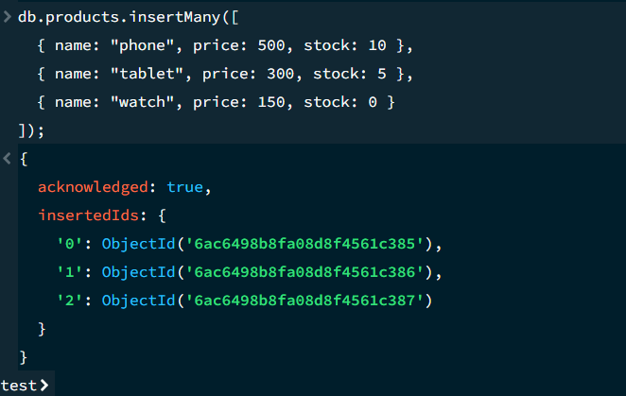

Step 4: View Products in Formatted JSON
Query:
db.products.find().pretty();

Output:
