§
LEDGER
Student Course & Grade Management System
A Data-Driven Java Application — Project Report
Full name | ADD_YOUR_FULL_NAME_HERE
Student ID | ADD_YOUR_STUDENT_ID_HERE
Course / Module | ADD_YOUR_MODULE_NAME_HERE
Submission date | ADD_SUBMISSION_DATE_HERE
GitHub repository | ADD_YOUR_GITHUB_REPO_URL_HERE
Video demonstration | ADD_YOUR_VIDEO_URL_HERE

Note: replace every ADD_… placeholder above before submitting — full name, student ID, module, date, and the live GitHub/video links.

Table of Contents
1 Introduction
2 System Architecture
3 Implementation
4 Results
5 Challenges and Solutions
6 Conclusion and Future Work

(Section and sub-section headings are also navigable via Word's built-in Navigation Pane, since all headings use Word heading styles.)

1. Introduction

1.1 Overview
Ledger is a data-driven web application that manages the academic records of a small institution: the students enrolled, the courses on offer, and the grade each student earns in each course per semester. It was built to satisfy a coursework brief requiring a backend with full CRUD support, a relational database with a properly designed schema, a RESTful API consumed by a working interface, and robust, centralized error handling — all backed by this written report.

1.2 Problem domain and significance
Course and grade administration is a task every school, university, or training provider performs continuously, and it is a genuinely relational problem: a student can take many courses, a course has many students, and the interesting data — the grade — lives on the relationship itself rather than on either side of it. That makes it a good vehicle for demonstrating proper schema design (a many-to-many relationship resolved through a join entity), non-trivial business logic (computing a GPA from weighted credit hours), and realistic failure modes (duplicate enrollments, invalid grades, missing records) that a production system has to handle gracefully rather than crash on.

1.3 Objectives
- Design a normalized relational schema for students, courses, and enrollments, and implement it with JPA/Hibernate against MySQL.
- Build a layered Spring Boot backend (controller → service → repository) exposing full CRUD operations over a RESTful JSON API.
- Implement real business logic beyond simple CRUD: automatic GPA calculation, duplicate-enrollment prevention, and grade validation.
- Centralize error handling so that no single bad request, missing record, or unexpected condition can crash the API or leak an internal stack trace.
- Provide a working interface (an HTML/JS dashboard) so the data can be created, browsed, and edited without needing a separate API client.
- Document the system's design, implementation, and behaviour thoroughly enough for another developer to maintain or extend it.

1.4 Scope
The system covers three entities — Student, Course, and Enrollment — and the operations a registrar would routinely perform on them: registering and updating students, maintaining a course catalog, enrolling a student in a course for a given semester, recording or amending a grade, and viewing a student's computed GPA. Authentication/authorization, multi-institution support, and transcript-PDF generation were intentionally left out of scope to keep the project focused on the required backend, database, API, and error-handling pillars; some of these are suggested as future work in Section 6.

2. System Architecture

2.1 Architectural style
The backend follows a classic layered (n-tier) architecture, which was chosen over a more elaborate style (e.g. hexagonal/ports-and-adapters, or a microservice split) because the problem domain is a single bounded context with three closely related entities — introducing extra architectural machinery would add ceremony without adding clarity for a project of this size. Each layer has one responsibility and depends only on the layer directly beneath it:
- Controller layer — translates HTTP requests into service calls and service results into HTTP responses. Contains no business logic.
- Service layer — owns business rules: uniqueness checks, grade parsing/validation, and GPA calculation. Talks to repositories, never directly to SQL.
- Repository layer — Spring Data JPA interfaces that translate method calls into SQL via Hibernate. No business logic here either.
- Database — MySQL in the default profile, or an in-memory H2 instance in the ‘demo’ profile, so the app can be evaluated with zero external setup.

Cutting across every layer is a single GlobalExceptionHandler, annotated with @RestControllerAdvice, which intercepts any exception thrown anywhere in the request lifecycle and converts it into a consistent JSON error response. This is what lets the controller and service methods stay simple — they throw a plain, descriptive exception when something is wrong and trust the handler to turn it into the correct HTTP status and message.
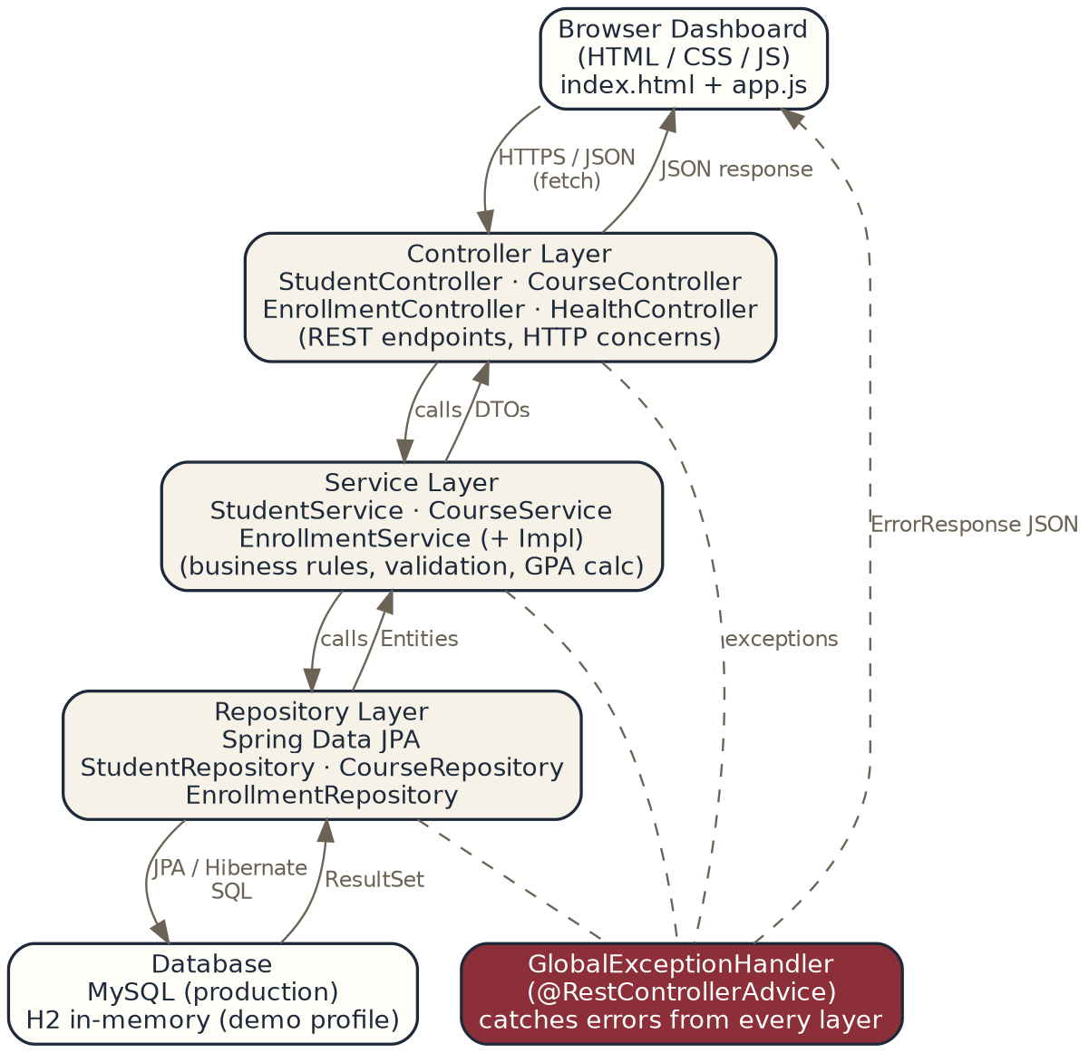
Figure 2.1 — Layered architecture: request flow (solid arrows) and error flow (dashed arrows).

2.2 Technology choices and rationale
Concern | Choice & why
Language / runtime | Java 17 — long-term-support release, required target for the assignment.
Framework | Spring Boot 3.3 — the de-facto standard for production Java REST APIs; auto-configuration, dependency injection, and starter dependencies keep boilerplate low while remaining fully explicit about wiring.
Persistence | Spring Data JPA + Hibernate — maps entity classes to relational tables and derives most repository queries from method names, reducing hand-written SQL and its associated risk of injection bugs.
Database | MySQL 8 (primary) with an H2 in-memory fallback profile — MySQL for a realistic production-style relational database; H2 so the grader/reviewer can run the app instantly without installing anything.
Validation | Jakarta Bean Validation (@NotBlank, @Email, @Min) — declarative request validation applied consistently at the DTO boundary.
Frontend | Plain HTML/CSS/vanilla JS — no build step, framework version drift, or bundler required to demonstrate the API is genuinely usable end-to-end.
Build tool | Maven — standard, well-documented dependency management and build lifecycle for Java.

2.3 Database design
The schema is fully normalized to third normal form. Student and Course are independent entities; their many-to-many relationship is resolved through Enrollment, a join entity that also carries attributes of the relationship itself — semester and grade — which could not live on either Student or Course alone. A composite uniqueness constraint on (student_id, course_id, semester) prevents the same student being enrolled in the same course twice in one semester at the database level, as a second line of defence behind the application-level check in the service layer.
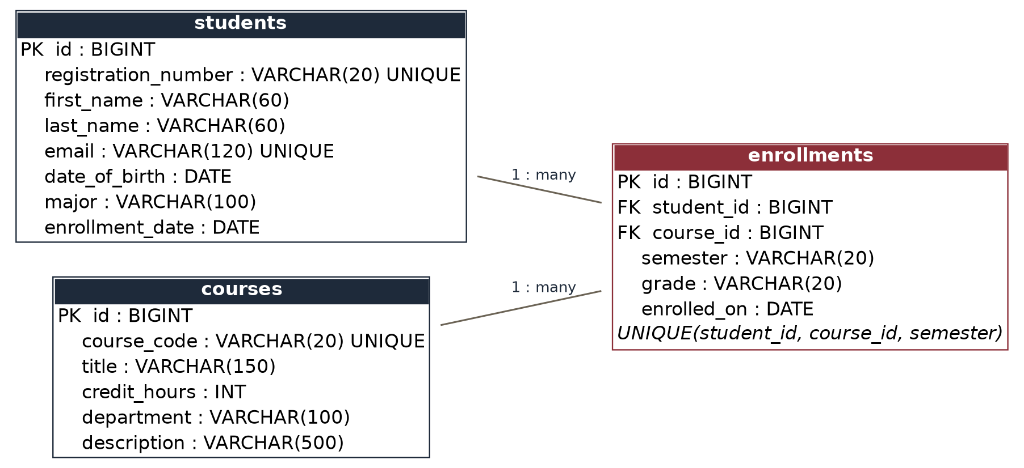
Figure 2.2 — Entity-relationship diagram for the students / courses / enrollments schema.

3. Implementation

3.1 Backend development
Each entity has a matching REST controller, service interface + implementation, and Spring Data JPA repository, giving the project 3 × 4 = 12 cleanly separated classes for its core domain, plus shared DTOs and exception classes. Controllers are intentionally thin — every method simply delegates to the service layer and wraps the result in a ResponseEntity with the appropriate status code (201 Created on POST, 204 No Content on DELETE, and so on):
@PostMapping
public ResponseEntity<StudentDTO> create(@Valid @RequestBody StudentDTO dto) {
StudentDTO created = studentService.create(dto);
return ResponseEntity.status(HttpStatus.CREATED).body(created);
}
Listing 3.1 — StudentController.create(): thin controller, @Valid triggers bean validation automatically.
The service layer is where the actual business rules live. For example, GPA is not stored as a column — it is calculated on demand from a student's graded enrollments, weighted by each course's credit hours, which is the standard way GPA is defined and avoids the schema ever holding a stale, denormalized value:
public double calculateGpa(Long studentId) {
List<Enrollment> graded = enrollmentRepository
.findGradedEnrollmentsByStudent(studentId);
double totalPoints = 0.0;
int totalCredits = 0;
for (Enrollment e : graded) {
int credits = e.getCourse().getCreditHours();
totalPoints += e.getGrade().getGpaPoints() * credits;
totalCredits += credits;
}
return totalCredits == 0 ? 0.0
: Math.round((totalPoints / totalCredits) * 100.0) / 100.0;
}
Listing 3.2 — StudentServiceImpl.calculateGpa(): credit-weighted GPA on a standard 4.0 scale.

3.2 Database interaction
Entities are plain JPA-annotated classes; Spring Data JPA repositories provide CRUD for free (save, findById, findAll, deleteById, existsById) and let additional queries be declared just by their method signature, with Hibernate generating the SQL:
public interface EnrollmentRepository
extends JpaRepository<Enrollment, Long> {

List<Enrollment> findByStudentId(Long studentId);

boolean existsByStudentIdAndCourseIdAndSemester(
Long studentId, Long courseId, String semester);

@Query("SELECT e FROM Enrollment e WHERE e.student.id = :studentId " +
"AND e.grade <> com.university.sms.model.Grade.NOT_GRADED")
List<Enrollment> findGradedEnrollmentsByStudent(
@Param("studentId") Long studentId);
}
Listing 3.3 — EnrollmentRepository: derived queries plus one explicit JPQL query.
One deliberate implementation decision worth documenting: JPA entities in this project use Lombok's @Getter/@Setter rather than @Data. Student, Course, and Enrollment reference each other bidirectionally (a Student holds a list of Enrollments; an Enrollment holds references back to its Student and Course). @Data would have generated equals()/hashCode()/toString() methods that recurse into those collections and back again, risking a StackOverflowError the first time an entity was logged, compared, or placed in a hash-based collection. This was caught during development and is recorded in Section 5 as a challenge and fix.

3.3 API design
The API is organised around the three resources, plus a health endpoint, under a common /api base path. The full endpoint reference:
Method | Endpoint | Description
GET | /api/health | Health check for the backend
POST | /api/students | Create a student
GET | /api/students | List all students, each with computed GPA
GET | /api/students/{id} | Get one student
PUT | /api/students/{id} | Update a student
DELETE | /api/students/{id} | Delete a student (cascades enrollments)
GET | /api/students/{id}/gpa | Get just the computed GPA
POST | /api/courses | Create a course
GET | /api/courses | List all courses
GET | /api/courses/{id} | Get one course
PUT | /api/courses/{id} | Update a course
DELETE | /api/courses/{id} | Delete a course (cascades enrollments)
POST | /api/enrollments | Enroll a student in a course for a semester
GET | /api/enrollments | List all enrollments
GET | /api/enrollments/student/{id} | List one student's enrollments
GET | /api/enrollments/course/{id} | List one course's enrollments
PATCH | /api/enrollments/{id}/grade | Update just the grade
DELETE | /api/enrollments/{id} | Remove an enrollment

3.4 Error handling
Three custom, domain-specific exceptions cover the expected failure cases — ResourceNotFoundException (404), DuplicateResourceException (409), and InvalidRequestException (400) — and are thrown directly from the service layer wherever a business rule is violated, e.g. registering a duplicate email or enrolling the same student in the same course/semester twice. A single GlobalExceptionHandler then catches these, plus Spring's own validation, database-constraint, malformed-JSON, and type-mismatch exceptions, and — critically — a catch-all handler for anything unanticipated, so the API can never return a raw 500 stack trace to a client:
@ExceptionHandler(Exception.class)
public ResponseEntity<ErrorResponse> handleGeneric(
Exception ex, HttpServletRequest req) {
return build(HttpStatus.INTERNAL_SERVER_ERROR,
"An unexpected error occurred. Please try again " +
"or contact the administrator.",
req, null);
}
Listing 3.4 — The catch-all fallback handler: the application's last line of defence.
Every handler returns the same ErrorResponse shape (timestamp, HTTP status, error, message, request path, and optional field-level details), so any client — including the bundled dashboard — can parse errors predictably instead of special-casing each failure type. The frontend mirrors this philosophy: every fetch() call goes through a single apiCall() wrapper that catches network failures and non-2xx responses and surfaces a readable message via a toast or inline form error, rather than failing silently or breaking the page.

3.5 Frontend / interface
The interface is a single-page HTML/CSS/vanilla-JS dashboard (no framework or build step) served directly from Spring Boot's static resources folder, so opening http://localhost:8080 is the entire setup. It has three tabs — Students, Courses, and Enrollments & Grades — each with a form for creating/editing records on the left and a live table on the right, wired directly to the REST API described above.

4. Results
The screenshots below were captured directly from the application's own HTML/CSS, populated with representative sample data (also available as seed data in sql/schema_reference.sql), to demonstrate each part of the interface end-to-end.

4.1 Student roll
The Students tab registers new students and lists the full roll with each student's computed GPA, pulled live from GET /api/students. Editing a row populates the form on the left for update; deleting prompts for confirmation and cascades to that student's enrollments.
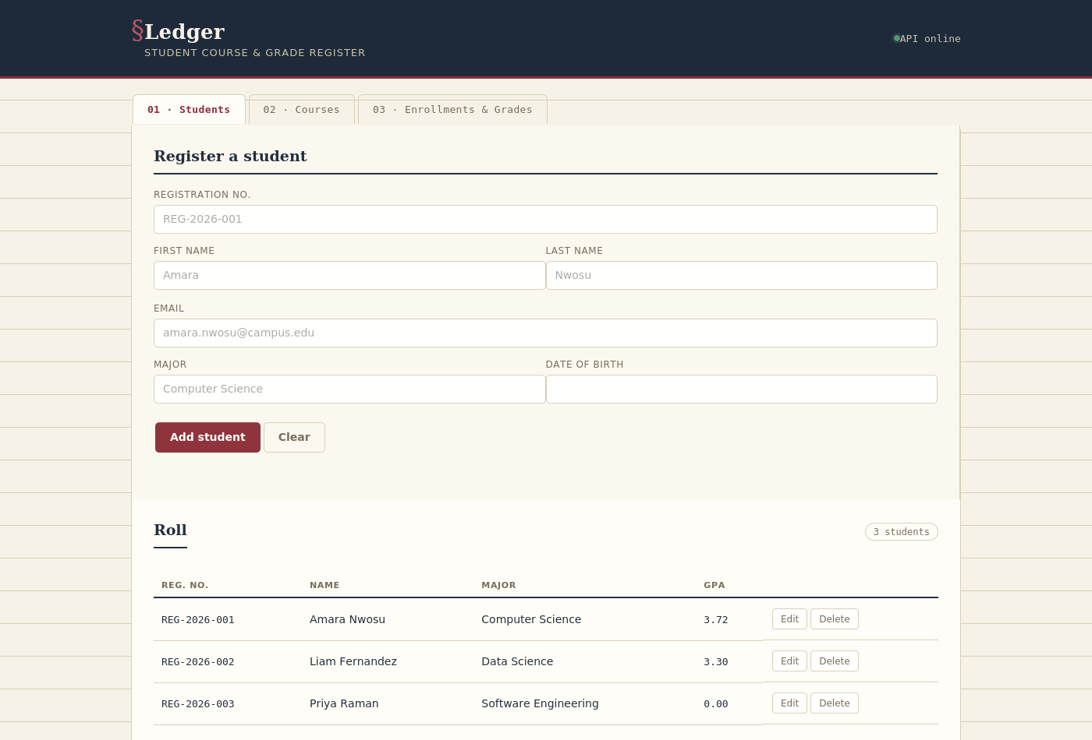
Figure 4.1 — Students tab: registration form and roll, showing computed GPA per student.

4.2 Course catalog
The Courses tab manages the catalog and shows, for each course, how many students are currently enrolled — a count derived from the Enrollment relationship rather than stored redundantly.
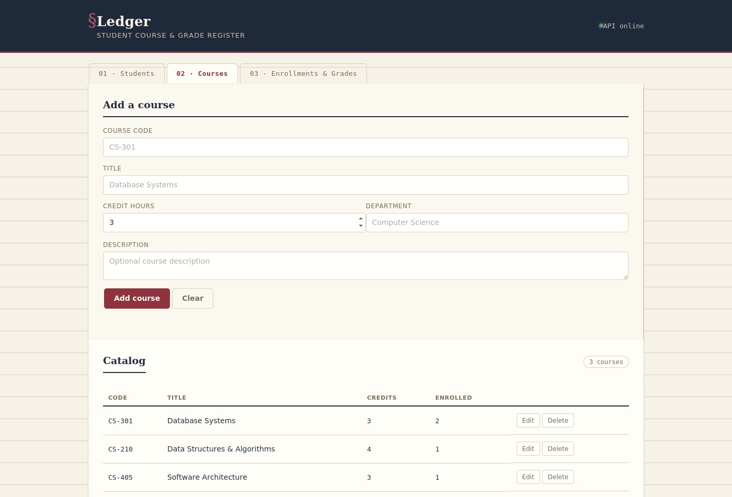
Figure 4.2 — Courses tab: catalog with live enrollment counts.

4.3 Enrollments & the gradebook
The Enrollments tab is where a student is linked to a course for a semester and, later, given a grade. The gradebook table reflects POST /api/enrollments and PATCH /api/enrollments/{id}/grade results immediately.
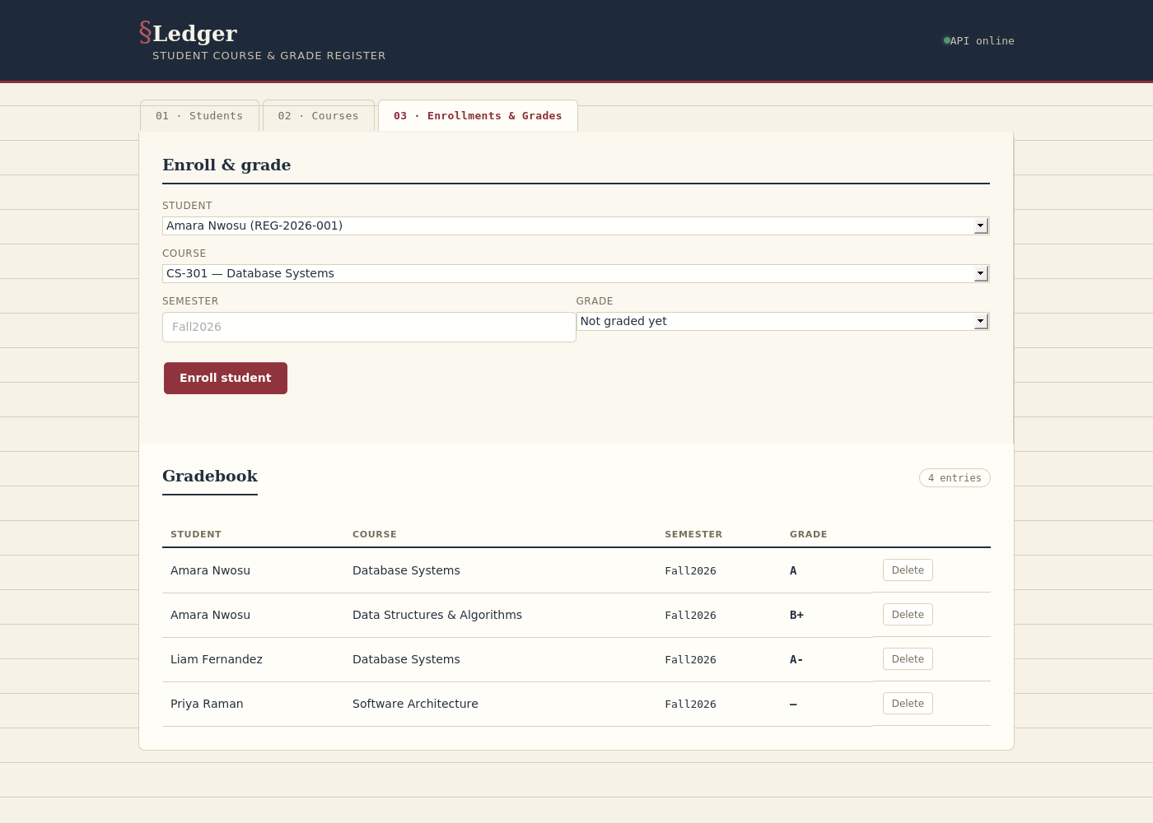
Figure 4.3 — Enrollments tab: enrollment form and gradebook with letter grades.

4.4 Error handling in practice
The two error paths below are both real, reachable states, not mocked UI: attempting to register a second student with an email already on file triggers the backend's DuplicateResourceException, surfaced as an inline form message; and if the API is ever unreachable, the frontend's fetch wrapper catches the network failure and raises a toast rather than leaving the user looking at a blank or frozen page.
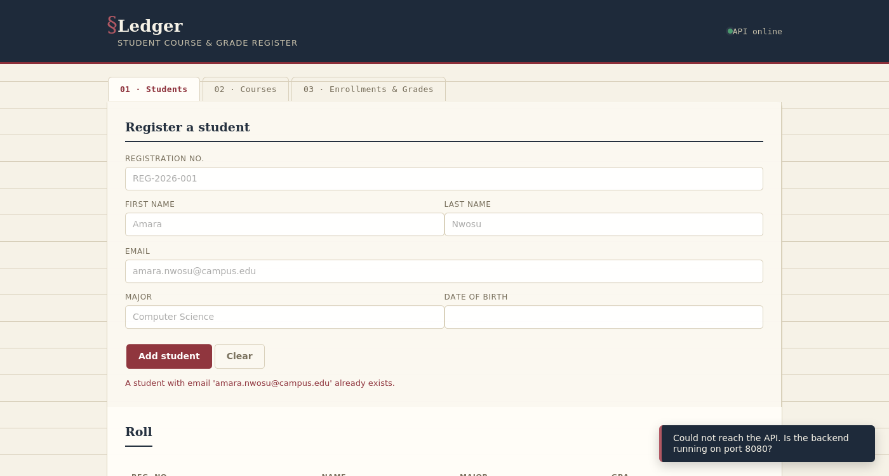
Figure 4.4 — A 409 Conflict surfaced inline, and a network failure surfaced as a toast.

4.5 Sample API responses
A successful creation (HTTP 201):
POST /api/students
{
"registrationNumber": "REG-2026-004",
"firstName": "Sara", "lastName": "Kim",
"email": "sara.kim@campus.edu", "major": "CS"
}

201 Created
{
"id": 4, "registrationNumber": "REG-2026-004",
"firstName": "Sara", "lastName": "Kim",
"email": "sara.kim@campus.edu", "major": "CS",
"enrollmentDate": "2026-08-26", "gpa": 0.0
}

A validation failure (HTTP 400), produced by the GlobalExceptionHandler:
{
"timestamp": "2026-08-26 10:12:03",
"status": 400,
"error": "Bad Request",
"message": "Validation failed for one or more fields",
"path": "/api/students",
"details": ["email: Email must be a valid email address"]
}

5. Challenges and Solutions

5.1 Recursive equals/hashCode/toString on bidirectional entities
Challenge: the initial version of the entity classes used Lombok's @Data annotation for brevity. Because Student, Course, and Enrollment reference each other bidirectionally (Student ↔ Enrollment ↔ Course), the generated equals()/hashCode()/toString() methods would walk into those relationships and back again indefinitely — a latent StackOverflowError waiting for the first time an entity was logged, printed, or placed in a HashSet.
Solution: replaced @Data with @Getter/@Setter on all three entities, so no equals/hashCode/toString are generated from the relationship fields at all (JPA entities are generally safer relying on identity/primary-key semantics rather than reflective field-based equality anyway). @JsonIgnore was also kept on the collection sides so Jackson's JSON serialization never attempts to walk the same cycle when returning entities.

5.2 Preventing duplicate enrollments at two levels
Challenge: a student could, in principle, be enrolled in the same course for the same semester twice, which would corrupt GPA calculations (double-counting credit hours) and make no academic sense.
Solution: this is enforced twice, deliberately. The service layer checks existsByStudentIdAndCourseIdAndSemester() before inserting and throws a friendly DuplicateResourceException if it already exists — giving a clear 409 response. As a second, database-level safety net (in case of a race condition or a future code path that bypasses the service), a composite UNIQUE constraint on (student_id, course_id, semester) exists at the schema level; if it is ever violated regardless, the GlobalExceptionHandler's DataIntegrityViolationException handler still converts it into a clean error rather than a 500.

5.3 Letting the API run with zero external setup
Challenge: requiring a grader or reviewer to install and configure MySQL before they can even start the application creates unnecessary friction and risk of environment-specific failures unrelated to the actual project work.
Solution: Spring profiles were used to separate database configuration from application code. The default ‘mysql’ profile targets a real MySQL instance as the primary, production-style database (satisfying the ‘real-world’ database requirement), while an alternative ‘demo’ profile points at an in-memory H2 database with the same JPA entity mappings, letting anyone run `mvn spring-boot:run -Dspring-boot.run.profiles=demo` and have a fully working system in seconds, with the H2 web console available to inspect the live schema and data.

5.4 Keeping error responses consistent across many failure types
Challenge: a REST API has many distinct ways to fail — a missing record, a duplicate value, a failed validation, malformed JSON, a wrong parameter type, an unsupported HTTP method, a database constraint violation, or a genuinely unexpected bug — and handling each ad hoc in individual controller methods would be repetitive and easy to get inconsistent.
Solution: all of these were centralized in one GlobalExceptionHandler using @RestControllerAdvice, each mapped to the correct HTTP status and shaped into the same ErrorResponse DTO. This meant controller and service code could stay focused on business logic — simply throwing a descriptive exception — while the handler guarantees the client always receives predictable, parseable JSON, never a raw stack trace, regardless of what went wrong or where.

5.5 Building without access to Maven Central in this environment
Challenge: the sandbox this project was authored in restricts outbound network access to a small allow-list of domains that does not include Maven Central, so `mvn compile`/`mvn test` could not be executed here to verify the build.
Solution: this was mitigated with a careful manual review of every class for signature consistency (constructor field order versus DTO field order, repository method names versus entity field names, service interface methods versus their implementations and controller call sites), and by rendering the frontend's actual HTML/CSS to verify it independently of the backend. The clear recommendation — and the natural first step after downloading the project — is to run `mvn clean install` locally, where full internet access will allow Maven to resolve dependencies normally.

6. Conclusion and Future Work

6.1 Summary
Ledger meets each requirement set out in the brief: a layered Spring Boot backend with full CRUD across three related resources; a properly normalized MySQL schema (with a zero-setup H2 fallback) accessed through Spring Data JPA; a documented RESTful API exercised by a real, working HTML/JS dashboard; and centralized, defensive error handling that keeps the application functional and informative under invalid input, duplicate data, missing records, and unexpected conditions alike. Beyond bare CRUD, the system implements genuine domain logic — credit-weighted GPA calculation and duplicate-enrollment prevention enforced at both the application and database layers — that would be needed in a real registrar's system.

6.2 Future work
- Authentication & authorization — add Spring Security with role-based access (e.g. only staff can edit grades; students can only view their own record).
- Pagination & search — the current list endpoints return every row; production scale would need pagination, filtering, and search (e.g. by name, department, or semester).
- Transcript export — generate a PDF transcript per student, combining this project's data model with the PDF-generation techniques used elsewhere in coursework.
- Audit trail — record who changed a grade and when, which matters academically and is a natural extension of the existing Enrollment entity.
- Automated test coverage — expand beyond the current context-load smoke test to unit tests for the service layer (especially GPA calculation edge cases) and integration tests for each controller.
- Containerization — package the application and a MySQL instance together with Docker Compose so the ‘real’ database profile is as easy to start as the H2 demo profile is today.

6.3 Closing remark
The project demonstrates that ‘advanced programming techniques’ in a data-driven application are less about any single clever trick and more about disciplined separation of concerns — keeping HTTP, business rules, and persistence in distinct layers — and about treating error handling as a first-class design concern from the start, rather than an afterthought bolted on once something breaks in front of a user.

