🔷 1. Project Explanation (Simple Overview)

📌 Problem Statement
Build a system that predicts diseases using patient data stored in SQL, ML models in Python, and a React frontend
👉 In simple words:
A smart healthcare system that:
- Collects patient data
- Tracks health metrics
- Uses ML to predict possible diseases early

🔷 2. System Architecture

🧩 Components

1. Database (SQL)
From page 1 & 2:
- Patient Table
  - name, age, gender, city
- Health Record Table
  - blood pressure, sugar, cholesterol, heart rate, BMI
- Symptoms Table
  - list of symptoms (fever, cough, fatigue)
- Patient-Symptom Mapping
  - which patient has which symptoms
- Medication Table
  - disease → medicine mapping

2. Backend (Django / Flask)
- Fetch data from SQL
- Preprocess data
- Run ML model
- Return prediction

3. ML Model (Python)
- Takes patient data + symptoms
- Predicts disease (e.g., Diabetes, Heart Disease)

4. Frontend (React)
- User inputs symptoms
- Displays prediction results
- Shows health trends

🔷 3. Workflow (End-to-End Flow)
👉 Step-by-step:
- User enters:
  - Symptoms
  - Basic details
- Backend:
  - Fetches past records
  - Combines with input
- ML Model:
  - Predicts disease probability
- Output:
  - Disease prediction
  - Suggested medication

🔷 4. ML Model – What Features You Need ⚡ (Very Important)
This is what interviewers care about most.

✅ 1. Basic Features (Demographic)
- Age
- Gender
- City (optional)
👉 Why?
Some diseases depend on age/gender.

✅ 2. Clinical Features (MOST IMPORTANT)
From your health table:
- Blood Pressure (split into systolic/diastolic)
- Sugar Level
- Cholesterol
- Heart Rate
- BMI
👉 Example:
- High sugar → Diabetes
- High BP + cholesterol → Heart disease

✅ 3. Symptoms Features
From symptoms + mapping table:
Convert symptoms into binary encoding
Symptom | Value
Fever | 1
Cough | 0
Fatigue | 1
👉 This is called:
- One-hot encoding / Multi-label encoding

✅ 4. Derived Features (Advanced 🔥)
You should create these (very important for ML quality):
- BMI category (Underweight / Normal / Obese)
- BP category (Normal / High)
- Sugar category (Normal / Diabetic)
👉 Feature engineering = better accuracy

✅ 5. Time-Based Features (Optional but Powerful)
From dates:
- Trend of sugar over time
- Avg BP over last 7 days
👉 Useful for:
- LSTM / time-series models

🔷 5. Target Variable (What You Predict)
Your model predicts:
👉 Disease label
Example:
- 0 → No disease
- 1 → Diabetes
- 2 → Heart Disease

🔷 6. ML Algorithms You Can Use
Start simple:

🟢 Beginner
- Logistic Regression
- Decision Tree

🟡 Intermediate
- Random Forest (best choice)
- XGBoost

🔴 Advanced
- Neural Networks
- LSTM (if time-series)

🔷 7. Data Preprocessing Steps
Very important:
- Handle missing values
- Encode categorical data
- Normalize features
- Balance dataset (if needed)

🔷 8. Output of Model
Instead of just disease, return:
- Disease name
- Probability (e.g., 85%)
- Risk level (Low / Medium / High)

🔷 9. Extra Features (To Make Project Stand Out 🚀)
Add these:

⭐ Smart Features
- Health dashboard (graphs)
- Daily monitoring alerts
- Risk prediction over time

⭐ AI Features
- Chatbot for symptom explanation
- Personalized suggestions

⭐ Backend Features
- JWT authentication
- User history tracking

🔷 10. Interview Explanation (Short Version 🎯)
If asked:
👉 Say this:
“This is a disease prediction system where patient data like vitals and symptoms are stored in SQL. I built an ML model using features like blood pressure, sugar level, BMI, and encoded symptoms to predict diseases like diabetes and heart disease. The backend processes data and the React frontend allows users to input symptoms and view predictions.”

🔥 Final Insight
👉 The most important part of this project is NOT the UI
👉 It’s:
- Feature engineering
- Data quality
- Model accuracy

If you want next step, I can:
✅ Help you design the ML pipeline (code + architecture)
✅ Give dataset + training code
✅ Or help you explain this in interviews with confidence
Just tell me 👍
What features i can add to the database for more disease prediction to increase the scope of system . Especially in health record table and Symptoms table
Great question — this is exactly how you turn a basic project into a strong ML + real-world system 🔥
Right now your database is too limited (BP, sugar, cholesterol, etc.).
To increase scope, you need to add multi-dimensional health data.

🔷 1. Upgrade: Health Record Table (Very Important)
Currently you have:
- BP, Sugar, Cholesterol, Heart Rate, BMI
👉 This is good but not enough for multiple disease prediction

✅ Add These Features

🫀 A. Cardiovascular Features
- ECG result (Normal / Abnormal)
- Oxygen Saturation (SpO2)
- Chest pain type
- Resting ECG
- Max heart rate achieved
👉 Helps predict:
- Heart Disease
- Stroke

🩸 B. Blood Test Features
- Hemoglobin
- RBC count
- WBC count
- Platelet count
👉 Helps predict:
- Anemia
- Infection
- Blood disorders

🍬 C. Diabetes-Specific Features
- Fasting blood sugar
- HbA1c (VERY important)
- Insulin level
👉 HbA1c is gold standard for diabetes prediction

🧬 D. Liver Function
- ALT (SGPT)
- AST (SGOT)
- Bilirubin
👉 Helps detect:
- Liver disease

🧪 E. Kidney Function
- Creatinine
- Urea
- Sodium / Potassium
👉 Helps detect:
- Kidney disease

🫁 F. Respiratory Features
- Respiratory rate
- Lung capacity (optional)
👉 Helps detect:
- Asthma
- COVID / infections

⚖️ G. Lifestyle Features (VERY IMPORTANT 🔥)
- Smoking (Yes/No)
- Alcohol consumption
- Physical activity level
- Diet type (veg/non-veg/junk-heavy)
- Sleep hours
👉 These drastically improve ML performance

🧠 H. Mental Health Indicators (Advanced)
- Stress level (1–10)
- Anxiety level
- Depression score
👉 Helps future expansion (mental health prediction)

🔷 2. Upgrade: Symptoms Table (CRITICAL for ML)
Right now:
- Fever, Cough, Fatigue ❌ (too basic)

✅ Expand Symptoms to Multi-Domain

🤒 A. General Symptoms
- Fever
- Fatigue
- Weight loss
- Loss of appetite

🫀 B. Heart-Related Symptoms
- Chest pain
- Shortness of breath
- Palpitations
- Dizziness

🍬 C. Diabetes Symptoms
- Frequent urination
- Excessive thirst
- Blurred vision
- Slow healing wounds

🫁 D. Respiratory Symptoms
- Cough (dry/wet)
- Wheezing
- Breathlessness

🧠 E. Neurological Symptoms
- Headache
- Seizures
- Memory loss
- Numbness

🧪 F. Digestive Symptoms
- Nausea
- Vomiting
- Abdominal pain
- Diarrhea

🦠 G. Infection Symptoms
- Chills
- Sweating
- Body pain

🔥 Pro Tip (Very Important)
Instead of just storing symptom name →
Store symptom attributes:
Feature | Example
Severity | Mild / Moderate / Severe
Duration | 2 days
Frequency | Continuous / Occasional
👉 This makes your dataset much richer for ML

🔷 3. Add New Tables (To Expand Scope 🚀)

✅ 1. Family History Table
- Diabetes (Yes/No)
- Heart disease
- Cancer
👉 Genetics matter a LOT

✅ 2. Medication History Table
- Current medicines
- Past treatments

✅ 3. Allergy Table
- Drug allergies
- Food allergies

✅ 4. Hospital Visit / Diagnosis Table
- Doctor diagnosis (label for ML)
- Final confirmed disease
👉 This becomes your target variable

🔷 4. Feature Engineering Opportunities 🔥
With new data, you can create:
- Risk score (custom)
- BMI category
- BP category
- Lifestyle risk index

🔷 5. Result: What Diseases You Can Now Predict
With expanded features, your system can handle:
- Diabetes
- Heart disease
- Kidney disease
- Liver disease
- Respiratory diseases
- Anemia
- Infections
- Mental health risk (basic)

🔷 6. Final Insight (Very Important)
👉 More features ≠ better model automatically
You need:
- Relevant features
- Clean data
- Proper encoding

🔷 7. Best Strategy (For Your Project)
If you're building this for internship:
👉 Focus on:
- Diabetes
- Heart Disease
- General illness predic

🧠 🩺 What Your Features ACTUALLY Mean
Think of your dataset like a digital health report of a patient.
Each column = one medical signal that helps detect disease.

❤️ 1. Blood Pressure (BP)
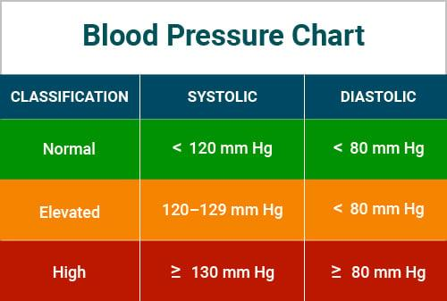
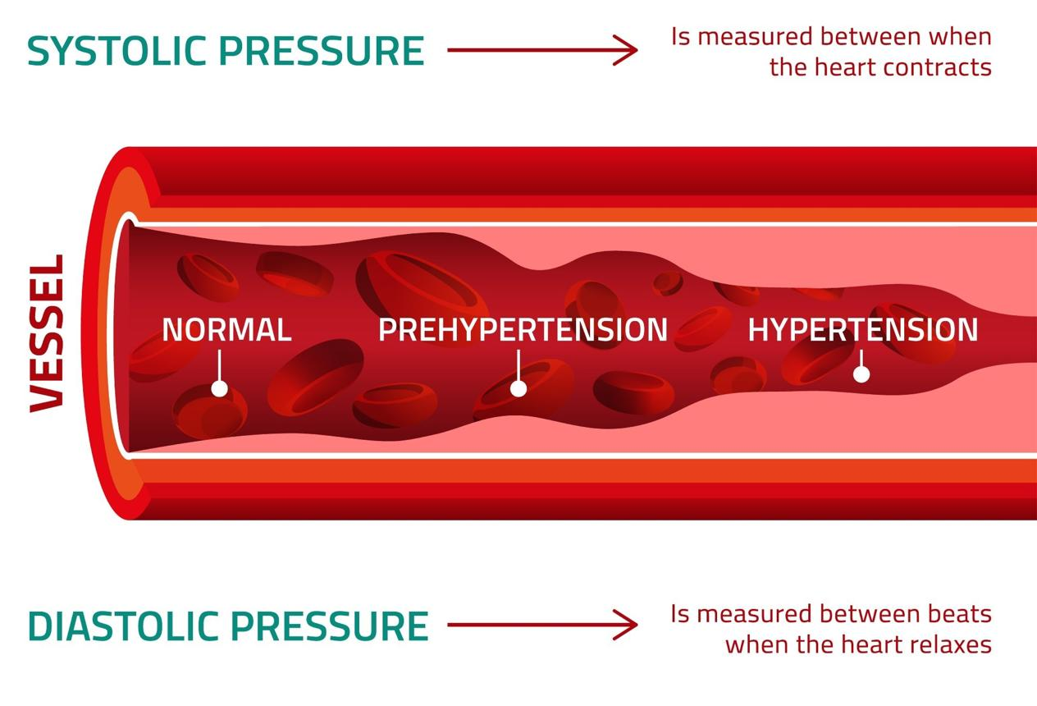
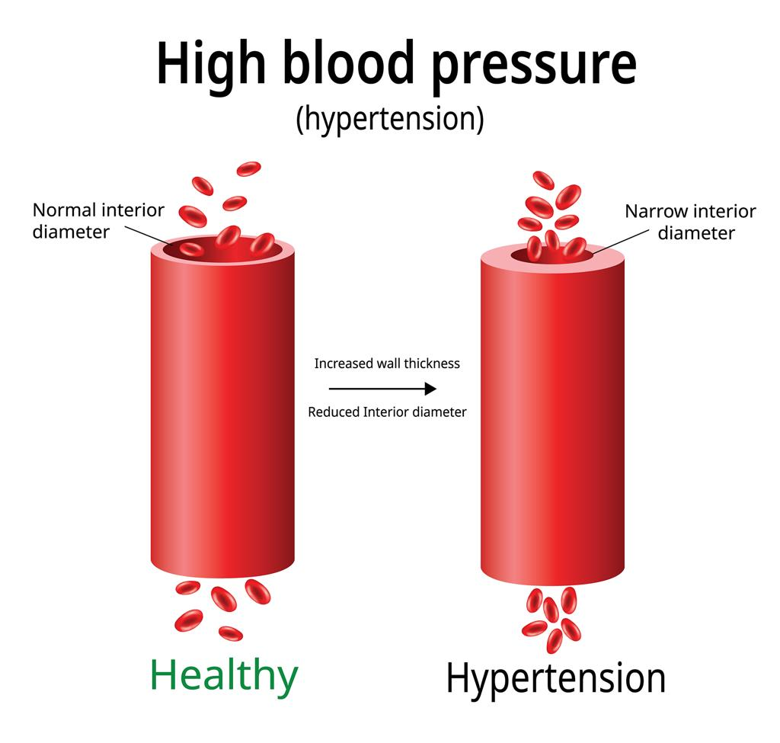
6

Columns:
- systolic_bp → pressure when heart beats
- diastolic_bp → pressure when heart rests

Values Meaning:
- Normal → 120/80
- High → >140/90

Impact:
👉 High BP damages arteries → leads to:
- Heart Disease
- Stroke

❤️ 2. Heart Rate
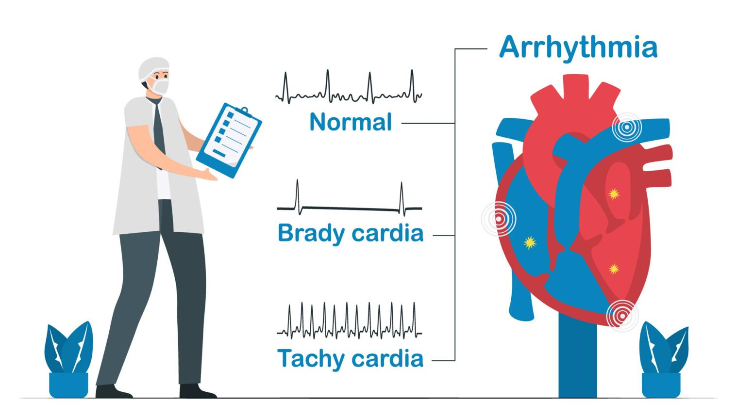
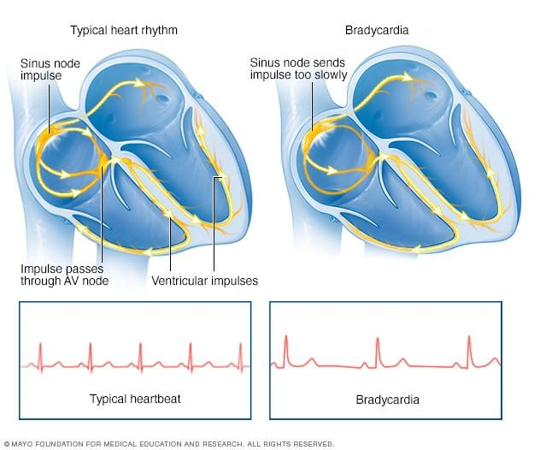
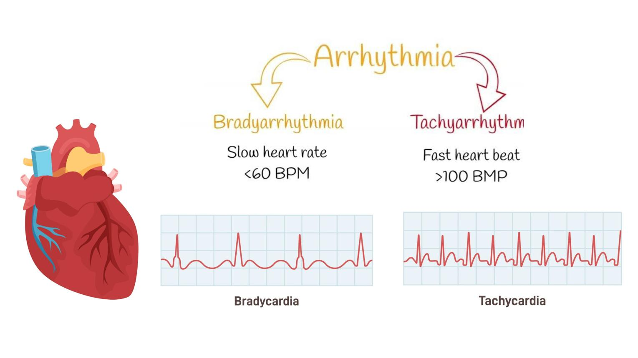
5

Column:
- heart_rate (beats per minute)

Values:
- Normal → 60–100 bpm
- High → stress / heart issues

Impact:
👉 Abnormal heart rate → cardiac risk

⚖️ 3. BMI (Body Mass Index)
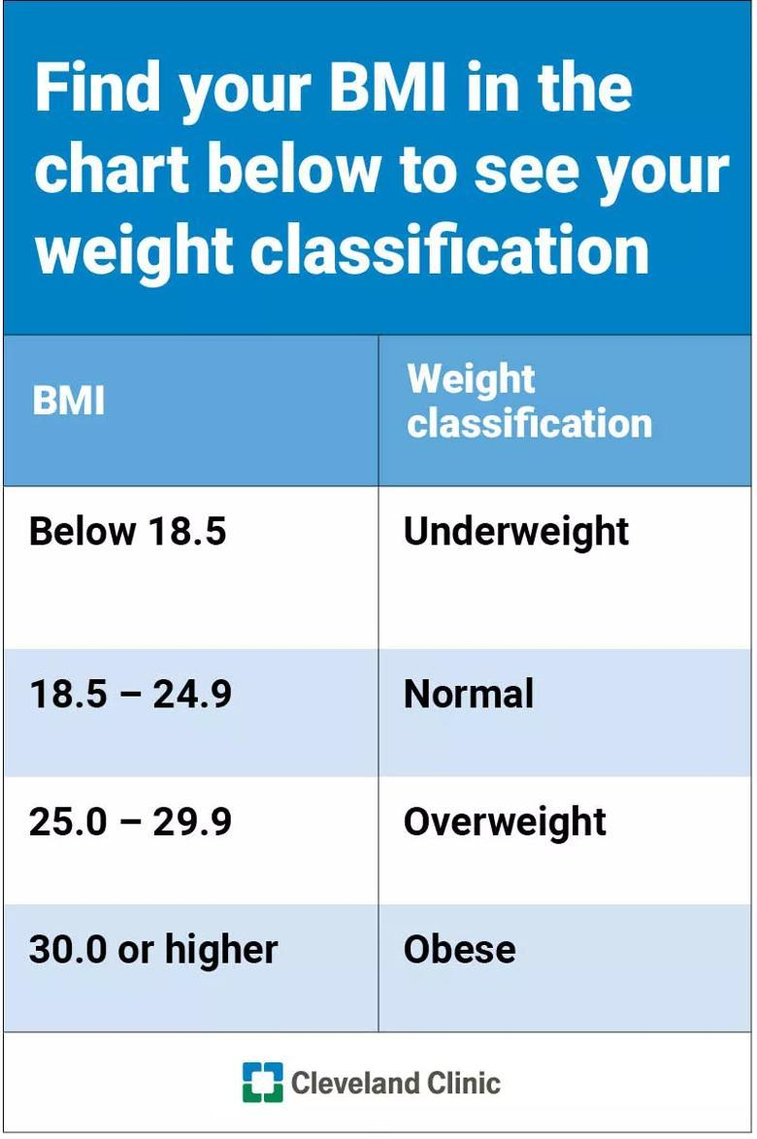
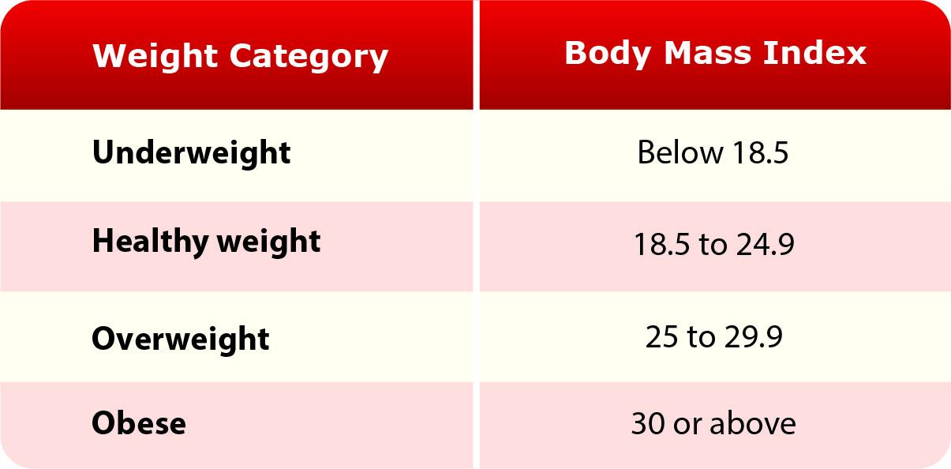
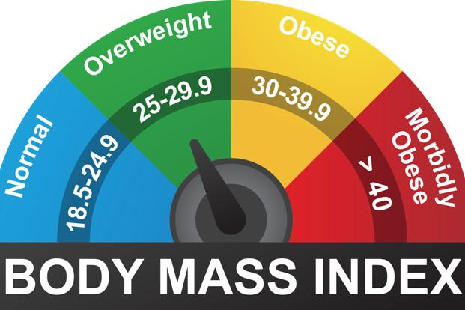
6

Column:
- bmi

Values:
- <18.5 → underweight
- 18–25 → normal
- 30 → obese

Impact:
👉 High BMI →
- Diabetes
- Heart disease

🍬 4. Sugar Levels (Diabetes Indicators)
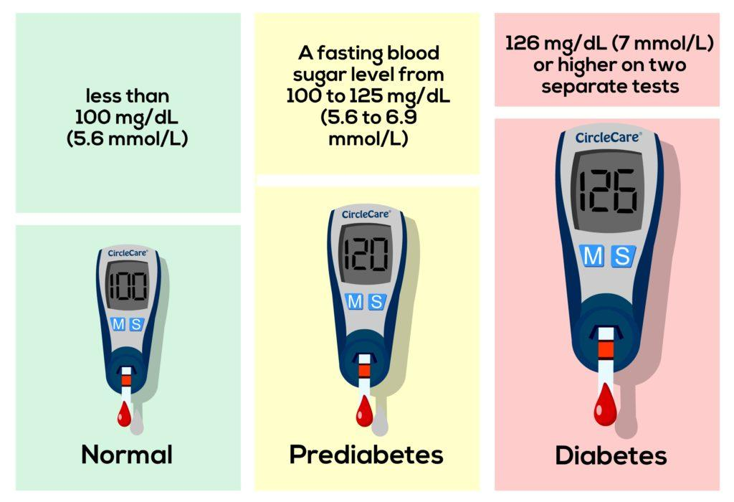
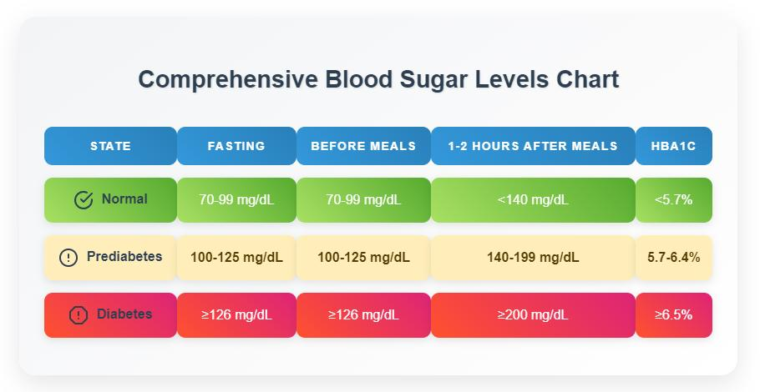
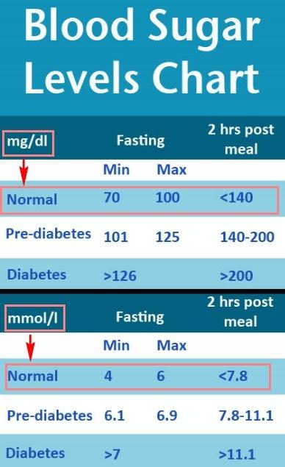
5

Columns:
- fasting_blood_sugar
- hba1c

Values:
- Normal sugar → <100
- Diabetes → >126
- HbA1c:
  - Normal → <5.7
  - Diabetes → >6.5

Impact:
👉 High sugar damages:
- Kidneys
- Eyes
- Nerves

🧪 5. Creatinine (Kidney Function)
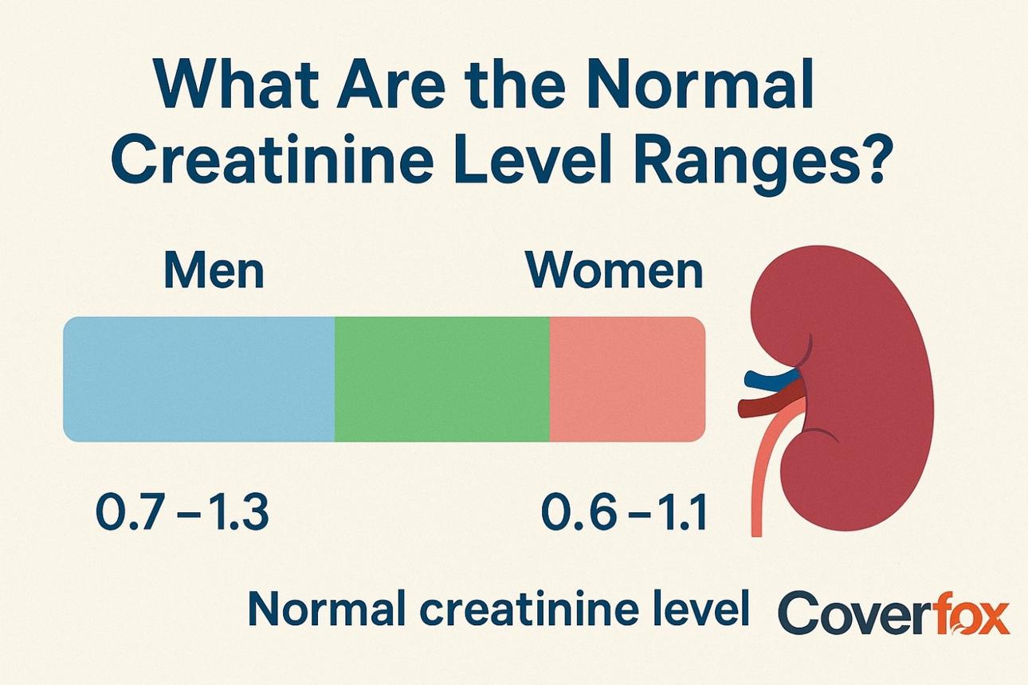
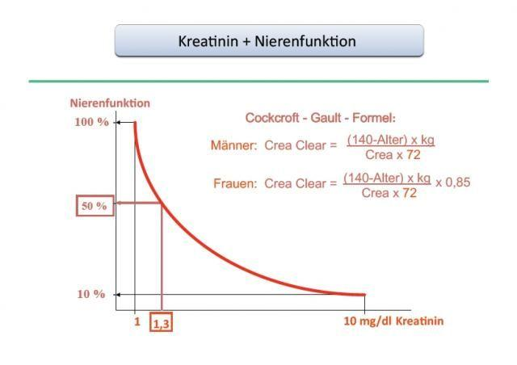
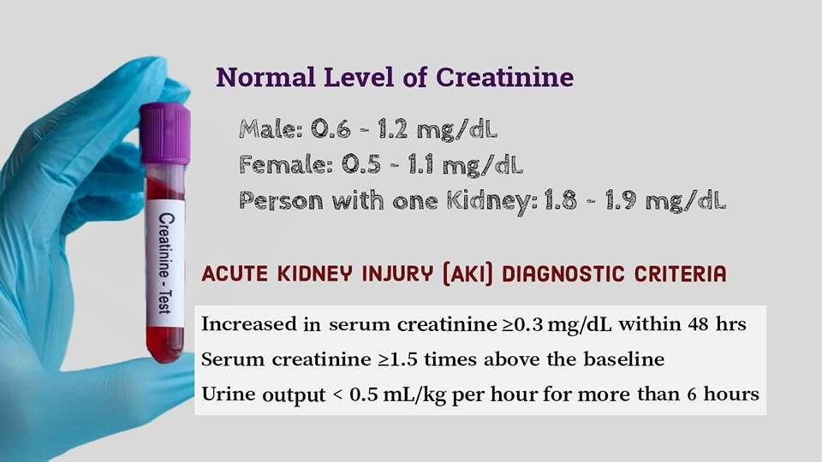
4

Column:
- creatinine

Values:
- Normal → 0.7–1.3
- High → kidney damage

Impact:
👉 If creatinine ↑ → kidneys not filtering properly

🧬 6. ALT (SGPT) – Liver Function
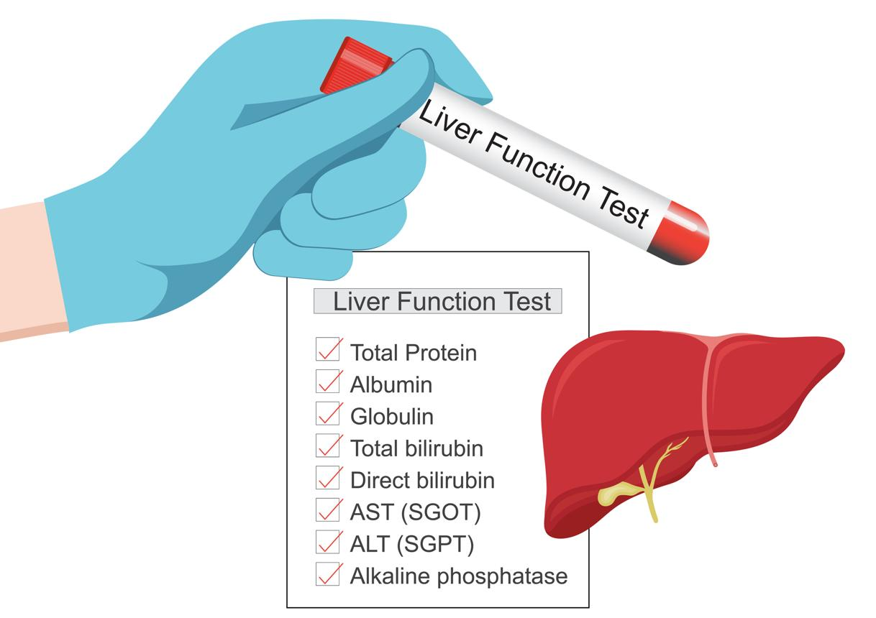
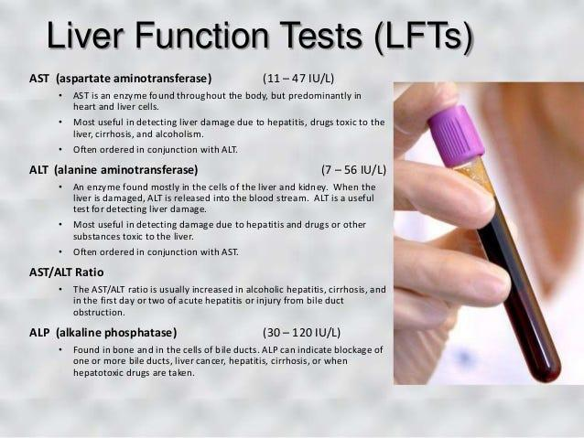
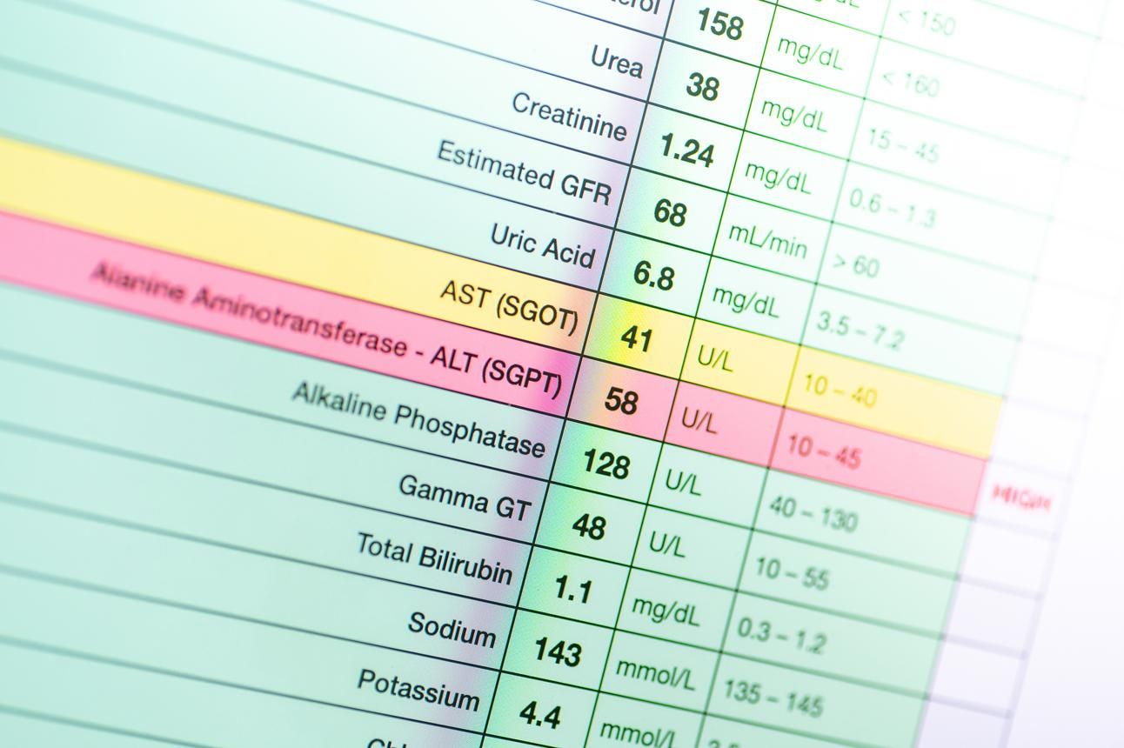
6

Column:
- alt_sgpt

Values:
- Normal → <40
- High → liver damage

Impact:
👉 Indicates:
- Fatty liver
- Hepatitis

🧈 7. Cholesterol
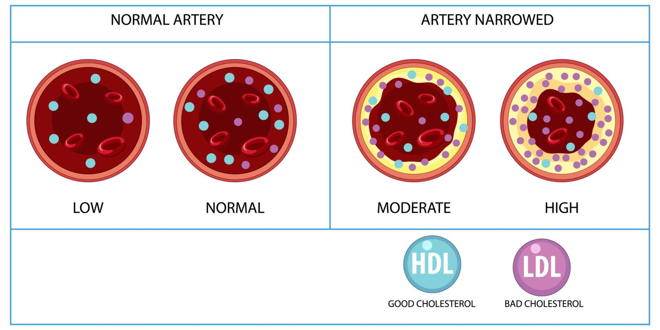
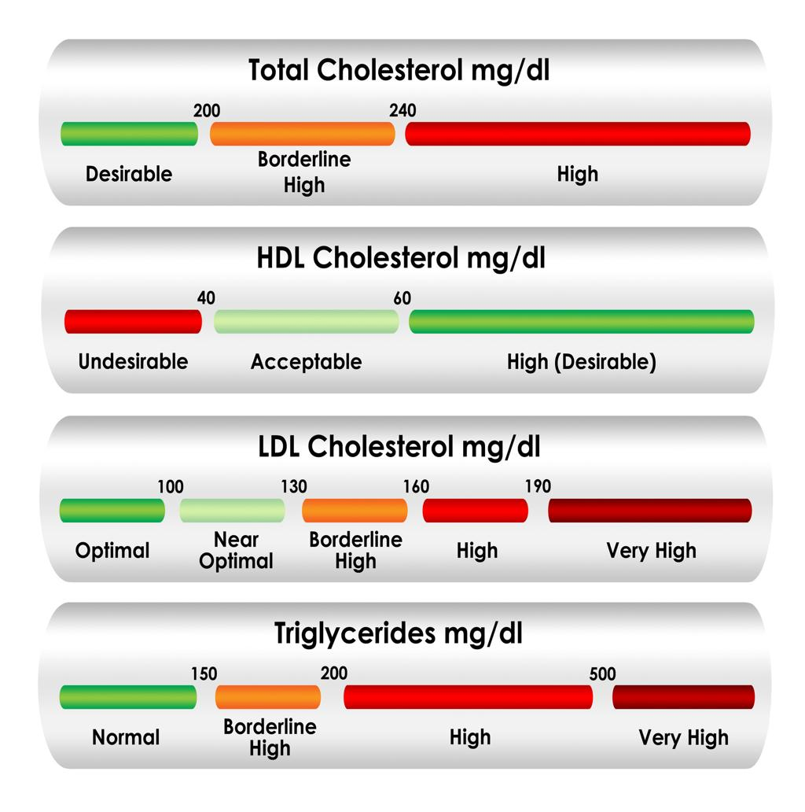
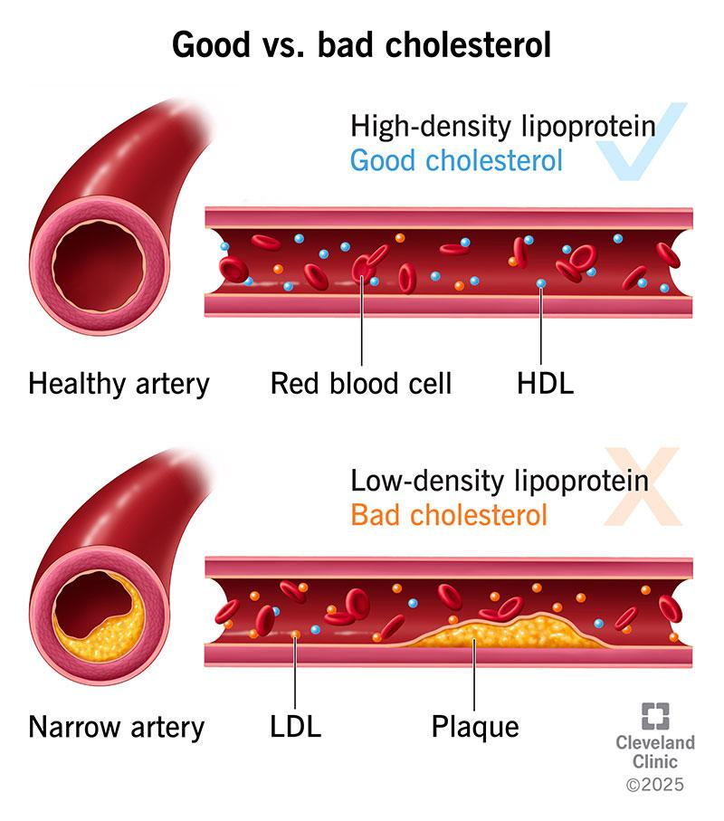
4

Columns:
- total_cholesterol
- ldl (bad)
- hdl (good)

Values:
- LDL high → dangerous
- HDL high → protective

Impact:
👉 High LDL → artery blockage → heart disease

🚬 8. Lifestyle Features

Columns:
- smoking (0/1)
- physical_activity_level
- stress_level

Impact:
- Smoking → damages lungs + heart
- Low activity → obesity
- Stress → heart + mental health

🤒 9. Symptoms (VERY IMPORTANT FOR ML)

Examples:
- chest_pain → heart disease
- frequent_urination → diabetes
- abdominal_pain → liver / diarrhea
- diarrhea_symptom → infection
- fever → infection

🔷 1. Disease Prediction Result (Must Have)

✅ What to show
- Predicted disease
- Confidence score (probability)
- Risk level

🎯 Visualization ideas
- Gauge chart (speedometer style)
- Probability bar chart
Example:
- Diabetes → 78% (High Risk 🔴)
- Heart Disease → 35% (Medium Risk 🟡)
👉 Why important:
Users understand risk instantly

🔷 2. Health Dashboard (Core Feature)

✅ Show all vitals in one place

📊 Charts:
- Line chart → BP over time
- Line chart → Sugar level trend
- Line chart → Heart rate trend
👉 This comes from your health_records table

💡 Example insights:
- “Your sugar is increasing in last 7 days”
- “BP is consistently high”
👉 This makes your system intelligent

🔷 3. Symptom Analysis Visualization

✅ Show:
- Selected symptoms
- Severity level

📊 Charts:
- Bar chart → symptom severity
- Radar chart → symptom distribution
Example:
- Fever → High
- Fatigue → Medium
👉 Helps doctors + users understand condition quickly

🔷 4. Risk Factor Breakdown (Very Powerful 🔥)

✅ Show WHY model predicted disease

📊 Charts:
- Feature importance chart
- SHAP plot (advanced)
Example:
- High sugar → 40% impact
- High BMI → 25% impact
👉 This builds trust in ML model

🔷 5. Lifestyle Impact Visualization

✅ Show:
- Smoking
- Sleep
- Activity

📊 Charts:
- Pie chart → lifestyle habits
- Scorecard → health score
Example:
- Sleep → Low ❌
- Activity → Medium ⚠️
👉 Makes system more personalized

🔷 6. Historical Comparison (Very Impressive)

📊 Show:
- Past vs current health
Example:
Metric | Last Month | Now
Sugar | 120 | 160 🔴
BP | 130/85 | 150/95 🔴
👉 Add:
- “Condition worsening” alert

🔷 7. Multi-Disease Probability Chart

📊 Show all predictions together
Bar chart:
- Diabetes → 80%
- Heart Disease → 40%
- Kidney Disease → 20%
👉 This shows:
- Model is not binary
- It’s intelligent

🔷 8. Alerts & Notifications UI

🚨 Examples:
- “High BP detected”
- “Risk of diabetes increasing”
👉 Use:
- Color coding (Red / Yellow / Green)

🔷 9. Medication Recommendation Display

✅ Show:
- Disease → medicine
Example:
- Diabetes → Metformin
- Heart Disease → Aspirin
👉 From your medication table

🔷 10. Health Score (Very Attractive Feature 🔥)

📊 Show:
- Overall score (0–100)
Example:
- 85 → Good 🟢
- 60 → Moderate 🟡
- 30 → Risk 🔴
👉 Combine:
- BP
- Sugar
- BMI
- Lifestyle

🔷 11. (Advanced) Time-Series Prediction

📊 Show future prediction:
- Sugar after 7 days
- BP trend
👉 Use:
- LSTM (optional)

🔷 12. Recommended Tech Stack for Visualization

🟢 React Libraries:
- Chart.js (easy)
- Recharts (best for dashboards)
- D3.js (advanced)

🔷 13. Final UI Layout (Best Design)
👉 Your app should have:

🧩 Dashboard
- Health summary
- Trends

🧩 Prediction Page
- Disease + probability
- Risk explanation

🧩 History Page
- Past records
- Graphs
- Heart disease is mainly caused by high cholesterol, high blood pressure, smoking, obesity, diabetes, and an unhealthy lifestyle with poor diet and lack of exercise. Stress also plays a major role. To prevent heart disease, one should exercise regularly, avoid fried and processed foods, reduce salt intake, manage stress through yoga or meditation, and regularly monitor blood pressure and cholesterol levels. Treatment usually includes medications like statins, beta-blockers, and blood thinners such as aspirin, but these must be taken under medical supervision. From a Vedic perspective, herbs like Arjuna bark help strengthen the heart, Ashwagandha reduces stress, and consuming garlic with honey or Tulsi tea supports cardiovascular health.
- Kidney disease commonly occurs due to diabetes, high blood pressure, infections, dehydration, and excessive use of painkillers. Preventive measures include drinking sufficient water, controlling blood sugar and blood pressure, limiting salt and protein intake, and avoiding unnecessary medications. Treatment may involve drugs like ACE inhibitors, diuretics, or in severe cases, dialysis. Herbal remedies such as Punarnava and Gokshura are known in Ayurveda to support kidney function, while natural fluids like coconut water and barley water help maintain hydration and detoxification.
- Diabetes is caused by insulin resistance, genetic factors, obesity, sedentary lifestyle, and high intake of sugar and refined carbohydrates. Prevention focuses on maintaining a healthy weight, exercising regularly, and avoiding excessive sugar consumption. Monitoring blood glucose levels is essential. Medical treatment includes drugs like Metformin, insulin therapy, and other glucose-lowering medications. Vedic remedies include consuming fenugreek seeds (methi), bitter gourd (karela) juice, jamun seed powder, and neem leaves, all of which help in controlling blood sugar levels naturally.
- Diarrhea is typically caused by contaminated food or water, bacterial or viral infections, food poisoning, and poor hygiene. Preventive steps include maintaining proper hygiene, drinking clean water, and avoiding unsafe food. The main treatment focuses on rehydration using Oral Rehydration Solution (ORS), zinc supplements, and antibiotics in bacterial cases. From a traditional approach, remedies like buttermilk with black salt, pomegranate peel powder, banana with rice (BRAT diet), and ginger tea help in managing symptoms and improving digestion.
- Liver disease is often linked to excessive alcohol consumption, fatty diets, hepatitis infections, obesity, and diabetes. Prevention includes avoiding alcohol, maintaining a balanced low-fat diet, managing weight, and taking vaccinations such as for Hepatitis B. Treatment depends on the cause and may include antiviral drugs or lifestyle modifications. Ayurvedic support includes Amla, which is rich in antioxidants, Kutki herb for liver detox, turmeric milk for anti-inflammatory benefits, and aloe vera juice to improve liver function.

- Overall, maintaining a healthy lifestyle is the most effective way to prevent these diseases. This includes regular physical activity, a balanced diet, adequate hydration, proper sleep, and stress management. Herbal and Vedic approaches can support health, but they should complement—not replace—modern medical treatment, and it is always advisable to consult a healthcare professional before starting any medication or remedy.

