Cryptocurrency

Dashboard



# 

# 1. ABOUT THE

# PROJECT

A cryptocurrency is **a digital or virtual currency that is secured by cryptography**, which makes it nearly impossible to counterfeit or double-spend. Many cryptocurrencies are decentralized networks based on blockchain technology—a distributed ledger enforced by a disparate network of computers. The project is the analysis of different types of cryptocurrency over various years.

# 2. ABOUT THE

# DATA

The dataset has one csv file for each currency. Price history is available on a daily basis from April 28, 2013. This dataset has the historical price information of some of the top crypto currencies by market capitalization.

**DATE**

**1**

The DATE describes the date of observations.

**OPEN**

The OPEN is the Opening Price on the given day.

**HIGH**

**3**

The HIGH is the highest price on the given day.

**LOW**

**4**

The LOW is the lowest price on the given day.

**CLOSE**

The CLOSE is the closing price on the given day.

**VOLUME**

**6**

The VOLUMNE is the volume of transactions on the given day.

**MARKET CAP**

**7**

The MARKET CAP is the market capitalization in USD.

**Cryptocurrency Used :**

**1.AAVE COIN 2.COSMOS COIN 3. IOTA COIN 4. LITE COIN**

**5.CRYPTO.COM COIN 6.BITCOIN 7.DOGE COIN 8.MONO COIN**

**9.BINANCE COIN 10.CARDANO CION 11.EOS COIN 12.NEM COIN**

**13.CHAINLINK COIN 14.ETHERIUM 15.POLKADOT COIN 16.SOLANA COIN**

**17.UNISWAP COIN 18.USD COIN 19.TETHER COIN 20.WRAPPED BITCOIN**

**21.TRON COIN 22.XRP COIN**

# 3. INSIGHTS TO

# FIND OUT

**1.What is the Final Close Price?**

**2.What is the highest close price?**

**3.What is the lowest close price?**

**4.What is the average daily volume?**

**5.What is comparison of Close Price within Selected time?**

**6.What is Average Volume by Date range?**

**7.What is Price Comparison table of various cryptocurrencies?**

**8.Who are the best performers in last 30 Days and 365 Days?**

**9.Who are the worst performers in last 30 Days and 365 Days?**

**10.What is Price correlation of various cryptocurrencies?**

# 4.VISUAL ANALYTICS AND FINDINGS

**Close Price (High)**

**Close Price (Final)**

2,324.68

4,168.70

13,492

**Average Daily Volume**

**Close Price (Low)**

84.31

**Close price within selected date:**

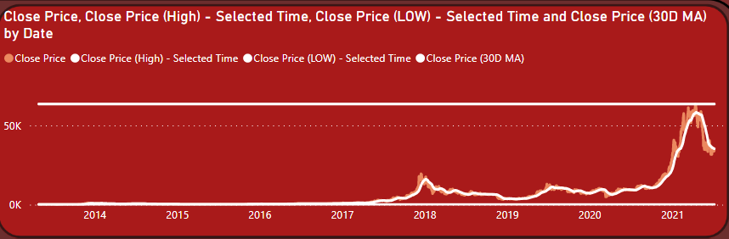

**Average Volume by Date:**

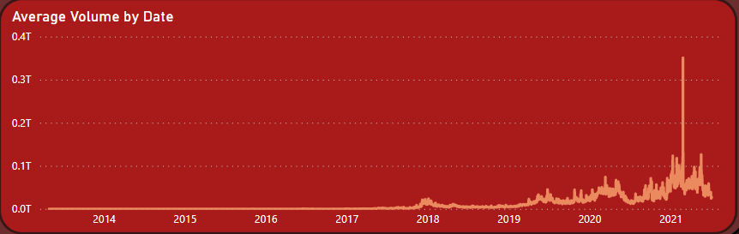

**Best Performers:**

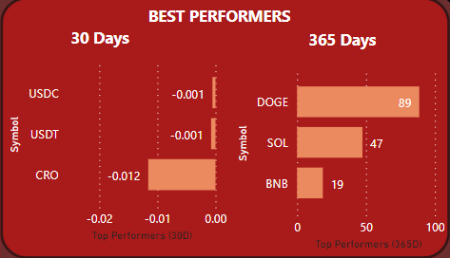

**Worst Performers:**

