**SportyShoes.com**

**SimpliLearn FSJD – Implement Frameworks The DevOps Way**

**Name of the Project:**

SportyShoes.com

**Developer Details:**

**Name –** Rushikesh Nikam

**Course**  - Full Stack Java Developer, Simplilearn

**Link to Github Repository**:

<https://github.com/Rushi9527/Phase3Project.git>

**Project Home Page**

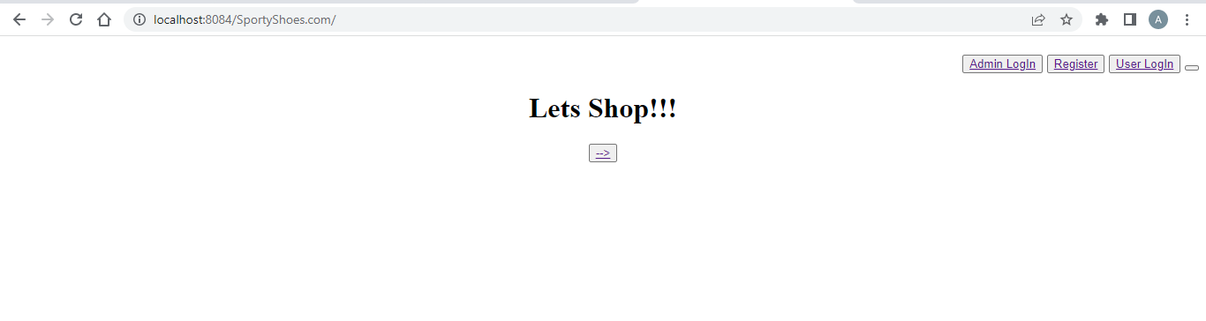

**Admin Login Page**

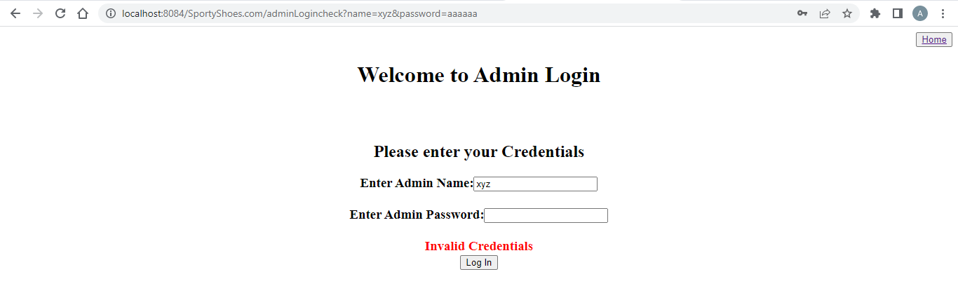

**Admin Home page**



**Manage Products Page**

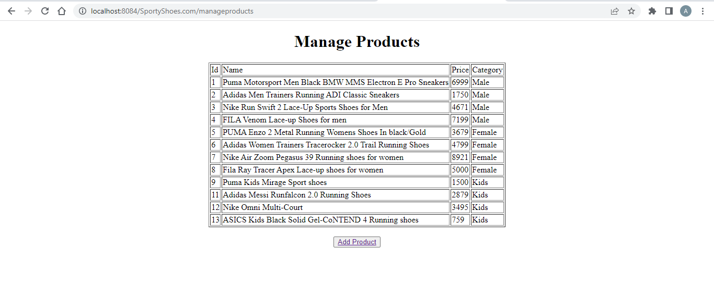

**Add Product Page**

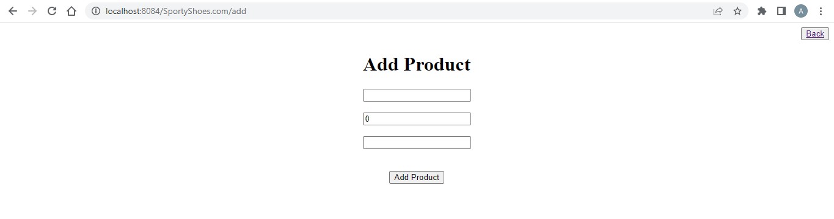

**Product Add Successful Page**

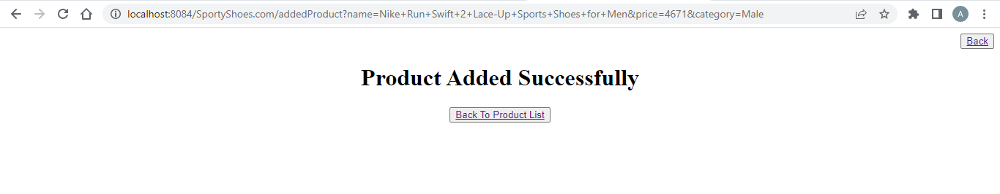

**User List**

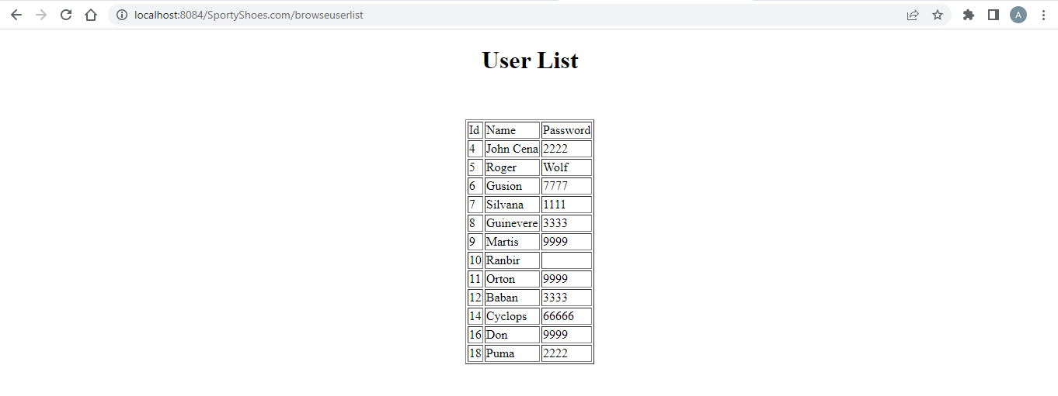

**Purchase Reports**

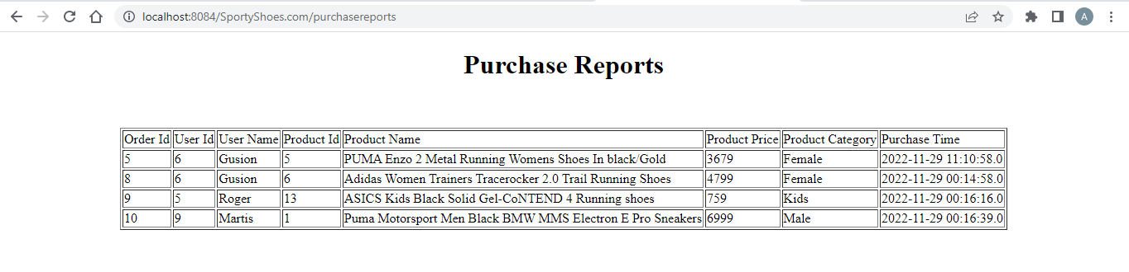

**Register User**

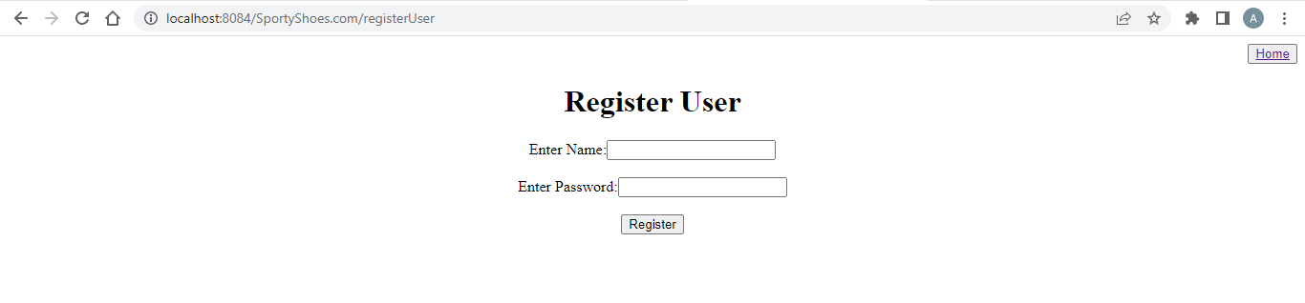

**User Registration Successful Page**

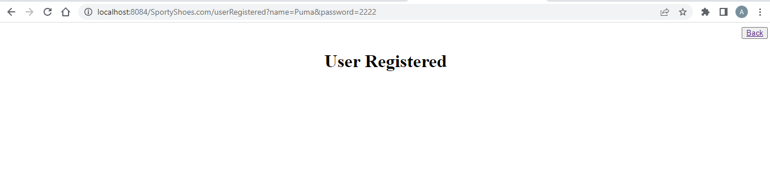

**User Login**

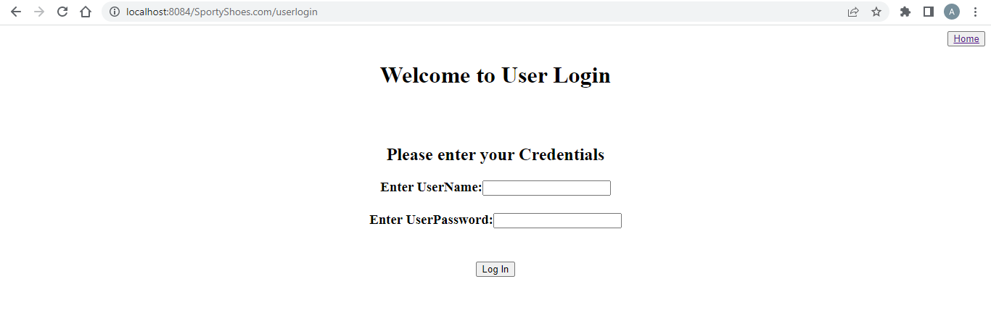

**User Home Page**

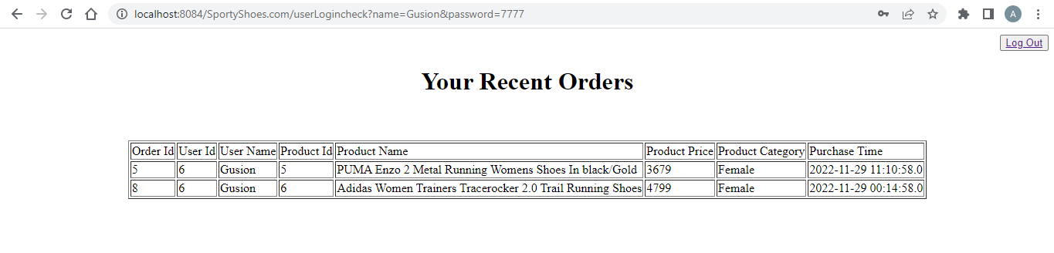

**Shopping Page**

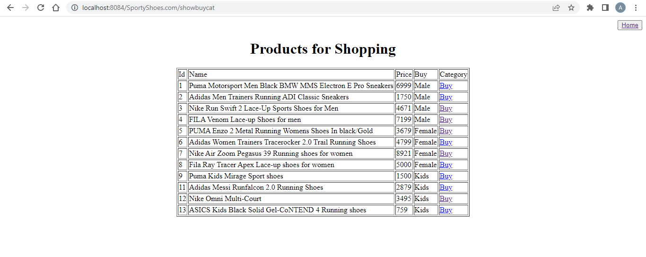

**Order Confirm Page**

