**Assignment : Data Analyst - Antarctica Global Report Submission**

**By : Rushikesh Khandare**

**1. Answers to the following questions:**

1. Lead Generation Efficiency: Calculate the lead generation efficiency for each associate as the ratio of total leads generated to the total time spent on lead generation. Which associate has the highest efficiency?

Ans:-

Associate with highest lead generation efficiency:

Day Date Leads Time spent Avg Time Per Daily Team No. of Employee Lead

on LG (mins) Lead (mins) Review Incomplete Name Generation

Leads Efficiency

Fri 28/07/2023 12.0 240.0 20.0 Attended 0.0 Raj 0.050000

Fri 28/07/2023 5.0 46.0 9.0 Attended 0.0 Arya 0.108696

Fri 28/07/2023 20.0 360.0 18.0 Attended 0.0 Ali 0.055556

2. Daily Performance Variability: Determine the standard deviation of the daily number of leads generated by each associate. Which associate shows the highest variability in daily performance?

Ans:-

Standard deviation of leads for each associate:

Employee Name Leads

0 Ali 2.518456

1 Arya 1.773361

2 Raj 2.208157

Associate with the highest variability in daily performance:

Employee Name Ali

Leads 2.518456

3. Time Management Analysis: Analyze the relationship between the average time per lead and the total number of leads generated per day for each associate. Is there a significant correlation?

Ans:-

Correlation coefficient: -0.3683071179069005

P-value: 2.9019970051433245e-07

4. Compare the average number of leads generated on days when daily team reviews were attended versus missed for each associate. What is the percentage difference in performance?

Ans:-

Employee Name Avg Leads (Review Attended) Avg Leads (Review Missed) Percentage Difference (%)

0 Ali 11.902439 11.000000 8.203991 1

1 Arya 11.560976 12.000000 -3.658537

2 Raj 10.923077 10.045455 8.736512

5.Incomplete Leads Reduction Over Time: Calculate the trend (using a linear regression model) of the number of incomplete leads over time for each associate. Are there any significant improvements or deteriorations?

Ans:-

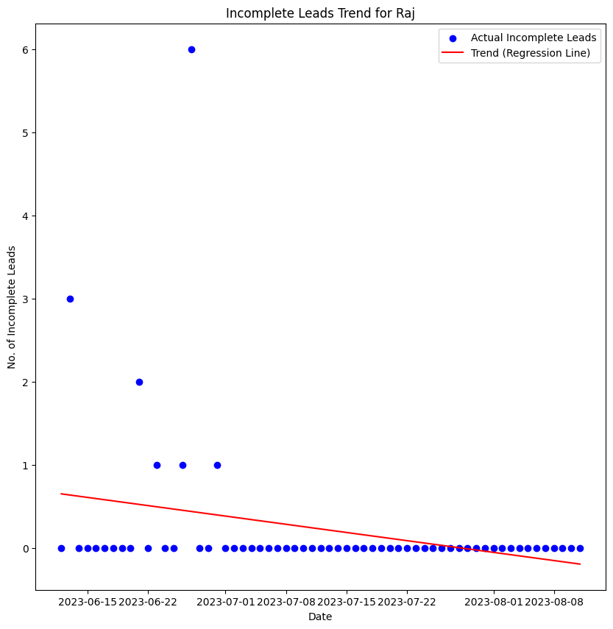

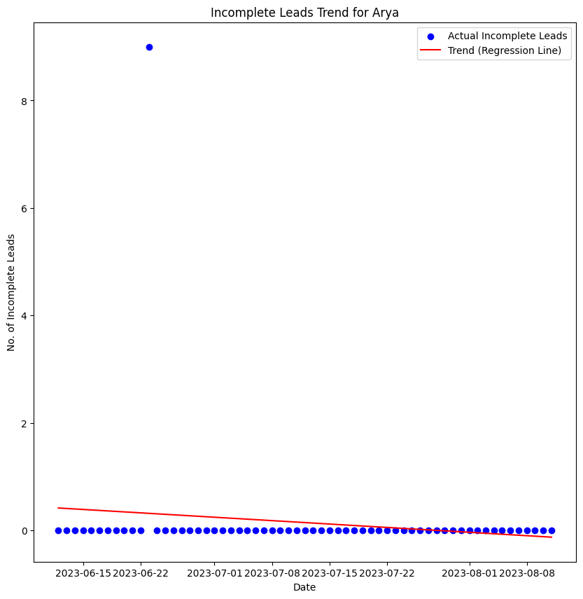

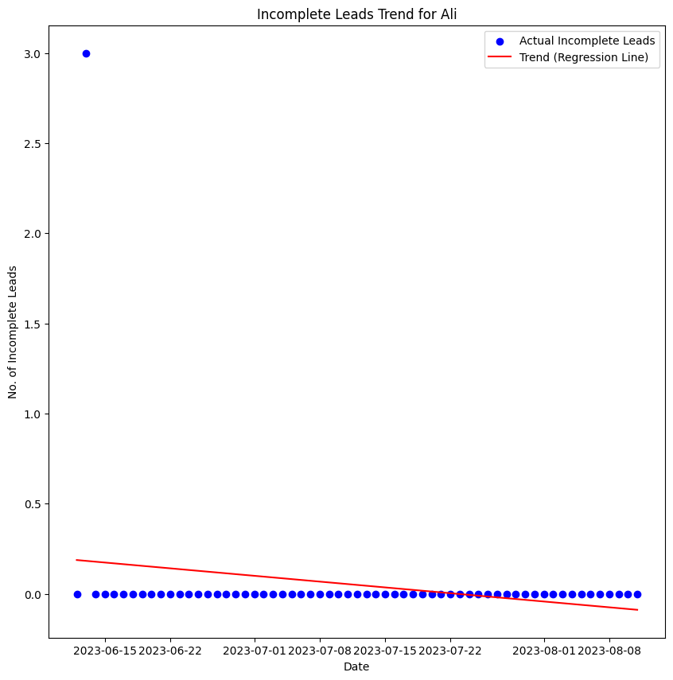

6. Performance Consistency: Calculate the coefficient of variation (CV) for the daily leads generated by each associate. Which associate has the most consistent performance?

Ans:-

Employee Name CV (%)

0 Ali 21.698566

1 Arya 15.150562

2 Raj 20.818789

Associate with the most consistent performance: Arya with CV: 15.15%

7. High-Performance Days: Identify the top 10% of days with the highest lead generation for each associate. What is the average time spent on lead generation during these high-performance days?

Ans:-

Employee Name Avg Time on High-Performance Days (mins)

0 Ali 264.285714

1 Arya 161.428571

2 Raj 307.142857

8. Impact of Longer Lead Generation Time: Determine if there is a threshold in the time spent on lead generation beyond which the number of leads generated significantly increases. What is the optimal time spent on lead generation for maximizing leads?

Ans:-

The optimal time spent on lead generation for maximizing leads is

370.0 minutes.

135.0 minutes.

240.0 minutes.

9. Comparative Day Analysis: Calculate the average leads generated on weekdays versus weekends for each associate. Are there any notable differences in performance based on the day of the week?

Ans:-

Employee Name Day Type Leads

0 Ali Weekday 11.606557

1 Arya Weekday 11.704918

2 Raj Weekday 10.606557

10. Predictive Analysis: Using a simple linear regression model, predict the number of leads each associate is expected to generate based on their time spent on lead generation. How accurate is the model when compared to actual data?

Ans:- 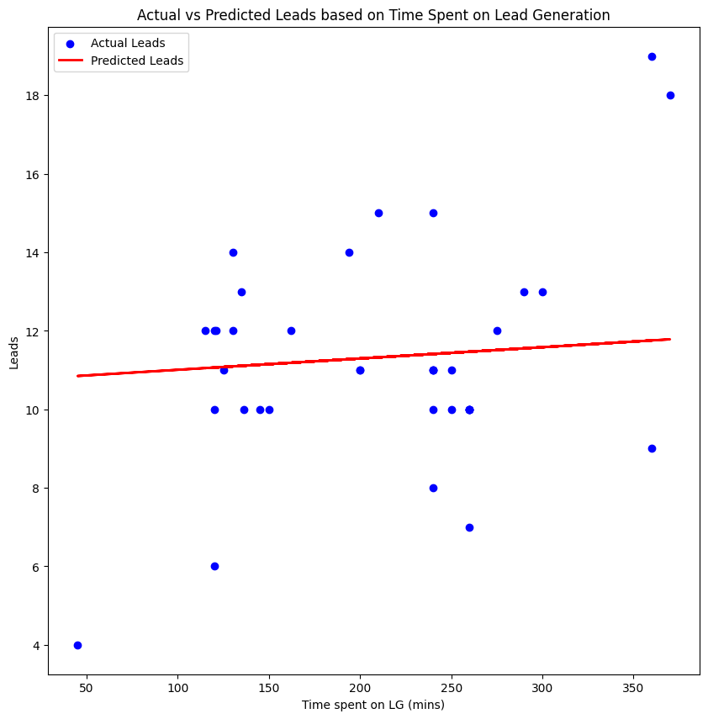

**2. Dashboarding**

**Link:-**

**3. Recommendations:**

Based on your analysis, provide recommendations for the Business Development Team. These recommendations should be data-driven and aimed at improving team performance. Suggest specific actions or strategies that can help employees improve their performance.

Ans:-

1. Optimize Time Spent on Lead Generation:

• Time Management Training: Provide training on efficient time management and effective lead generation techniques.

• Set Time Guidelines: Establish guidelines for the optimal amount of time to spend on lead generation activities, based on data-driven insights.

• Monitor and Adjust: Regularly monitor the time spent on lead generation and adjust strategies based on performance data.

1. Enhance Performance Consistency:

• Standardize Best Practices: Develop and implement standardized procedures and best practices for lead generation to reduce performance variability.

• Regular Training and Coaching: Offer ongoing training and coaching to address areas of inconsistency and help employees adopt best practices.

• Performance Metrics: Use performance metrics to identify and address the causes of variability, providing additional support where needed.

1. Leverage High-Performance Days:

• Analyze High-Performance Days: Review what differentiates high-performance days (e.g., specific times, types of leads, team activities) and replicate these conditions on other days.

• Incentivize Best Practices: Reward and recognize employees who achieve high performance to encourage the replication of successful practices.

• Focus on Key Factors: Identify key factors contributing to high performance (e.g., time spent, team review attendance) and focus on enhancing these areas.