**Task 1**

**Implementing Denoising Algorithm on the CIFAR-10 dataset**

**CIFAR-10 dataset consists of:**

1. 60,000 color images (50,000 training and 10,000 testing)
2. Each of size 32 x 32 pixels (and 3 RGB channels)
3. 10 classes with 6,000 images per class

**Model/ Algorithm used:** Auto-Encoder

**Model Description:** The model consists of:

1. Convolutional and Transposed Convolutional blocks have been used for the process of encoding and decoding respectively
2. The encoding, as well as the decoding blocks, consists of:
   1. Convolutional Layer
   2. Batch Normalization
   3. ReLU activation
3. For encoding, 4 convolutional blocks with downsampling (using stride=2) as well as 1 convolutional block without downsampling that encodes an input image of size (32, 32, 3) to size (2, 2, 256)
4. For decoding, 4 deconvolutional blocks with upsampling (using stride=2) and interleaving concatenations (concatenating 1-3, 2-2, ,3-1) as well as 1 final deconvolutional block to decode (or reconstruct) input of size (2, 2, 256) to size (32, 32, 3)

**Noise Level Definitions:**

Noise level 1 – Normal distribution Noise with σ = 0.1 and μ=0.0 added on original image (0 to 1 scale)

Noise level 2 – Normal distribution Noise with σ = 0.3 and μ=0.0 added on original image (0 to 1 scale)

Noise level 3 – Normal distribution Noise with σ = 0.2 and μ=0.0 added on original image (0 to 1 scale)

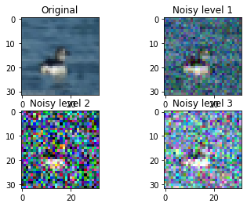

**Result:**

|  |  |  |  |
| --- | --- | --- | --- |
| **Noise Level** | **MSE due to noise** | **MSE after Denoising** | **% MSE reduction** |
| Level 1 | 0.009301500465682004 | 0.0018085037252333006 | 80.56 % |
| Level 2 | 0.06423948776161378 | 0.005378082184701831 | 91.62 % |
| Level 3 | 0.06284711724643248 | 0.004208274083313448 | 93.31 % |

**Visualized Results:**

For noise level 1 –

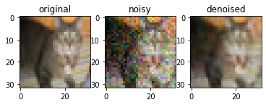

For noise level 2 –

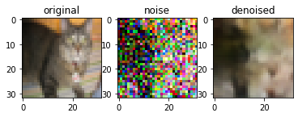

For noise level 3 –

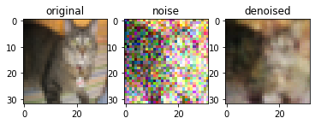

**Task 2**

**SODA: Detecting Covid-19 in Chest X-rays with Semi-supervised Open Set Domain Adaptation**

The authors of the paper have developed and proposed a novel SODA (Semi-Supervised Open Set Domain Adaptation) approach, mainly targeted at the chest X-ray dataset for detection of COVID-19. Chest x-rays have extensively been used for disease diagnosis, and here the author aims to extend and build similar models for detecting COVID-19.

The main problem highlighted in the paper is the unavailability of a large COVID-19 dataset (only 328 chest x-rays images available in the new COVID-19 dataset). Some of the prior work on the COVID-19 dataset is based on CNNs, which were already pretrained on the already available dataset and only fine-tuned on the new dataset. But this is not appropriate as the domain shift is not taken into account, and also such models are prone to overfitting and eventually won’t give a better-generalized performance. The SODA architecture proposed aims to tackle these challenges.

The “open” term in SODA is because the architecture allows different labels to exist in the source as well as the target set. It is “Semi-Supervised” because labeled, as well as unlabelled datasets, are being dealt with in the problem. The proposed architecture consists of the following:

1. Feature Extractor: Extracts features (based on CNN) from chest x-ray input images.
2. Multilabel Classifier: Classifies based on input features (1-layer NN).
3. Domain Discriminator (general): It transforms (based on MLP) extracted features to domain-invariant features.
4. Domain Discriminator (common): To overcome false alignment and negative transfer, this layer has been proposed by the authors. It is activated (based on MLP) only for labeled images.
5. Common Label Recognizer: It predicts (based on MLP) the probability of common labels. The probability output from this module is used as the weight in loss function of common domain discriminator as well as to reweigh unlabelled samples in general domain discriminator.

A large dataset consisting of over 112k chest x-ray images (comprising of 14 disease labels) has been used as the source domain and COVID-19 dataset (328 images) in the target domain. Baseline comparison of the proposed architecture is done with some of the popularly used fine-tuned models (for COVID-19 dataset) and also with two popular domain adaptation models. SODA achieves better performance (the metric used AUC-ROC score) than state-of-the-art models. Authors state that SODA works well for lung pathology location as well as it can as an effective domain adaption technique, especially for radiology imaging problems.