Linux Commands Assignment

1. Creating and Renaming Files/Directories
Commands:
mkdir test_dir
cd test_dir
touch example.txt
mv example.txt renamed_example.txt
Explanation:
Created directory and renamed file.
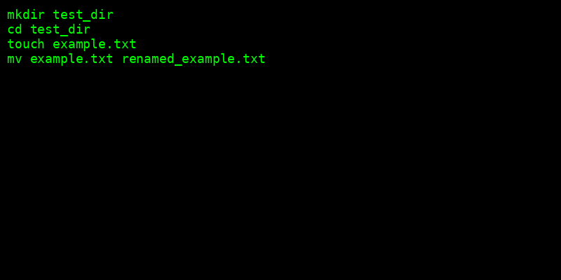

2. Viewing File Contents
Commands:
cat /etc/passwd
head -n 5 /etc/passwd
tail -n 5 /etc/passwd
Explanation:
Displayed file contents using cat, head, tail.
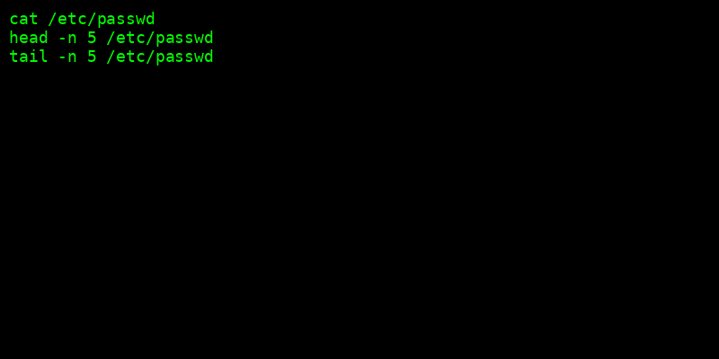

3. Searching for Patterns
Commands:
grep 'root' /etc/passwd
Explanation:
Used grep to search 'root'.


4. Zipping and Unzipping
Commands:
zip -r test_dir.zip test_dir
unzip test_dir.zip -d unzipped_dir
Explanation:
Compressed and extracted directory.


5. Downloading Files
Commands:
wget https://www.w3.org/TR/PNG/iso_8859-1.txt
Explanation:
Downloaded file using wget.
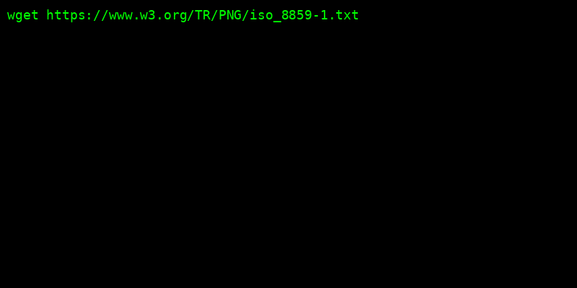

6. Changing Permissions
Commands:
touch secure.txt
chmod 444 secure.txt
Explanation:
Set file to read-only.


7. Environment Variables
Commands:
export MY_VAR='Hello, Linux!'
echo $MY_VAR
Explanation:
Created and displayed environment variable.


