Deep Packet Inspection &
Network Traffic Analysis Engine
Project Interview & Viva Preparation Notes
C++17 • PCAP • Multithreading • Network Traffic Analysis • Wireshark/TShark

1. 30-Second Project Explanation
Say: “This project is a C++-based Deep Packet Inspection engine that analyzes network traffic from PCAP files. It parses packets, tracks flows, identifies TCP/UDP traffic, extracts TLS SNI and HTTP Host information, classifies applications and domains, and applies configurable traffic-blocking rules. The processing pipeline uses Load Balancers and multiple Fast Path workers, and the engine generates an output PCAP and processing statistics. I also validated the results independently using Wireshark/TShark.”

2. 2-Minute Explanation
The engine starts with a PCAP file. The PCAP reader reads packets and extracts the relevant packet information. Packets are dispatched through Load Balancers to Fast Path workers for parallel processing. The engine maintains flow information and analyzes packet headers and payloads. For HTTPS traffic it can inspect TLS SNI, for HTTP traffic it can inspect the Host information, and DNS traffic is identified using DNS ports. The detected information is mapped to application/domain classifications. A rules engine can apply IP, domain, or application blocking decisions. Matching packets are dropped; other packets are forwarded to the output PCAP. The engine also reports packet, byte, TCP/UDP, forwarding, dropping, application, and thread statistics.

3. System Architecture
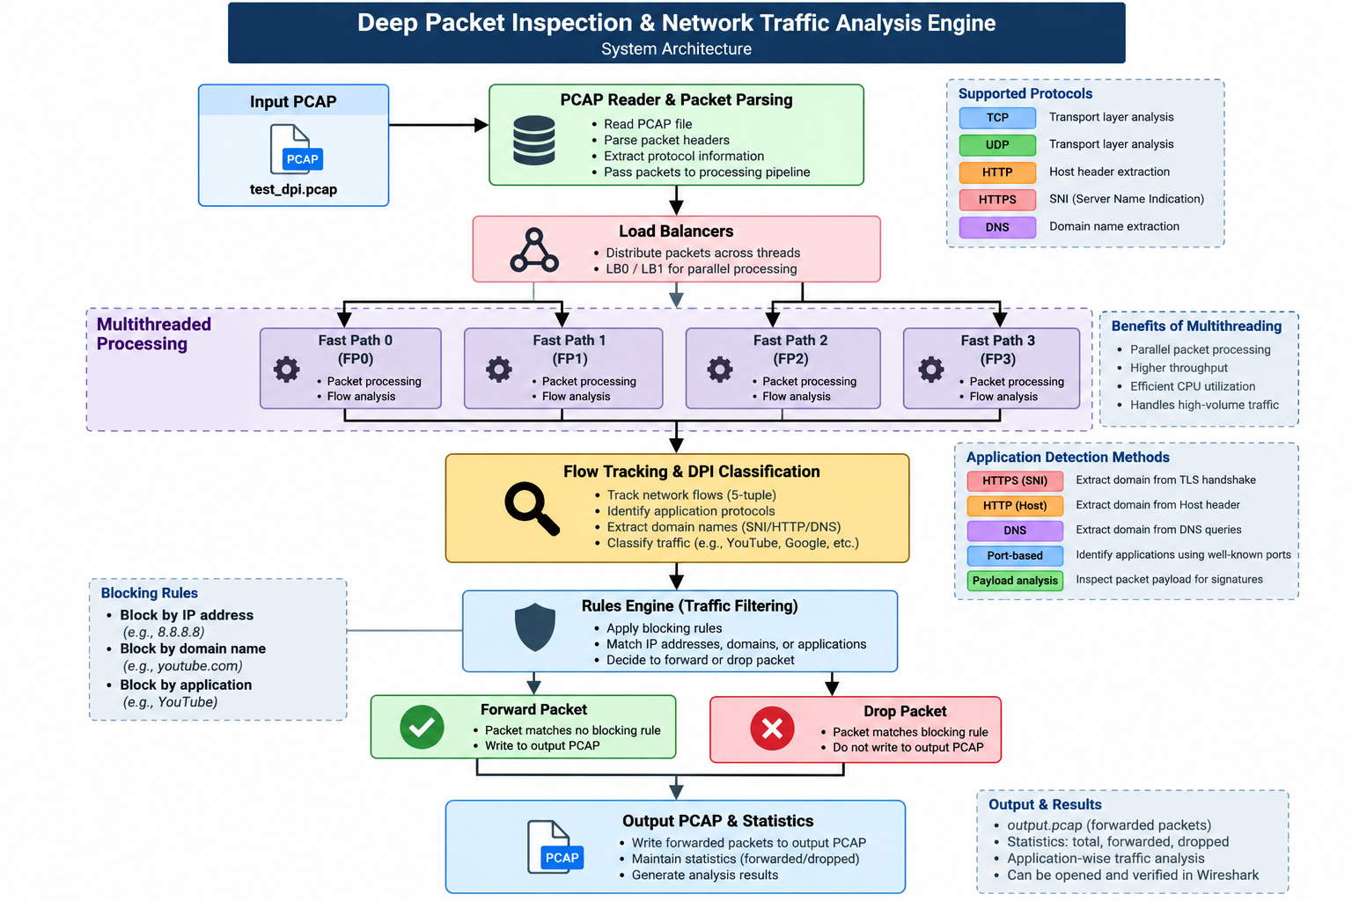
Figure 1. DPI engine processing architecture

4. Processing Flow
- 1. Input PCAP
- 2. PCAP Reader & packet parsing
- 3. Load Balancers
- 4. Fast Path workers
- 5. Flow tracking & DPI classification
- 6. SNI / HTTP Host / DNS / port-based analysis
- 7. Rules engine
- 8. Forward or drop
- 9. Output PCAP + statistics

5. Technologies & Concepts
Technology / Concept | Role
C++17 | Core DPI engine implementation.
PCAP | Input/output packet capture format used for offline traffic analysis.
Multithreading | Load Balancer and Fast Path processing architecture.
TCP/UDP | Transport-layer traffic identification.
TLS SNI | Used to extract server/domain information from HTTPS Client Hello traffic.
HTTP Host | Used for HTTP host identification.
DNS | DNS traffic identification and analysis.
Wireshark/TShark | Independent packet-level inspection and validation.

6. Demonstrated Features
- PCAP file reading and packet parsing
- TCP/UDP traffic identification
- Flow tracking
- TLS SNI extraction
- HTTP Host detection
- DNS identification
- Application classification
- Domain detection
- Application blocking
- Domain blocking
- IP blocking rule configuration was tested but did not drop the tested traffic
- Output PCAP generation
- Packet/byte/application/thread statistics
- Multithreaded Load Balancer → Fast Path architecture

7. Verified Testing Results
The following results are based on the tests actually performed during project validation.
Test | Result | Evidence
Baseline PCAP processing | PASS | 77 packets, 5,738 bytes; 73 TCP and 4 UDP; 77 forwarded, 0 dropped.
Application blocking — YouTube | PASS | 76 forwarded / 1 dropped; TShark found no matching www.youtube.com TLS SNI in blocked_output.pcap.
Domain blocking — youtube.com | PASS | 76 forwarded / 1 dropped; TShark found no matching www.youtube.com TLS SNI in domain_blocked.pcap.
IP blocking — 8.8.8.8 | NOT PASSED | Rule accepted, but 77 forwarded / 0 dropped. TShark still found four DNS packets to 8.8.8.8 in ip_blocked.pcap.
Output PCAP readability | PASS | TShark successfully read output.pcap.
Performance benchmark | RECORDED | 0.643 s wall time for the 77-packet test capture.

8. Benchmark Result
- Input: 77 packets / 5,738 bytes
- Wall-clock time: 0.643 seconds
- User CPU time: 0.015 seconds
- System CPU time: 0.015 seconds
- Approximate rate for this small test capture: 119.8 packets/sec
- Important: this is a small test-case benchmark, not a maximum or production throughput claim.

9. Commands You Should Remember
Build: g++ -std=c++17 -O2 -I include -o dpi_engine.exe src/dpi_mt.cpp src/pcap_reader.cpp src/packet_parser.cpp src/sni_extractor.cpp src/types.cpp
Normal run: ./dpi_engine.exe test_dpi.pcap output.pcap
Block application: ./dpi_engine.exe test_dpi.pcap blocked_output.pcap --block-app YouTube
Block domain: ./dpi_engine.exe test_dpi.pcap domain_blocked.pcap --block-domain youtube.com
Block IP: ./dpi_engine.exe test_dpi.pcap ip_blocked.pcap --block-ip 8.8.8.8
Benchmark: time ./dpi_engine.exe test_dpi.pcap benchmark_output.pcap

10. Interview / Viva Questions & Answers
Q: What is Deep Packet Inspection?
A: DPI is the inspection and classification of network packets beyond basic header information. It can use protocol details and selected payload/application metadata to identify traffic.
Q: Why is this project useful?
A: It demonstrates traffic analysis, application/domain identification, configurable filtering, PCAP processing, and multithreaded packet processing.
Q: Why C++?
A: C++ provides low-level control over packet structures, memory, concurrency, and performance, which are relevant to packet-processing systems.
Q: Why multithreading?
A: Packet processing can be divided across workers so multiple packets/flows can be processed concurrently. The project uses Load Balancers and Fast Path workers.
Q: What is SNI?
A: Server Name Indication is an extension in the TLS handshake that can expose the requested server/domain name, allowing the engine to classify HTTPS traffic without decrypting the application payload.
Q: How does the project identify HTTP traffic?
A: It recognizes HTTP traffic using the relevant port and can extract the Host information from the HTTP payload.
Q: How does application blocking work?
A: The engine classifies traffic and applies configured application rules. If the flow matches a blocked application, the packet is counted as dropped instead of being forwarded.
Q: How does domain blocking work?
A: The engine compares the detected domain/SNI against configured blocked-domain rules and drops matching traffic.
Q: What is a PCAP?
A: PCAP is a packet-capture file format used to store captured network traffic for later analysis.
Q: How did you validate the blocking functionality?
A: I checked the DPI engine's forwarding/dropping statistics and then independently inspected the generated PCAP with TShark to verify that blocked YouTube SNI traffic was absent.
Q: What limitation did you observe?
A: The tested IP-blocking rule for 8.8.8.8 was accepted but did not drop the four DNS packets to that address. I recorded it as a known limitation rather than modifying the tutor-provided core implementation.
Q: Did you write the entire engine from scratch?
A: The core implementation came from the tutor-provided repository. My work included setting up the environment, building and running the engine, validating its features, testing blocking behavior, using Wireshark/TShark for independent verification, and documenting the system and results. I would only claim additional code changes if I actually made them.

11. How to Explain Your Contribution
Use an honest version of this answer: “The base DPI implementation was provided through my tutor/repository. I focused on getting the project running in a Windows/MSYS2 environment, understanding the processing pipeline, compiling and validating the executable, testing application and domain blocking, inspecting PCAPs with Wireshark/TShark, benchmarking the test workload, and preparing the project documentation and presentation material.”

12. Strengths to Highlight
- Networking + cybersecurity relevance
- C++ and systems-level programming context
- Multithreaded processing architecture
- Real packet-capture analysis rather than only simulated data
- Application/domain identification
- Configurable traffic filtering
- Independent validation with Wireshark/TShark
- Measured test results instead of unsupported performance claims

13. Limitations & Future Scope
- Investigate the observed IP-blocking behavior if IP filtering is required.
- Test on larger PCAP datasets before making throughput comparisons.
- Add richer machine-readable reporting if required.
- Expand protocol/application coverage.
- Add a dashboard for traffic/application statistics.
- Add automated regression tests for blocking and classification behavior.

14. Last-Minute Interview Cheat Sheet
Architecture: PCAP → Reader/Parser → Load Balancer → Fast Paths → Flow Tracking/DPI Classification → Rules → Forward/Drop → Output PCAP/Statistics
Key technologies: C++17, PCAP, TCP/UDP, TLS SNI, HTTP Host, DNS, multithreading, Wireshark/TShark
Verified blocking: YouTube application and youtube.com domain blocking.
Known issue: The tested 8.8.8.8 IP-blocking case did not drop packets.
Benchmark: 77 packets / 5,738 bytes in 0.643 s on the test capture; not a production throughput claim.

