**1. Introduction**

**Objectives**

The purpose of this document is to provide a detailed description of the software system "Doctor at Call." This system aims to book appointment, facilitating consultations and medical assistance.

**Scope**

The "Doctor at Call" system will include a web application accessible to users seeking medical advice. The application will enable users to book with available doctors for consultations and visiting.

**Definitions, Acronyms, and Abbreviations**

SRS: Software Requirements Specification

API: Application Programming Interface

UI: User Interface

**2. System Description**

**System Overview**

"Doctor at Call" is a telemedicine application that allows users to request on-demand medical consultations with registered and available doctors. The system will prioritize ease of use, security, and real-time communication.

**System Features**

**User Registration and Authentication**

* Users can create accounts with their personal information.
* A secure authentication mechanism will be implemented**.**

**Doctor Availability Status**

* Doctors can set their availability status (online/offline).
* Real-time updates on doctor availability.

**Appointment Scheduling**

* Users can schedule appointments with available doctors.
* Notifications for upcoming appointments.
* Secure and encrypted communication.
* Appointment Request Processing
* Upon user request, the system should identify and display a list of available doctors based on their specialization, availability, and proximity to the user's location.
* Users can select a preferred doctor and propose a time slot for the appointment.

**Prescription and Medical Records**

* Doctors can generate and share electronic prescriptions.
* Users can access and manage their medical records.

**3. Functional Requirements**

**User Module**

**User Registration**

* Users must provide valid information for registration.
* Unique usernames and passwords for authentication.

**Profile Management**

* Users can update their profiles.
* Option to add and edit medical history**.**

**Appointment Booking**

* Users can view available doctors and schedule appointments.
* Confirmation notifications for booked appointments.

**Doctor Module**

**Doctor Registration**

* Doctors must provide necessary credentials for registration.
* Verification process for medical professionals.

**Availability Management**

* Doctors can set and update their availability status.
* Real-time synchronization with the user interface.

**Consultation Management**

* Doctors receive and accept/reject appointment requests.

**Prescription and Medical Records Management Prescription Generation**

* Doctors should have the capability to create electronic prescriptions during or after a consultation.
* Prescriptions should include details such as medication names, dosage, and instructions.

**Prescription Delivery**

* Users should receive electronic prescriptions securely through the application.
* Prescription details should be stored in the user's medical records.

**Medical Records Access**

* Users should have the ability to access and download their medical records at any time.
* The system should maintain a secure and organized repository of medical records for each user.

**Medical History Update**

* Users should be able to add, edit, or update their medical history through the application.
* Changes in the medical history should be reflected in future consultations.

**4. Non-functional Requirement**

**Performance**

* The server must be able to support an unlimited number of devices, i.e., it must place no restrictions on the number of gadgets that can be used simultaneously.
* A limitless amount of active client payments must be supported by the server, and payments must never be lost.

**Security**

* Registered users will be allowed to place an Appointment.
* Sensitive data will always be transmitted with encryption. The system will internally maintain a secure communication channel between servers (web servers, application servers, database servers).

**Reliability**

* The system should be scalable, with the ability to accommodate a large number of users at once.
* The site's response time should be as quick as feasible, and it should be able to load balance the server.

**Availability**

* This application is available for 24 hours anywhere, anytime.

**Maintainability**

* Commercial database software will be used to maintain System data Persistence.
* A readymade Web Server will be installed to host online doctor at call portal (Web Site) to management server capabilities.
* IT operations team will easily monitor and configure the system using Administrative tools provided by Servers.
* Separate environments will be maintained for the system for isolation in production, testing, and development.

**Portability**

* PDA: Portable Device Application
* The system will provide a portable User Interface (HTML, CSS, JS) through which users will be able to access the Doctor at Call portal.
* The system can be deployed to a single server, multi-server, to any OS, Cloud (Azure or AWS or GCP).

**Accessibility**

* After authentication, only logged-in users will be able to place an Appointment.
* Through a personalized dashboard, the BOD team will be able to monitor daily, weekly, monthly, and annual business growth.

**Efficiency**

* The system will be able to manage all transactions with isolation.

**Safety**

* All the data will be hidden for other users.

**Scalability**

* Online Doctor at Call portal will be secure from malicious attacks.
* Online Doctor at Call portal functionalities are protected from the outside with proper configuration.
* Online Doctor at Call portal will always be kept updated with the latest antivirus software.
* Data will be backed up periodically to ensure the safety of data using an incremental backup strategy.
* Role-based security will be applied for Application data and operations accessibility.

**Benefits**

* The Patients will save time because they are not going to the clinic.
* The doctor can visit patient at the proper time.
* The patient can book doctor appointment at any time from its place in that area.

**5. Data Flow Diagram**

**Level 0**

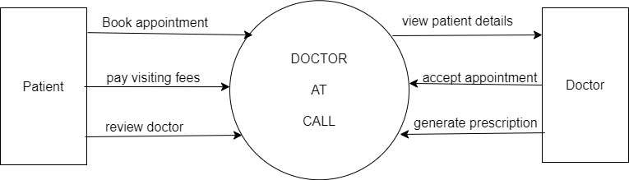

**Level 0**

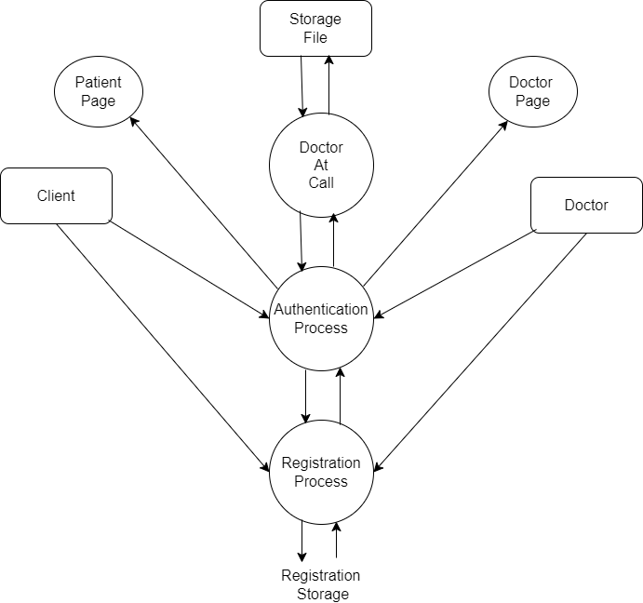

**6. Use Case Diagram**

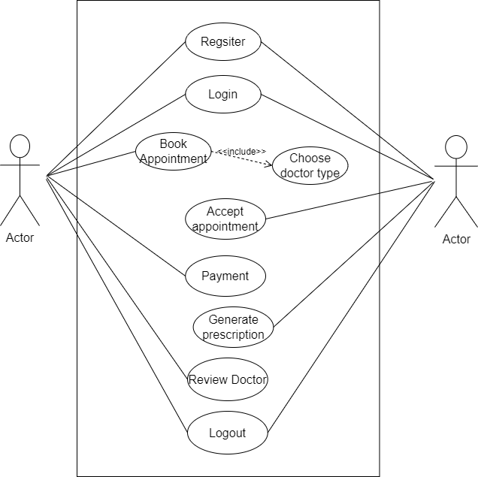

**7. Entity Relationship Diagram**

