Synopsis On

“BookBridge”

Submitted to the Uttaranchal University in partial fulfilment of the requirements for the award of the Degree of
MASTER OF COMPUTER APPLIC ATIONS

Submitted by

𝐀𝐍𝐀𝐌𝐈𝐊𝐀
(Learner ID: 2326010006)

Under the Guidance of

Guide Name with Designation (Faculty Guide)



UTTARANCHAL UNIVERSITY, DEHRADUN

Table of Content

S.no | Topic | Page No
1 | Introduction and Objectives of the Project. | 3
2 | Tools/Platform, Hardware and Software Requirement specifications. | 4
3 | Problem Definition, Requirement Specifications (Detailed functional Requirements and Technical Specifications), Project Planning and Scheduling (Gantt chart and PERT chart). | 5
4 | Analysis (Data Models like 0, 1 and 2 level DFDs, Complete ER Diagrams with cardinality, Class Diagrams etc. as per the project requirements). | 7
5 | A complete structure which includes: | 9
 | a. Number of modules and their description to provide estimation of the | 9
 | b. student’s effort on the project. Along with process logic of each Module. | 9
 | c. Data Structures as per the project requirements for all the modules. | 9
 | d. Process Logic of each module. | 9
 | e. List of reports that are likely to be generated. | 9
6 | Proposed security mechanisms at various levels | 10
7 | Future scope and further enhancement of the project. | 11
8 | Bibliography | 12

Introduction and Objectives of the Project
  - Introduction of BookBridge

The BookBridge Project is an innovative digital platform designed to create a bridge between readers, learners, and book providers such as libraries, authors, and educational institutions. In an age where access to knowledge is crucial for academic and personal development, BookBridge aims to eliminate the barriers that prevent individuals from obtaining books and learning materials easily. It integrates technology with education by offering a centralized, user-friendly system for searching, borrowing, and sharing books—both physical and digital.

This project leverages the power of modern web technologies (or mobile application frameworks, if applicable) to promote the culture of reading and knowledge sharing. Through BookBridge, users can register, browse book categories, check availability, issue or return books online, and even review or recommend books to others. For administrators and librarians, the system simplifies catalog management, user tracking, and data reporting, thereby increasing operational efficiency and reducing manual workload.

Ultimately, BookBridge seeks to encourage literacy, improve accessibility to academic resources, and strengthen the connection between readers and knowledge providers. It serves as a bridge between those who seek books and those who provide them, ensuring that knowledge flows freely and effectively.

  - Objectives of BookBridge

- To develop a digital bridge between book donors and readers, enabling easy exchange and distribution of books.
- To promote reading culture by making educational and leisure books accessible to students and communities.
- To create an efficient database system for managing book inventory, donor details, and requests.
- To reduce resource wastage by reusing old or unused books and distributing them to those in need.
- To provide transparency and tracking in book donation and delivery processes.
- To support educational equality by ensuring that books are available to learners irrespective of their economic background.
- To encourage community participation and collaboration through voluntary book sharing and contributions.

Tools/Platform, Hardware and Software Requirement specifications

- Tools/Platform
- Backend: Django 4.x (Python)
- Database: SQLite (Development) / PostgreSQL (Production)
- Frontend: Bootstrap 5.3, Font Awesome, Google Fonts (Inter + Playfair Display)
- Authentication: Django Auth with Email Verification
- Payment Gateway: Razorpay API Integration (Test & Live Mode)
- Deployment Ready: Compatible with Heroku, Railway, AWS, DigitalOcean

- Hardware Requirements
- Processor: Intel i3 or higher
- RAM: 4 GB minimum (8 GB recommended)
- Storage: 100 GB free space (for project files & database)
- Internet: Stable connection for API integrations and deployment

- Software Requirements
- Operating System: Windows 10/11, Linux, or macOS
- Python: Version 3.10 or higher
- Web Browser: Latest versions of Chrome, Firefox, or Edge
- Code Editor/IDE: VS Code, PyCharm, or Sublime Text
- Additional Tools: Git for version control

Problem Definition, Requirement Specifications (Detailed functional Requirements and Technical Specifications), Project Planning and Scheduling (Gantt chart and PERT chart)

1. Problem Definition:
BookBridge is an online platform aimed at connecting book buyers and sellers, facilitating smooth transactions, easy book searches, and efficient delivery. The problem it solves is the difficulty in finding books at reasonable prices and connecting local and online sellers with buyers.

2. Requirement Specifications:
a. Functional Requirements:
- User registration and authentication (email verification).
- Search and filter books by category, author, price, etc.
- Add, update, and remove books (for sellers).
- Cart and checkout system with Razorpay payment integration.
- Order tracking and notifications.
- Admin panel for managing users, books, and orders.
b. Technical Specifications:
- Backend: Django 4.x (Python), SQLite for development, PostgreSQL for production.
- Frontend: Bootstrap 5.3, Font Awesome, Google Fonts.
- Deployment: Heroku, Railway, AWS, or DigitalOcean compatible.
- Security: Django authentication, HTTPS, input validation.

3. Project Planning and Scheduling:
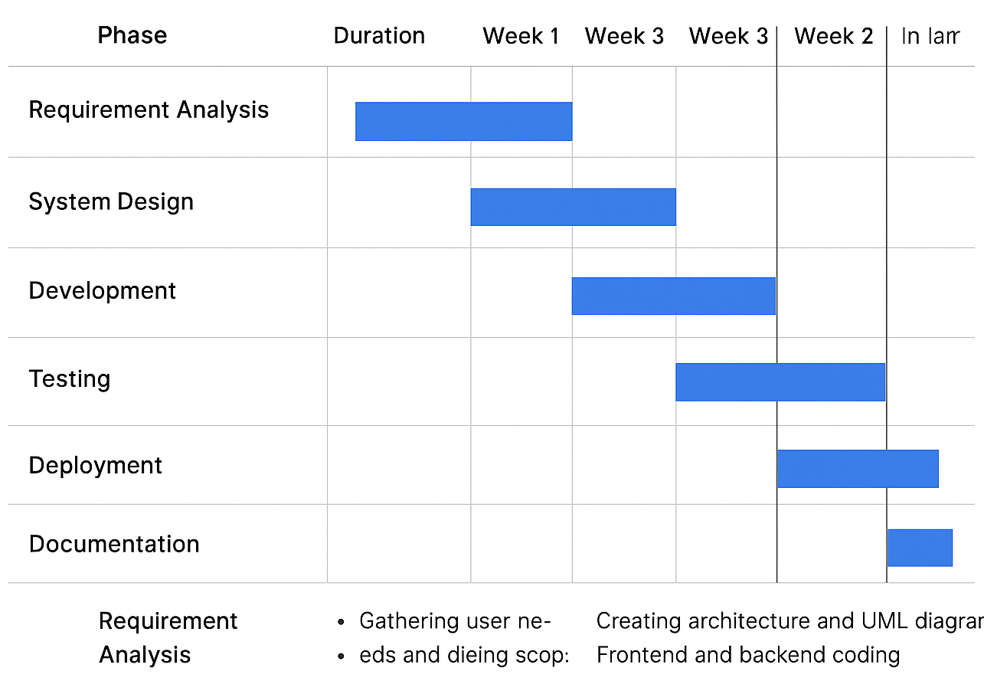
Fig.1 Gantt Chart

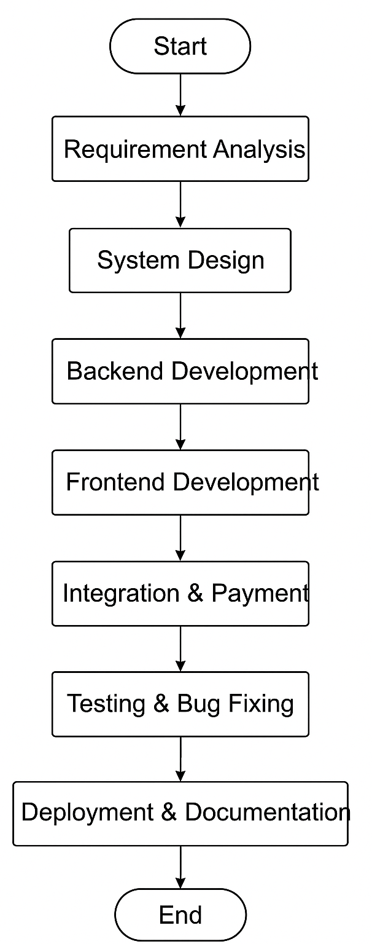

Fig.2 PERT Chart

Analysis (Data Models like 0, 1 and 2 level DFDs, Complete ER Diagrams with cardinality, Class Diagrams etc. as per the project requirements)
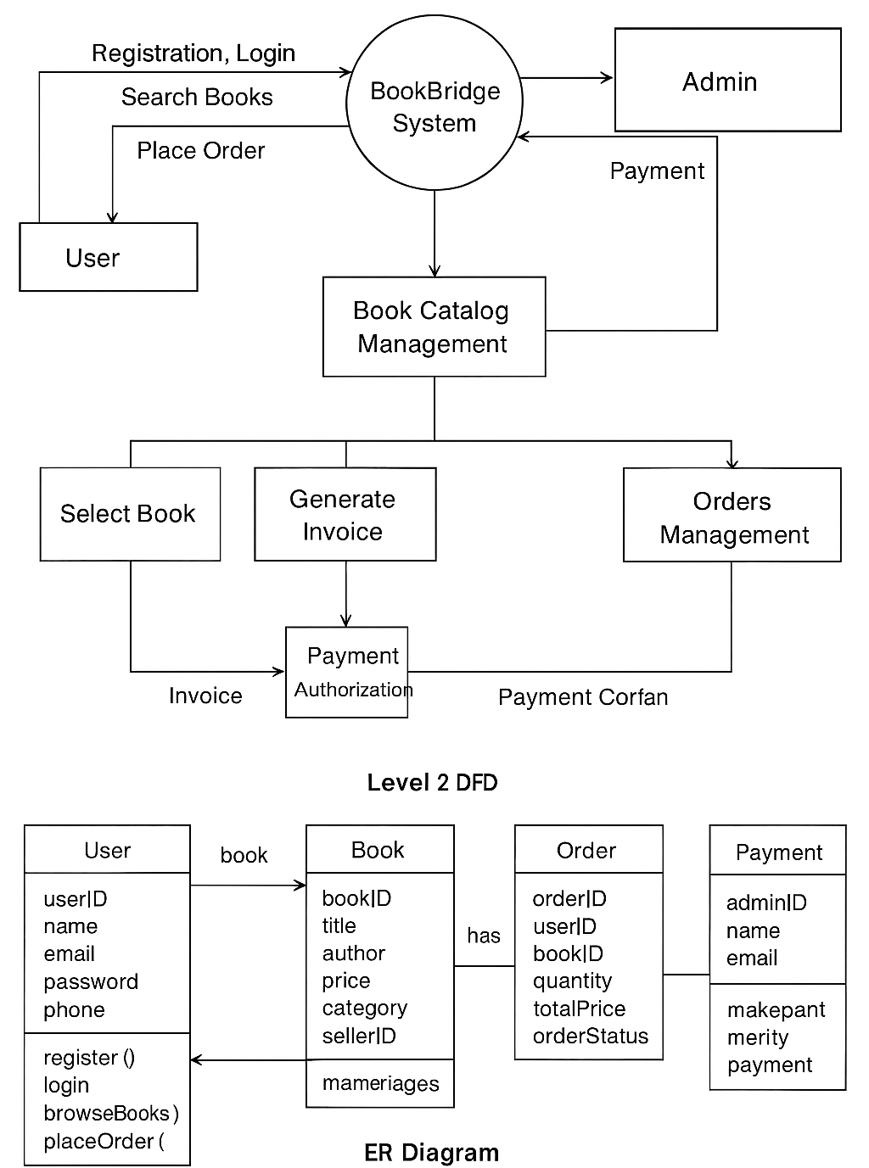
Fig.3 DFD

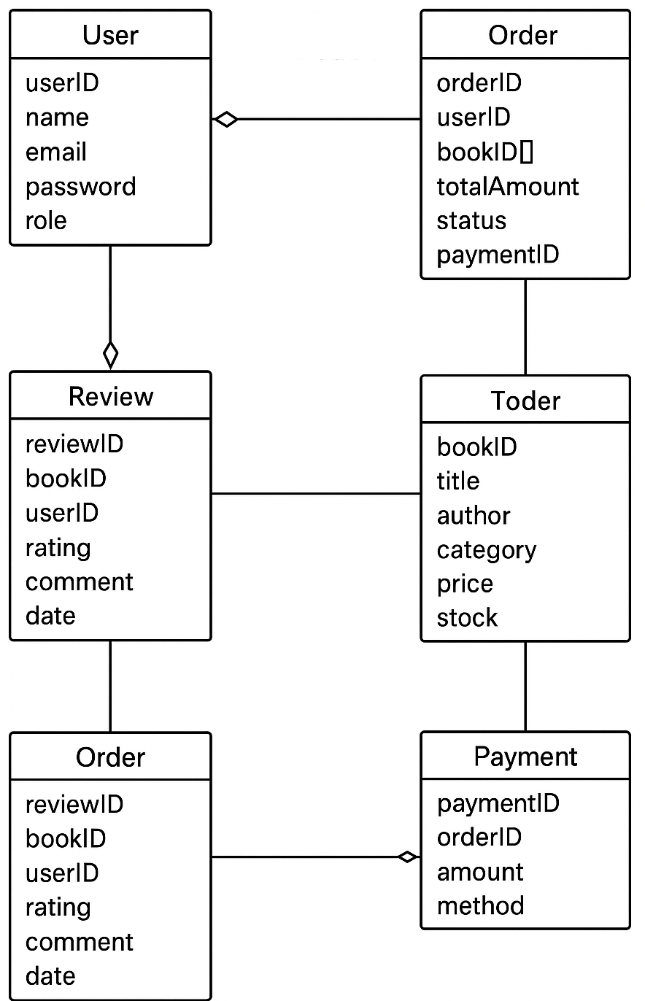
Fig.4 ER Diagram

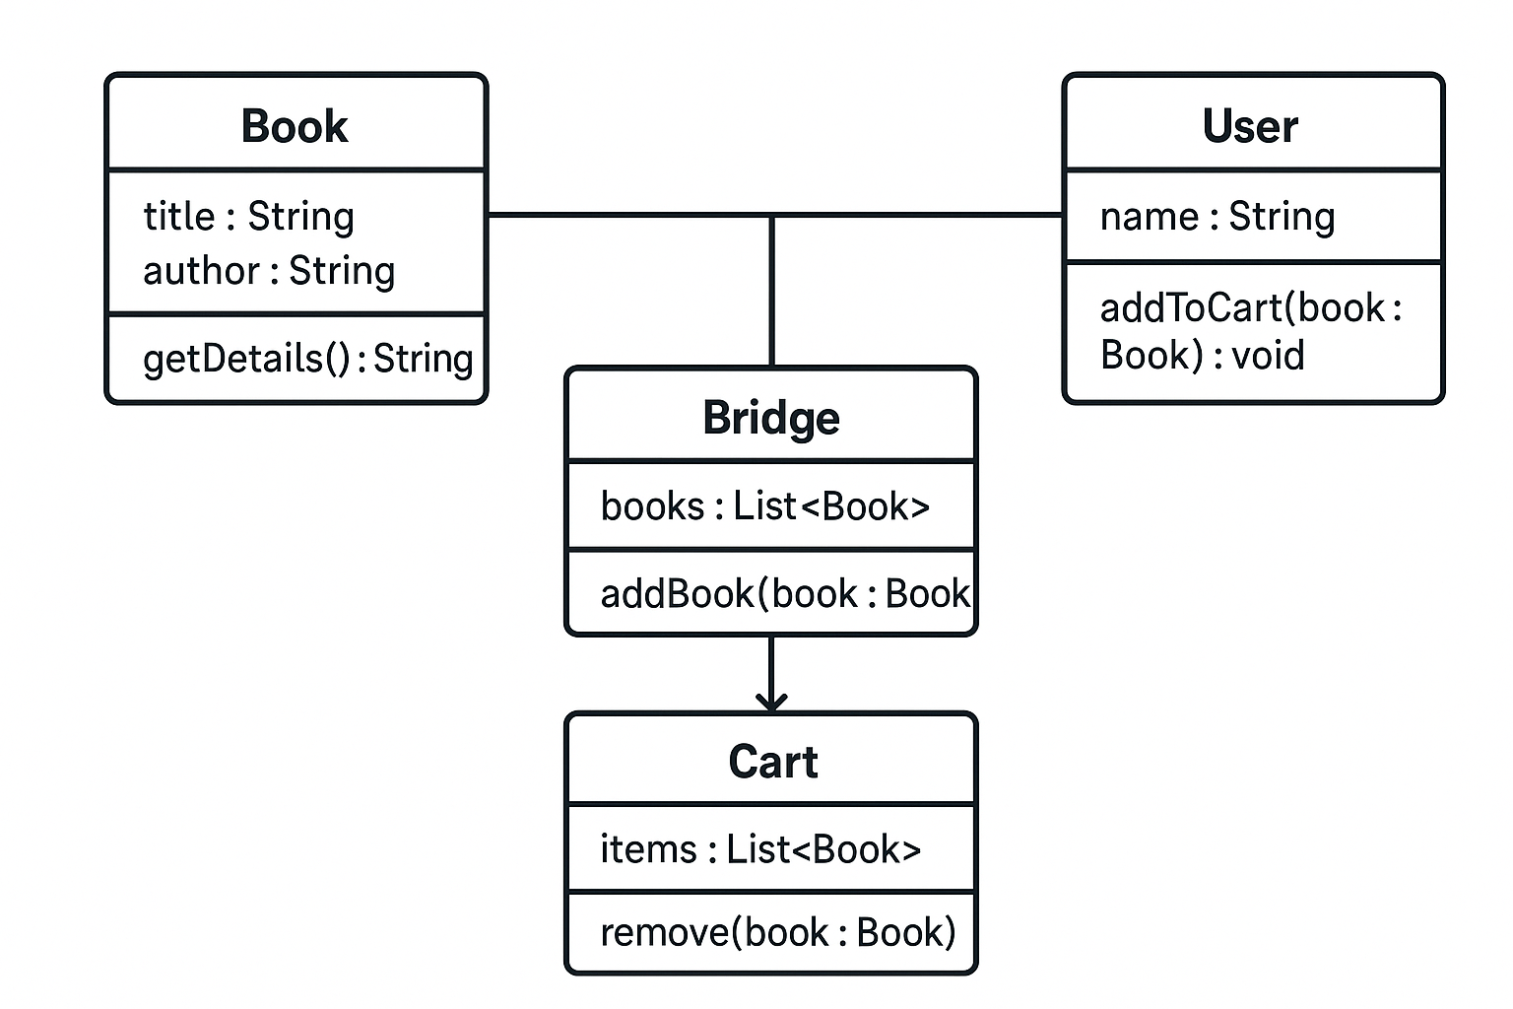
Fig.5 Class Diagram

A complete structure which includes:

a. Number of Modules & Description

- User Module – Registration, login, profile management.
- Book Catalog Module – Browse/search books, filter by category/author.
- Book Borrowing Module – Issue/return books, track due dates.
- Payment Module – Fine calculation, online payment integration.
- Admin Module – Manage books, users, view reports.
- Notification Module – Email/SMS alerts for due dates, announcements.

b. Student’s Effort & Process Logic

- Effort depends on module complexity (e.g., Admin > User Module).
- Process Logic Example (Book Borrowing):
  - User selects a book → Check availability → Update database → Generate receipt → Send notification.

c. Data Structures

- User Module: Array/List for users, HashMap for quick lookup by ID.
- Book Catalog: LinkedList or ArrayList of books, HashMap by ISBN.
- Borrowing: Queue for borrow requests, Map for due dates.
- Payment: Array/List for transactions, HashMap for fines.
- Admin: Arrays/Lists for managing data, Trees for reports.

d. Process Logic of Each Module

- User Module: Input → Validate → Store → Confirmation.
- Book Catalog: Query → Filter/Sort → Display.
- Borrowing: Request → Check → Update → Notify.
- Payment: Calculate → Validate → Process → Record.
- Admin: Input → CRUD Operations → Generate Reports.
- Notification: Trigger → Send Email/SMS → Log.

e. Reports Likely to be Generated

- User activity report
- Book availability report
- Borrowing/return history
- Fine/payment report
- Admin summary report

Proposed security mechanisms at various levels

1. Application Level
- Role-based authentication (Admin, Seller, Buyer)
- Password hashing and secure session management
- Input validation to prevent SQL injection and XSS

2. Network Level
- HTTPS/SSL for encrypted communication
- Firewall and API security with tokens/OAuth
- Rate-limiting to prevent DDoS attacks

3. Database Level
- Access control for authorized users only
- Encryption of sensitive data
- Regular secure backups

4. System Level
- Server hardening and regular security updates
- Intrusion detection and logging of critical actions

5. Frontend Level
- Input sanitization and CAPTCHA for bot protection
- Secure cookies and HTTPS enforcement

6. Additional Measures
- Two-Factor Authentication (2FA)
- Compliance with data privacy regulations (GDPR/IT Act)
- Regular security audits and vulnerability testing

Future scope and further enhancement of the project.

1. Mobile Application Development
- Develop Android and iOS apps for easier access on smartphones.
- Provide push notifications for offers, new arrivals, and order updates.
2. Advanced Payment Options
- Integrate multiple payment gateways like PayPal, Stripe, UPI, and wallets.
- Implement one-click payments and EMI options for higher-value purchases.
3. Recommendation System
- Introduce AI-based recommendation algorithms to suggest books based on:
  - User purchase history
  - Browsing patterns
  - Ratings and reviews
- Can enhance user engagement and increase sales.
4. Enhanced Search & Filter
- Add advanced search features:
  - Search by genre, author, rating, language, or price.
- Implement AI-powered predictive search for faster results.
5. E-Book & Digital Content Support
- Support digital books (PDF/ePub) downloads.
- Implement DRM (Digital Rights Management) to prevent unauthorized sharing.
6. Inventory & Supplier Management
- Integrate supplier portals to automate stock updates.
- Use AI-based inventory prediction to optimize stock levels.
7. Review & Rating Analytics
- Analyze user feedback for quality improvement.
- Provide graphical insights for admins on sales trends, popular books, and customer satisfaction.
8. Multi-Language Support
- Offer multi-language interfaces for a wider audience.
- Support regional content for localized markets.
9. Chatbot & Customer Support
- Integrate a chatbot for 24/7 customer assistance.
- Automate FAQs, order tracking, and basic queries.
10. Security & Privacy Enhancements
- Implement biometric login (fingerprint/face recognition).
- Advanced encryption for sensitive data and secure payment processing.
11. Gamification & Loyalty Programs
- Introduce reward points, badges, and referral programs.
- Encourage repeat purchases and user retention.

BIBLIOGRAPHY

1. Books and Textbooks
- Pankaj Jalote, An Integrated Approach to Software Engineering, 3rd Edition, Springer, 2017.
- Kendall & Kendall, Systems Analysis and Design, 9th Edition, Pearson, 2019.
- Roger S. Pressman, Software Engineering: A Practitioner’s Approach, 8th Edition, McGraw-Hill, 2014.
2. Websites and Online Resources
- Django Official Documentation: https://docs.djangoproject.com
- Bootstrap Documentation: https://getbootstrap.com
- Razorpay API Documentation: https://razorpay.com/docs
- W3Schools: https://www.w3schools.com
3. Research Papers & Articles
- Kaur, Harpreet & Singh, Manpreet. Online Bookstore Management System: A Review, International Journal of Computer Applications, 2018.
- Sharma, R. Security Measures in Web-Based Applications, IJCSIT, 2017.
4. Tools & Software Documentation
- SQLite Documentation: https://www.sqlite.org/docs.html
- PostgreSQL Documentation: https://www.postgresql.org/docs
- Heroku Deployment Guide: https://devcenter.heroku.com

