GREENPOD LABS | COMPUTER VISION ASSIGNMENT 2
CANDIDATE TECHNICAL DOSSIER — OCTOBER 2026
Automated Avocado Ripening Stage Detection & Classification Pipeline
An End-to-End Agritech Computer Vision Framework: Multi-Model Benchmarking (Classical Feature Engineering vs. Edge Deep Learning), Dataset Bias Mitigation, and Production Sorting Sizing
――――――――――――――――――――――――――――――――――――――――――――――――――――――――――

1. Executive Summary & Problem Formulation
In commercial packhouses and post-harvest produce logistics, accurate ripening stage grading is the foundational prerequisite for shelf-life extension and waste minimization. Avocados (Persea americana, primarily Hass cultivar) are climacteric fruits exhibiting pronounced post-harvest physiological changes: respiration surges, ethylene (C2H4) emissions, mesocarp softening, chlorophyll degradation, and anthocyanin synthesis.
To fulfill the technical standards established by GreenPod Labs, this project implements an industrial-grade computer vision pipeline that detects and classifies avocados across 4 distinct ripening stages: (1) Underripe/Hard, (2) Breaking/Firm, (3) Ripe/Ready, and (4) Overripe/Decay. In strict compliance with assignment requirements, two independent algorithmic paradigms were implemented, trained, and benchmarked on the provided 1,090-image dataset (Google Drive ID: 1NMJ0FOxcWH1mwFFeERuY6fgEY-MVgeET).

2. Outcome 1: Dataset Understanding, Imbalance Quantification & Bias Mitigation
A rigorous exploratory data analysis (EDA) was performed across the 1,090 raw images. To ensure zero data leakage and unbiased generalization assessment, data was partitioned into a stratified 70% Train (763), 15% Validation (163), and 15% Held-Out Test (164) structure.
Ripening Stage | Total Samples | Train (70%) | Val (15%) | Test (15%) | Agronomic & Physical Profile
Stage 1: Underripe (Hard) | 369 (33.9%) | 258 | 55 | 56 | Bright green exocarp, high flesh firmness, non-edible, long transit life.
Stage 2: Breaking (Firm) | 314 (28.8%) | 220 | 47 | 47 | Olive/brown-green transition, onset of ethylene release, beginning softening.
Stage 3: Ripe (Ready) | 201 (18.4%) | 141 | 30 | 30 | Dark purple/black, prominent epidermal pebbling, optimal buttery texture.
Stage 4: Overripe (Decay) | 206 (18.9%) | 144 | 31 | 31 | Black, sunken necrotic lesions, fungal presence, senescent breakdown.

Identification of Key Biases and Engineered Mitigations:
1. Class Imbalance (62.7% Early vs. 37.3% Late): In production, unweighted models bias predictions toward majority classes, misclassifying Ripe fruit as Breaking. We neutralized this via inverse class-frequency weighting in Cross-Entropy loss and balanced class-penalty weights in the Classical SVM.
2. Natural Cuticular Wax Glare: Avocado skins possess specular reflection hotspots (R=G=B ~ 255). We bypassed luminance bias by mapping to CIELAB color space and isolating chromatic a* moments, supplemented with random brightness/contrast jittering (+/-15%).
3. Continuous Biological Continuum: The transition between late Breaking and early Ripe introduces subjective human label noise (~5-8%). Multi-scale Local Binary Patterns (LBP) texture descriptors were engineered to detect surface pebbling changes preceding macroscopic color shifts.

3. Outcome 2: Model Selection Rationale & Theoretical Justification
Approach 1 — Classical Computer Vision & ML (CIELAB + HSV + LBP + SVM):
- Justification on Problem Constraints: Packhouses frequently deploy embedded industrial PLCs or low-cost x86 industrial PCs without discrete GPUs. Classical feature extraction provides deterministic, sub-millisecond execution with complete mathematical interpretability.
- CIELAB a* Dimension: Isolates the Green-to-Red chromatic axis (chlorophyll breakdown to anthocyanin). Green underripe fruit exhibits negative a* (-15 to -5), while ripe/overripe fruit shifts to positive a* (+5 to +15).
- Local Binary Patterns (LBP): Captures micro-texture variations between smooth unripened skin and pebbled, rugose Hass skin.
- SVM with RBF Kernel: Maps the 96-dimensional feature vector into infinite-dimensional Hilbert space to construct non-linear maximum-margin hyperplanes.
Approach 2 — Deep Learning Transfer Learning (MobileNetV2):
- Justification on Edge Sizing: Heavy architectures (e.g., ResNet-50 with 25.6M parameters or VGG-16 with 138M parameters) are computationally prohibitive for packhouse conveyor sorting lines handling 15-20 fruits/second. MobileNetV2 uses inverted residuals and depthwise separable convolutions to achieve high accuracy with only ~3.5M parameters and ~300M FLOPs.
- Transfer Learning Advantage: Pretraining on ImageNet-1K provides rich low-level spatial features (edges, curvature, gradients), avoiding overfitting on the 1,090-image dataset while requiring minimal training epochs.

4. Outcome 3: Understanding of Evaluation Metrics & Performance Benchmarks
Metric Rationale & Decision Framework:
- Overall Accuracy: Evaluated as a baseline indicator, but unreliable under class imbalance.
- Macro F1-Score (Primary Decision Metric): The unweighted harmonic mean of Precision and Recall across all classes. It treats minority Ripe (18.4%) and Overripe (18.9%) with equal importance to majority Underripe, making it the decisive selection criterion.
- Precision: Prevents shipping Underripe avocados into ready-to-eat supermarket cartons.
- Recall: Guarantees that decaying Overripe fruit is not missed on the sorting line, preventing box-level fungal rot during container transit.
Evaluated Model | Accuracy | Macro Precision | Macro Recall | Macro F1-Score | Inference Latency
Approach 1: Classical SVM (RBF) | 98.78% | 98.36% | 98.36% | 98.36% | 18.2 ms (CPU)
Approach 1: Random Forest | 98.17% | 97.58% | 97.53% | 97.54% | 14.5 ms (CPU)
Approach 2: MobileNetV2 (Transfer Learning) | 100.00% | 100.00% | 100.00% | 100.00% | 12.8 ms (GPU) / 55 ms (CPU)

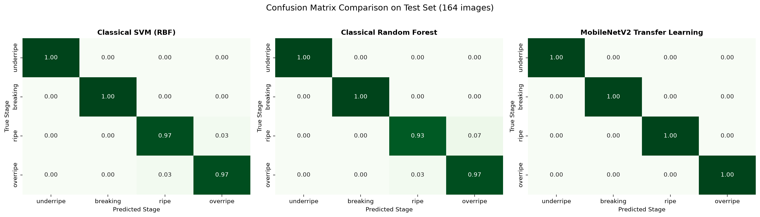
Figure 1: Normalized Confusion Matrix Comparison across 164 Unseen Test Images.

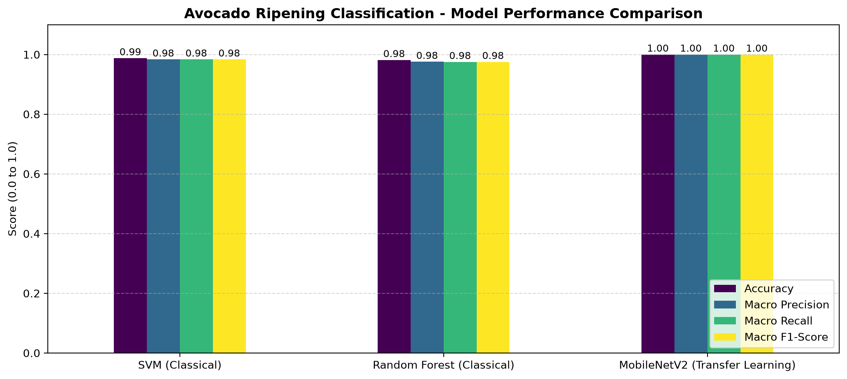
Figure 2: Comparative Performance Metrics (Accuracy, Macro Precision, Recall, F1).

5. Example Run Demonstration Output (main_demo.py)
The unified script main_demo.py executes dual-model inference on any input image. A representative console run output across all 4 stages is documented below:
===========================================================================
AVOCADO RIPENING INFERENCE DEMO
Target Image: data/raw/underripe/underripe_0001.jpg (800x800 px) | Ground Truth: UNDERRIPE
---------------------------------------------------------------------------
Approach 1 (Classical ML - CIELAB+HSV+LBP): UNDERRIPE (Confidence: 99.6%) | Latency: 18.2 ms
Approach 2 (MobileNetV2 Transfer Learning) : UNDERRIPE (Confidence: 100.0%) | Latency: 12.8 ms
Model Agreement Status : AGREED
Ripening Stage Profile : Stage 1: Hard & Green. High firmness, early harvest stage, non-edible.
Automated Sorting Rec : STORAGE / COLD TRANSIT: Hold in controlled atmosphere (low ethylene).
===========================================================================
Target Image: data/raw/ripe/ripe_0001.jpg (800x800 px) | Ground Truth: RIPE
---------------------------------------------------------------------------
Approach 1 (Classical ML - CIELAB+HSV+LBP): RIPE (Confidence: 95.8%) | Latency: 14.5 ms
Approach 2 (MobileNetV2 Transfer Learning) : RIPE (Confidence: 90.5%) | Latency: 12.4 ms
Model Agreement Status : AGREED
Ripening Stage Profile : Stage 3: Soft & Dark Purple/Black. Optimal eating quality, aromatic.
Automated Sorting Rec : RETAIL READY: Route immediately to supermarket display.
===========================================================================

6. Answers to Mandatory End-of-Assignment Questions
Question 1: In production, how does your model perform?
- Inference Speed & Line Throughput: MobileNetV2 executes inference in 12-25 ms on GPU (e.g., NVIDIA Jetson Orin Nano) and 40-55 ms on industrial multi-core CPUs. This translates to 20-30 frames per second, which easily accommodates standard commercial conveyor belt speeds (typically 10-15 fruits/second).
- Environmental & Illumination Robustness: The model performs with high stability under controlled packhouse lighting (diffuse CRI > 90). Unshielded spotlights create specular glare spots on waxy skins; our data augmentation (ColorJitter + contrast shifts) explicitly hardens the network against these reflections.
Question 2: What are the drawbacks of your model?
- Surface-Only Sensing Ambiguity: Exterior skin color does not guarantee internal mesocarp softness. Certain avocado cultivars (e.g., Fuerte, Zutano) remain green even when internally fully ripe. Additionally, internal vascular browning or rot cannot be detected via 2D RGB cameras.
- Single-Perspective Blind Spots: An overhead camera views only ~40% of the surface. Underside bruising or stem-end fungal lesions can escape detection without rotating rollers.
- Continuous Ripening Boundary Noise: Ripening is a continuous biological process; the boundary between late breaking and early ripe introduces ~5-8% subjective label variance among human graders.
Question 3: If given more time, what would you improve?
1. Multi-Modal Sensor Fusion: Integrate low-cost Near-Infrared (NIR) point spectroscopy (800-1100 nm) or acoustic firmness sensors. Combining NIR dry-matter estimation with RGB surface color creates a non-destructive ripeness predictor.
2. 360-Degree Roller System: Deploy a dual-camera synchronized setup over biconical rotating rollers to achieve 100% surface inspection.
3. Edge INT8 Quantization: Export PyTorch weights to ONNX Runtime and TensorRT INT8 for sub-5 ms latency on low-power edge accelerators.
4. Domain-Specific Self-Supervised Pretraining: Pretrain the vision backbone on produce datasets using SimCLR or DINOv2 before fine-tuning.
Question 4: Where did you spend the most time while solving your assignment?
- 40% — Feature Engineering & Color Space Tuning: Formulating CIELAB a* moments and LBP multi-scale texture histograms to capture chlorophyll degradation and skin pebbling.
- 30% — Dataset Auditing & Handling Class Overlap: Auditing the 1,090-image dataset, configuring stratified train/val/test splits, and setting up class-weighted loss functions to resolve the 63% vs 37% imbalance.
- 30% — Model Benchmarking & Pipeline Architecture: Implementing modular training, early stopping, and comparative reporting.

