

Darshan University

A Project Report on

**“ADMISSION MANAGEMENT”**

Under the subject

**Software Engineering (2101CS503)**

B. Tech, Semester – IV

Computer Science & Engineering Department

|  |  |
| --- | --- |
| Submitted By | |
| Student Name:Rushi Gambhava | Enrollment No.:23010101082 |
| Academic Year  (2024-2025) | |
| Internal Guide  Prof. Raj Gondaliya  Darshan University | Dean-DIET  Dr. Gopi Sanghani  Darshan University |

|  |  |
| --- | --- |
|  | **Computer Science & Engineering Department**  **Darshan University** |

**DECLARATION**

We hereby declare that the SRS, submitted along with the **Software Engineering** **(2101CS503)** for entitled **“Admission management”** submitted in partial fulfilment for the Semester-5 of **Bachelor Technology (B. Tech)** in **Computer Science and Engineering (CSE)** Departmentto Darshan University, Rajkot, is a record of the work carried out at **Darshan University, Rajkot** under the supervision of **Prof, RajKumar Gondaliya** and that no part of any of report has been directly copied from any students’ reports, without providing due reference.

(Rushi Gambhava)

Student’s Signature

Date: __________

|  |  |
| --- | --- |
|  | **Computer Science & Engineering Department**  **Darshan University** |

**CERTIFICATE**

This is to certify that the SRS on **“Admission management” has** been satisfactorily prepared by Rushi Gambhava(23010101082) under my guidance in the fulfillment of the course **Software Engineering (2101CS503)** work during the academic year 2024-2025.

|  |  |  |
| --- | --- | --- |
| Internal Guide  Prof. RajKumar Gondaliya  Darshan University |  | Dean-DIET  Dr. Gopi Sanghani  Darshan University |

**Acknowledgement**

I wish to express my sincere gratitude to my project guide **Prof. RajKumar Gondaliya** and all the faculty members for helping me through my project by giving me the necessary suggestions and advices along with their valuable co- ordination in completing this work.

I also thank my parents, friends and all the members of the family for their precious support and encouragement which they had provided in completion of my work. In addition to that, I would also like to mention the Darshan University personals who gave me the permission to use and experience the valuable resources required for the project from the University premises.

Thus, in conclusion to the above said, I once again thank the faculties and members of **Darshan University** for their valuable support in completion of the project.

Thanking You

Rushi Gambhava

**ABSTRACT**

The Admission Management project is a digital platform designed to simplify and streamline the admissions process for educational institutions. It offers a user-friendly student portal for application submission, document uploads, and status tracking, along with an admin dashboard for reviewing applications, communicating with applicants, and making decisions. The system includes automatic email and SMS notifications to keep applicants updated, tools for generating reports and analyzing data, and integration capabilities with other systems like payment gateways and student databases. This project aims to save time, reduce errors, and improve the overall admissions experience for both students and administrators.

Main purpose of this system is to reduce human efforts as much as possible.

**Table of Contents**

List of Figures VI

List of Tables II

1 Introduction 1

1.1 Product perspective 1

1.2 Product features 1

1.2.1 There are three different users who will be using this product: 1

1.2.2 The features that are required for the Administrator are: 1

1.2.3 The features that are required for the Applicant are: 1

1.3 Functional Requirement 2

1.3.1 Student 2

1.3.2 Staff 2

1.3.3 Admin 2

1.4 Non-Functional Requirement 2

1.4.1 Usability: 2

1.4.2 Accuracy: 2

1.4.3 Availability: 2

1.4.4 Maintainability: 2

2 Design and Implementation Constraints 3

2.1 Use case diagram 3

2.2 Activity diagram and Swimlane diagram 4

# List of Figures

Figure 2.1‑1 Use case diagram for Admission management system 3

Figure 2.2‑1 Activity diagram of Admission Management(Student) 4

Figure 2.2‑2 Activity Diagram of Admission Management 5

Figure 2.3‑1 Sequence diagram for student Admission 7

# List of Tables

Table 3.1‑1 Screen element of Registration form 12

Table 3.2‑1 Screen element of Login form 13

Table 3.3‑1 Screen element of Add borrower book 15

Table 3.2‑1 Screen element of Login form 16

Table 4.1‑1 Table: Student 17

Table 4.1‑2 Table: Course 17

Table 4.1‑3 Table: Staff 17

Table 4.1‑4 Table: Faculty 17

# Introduction

## Product perspective

The Admission Management project is a web-based platform designed to simplify and improve the admissions process for schools and colleges. It offers a user-friendly portal for students to submit applications, upload documents, and track their status, and a secure dashboard for staff to review applications and communicate with applicants. The system integrates with existing student databases and payment services, provides automatic notifications, and generates reports to help schools analyze and enhance their admissions process. This project aims to save time, reduce errors, and make admissions easier and more efficient for everyone involved.

## Product features

### There are three different users who will be using this product:

* **Administrator** who will be managing admissions and student data.
* **Applicant** who will be applying for admission.
* **Guest** who will request information or submit an application.

### The features that are required for the Administrator are:

* Manage the movement of student applications and avoid losing important documents.
* Search for a specific application based on applicant name, admission number, program, etc.
* Print admission-related documents such as offer letters or student IDs.
* Track which applicants have completed admission requirements and submitted necessary documents. Offers modules for Application Management, Student Records, and Queries.
* Approve or reject an application.
* View the list of applicants for each program or department.
* Accept admission confirmation or withdrawal from applicants.
* Add new programs or courses to the system.
* Edit existing applicant information or program details.
* View reports on the number of applications received, admissions approved, etc.
* Access all applicant accounts and update their application status.

### The features that are required for the Applicant are:

* View different programs and courses available.
* View the status of their application.
* Create and manage an account in the admission system.
* View the list of documents they have submitted or need to submit.
* Request to change program or defer admission.
* Submit applications and upload required documents online.

## Functional Requirement

### **Student**

1. **Registration**: Students register using name, email ID, and mobile number.
2. **Login**: Students log in using email ID and password.
3. **View Profile**: Students can view their profile.
4. **Edit Profile**: Students can update their profile as needed.
5. **Fill Form**: Students fill out forms for any degree as per requirement.
6. **View Program Details**: Students view details of programs offered by the university.
7. **View Faculty Details**: Students view details about faculty members.
8. **Upload Documents**: Students upload documents like living certificates, proof of ID, and 12th mark sheets.
9. **View Fee Structure**: Students view fee structures for various programs.
10. **Fees Payment**: Students pay fees using cash, check, DD, or UPI.
11. **View Scholarship Details**: Students view scholarships provided by the government or university.
12. **Check Email**: Students check emails for updates.
13. **Collect Fee Receipt**: After payment, students collect a fee receipt.
14. **Apply for Scholarship**: Students apply for scholarships.
15. **View Education Loan Details**: Students view details about education loans.
16. **Apply for Transportation Service**: Students apply for transportation services, select routes and cities, and pay fees.
17. **Track Application Status**: Students can track the status of their admission applications.
18. **View Important Dates**: Students view critical dates related to admissions, payments, and other processes.
19. **Download Admission Form**: Students can download filled admission forms for their records.
20. **Provide Feedback**: Students submit feedback about the admission process.

### **Staff**

1. **Register**: Staff register using name, email ID, and password.
2. **Login**: Staff log in using email ID and password.
3. **View Student Details**: After students fill out forms, staff can view all details.
4. **Send Email**: Staff send emails to students about admission status.
5. **Collect Fees**: Staff collect student fees.
6. **Provide Fee Receipt**: Staff issue fee receipts after payment.
7. **Application Review and Approval**: Staff review and approve applications.
8. **Verify Documents**: Staff verify the uploaded documents submitted by students.
9. **Track Pending Applications**: Staff monitor and manage pending or incomplete applications.

### **Admin**

1. **View Yearly Records**: Admin views yearly admission records.
2. **Generate Reports**: Admin generates various reports (e.g., yearly admissions, scholarship applications, fee collection).
3. **Manage Staff Accounts**: Admin creates, updates, and deletes staff accounts.
4. **Audit Logs**: Admin monitors activity logs for transparency and security.
5. **Set Application Deadlines**: Admin defines and updates deadlines for applications, fee payments, and other key events.
6. **Monitor Program Popularity**: Admin analyzes the popularity of different programs based on student applications.
7. **Update Program Details**: Admin manages details of programs offered by the university.
8. **Handle Complaints**: Admin addresses complaints and issues raised by students or staff.
9. **Approve Scholarships**: Admin reviews and approves scholarship applications.
10. **Oversee Transportation Services**: Admin monitors transportation service usage and payments.

## Non-Functional Requirement

### Usability:

* The UI should be simple enough for everyone to understand and get the relevant information without any special training. Different languages can be provided based on the requirements.

### Accuracy:

* The data stored about the books and the fines calculated should be correct, consistent, and reliable.

### Availability:

* The System should be available for the duration when the library operates and must be recovered within an hour or less if it fails. The system should respond to the requests within two seconds or less.

### Maintainability:

* The software should be easily maintainable and adding new features and making changes to the software must be as simple as possible. In addition to this, the software must also be portable.

# Design and Implementation Constraints

## Use case diagram

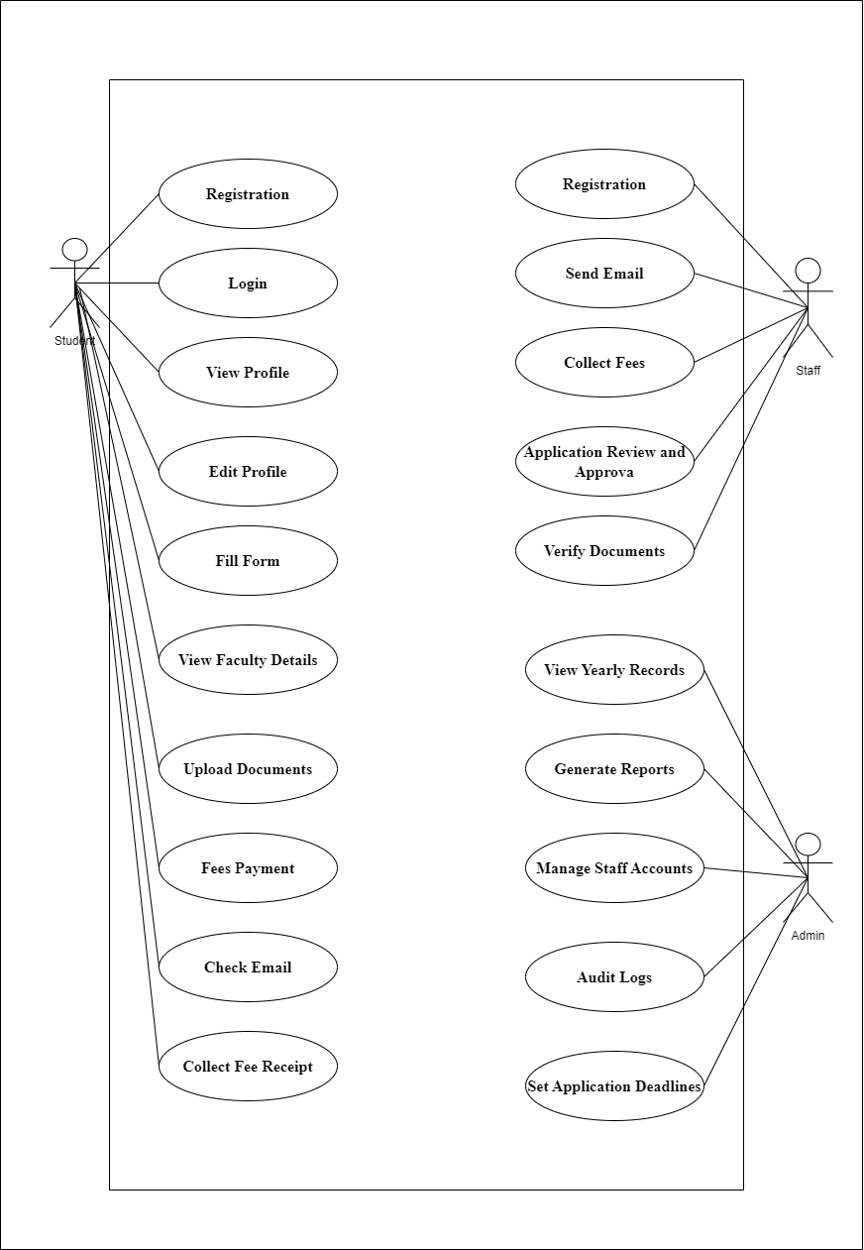

Figure 2.1‑1 Use case diagram for Admission management system

## Activity diagram and Swimlane diagram

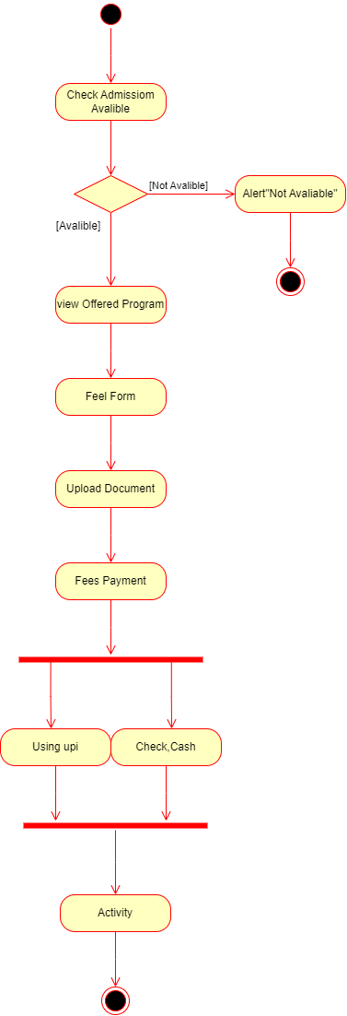

Figure 2.2‑1 Activity diagram of Admission Management(Student)

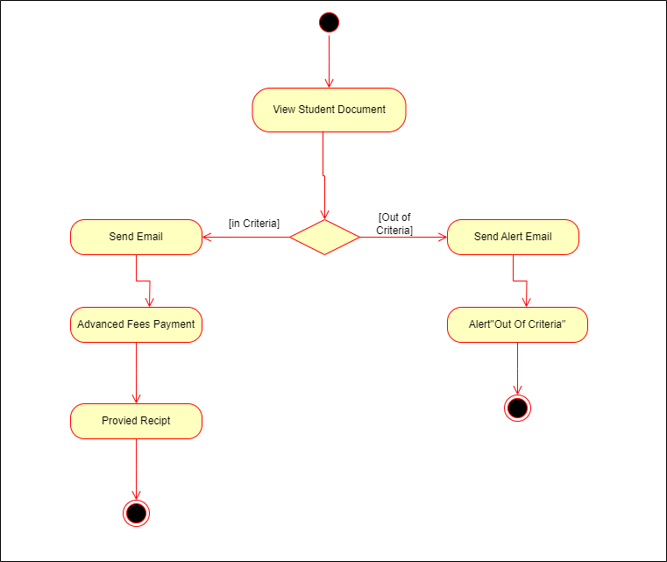

Figure 2.2‑2 Activity Diagram of Admission Management(Staff)

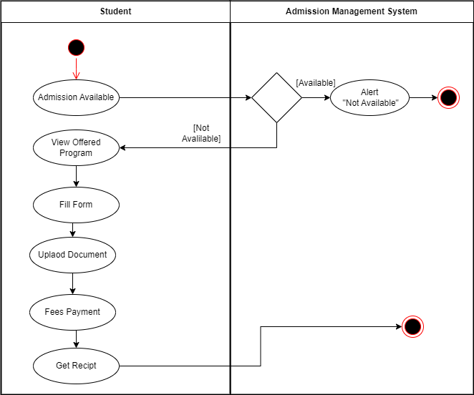

Figure 2.3‑Swimlane Diagram of Admission Management