### Experiment no 1

Aim: Implementing Basic tags in HTML.

Code :

<head>

<meta charset="UTF-8">

<meta name="viewport" content="width=device-width, initial-scale=1.0">

<link rel="stylesheet" href="styles.css">

<title>Knotcraft</title>

</head>

<body>

<header>

<div class="container">

<img src="./college/Group 2.png" alt="Wedding Planner Logo" class="logo">

<nav>

<ul class="nav-links">

<li><a href="#home">Home</a></li>

<li><a href="#about-us">About Us</a></li>

<li><a href="#services">Services</a></li>

<li><a href="#contact">Contact Us</a></li>

</ul>

</nav>

<div class="menu-toggle">&#9776;</div>

</div>

</header>

<div class="background-image">

<div class="overlay">

<h1>Welcome to KnotCraft: Where Every Knot Tells a Story</h1>

</div>

</div>

Output:

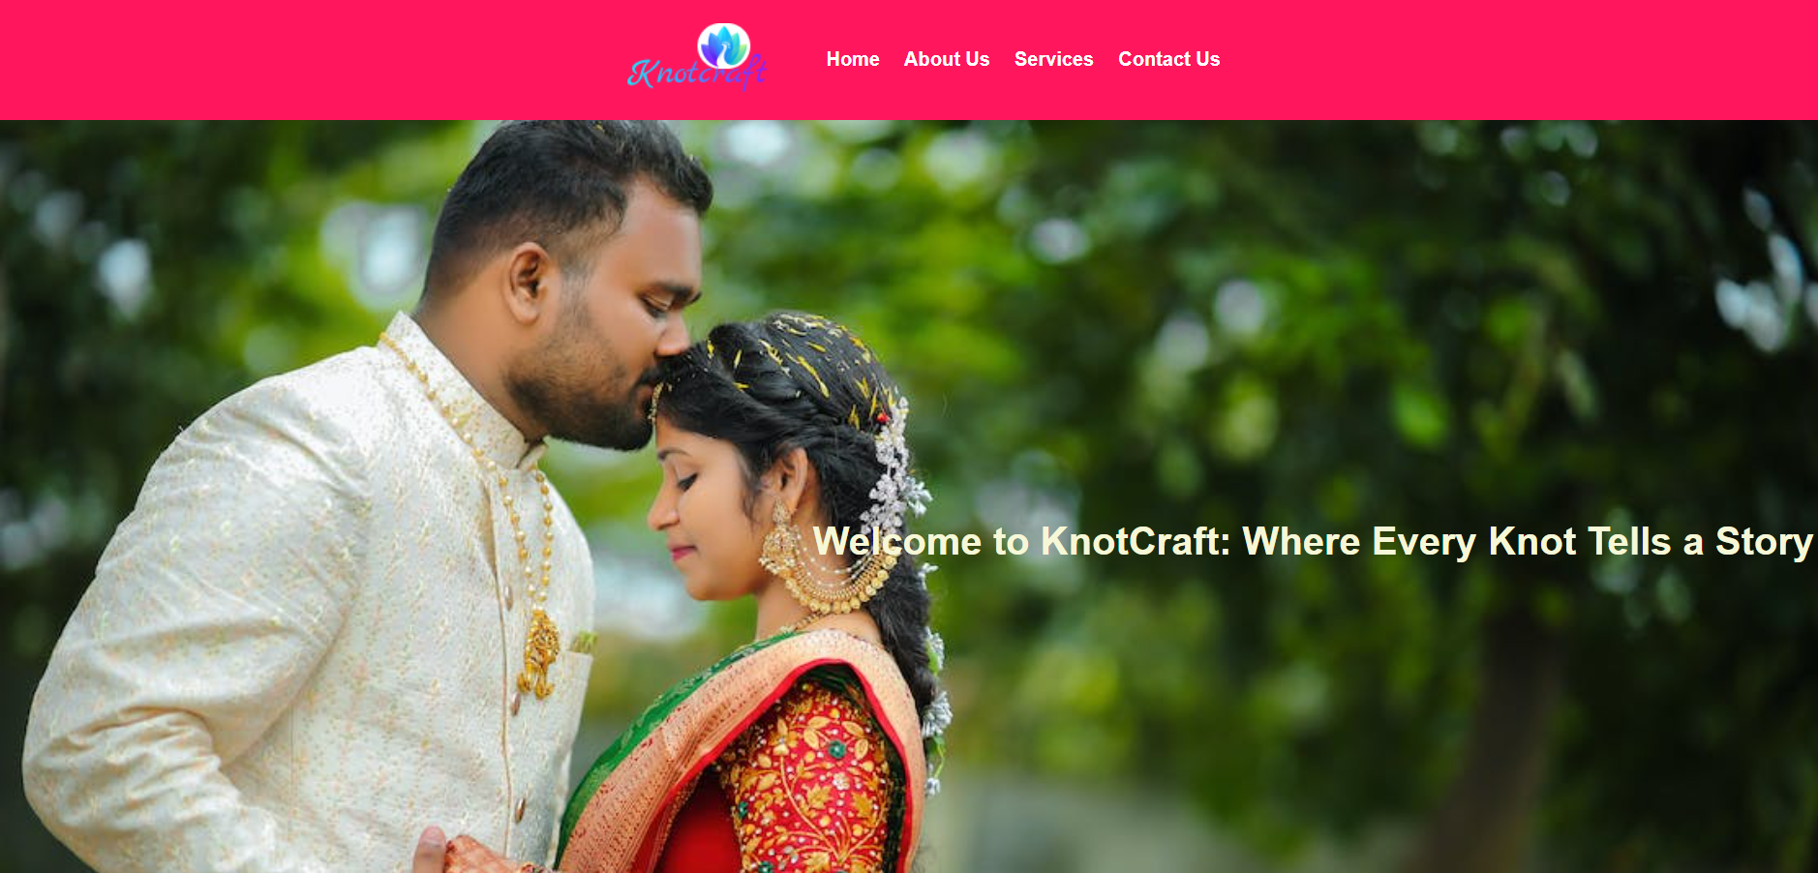

Conclusion: here we use basis tags of html ,and using basic tags we created our website.

# Experiment no:2

Aim: Design a web page using table tag exploring all attributes.

Code: <table>

<tr>

<th>Service</th>

<th>Description</th>

<th>Price</th>

</tr>

<tr>

<td>Full Wedding Planning</td>

<td>Complete wedding planning and coordination.</td>

<td>Rs 4,99,999</td>

</tr>

<tr>

<td>Partial Wedding Planning</td>

<td>Assistance with select planning elements.</td>

<td>Rs 1,00,000</td>

</tr>

<tr>

<td>Day-of Coordination</td>

<td>Coordination on the wedding day.</td>

<td>Rs 30,000</td>

</tr>

</table>

Output: 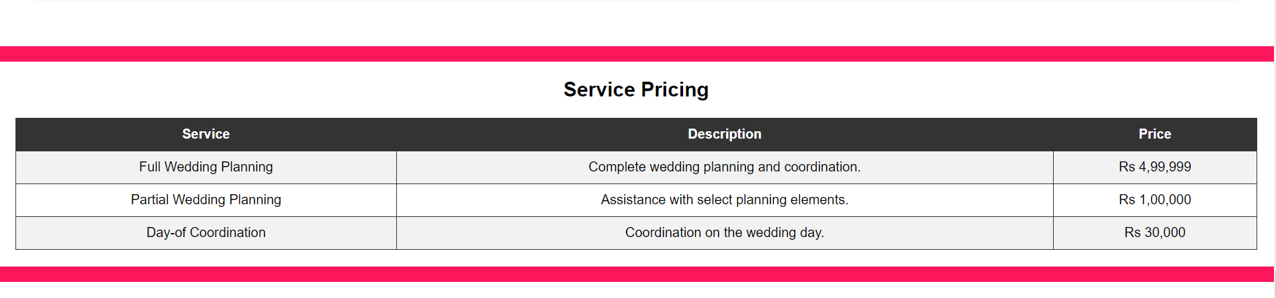

Conclusion: we have successfully Created table using table tag in HTML.

# Experiment no 3

Aim: : Design a form in html considering all input types.

Code: <form action="">

<div class="inputBox">

<input type="text" placeholder="your name">

<input type="email" placeholder="your email">

</div>

<div class="inputBox">

<input type="number" placeholder="your number">

<input type="text" placeholder="your address">

</div>

<textarea placeholder="say something" name="" id="" cols="30" rows="10"></textarea>

<input type="submit" value="send message" class="btn">

</form>

Output: 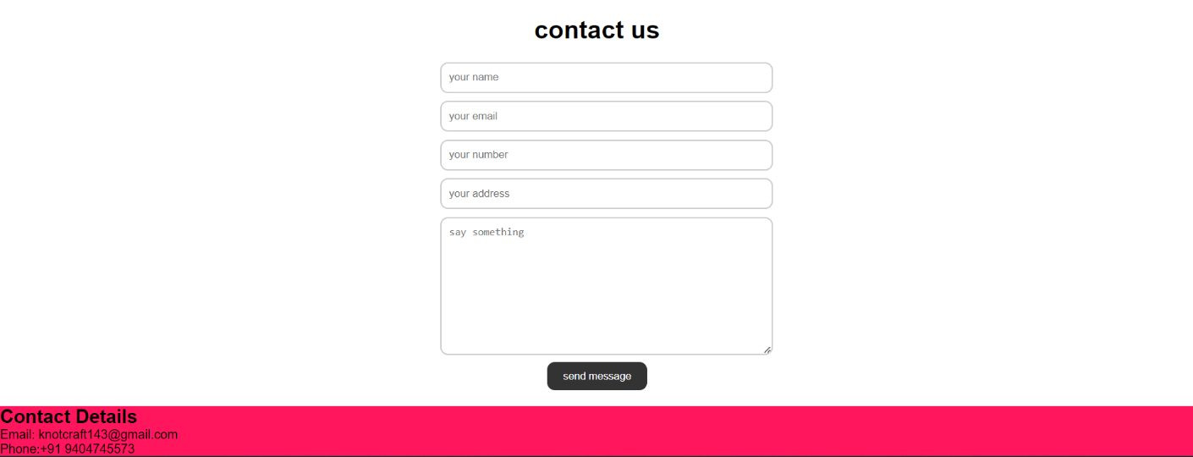

Conclusion: Created registration form using form tag in HTML.

## Experiment no 4

Aim: Design a web page using inline & embedded CSS.

<div class="team-member">

<img src="css/ls2.jpg" alt="Wedding Planner Team Member 1">

<h3>Rushi Gavhane</h3>

<p>Wedding Planner</p>

<p>Full Wedding Planning Specialist</p>

</div>

<div class="team-member">

<img src="college/ls1.jpg" alt="Wedding Planner Team Member 2">

<h3>Aman Bhogale</h3>

<p>Event Coordinator</p>

<p>Partial Wedding Planning Expert</p>

</div>

<div class="team-member">

<img src="college/ls3.jpg" alt="Wedding Planner Team Member 3">

<h3>Shanuj Tiwari</h3>

<p>Logistics Manager</p>

<p>Day-of Coordination Specialist</p>

</div>

Output: 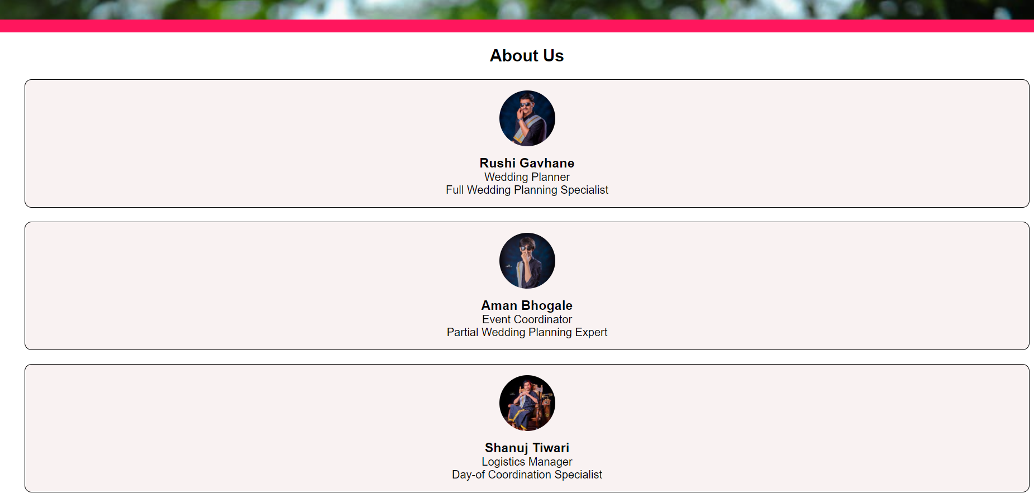

Conclusion – here with the help of inline css we created some webpages of our website.

## Experiment no 5

Aim: : Design webpage using external CSS Code:

body, h1, h2, h3, p, ul, ol, li, table, th, td {

margin: 0;

padding: 0;

}

body {

font-family: Arial, sans-serif;

background-color: #FF165D;

margin: 0;

padding: 0;

}

header {

background: #FF165D;

color: #fff;

display: flex;

justify-content: space-between;

align-items: center;

padding: 20px;

}

.container {

display: flex;

justify-content: space-between;

align-items: center;

max-width: 1200px;

margin: 0 auto;

padding: 0 20px;

}

.logo {

height: 60px;

margin-right: 20px;

}

.nav-links {

list-style: none;

display: flex;

align-items: center;

}

.nav-links li {

margin-left: 20px;

}

.nav-links a {

text-decoration: none;

color: #ffffff;

font-weight: bold;

}

.menu-toggle {

display: none;

font-size: 24px;

cursor: pointer;

}

.background-image {

background-image: url('./college/background\ image.jpg');

background-size: cover;

background-repeat: no-repeat;

background-attachment: fixed;

width: 100%;

height: 100vh;

position: relative;

text-align: right; /* Align text on the background image to the right */

}

.overlay {

position: absolute;

top: 0;

right: 0;

bottom: 0;

left: 0;

background: rgba(0, 0, 0, 0);

color: #F6F7D7;

display: flex;

flex-direction: column;

justify-content: center;

align-items: flex-end;

padding: 20px;

text-align: right;

height: 90%;

}

h1 {

font-size: 2rem;

margin: 0;

}

.main {

text-align: center;

padding: 20px;

}

#about-us {

background-color: #fff;

padding: 20px;

text-align: center;

}

#services {

background-color:#ffffff;

text-align: center;

}

#service-pricing {

background-color: #fff;

padding: 20px;

text-align: center;

}

table {

width: 100%;

border-collapse: collapse;

border: 1px solid #333;

margin-top: 20px;

}

th, td {

border: 1px solid #333;

padding: 10px;

}

th {

background-color: #333;

color: #fff;

}

tr:nth-child(even) {

background-color: #f2f2f2;

}

#contact {

background-color: #fff;

padding: 20px;

text-align: center;

}

form {

max-width: 400px;

margin: 0 auto;

}

form label {

display: block;

font-weight: bold;

margin-bottom: 5px;

}

form input[type="text"],

form input[type="number"],

form input[type="email"] {

width: 100%;

padding: 10px;

margin: 5px 0;

border: 2px solid #ccc;

border-radius: 10px;

outline: none;

}

form textarea {

width: 100%;

padding: 10px;

margin: 5px 0;

border: 2px solid #ccc;

border-radius: 10px;

outline: none;

}

form input[type="submit"] {

background: #333;

color: #fff;

border: none;

border-radius: 10px;

padding: 10px 20px;

cursor: pointer;

transition: background-color 0.3s;

}

form input[type="submit"]:hover {

background-color: #555;

}

#contact h2 {

margin-top: 20px;

}

.contact p {

margin: 10px 0;

}

.image-container {

display: flex;

justify-content: center;

}

.image-container img {

border-radius: 50%;

margin: 0px;

width: 80px;

height: 80px;

}

.team-member {

text-align: center;

margin: 20px;

border: 1px solid #000000;

padding: 15px;

border-radius: 10px;

background-color: #f9f2f2;

}

.team-member img {

border-radius: 50%;

width: 80px;

height: 80px;

margin-bottom: 10px;

}

#services {

text-align: center;

padding: 40px;

}

.service {

background-color: #f9f2f2;

padding: 20px;

border-radius: 10px;

margin: 20px 0;

text-align: left;

box-shadow: 0 4px 6px rgba(0, 0, 0, 0.1);

}

.service h3 {

font-size: 1.5rem;

margin-top: 0;

}

.service p {

font-size: 1rem;

margin-bottom: 10px;

}

.service p:last-child {

margin-bottom: 0;

}

Output: 

Conclusion: Created webpage which contain external cascading style sheets.

### Experiment no 6

Aim: Design & implement all types of popup boxes using JAVA Script Code:

<div>

<button onclick="showAlert()">Alert</button>

<button onclick="showConfirm()">Confirm</button>

<button onclick="showPrompt()">Prompt</button>

</div>

<script> function showAlert() { alert('This is an alert message.');

}

function showConfirm() { if (confirm('Do you want to proceed?')) { alert('You clicked OK.');

} else { alert('You clicked Cancel.');

}

}

function showPrompt() { const userInput = prompt('Please enter your name:', 'John Doe'); if (userInput !== null) { alert('Hello, ' + userInput + '!');

} else { alert('You canceled or closed the prompt.');

}

}

</script>

Output:

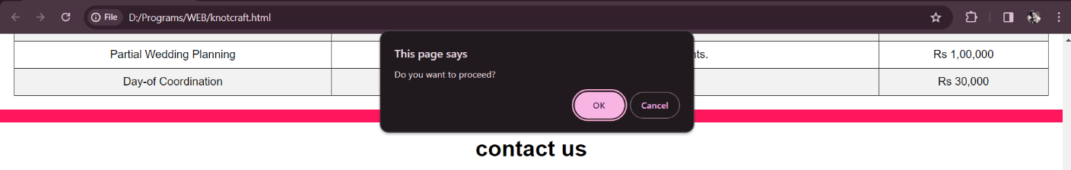

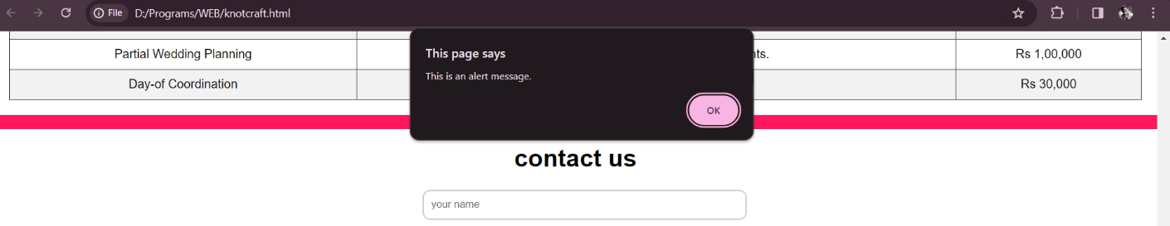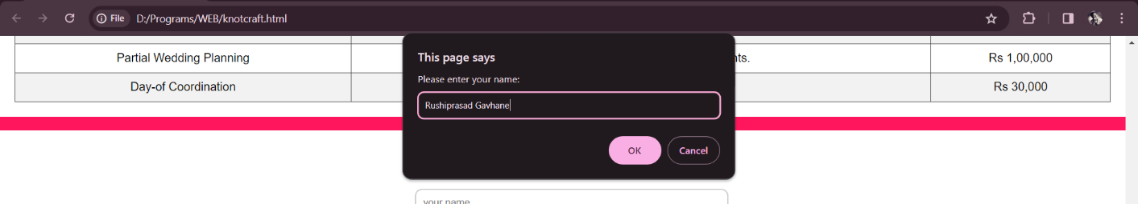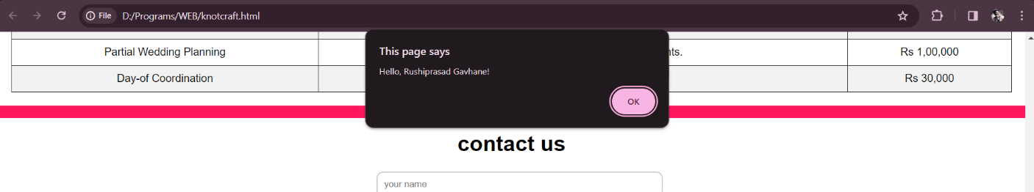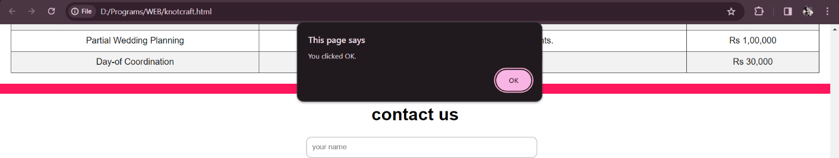

Conclusion: Created a java script program which display all types of popup boxes

# **Experiment no:7**

Aim: Design a calculator in html using JAVA Script taking inputs from user.

Code: <!DOCTYPE html>

<html lang="en">

<head>

<meta charset="UTF-8">

<meta name="viewport" content="width=device-width, initial-scale=1.0"> <title>Document</title>

<link rel="stylesheet" href="style.css">

</head>

<body>

<h1> Calculator Program in JavaScript </h1>

<div class= "formstyle">

<form name = "form1">

<input id = "calc" type ="text" name = "answer"> <br> <br>

<input type = "button" value = "1" onclick = "form1.answer.value += '1' ">

<input type = "button" value = "2" onclick = "form1.answer.value += '2' ">

<input type = "button" value = "3" onclick = "form1.answer.value += '3' ">

<input type = "button" value = "+" onclick = "form1.answer.value += '+' "> <br> <br>

<input type = "button" value = "4" onclick = "form1.answer.value += '4' ">

<input type = "button" value = "5" onclick = "form1.answer.value += '5' ">

<input type = "button" value = "6" onclick = "form1.answer.value += '6' ">

<input type = "button" value = "-" onclick = "form1.answer.value += '-' "> <br> <br>

<input type = "button" value = "7" onclick = "form1.answer.value += '7' ">

<input type = "button" value = "8" onclick = "form1.answer.value += '8' ">

<input type = "button" value = "9" onclick = "form1.answer.value += '9' "> <input type = "button" value = "*" onclick = "form1.answer.value += '*' "> <br> <br>

|  |
| --- |
|  |

<input type = "button" value = "/" onclick = "form1.answer.value += '/' ">

<input type = "button" value = "0" onclick = "form1.answer.value += '0' ">

<input type = "button" value = "." onclick = "form1.answer.value += '.' ">

<input type = "button" value = "=" onclick = "form1.answer.value = eval(form1.answer.value) ">

<br>

<input type = "button" value = "Clear All" onclick = "form1.answer.value = ' ' " id=

"clear" >

<br>

</form>

</div>

</body>

</html>

Output:

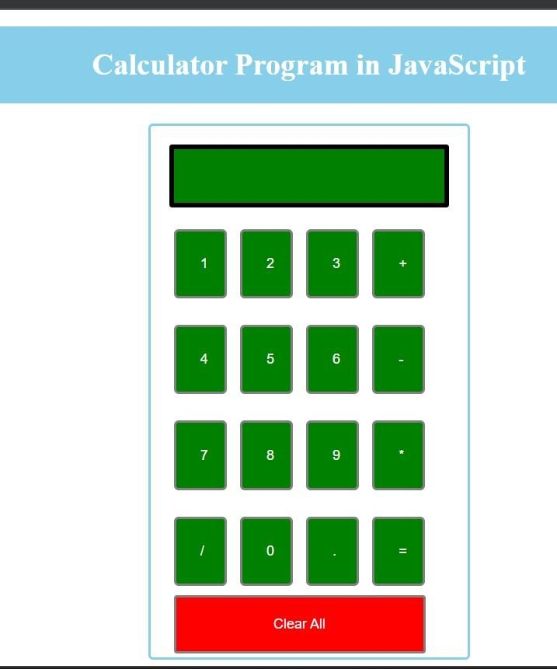

Conclusion: here we created the calculator using html, css , javascript.