Enterprise Network Design and Simulation for a Multi-Location Organization
Computer Networks Mini Project
Rushikesh Batkamwar | Roll No: 62
Cisco Packet Tracer | 31 October 2026

1. Problem statement
Design and simulate an enterprise network connecting a Head Office (HQ) and a Branch Office through an ISP network using Cisco Packet Tracer. The visible topology contains three Cisco 2911 routers: an HQ router labelled Area 1, an ISP router and a Branch Office router labelled Area 2. Each office has three access switches, with multiple PCs connected to each switch. The design represents two office LAN environments connected across an ISP path. The supplied topology screenshot confirms device placement and visible connections; it does not show IP addressing, routing protocol settings, DHCP, NAT, ACL or test results.

2. Networking requirements
Requirement | Design representation
Connect two office locations | HQ and Branch Office are connected through an ISP router.
Provide local wired connectivity | Each office has three 2960-series access switches connecting its PCs.
Support multiple end devices | HQ and Branch Office each contain 18 PCs in the visible topology.
Route traffic between locations | The HQ, ISP and Branch Office routers provide the routed WAN path.
Validate communication | Test local gateway access, inter-office reachability and any configured network services.

Scope and deliverables
The submitted simulation is EnterpriseNetwork.pkt. This report describes the visible network topology, device inventory, intended network roles and a validation plan. Actual IP addressing, routing configuration and measured results must be copied from the Packet Tracer file after testing.

3. Network topology
The topology is organized into two office areas connected through an ISP router. At HQ, Router0 (Area 1) connects to three 2960-series access switches, serving PC0 to PC17. At the Branch Office, Router2 (Area 2) connects to three access switches, serving PC18 to PC35. Router1 is labelled ISP and provides the transit connection between the two office routers.
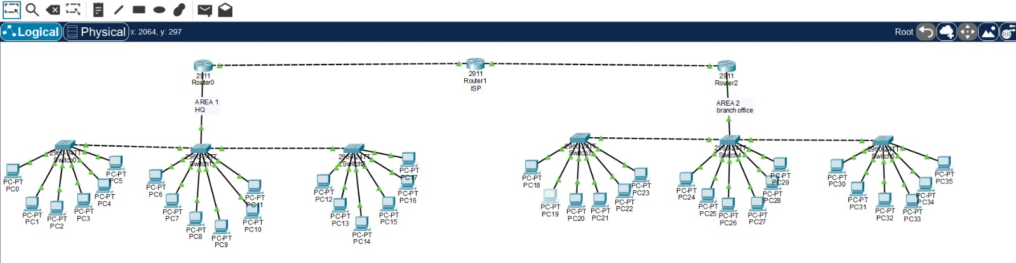
Figure 1. Enterprise network logical topology showing HQ, ISP and Branch Office, with three access switches and 18 PCs at each office.

Equipment inventory
Equipment | Quantity visible | Role
Cisco 2911 Router | 3 | HQ router (Area 1), ISP router and Branch Office router (Area 2).
Cisco 2960-series Switch | 6 | Three access switches at HQ and three at the Branch Office.
PC-PT | 36 visible | PC0–PC17 at HQ and PC18–PC35 at the Branch Office.

4. IP addressing plan
The screenshot does not display IP addresses or subnet masks. Fill this table using the router interface configuration and PC IP Configuration windows in EnterpriseNetwork.pkt. Do not use guessed values.
Network segment | Subnet / prefix | Default gateway | Visible endpoints / notes
HQ LAN / switch group 1 | Not visible in screenshot | To be read from router/PC configuration | PC0–PC5
HQ LAN / switch group 2 | Not visible in screenshot | To be read from router/PC configuration | PC6–PC11
HQ LAN / switch group 3 | Not visible in screenshot | To be read from router/PC configuration | PC12–PC17
Branch LAN / switch group 1 | Not visible in screenshot | To be read from router/PC configuration | PC18–PC23
Branch LAN / switch group 2 | Not visible in screenshot | To be read from router/PC configuration | PC24–PC29
Branch LAN / switch group 3 | Not visible in screenshot | To be read from router/PC configuration | PC30–PC35
WAN HQ–ISP | Not visible in screenshot | To be read from router interface configuration | Record both endpoint addresses and mask
WAN ISP–Branch | Not visible in screenshot | To be read from router interface configuration | Record both endpoint addresses and mask

5. Configuration summary
- Connect HQ PCs PC0–PC17 to the three HQ access switches as shown in the topology.
- Connect Branch Office PCs PC18–PC35 to the three branch access switches as shown.
- Connect the HQ router to the ISP router and the ISP router to the Branch Office router using the WAN links shown.
- Assign an IPv4 subnet and default gateway to each LAN. If all three switches at one office are intended to form one LAN, verify that they are connected at Layer 2 and share the same subnet; otherwise document the separate subnets.
- Assign IP addresses to the router WAN interfaces from a suitable point-to-point address plan and ensure the two WAN links use non-overlapping subnets.
- Configure a routing method on all three routers so HQ and Branch Office LAN routes are exchanged through the ISP. Record the actual method and commands used (for example, static routes or a dynamic routing protocol).
- If DHCP is implemented, configure the server or router pools and any required DHCP relay. The screenshot does not show a DHCP server.
- If NAT, ACLs or other security features are implemented, document their actual configuration and test them. They are not confirmed by the topology screenshot.
Configuration evidence to attach: router interface status, routing tables, WAN interface addressing, and PC IP configuration from both office locations.

6. Testing and observed results
Use this checklist to validate the Packet Tracer simulation. Replace expected results with the actual observed outcomes.
Test | Procedure | Expected result
Link status | Check router interfaces with show ip interface brief. | All used interfaces should be up/up.
PC addressing | Run ipconfig on representative PCs from each switch group. | Each PC should have a valid IP, mask and default gateway.
Local gateway | Ping the local default gateway from each LAN. | Replies confirm PC-to-router connectivity.
HQ internal connectivity | Ping between PCs connected to different HQ switches. | Replies confirm the HQ switching/subnet design supports the intended communication.
Branch internal connectivity | Ping between PCs connected to different branch switches. | Replies confirm the branch switching/subnet design supports the intended communication.
Inter-office connectivity | Ping a known HQ PC from a Branch PC and vice versa. | Replies confirm WAN routing between the two offices.
Routing verification | Run show ip route on all three routers. | Routes to remote office LANs appear through the configured WAN path.

7. Outcome and limitations
The visible topology represents an enterprise network with two office locations connected through an ISP router. It demonstrates a multi-router WAN design and multiple switched access segments at each location. The project is complete only after the IP plan, routing configuration and end-to-end connectivity tests are verified in Packet Tracer.
- The screenshot shows three 2911 routers, six 2960-series switches and 36 PCs (PC0–PC35).
- The visible labels identify Router0 as Area 1 / HQ, Router1 as ISP and Router2 as Area 2 / Branch Office.
- No server devices are visible in the supplied screenshot. Therefore DHCP, DNS, HTTP, email or file services are not claimed in this report.
- The screenshot does not reveal subnet masks, IP addresses, routing protocol, NAT, ACLs or measured test outcomes. These must be checked in EnterpriseNetwork.pkt before submission.
- Add your own screenshots of router IP configuration, routing tables, PC addressing and successful inter-office ping tests after validating the simulation.

Student declaration
I have reviewed the network topology and will verify all addressing, routing and connectivity results in Cisco Packet Tracer before final submission.
Student: Rushikesh Batkamwar Roll No.: 62 Section: AIML-B
Date: 31/10/2026

