A
PROJECT SCHOOL REPORT
ON
Early Disease Detection Using AI: A Deep Learning Approach to Predicting Cancer and Neurological Disorders
Submitted By
Sayini Anshu 23P81A6656
Rallabandi Lakshmi Nikhila 23P81A0550
B. Abhinav Varma 23P81A0579
A.Rushika 23P81A6905
D.Venkat 23P81A6921
Under the guidance
of
Mrs. K. Navatha

Asst. Professor, Dept. of CSE(AIML)



KESHAV MEMORIAL COLLEGE OF ENGINEERING
Koheda Road, Chintpalliguda, Ibrahimpatnam, Telangana 501510.
November , 2025

KESHAV MEMORIAL COLLEGE OF ENGINEERING

A Unit of Keshav Memorial Technical Education (KMTES)
Approved by AICTE, New Delhi & Affiliated to Jawaharlal Nehru Technological University, Hyderabad

CERTIFICATE
This is to certify that the project work entitled “Early Disease Detection Using AI: A Deep Learning Approach to Predicting Cancer and Neurological Disorders” is a bonafide work carried out by “Sayini Anshu, Rallabandi Lakshmi Nikhila, B. Abhinav Varma, A.Rushika, D.Venkat” of III year I semester Bachelor of Engineering in CSE/CSE(AIML)/CSO during the academic year 2024-2025 and is a record of bonafide work carried out by them.

PROJECT MENTOR
Mrs. K. Navatha
Asst. Professor, CSE(AIML)

ABSTRACT
Early detection of critical illnesses such as cancer and neurological disorders plays a pivotal role in improving patient prognoses, reducing treatment costs, and enabling timely clinical intervention. Despite advancements in conventional diagnostic approaches, challenges remain due to dependency on specialized expertise, interpretative variability, and delayed detection at initial stages. Recent progress in artificial intelligence offers promising solutions by enabling automated and precise early disease prediction. This research evaluates the models applied to multimodal biomedical datasets, including histopathological images, CT and MRI scans, and EEG signals in CSV format. Comprehensive preprocessing strategies were utilized to optimize model performance across varied spatial and temporal data types. The multi-level classification facilitated modality validation and progressive disease classification for cancer and neurological disorder detection. These approaches enhance early diagnostic accuracy and scalability.

CONTENTS
S.NO TITLE PAGE NO.
 | ABSTRACT  TABLE OF CONTENTS  LIST OF FIGURES  LIST OF TABLES | i  ii-iii  iii  iv
- Introduction
1.1 Background 1
1.2 Objective 1-2
1.3 Scope 2
- Literature Survey
2.1 Overview of AI-Based Medical Diagnostic Systems 3
2.2 Machine Learning Models for Classification 3-5
- Software Requirements Specification
3.1 Purpose & Scope 6
3.2 Definitions and References 6
3.3 System Overview 7
3.4 Operating Environment 7
3.5 Functional & Non-functional Requirements 7-8
- Proposed Work, Architecture, Technology Stack
& Implementation Details
4.1 System Architecture 9-11
4.2 Technology Stack 11-13
4.3 Implementation Details 13-14
- Results and Discussions
5.1 Output Demonstration 15-16
5.2 Performance Metrics 16-18
5.3 Functional Demonstration 18-25
- Conclusion & Future Scope 26
- References 27-28

LIST OF FIGURES

Fig. No. | Figure Name | Page No.
1 | Architecture Diagram | 10
2 | Multi-Level Classification Architecture | 11
3 | Disease Model Accuracies | 14
4 | Image Upload Analysis | 16
5 | Disease Model Metrics Comparison | 17
6 | Pipeline Performance Metrics | 18
7 | Demonstration of Functionality | 18

LIST OF TABLES

Table No. | Table Name | Page No.
1 | Models and Purpose | 12
2 | Models and Accuracies | 13
3 | Performance Metrics | 16

CHAPTER-1
INTRODUCTION
1.1 Background
Early and accurate diagnosis of life-threatening diseases such as cancer and neurological disorders is vital for effective treatment and improved patient survival rates. However, traditional diagnostic methods largely depend on manual interpretation of medical imaging data such as CT scans, MRI scans, EEG signals, and histopathology images. This manual process is time-consuming, requires significant expertise, and is prone to human error or subjective bias. Moreover, in many under-resourced or rural healthcare settings, the shortage of specialized doctors further delays diagnosis and treatment initiation.
Cancers like lung, breast, and colon cancer demand highly precise image-based detection, as minor abnormalities or early-stage tumors are often difficult to identify visually. Similarly, neurological conditions such as Alzheimer’s disease, epilepsy, and multiple sclerosis exhibit complex imaging and signal patterns that can easily be misinterpreted without advanced tools. Misdiagnosis or delayed detection not only affects patient outcomes but also increases the emotional and financial burden on patients and healthcare systems.
With rapid advancements in Artificial Intelligence (AI), particularly in Deep Learning and Computer Vision, there is immense potential to revolutionize medical diagnostics. AI models can efficiently process large amounts of imaging data, recognize subtle patterns beyond human perception, and deliver consistent and objective results. However, most existing AI-based diagnostic systems are disease-specific and limited to a single type of data input, restricting their versatility and real-world adoption.
To overcome these challenges, the Medical AI Assistant for Early Detection of Cancer and Neurological Diseases has been conceptualized. This intelligent system leverages a Multi-Level Classification architecture to automatically identify the type of medical input—CT, MRI, EEG, or histopathology—and route it to the appropriate network. The system further classifies whether the input corresponds to a cancer or neurological condition and pinpoints the exact disease type. By integrating multiple deep learning models under one platform, this project aims to support healthcare professionals with fast, accurate, and reliable diagnostic insights while enhancing accessibility and efficiency in medical analysis.
1.2 Objective
The primary goal of this project is to develop an AI-powered medical assistant that supports doctors in the early detection of cancer and neurological diseases by automating medical image analysis. The system is designed to ensure accuracy, speed, and usability while maintaining a modular architecture adaptable to various medical domains. The key objectives include:
- Implement a Multi-Level Classification model that acts as the core architecture for giving accurate prediction based on the input data type.
- Develop multiple levels for binary classification to validate input type (CT, MRI, EEG, or histopathology) and reject invalid or unsupported inputs.
- Classify and route valid inputs into appropriate domains—Cancer or Neurological—based on the medical image type.
- Deploy specialized CNN models for detailed classification of diseases:
  - Cancer: Lung, Breast, and Colon Cancer
  - Neurological: Alzheimer’s, Epilepsy, and Multiple Sclerosis
- Provide precise predictions on disease type and assist doctors in early diagnosis.
- Create a user-friendly web interface that allows doctors to sign up, log in, enter patient details and upload medical data for analysis.
- Build an interactive dashboard displaying user profiles, upload history, report generation and detailed website information.
- Ensure secure data handling and error management for invalid or corrupted inputs.
- Support scalability and integration, enabling the future addition of new diseases and expert models.
By combining AI’s analytical capabilities with an intuitive and secure user interface, this project aims to empower medical professionals, reduce diagnostic workload, and promote early detection for better healthcare outcomes.
1.3 Scope
The Medical AI Assistant for Early Detection of Cancer and Neurological Diseases is designed as a comprehensive platform that supports healthcare professionals in diagnosing critical medical conditions through advanced AI techniques. The system caters primarily to doctors and medical practitioners, enabling them to upload medical images such as CT scans, MRI scans, EEG signals, and histopathology slides for automated analysis and disease prediction.
From a technical perspective, the project demonstrates the integration of deep learning, medical imaging, and web technologies within a unified framework. Using a Multi-Level Classification architecture, the system intelligently identifies the type of input, validates its authenticity, and directs it to specialized CNN models for disease-specific classification.
The platform includes a user dashboard for managing profiles, viewing upload history, report generation, downloading the reports and accessing analytical results, ensuring ease of use and transparency. Its modular and scalable design allows future integration of additional disease categories, imaging modalities, and hospital information systems. Ultimately, the project showcases how AI can be effectively utilized to enhance diagnostic accuracy, assist doctors in early detection, and reduce diagnostic delays, contributing to improved healthcare outcomes and efficient clinical workflows.
CHAPTER-2
LITERATURE SURVEY
2.1 Overview of AI-Based Medical Diagnostic Systems
The field of medical diagnostics has witnessed a rapid transformation with the integration of Artificial Intelligence (AI), particularly in the domains of Computer Vision, Deep Learning, and Medical Image Analysis. Traditionally, diagnosis of diseases such as cancer and neurological disorders relied heavily on manual interpretation of medical data like CT scans, MRI scans, EEG signals, and histopathology slides. While effective, these methods are time-intensive, prone to human error, and dependent on specialist expertise, leading to delayed or inconsistent results—especially in under-resourced healthcare environments.
Recent advancements in AI have enabled the automation of medical image interpretation, making diagnostic processes faster, more accurate, and accessible. Models such as Convolutional Neural Networks (CNNs) and Vision Transformers (ViTs) have demonstrated exceptional performance in identifying subtle patterns within medical images, facilitating the early detection of cancers and neurological abnormalities. Furthermore, frameworks like Mixture of Experts (MoE) and transfer learning allow multiple models to collaborate, ensuring better generalization across different imaging modalities.
Globally, AI-driven platforms such as IBM Watson Health, Google DeepMind’s healthcare initiatives, and PathAI have made significant progress in medical imaging and predictive diagnostics. In India, several research initiatives are focusing on AI for cancer screening, EEG signal analysis, and automated radiology, though most are limited to single-disease detection or isolated imaging types.
Despite these advancements, challenges remain—such as lack of unified systems that can handle multiple disease categories, data privacy concerns, and difficulty in integrating AI tools into clinical workflows. These limitations highlight the need for a comprehensive, multi-specialty diagnostic platform capable of handling diverse inputs and providing accurate disease classification.
The proposed Medical AI Assistant for Early Detection of Cancer and Neurological Diseases addresses these gaps by integrating multiple deep learning models into a unified, intelligent system. Through the Multi-Level Classification architecture, it automatically identifies the input type, validates it, and routes it to specialized CNN models for disease-specific classification. This unified approach enhances diagnostic efficiency, supports doctors in decision-making, and contributes to faster, more reliable early detection across multiple medical domains.
2.2 Machine Learning Models for Classification
Machine learning and deep learning techniques are central to the Medical AI Assistant for Early Detection of Cancer and Neurological Diseases, enabling automated, accurate, and scalable analysis of medical imaging data. The system uses a multi-layer classification pipeline, where each layer network specializes in a specific disease category, allowing precise diagnosis across multiple medical domains.
In the first stage, a custom CNN model built from scratch validates the uploaded input. This model determines whether the image belongs to one of the supported medical data types—CT scans, MRI scans, EEG signals, or histopathology slides. Inputs that do not match these formats are flagged as invalid, preventing erroneous analysis and ensuring that only clinically relevant data is processed further.
Once validated, the input is classified into one of two major categories: cancer or neurological disorders. The system then routes the data to the appropriate model specialized for the specific disease – Breast Cancer, Lung Cancer, Colon Cancer, Alzheimer’s or Multiple Sclerosis. This approach ensures that each model focuses on a well-defined subset of medical conditions, improving accuracy and reducing the risk of misclassification.
The expert models used in the project include:
Cancer Detection
- Lung Cancer – EfficientNet-B0: Classifies CT scans to detect early lung nodules and tumors with high sensitivity and efficiency.
- Breast Cancer – ResNet-18: Analyzes histopathology images to differentiate between benign and malignant tissues using deep residual learning.
- Colon Cancer – ResNet-18: Lightweight residual network optimized for accurate classification of colon CT scan images.
Neurological Disorders
- Epilepsy – Hybrid CNN-LSTM: Combines CNN-based spatial feature extraction with LSTM-based temporal sequence analysis of EEG signals to detect seizure patterns accurately.
- Alzheimer’s Disease – EfficientNetB3: Efficiently identifies structural brain changes in MRI scans, leveraging the model’s optimized scaling to balance depth, width, and resolution.
- Multiple Sclerosis – ConvNeXt Tiny: Detects lesions and demyelination patterns in MRI scans, providing robust classification for early intervention.
All models are trained on labelled datasets using data augmentation techniques such as rotation, flipping, and normalization to improve generalization. Transfer learning from pre-trained models further enhances performance, particularly when labelled medical data is limited.
The system’s performance is evaluated using metrics like accuracy, precision, recall, F1-score, and ROC-AUC, ensuring reliability and clinical relevance. By combining a robust input-validation stage, disease classification, and specialized models, this pipeline provides efficient, accurate, and scalable support for early disease detection, aiding doctors in making timely and informed decisions.

CHAPTER-3

SOFTWARE REQUIREMENTS SPECIFICATION

3.1 Purpose & Scope
Purpose:
The purpose of this project is to develop a software system for the early prediction of cancer and neurological disorders. The system utilizes advanced machine learning and deep learning models, including CNN, and LSTM, to analyze medical images (e.g., MRI, CT scans) and physiological signals (e.g., EEG) for early detection and classification of diseases. This solution aims to support healthcare professionals by providing accurate and timely diagnostic assistance, ultimately improving patient outcomes.
Scope:
The project covers the complete pipeline from data acquisition and preprocessing through model inference to result reporting and storage. It integrates AI models into a user-friendly web platform for doctors, researchers, and technicians. Applications include:
- Early diagnosis aiding healthcare providers.
- Automated analysis of medical imaging and signals.
- Patient record management and tracking.
- Research tool for model evaluation and data exploration.

3.2 Definitions & References
Definitions:
- CNN (Convolutional Neural Network): A deep learning model used for analyzing medical images like MRI and CT scans to detect and classify cancers with high accuracy.
- CNN-LSTM: CNN-LSTM is a hybrid deep learning model combining the strengths of Convolutional Neural Networks (CNN) and Long Short-Term Memory (LSTM) networks.
- EEG (Electroencephalogram): Measurement of brain electrical activity used for diagnosing neurological conditions like epilepsy.
- MRI Scans: Imaging technique providing detailed tissue contrast used extensively for cancer and tumor diagnosis.​
- CT Scans: Cross-sectional imaging useful in identifying tumors and lesions.
- Histopathology Slides: Microscopic tissue images analyzed to detect cancer, often using CNN-based automated image analysis.​
References:
- IEEE Standard 830-1998 for Software Requirements Specification format.
- Recent research paper on medical image classification and neurological AI diagnostics.
- Dataset Sources: Kaggle
- Google Colab for GPU acceleration

3.3 System Overview
The system processes medical inputs through several stages:
- Data Upload: Interface for medical image and EEG signal input.
- Preprocessing: Data normalization and artifact removal for model compatibility.
- Classification Modules:
  - CNN for cancer detection in imaging data.
  - CNN-LSTM-based model for seizure and neurological disorder classification from EEG.
- Results Display: Web dashboard showing diagnostic results, and patient history.
- Report Generation: Download reports of the patients.
- Data Storage: Secure database for patient records and inference logs.

3.4 Operating Environment
Software Requirements:
- Operating Systems: Windows 10/11.
- Programming Languages: Python 3.x, JavaScript (React for frontend).
- Libraries:
- Pytorch, TorchVision
- OpenCV, NumPy, Pandas
- Flask for backend APIs
- Express.js, MongoDB
- React.js for frontend
Hardware Requirements:
- Development environment: Google Colab GPU
- Minimum specifications: Intel i5 CPU, 8+ GB RAM, 20 GB disk space.
- Recommended: NVIDIA GPUs for model training and inference.

3.5 Functional & Non-functional Requirements

3.5.1 Functional Requirements
- Data Upload and Validation: Accept JPG, JPEG, PNG medical images, and CSV EEG signal files. Validate data formats and integrity.
- Preprocessing Pipeline: Resizing images, normalizing.
- Disease Prediction:
  - CNN model for cancer classification from imaging data.
  - CNN-LSTM model for detecting neurological disorders from EEG data.
- Result Visualization: Dashboards for displaying predictions with appropriate visualizations and report generation.
- Patient Management: Secure login, data history, and report generation features.
- Model Updating: Ability to retrain or fine-tune models with new data via admin interface.

3.5.2 Non-functional Requirements
- Performance: Real-time or near real-time inference (<10 seconds per sample).
- Usability: Intuitive UI to support diverse medical and technical users.
- Security: Encryption of patient data, secure authentication, compliance with healthcare data regulations (e.g., HIPAA).
- Scalability: Support multiple concurrent users, integration with hospital databases.
- Reliability: High uptime (>99%), robust error handling, and data backup.
- Maintainability: Well-documented code with modular design for easy updates.

CHAPTER-4
Proposed Work, Architecture, Technology Stack
&
Implementation Details
4.1 System Architecture
The proposed system for early disease detection using artificial intelligence is designed as a modular, cloud-enabled web platform that enables doctors to diagnose cancer and neurological disorders efficiently. The system architecture is illustrated in Figure 1 and can be divided into five major components: User Interaction, Backend Processing, Multi-Level Classification (AI Model), Database, and Output & Reporting modules.

User Interaction
The user interacts with the platform through a web browser interface. The core user flow begins with the React App, providing dedicated components for Doctor registration/login (Sign In/Sign Up). Once authenticated, doctors access the Dashboard, which offers functionalities for uploading medical images, managing user profiles, viewing upload history, exploring disease descriptions, and checking prediction results and downloading them. All user actions within the dashboard are seamlessly linked to the backend processing workflow.

Backend Processing
The backend is powered by a Node.js server and an Express.js API, which orchestrate core functionalities. There are dedicated API endpoints for uploading images, fetching diagnostic reports, performing image/data preprocessing, executing classification requests, and retrieving prediction results.
A REST API Service acts as an interface between the backend and the AI-based inference engine, ensuring scalability and supporting advanced model hosting.

Multi-Level Classification (AI Processing Module)
At the heart of the system lies the Multi-Level Classification module, responsible for the intelligent analysis and prediction of disease types. This module implements a four-stage workflow:
- Modality Validation: The first stage verifies the type of input data (e.g., MRI, CT, EEG) to ensure proper downstream handling.
- Cancer vs Neurological Classification: The second stage determines the broad disease category, differentiating between cancerous and neurological cases.
- Subtype Classification: Based on the selected modality and disease group, the third stage performs fine-grained classification into specific subtypes (e.g., breast cancer, lung cancer, epilepsy, Alzheimer’s).
- Final Prediction: The output layer generates the final predicted class, completing the inference pipeline.

Database
A MongoDB-based document store manages all persistent application data. The database stores:
- Doctor details and authentication records,
- Uploaded medical images and related metadata,
- Prediction results for each case, accessible for review and audit.
This integration ensures secure, scalable, and efficient storage and retrieval operations across the platform.

Output & Reports
All inference results are compiled and presented via the Output & Reports module. This includes:
- Visualization and download of uploaded images,
- Display of disease predictions and subtype information,
- Comprehensive reports that can be integrated into case histories and shared with clinicians.
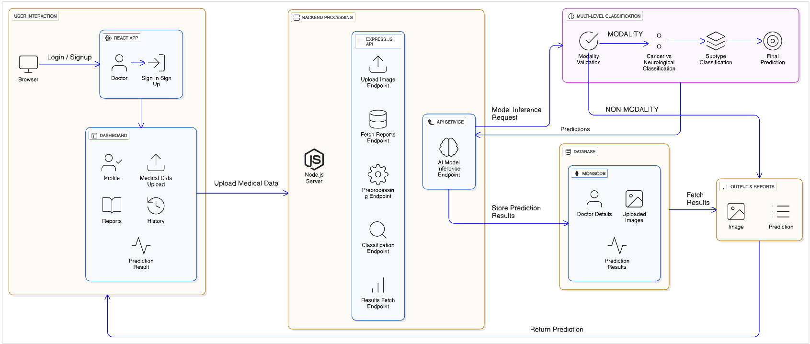
Fig-1: Architecture Diagram
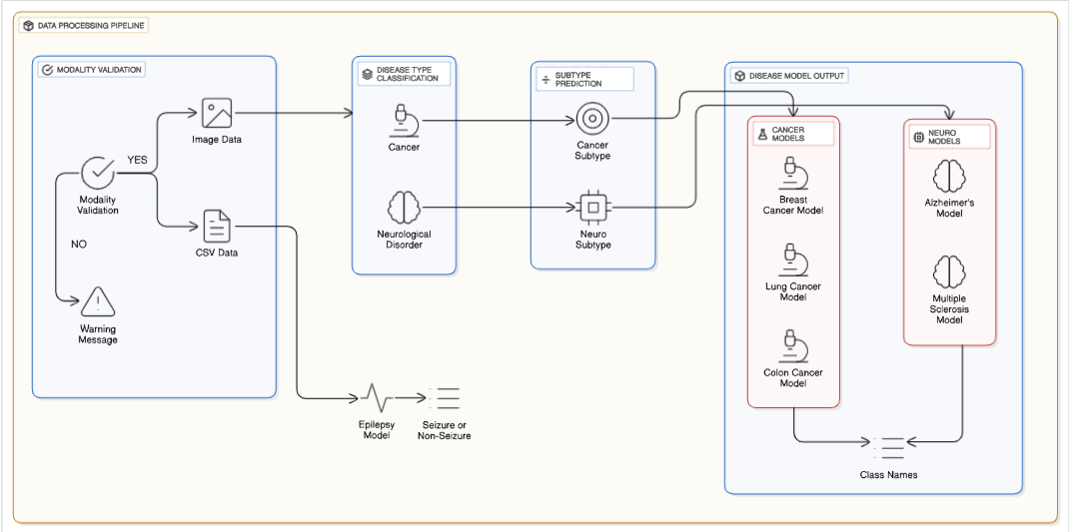
Fig-2: Multi-Level Classification Architecture
4.2 Technology Stack
The technology stack for the Medical AI Assistant for Early Disease Detection combines efficient frontend and backend frameworks, advanced machine learning libraries, and a scalable database system. Each technology is chosen to maximize accuracy, usability, and extensibility for real-world clinical scenarios.

Frontend (User Interface)
- React.js: A robust JavaScript library for building dynamic web UIs. React offers a responsive, interactive dashboard for doctors, supports real-time image uploads, and enables profile and history management through modular components.
- CSS & JavaScript: Used to style and structure web pages for a clean, medical-grade user experience. Custom scripts ensure interactive data visualizations and smooth transitions for prediction results.

Backend (Server-Side)
- Node.js: Handles server-side logic, incoming HTTP requests, API orchestration, and communication between the frontend, AI models, and database.
- Express.js: Simplifies REST API development, enabling secure routing for image uploads, report queries, preprocessing, and model prediction endpoints.
- Python Integration (Flask API): Deep learning models are developed in Python (using PyTorch) and triggered from Node.js exposed through REST APIs using Flask, allowing seamless interaction between server and AI modules.

Database
- MongoDB: A scalable NoSQL database that stores doctor profiles, image upload data, and prediction results in a flexible JSON-like format. The data structure supports fast access and future expansion for new modalities or disease types.

AI and Machine Learning
- PyTorch: Used to build and train custom and transfer learning-based deep learning models for medical image and signal analysis.
- Convolutional Neural Networks (CNNs): Core model for spatial feature extraction in CT, MRI, and histopathology images. Used for modality validation and disease classification.
- LSTM/CNN-LSTM: Specialized in temporal analysis of EEG data to detect seizure patterns and other neurological signals.
- EfficientNet, ResNet-18, ConvNeXt, Multi-level Classification: Pre-trained and custom architectures chosen for high accuracy in cancer and neurological disease subtyping.
Model Name | Type | Source | Purpose | Task Type
Hybrid CNN-LSTM | Neurological | EEG | Epilepsy seizure detection | Time-series
EfficientNet-B3 | Neurological | MRI | Alzheimer’s disease classification | Image Classification
ConvNeXt-Tiny | Neurological | MRI | Multiple Sclerosis lesion detection | Image Classification
EfficientNet | Cancer | CT | Lung cancer detection | Image Classification
ResNet-50 | Cancer | Histopathology | Breast cancer prediction | Image Classification
ResNet-18 | Cancer | CT | Colon cancer detection | Image Classification
Table-1: Models and Purpose

Category | Disease | Model Architecture | Accuracy
Neurological | Epilepsy | Hybrid CNN-LSTM | 98%
Neurological | Alzheimer’s | EfficientNet-B3 | 96.04%
Neurological | Multiple Sclerosis | ConvNeXt Tiny | 95%
Cancer | Lung Cancer | EfficientNet | 96.4%
Cancer | Breast Cancer | ResNet | 98.6%
Cancer | Colon Cancer | ResNet-18 | 99%
Table-2: Models and Accuracies
4.3 Implementation Details
The implementation is divided primarily into the User Dashboard and the backend pipelines that process uploaded data, enabling smooth interaction between users and the diagnostic AI models.

User Dashboard Implementation
- Data Upload:
  - Users can upload images in JPG, JPEG, PNG formats, or EEG signals in CSV format.
- Modality Validation:
  - Upon clicking the "Analyze Image" button, the first classification pipeline verifies whether the uploaded data matches one of the accepted medical modalities (MRI, CT, EEG, or Histopathology).
  - If the data is invalid or unsupported, an error message is displayed and the user is prompted to upload the correct data type.
- Disease Prediction:
  - If modality classification is successful, then we perform detailed disease analysis.
  - The second pipeline predicts the disease type (Cancer or Neurological Disorder), subtype (Breast, Lung, Colon, Alzheimer’s, Epilepsy, Multiple Sclerosis), and final diagnosis category (Benign, Malignant, Normal, Healthy, Diseased).
- Result Display and History:
  - Predictions, including type, subtype, and diagnosis, are stored in MongoDB under the user’s profile.
  - Users can view a history page showing past uploads along with detailed results and timestamps.
  - The dashboard includes appealing visuals such as charts and status indicators to summarize historic results and current analysis.
- Error Handling and Feedback:
  - Users receive real-time error messages for unsupported file types or invalid modalities.
  - Successful analyses display results and explanatory notes where applicable.

Backend and Data Management
- Model Integration:
  - The backend integrates multiple trained models for modality classification and disease prediction, orchestrated through API endpoints callable from the dashboard.
- Data Security:
  - All user data, analysis results, and medical files are securely stored in MongoDB with encryption.
  - Authentication mechanisms ensure data access is restricted to authorized users only.

Visual and UX Features
- The dashboard provides a user-friendly interface with:
  - Intuitive data upload forms with clear guidance.
  - Interactive elements enabling users to initiate analysis steps sequentially.
  - Visual feedback on processing status and report generation which can be downloaded.
  - Historical activity logs visualized with graphs and charts for trend analysis.
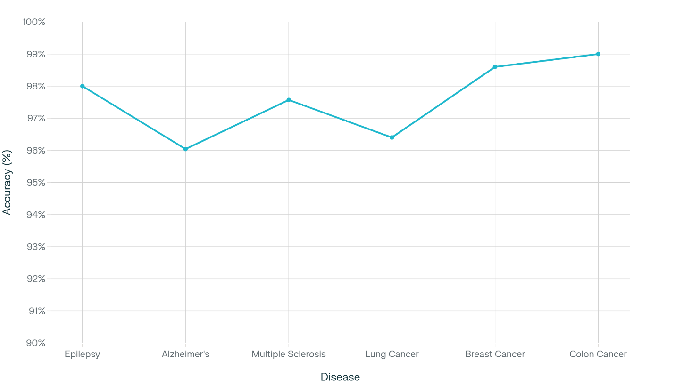
Fig-3: Disease Model Accuracies

CHAPTER-5
RESULTS & DISCUSSIONS

5.1 Output Demonstration
The output of our system for early prediction of cancer and neurological disorders is demonstrated through detailed results generated from sequential pipelines analyzing diverse medical data modalities.
Input Submission:
- Users upload medical data files in JPG, JPEG, PNG (for images), or CSV (for EEG signals).
Modality Classification:
- The system validates whether the uploaded data matches a recognized modality using a specialized classification model.
- If invalid, an error message is displayed to guide the user.
- If valid, the system enables progression to detailed analysis.
Disease Prediction:
- The second pipeline classifies the disease category as cancer or neurological disorder.
- Further sub-classification includes subtypes such as breast, lung, colon cancer, Alzheimer's, epilepsy, or multiple sclerosis.
- Final diagnosis is displayed as benign/malignant/normal or healthy/diseased accordingly.
Results and Visualization:
- Output includes predicted type, subtype, and diagnosis result.
- Results, along with timestamps, are stored in MongoDB and displayed on the user dashboard.
- The dashboard features appealing visual presentations like charts summarizing historical results and current analysis status.
User Interaction:
- Users can view history of uploads and diagnoses with relevant details in a well-organized manner.
- Real-time feedback and error notifications enhance usability.
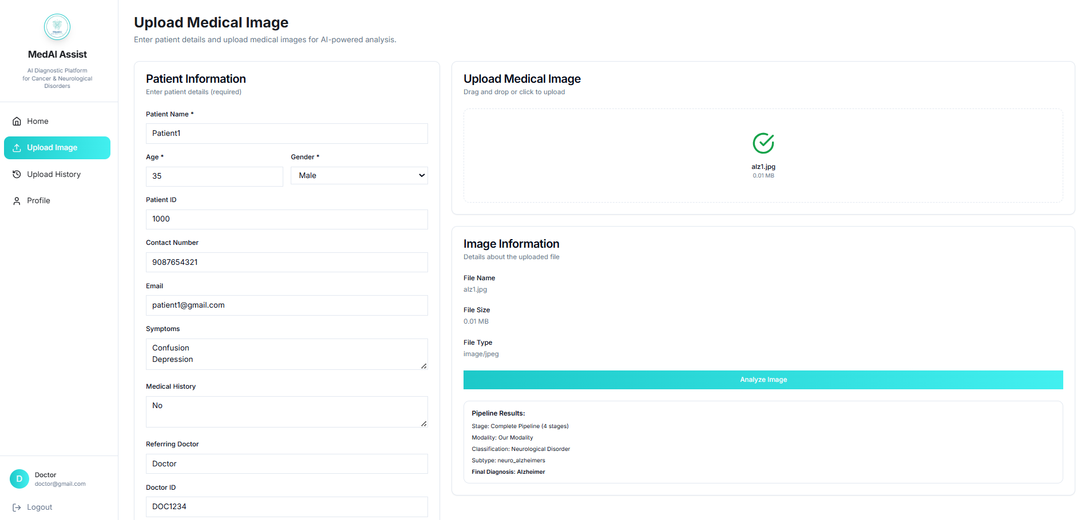
Fig-4: Image Upload Analysis

5.2 Performance Metrics
We evaluate system performance primarily using the following metrics across the pipelines:
Metric | Description
Accuracy | Percentage of total correct predictions made by the system.
Precision | Proportion of true positive predictions among all positive predictions; measures correctness.
Recall | Proportion of true positive predictions among all actual positives; measures completeness.
F1 Score | Harmonic mean of precision and recall; balances false positives and false negatives.
ROC-AUC | Area under the Receiver Operating Characteristic curve; measures tradeoff between sensitivity and specificity.
Table-3: Performance Metrics
- Accuracy
  - Represents the overall proportion of correct predictions made by the model among all cases.
  - Gives a general sense of the model’s correctness across both positive and negative classes.
  - Can be misleading if the dataset is imbalanced, as high accuracy could reflect dominance of one class.
  - Useful as an initial indicator but should be assessed with complementary metrics.
- Precision
  - Measures the fraction of true positive predictions out of all predicted positives.
  - Indicates how often the model’s positive predictions are actually correct.
  - Crucial in medical diagnosis to minimize false positives, which could cause unnecessary interventions.
  - A higher precision shows greater reliability in positive identifications.
- Recall
  - Reflects the model’s ability to find all actual positive cases in the data.
  - Important for minimizing false negatives, reducing missed disease detections.
  - Especially vital in health applications where not detecting a disease can have serious consequences.
  - High recall ensures comprehensive detection of patients with illness.
- F1 Score
  - The harmonic mean of precision and recall, balancing the two metrics into one.
  - Provides a single measure to evaluate model performance when classes are imbalanced.
  - Prevents scenarios where high precision or recall alone could be misleading.
  - Indicates how well the model balances identifying positives correctly without too many errors.
- ROC-AUC
  - Measures how well the model separates classes at various threshold settings.
  - A higher ROC-AUC (closer to 1) means better distinction between positive and negative classes.
  - Provides insight into trade-offs between true positive rate and false positive rate.
  - Useful for assessing overall classification capability beyond a fixed threshold.
Application of Metrics:
- Used for evaluating both modality classification and disease subtype prediction models.
- Metrics ensure the system maintains high reliability in identifying correct modalities and accurate.
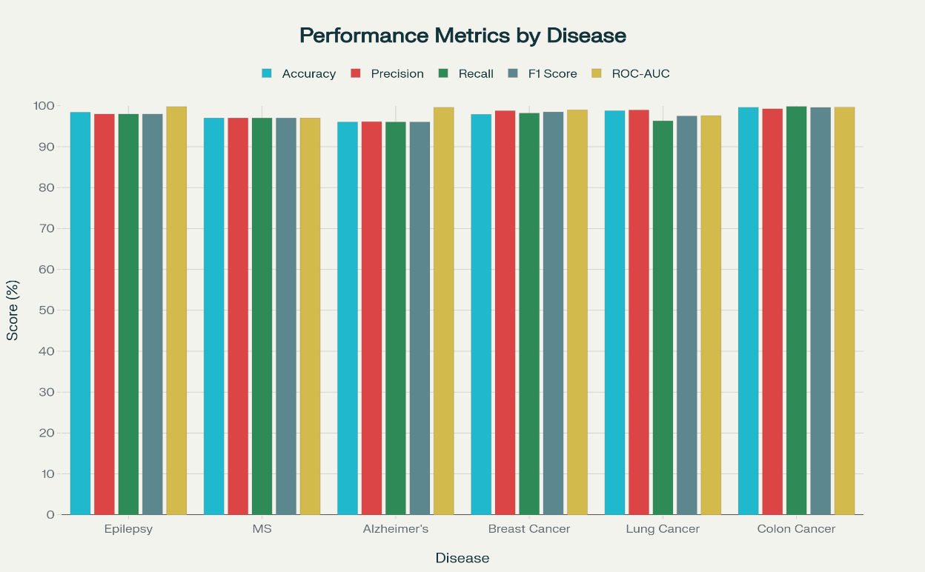
Fig-5: Disease Model Metrics Comparison
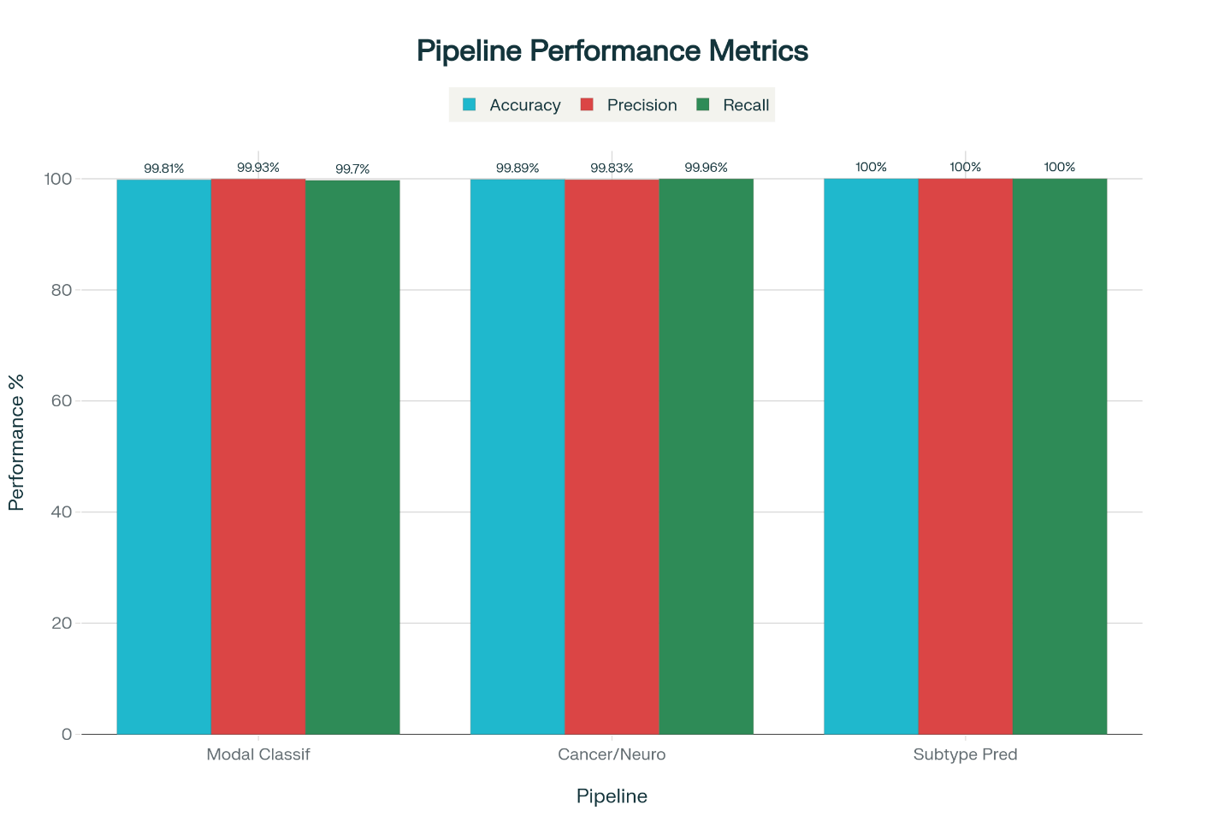
Fig-6: Pipeline Performance Metrics
5.3 Functional Demonstration
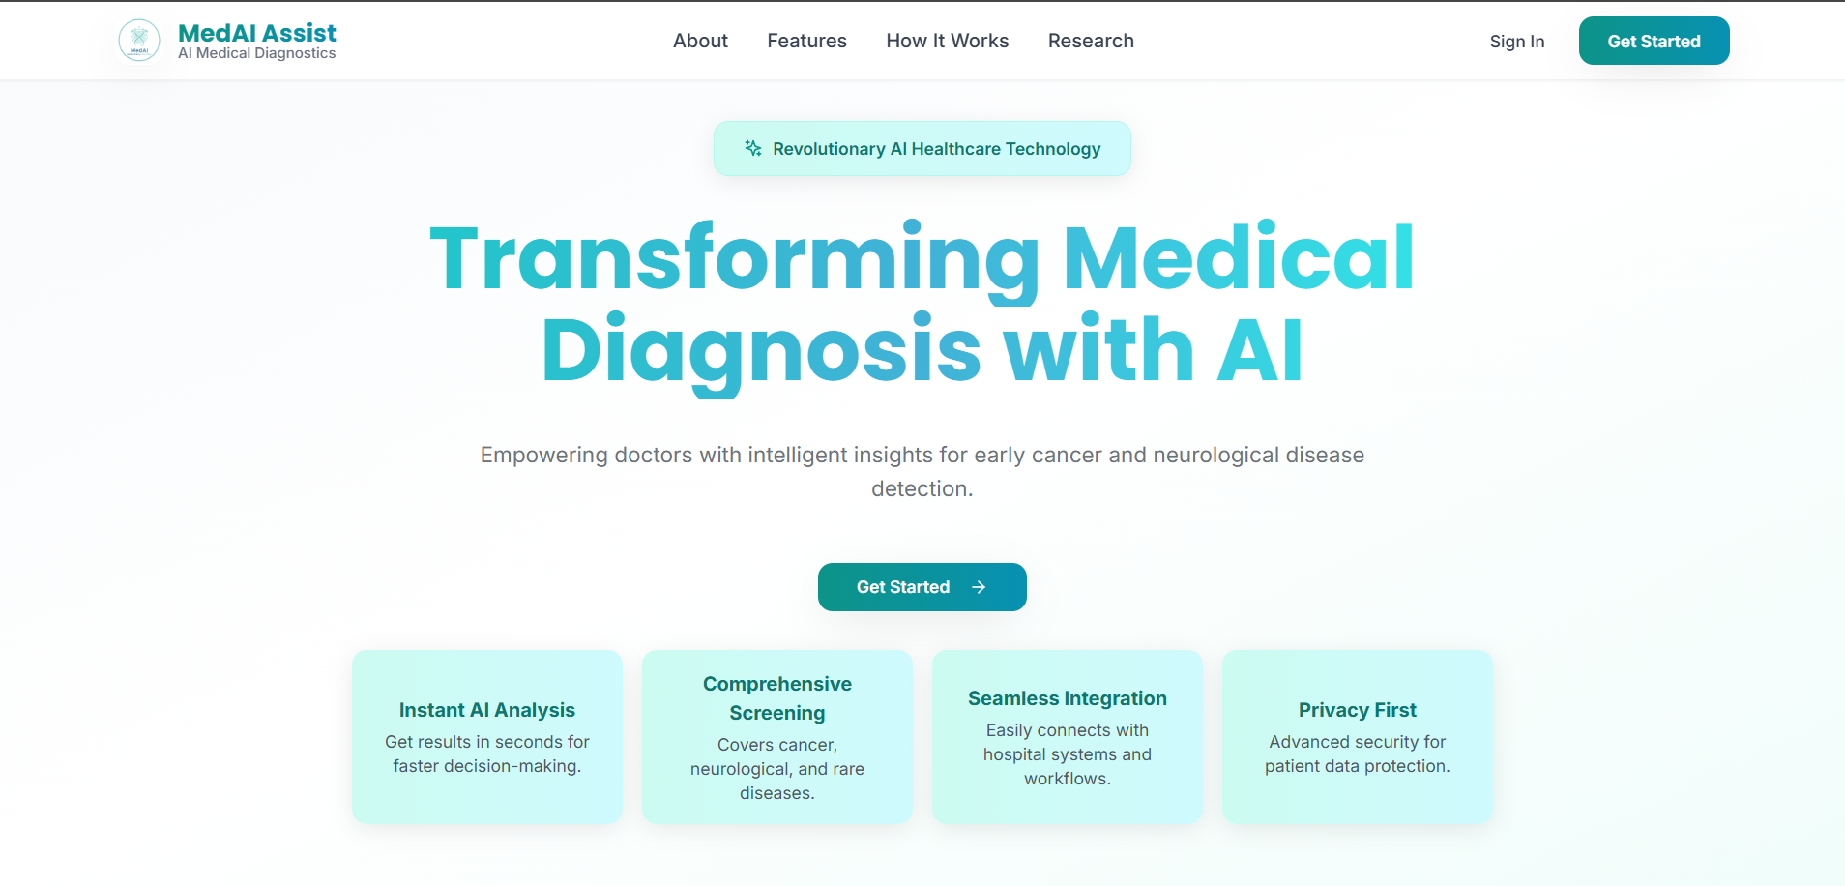
Fig-7.1.1: Landing Page
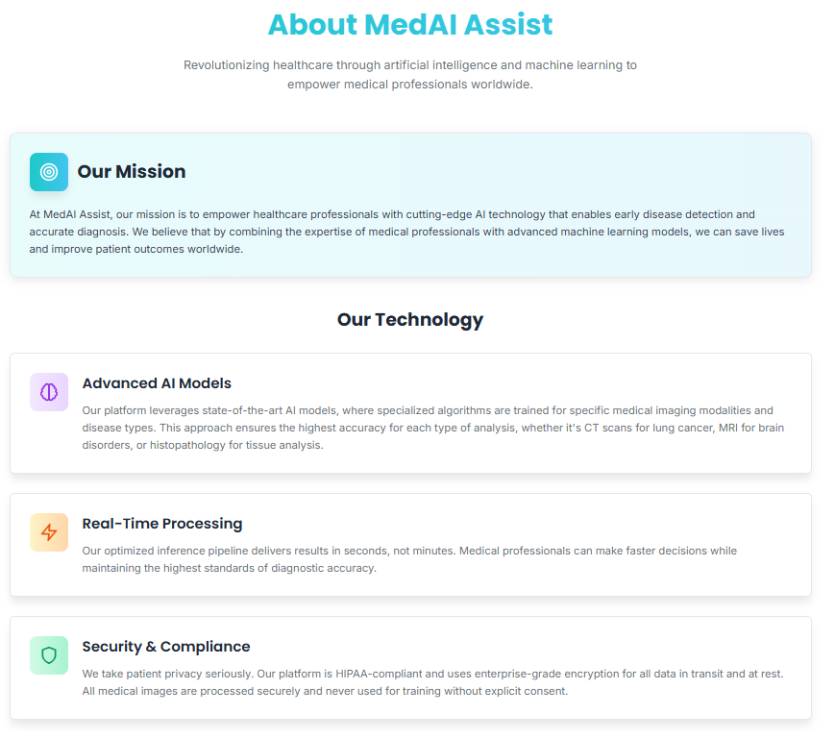
Fig-7.1.2: About Page
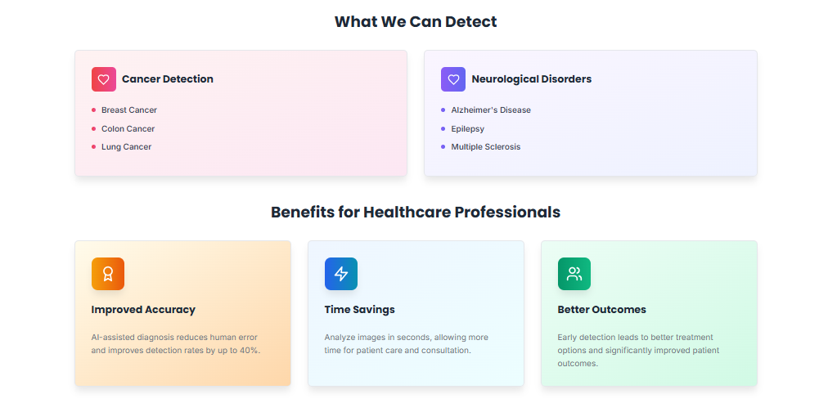
Fig-7.1.3: About Page
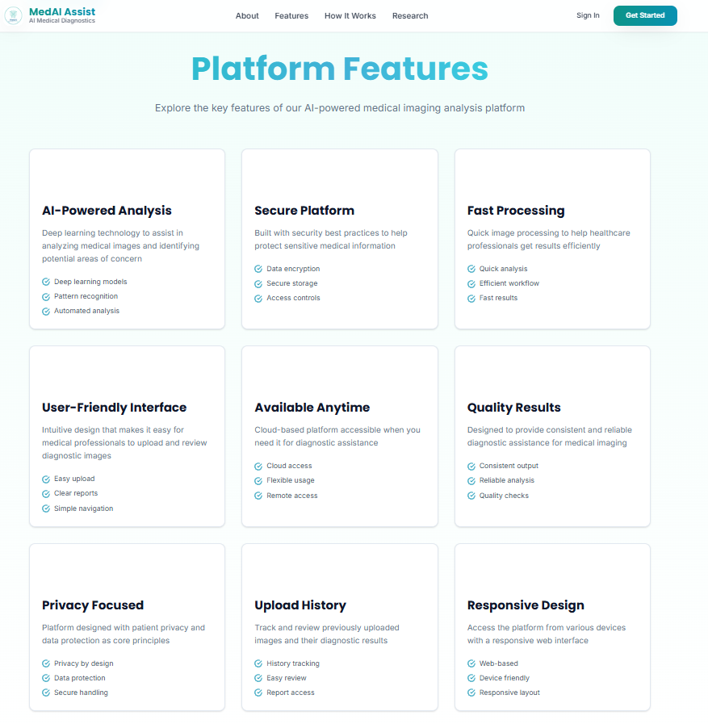
Fig-7.1.4: Features Page
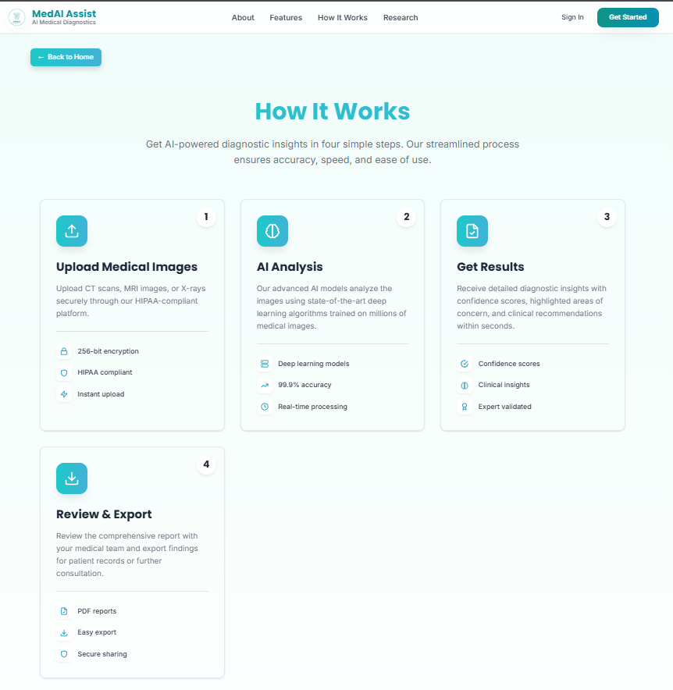
Fig-7.1.5: How It Works Page
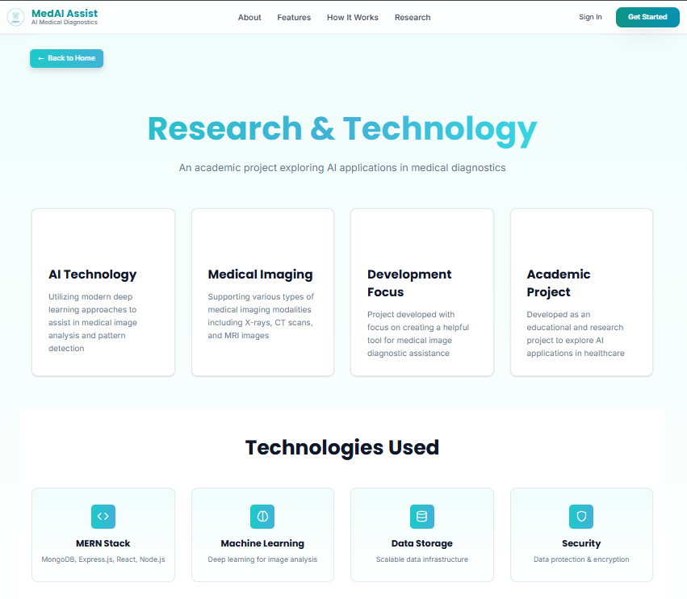
Fig-7.1.6: Research Page
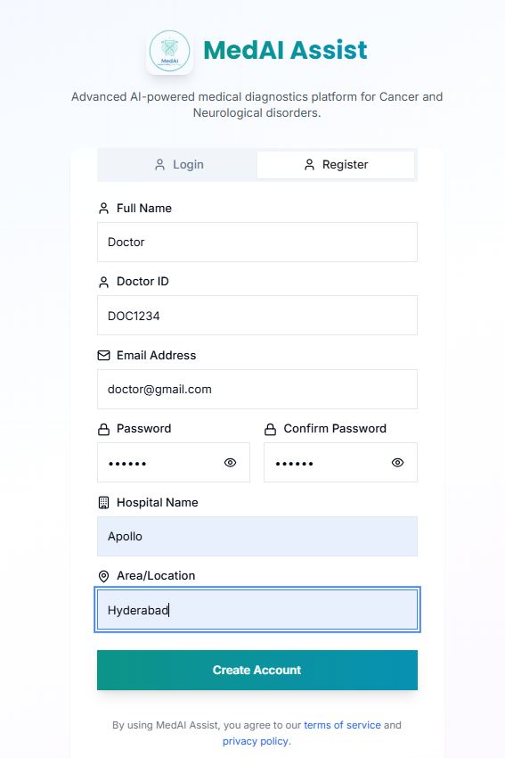
Fig-7.2: User Register
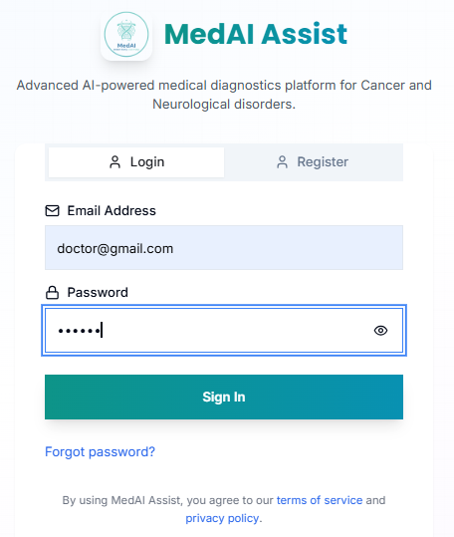
Fig-7.3: User Login
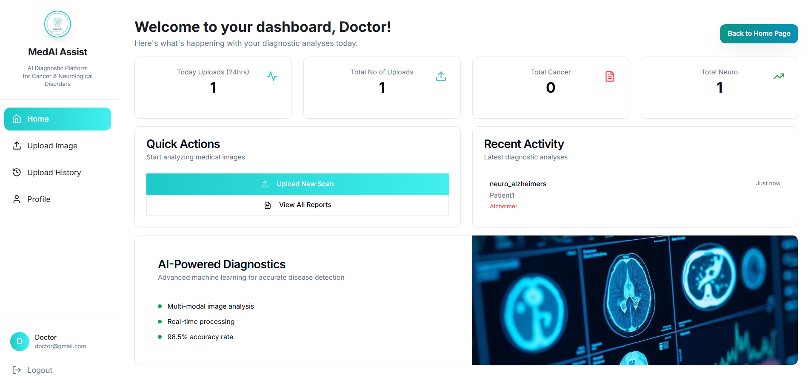
Fig-7.4: User Dashboard
Fig-7.5: Medical Data Analysis
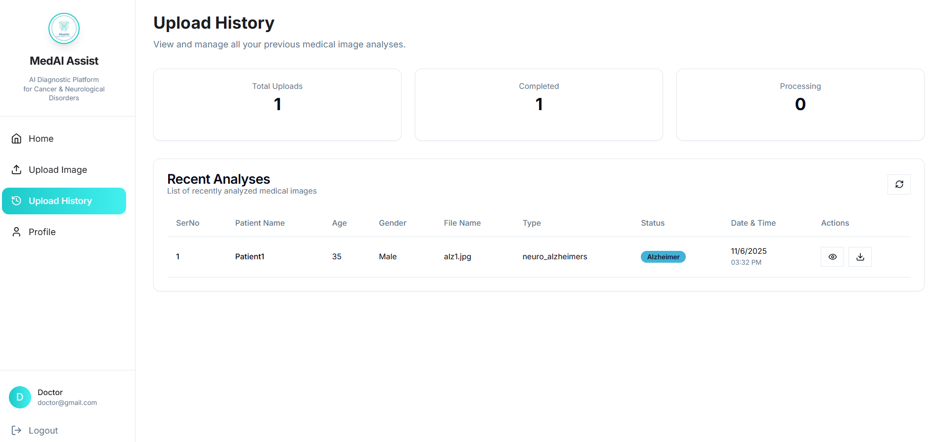
Fig-7.6: Upload History
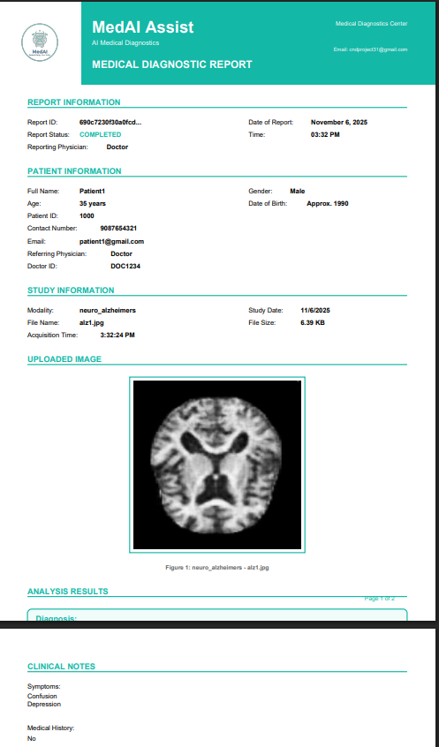
Fig-7.7: Downloaded Report
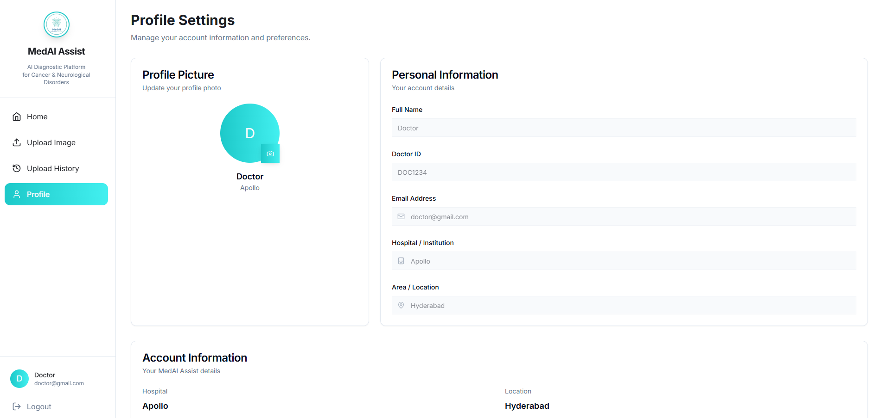
Fig-7.8: Profile
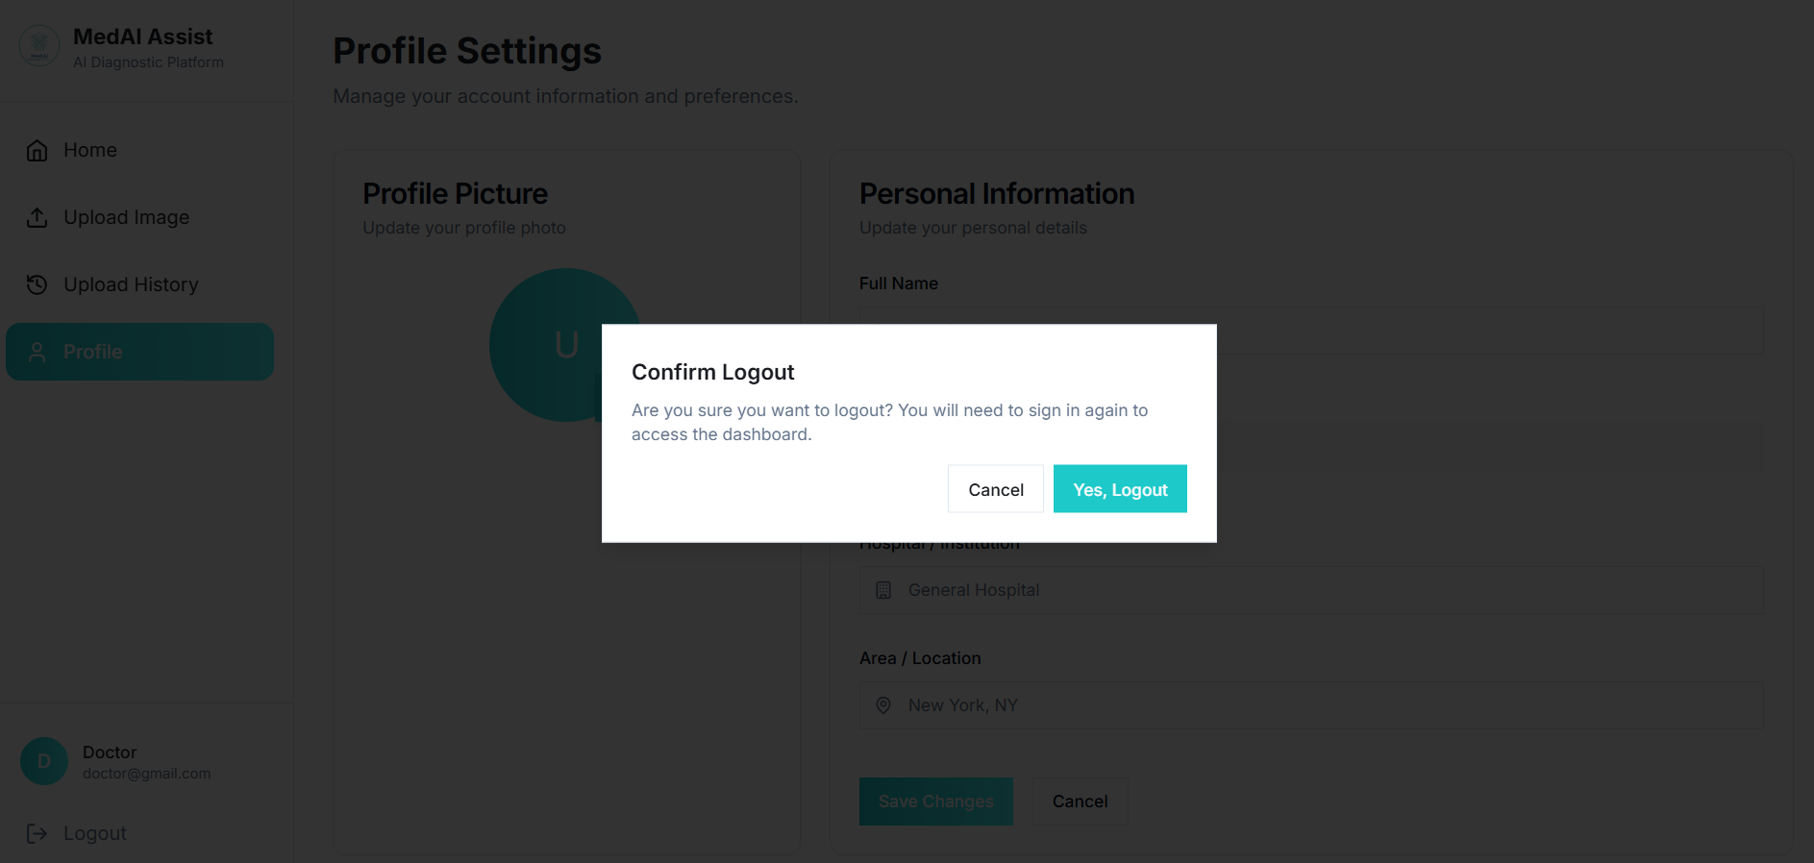
Fig-7.9: Logout

CHAPTER-6
CONCLUSION & FUTURE SCOPE

Conclusion
The developed system presents an effective solution for the early prediction of cancer and neurological disorders by leveraging multimodal medical data, including MRI, CT, EEG, and histopathology. Its dual-pipeline design ensures that only validated modalities undergo in-depth disease classification, enhancing diagnostic precision and reliability. The integration of advanced AI models with a user-friendly dashboard facilitates seamless interaction for users and healthcare professionals, promoting efficient data upload, analysis, and historical tracking. The use of a secure, scalable database ensures robust data management, making the system practical for real-world healthcare settings.
Furthermore, the system demonstrated promising results through key performance metrics such as accuracy, precision, recall, F1 score, and ROC-AUC, indicating strong diagnostic capabilities across disease types and subtypes. The responsive interface and real-time feedback offer an enhanced user experience, supporting early and accurate disease detection critical for timely clinical decision-making.
Overall, this project showcases the potential of combining deep learning and medical imaging analysis into a cohesive platform that aids healthcare providers while maintaining data security and usability. It lays the foundation for future enhancements and broader adoption in the medical diagnostics field.

Future Scope
- Incorporating Mixture of Experts (MOE) models can improve prediction accuracy by dynamically selecting specialized expert sub-models based on data type and disease subtype.
- Federated Learning can be integrated for privacy-preserving, collaborative training across multiple healthcare institutions without sharing sensitive patient data.
- Explainable AI (XAI) techniques should be adopted to increase interpretability and clinician trust by providing clear and transparent rationales behind AI-driven predictions.
- Future extensions can target personalized medicine approaches and real-time patient monitoring for proactive healthcare interventions.
- Ensuring compliance with regulatory standards and ethical AI principles will be crucial for safe and responsible deployment in clinical environments.

CHAPTER-7
REFERENCES
The following resources were used in the development of the Early Disease Detection Using AI: A Deep Learning Approach to Predicting Cancer and Neurological Disorders:
[1] "Application of Deep Learning in Cancer Prognosis Prediction Model" Reviews recent deep learning models for cancer prognosis including data types, model architectures, performance, and challenges in clinical adoption. https://pmc.ncbi.nlm.nih.gov/articles/PMC10503281/
[2] "Enhancing Cancer Stage Prediction through Hybrid Deep Neural Networks" Comparative study presenting hybrid deep neural networks that improve stage prediction accuracy by integrating heterogeneous cancer data.
https://www.frontiersin.org/articles/10.3389/fdata.2024.1359703/full
[3] "PsyneuroNet Architecture for Multi-class Prediction of Neurological Disorders using EEG" Proposes a deep learning architecture for multi-class classification of neurological disorders based on EEG time-series analysis.
https://www.sciencedirect.com/science/article/abs/pii/S1746809424011388
[4] "Revolutionizing Neurology: The Role of Artificial Intelligence" Discusses transformative impact of AI technologies in neurology, focusing on diagnostic accuracy and prediction of neurological disorders.
https://pmc.ncbi.nlm.nih.gov/articles/PMC11224934/
[5] "Machine Learning in Early Diagnosis of Neurological Diseases" Examines machine learning approaches for early detection of neurological disorders, emphasizing improvements in clinical workflows.
https://www.sciencedirect.com/science/article/pii/S3050623925000355
[6] Kaggle Dataset: Epilepsy: https://www.kaggle.com/datasets/harunshimanto/epileptic-seizure-recognition
[7] Kaggle Dataset: Multiple Sclerosis: https://www.kaggle.com/datasets/buraktaci/multiple-sclerosis?select=MS
[8] Kaggle Dataset: Alzheimer’s: https://www.kaggle.com/datasets/lukechugh/best-alzheimer-mri-dataset-99-accuracy
[9] Kaggle Dataset: Lung Cancer:https://www.kaggle.com/datasets/adityamahimkar/iqothnccd-lung-cancer-dataset
[10] Kaggle Dataset: Breast Cancer: https://www.kaggle.com/datasets/ambarish/breakhis
[11] Kaggle Dataset: Colon Cancer: https://www.kaggle.com/datasets/orvile/coloncancerct-2025-abdominal-ct-scans
[12] MongoDB Official Documentation https://www.mongodb.com/docs/
[13] Express.js Official Documentation https://expressjs.com/
[14] React.js Official Documentation https://react.dev/
[15] Node.js Official Documentation https://nodejs.org/en/docs
[16] GitHub Repository https://github.com/AbhinavVarma01/CND-MedAI

