To solve linear programming using R studio, we need to install lpsolve package Install.packages(“lpsolve”)

**PRACTICAL 1**

**GRAPHICAL METHOD USING R PROGRAMMING**

*# R Program*

*#Find a geometrical interpretation and solution as well for the following LP problem #Max z= 3x1 + 5x2*

*#subject to constraints:*

*#x1+2x2<=2000 #x1+x2<=1500 #x2<=600 #x1,x2>=0*

# Load lpSolve require(lpSolve)

## Set the coefficients of the decision variables -> C of objective function C <- c(3,5)

# Create constraint martix B A <- matrix(c(1, 2,

1, 1,

0, 1

), nrow=3, byrow=TRUE)

# Right hand side for the constraints B <- c(2000,1500,600)

# Direction of the constraints constranints_direction <- c("<=", "<=", "<=")

# Create empty example plot plot.new()

plot.window(xlim=c(0,2000), ylim=c(0,2000)) axis(1)

axis(2)

title(main="LPP using Graphical method") title(xlab="X axis")

title(ylab="Y axis") box()

# Draw one line

segments(x0 = 2000, y0 = 0, x1 = 0, y1 = 1000, col = "green") segments(x0 = 1500, y0 = 0, x1 = 0, y1 = 1500, col = "green") segments(x0 = 0, y0 = 0, x1 = 600, y1 = 0, col = "green")

# Find the optimal solution optimum <- lp(direction="max",

objective.in = C, const.mat = A,

const.dir = constranints_direction, const.rhs = B,

all.int = T)

# Print status: 0 = success, 2 = no feasible solution print(optimum$status)

# Display the optimum values for x1,x2 best_sol <- optimum$solution names(best_sol) <- c("x1", "x2") print(best_sol)

# Check the value of objective function at optimal point print(paste("Total cost: ", optimum$objval, sep=""))

OUTPUT:

[Workspace loaded from ~/.RData]

* # Right hand side for the constraints

> B <- c(2000,1500,600)

* # R Program
* # Load lpSolve
* require(lpSolve)

Loading required package: lpSolve

* ## Set the coefficients of the decision variables -> C
* C <- c(3,5)
* # Create constraint martix B
* A <- matrix(c(1, 2,

+ 1, 1,

+ 0, 1

+ ), nrow=3, byrow=TRUE)

>

* # Right hand side for the constraints
* B <- c(2000,1500,600)

>

* # Direction of the constraints
* constranints_direction <- c("<=", "<=", "<=")

>

>

* # Create empty example plot
* #plot(2000, 2000, col = "white", xlab = "", ylab = "")
* plot.new()
* plot.window(xlim=c(0,2000), ylim=c(0,2000))
* axis(1)
* axis(2)
* title(main="LPP using Graphical method")
* title(xlab="X axis")
* title(ylab="Y axis")
* box()
* # Draw one line
* segments(x0 = 2000, y0 = 0, x1 = 0, y1 = 1000, col = "green")
* segments(x0 = 1500, y0 = 0, x1 = 0, y1 = 1500, col = "green")
* segments(x0 = 0, y0 = 0, x1 = 600, y1 = 0, col = "green")

>

>

>

* # Find the optimal solution
* optimum <- lp(direction="max",

+ objective.in = C,

+ const.mat = A,

+ const.dir = constranints_direction,

+ const.rhs = B,

+ all.int = T)

* # Print status: 0 = success, 2 = no feasible solution
* print(optimum$status)

[1] 0

* # Display the optimum values for x1,x2
* best_sol <- optimum$solution
* names(best_sol) <- c("x1", "x2")
* print(best_sol) x1 x2

1000 500

>

* # Check the value of objective function at optimal point
* print(paste("Total cost: ", optimum$objval, sep=""))

[1] "Total cost: 5500"

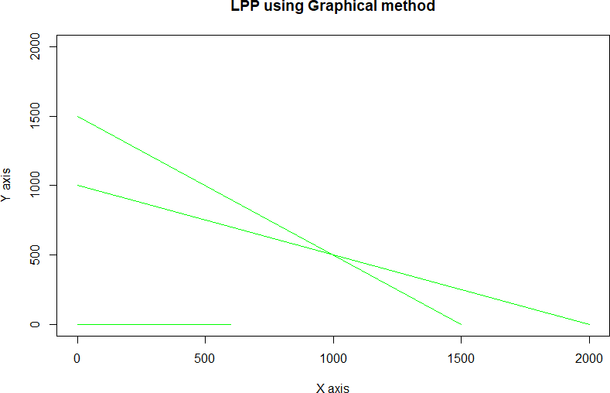

# PRACTICAL 2

**Simplex Method with 2 variables using Python**

from scipy.optimize import linprog #Max z=3x1+2x2

#subject to #x1 + x2 <=4 #x1 - x2 <=2 #x1,x2>=0 obj = [-3, -2]

lhs_ineq = [[ 1, 1], # Red constraint left side

... [1, -1]] # Blue constraint left side

rhs_ineq = [4, # Red constraint right side

... 2] # Blue constraint right side

bnd = [(0, float("inf")), # Bounds of x

... (0, float("inf"))] # Bounds of y

>>> opt = linprog(c=obj, A_ub=lhs_ineq, b_ub=rhs_ineq,

... bounds=bnd,method="revised simplex")

>>> opt

opt.fun

opt.success

opt.x

”/ ju pyter simplex 1with2variables Last crerkpr I: a day ago (unsaved changes) 



Sonve following linear programming problem with two variables using simplex method.





x1.x2>= 0



fun: -11.?



-11.?



# PRACTICAL 3

**Simplex Method with 3 variables using Python**

from scipy.optimize import linprog #Min z= x1-3x2+2x3

#subject to #3x1-x2+3x3<=7 #-2x1+4x2<=12

#-4x1+3x2+8x3<=10 #x1,x2,x3>=0

obj = [1, -3, 2]

lhs_ineq = [[ 3, -1, 3], # Red constraint left side

... [-2, 4, 0], # Blue constraint left side

... [ -4, 3, 8]] # Yellow constraint left side

rhs_ineq = [7, # Red constraint right side

... 12, # Blue constraint right side

... 10] # Yellow constraint right side

bnd = [(0, float("inf")), # Bounds of x

... (0, float("inf")),

... (0, float("inf"))] # Bounds of y

>>> opt = linprog(c=obj, A_ub=lhs_ineq, b_ub=rhs_ineq,

... bounds=bnd,

... method="revised simplex")

>>> opt

jupyter simplexWith3Variables rash checLpoirt: 2 hours ago (autosaved) 

File Edit View Insert Cell Kernel Widget s Help 

In #] from scipy.optimzze import linprog





In {33]: 14 bnd = l 10. floatl"ini'}?, Bounds oi i



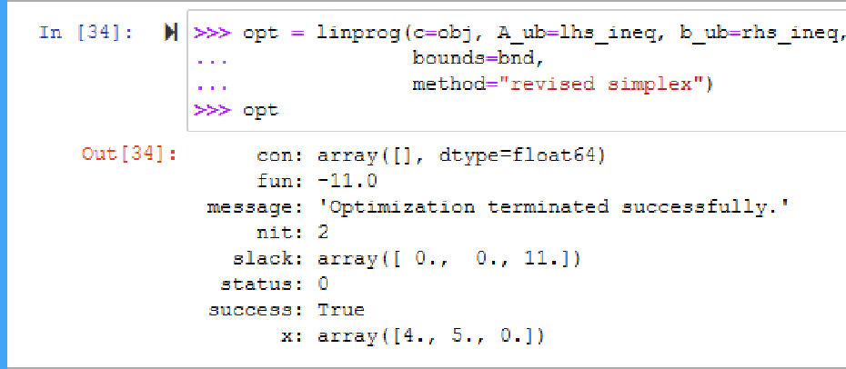

# PRACTICAL 4

**Simplex Method with Equality Constraints Using Python**

### from scipy.optimize import linprog #Max z=x+2y

#subject to #2x+y<=20

#-4x+5y<=10 #-x+2y>=-2

#-x+5y=15 #x,y>=0

obj = [-1, -2]

lhs_ineq = [[ 2, 1], # Red constraint left side

... [-4, 5], # Blue constraint left side

... [ 1, -2]] # Yellow constraint left side

rhs_ineq = [20, # Red constraint right side

... 10, # Blue constraint right side

... 2] # Yellow constraint right side

lhs_eq = [[-1, 5]] # Green constraint left side rhs_eq = [15] # Green constraint right side

bnd = [(0, float("inf")), # Bounds of x

... (0, float("inf"))] # Bounds of y

opt = linprog(c=obj, A_ub=lhs_ineq, b_ub=rhs_ineq,

... A_eq=lhs_eq, b_eq=rhs_eq, bounds=bnd,

... method="revised simplex")

Opt

**## method =”revised simplex” solves linear programming problem using two phase simplex method.**

:

con: array([0.])

fun: -16.818181818181817

message: 'Optimization terminated successfully.' nit: 3

slack: array([ 0. , 18.18181818, 3.36363636])

status: 0 success: True

x: array([7.72727273, 4.54545455])

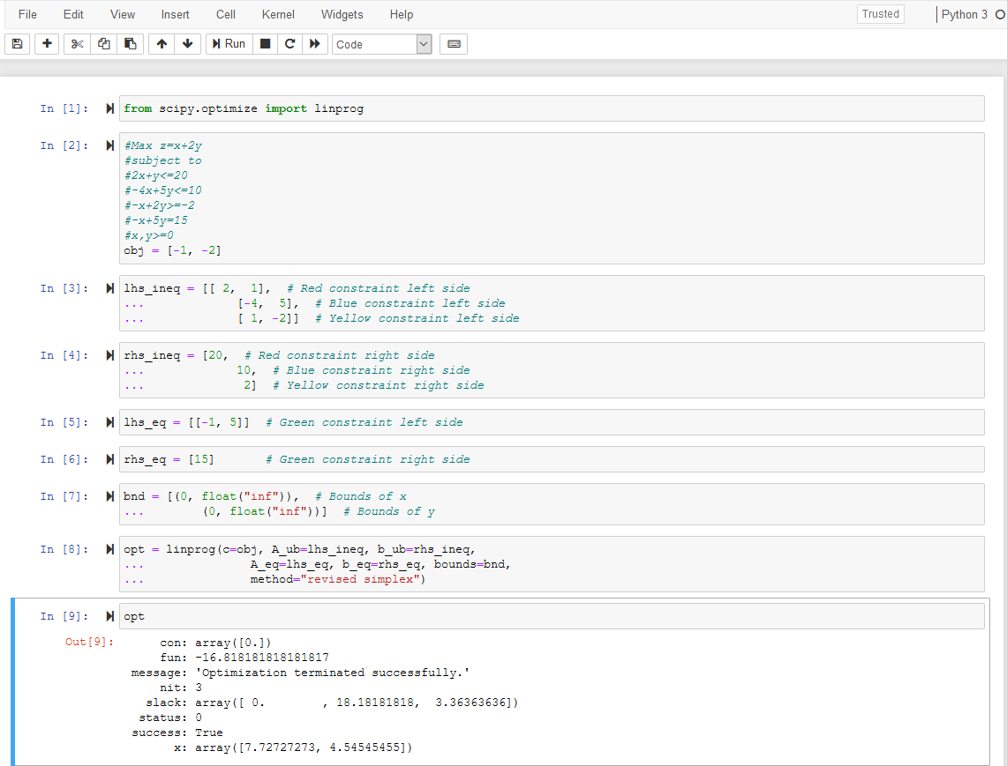

# PRACTICAL 5

**BigM Simplex Method using Python**

**Solve Following linear programming problem using Big M Simplex method.**

Min z= 4x1 + x2 subjected to:

3x1 + 4x2 >= 20 x1 + 5x2 >= 15 x1, x2 >= 0

from scipy.optimize import linprog obj = [4, 1]

lhs_ineq = [[ -3, -4], # left side of first constraint

... [-1, -5]] # right side of first constraint

rhs_ineq = [-20, # right side of first constraint

... -15] # right side of Second constraint

bnd = [(0, float("inf")), # Bounds of x1

... (0, float("inf"))] # Bounds of x2

>>> opt = linprog(c=obj, A_ub=lhs_ineq, b_ub=rhs_ineq,

... bounds=bnd,method="interior-point")

>>> opt

## ## method =” interior-point” solves linear programming problem using default simplex method.

jupyter BigM Simplex Method net c «ckgoir‹. 37 miv Us ago {a t»saea 

File Edit Vie'a/ Insert Cell Kernel Widgets Help

### Solve Following linear programming problem using Big M Simplex method.

Min z= + x2







zn W ob, [4, il

In @ lRs ioeq [[ -3, -4], A iszb xzñs sz zirst csnstraint

... [-1, -3]] t rig2t sids sz zirs csnstrzint In {44]: #| rhs_ioeq = [-20, right site o5 zirst csnstraint

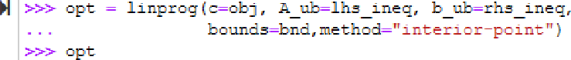In 145]: #1 bod [CD, floatC’ioi’}T, # Bo«n1 s£ xI

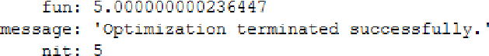

In

Cut[4G]:

con: array([|, dtype=float64)

slack: array([1.842774B1e-10, 1.0O000000e+01|)

status: 0



# PRACTICAL 6

**RESOURCE ALLOCATION PROBLEM BY SIMPLEX METHOD**

**Use SciPy to solve the resource allocation problem stated as follows:**

Max z= 20x1 + 12x2 +40x3 + 25x4 (profit) subjected to:

x1 + x2 + x3 + x4 <= 50 (manpower)

3x1 + 2x2 + x3 <= 100 -------------(material A)

x2 + 2x3 <= 90 -------------(material B)

x1, x2, x3, x4 >= 0

**from scipy.optimize import linprog**

**obj = [-20, -12, -40, -25] #profit objective function**

**lhs_ineq = [[1, 1, 1, 1], # Manpower**

**... [3, 2, 1, 0], # Material A**

**... [0, 1, 2, 3]] # Material B**

**rhs_ineq = [ 50, # Manpower**

**... 100, # Material A**

**... 90] # Material B**

**opt = linprog(c=obj, A_ub=lhs_ineq, b_ub=rhs_ineq,**

**... method="revised simplex")**

**Opt**

File Edit View lnseñ Cell Widgets Help 



### Use SciPy to solve the resource allocation problem stated as follows:

Hax z= 20x1 + 12x2 +40x3 + 25x4 (proft)



xl + n2 x3 x4 ‹= S0 lmanponer)







con: arrays[], dtype=floatG4)



slack: arrays[ 0., 40., 0.])



The resuit tells you that the maximal profit is 1900 and corresponds to x = B and e = 4S. It’s not profitable to

The third product brings the largest profit per unit, so the factory will produce it the most.

Ihe first slack is 0, which means that the values of the left and right sides of the manpower **{first)**

are the same. The factory produces 50 units per day, and that's its full capacity.

Ihe second slack is 40 because the factory consumes 60 units of raw material A {1B units for the first product plus 45 for the third) out of a potential 100 units.

The third slack is 0, which means that the factory consumes all 90 units of the raw material B. Ihis entire amount

indicating that the optimization problem was successfully solved with the

# PRACTICAL 7

**INFEASIBILITY IN SIMPLEX METHOD**

**# Solve following linear programming problem using Simplex method**

**WHILE SOLVING LINEAR PROGRAMMING PROBLEM USING SIMPLEX METHOD, IF ONE OR MORE ARTIFICIAL VARIABLES REMAIN IN THE BASIS AT POSITIVE LEVEL AT THE END OF PHASE 1 COMPUTATION , THE PROBLEM HAS NO FEASIBLE SOLUTION( INFEASIBLE SOLUTION).**

**Example:**

**Max z= 200x - 300y subject to 2x+3y>=1200 x+y<=400 2x+3/2y>=900**

**x,y>=0**

**from scipy.optimize import linprog obj = [-200, 300]**

**lhs_ineq = [[ -2, -3], # Red constraint left side**

**... [1, 1], # Blue constraint left side**

**... [ -2, -1.5]] # Yellow constraint left side**

**rhs_ineq = [-1200, # Red constraint right side**

**... 400, # Blue constraint right side**

**... -900] # Yellow constraint right side**

**bnd = [(0, float("inf")), # Bounds of x**

**... (0, float("inf"))] # Bounds of y**

**opt = linprog(c=obj, A_ub=lhs_ineq, b_ub=rhs_ineq,**

**... bounds=bnd,**

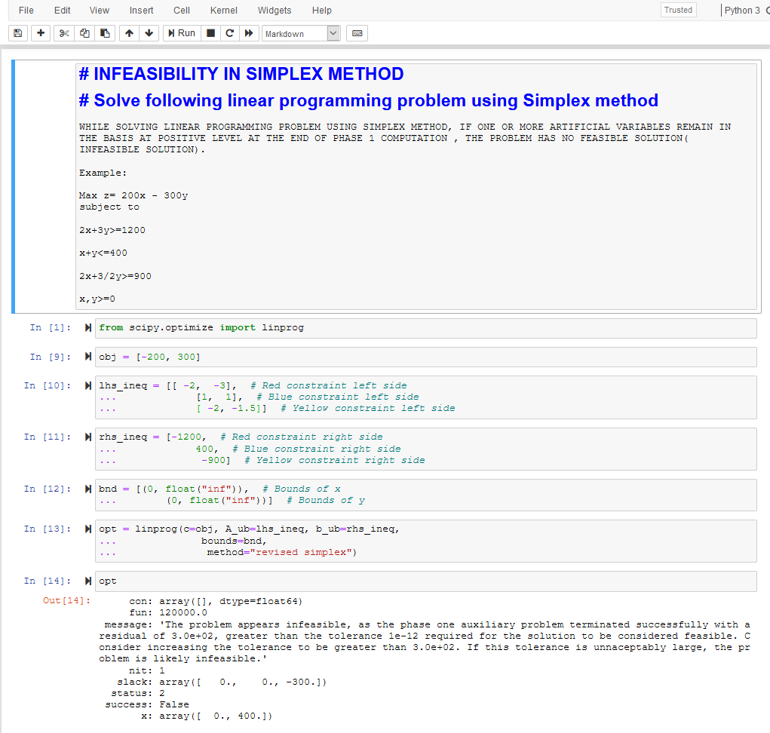**... method="revised simplex") opt**

**PRACTICAL 8 DUAL SIMPLEX METHOD**

##SOLVE FOLLOWING LINEAR PROGRAMMING PROBLEM USING DUAL SIMPLEX METHOD USING R PROGRAMMING

# Max z=40x1+50x2 #subject to

#2x1 + 3x2 <= 3 #8x1 + 4x2 <= 5 # x1, x2>=0

# Import lpSolve package library(lpSolve)

# Set coefficients of the objective function f.obj <- c(40, 50)

# Set matrix corresponding to coefficients of constraints by rows

# Do not consider the non-negative constraint; it is automatically assumed f.con <- matrix(c(2, 3,

8, 4), nrow = 2, byrow = TRUE)

# Set unequality signs f.dir <- c("<=",

"<=")

# Set right hand side coefficients f.rhs <- c(3,

5)

# Final value (z)

lp("max", f.obj, f.con, f.dir, f.rhs)

# Variables final values

lp("max", f.obj, f.con, f.dir, f.rhs)$solution

# Sensitivities

lp("max", f.obj, f.con, f.dir, f.rhs, compute.sens=TRUE)$sens.coef.from lp("max", f.obj, f.con, f.dir, f.rhs, compute.sens=TRUE)$sens.coef.to

# Dual Values (first dual of the constraints and then dual of the variables) # Duals of the constraints and variables are mixed

lp("max", f.obj, f.con, f.dir, f.rhs, compute.sens=TRUE)$duals

# Duals lower and upper limits

lp("max", f.obj, f.con, f.dir, f.rhs, compute.sens=TRUE)$duals.from lp("max", f.obj, f.con, f.dir, f.rhs, compute.sens=TRUE)$duals.to

**OUTPUT:**

##SOLVE FOLLOWING LINEAR PROGRAMMING PROBLEM USING DUAL SIMPLEX METHOD USING R PROGRAMM

* # Max z=40x1+50x2
* #subject to
* #2x1 + 3x2 <= 3
* #8x1 + 4x2 <= 5

> # x1, x2>=0

>

>

* # Import lpSolve package
* library(lpSolve)

>

* # Set coefficients of the objective function
* f.obj <- c(40, 50)

>

* # Set matrix corresponding to coefficients of constraints by rows
* # Do not consider the non-negative constraint; it is automatically assumed
* f.con <- matrix(c(2, 3,

+ 8, 4), nrow = 2, byrow = TRUE)

>

* # Set unequality signs
* f.dir <- c("<=",

+ "<=")

>

* # Set right hand side coefficients
* f.rhs <- c(3,

+ 5)

>

* # Final value (z)
* lp("max", f.obj, f.con, f.dir, f.rhs) Success: the objective function is 51.25

>

* # Variables final values
* lp("max", f.obj, f.con, f.dir, f.rhs)$solution [1] 0.1875 0.8750

>

* # Sensitivities
* lp("max", f.obj, f.con, f.dir, f.rhs, compute.sens=TRUE)$sens.coef.from [1] 33.33333 20.00000
* lp("max", f.obj, f.con, f.dir, f.rhs, compute.sens=TRUE)$sens.coef.to [1] 100 60

>

* # Dual Values (first dual of the constraints and then dual of the variables)
* # Duals of the constraints and variables are mixed
* lp("max", f.obj, f.con, f.dir, f.rhs, compute.sens=TRUE)$duals [1] 15.00 1.25 0.00 0.00

>

* # Duals lower and upper limits
* lp("max", f.obj, f.con, f.dir, f.rhs, compute.sens=TRUE)$duals.from [1] 1.25e+00 4.00e+00 -1.00e+30 -1.00e+30
* lp("max", f.obj, f.con, f.dir, f.rhs, compute.sens=TRUE)$duals.to [1] 3.75e+00 1.20e+01 1.00e+30 1.00e+30

>

**PRACTICAL 9 TRANSPORTATION PROBLEM**

##sOLVE FOLLOWING TRANSPORTATION PROBLEM IN WHICH CELL ENTRIES REPRESENT UNIT COSTS USING R PROGRAMMING.

# "Customer 1", "Customer 2", "Customer 3", "Customer 4" SUPPLY

|  |  |  |  |  |  |
| --- | --- | --- | --- | --- | --- |
| #sUPPLIER 1 | 10 | 2 | 20 | 11 | 15 |
| #sUPPLIER 1 | 12 | 7 | 9 | 20 | 25 |
| #sUPPLIER 1 | 4 | 14 | 16 | 18 | 10 |

#DEMAND 5 15 15 15

# Import lpSolve package library(lpSolve)

# Set transportation costs matrix costs <- matrix(c(10, 2, 20, 11,

12, 7, 9, 20,

4, 14 , 16, 18), nrow = 3, byrow = TRUE)

# Set customers and suppliers' names

colnames(costs) <- c("Customer 1", "Customer 2", "Customer 3", "Customer 4")

rownames(costs) <- c("Supplier 1", "Supplier 2", "Supplier 3")

# Set unequality/equality signs for suppliers row.signs <- rep("<=", 3)

# Set right hand side coefficients for suppliers row.rhs <- c(15, 25, 10)

# Set unequality/equality signs for customers col.signs <- rep(">=", 4)

# Set right hand side coefficients for customers col.rhs <- c(5, 15, 15, 15)

# Final value (z)

TotalCost <- lp.transport(costs, "min", row.signs, row.rhs, col.signs, col.rhs)

# Variables final values

lp.transport(costs, "min", row.signs, row.rhs, col.signs, col.rhs)$solution print(TotalCost)

**OUTPUT:**

* ##sOLVE FOLLOWING TRANSPORTATION PROBLEM IN WHICH CELL ENTRIES REPRESENT UNIT COSTS U

>

* # "Customer 1", "Customer 2", "Customer 3", "Customer 4" SUPPLY

|  |  |  |  |  |  |
| --- | --- | --- | --- | --- | --- |
| * #sUPPLIER 1 | 10 | 2 | 20 | 11 | 15 |
| * #sUPPLIER 1 | 12 | 7 | 9 | 20 | 25 |
| * #sUPPLIER 1 | 4 | 14 | 16 | 18 | 10 |
| * #DEMAND | 5 | 15 | 15 | 15 |  |

>

* # Import lpSolve package
* library(lpSolve)

>

* # Set transportation costs matrix
* costs <- matrix(c(10, 2, 20, 11,

+ 12, 7, 9, 20,

+ 4, 14 , 16, 18), nrow = 3, byrow = TRUE)

>

* # Set customers and suppliers' names
* colnames(costs) <- c("Customer 1", "Customer 2", "Customer 3", "Customer 4")
* rownames(costs) <- c("Supplier 1", "Supplier 2", "Supplier 3")

>

* # Set unequality/equality signs for suppliers
* row.signs <- rep("<=", 3)

>

* # Set right hand side coefficients for suppliers
* row.rhs <- c(15, 25, 10)

>

* # Set unequality/equality signs for customers
* col.signs <- rep(">=", 4)

>

* # Set right hand side coefficients for customers
* col.rhs <- c(5, 15, 15, 15)

>

* # Final value (z)
* TotalCost <- lp.transport(costs, "min", row.signs, row.rhs, col.signs, col.rhs)

>

>

* # Variables final values
* lp.transport(costs, "min", row.signs, row.rhs, col.signs, col.rhs)$solution [,1] [,2] [,3] [,4]

[1,] 0 5 0 10

[2,] 0 10 15 0

[3,] 5 0 0 5

>

* print(TotalCost)

Success: the objective function is 435

>

**PRACTICAL 10 ASSIGNMENT PROBLEM**

**#SOLVE FOLLOWING ASSIGNMENT PROBLEM REPRESENTED IN FOLLOWING MATRIX USING R PROGRAMMING**

**# Assignment Problem**

|  |  |  |  |
| --- | --- | --- | --- |
| **#** | **JOB1** | **JOB2** | **JOB3** |
| **#W1** | **15** | **10** | **9** |
| **#W2** | **9** | **15** | **10** |
| **#W3** | **10** | **12** | **8** |

**# Import lpSolve package library(lpSolve)**

**# Set assignment costs matrix costs <- matrix(c(15, 10, 9,**

**9, 15, 10,**

**10, 12 ,8), nrow = 3, byrow = TRUE)**

**# Print assignment costs matrix costs**

**# Final value (z) lp.assign(costs)**

**# Variables final values lp.assign(costs)$solution**

**OUTPUT:**

* #SOLVE FOLLOWING ASSIGNMENT PROBLEM REPRESENTED IN FOLLOWING MATRIX USING R PROGRAMMI
* # Assignment Problem
* # JOB1 JOB2 JOB3

>

|  |  |  |  |
| --- | --- | --- | --- |
| * #W1 | 15 | 10 | 9 |
| * #W2 | 9 | 15 | 10 |
| * #W3 | 10 | 12 | 8 |

* # Import lpSolve package
* library(lpSolve)

>

* # Set assignment costs matrix
* costs <- matrix(c(15, 10, 9,

+ 9, 15, 10,

+ 10, 12 ,8), nrow = 3, byrow = TRUE)

>

* # Print assignment costs matrix
* costs

|  |  |  |
| --- | --- | --- |
|  | [,1] | [,2] [,3] |
| [1,] | 15 | 10 9 |
| [2,] | 9 | 15 10 |
| [3,] | 10 | 12 8 |
| > |  |  |

* # Final value (z)
* lp.assign(costs)

Success: the objective function is 27

>

* # Variables final values
* lp.assign(costs)$solution [,1] [,2] [,3]

[1,] 0 1 0

[2,] 1 0 0

[3,] 0 0 1

>