AHB to APB Bridge – Project Report
Name: Rushikesh Prashant Dandgawhal
Course: VLSI Design Internship
Batch: DI 64
Learner ID: 7406717041
Emai: rushikeshdandgawhal@gmail.com

1. Architecture
The AHB to APB bridge connects high-speed AHB bus to low-power APB peripherals. It converts pipelined AHB transactions into simple APB transfers using control logic and FSM.
Overview
The bridge translates AHB burst-capable, pipelined transfers into APB's simple, two-phase (SETUP → ENABLE) non-pipelined protocol. Since APB is slower and has no pipelining, the bridge must sample, hold, and sequence AHB transactions carefully.

Module Decomposition
Module 1 — AHB Slave Interface (ahb_slave_if)
This module is the AHB-facing front-end. Its sole job is to watch the AHB bus, qualify incoming transfers, and latch address/control/data into stable intermediate registers for the APB controller to consume.
Inputs received from AHB bus:
Signal | Role
HCLK, HRESETn | Clock and active-low reset
HADDR[31:0] | Address presented in address phase
HWRITE | Direction: 1 = write, 0 = read
HTRANS[1:0] | Transfer type — only NONSEQ (2'b10) and SEQ (2'b11) are valid
HREADYin | AHB bus ready — qualifies when a new address phase is valid
HWDATA[31:0] | Write data, arrives one cycle after address phase

Intermediate signals produced:
Signal | Role
valid | Asserted when HTRANS is NONSEQ or SEQ and HREADYin is high — qualifies a real transfer
Haddr1 | First pipeline stage latch of HADDR — holds address captured at end of address phase
Haddr2 | Second pipeline stage latch — forwarded to APB when the FSM is ready to launch
Hwdata1 | Latch of HWDATA one cycle after address (aligns write data with address)
Hwdata2 | Second stage hold of write data — stable throughout APB SETUP+ENABLE phases
Hwritereg | Latched copy of HWRITE, pipelined alongside address so direction is consistent when APB launches
tempselx | Decoded select signal — a combinational decode of the latched address to identify which APB slave is targeted

Why two pipeline stages? AHB is pipelined: the address of transaction N+1 arrives while data of transaction N is still being driven. The two-stage latching (Haddr1 → Haddr2, Hwdata1 → Hwdata2) absorbs this overlap and presents a stable, non-changing address+data pair to the APB side while the FSM completes the current transfer.

Module 2 — APB Controller (apb_controller)
This module is the APB-facing back-end and FSM engine. It consumes the stable intermediate signals and drives the APB bus through its mandatory two-phase protocol.
FSM States:
IDLE ──(valid)──► SETUP ──(always)──► ENABLE ──(transfer done)──► IDLE or SETUP
State | Behavior
IDLE | No transfer pending. All APB outputs deasserted. Waiting for valid
SETUP | PSELx asserted, PENABLE low. Address/data/direction driven onto APB. Lasts exactly one cycle
ENABLE | PENABLE asserted. APB slave latches the transfer. For reads, PRDATA is captured here. Returns to IDLE (or SETUP if back-to-back)

Outputs driven onto APB bus:
Signal | Driven from | Role
PADDR[31:0] | Haddr2 | Stable address for APB slave
PWRITE | Hwritereg | Direction, held stable across SETUP+ENABLE
PWDATA[31:0] | Hwdata2 | Write data, held stable across SETUP+ENABLE
PSELx | tempselx + FSM | Selects target APB slave, asserted in SETUP and ENABLE
PENABLE | FSM | Low in SETUP, high in ENABLE
PRDATA[31:0] | APB slave | Read data returned to AHB HRDATA

Module 3 — Top Bridge Module (ahb_to_apb_bridge)
This is the structural wrapper — it instantiates and connects the two sub-modules. No logic lives here; it only wires ports. The top module also routes PRDATA back from apb_controller to HRDATA on the AHB side, and ties HREADYOUT low during APB transfer cycles (stalling AHB until the bridge finishes).
Complete Data Flow — Step by Step
Cycle 1 AHB drives HADDR, HWRITE, HTRANS
- valid is computed combinational
- Haddr1, Hwritereg latched on rising edge

Cycle 2 AHB drives HWDATA (data phase)
- Hwdata1 latched; Haddr1 → Haddr2 forwarded
- FSM sees valid, moves IDLE → SETUP
- PSELx asserted, PENABLE=0, PADDR/PWDATA/PWRITE driven

Cycle 3 FSM moves SETUP → ENABLE
- PENABLE asserted
- APB slave completes transfer
- PRDATA valid (for reads)

Cycle 4 FSM returns to IDLE (or SETUP for next transfer)
- HREADYOUT released HIGH → AHB master may proceed

Key Design Decisions
Decision | Rationale
Two-stage address/data latching | Handles AHB pipeline overlap safely without data corruption
valid as qualifier (not raw HTRANS) | Filters out IDLE and BUSY transfers — only real transactions enter the FSM
tempselx decoded from latched address | Ensures slave select is stable before APB SETUP begins
HREADYOUT held low during SETUP+ENABLE | Stalls AHB master cleanly — bridge backpressures rather than dropping data
FSM strictly two-phase (SETUP → ENABLE) | Matches APB protocol exactly — no shortcuts that violate setup/hold requirements

This architecture gives you a clean boundary between clock-domain concerns (AHB sampling) and protocol-sequencing concerns (APB FSM), making each module independently verifiable.

2. Block Diagram
The design consists of AHB interface, APB interface, control logic, and FSM for managing read/write operations. The block diagram of the AHB to APB Bridge illustrates the interfacing between a high-performance AHB bus and low-power APB peripherals. The design consists of three major components: the AHB Slave Interface, the APB Controller FSM, and APB Slaves.
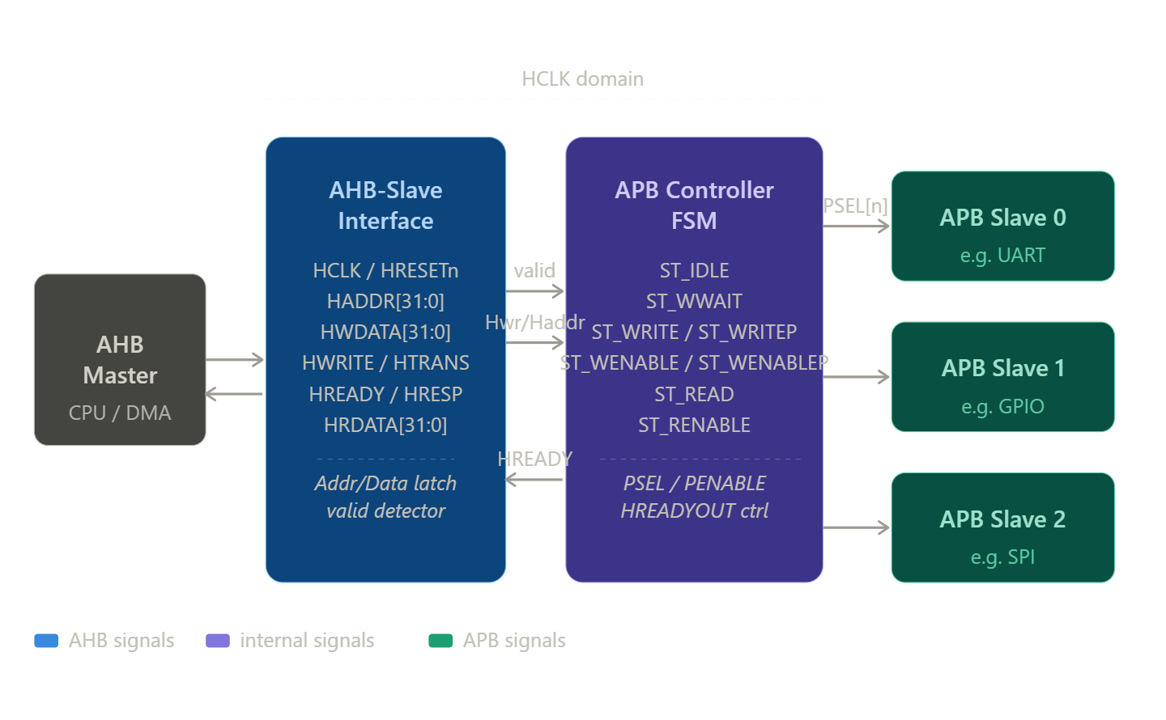
Figure 2.1 Block diagram of AHB2APB Bridge
1. AHB Master
The AHB Master (such as CPU or DMA) initiates all read and write transactions. It provides address, control, and data signals to the bridge.

2. AHB Slave Interface
This block acts as an interface between the AHB bus and the internal bridge logic.
Key signals:
- HCLK / HRESETn → Clock and reset signals
- HADDR[31:0] → Address bus
- HWDATA[31:0] → Write data
- HWRITE / HTRANS → Control signals
- HREADY / HRESP → Handshake signals
- HRDATA[31:0] → Read data
Function:
- Captures address and control signals from AHB
- Latches data during transactions
- Detects valid transfers using control signals
- Sends processed signals (valid, address, write/read info) to FSM

3. APB Controller FSM (Finite State Machine)
This is the core control unit of the bridge.
Main States:
- ST_IDLE → Waiting for transaction
- ST_WWAIT → Wait before write
- ST_WRITE / ST_WRITEP → Write operation handling
- ST_WENABLE / ST_WENABLEP → Enable write to APB
- ST_READ → Read operation handling
- ST_RENABLE → Enable read from APB
Function:
- Converts AHB transactions into APB protocol
- Generates APB control signals like PSEL and PENABLE
- Controls timing and sequencing of operations
- Manages HREADYOUT to stall AHB when needed

4. APB Slaves
These are low-power peripheral devices such as:
- UART
- GPIO
- SPI
Key signals:
- PSEL → Select signal for slave
- PENABLE → Enable signal for transfer
- PADDR, PWDATA, PRDATA → Address and data
Function:
- Perform read/write operations
- Respond to control signals from FSM
- Return data during read operations

5. Data Flow Summary
- AHB Master sends address and control signals
- AHB Interface captures and validates them
- FSM processes and converts to APB format
- APB slave executes operation
- Data is returned back through the bridge

6. Key Features
- Supports high-speed AHB to low-speed APB conversion
- Uses FSM for controlled data transfer
- Ensures proper synchronization between buses
- Reduces power consumption for peripherals

3. Waveforms

3.1 Top Module Waveform
This waveform shows overall AHB to APB transaction flow including address, control, and data signals. The top module waveform represents the complete operation of the AHB to APB bridge, showing how address, control, and data signals interact during a transaction. It illustrates the coordination between AHB and APB protocols, including signal transitions for read and write operations and the overall data flow through the bridge.
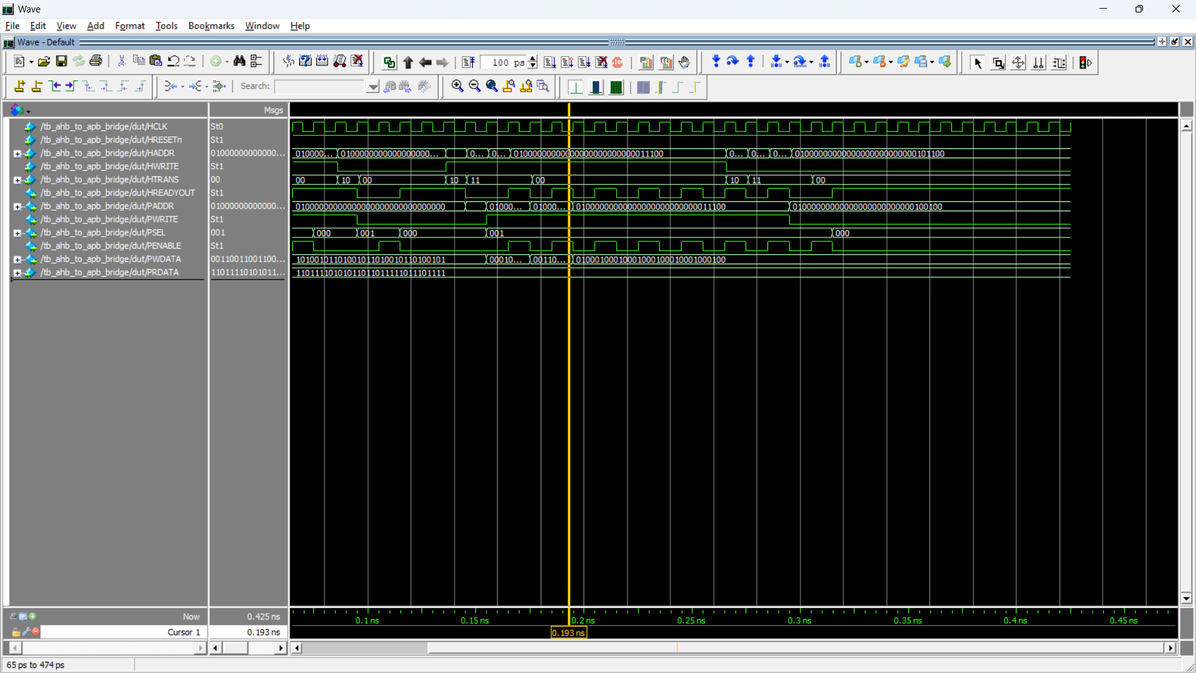
Figure 3.1.1 Top model waveform

3.2 Write Operation
This waveform shows data transfer from AHB master to APB slave with proper control signals. The write operation waveform demonstrates how data is transferred from the AHB master to the APB slave. It shows the activation of control signals such as write enable, address placement, and data transfer along with proper timing of PSEL and PENABLE signals to ensure correct data writing.
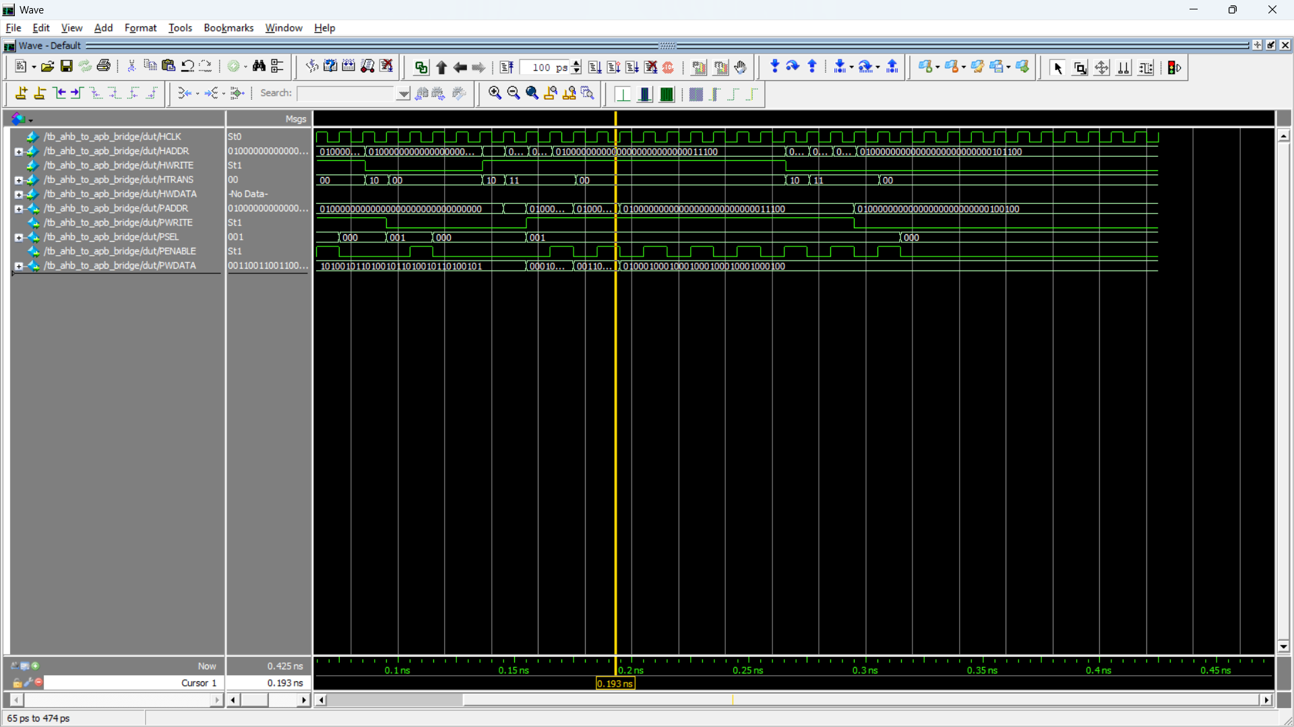
Figure 3.2.1 Waveform for Write operation

3.3 Read Operation
This waveform shows data transfer from APB slave back to AHB master. The read operation waveform illustrates the transfer of data from the APB slave back to the AHB master. It highlights how the address is sent, the read control signals are activated, and the data is returned through PRDATA and HRDATA with proper synchronization.
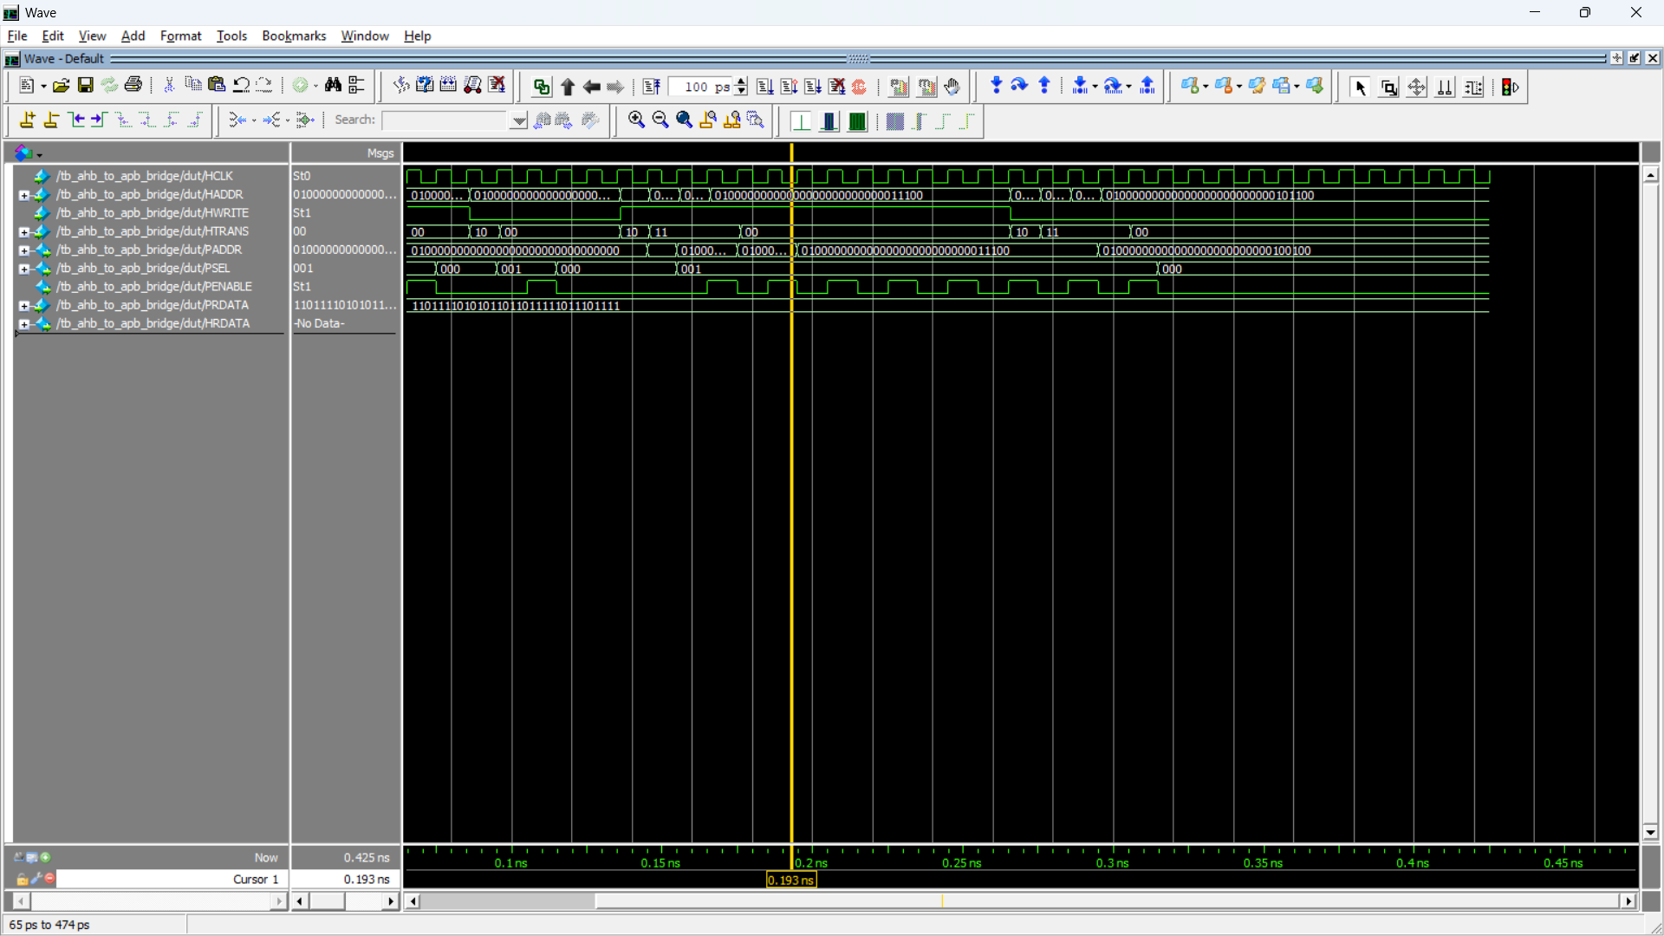
Figure 3.3.1 Waveform for Read operation

3.4 Sub-block Output Waveforms
These waveforms include control signals such as PSEL, PENABLE, and state transitions. The sub-block output waveforms display the internal control signals generated by the FSM, such as PSEL, PENABLE, and state transitions. These waveforms help in understanding the step-by-step operation of the bridge and verify the correct sequencing of APB transactions.

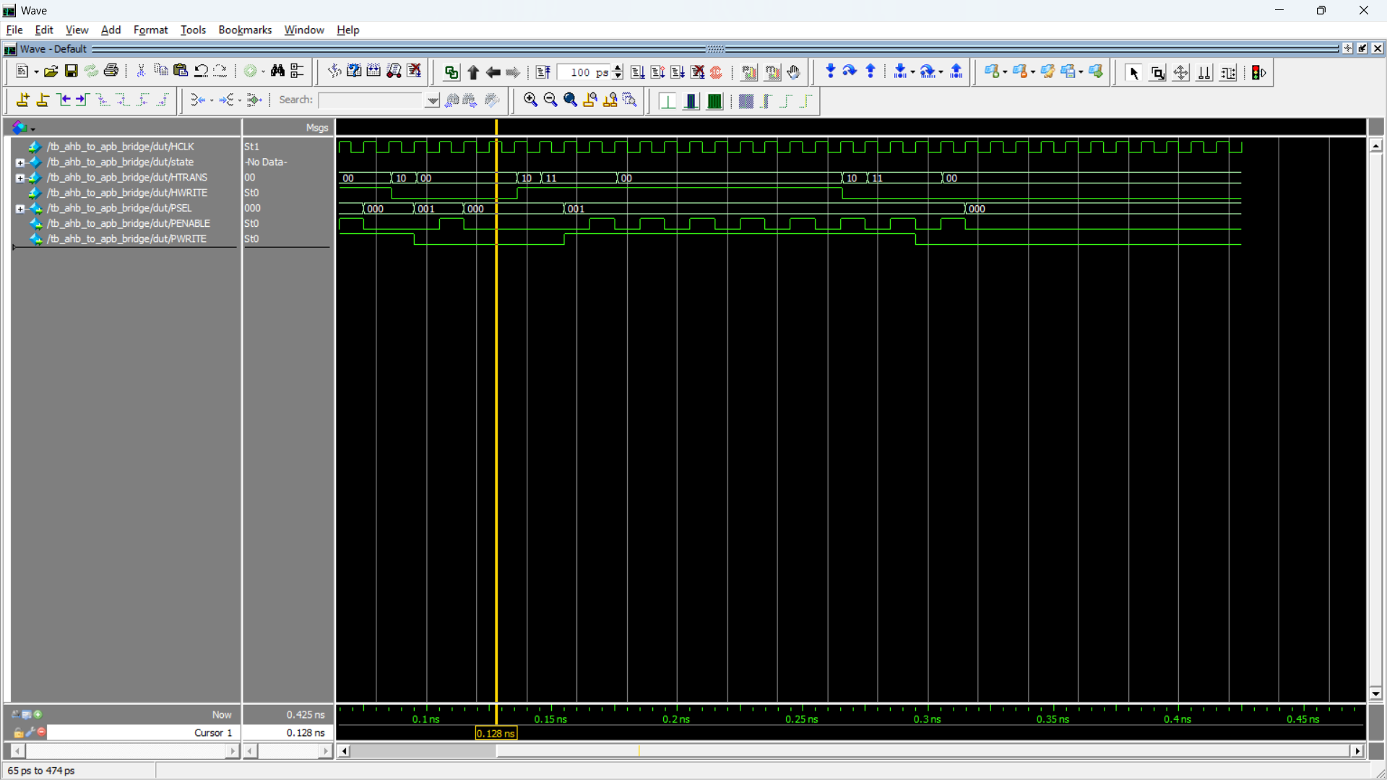
Figure 3.4.1 Sub-block output waveform

4. Synthesis
The synthesized circuit diagram represents the hardware implementation of the AHB to APB bridge. Synthesis is the process of converting the high-level RTL (Register Transfer Level) design of the AHB to APB bridge into a gate-level implementation using logic gates and flip-flops. During synthesis, the design is optimized for area, speed, and power while ensuring correct functionality. The synthesized circuit diagram represents how the AHB interface, APB controller FSM, and control logic are physically realized in hardware. It includes combinational logic for decision making and sequential elements for state storage. The synthesis results confirm that the design is implementable on hardware and accurately reflects the intended behavior of the bridge.

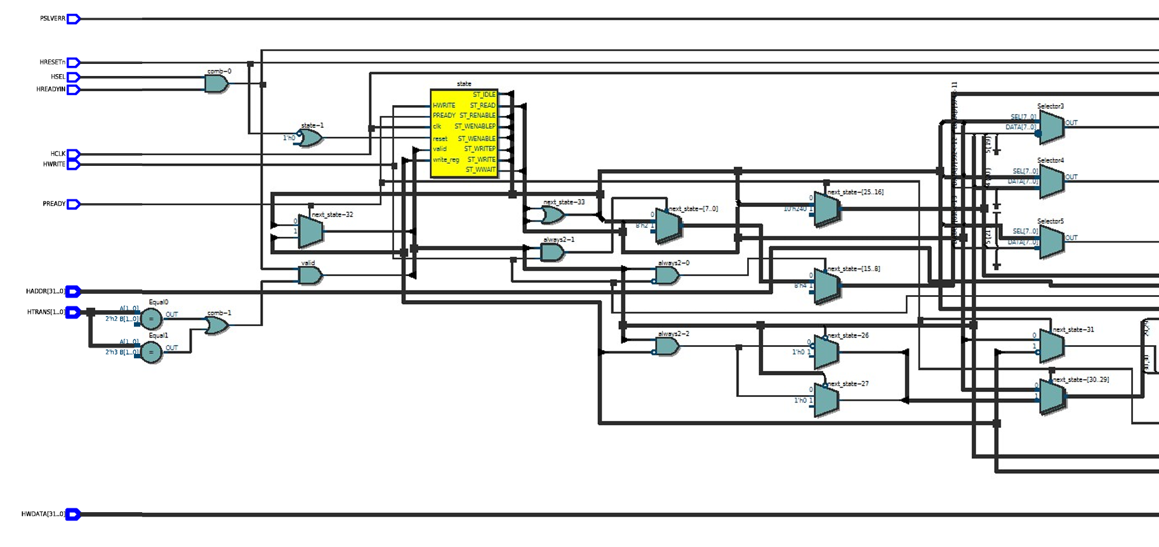
Figure 4.1 Initial part of synthesis
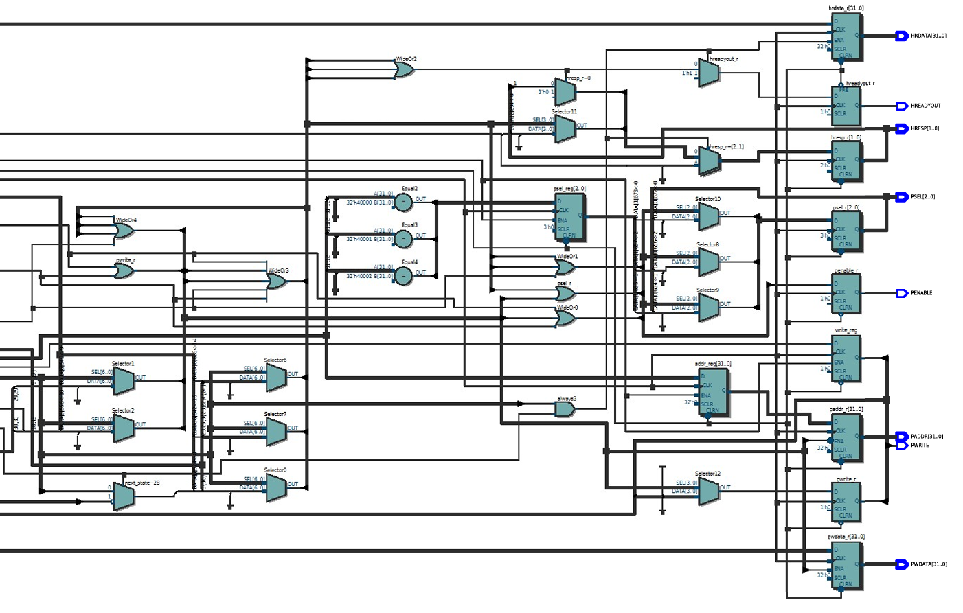
Figure 4.2 Remaining part of synthesis

5. Conclusion
The AHB to APB bridge was successfully designed and verified. The waveforms confirm correct operation of read and write transfers. The AHB to APB bridge was successfully designed, simulated, and synthesized to enable efficient communication between high-performance AHB systems and low-power APB peripherals. The design employs a well-structured finite state machine to accurately translate pipelined AHB transactions into APB-compatible operations while maintaining proper timing and control signal sequencing. The simulation waveforms validate the correctness of both read and write operations, demonstrating proper synchronization, data integrity, and protocol compliance. Furthermore, the synthesized circuit confirms that the design is hardware-efficient and suitable for practical implementation. This project highlights the importance of protocol bridging in system-on-chip designs and demonstrates a scalable and reliable solution for integrating heterogeneous bus architectures.

