**Pipeline-Job**  
**Assignment – 1**  
I created 3 private repos with Index.html and Jenkinsfile

**Repo-1 with R1-master Pipeline-Job  
Repo-2 with R2-2025Q1 Pipeline-Job  
Repo-3 with R3-2025Q2 Pipeline-Job**

**I created pipeline job-1 name as R1-master and save it.**

**I want to deploy repo-1 index.html file in master machine on path : /var/www/html/**

**Script : -**

**Build run successfully : -**

**Output : -**

**Here for job-2 and job-3 need to change repo URL and branch.**for Job-2 URL <https://github.com/Rushikesh-Dhotare/repo-2.git> and branch */2025R1

for Job-2 URL <https://github.com/Rushikesh-Dhotare/repo-3.git> and branch */2025R2

**For Job-2 and Job-3 script is same.**

**Build run successful for both jobs**

**Job – 2 output : -**

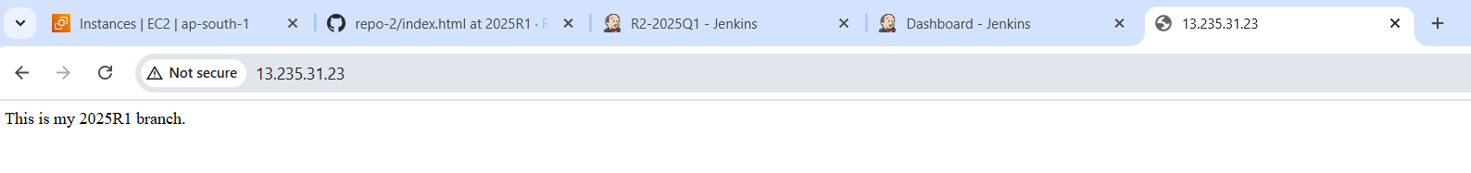

**Job-3 Output : -**

