Created slave-1 and slave-2

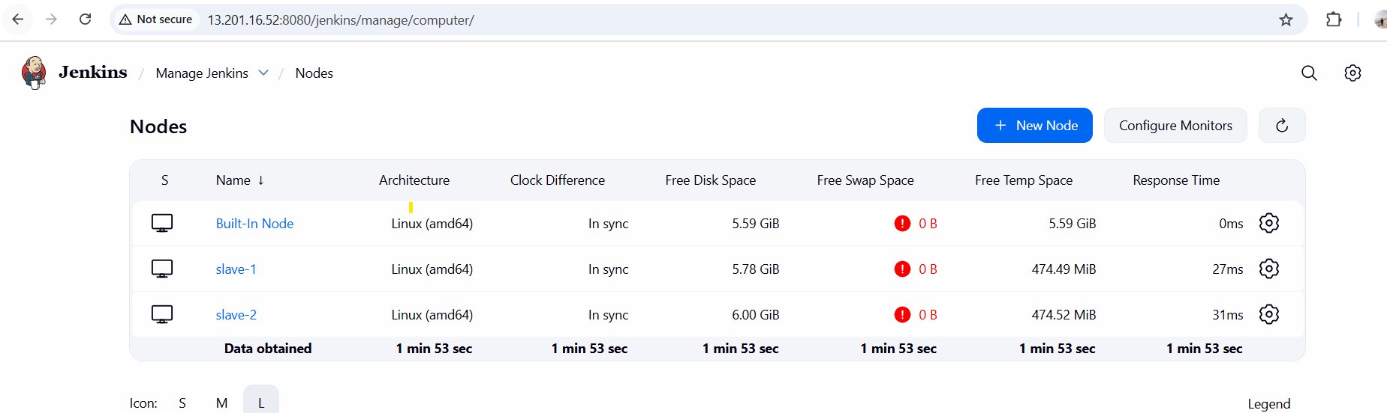  
  
For slave-1  
  
**I already configured webhook in Jenkins and Repository as well.**

**

Here I am deploying index.html file in **slave-1 using repo-1.**

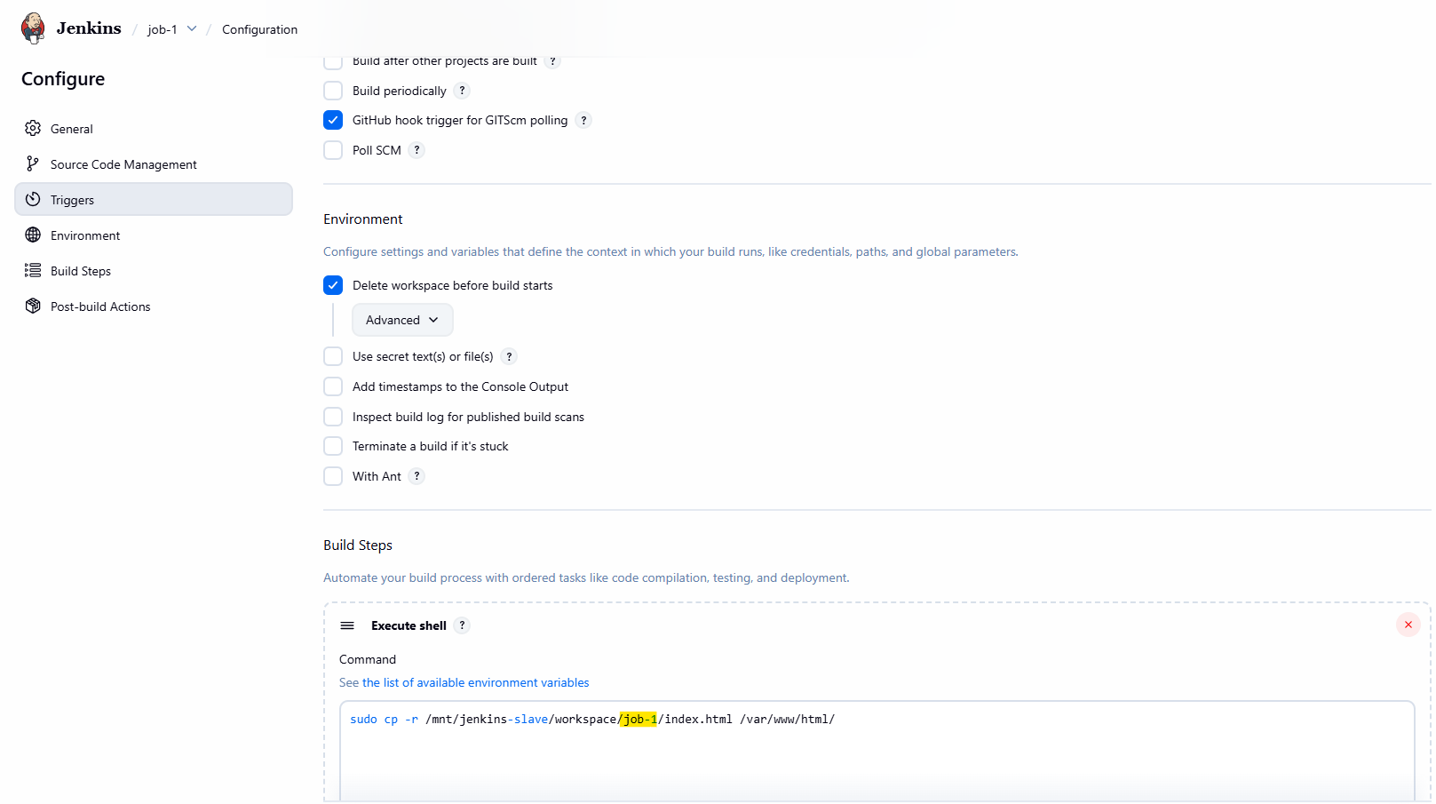

**Job run successfully  
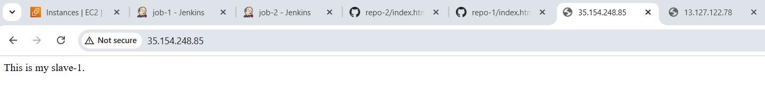**

**After doing changes in git Repo-1  
  
**

**Doing same steps for Job-2 (slave-2)**For the slave 2 only changed the Host IP as - 172.31.41.123 (slave-2 machine)  
for Job-2 URL <https://github.com/Rushikesh-Dhotare/repo-2.git> and branch */2025R1  
  
**for execute shell**sudo cp -r /mnt/jenkins-slave/workspace/job-2/index.html /var/www/html/  
  
**Job run successfully**

**After change in git Repo-2**

