**I have a machine with configured with Tomcat and Jenkins as well as httpd running.**

1. **I created 3 public repositories**

1. **Configured API connection between Jenkins and GitHub**

1. **Then I have created 3 branches and created index file in repositories**

Master in Repo-1 with index.html file  
2025R1 in Repo-2 with index.html file  
2025R3 in Repo -3 with index.html file

1. **Jenkins configured in all 3 repositories**

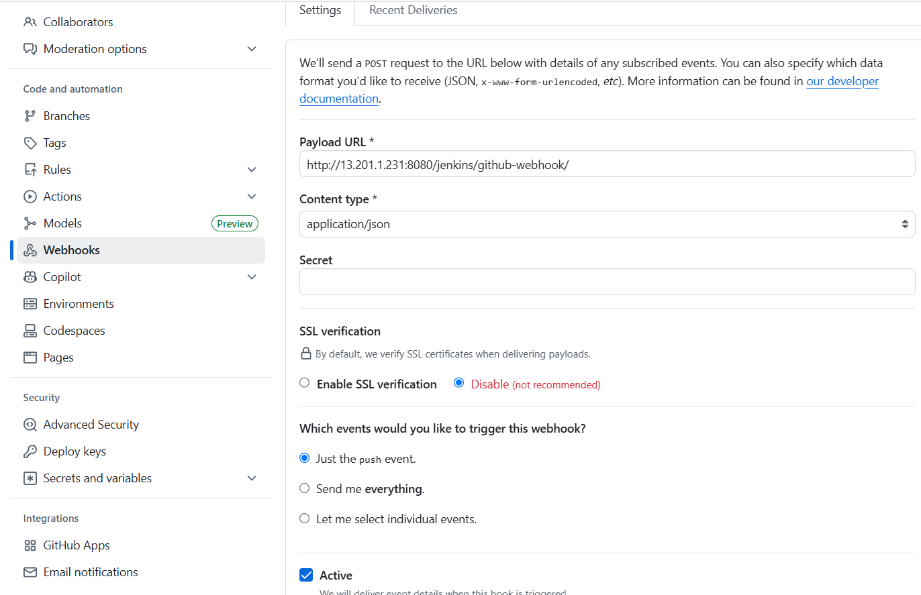

1. **Created 3 jobs and configured the webhook and execute shell commands  
   A screenshot of a computer

   AI-generated content may be incorrect.**

**For Job-1**

**Here for job-2 and job-3 need to change repo URL and branch.**for Job-2 URL <https://github.com/Rushikesh-Dhotare/repo-2.git> and branch */2025R1

for Job-2 URL <https://github.com/Rushikesh-Dhotare/repo-3.git> and branch */2025R2

**Enabled GitHub hook trigger for GITScm polling and execute shell   
  
**

**Here for Job-2**cd /var/www/html/

cp -r /root/.jenkins/workspace/job-2/index.html .

chmod -R 744 index.html

**for Job-3**

cd /var/www/html/

cp -r /root/.jenkins/workspace/job-2/index.html .

chmod -R 744 index.html

**After build the job-1 without change**

**after changing file content from git for Job-1**

**Same for the job-2 and job-3  
Job-2  
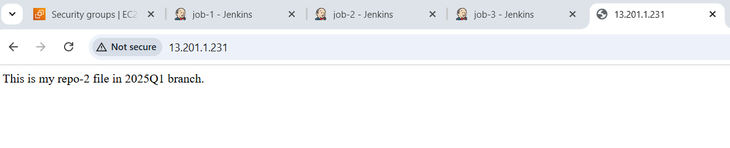**

**Job-3  
**

