Plotting of different time series

Rushikesh

2024-02-25

library(TSstudio)

## Warning: package 'TSstudio' was built under R version 4.3.2

rainfall = c(799,114.8,865.1,1331.6,985.4,918.5,685.6,998.6,784.2,985,828.8,107.1)  
rainfall.timeseries=ts(rainfall,start = c(2012,1),frequency = 12)  
print(rainfall.timeseries)

## Jan Feb Mar Apr May Jun Jul Aug Sep Oct  
## 2012 799.0 114.8 865.1 1331.6 985.4 918.5 685.6 998.6 784.2 985.0  
## Nov Dec  
## 2012 828.8 107.1

plot(rainfall.timeseries)

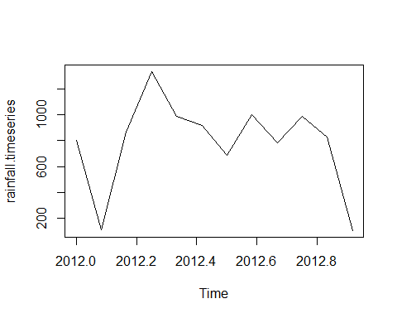

#combined time series  
rainfall1 = c(799,114.8,865.1,1331.6,985.4,918.5,685.6,998.6,784.2,985,828.8,107.1)  
rainfall2 = c(655,1306.9,1323.4,1172.2,562.2,824,822.4,1265.5,799.6,1105.6,1106.7,1337.8)  
combinedrain = matrix(c(rainfall1,rainfall2),nrow = 12)  
rainfall.timeseries=ts(combinedrain,start = c(2012,1),frequency = 12)  
print(rainfall.timeseries)

## Series 1 Series 2  
## Jan 2012 799.0 655.0  
## Feb 2012 114.8 1306.9  
## Mar 2012 865.1 1323.4  
## Apr 2012 1331.6 1172.2  
## May 2012 985.4 562.2  
## Jun 2012 918.5 824.0  
## Jul 2012 685.6 822.4  
## Aug 2012 998.6 1265.5  
## Sep 2012 784.2 799.6  
## Oct 2012 985.0 1105.6  
## Nov 2012 828.8 1106.7  
## Dec 2012 107.1 1337.8

ts.plot(rainfall.timeseries,col = c("black","green"))

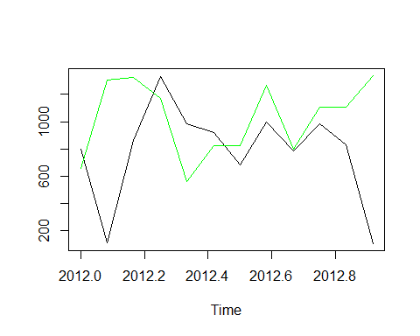

#working with air passenger data  
data("AirPassengers")  
class(AirPassengers)

## [1] "ts"

start(AirPassengers)

## [1] 1949 1

end(AirPassengers)

## [1] 1960 12

plot(AirPassengers)

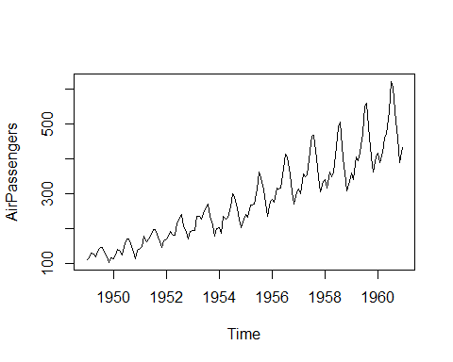

tsdata = ts(AirPassengers,frequency = 12)  
ddata = decompose(tsdata,"multiplicative")  
plot(ddata)

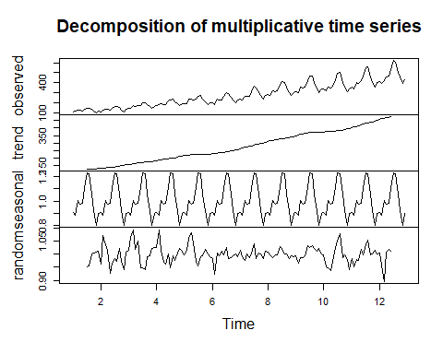

ts.plot(ddata$trend)

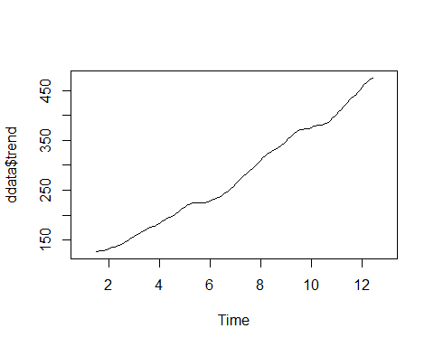

ts.plot(ddata$seasonal)

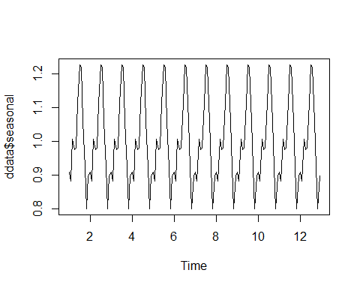

ts.plot(ddata$random)

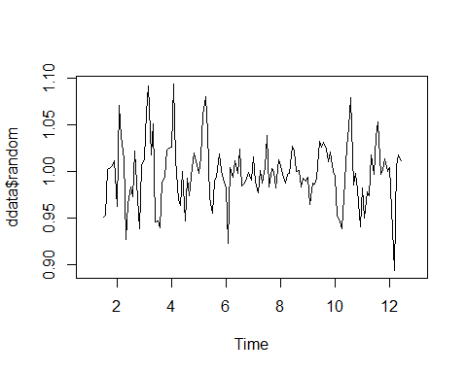

plot(AirPassengers)  
abline(reg = lm(AirPassengers~time(AirPassengers)))

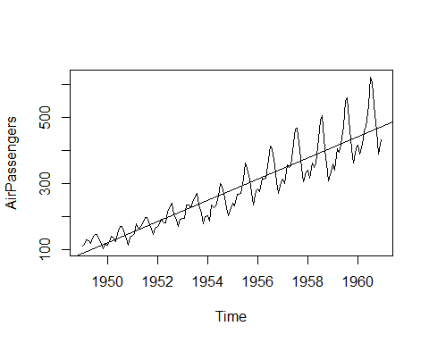

boxplot(AirPassengers~cycle(AirPassengers),xlab = "date",ylab = "Passenger number(1000's)")

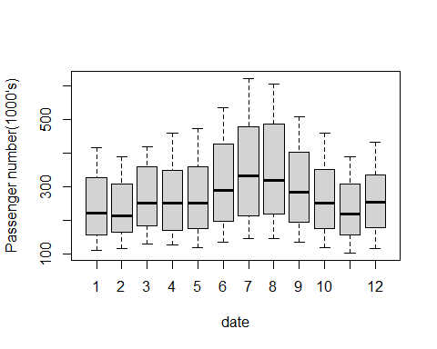

#working with nile data  
ts.plot(Nile,xlab="year",ylab = "river volume(1e9m^3)")

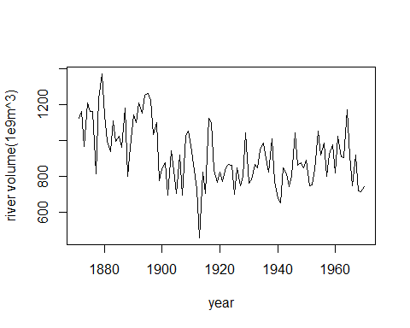

#stationary and non-stationary time series  
eps = rnorm(100,mean = 0,sd=1)  
mu = 2  
x_t = mu + eps  
ts.plot(x_t,main = "Example of(random) stationary time series",ylab = "expression(x_t)")

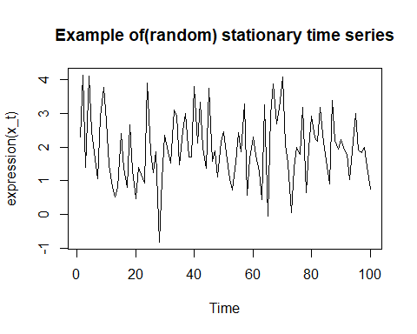

#random walk process  
z = rnorm(100,mean = 0.5,sd=1.5)  
x =0   
for (i in 2:length(z)) {  
 x[i]=x[i-1]+z[i]  
}  
ts.plot(x,main = "Raandom walk Process")

