Moving Average Time Series

Rushikesh

2024-02-25

library(forecast)

## Warning: package 'forecast' was built under R version 4.3.2

## Registered S3 method overwritten by 'quantmod':  
## method from  
## as.zoo.data.frame zoo

opar = par(no.readonly = TRUE)  
par(mfrow = c(2,2))  
ylim = c(min(Nile),max(Nile))  
  
plot(Nile,main = "row timeseries")  
  
plot(ma(Nile,3),main = "Simple moving avg(k=3)",ylim=ylim)  
  
plot(ma(Nile,7),main = "Simple moving avg(k=7)",ylim=ylim)  
  
plot(ma(Nile,15),main = "Simple moving avg(k=15)",ylim=ylim)

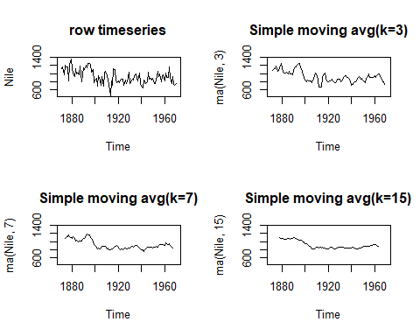

par(opar)

## Including Plots

You can also embed plots, for example:



Note that the echo = FALSE parameter was added to the code chunk to prevent printing of the R code that generated the plot.