Exponential smoodhing

Rushikesh

2024-02-25

library(forecast)

## Warning: package 'forecast' was built under R version 4.3.2

## Registered S3 method overwritten by 'quantmod':  
## method from  
## as.zoo.data.frame zoo

y = c(71,70,69,68,64,65,72,78,75,75,75,70)  
yt = ts(y,start = c(1,1),frequency = 1)  
  
fit1 = ets(yt,model = "ANN",alpha = 0.1)  
A1 = fit1$fitted;A1

## Time Series:  
## Start = 1   
## End = 12   
## Frequency = 1   
## [1] 70.65167 70.68650 70.61785 70.45607 70.21046 69.58941 69.13047 69.41743  
## [9] 70.27568 70.74811 71.17330 71.55597

fit2 = ets(yt,model = "ANN",alpha = 0.3)  
A2 = fit2$fitted;A2

## Time Series:  
## Start = 1   
## End = 12   
## Frequency = 1   
## [1] 69.75756 70.13029 70.09121 69.76384 69.23469 67.66428 66.86500 68.40550  
## [9] 71.28385 72.39869 73.17909 73.72536

fit3 = ets(yt,model = "ANN",alpha = 0.5)  
A3 = fit3$fitted;A3

## Time Series:  
## Start = 1   
## End = 12   
## Frequency = 1   
## [1] 70.04754 70.52377 70.26189 69.63094 68.81547 66.40774 65.70387 68.85193  
## [9] 73.42597 74.21298 74.60649 74.80325

fit4 = ets(yt,model = "ANN",alpha = 0.7)  
A4 = fit1$fitted;A4

## Time Series:  
## Start = 1   
## End = 12   
## Frequency = 1   
## [1] 70.65167 70.68650 70.61785 70.45607 70.21046 69.58941 69.13047 69.41743  
## [9] 70.27568 70.74811 71.17330 71.55597

fit5 = ets(yt,model = "ANN",alpha = 0.9)  
A5 = fit1$fitted;A5

## Time Series:  
## Start = 1   
## End = 12   
## Frequency = 1   
## [1] 70.65167 70.68650 70.61785 70.45607 70.21046 69.58941 69.13047 69.41743  
## [9] 70.27568 70.74811 71.17330 71.55597

plot(yt,col="blue")  
lines(A1,lty=1)  
lines(A2,lty=2)  
lines(A3,lty=3)  
lines(A4,lty=4)  
lines(A5,lty=5)  
  
legend("topleft",c("Row Data","alpha = 0.1","alpha=0.3","alpha=0.5","alpha=0.7","alpha=0.9",  
 lty=c(1,2,3,4,5),col = c("red","pink","blue","orange","yellow","lightblue")))

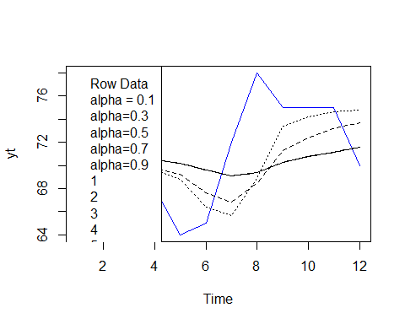

#double exp smoodhing  
s = c(7,6,5,4,8,9,10,11,10,7)  
S1 = ts(s,start = c(1,1),frequency = 1);S1

## Time Series:  
## Start = 1   
## End = 10   
## Frequency = 1   
## [1] 7 6 5 4 8 9 10 11 10 7

fit = ets(S1,model = "AAN");fit

## ETS(A,A,N)   
##   
## Call:  
## ets(y = S1, model = "AAN")   
##   
## Smoothing parameters:  
## alpha = 1e-04   
## beta = 1e-04   
##   
## Initial states:  
## l = 5.02   
## b = 0.4823   
##   
## sigma: 2.2424  
##   
## AIC AICc BIC   
## 44.06883 59.06883 45.58176

pred = forecast(fit4);pred

## Point Forecast Lo 80 Hi 80 Lo 95 Hi 95  
## 13 71.50469 66.34130 76.66808 63.60797 79.40141  
## 14 71.50469 65.20197 77.80741 61.86551 81.14387  
## 15 71.50469 64.23916 78.77022 60.39302 82.61636  
## 16 71.50469 63.38979 79.61959 59.09402 83.91536  
## 17 71.50469 62.62126 80.38812 57.91865 85.09072  
## 18 71.50469 61.91412 81.09526 56.83718 86.17220  
## 19 71.50469 61.25565 81.75372 55.83014 87.17923  
## 20 71.50469 60.63701 82.37236 54.88401 88.12536  
## 21 71.50469 60.05174 82.95764 53.98891 89.02046  
## 22 71.50469 59.49495 83.51442 53.13738 89.87199

plot(fit)

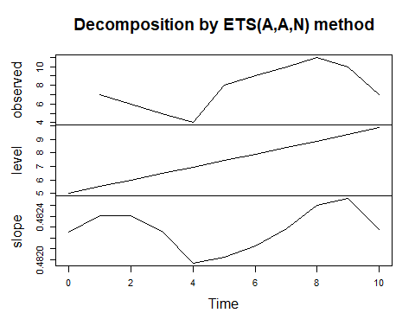

#triple exp smoodhing  
Fit = ets(AirPassengers,model = "AAA")  
Fit

## ETS(A,A,A)   
##   
## Call:  
## ets(y = AirPassengers, model = "AAA")   
##   
## Smoothing parameters:  
## alpha = 0.9935   
## beta = 2e-04   
## gamma = 6e-04   
##   
## Initial states:  
## l = 120.9608   
## b = 1.3934   
## s = -29.1816 -54.3842 -20.7169 15.0727 65.1554 66.1846  
## 33.5822 -4.232 -8.0946 -3.8205 -34.3364 -25.2288  
##   
## sigma: 18.0471  
##   
## AIC AICc BIC   
## 1565.872 1570.729 1616.359

Pred = forecast(Fit,5);Pred

## Point Forecast Lo 80 Hi 80 Lo 95 Hi 95  
## Jan 1961 437.2863 414.1580 460.4145 401.9146 472.6579  
## Feb 1961 429.5850 396.9800 462.1899 379.7200 479.4500  
## Mar 1961 461.5371 421.6441 501.4302 400.5260 522.5483  
## Apr 1961 458.6587 412.6149 504.7025 388.2408 529.0766  
## May 1961 463.9389 412.4724 515.4055 385.2276 542.6503

plot(Fit)

