Auto regressive

Rushikesh

2024-02-25

#y = 0.5y(t-1)+e(1)  
y=rnorm(250,0,2)  
y1 = numeric(250)  
y1[1]=y[1]  
for (i in 2:250) {y1[i] = 0.5\*y1[i-1]+y[i]}  
plot.ts(y1)

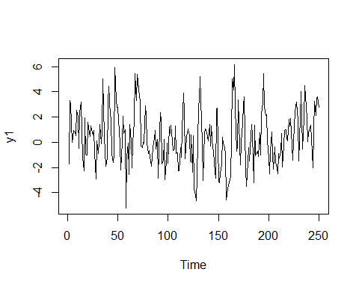

acf(y1)

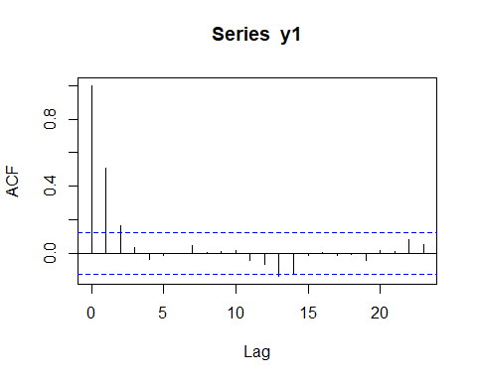

#y=0.7y(t-1)+e(t)  
y=rnorm(250,0,2)  
y1 = numeric(250)  
y1[1]=y[1]  
for (i in 2:250) {y1[i] = 0.7\*y1[i-1]+y[i]}  
plot.ts(y1)

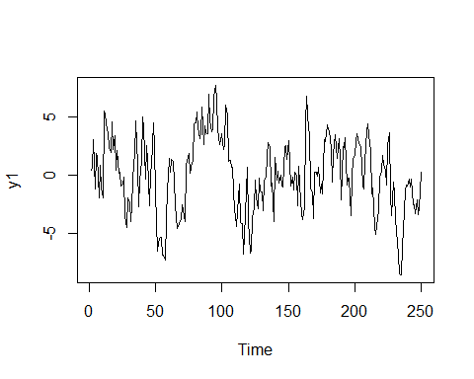

acf(y1)

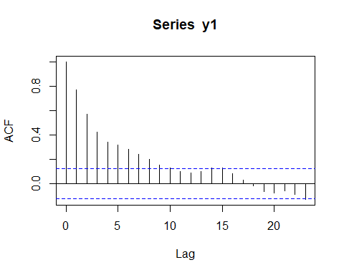

#y=0.7y(t-1)+0.3y(t-2)+e(t)  
y=rnorm(250,0,2)  
y1[1]=y[1]  
y1[2]=y[2]  
for (i in 3:250) {y1[i] = 0.7\*y1[i-1]+0.3\*y1[i-2]+y[i]}  
plot.ts(y1)

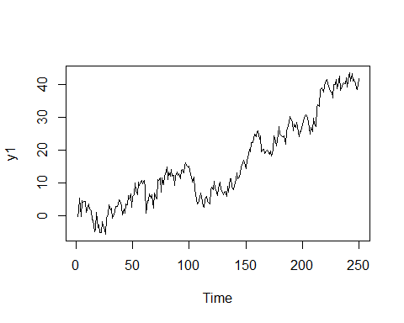

acf(y1)

