|  |  |  |
| --- | --- | --- |
| **Retail Mart Management** | | |
| **Description** |  | A data analyst of a retail shop, Happy Mart, wants to store the product details, the customer details, and the order details to provide unparalleled insights about customer behavior and product stock details daily. | |
| **Programming Language** |  | MySQL | |
| **Software** |  | Xampp | |

|  |
| --- |
|  |

|  |
| --- |
|  |

The design of the database helps to easily evaluate and identify the performance of the shop to increase the daily sales.

Creating a database and name it sql_basics, This database will contain three tables customer, product and sales.

**SUMMARY OF STEPS TAKEN FOR THE PROJECT** :-

➢ Data modelling ➢ Creating a database called sql_basics ➢ Creating both the customer and product datasets ➢ Creating the sales datasets .

This was accomplished by power-BI, this gives a visual aid on how the database tables will be structured.

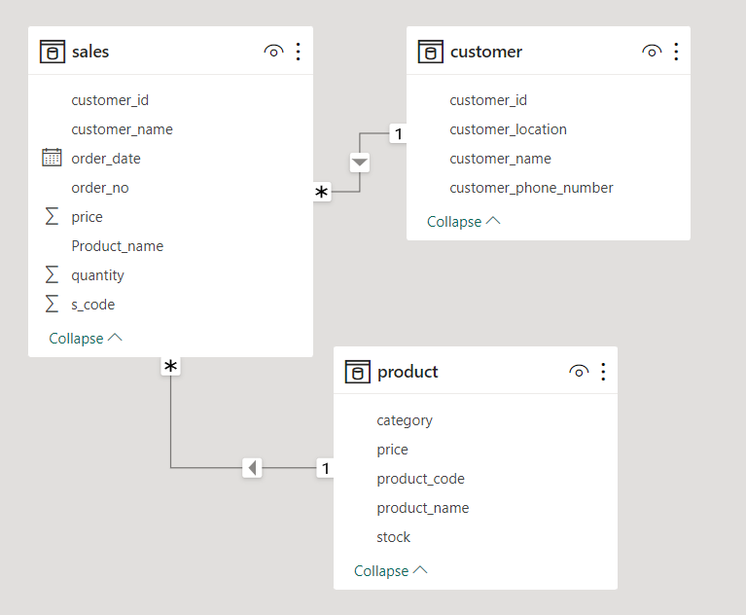 The first step to tackling this project is to create a database called sql_basics using the query **create database sql_basics;**

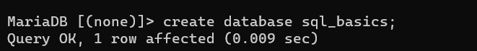

The database sql_basics has been created.to show a database called sql_basics using the query **show databases;**

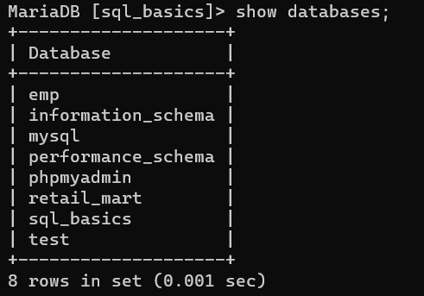

Next, we can use the database by using the query: **use sql_basics;**

use database

The next step is to create both the Customer and Product tables so that,

The query for the creation of customer table: **create table customer (customer_id int,**

**customer_name varchar(25),customer_location varchar(25),customer_phone_number int);**

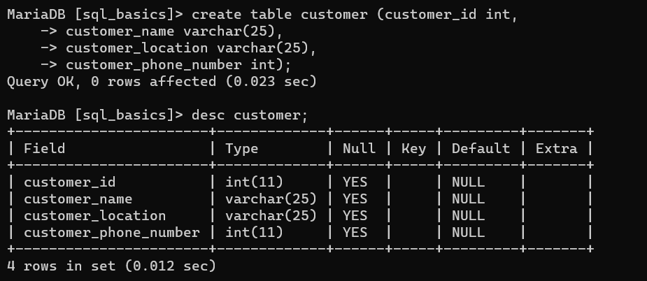

The query for the creation of product table: **create table product(product_code varchar(25),product_name varchar(25),price float,stock int,category varchar(25));**

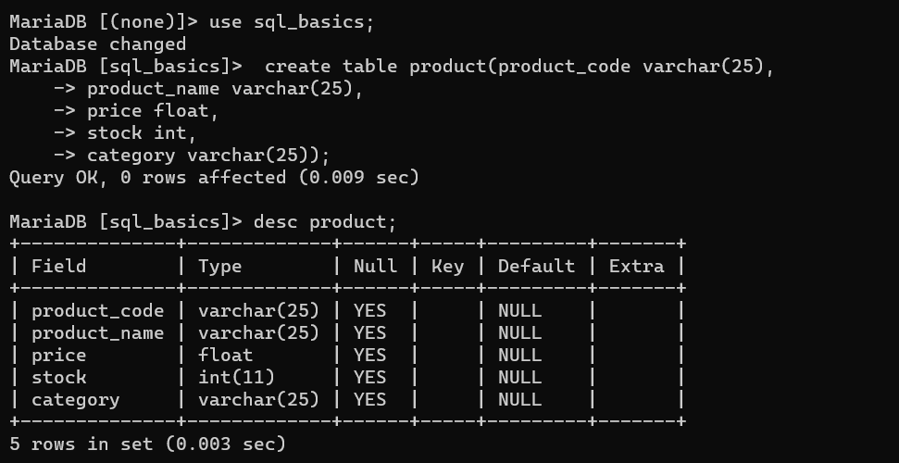

The query for the creation of sales table:  **create table sales (date date,order_number varchar (10),customer_id int,customer_name varchar (25),S_code int,Product_name varchar (25),quantity int,price float );**

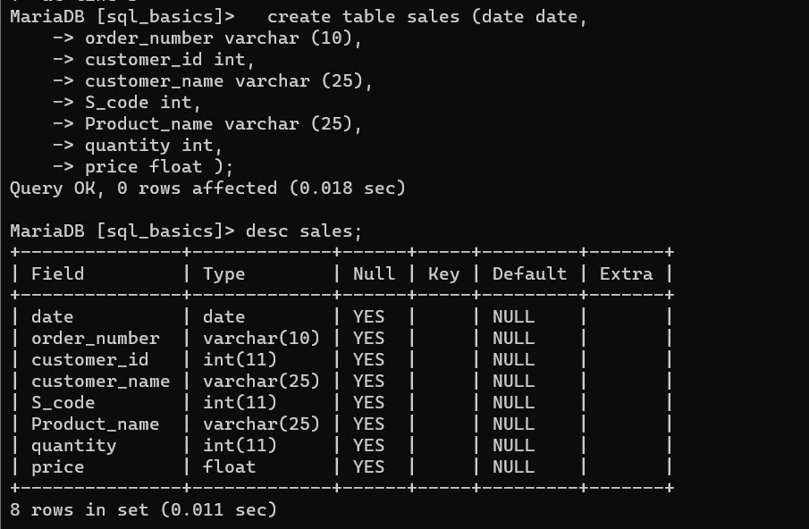

* Write a query to add two new columns such as **S_no** and **categories** to the sales table.

**alter table sales add S_no int;**

**alter table sales add categories varchar(25);**

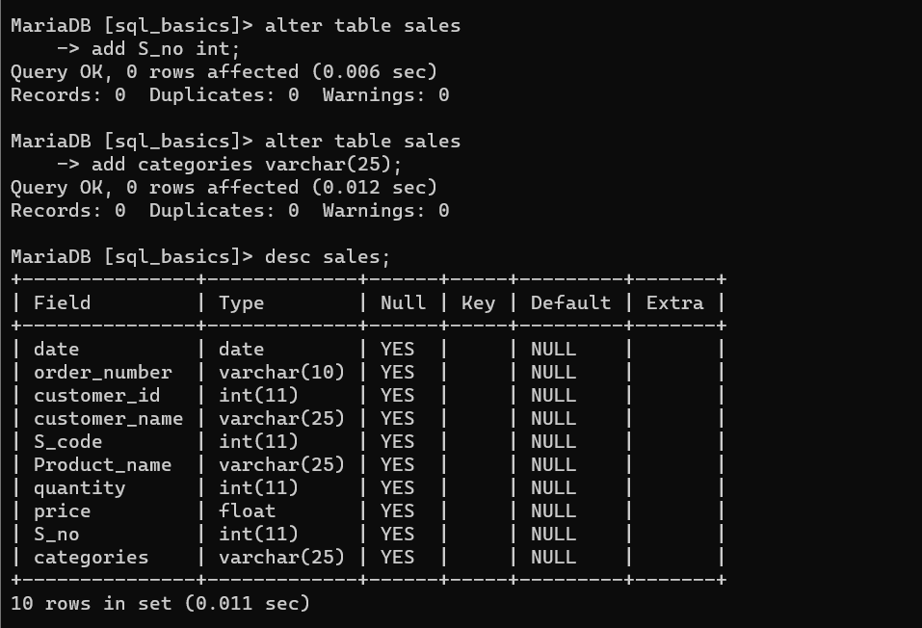

* Write a query to **insert values** into the tables.

**insert into customer (customer_id, customer_name, customer_location,**

**customer_phone_number)**

**values (1111, 'Nisha', 'kerala', 8392320),(1212,'Oliver', 'kerala', 4353891),**

**(1216 ,'Nila' ,'delhi',3323242),(1246 ,'Vignesh', 'chennai', 1111212),**

**(1313 ,'shiny', 'Maharastra' ,5454543),(1910 ,'Mohan' ,'mumbai', 9023941),**

**(2123, 'Biyush' ,'Bombay', 1253358),(3452 ,'Alexander', 'West Bengal', 1212134),**

**(3921 ,'Mukesh' ,'Manipur', 4232321),(5334 ,'Christy' ,'pakistan', 2311111),**

**(9021, 'Rithika' ,'Kashmir', 1121344),(9212 ,'Jessica', 'banglore', 1233435),**

**(9875, 'Stephen', 'chennai' ,1212133);**

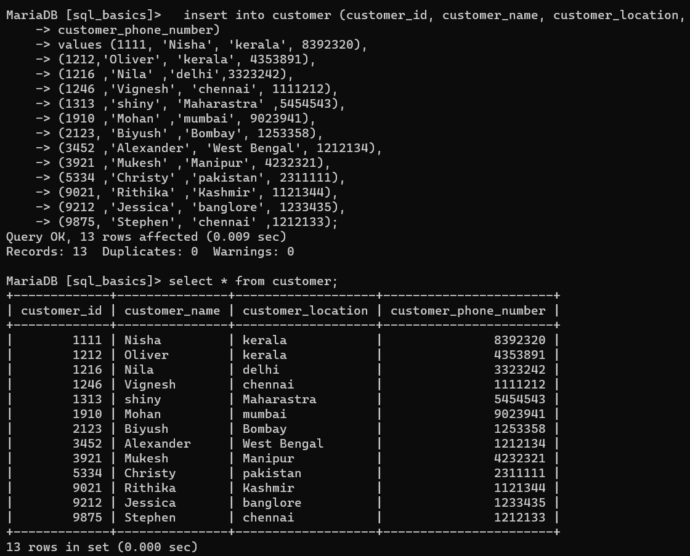

**insert into product (product_code, product_name, price, stock, category)**

**values(2, 'cornoto', 50, 21, 'icecream'),(3, 'Pen', 10, 52 ,'Stationary'),**

**(4, 'Lays' ,10 ,20, 'snacks'),(5, 'mayanoise', 90, 10, 'dip'),**

**(6 ,'jam', 105 ,10 ,'spread'),(7 ,'shampoo', 5, 90, 'hair product'),**

**(8, 'axe' ,210, 4 ,'perfume'),(9 ,'park avenue', 901, 2, 'perfume'),**

**(10, 'wattagirl', 201 ,3 ,'perfume'),(11, 'pencil', 4, 10 ,'Stationary'),**

**(12, 'sharpener', 5, 90, 'Stationary'),**

**(13 ,'sketch pen' ,30 ,10, 'Stationary'),(14 ,'tape', 15, 30, 'Stationary'),**

**(15 ,'paint', 60 ,12, 'Stationary'),(16, 'chocolate', 25, 50, 'snacks'),**

**(17 ,'biscuts', 60 ,26 ,'snacks'),(18, 'mango', 100 ,21, 'fruits'),**

**(19 ,'apple', 120 ,9, 'fruits'),(20 ,'kiwi', 140, 4, 'fruits'),**

**(21 ,'carrot', 35 ,12 ,'vegetable'),(22 ,'onion ',22, 38 ,'vegetable'),**

**(23, 'tomato' ,21, 15 ,'vegetable'),(24, 'serum' ,90, 4, 'hair product'),**

**(25, 'conditioner' ,200 ,5,'hair product'),(26, 'oil bottle', 40 ,2 ,'kitchen utensil');**

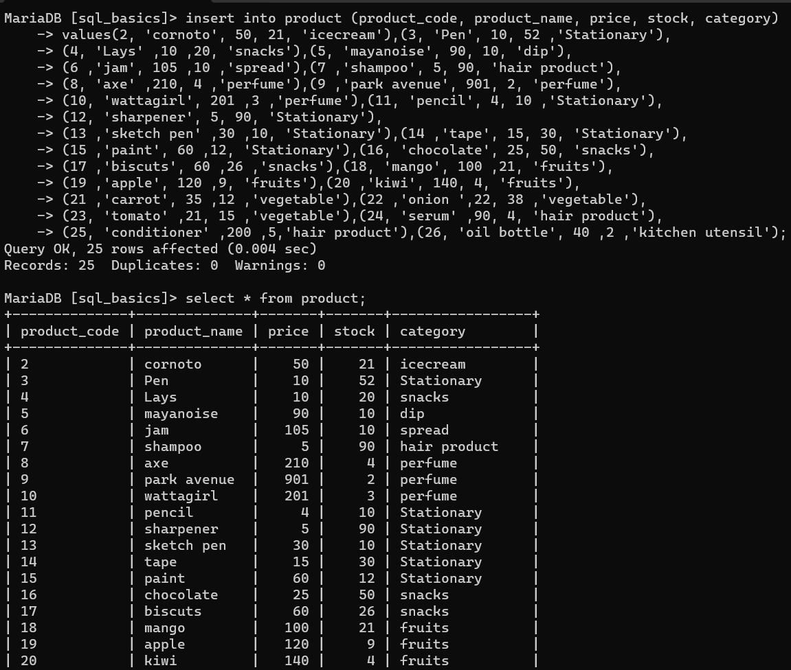

**Insert into sales( date,order_number,customer_id,customer_name,S_code,**

**Product_name,quantity,price)**

**values("2016-10-19","HM09",3921,"Mukesh",17,"biscuits",10,500),**

**(“2016-10-16”,” HM10”,9875,”Stephen”,2,”cornoto”,10,500),**

**(“2018-04-12”,”HM03”,1212,”Oliver”,20,”kiwi”,3,420),**

**(“2018-05-02”,“HM05”,1910,”Mohan”,20,”kiwi”,2,280),**

**(“2018-09-20”,”HM08”,5334,”Chirsty”,16,”chocolate”,2,50),**

**(“2019-01-11”,”HM07”,1246,”Vignesh”,19,”apple”,5,600),**

**(“2019-03-15”,”HM01”,1910,”Mohan”,5,”mayanoise”,4,360),**

**(“2021-02-10”,”HM04”,1111,”Nisha”,25,”conditioner”,5,1000),**

**(“2021-02-12”,”HM02”,2123,”Biyush”,3,”Pen”,2,20);**

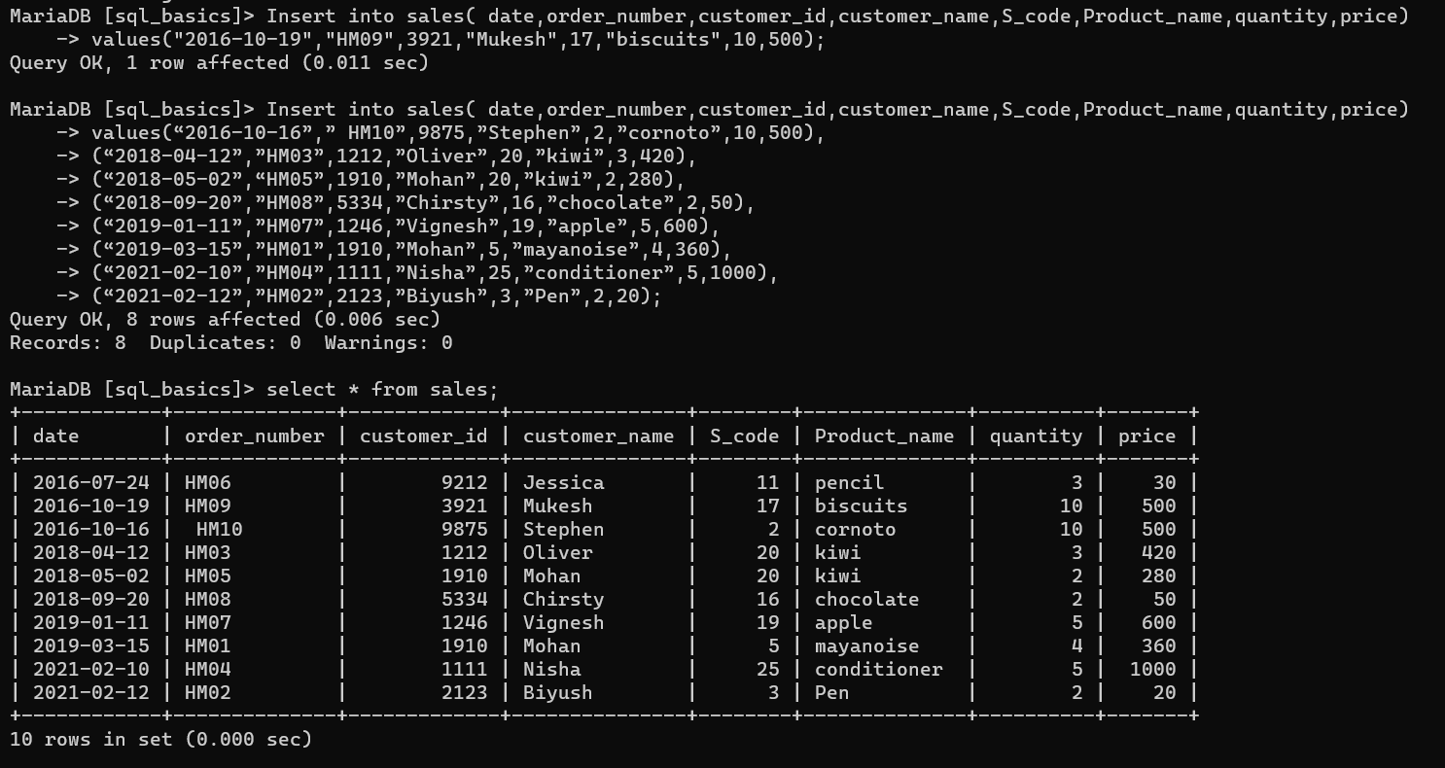

* Write a query to change the column type of **stock** in the product table to **varchar**.

**alter table product modify column stock varchar(15);**

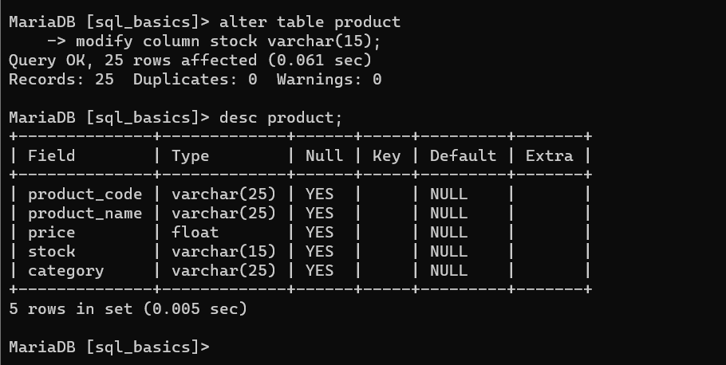

* Write a query to **change** the table name from **customer**-to-**customer** details.

**alter table customer rename to customer_details;**

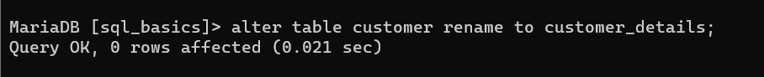

* Write a query to **drop** the columns **S_no** and **categories** from the sales table.

**alter table sales drop column S_no;**

**alter table sales drop column categories;**

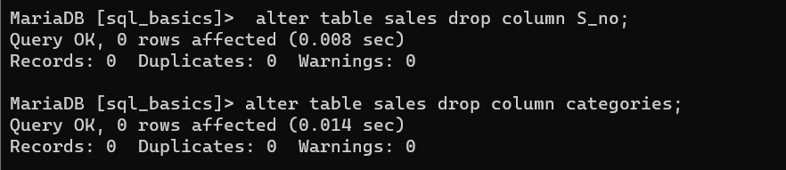

* Write a query to **display** order_number, customer id, order date, price, and quantity from the sales table.

**select order_number,customer_id,date,price,quantity from sales;**

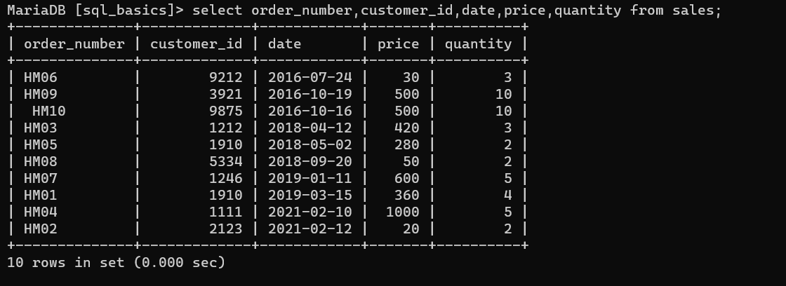

* Write a query to display all the details in the product table if the **category is stationary**.

**select * from product where category='stationary';**

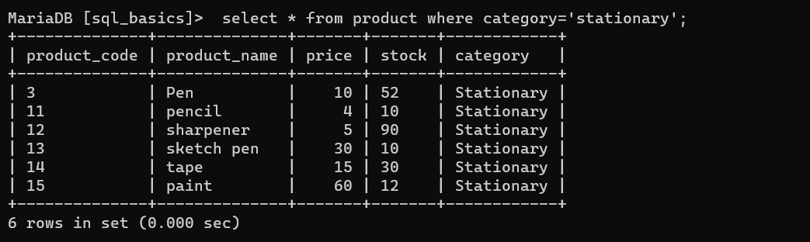

* Write a query to display a **unique category** from the product table.

**select distinct category from product;**

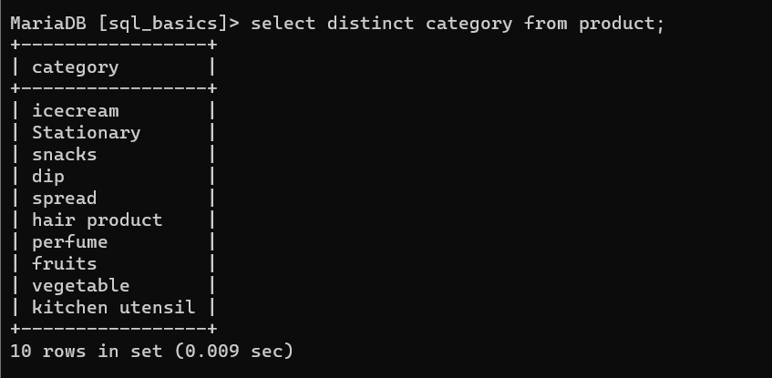

* Write a query to display the sales details if **quantity is greater than 2** and **price is lesser than 500** from the sales table.

**select * from sales where quantity > 2and price < 500;**

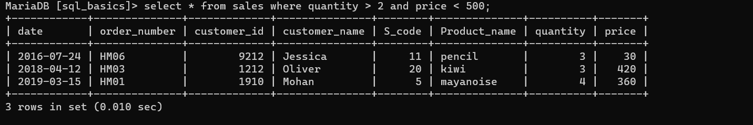

* Write a query to display the customer’s name if the **name ends with a**.

**select customer_name from customer_details where customer_name like '%a';**

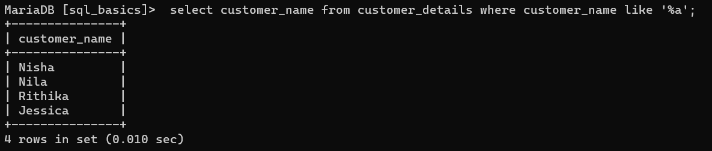

* Write a query to display the product details in **descending order** of the **price**.

**select * from product order by price desc;**

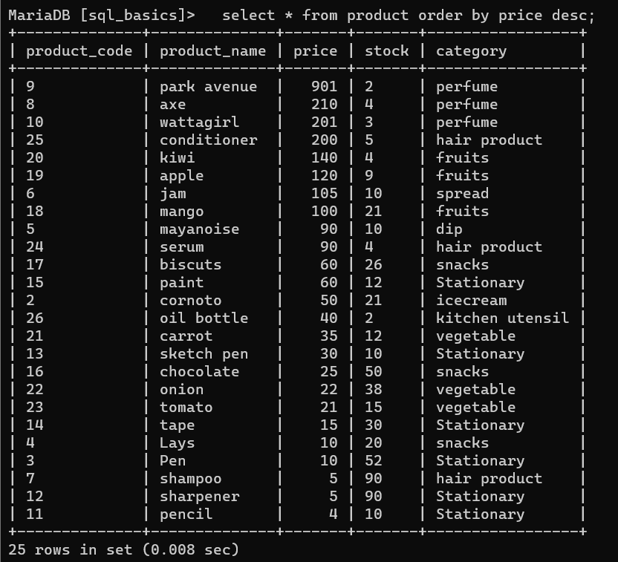

* Write a query to display the product code and category from similar categories that are greater than or equal to 2.

**select product_code,category from product**

**Where category in (select category from product**

**Group by category**

**Having count(*)>=2);**

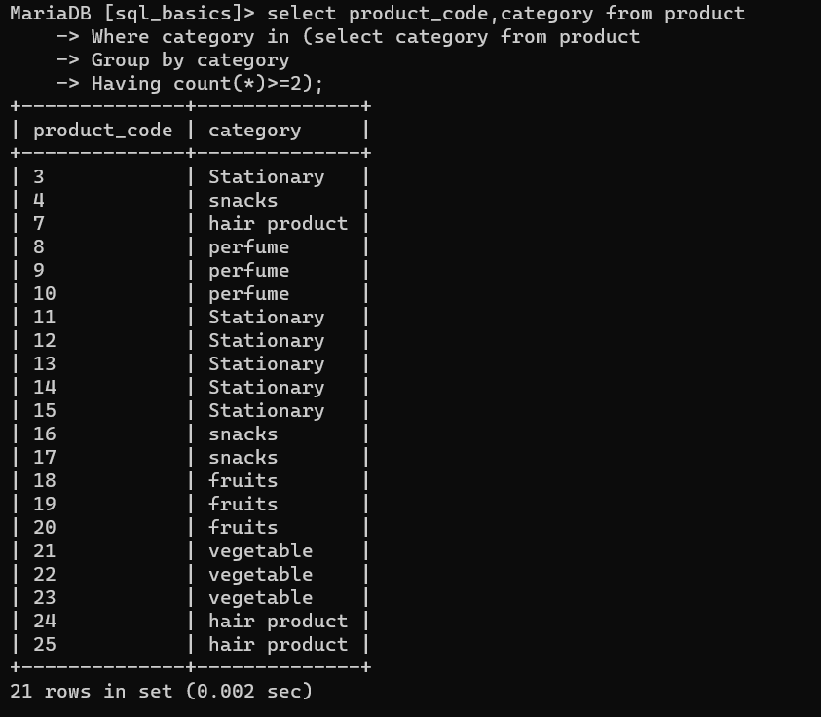

* Write a query to display the order number and the customer name to combine the results of the order and the customer tables including duplicate rows.

**select concat(s.order_number,” “,c.customer_name)as O_no_C_name from sales S**

**Inner Join customer_details C on S.customer_id=C.ccustomer_id;**

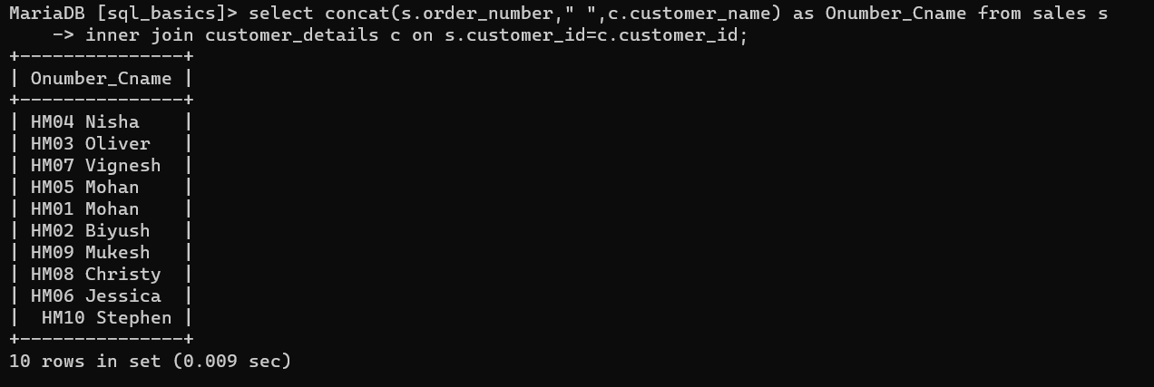

|  |  |
| --- | --- |
| **Name** | Rushikesh.S.Sakhare |
| **Course** | P.G. in Data Analytics |
| **Module** | Data Analytics Essentials |