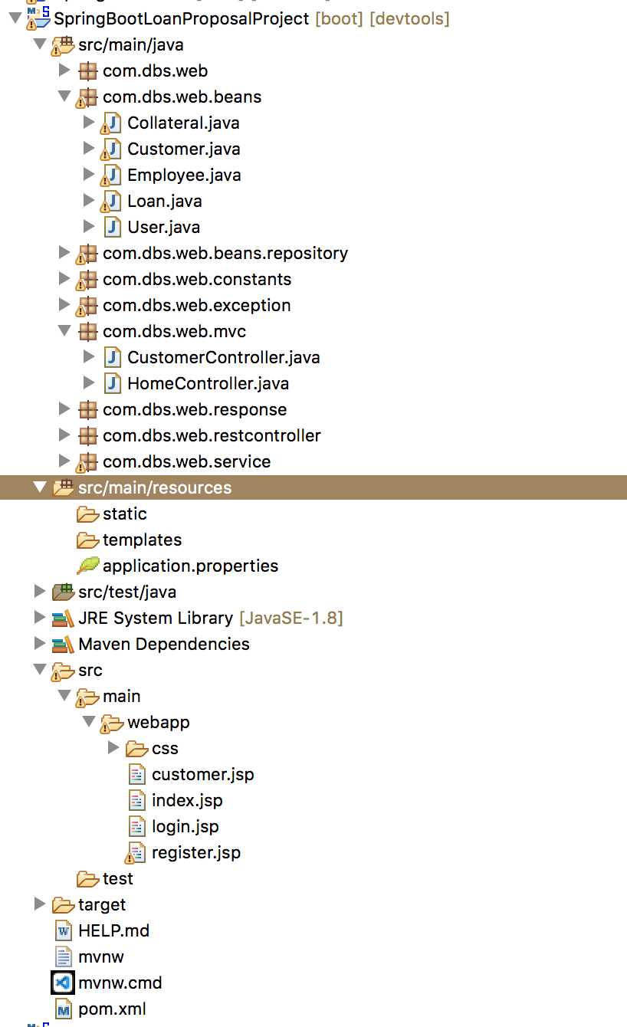

Added jstl, tomcat-embed-jasper dependencies, plus you will see some commented code which we will discuss later

Added jsp and css files in webapp folder

Added mvc prefix and suffix properties

Added mvc package with controller classes as shown

Added password and also modified customer table for password column