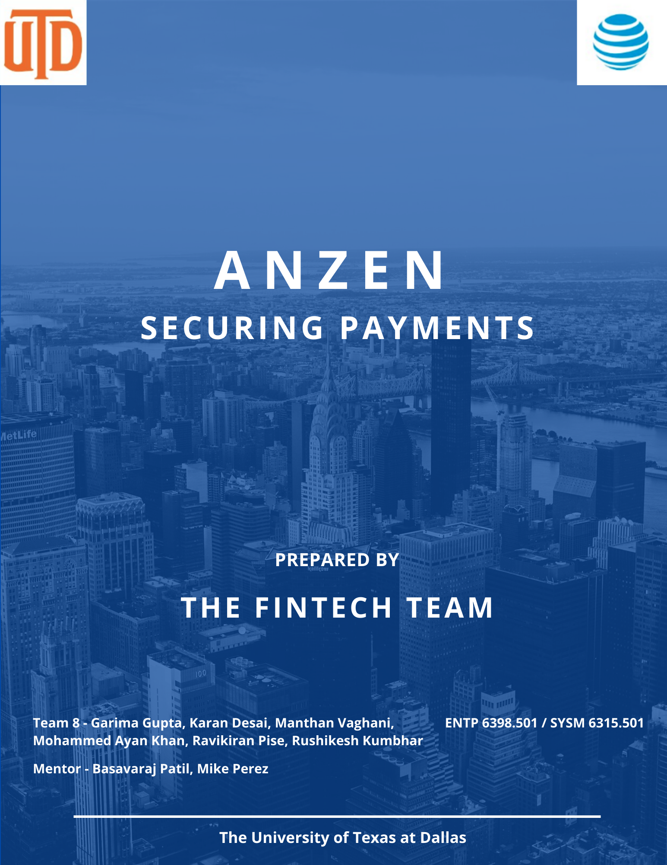

TABLE OF CONTENTS-

|  |  |  |  |
| --- | --- | --- | --- |
| Index | | Description | Page No. |
| 1.0 | | INTRODUCTION | 3 |
|  | 1.1. | Product Outline | 3 |
| 1.2 | Leveraging 5G and Edge | 3 |
| 1.3 | Customers | 3 |
| 1.4 | Value of Solution to Customer | 3 |
| 1.5 | Cost to Customer | 4 |
| 1.6 | Value to AT&T | 4 |
| 1.7 | Ecosystem & AT&T Partners | 4 |
| 2.0 | | Marketing Pan | 5 |
|  | 2.1 | Overall Marketing Plan | 5 |
| 2.2 | Digital Marketing | 6 |
| 2.3 | Target Market | 8 |
| 2.4 | Market Positioning | 8 |
| 3.0 | | Pricing Strategy | 9 |
|  | 3.1 | Pricing for different layers | 9 |
| 4.0 | | Sales Plan | 11 |
|  | 4.1 | Sales processes | 11 |
| 4.2 | Sales cycle overview | 13 |
| 5.0 | | Financial Plan | 14 |
|  | 5.1 | Development costing | 14 |
|  | 5.2 | Revenue Calculations | 16 |
|  | 5.3 | Profit and Loss Statement | 17 |
|  | 5.4 | Breakeven analysis | 18 |
|  | 5.5 | Growth per Year | 18 |
| 6.0 | | Risk Assessment and Success Factors | 19 |
|  | 6.1 | Risk | 19 |
|  | 6.2 | Key Success Factors | 19 |
| 7.0 | | Conclusion | 20 |
| 8.0 | | References | 20 |

# INTRODUCTION

* 1. **Product Outline:**

We are proposing a solution to secure online payments to avoid online payment frauds through 5G, Edge Computing and Blockchain. The solution will be built through the decentralized transfer of payment data.

* 1. **Leveraging 5G & Edge:**

The data will be decentralized in several edge systems and blocks of the chain. Blockchain-based authentication requires validation of all transactions through each decentralized block in the system. This causes latency in the execution of transactions which can be avoided by using 5G.

* 1. **Customers:**

Our target customers are E-commerce companies having platforms that execute online payments on a large-scale basis. A study from Juniper Research has found that the value of losses due to eCommerce fraud will rise this year, from $17.5 billion in 2020 to over $20 billion by 2021; a growth of 18% over a single year.

* 1. **Value of Solution to Customer**
* A study from Juniper Research has found that the value of losses due to eCommerce fraud will rise this year, from $17.5 billion in 2020 to over $20 billion by 2021; a growth of 18% over a single year. Online sellers are losing $130 billion to online payment fraud between 2018 and 2023.
* It is estimated that more than 30% of frauds occur through Man-In-The-Middle (MITM) attacks.
* Online payment fraud costs 1.8% of total revenue on average. The average gross profit margin in online retail is 40%, thus loss of profit is 0.72% (40% of 1.8) of total revenue. Given that Man-in-the-middle attacks account for 30% of total fraud, the loss of direct profit/money becomes 0.72*0.3 = 0.216% of total revenue. The total estimated E-commerce sales in 2021 were USD 871 billion. Thus, the total loss we are trying to save is at least = 0.216% of 870 = USD 1.88 billion per annum.
* Also, man-in-the-middle attacks lead to chargebacks on which E-commerce firms lose $2.94 on every $1 chargeback due to chargeback fees, merchandise distribution, fraud investigation, legal prosecution, and software security.
* Besides all this, 81% of consumers say they would stop engaging with a brand online following a data breach. This accounts for additional customer lifetime value lost by E-commerce companies over and above the above-calculated costs.
  1. **Cost to customers**

Customers should ideally be charged for each transaction protected. This charge should also depend on the amount of the transaction being made. This charge will also depend on AT&T’s fixed costs and operating costs for offering our solution to the market. Besides, it will also depend on the customer’s willingness to pay. A balance has to be achieved by analyzing the values calculated in cost-to-customers and the operational + fixed costs of AT&T.

* 1. **Value to AT&T**

There are multiple benefits to AT&T

* The indirect value which AT&T gets from this is enhanced security of its online payment processes.
* Profits through selling this solution to customers.
* Scope to enter the broader market by offering decentralized data storage services to protect the most valuable data assets of companies like data of authentication credentials, credit cards, and other company-specific important data assets.
  1. **Ecosystem & AT&T Partners**

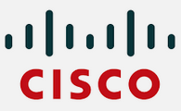

* The network and scaling will be handled by AT&T itself and for the hard work and edge systems CISCO
* Blockchain solution and deployment will be with service partners Amazon web services.
* The payment gateway integration partners will be companies like visa, MasterCard, etc.,
* Finally, the payment processing happens on the e-commerce with the payment gateways like Anzen, stripe, etc.,

# MARKETING PLAN

**2.1 Overall Marketing Plan:**

Anzen will use demographic and psychographic segmentation strategies to target the different consumer bases based on groups, choices, preferences, and tastes. We will use a differentiated targeting strategy to fix the varying demands of the users. Product-based positioning will be used in the positioning strategy of Anzen to develop appropriate visibility in several markets. The main mission of the company is to create a safe and convenient method for transactions. **Segmentation, Targeting, and Positioning:**

### ****Competitive Advantage:****

#### **Exclusive Platform:**

Our digital platform offers an end-to-end interface that helps the merchants and users in performing mobile and digital transactions without any nuisance. We provide hassle-free transaction service without any risk which is the biggest achievement of the company.

### ****BCG Matrix:****

Anzen will have major digital business payment platforms for customers. Businesses will be linked together in the form of transactions and connecting thousands and millions of merchants and customers globally. Businesses will be successful, that’s why both are started in the BCG matrix.

### ****Distribution Strategy:****

The company will create user interfaces that assist the customers in transaction processing and will offer payment platforms. As a result, we can receive and send payments in different markets without any trouble. To shorten the boundaries, we integrate merchant accounts and consumer digital wallets digitally.

### ****Competitive Analysis:****

There is no denying that the national digital payment market is highly competitive and Anzen will be facing stiff competition from different players. We are competing with rivals on some specific factors like user-friendly interfaces, customer service, ease of transactions, and engaging capabilities. We will be attracting merchants and consumers with its offerings and products. The major competitors of Anzen are Palo Alto, Wepay, Fintech firms, Verizon, and several other digital platforms.

### ****Market Analysis:****

The digital payment industry has different challenges in both developing and developed nations in the form of per capita income, increasing literacy rate, automation, and migration of people. Plus, the appearance of other fintech companies is another important factor that is giving head-on competition to Anzen.

### ****Customer Analysis:****

Most of the customers of Anzen will be tech-savvy and offer to make online or digital transactions or payments. Most users of [Anzen](https://www.paypal.com/us/home) will be B2C firms and merchants.

#### **2.2 Digital Marketing-**

#### **Anzen’s Email Marketing:**

Email marketing is a tried-and-true method of reaching both individual consumers and business customers. Did you know that 93% of our competitors use emails? Emails will lead to engagement which turns subscribers into leads … and then customers.

Email marketing is also a powerful vehicle for sharing your brand’s content. 83% of our competitors use email newsletters as part of their content marketing program, and 40% of our competitor’s marketers say these newsletters are most critical to their content marketing success.

With the constant barrage of emails flooding our inboxes today, it’s more important than ever to create and send out effective marketing emails.

#### **Anzen’s Digital Marketing:**

Every business, whether should have a digital presence — which is comprised of paid ads, search engine optimization, a website, and any other place our competitor’s company is active online. Let’s walk through a handful of tactics that strengthen our digital marketing strategy.

##### 1. Define the target audience.

##### 2. Create a website.

##### 3. Optimize our digital presence.

##### 4. Run PPC campaigns.

Finally, round out our digital presence with [pay-per-click (PPC) advertising](https://blog.hubspot.com/marketing/ppc), which allows us to get our content and brand in front of new audiences via search engines and other advertising platforms. Maximizing our PPC investment by advertising more than our specific products or services — such as our brand personality, blog or social media content, or company tagline.

#### **Anzen’s Content Marketing**

Whereas a traditional PR marketing strategy interrupts a consumer’s day-to-day with promotional material, a content marketing strategy adds valuable information and informs the consumer — which is precisely what our customers are looking for. Not to mention that content marketing supports SEO efforts, which involves anticipating what your audience is searching for, helping them discover your website and content … and potentially converting them to customers.

Because our buyer’s journey is slightly different than the B2C buyer’s journey (which has shorter sales cycles and fewer decision-makers involved), the content we create for your customer’s content marketing strategy may vary more than the content you’ve seen as a consumer yourself, as illustrated in the below graphic.

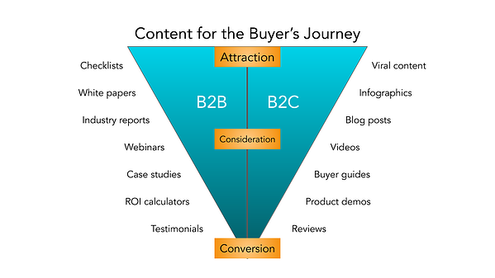

#### Our social media Marketing

75% of B2-B buyers and 84% of C-Suite executives use social media when making a purchase. That’s right — social media marketing isn’t just for brands targeting individual consumers.

Many competitors’ companies struggle with social media marketing, though. It will be harder to use social media to connect with business customers, especially because (as we mentioned above) there’s typically a lengthier sales cycle and longer chain of command.

Honestly, our social media marketing might not be where we convert the greatest number of leads, and that’s OK. It likely comes into play near the beginning of our customers’ buyer’s journeys.

Social media is a powerful tool for building brand awareness, giving our company an online personality, and humanizing our business — all very powerful factors when it comes to marketing and connecting with potential customers. Like email marketing, social media is also a highly effective channel for sharing our content and enhancing our brand expertise, the latter of which we know our customers appreciate.

2.3 Target Market

Anzen’s target market includes both small startups and Fortune 500 giants looking for secure payment services.

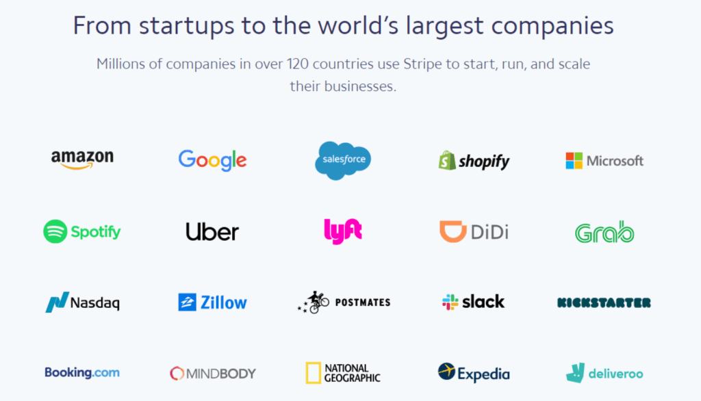

2.4 Market Positioning

Describing Business Strength vs Product Offering Strength from Low, Medium, and High aspects of services they provide in terms of giving security to different types of Digital/eCommerce Payments. Some companies out of this positioning chart also provide many different features but we are just focusing on online secure payments. So according to our Business Strengths and product offering strength, we are almost at the top of leading payment security providers.

1. PRICING STRATEGY –

Pricing decisions are complex and made taking into account many factors – the customers, the competition, the number of transactions per year, the Frequency of transactions, and environmental factors. The typical steps in setting a pricing policy are a) selecting the pricing objective b) Determining demand c) Estimating costs d) analyzing competitors’ costs, prices, and others e) selecting a pricing method, f) number/frequency of transactions, and f) setting a final price. The pricing objective of AT&T is to gain as many markets shares. Below, we will cover the rest of the steps in detail as we construct the final price.

There are multiple tiers of services offered by AT&T based on the incremental numbers of transactions.

* Less than 1 million
* 1 million to 10 million
* 10 million to 50 million
* 50 million to 100 million
* 100 million to 500 million
* More than 500 million

For price modeling, we will just consider all offerings as they are of immediate priority to AT&T and they already have the network and partial platforms built already for them.

## Pricing for different numbers of transactions-

As Stated above, below is the pricing model for different numbers of transactions-

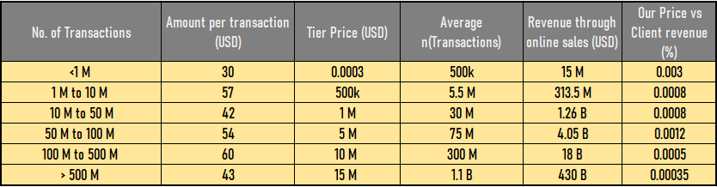

* For less than 1 million of several transactions the pricing will be fixed o.3% of the transaction amount, which will include all amount transactions.
* For several transactions more than 1 million until 10 million companies will be charged a fixed $5,00,000. Where the number of transactions can be varied across the range and customers need to pay fixed pricing.
* For several transactions more than 10 million to 50 million the pricing will be fixed and that is $10,00,000.
* For several transactions more than 50 million to 100 million the pricing will be fixed and that is $50,00,000.
* For several transactions more than 100 million to 500 million the pricing will be fixed and that is $100,00,000.
* For the number of transactions more than 500 million the pricing will be $150,00,000.
* The pricing objective of AT&T is to gain as many markets shares. Below, we will cover the rest of the steps in detail as we construct the final price.
* The Price vs Client revenue percentage is decreasing concerning the number of transaction increases.

1. SALES PLAN –

An effective sales plan in place can help as a building block for the growth as well help in the steady scalability and sustainability factors of the organization. Apart from the basic account qualification criteria, the sales plan also needs the right team personnel to reach out to the CXOs of various customers for networking and acts as a brand ambassador of Anzen. The right salesperson will have the skills like sales leads hunting/farming, nurturing the leads, establishing intent with clients, converting the leads into opportunities, doing the right stakeholder mapping from both clients and Anzen, conducting a thorough Proof of concept with clients, effectively negotiate the commercials and convert the client into a paying customer.

4.1. Sales Processes-

The sales process will consist of the following steps to ensure a smooth conversion flow:

* Profiling the right talent –

To attract the right talent for Anzen who has market understanding and has worked previously in the Fintech companies like Klarna, Coinbase, etc. He/She understands the company values and acts as a primary liaison between the client and Anzen. Over the initial 2-3 months the salesperson will be trained and taken through the product and company processes.

* Marketing Qualified Leads/ Sales Qualified Leads –

Initially, the leads will be generated using software like HubSpot, LinkedIn Lusha, and direct inquiries through various networking and marketing events. We will also activate the blast email campaign from MailChimp

* Opportunity –

After the intent has been established with the client company, the lead will be converted to an opportunity and will be kept warm while understanding the current process gaps and engaging the customer through the pull strategy.

* Stakeholder Mapping –

For successful conversion of the client, the most important thing is to leverage the industry connections. For this, stakeholder mapping is important to establish the connection with the various leadership executives and engage the decision-makers of the customer.

* POC/Pilot –

Engage the customer and take necessary approvals to conduct a pilot of the product with the customer. While this will positively help with the simulation of the actual look and feel of the product, it will also help Anzen to gain the confidence of the customer with their payment processing gaps.

* Commercial Negotiation –

With the POC run at the client, the final step will be negotiation with the senior leadership or the purchasing/procurement/finance department of the customer. For this, strategically defining the floor and ceiling of the price will play an important role in closing the commercials.

* LOI/Legal Review –

As we are dealing with the sensitive data of the transaction, we will need to be compliant with the Information security policy and proprotecte PII data while interacting with the CISO, DPO, and CIO of the customers. This process will take 1-2 months to receive the go-ahead head while the legal team of both sidraftsraft the legal document and come to consent.

* Deal Won

The below diagram represents the stages in tandem with the timelines each conversion will take and also the funneling of the customers at each step

LOI/ Legal Review

{1-3 months} | 16 customers

**Deal Won**

**6 customers**

Intent / Opportunity

{0.5 month} | 225 customers

POC/ Pilot

{2-3 months} | 75 customers

Stakeholder Mapping

{1 month} | 125 customers

Commercial Negotiation

{1-2 months} | 35 customers

4.2. Sales Cycle Overview-

1. **The Customers Profiling**

* **Size of Account**

The account should fall in the below-mentioned slabs

|  |  |  |  |  |  |
| --- | --- | --- | --- | --- | --- |
| **Category of Account** | | | | | |
|  | **Small** | **Medium** | **SOME** | **Large** | **Enterprise** |
| **Volume of transactions** | >1 million | 10-50 million | 50-100 million | 100-500 million | <500 million |

* **Buyer persona/ Mapping Stakeholders**

Background - Designation, Tenure in company, Maturity

Demographics - Male/Female, Urban/ Suburban

Change Catalyst - Yes/No

* **Key Business Need**

The current product has a vulnerability in the payments process and needed a comprehensive solution that tackles the external threats.

* **Mode of Engagement/ Likeliness to Buy**

The account will likely fall in these categories after the initial meeting

I. Client wants to start straight away

Ii. The client wants to do a pilot

Iii. RFPs are called for Quote Comparison/Evaluation

* **Deal History**

Cold lead that can be converted through various marketing engagement channels

1. **Strategic Exceptions**

There are a few parameters to add if the above-mentioned criteria do not qualify for going ahead with the account.

* **Brand Entity**

The brand entity will be a deciding factor too while qualifying an account even if the users are fewer but we will be adding a brand to the portfolio. It can be divided into 2 parts :

Small (High growth startup/ established brand)

Enterprise (more profit margin due to certain company policies)

* **Risk Appetite (Internal Call)**

In terms of operational bandwidth and expansion in a different geography, we need to see the revenue margins Ability to bear a fixed cost

* **Volume of account**

In accounts where transaction volume is low, the current SOW will be sacrosanct.

1. FINANCIAL PLAN –
   1. Development costing-

The development cost includes many subdivided things, those are human resources cost, infrastructure cost, scaling cost, and cost from partners. All those costs are explained below in the tabular format

* **Human Capital Cost-**
* The following table shows different human resources cost over the 5 years.

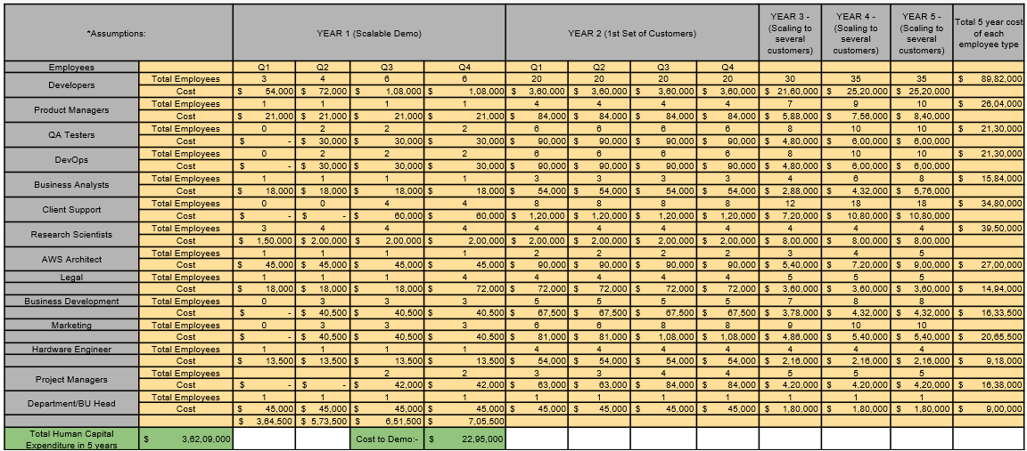

* The total Human Capital expenditure in 5 years will be 3,62,09,000 USD.
* The table is formatted based on the quarterly for the first 2 years where the major development going to take place and yearly for the 3rd, 4th, and 5th year.
* The employees include from different backgrounds together in this table from development, testing, sales, and marketing.
* The assumptions taken here are the number of employees will increase as the number of customers increases over time to balance the workload.
* Monthly salary for each of the employee can be summarized based on the above overall table
* **Infrastructure Costs-**

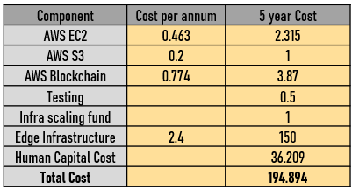

* The Infrastructure Cost includes costs from AWS deployment environments, blockchain, testing infrastructure, and edge infrastructure.
* The above table gives details of cost per annum as well as the total 5-year infrastructure cost which is a total, of 194,894 USD.
* The edge and blockchain costing is considered based on the assumption of costing of 125000 USD each month for edge processing and operations.
* The majority of costing is going towards the edge and blockchain components.
* **Development cost overview-**
* The Following table contains data regarding the Development, Marketing, and BD, Legal, Infrastructure, client support cost over the first 5 years.

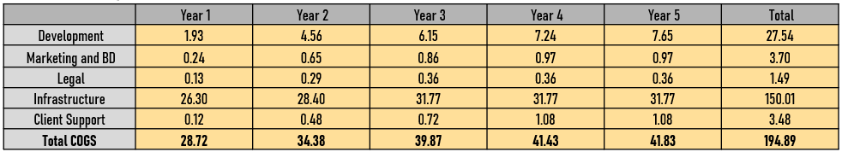

* The total COGS is provided in this table year-wise with a total of 194.89 million USD.
* The overall development, Marketing, and BD, legal, infrastructure costs are also provided year-wise with a total amount equal to the COGS.
* The development cost is calculated with the assumed number of customers over 5 Years.
  1. **REVENUE CALCULATIONS-**

The Revenue calculations include the pricing overview in different categories with the revenue concerning customers over the 5 years.

* **Pricing Overview-**
* Pricing decisions are complex and made taking into account many factors – the customers, the competition, the number of transactions per year, the Frequency of transactions, and environmental factors.



* The typical steps in setting a pricing policy are a) selecting the pricing objective b) Determining demand c) Estimating costs d) analyzing competitors’ costs, prices, and others e) selecting a pricing method, f) number/frequency of transactions, and f) setting a final price.
* The pricing objective of AT&T is to gain as many markets shares. Below, we will cover the rest of the steps in detail as we construct the final price.
* The Price vs Client revenue percentage is decreasing concerning the number of transaction increases.
* **Customers and Revenue Calculation-**
* The following table gives the comparison of the number of customers vs revenue calculations.
* The first customer is in the q1 of the first year and from then the revenue is started.
* There is a significant increment in several customers from year one to year 5. As it will be assumed to reach the USD over the 5 years.
* The revenue is calculated differently with the above pricing formula based on the number of transactions and this is provided year-wise in this table.
* The table also shows the YOY revenue, which is increasing each year.
* The same calculations are used to calculate the profit and loss statement and determine the breakeven point of the project.
* The profit and loss are provided with overall cost and revenue which is negative in the first year but increases gradually over the course.

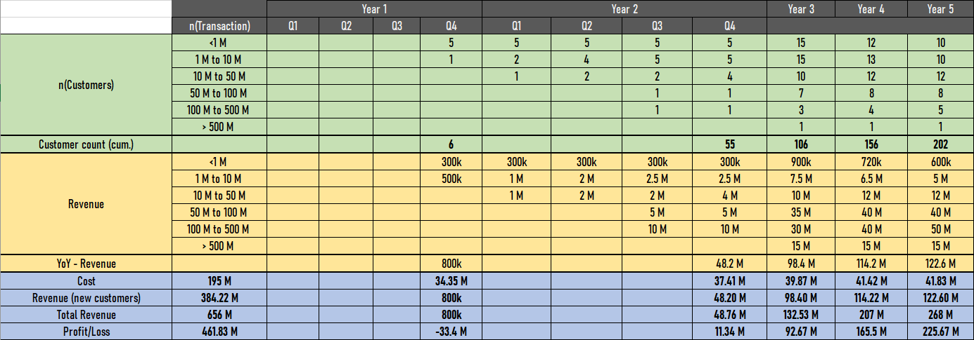

* The profit/loss for first-year is -33.4 M(USD) and from then it is increasing to reach 225.67 M(USD) at the end of 5 years.
  1. PROFIT AND LOSS STATEMENT-
* The Profit and loss statement is calculated considering revenues from all components of the project w.r.t the pricing of each component used during the project timeline.

* 1. BREAKEVEN ANALYSIS-

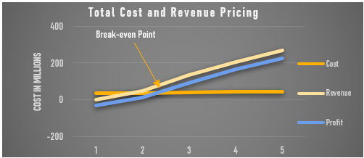

* The Breakeven Analysis is calculated based on the numbers we got from profit and loss statements and financial calculations for costing and revenue.
* The graph shows the cost in millions vs years for 1 to 5. With different projections of the cost, revenue, and profit.
* The cost is constant as assumed to be put the same amount over the year for the development and support of the project.
* The revenue is -ve in the first year and increase gradually over the period.
* The Profit is calculated and projected based on the cost and revenue which is also increasing over the time in 5 years.
* The breakeven point is coming in the latter half considerably Q4 of the 2nd tear. Same is indicated with the point (Break-even pit in the graph.
  1. GROWTH PER YEAR-
* The above graph shows the Growth per year from year 1 to The year 5
* It consists of 3 columns cost, total revenue, profit and considered for the first 5 years.
* The graph indicates as also shown in breakeven point graph in the first year there is very less revenue with price almost constant for 5 years the revenue so the profit is increasing after 2ns year.

1. RISK**-**

* **Risk Identification -** Identify the relevant risk to organization PII (Asset Risks | People Risks | Technology Risks | Process Risks | Competition Risks)
* **Risk Analysis** - Identify the likelihood and impact of the applicable risks on the organization’s PII
* **Risk Evaluation** - Based on the Residual Risk, decide on treatment Options- Accept | Mitigate | Transfer| Avoid
* **Risk Mitigation** - Detailed sales pitch| white papers research|quick win from earlier customers | Monitor Competition pricing strategy
* **PII Data -** Potential that either the company or end-user will have concerns about the data being directly sent via AT&T, so whitelisting the URLs is important.

6.1**. RISK ASSESSMENT-**

* Customer Retention – The math relies upon the assumption of 70% customer retention YoY
* Aggressive Customer Acquisition – The model is dependent on the total acquisition of the customers by  
  the team
* Single Investor - Since AT&T is the sole investor in the venture, the funding is innately tied to AT&T’s performance and growth

**6.2. SUCCESS FACTORS-**

* + - Sustainable and scalable growth over 5 years
    - Financially viable business model with recurring revenue from customers
    - Multi-party collaboration
    - Extension to S, M, & L businesses
    - Scalability of Solution capabilities

**7.0 SUMMARY-**

* In summary the report starts with the explanation of the product solution which is to secure payment, the value, and uses to customers, and AT&T also explains how this new service will leverage 5G and Edge Computing.
* The architecture of the end-to-end solution is provided with each component in the flow chart in sequence, with the service needs and dependent things to provide a solution to the customer.
* The overall cost is provided which included human resources, infrastructure, licensing, development, service support, sales, marketing, and Miscellaneous costs, with an overall cost vs revenue model for the first 5 years.
* The overall costing and Profit and loss statement with Breakeven analysis are given in this report.

**8.0 References-**

* <https://www.juniperresearch.com/press/online-payment-fraud-losses-to-exceed-200-billion>
* <https://www.businesswire.com/news/home/20210425005002/en/Juniper-Research-eCommerce-Losses-to-Online-Payment-Fraud-to-Exceed-20-Billion-Annually-in-2021>
* <https://www.businesswire.com/news/home/20210425005002/en/Juniper-Research-eCommerce-Losses-to-Online-Payment-Fraud-to-Exceed-20-Billion-Annually-in-2021>
* [https://www.csoonline.com/article/3340117/man-in-the-middle-attack-definition-and-examples.html#:~:text=Though%20not%20as%20common%20as,are%20difficult%20to%20come%20by.](https://www.csoonline.com/article/3340117/man-in-the-middle-attack-definition-and-examples.html#:~:text=Though%20not%20as%20common%20as,are%20difficult%20to%20come%20by)
* <https://www.vesta.io/blog/the-true-cost-of-ecommerce-fraud-2021>
* <https://www.ravelin.com/insights/online-payment-fraud#:~:text=Global%20fraud%20average%20costs%3A,businesses%20lose%20an%20extra%20%242.94>
* <https://www.census.gov/retail/mrts/www/data/pdf/ec_current.pdf>