**Q1. Why 'pip' is used while installing the PySpark?**

* **pip' is a package manager for Python** t**hat is used to install and manage Python packages.**
* PySpark is a Python package that provides an interface for Apache Spark, a powerful distributed computing system.

When you install PySpark using pip, it automatically **installs all the necessary dependencies and libraries** required for running PySpark. These dependencies include Python packages like **Py4j, which is required for the communication between Python and Java** **components of Spark,** **and other Spark libraries like Spark SQL, Spark Streaming, and Spark MLlib.**

So, 'pip' is used while installing PySpark to simplify the installation process and ensure that all necessary dependencies are installed correctly. Additionally, using pip to install PySpark ensures that you are using the latest stable version of PySpark available on the Python Package Index (PyPI).

**Q2. Why 'pip' is used while installing the PySpark?**

When you install a package using pip, the installation takes place in a location specific to your Python environment.

By default, when you install packages using pip, they are installed in the site-packages directory of the Python environment that you are using. This directory is typically located in the Python installation folder, and contains all of the third-party packages and modules that you have installed using pip.

However, if you are using virtual environments to manage your Python packages, the installation will take place within the virtual environment's site-packages directory. Virtual environments allow you to create isolated Python environments, each with its own set of packages and dependencies. This helps to avoid conflicts between different packages and makes it easier to manage dependencies for different projects.

You can use the command pip show <package-name> to find the location where a package is installed.

**Q3. When we install using pip where does the installation takes place?**

When you install a package using pip, the installation takes place in a **location specific to your Python environment.**

By default, when you install packages using pip, they are installed in the ***site-packages directory of the Python environment*** that you are using. This directory is typically located in the Python installation folder, and contains all of the third-party packages and modules that you have installed using pip.

However, if you are using **virtual environments** to manage your Python packages, the installation will take place **within the virtual environment's site-packages directory**. Virtual environments allow.you to create isolated Python environments, each with its own set of packages and dependencies. This helps to avoid conflicts between different packages and makes it easier to manage dependencies for different projects.

You can use the command pip show <package-name> to find the location where a package is installed.

**Q4. import pyspark?**

* Importing PySpark after installing it is necessary because it is the way to make the PySpark module and its associated classes, functions, and variables available to your Python program.
* PySpark is a Python library that provides an interface for **Apache Spark, which is a powerful big data processing engine.**
* ***When you install PySpark, you are essentially installing a package that contains all the necessary modules and files needed to use Spark from Python.***
* **However, simply installing PySpark does not automatically make all its functions and classes available in your Python program. You need to import it first to use it.**
* To import PySpark in your Python program, you can use the following command at the beginning of your code.

**Q5. Why from pyspark.sql import SparkSession?**

from pyspark.sql import SparkSession is used

* to import the SparkSession **class** from the pyspark.sql module in PySpark.
* **SparkSession is the entry point to programming Spark with the DataFrame and Dataset APIs, and it provides a way to interact with Spark using a programming interface.**
* It is used to configure, create, and manage Spark applications, and to create DataFrames, which are the main data structure in PySpark.
* By importing SparkSession from the pyspark.sql module, we can create a SparkSession object in our Python code, which allows us to interact with Spark using the DataFrame and Dataset APIs.

For example, we can create a SparkSession object as follows:

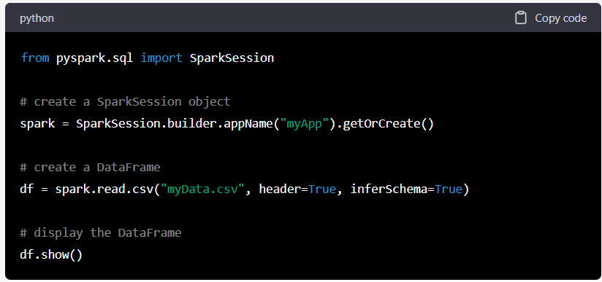

This code creates **a SparkSession object named spark**, which is used **to read a CSV file and create a DataFrame df.** ***We can then display the contents of the DataFrame using the show() method.***

Q6.: spark = SparkSession.builder.appName("myApp").getOrCreate() what does. appname and .get or create code do in this code?

* In the code spark = SparkSession.builder.appName("myApp").getOrCreate(), appName and getOrCreate() are methods used to **configure and create** a SparkSession object in PySpark.
* appName("myApp") is used to set the name of the Spark application to "myApp". This name will appear in the Spark UI and logs, and it is used to identify the application when running on a cluster.
* getOrCreate() is used to either create a new SparkSession object or retrieve an existing one. If a SparkSession object with the given name ("myApp" in this case) already exists, then it will be returned. Otherwise, a new SparkSession object will be created with the given name.
* The **builder method is used to create a builder object**, which is used to configure the SparkSession object. The builder object can be used to set various properties, such as the master URL, configuration options, and the name of the application.
* So, in summary, the code spark = SparkSession.builder.appName("myApp").getOrCreate() creates a SparkSession object with the name "myApp", or retrieves an existing one if it already exists. This object can be used to interact with Spark using the DataFrame and Dataset APIs.

Q7. spark?

SparkSession - in-memory

SparkContext

Spark UI

Version

v3.3.2

Master

local[*]

AppName

Project

Q8.music=spark.read.option('header','true').csv(r'C:\Users\pisal\OneDrive\Desktop\8_march_project\final_spotify.csv') Explain this code syntax

This code reads a CSV file named "final_spotify.csv" from the specified file path C:\Users\pisal\OneDrive\Desktop\8_march_project\ and creates a DataFrame named music using PySpark.

Let's break down the code syntax:

**spark refers to the SparkSession object** that was created earlier using the SparkSession.builder.appName("myApp").getOrCreate() method.

* .read is a method used to read data from a data source in PySpark.
* .option('header','true') sets an option for reading the CSV file. In this case, it sets the option to read the first line of the CSV file as the header, which means that the column names will be taken from the first row of the CSV file.
* .csv(r'C:\Users\pisal\OneDrive\Desktop\8_march_project\final_spotify.csv') specifies the file path of the CSV file to be read. In this case, it reads the "final_spotify.csv" file from the specified path.
* Finally, the entire expression spark.read.option('header','true').csv(r'C:\Users\pisal\OneDrive\Desktop\8_march_project\final_spotify.csv') creates a DataFrame named music by reading the CSV file with the specified options and file path.
* So, this code essentially creates a DataFrame named music by reading a CSV file named "final_spotify.csv" with header as the first row, located at the specified file path.

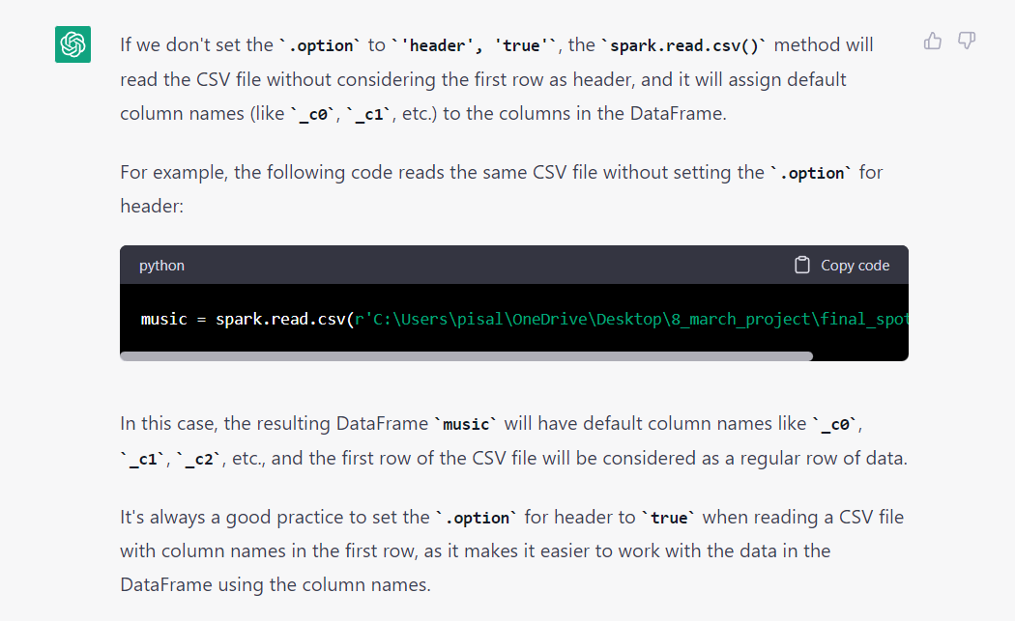

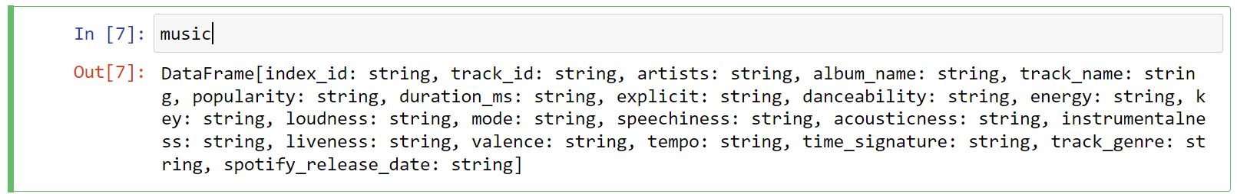

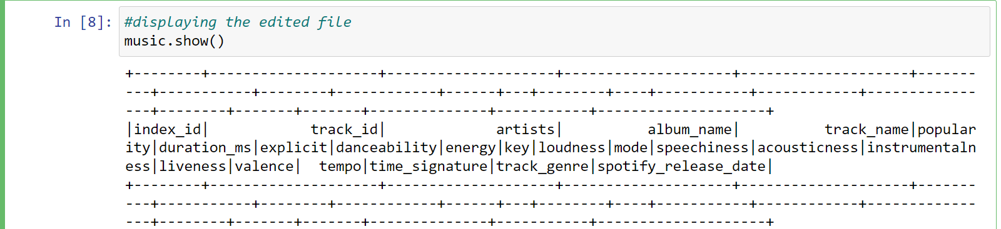

**Q.why df.printScheme is used?**

* df.printSchema() is a PySpark DataFrame method that is used to print the schema of a DataFrame in a tree format.
* A schema describes the structure of a DataFrame, including the column names, their data types, and any nested or complex types.
* By printing the schema of a DataFrame, you can get a quick overview of its structure and understand the data types of each column.
* The output of df.printSchema() will show the column names, their data types, *and whether they are nullable or not.* It is especially useful when working with large or complex DataFrames, where it may be difficult to keep track of the schema manually.
* For example, if you have a DataFrame named df, you can print its schema using the following code.

**Q. Explain this syntax:**

from pyspark.sql.types import IntegerType

from pyspark.sql.types import DoubleType

from pyspark.sql.types import BooleanType

from pyspark.sql.types import DateType

The syntax from pyspark.sql.types import <DataType> is used to import specific data types from the pyspark.sql.types module in PySpark.

**PySpark is a Python library** used for big data processing and analysis. The pyspark.sql.types module provides a set of data types that can be used for creating schema for DataFrames or Structured Streaming in PySpark.

The four data types mentioned in the syntax are:

**IntegerType:** A data type representing integer values. It has a range of -2147483648 to 2147483647 (**32-bit signed integer**).

**DoubleType:** A data type representing floating-point values with double precision. It has a range of approximately **1.7E-308 to 1.7E+308.**

**BooleanType:** A data type representing boolean values (True or False).

**DateType:** A data type representing date values. It stores values in the format "YYYY-MM-DD".

By importing these data types, they **can be used in PySpark programs to define the schema of DataFrames or Structured Streaming.** For example, to create a DataFrame with columns of type IntegerType, DoubleType, BooleanType and DateType, the following code can be used:

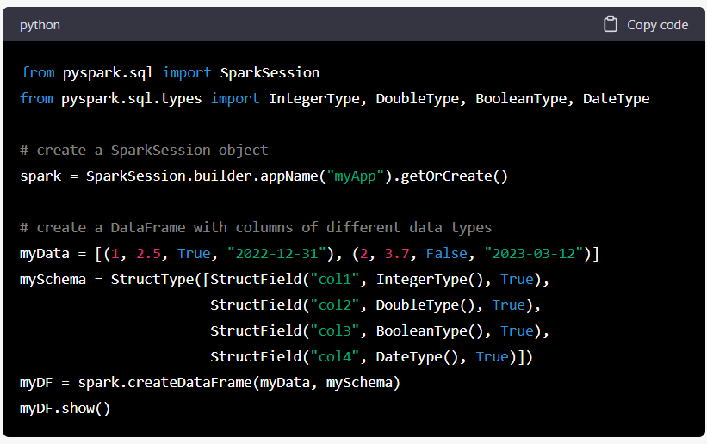

This will create a DataFrame with four columns, where the first column is of type IntegerType, the second column is of type DoubleType, the third column is of type BooleanType, and the fourth column is of type DateType.

**What is PySpark?**

* PySpark is **a Python library** used **for big data processing and analysis.** **It is a Python API for Apache Spark**, **a powerful open-source distributed computing framework.**
* **PySpark:** A Python library used for big data processing.
* Apache Spark provides a scalable and fault-tolerant platform for processing large amounts of data across clusters of computers.
* It allows developers to write distributed applications using a variety of programming languages, including Python, Java, Scala, and R. PySpark is the Python API for Apache Spark, which allows Python developers to use **Spark’s distributed computing** capabilities to process large-scale data
* **Apache Spark: Distributed Computing Framework**
* PySpark provides an **easy-to-use programming interface to Spark's distributed data processing capabilities**, allowing developers to write scalable data processing pipelines.
* PySpark's API is designed to be similar to **Pandas, a popular data manipulation library in Python**, making it easy for Python developers to learn and use. (**Pandas:** **A data manipulation library**).
* PySpark also **integrates with other Python libraries such as NumPy and SciP**y, making it easy to perform complex data analysis tasks using familiar tools. PySpark provides support for a wide range of data sources, including Hadoop Distributed File System (HDFS), Cassandra, HBase, and Amazon S3.
* PySpark is used in a wide range of applications, **including data processing, machine learning**, **graph processing**, and **stream processing**. It is widely adopted in industry and academia, and its popularity is driven by its ease of use, scalability, and performance.

Q: Explain this syntax music = music.withColumn("popularity",music["popularity"].cast(IntegerType()))

* **This is a syntax commonly used in PySpark, which is a Python library used for processing large datasets with distributed computing.**
* In this line of code, **a PySpark DataFrame named music is being modified by adding a new column named "popularity" to it.** The new column is being created by casting the values in the existing "popularity" column to an Integer data type using the cast() method.
* The withColumn() method is used to add a new column to the DataFrame. The first argument of withColumn() is the name of the new column, "popularity" in this case. The second argument is the transformation that will be applied to each row of the DataFrame to create the values in the new column, which is the cast() method in this case. The music["popularity"] syntax is used to select the "popularity" column of the music DataFrame, and then the cast() method is applied to the selected column to convert its values to Integer data type.
* Overall, this line of code is adding a new column named "popularity" to the music DataFrame by casting the values in the existing "popularity" column to an Integer data type.

**Q. Explain this syntax music.na.drop(how='any').count()**

This is a syntax commonly used in PySpark, which is a Python library used for processing large datasets with distributed computing.

* In this line of code, a PySpark DataFrame named music is being modified by dropping any rows that contain null or missing values.
* The na attribute is used to access methods that deal with null or missing values in the DataFrame.
* **The drop() method** is being used **with the how parameter set to "any" to drop any row that contains at least one null or missing value.**
* After dropping the null or missing values, the count() method is called on the resulting DataFrame **to get the number of remaining rows.** **This method returns an integer value** indicating the number of rows in the DataFrame after dropping any rows that contain **null or missing values.**
* Overall, this line of code is **dropping any rows that contain null or missing values** from the music DataFrame and returning the number of remaining rows.

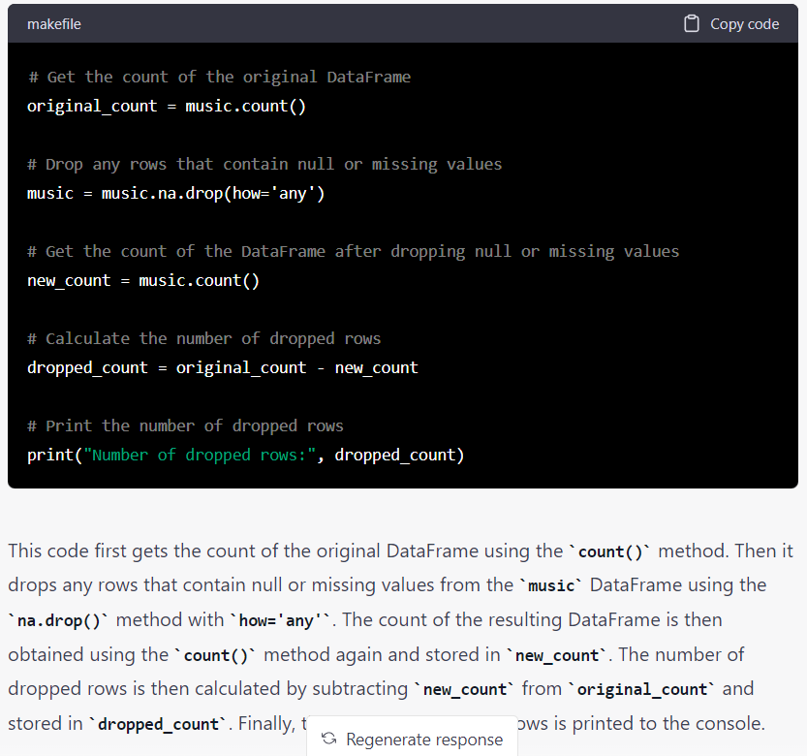

Q. Explain this syntax music.show(truncate=False)

* This is a syntax commonly used in PySpark, which is a Python library used for processing large datasets with distributed computing.
* In this line of code, a PySpark DataFrame named music is being displayed using the show() method. The show() method is used to display the contents of the DataFrame in a tabular format. The truncate parameter is set to False to prevent truncation of column values, meaning all column values will be displayed completely without being truncated.
* The show() method can be used with or without parameters. By default, the method displays the first 20 rows of the DataFrame in a tabular format, with truncated column values.
* *If you want to display a different number of rows, you can pass an integer value to the show() method, like music.show(50).*
* If you want to display the entire DataFrame without truncation, you can set the truncate parameter to False, like music.show(truncate=False).
* Overall, this line of code is displaying the contents of the music DataFrame in a tabular format without truncating the column values.

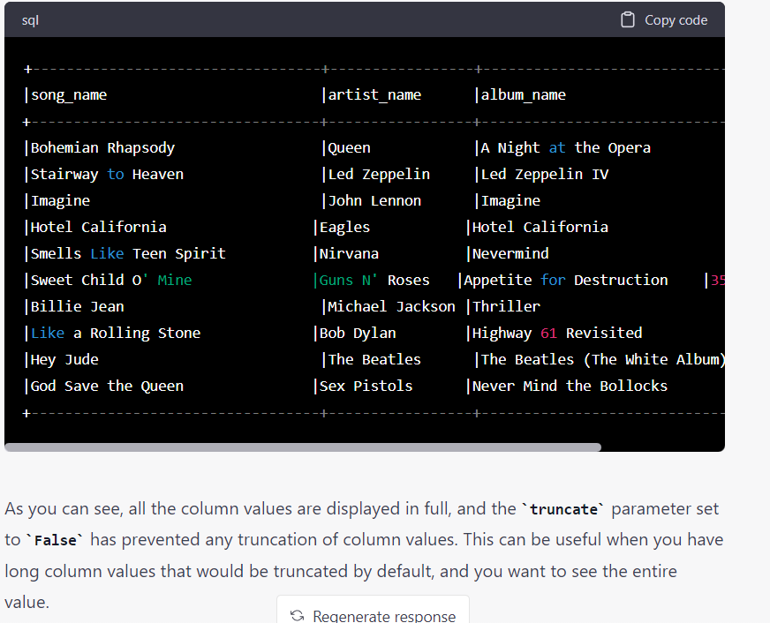

**i.e. truncation = false prevents the shortening of column values and displays the values in full.**

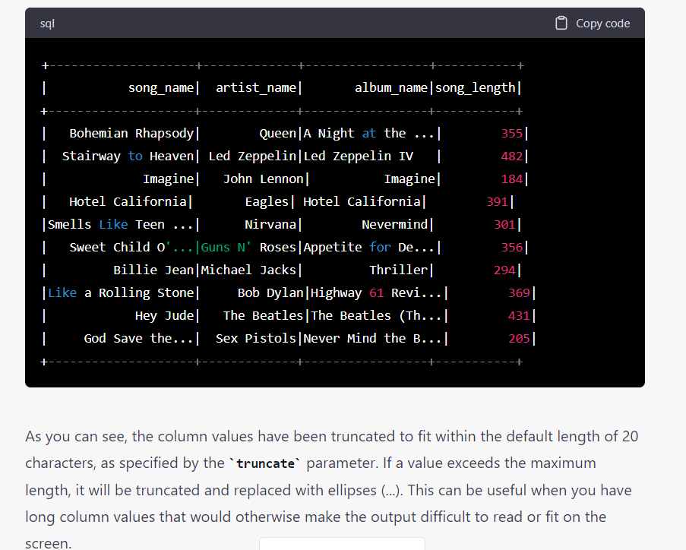

**Q. What is pyspark.sql?**

**pyspark.sql is a module in PySpark that provides a programming interface to work with structured data using Spark SQL. It allows users to perform SQL-like operations on distributed datasets using Spark's processing engine.**

**Feature Extraction:**

**Q.** from pyspark.sql.functions import col explain this syntax

* **from** is a Python **keyword that is used** to **import modules or specific functions/classes** from a module.
* **pyspark.sql.functions is a module** in PySpark that **provides functions** **for working with DataFrames and columns.**
* import is a Python keyword used to **import specific functions/classes** from a module.
* **col is a function** **in the pyspark.sql.functions module that returns a Column based on the given column name or expression.**

**So, the purpose of this code line is to import the col function from the pyspark.sql.functions module. The col function is commonly used in PySpark to refer to a column in a DataFrame.**

* **By using this function, users can specify the name of a column as a string or an expression and get a Column object, which can be used in various DataFrame operations such as filtering, selecting, and aggregating.**

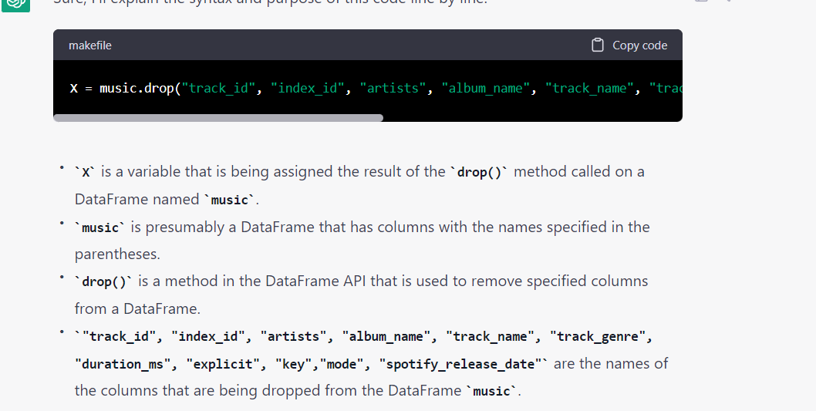

Overall, the purpose of this code line is to create a new DataFrame X that is a copy of the original DataFrame music, but with the specified columns dropped. The drop() method is called on the music DataFrame with the names of the columns to be dropped passed as arguments. The resulting DataFrame with the specified columns removed is then assigned to the variable X.

The resulting X DataFrame will have all the columns from music except for track_id, index_id, artists, album_name, track_name, track_genre, duration_ms, explicit, key, mode, and spotify_release_date.

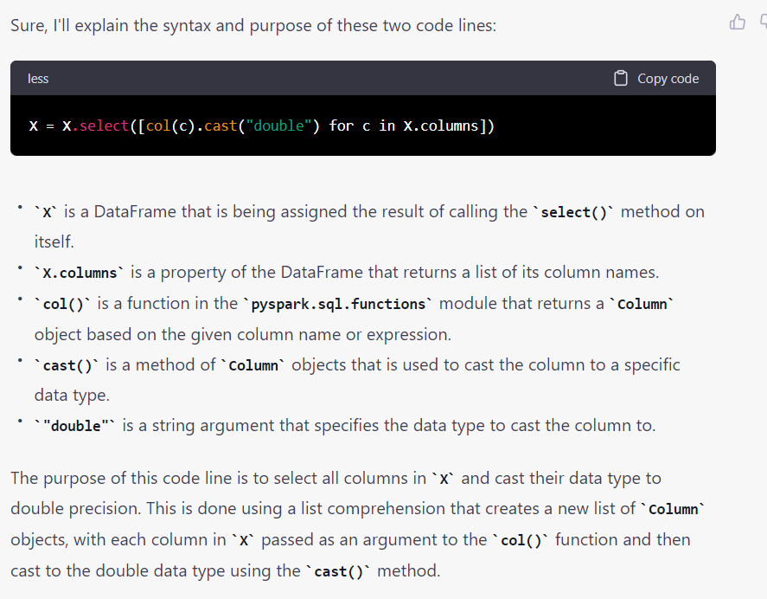 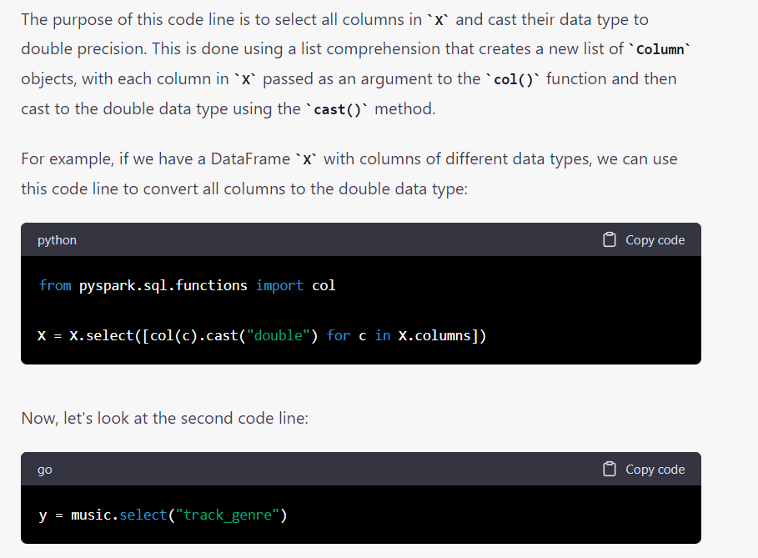 y is a DataFrame that is being assigned the result of calling the select() method on the music DataFrame.

"track_genre" is a string argument that specifies the name of the column to select.

The purpose of this code line is to create a new DataFrame y that has only one column, "track_genre", from the music DataFrame. The select() method is called on music with the column name "track_genre" passed as an argument. The resulting DataFrame y will have only one column named "track_genre".

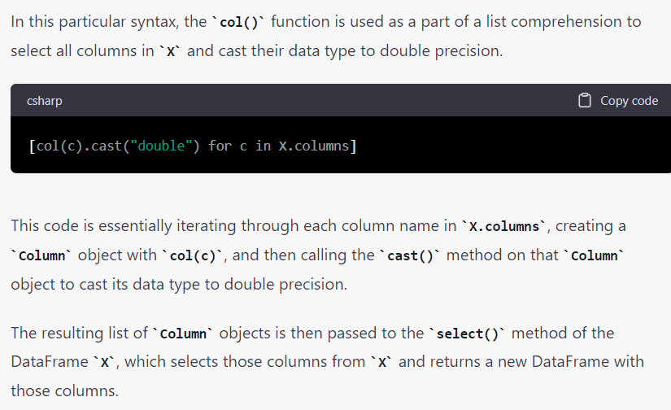

Q: from pyspark.ml.linalg import Vector

from pyspark.ml.feature import VectorAssembler

* from pyspark.ml.feature import VectorAssembler imports the VectorAssembler class from the pyspark.ml.feature module.
* **The VectorAssembler is a transformer** that **combines multiple columns of a DataFrame into a single vector column.**
* **assembler =** VectorAssembler(inputCols=X.columns, outputCol="features**") creates a VectorAssembler object named assembler.**
* The inputCols parameter is set to X.columns, **which is a list of column names from the DataFrame X.**
* **The outputCol parameter is set to "features", which is the name of the new vector column that will be created by the VectorAssembler.**
* X_transformed = assembler.transform(X).select("features") applies the transform() method of the VectorAssembler object assembler to the DataFrame X.
* **The transform() method combines the columns specified in inputCols into a new vector column specified by outputCol**.
* The result is a new DataFrame with an additional column named "features".
* ***Finally, the select() method is called on this new DataFrame to select only the "features" column and assign the resulting DataFrame to X_transformed.***
* ***The purpose of this code is to create a new DataFrame X_transformed that has all of the columns in the original DataFrame X combined into a single vector column.***
* **This can be useful for machine learning algorithms that require a single feature vector as input.**
* The VectorAssembler class is used to perform this operation by specifying the list of input column names (X.columns) and the name of the new output column ("features"), which is then applied to the original DataFrame X.

**from pyspark.ml.linalg import Vector:**

**The code from pyspark.ml.linalg import Vector imports the Vector class from the pyspark.ml.linalg module.**

* **The pyspark.ml.linalg module contains classes for linear algebra operations on Spark DataFrames. The Vector class is used to represent a dense vector of double precision floating point values.**
* **The Vector class provides various methods for performing vector operations such as addition, subtraction, dot product, and normalization.**

**Q. assembled_data=assembler.setHandleInvalid("skip").transform(X)**

* **The code assembled_data=assembler.setHandleInvalid("skip").transform(X) sets the handleInvalid parameter of the VectorAssembler object assembler to "skip", and applies the transform() method to the DataFrame X.**
* **If any of the input columns contain null or NaN values, the handleInvalid parameter specifies how to handle those missing values.**

Q**: from pyspark.ml.feature import StandardScaler:**

* **The code from pyspark.ml.feature import StandardScaler imports the StandardScaler class from the pyspark.ml.feature module.**
* **The pyspark.ml.feature module contains classes for feature engineering operations on Spark DataFrames.**
* **The StandardScaler class is used to transform features by scaling them to have a zero mean and unit variance. This is often used as a preprocessing step before applying machine learning algorithms.**

**Q: Why scaling is performed?**

* **Different scales: By scaling the features to a common scale.**
* **Gradient descent:** **Scaling the features can help to ensure that the cost function has a similar curvature in all directions, which can speed up the convergence of the algorithm.**
* **Regularization:** **Scaling the features can help to ensure that the regularization term has a similar strength for all features, which can improve the performance of the model.**

**in a dataset can help to improve the performance of machine learning algorithms**

**It rescales the input features so that they have zero mean and unit variance.**

**The fit() method of the StandardScaler object calculates the mean and standard deviation of each feature in the input dataset.**

These values are used to rescale the data when the transform() method is called.

**Q: from pyspark.ml.classification import RandomForestClassifier**

This code is importing a machine learning algorithm called RandomForestClassifier from the PySpark ML library.

* **classification:** This is a sub-module within the ml package that contains the algorithms and tools for classification tasks, such as predicting a categorical outcome variable.
* **RandomForestClassifier:** This is the specific machine learning algorithm that is being imported. It is a type of ensemble learning algorithm that combines multiple decision trees to make predictions.