Linux Basics – Assignment Submission

Student Name: [Rushikesh Mulik]

Date: [27/6/2025]

Git :[Link]

# 1. Creating and Renaming Files/Directories

* Commands Used:

1. mkdir test_dir
2. cd test_dir
3. touch example.txt
4. mv example.txt renamed_example.txt

Explanation:

Creates a directory, creates a file inside it, and renames the file.

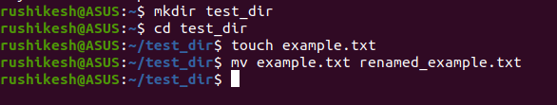

# 2. Viewing File Contents

* Commands Used:

1. cat /etc/passwd
2. head -n 5 /etc/passwd
3. tail -n 5 /etc/passwd

Explanation:

Displays the full content of /etc/passwd, then shows the first and last 5 lines.

# 3. Searching for Patterns

* Commands Used:

1. grep "root" /etc/passwd

Explanation:

Searches for all lines containing the word 'root' in /etc/passwd.

# 4. Zipping and Unzipping

* Commands Used:

1. cd ..
2. zip -r test_dir.zip test_dir
3. mkdir unzipped_dir
4. unzip test_dir.zip -d unzipped_dir

Explanation:

Compresses a directory and then extracts it into a new directory.

# 5. Downloading Files

* Commands Used:

1. wget https://www.learningcontainer.com/wp-content/uploads/2020/04/sample-text-file.txt

Explanation:

Downloads a sample text file using wget.

# 6. Changing Permissions

* Commands Used:

1. touch secure.txt
2. chmod 444 secure.txt

Explanation:

Creates a file and changes its permissions to read-only for all.

# 7. Working with Environment Variables

* Commands Used:

1. export MY_VAR="Hello, Linux!"
2. echo $MY_VAR

Explanation:

Sets and displays an environment variable.