Software Requirements Documentation
OpenCart – Open-Source E-Commerce Platform
Item | Details
Internship | QA Engineer Internship – Manual
Task | Week 1 – Understanding Software and Its Requirements
Prepared by | Rushikesh Garje
Software studied | OpenCart (open-source, publicly available web application)
Public demo | https://demo.opencart.com (storefront) and https://demo.opencart.com/admin (administration)
Document type | Functional and Non-Functional Requirements Document

1. Introduction

1.1 Purpose
This document records my understanding of OpenCart, a publicly available open-source e-commerce application. It describes what the software does, how users move through it, and the functional and non-functional requirements a manual QA engineer should know before writing test cases. It is written so that a reader who has never used OpenCart can follow it.

1.2 Scope
The document covers two parts of OpenCart: the customer-facing storefront and the administration panel. It focuses on core online-store behaviour: browsing, searching, cart, checkout, account management, catalogue management, order management and store settings. Third-party extensions and themes are out of scope.

1.3 Intended Audience
- Manual QA testers preparing test plans and test cases
- Business analysts and developers who need a quick requirement overview
- Reviewers evaluating my understanding of the software

1.4 Definitions
Term | Meaning
Storefront | The public website where customers browse and buy products.
Admin panel | The back-office area where store staff manage products, orders, customers and settings.
SKU / Model | A product code used to identify an item in the catalogue.
Guest checkout | Placing an order without creating a customer account.
FR / NFR | Functional Requirement / Non-Functional Requirement.

2. About the Software
OpenCart is a free, open-source online store management system written in PHP and backed by a MySQL/MariaDB database. It is released under the GNU General Public License, so anyone can download, inspect and use it. A store owner can set up a complete online shop without writing code, and developers can extend it with modules, extensions and themes.
Attribute | Details
Category | E-commerce / online shopping cart
Technology | PHP, MySQL/MariaDB, HTML, CSS, JavaScript (Bootstrap-based default theme)
Licence | GNU GPL (open source)
Access | Web browser on desktop, tablet or mobile; no installation needed to use the public demo
Main users | Shoppers (customers) and store administrators
Multi-store | Supports running several stores from one admin panel

3. Key Features

3.1 Storefront (Customer Side)
- Home page: banner slideshow, featured products, top navigation menu with categories.
- Product catalogue: category and sub-category browsing, product listing with sorting and pagination, grid/list view.
- Search: keyword search with optional category filter and description search.
- Product page: images, price, model, brand, availability, options, description, specifications, reviews and ratings.
- Shopping cart: add, update quantity, remove items, apply coupon or gift voucher, estimate shipping.
- Wish list and compare: save products for later and compare up to four products side by side.
- Customer account: register, log in, edit profile, change password, manage address book, view order history, returns and newsletter subscription.
- Checkout: guest or registered checkout, billing and delivery address, shipping method, payment method, order confirmation.
- Currency and language: switch between configured currencies and languages.
- Information pages: About Us, Delivery Information, Privacy Policy, Terms & Conditions, Contact Us, Site Map.

3.2 Administration Panel (Store Owner Side)
- Dashboard: summary of total orders, sales, customers, and recent activity.
- Catalogue management: add, edit, delete products, categories, manufacturers, attributes, options and filters.
- Order management: view orders, change order status, add order history comments, generate invoices and shipping lists.
- Customer management: view and edit customer records, customer groups, approvals.
- Marketing: coupons, banners, mailing and promotions.
- Extensions: enable or configure payment methods, shipping methods, order totals and modules.
- System settings: store details, tax classes and rates, currencies, languages, countries/zones, user accounts and permission groups.
- Reports: sales, products viewed and purchased, customer activity.

4. User Roles
Role | Description and Access
Guest visitor | Can browse, search, view products, add to cart and check out as guest. Cannot view order history or use wish list persistently.
Registered customer | Everything a guest can do, plus profile, address book, order history, wish list, returns and reward points.
Administrator | Full access to the admin panel: catalogue, orders, customers, extensions, settings and users.
Restricted admin user | Admin user whose permission group limits which admin pages can be viewed or modified.

5. User Flow

5.1 Customer Purchase Flow
- Open the storefront home page.
- Browse a category from the menu, or type a keyword in the search box.
- Open a product page and review price, description, options and reviews.
- Select required options (if any) and quantity, then click Add to Cart.
- Open the cart; update quantities, apply a coupon if available and check the totals.
- Click Checkout and choose Guest Checkout, Register Account or Login.
- Enter billing and delivery address details.
- Select a shipping method and a payment method.
- Review the order summary, accept the Terms & Conditions and confirm the order.
- See the order success page; the order appears in My Account > Order History (registered users).

5.2 Account Management Flow
Register with name, email, phone and password → log in → edit account details or change password → manage address book → view order history → log out.

5.3 Administrator Flow
Log in to admin → open Dashboard → Catalog > Products > Add New (enter name, description, model, price, quantity, image, category) → save → product becomes visible on the storefront → when a customer orders, open Sales > Orders → update order status (for example Pending → Processing → Shipped → Complete) → review Reports.

6. Functional Requirements
Priority: High = core business function; Medium = important but store can run without it; Low = convenience feature.
ID | Module | Requirement | Priority
FR-01 | Home page | The system shall display the store logo, main menu, search box, cart summary, banner and featured products on the home page. | Medium
FR-02 | Navigation | The system shall list product categories and sub-categories in the menu and open the matching product list on selection. | High
FR-03 | Product listing | The system shall show products with image, name, price and Add to Cart, with sorting (name, price, rating, model) and a choice of items per page. | High
FR-04 | Search | The system shall return products matching the keyword in name (and optionally description), and show a clear message when nothing matches. | High
FR-05 | Product details | The system shall show product images, price, availability, model, brand, description, specification and reviews on the product page. | High
FR-06 | Product options | The system shall require mandatory product options (such as size or colour) to be selected before adding to cart. | High
FR-07 | Add to cart | The system shall add the chosen product and quantity to the cart and update the cart count and total. | High
FR-08 | Cart management | The system shall allow quantity updates and item removal, and recalculate subtotal, taxes and total automatically. | High
FR-09 | Coupon / voucher | The system shall accept a valid coupon or gift voucher code and reject invalid or expired codes with an error message. | Medium
FR-10 | Registration | The system shall register a new customer when required fields are valid, the email is unique and the privacy policy is accepted. | High
FR-11 | Login / logout | The system shall authenticate customers with email and password, reject wrong credentials, and end the session on logout. | High
FR-12 | Forgot password | The system shall send a password-reset link to the registered email address. | Medium
FR-13 | Account management | The system shall let a logged-in customer edit profile details, change password and manage address book entries. | Medium
FR-14 | Guest checkout | The system shall let a visitor complete an order without registering, by entering personal and address details. | High
FR-15 | Checkout steps | The system shall collect billing address, delivery address, shipping method and payment method, and validate required fields at each step. | High
FR-16 | Order confirmation | The system shall create the order, show a success page with confirmation and send an order email to the customer. | High
FR-17 | Order history | The system shall show a registered customer all past orders with date, status and total, with order detail view. | Medium
FR-18 | Wish list | The system shall let a logged-in customer add and remove products from a wish list. | Low
FR-19 | Product compare | The system shall compare selected products side by side in a table of attributes. | Low
FR-20 | Reviews | The system shall let a visitor submit a rating and review for a product, shown after admin approval if moderation is enabled. | Low
FR-21 | Currency / language | The system shall switch displayed prices and text to the selected currency or language. | Low
FR-22 | Contact form | The system shall send the enquiry to the store email when name, email and message are valid. | Low
FR-23 | Admin login | The system shall restrict the admin panel to authenticated admin users and block access to unauthenticated visitors. | High
FR-24 | Product management | The system shall let an admin add, edit, enable/disable and delete products, including price, stock, images and category. | High
FR-25 | Category management | The system shall let an admin create, edit and delete categories and sub-categories. | High
FR-26 | Order management | The system shall let an admin view orders, filter them, update status, add comments and print invoice and shipping list. | High
FR-27 | Customer management | The system shall let an admin view, edit, enable or disable customer accounts and manage customer groups. | Medium
FR-28 | Payment and shipping set-up | The system shall let an admin enable, disable and configure payment and shipping methods used at checkout. | High
FR-29 | Tax and currency set-up | The system shall let an admin configure tax classes, tax rates and currencies, applied to storefront prices. | Medium
FR-30 | User permissions | The system shall let an admin create user groups with access and modify permissions per admin page. | Medium
FR-31 | Reports | The system shall provide reports for sales, products viewed/purchased and customer activity. | Low
FR-32 | Stock handling | The system shall reduce stock after an order and indicate out-of-stock products according to store settings. | High

7. Non-Functional Requirements
ID | Category | Requirement
NFR-01 | Performance | Pages such as home, category and product should load in about 3 seconds on a normal broadband connection; cart and checkout actions should respond within 2 to 3 seconds.
NFR-02 | Security | Passwords must be stored in hashed form; checkout and login pages should run over HTTPS; the system must resist common attacks such as SQL injection and cross-site scripting; admin pages must not be reachable without login.
NFR-03 | Session management | Customer and admin sessions should expire after inactivity and be invalidated on logout.
NFR-04 | Usability | The interface must be simple to navigate; error messages must be clear and appear next to the field; mandatory fields must be marked.
NFR-05 | Compatibility | The storefront and admin panel should work on current versions of Chrome, Firefox, Edge and Safari.
NFR-06 | Responsiveness | The layout should adapt to desktop, tablet and mobile screen sizes without broken or overlapping elements.
NFR-07 | Reliability / Availability | The store should be available for customers at all times except planned maintenance; orders must not be lost or duplicated if a user refreshes or double-clicks.
NFR-08 | Data integrity | Prices, taxes, totals, stock and order data must stay consistent between cart, checkout, confirmation email and admin panel.
NFR-09 | Scalability | The system should handle growth in products, customers and concurrent visitors by adding server resources or caching.
NFR-10 | Maintainability | Code is modular (extensions, modules, themes) so features can be changed or upgraded without rewriting the core.
NFR-11 | Portability | The application should run on common web server stacks (Apache or Nginx with PHP and MySQL/MariaDB) on Linux and Windows.
NFR-12 | Localization | The system should support multiple languages, currencies and regional formats for dates and prices.
NFR-13 | Accessibility | Images should have alternative text and forms should have labels so that assistive technologies can read them.
NFR-14 | SEO | Pages should support SEO-friendly URLs, page titles and meta descriptions.
NFR-15 | Backup and recovery | Admin should be able to back up and restore the database and files.

8. Business Rules
- An email address can be registered only once.
- An order cannot be placed with an empty cart.
- Disabled products and categories are not shown on the storefront.
- Shipping and payment options shown at checkout depend on the address and on what the admin has enabled.
- Order total = item prices + applicable taxes + shipping − discounts (coupon or voucher).
- Only admin users with the right permission can open or change a given admin page.

9. Assumptions and Constraints
- The public demo store is used for study, and its sample data can be reset by the OpenCart team.
- Real payment gateways are not connected in the demo, so payment results cannot be verified end to end.
- Behaviour can differ slightly between OpenCart versions and installed extensions.
- Requirements are derived from hands-on exploration of the application and its public documentation, since no formal SRS is published.

10. Testing Perspective (Manual QA Notes)
From a QA point of view, the following areas carry the most business risk and should receive the most test coverage:
- Checkout and payment: field validation, shipping and tax calculation, guest vs registered flow.
- Cart: quantity updates, coupon handling, price calculation and stock limits.
- Account security: registration validation, login errors, password reset, session expiry.
- Admin product and order management: data saved in admin must appear correctly on the storefront.
- Cross-browser and mobile layout: consistent behaviour across supported browsers and screen sizes.

11. Conclusion
OpenCart is a complete e-commerce system with a customer storefront and an administration panel. Its core value lies in a reliable path from product discovery to a confirmed order, supported by accurate catalogue, pricing, stock and order data. This document lists 32 functional and 15 non-functional requirements, the main user flows and the business rules that will form the basis for the test planning and test case design in the coming weeks.

Appendix A: Screenshots
Each figure below shows one key screen of OpenCart referred to in this document. Screenshots were taken by me from the public demo at https://demo.opencart.com.
Figure 1: Storefront home page
Shows the logo, search box, cart summary, Categories menu, banner slideshow and Featured products (FR-01, FR-02).
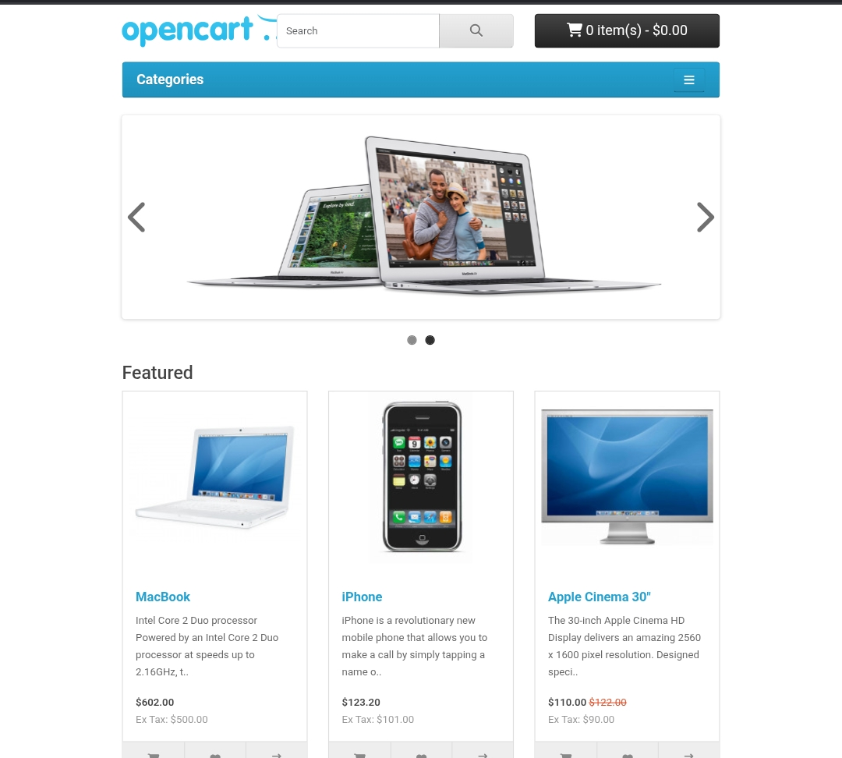
Figure 2: Featured products with Add to Cart, Wish List and Compare buttons
Each product card shows image, name, short description, price, tax-exclusive price and three action buttons (FR-03, FR-18, FR-19).
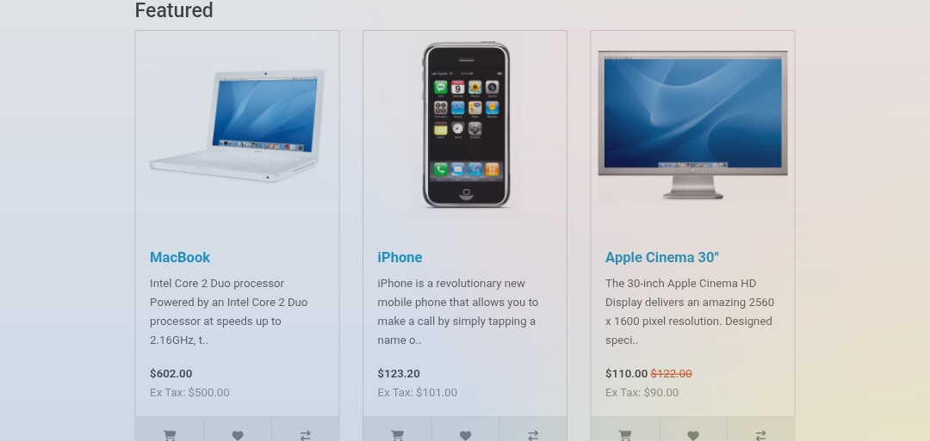
Figure 3: Product details page (MacBook)
Shows brand, product code, reward points, availability, price, quantity, Add to Cart, reviews, and Description / Specification / Reviews tabs (FR-05, FR-07, FR-20).
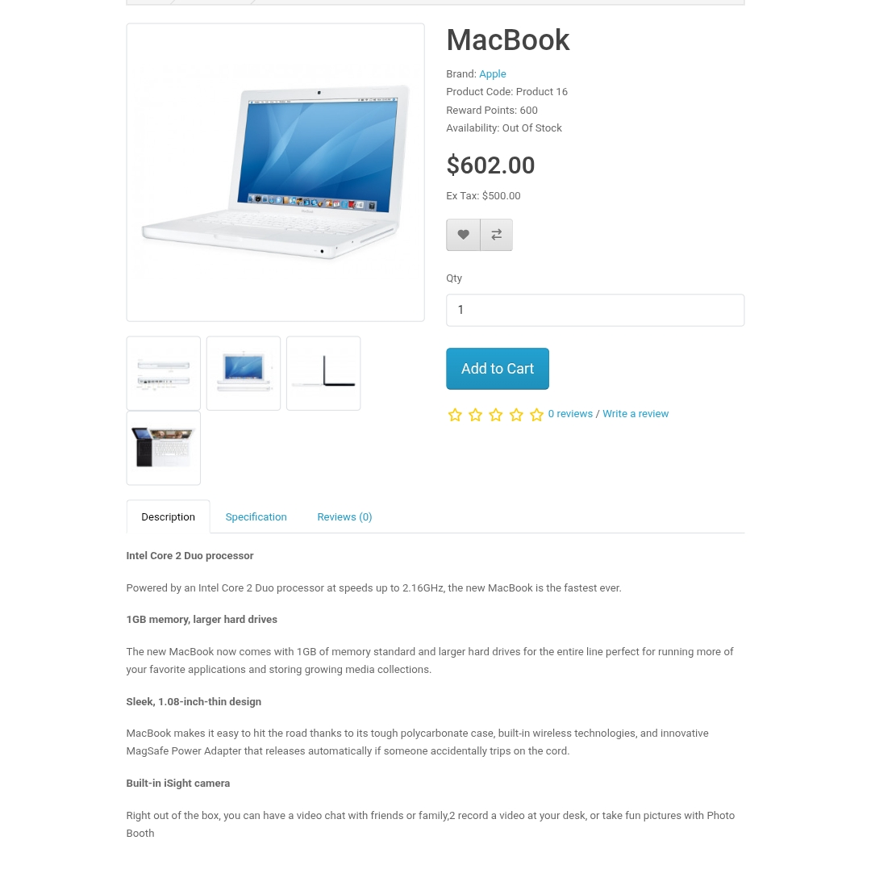
Figure 4: Shopping cart
Shows product, model, quantity update and remove buttons, sub-total, taxes, total, coupon and gift certificate options (FR-08, FR-09).
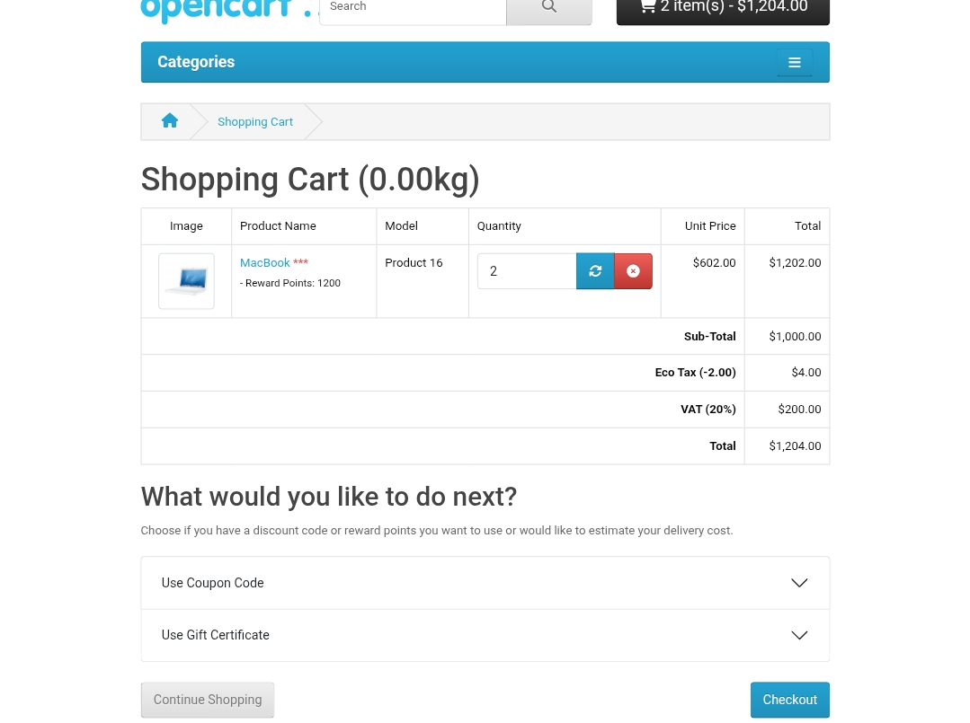
Figure 5: Checkout page
Shows Register Account / Guest Checkout choice, personal details, address, shipping and payment method selection, order summary and Confirm Order (FR-14, FR-15).


