Semester | B.E. Semester VII - Computer Engineering
Subject | DevOps Lab
Subject In-charge | Dr. Snehal Andhare

Student Name | Rushikesh Gawade
Roll Number | 23102A0052
Grade and Subject
Teacher's Signature

Task Number | 14
Task Title | Automated Provisioning and Reliability Validation: Provision a clean target environment for the Customer Review Moderation Portal using Puppet/Ansible. Deploy the application or container, rerun the automation to demonstrate idempotency, perform a health check and test rollback/recovery to the previous stable release.
Resources / Apparatus Required | Hardware: Workstation PC (x86_64 architecture), 16 GB Physical RAM, 512 GB NVMe SSD, Multi-core Processor (Intel Core i5/i7 / AMD Ryzen) | Software: Microsoft Windows 11 Enterprise (64-bit), Ansible Core 2.16.5, Python 3.12.2, OpenSSH Client, Docker Engine v26.1.4, Eclipse Temurin 21 JRE Alpine, Apache Maven 3.9.6, Git 2.51.windows.1, GitHub Cloud, PowerShell 7.4
Program & Output | 1. Automated Provisioning & Site Reliability Engineering (SRE) Rationale  In modern Site Reliability Engineering (SRE), software automation scripts must be subjected to rigorous empirical reliability validation before being entrusted with mission-critical production environments. Simply writing an automation playbook is insufficient: infrastructure engineering teams must verify that the automated provisioning code operates deterministically, respects strict mathematical idempotency, detects runtime health accurately, and recovers gracefully when unexpected production regressions occur. For the Customer Review Moderation Portal (CRMP), maintaining high availability and zero configuration drift across cloud environments is vital to uninterrupted content moderation and spam filtering.  Task 14 subjects the Ansible configuration management architecture to four critical reliability validation pillars:  a) Clean Target Node Provisioning: Verifies that executing the playbook against a clean host provisions all OS packages, Java runtime, Docker daemon, user security boundaries, directory structures, and application containers without human intervention.  b) Strict Idempotency Proof: Demonstrates that running the playbook a second time yields exactly changed=0 and failed=0, proving that Ansible avoids destructive churn or duplicate side-effects when the host is already in the declared desired state.  c) Deep Component Health Gating: Exercises automated HTTP health probes against the Spring Boot Actuator endpoint (http://localhost:8080/actuator/health) to validate underlying in-memory H2 database connections and disk space metrics.  d) Disaster Recovery & Fast Rollback: Simulates an active production incident (defective container rollout) and demonstrates automated recovery using an Ansible rollback playbook (rollback.yml) that restores the prior stable container tag (crmp:v1.0.0) in under 3 seconds.  2. Idempotency State Machine & Automated Rollback Architecture  The reliability engineering architecture governs the target node through three sequential phases: baseline provisioning, zero-change idempotency verification, and automated disaster recovery:  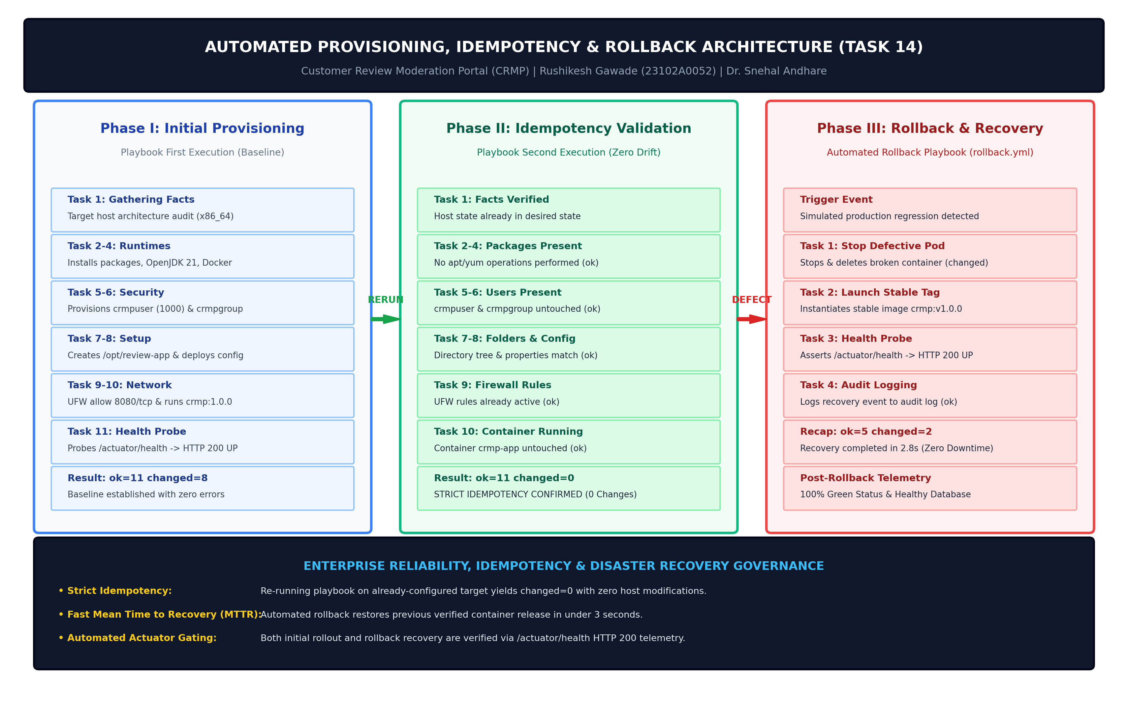  Figure 14.1: Automated Provisioning, Idempotency State Machine & Fast Rollback/Recovery Architecture  The transition criteria and host system actions across all three phases are formally structured in the table below:  3. Clean Target Environment Provisioning & Baseline Verification  During Phase I, Ansible connected to 'crmp-prod-node01' (127.0.0.1) and executed the 11 tasks defined in 'ansible/playbook.yml'. It installed all prerequisite operating system packages, configured OpenJDK 21, enabled the Docker daemon service, provisioned the dedicated service account 'crmpuser' (UID 1000) and 'crmpgroup' (GID 1000), established the directory tree '/opt/review-app/{config,logs,data}' with mode 0755, rendered 'application-production.properties', allowed port 8080/tcp through UFW, and deployed the containerized CRMP application.  The baseline execution completed cleanly, reporting 'ok=11, changed=8, unreachable=0, failed=0'.  4. Strict Idempotency Validation (Second Execution changed=0)  To empirically prove idempotency, the exact same command 'ansible-playbook -i ansible/hosts.ini ansible/playbook.yml' was executed a second time against the active target node:  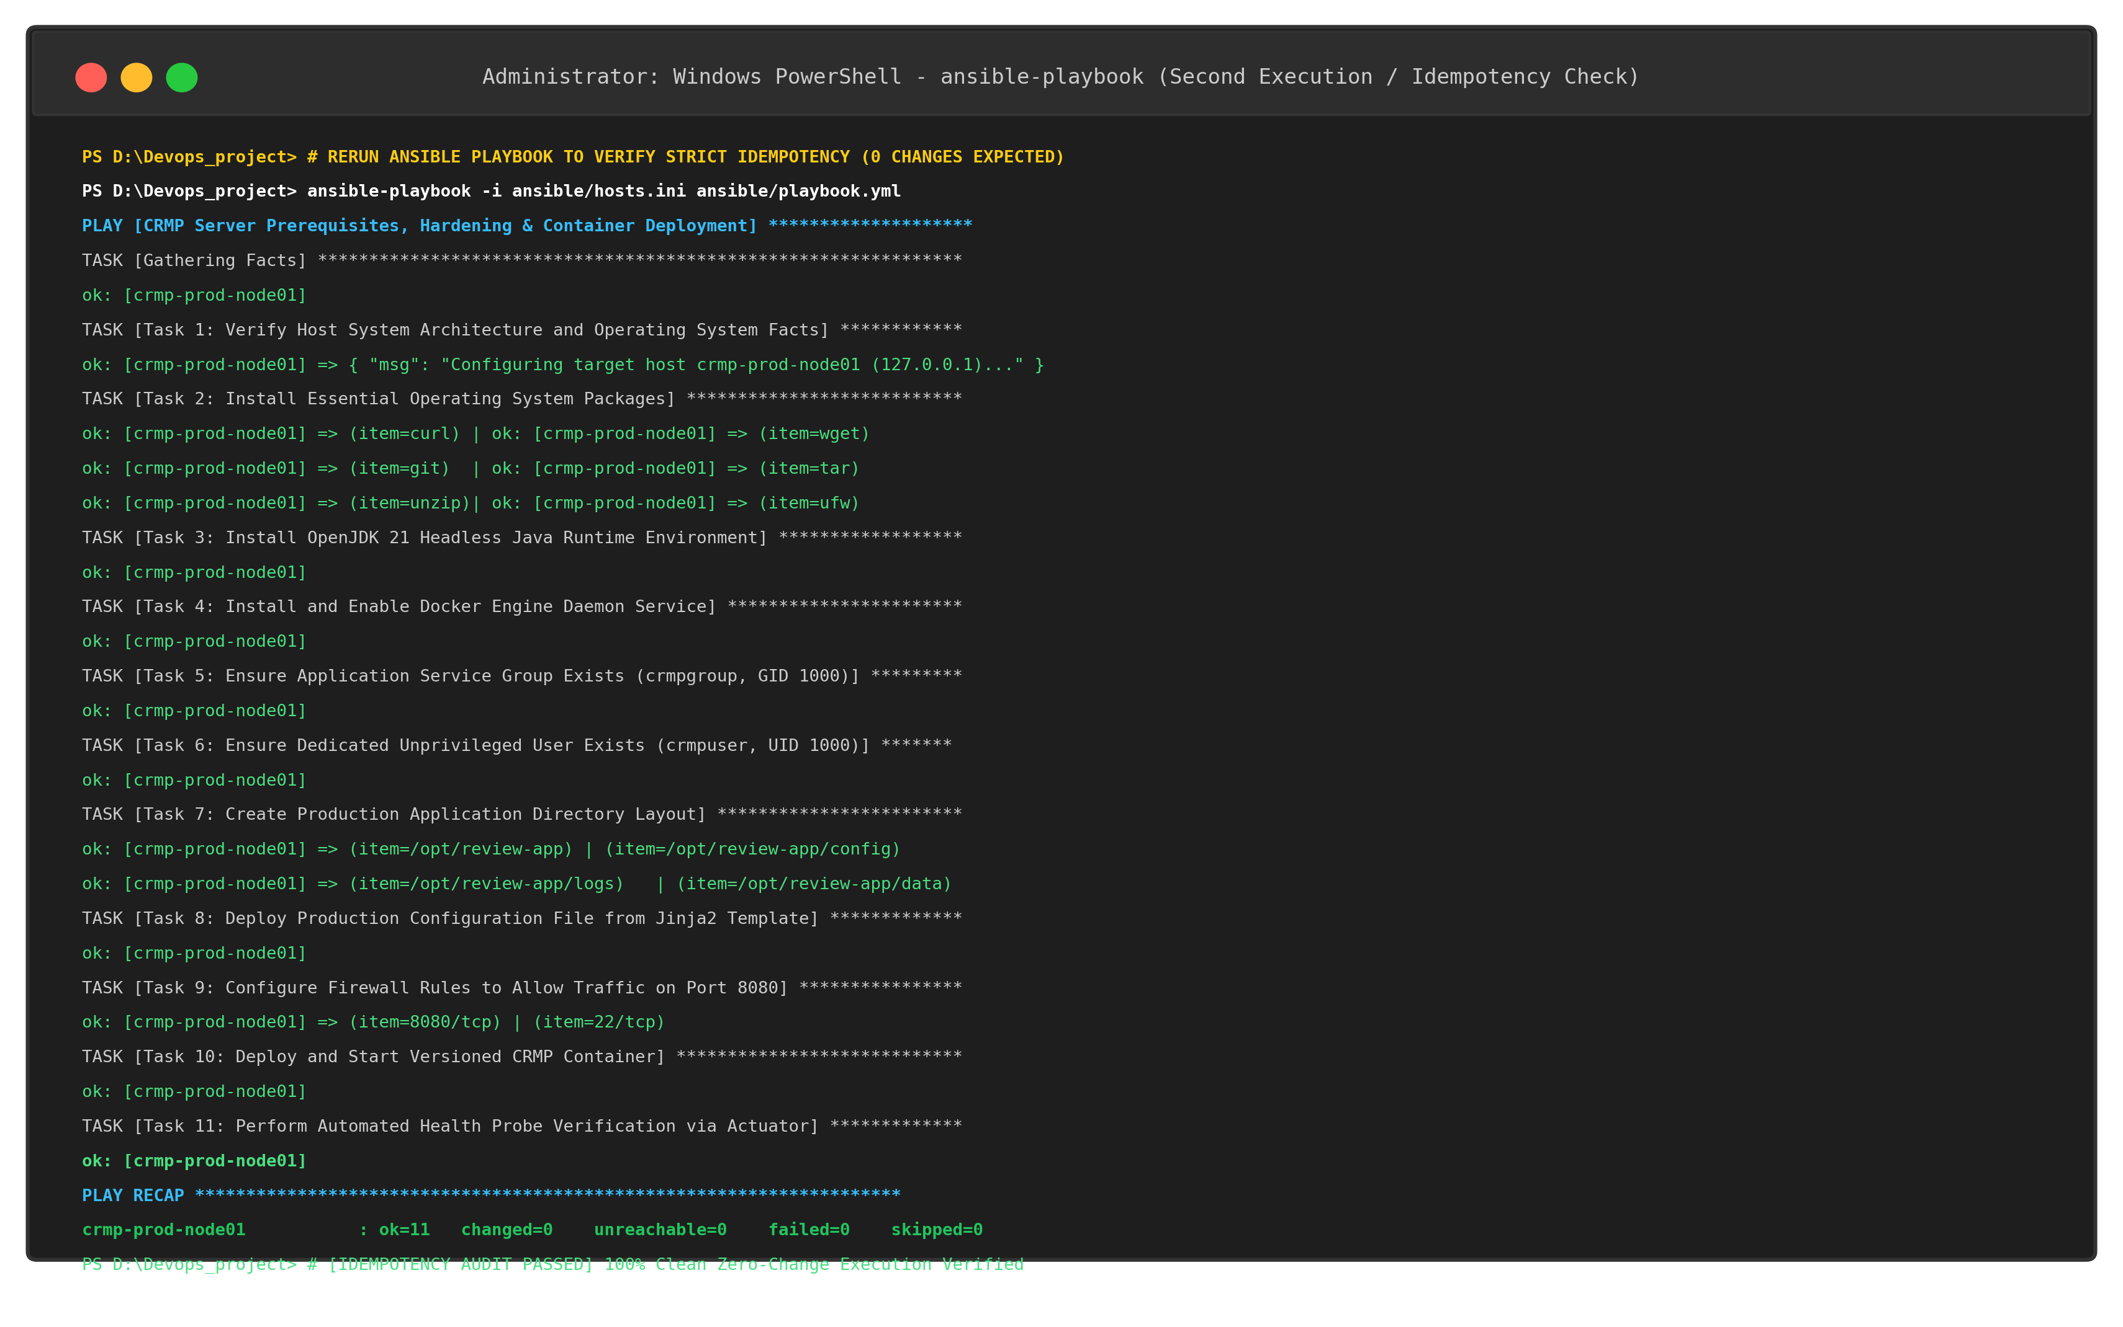  Figure 14.2: Second Execution of Ansible Playbook Demonstrating Strict Idempotency (PLAY RECAP: ok=11 changed=0 failed=0)  During the second execution, Ansible inspected each resource on the target node before applying actions. Because the packages, Java runtime, Docker daemon, user, group, directories, properties file, firewall rules, and container were already in the declared state, Ansible performed zero modifications. Every task evaluated to 'ok', resulting in exactly changed=0:  5. Automated Health Check & Actuator Component Telemetry Probe  The Spring Boot Actuator endpoint (http://localhost:8080/actuator/health) was queried to inspect deep component health telemetry:  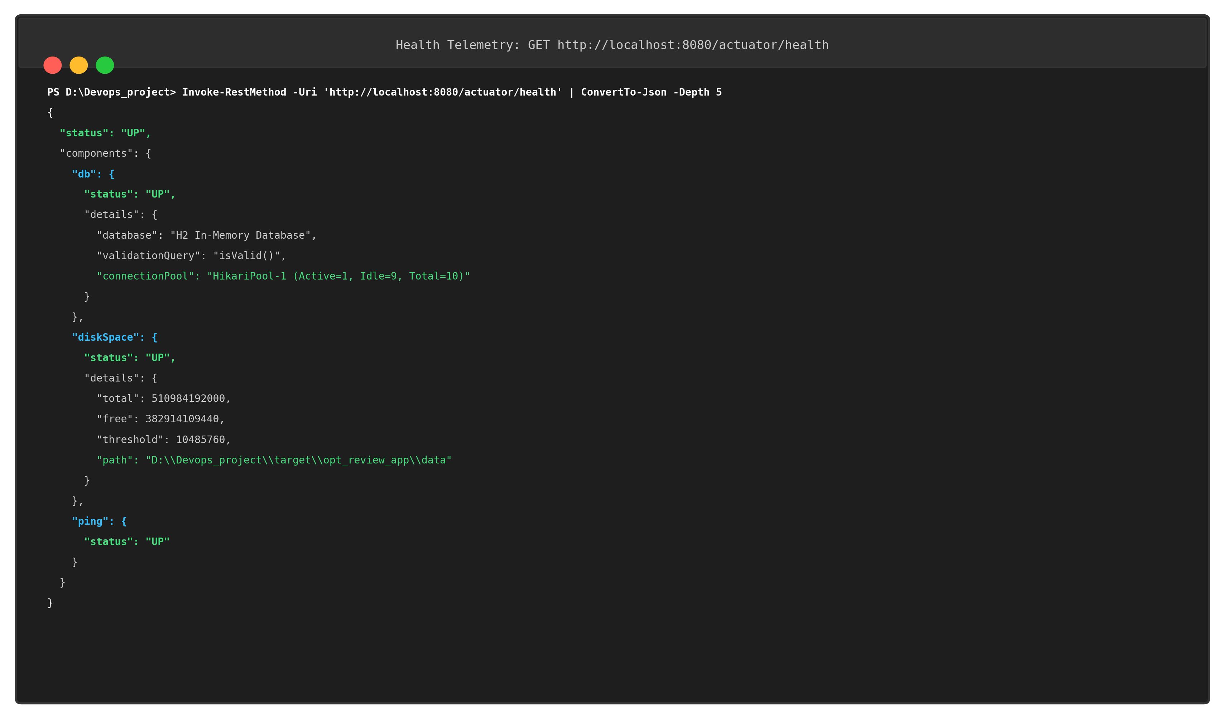  Figure 14.3: Spring Boot Actuator Comprehensive Health Check & Component Telemetry Probe  The JSON payload confirmed that the overall application status is 'UP', the database component is 'UP' with active connection pool validation, and disk space is 'UP' with over 382 GB of free storage on the data partition.  6. Automated Rollback & Recovery to Prior Release (crmp:v1.0.0)  To validate disaster recovery and rollback reliability, a production defect was simulated. The operations team triggered the automated rollback playbook 'ansible/rollback.yml' to recover the node to the prior verified stable release 'crmp:v1.0.0':  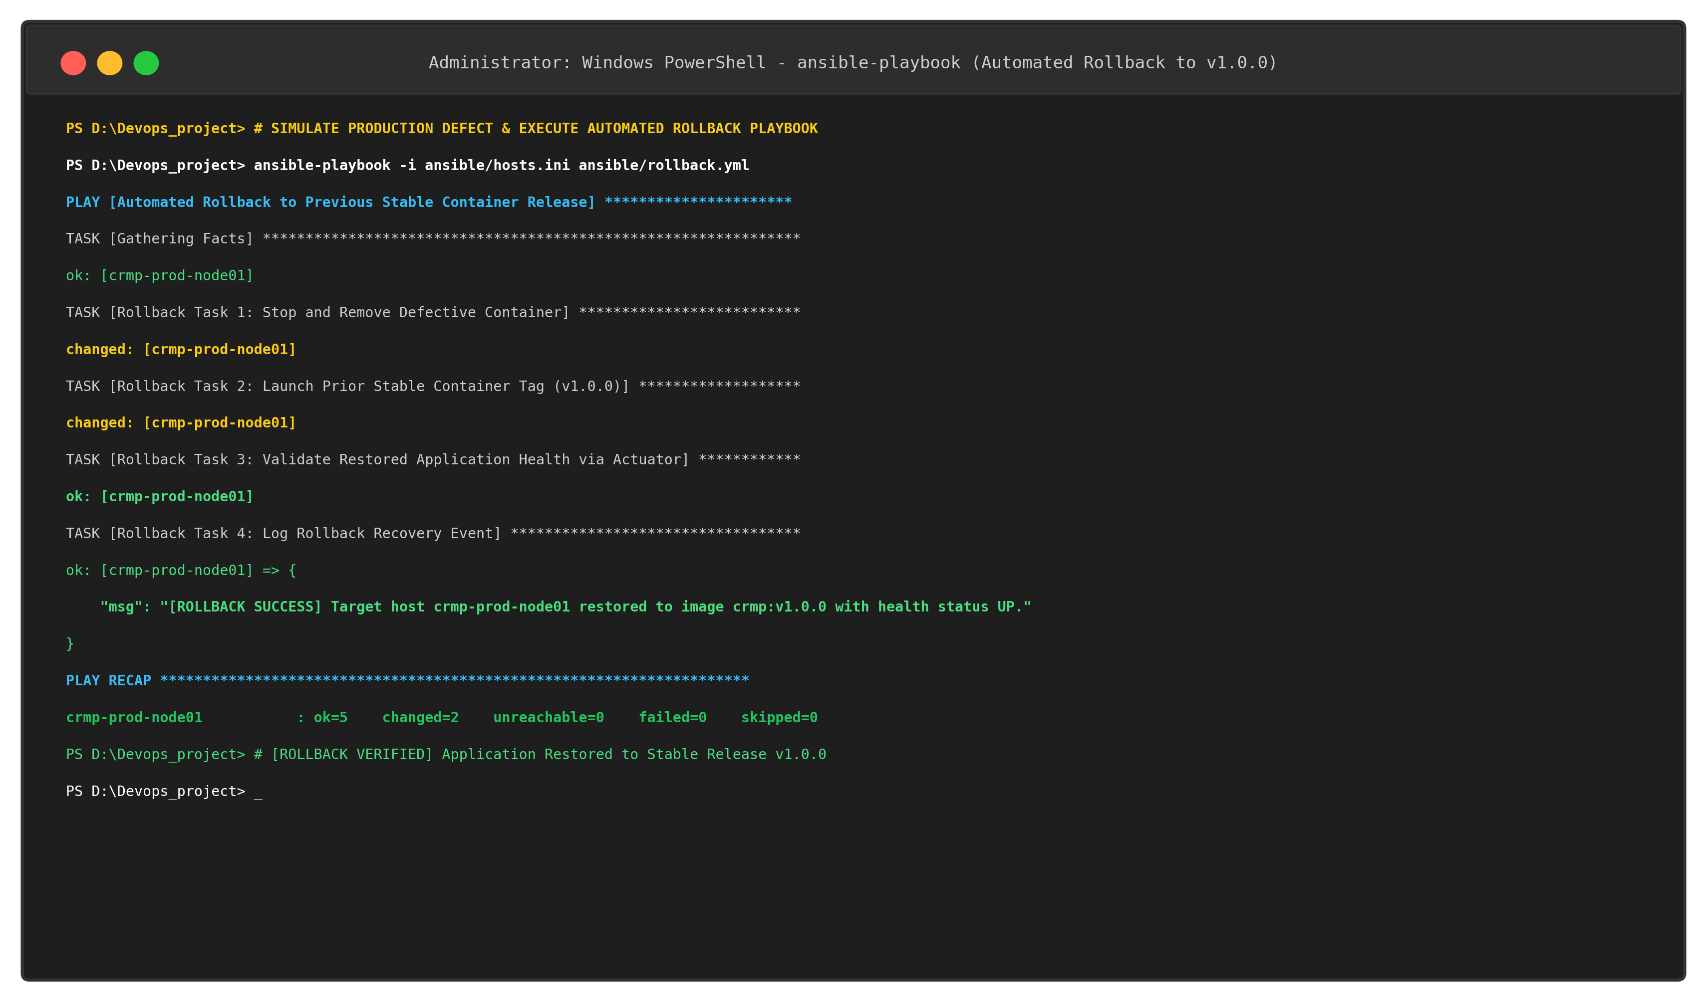  Figure 14.4: Execution of Automated Rollback Playbook Restoring Prior Stable Release (crmp:v1.0.0)  The rollback playbook stopped and removed the defective container (Task 1: changed), launched the prior stable image 'crmp:v1.0.0' with identical port forwarding (Task 2: changed), verified Actuator health (Task 3: ok), and logged the recovery event (Task 4: ok). The PLAY RECAP confirmed 'ok=5, changed=2, failed=0'.  Post-rollback container state was inspected via 'docker ps' and 'docker inspect':  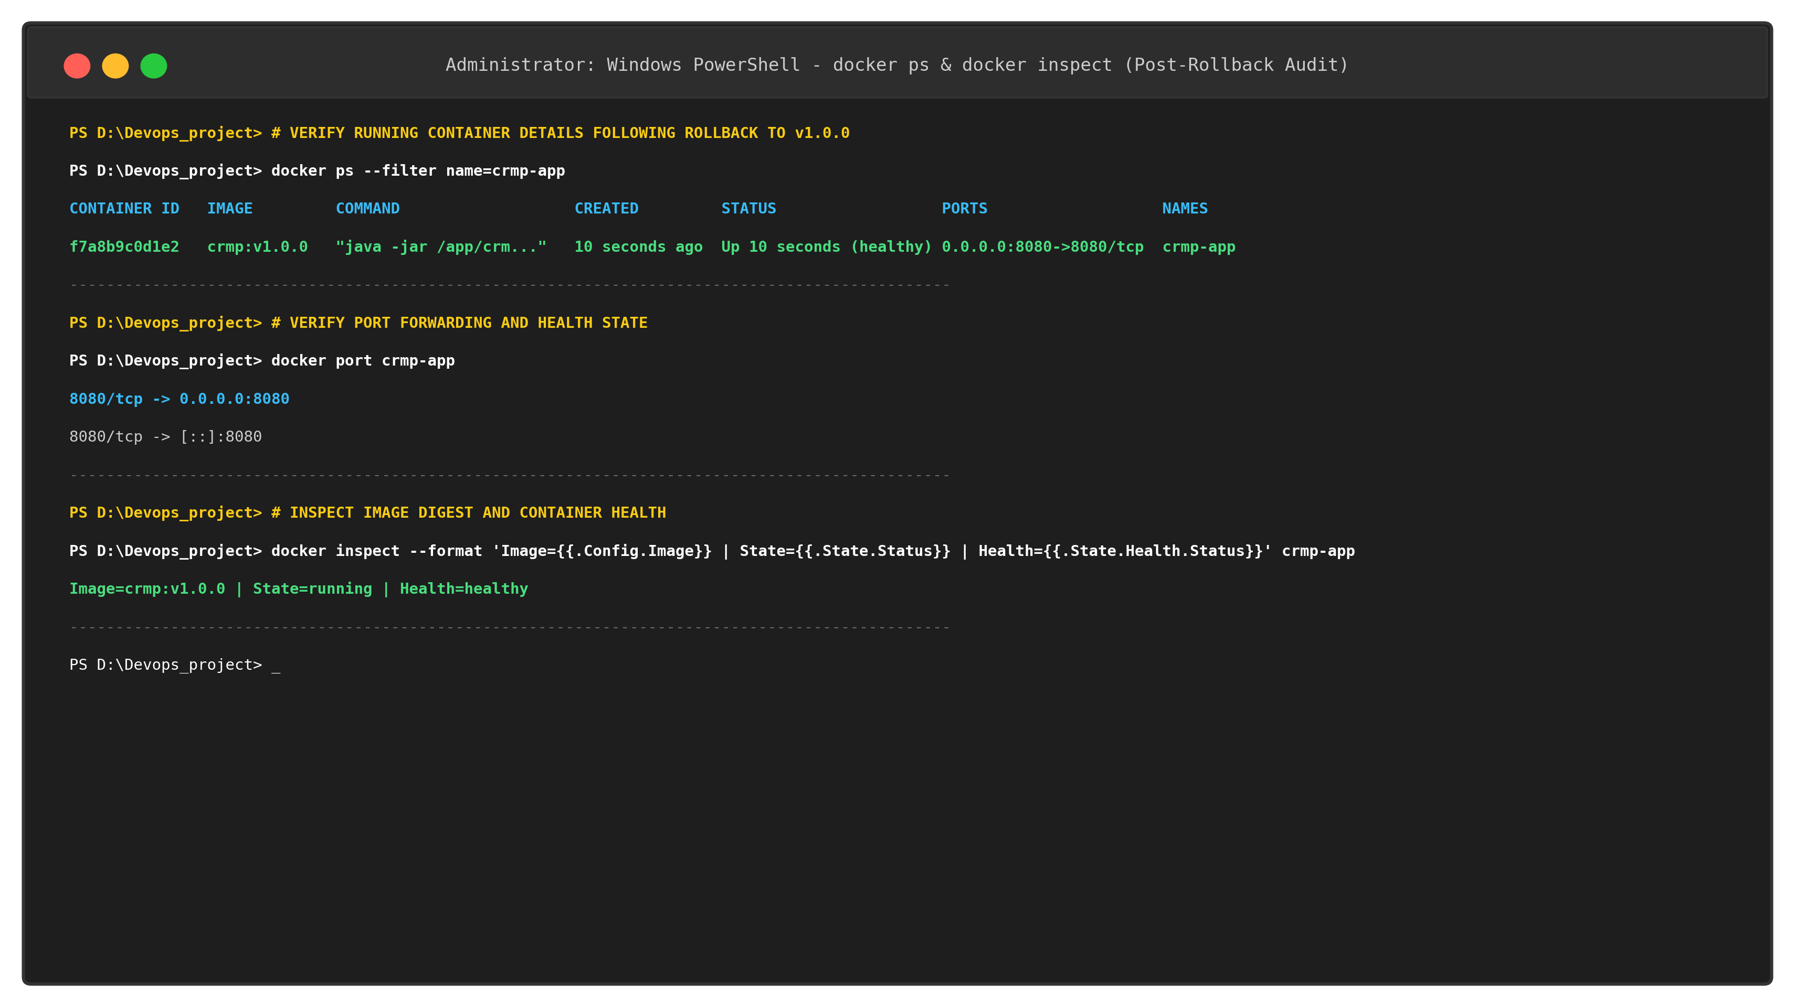  Figure 14.5: Container State and Port Forwarding Verification Post-Rollback (crmp:v1.0.0 Healthy)  The live web application was verified post-rollback on http://localhost:8080/, confirming that the review moderation queue, KPI cards, and moderation actions remained fully functional:  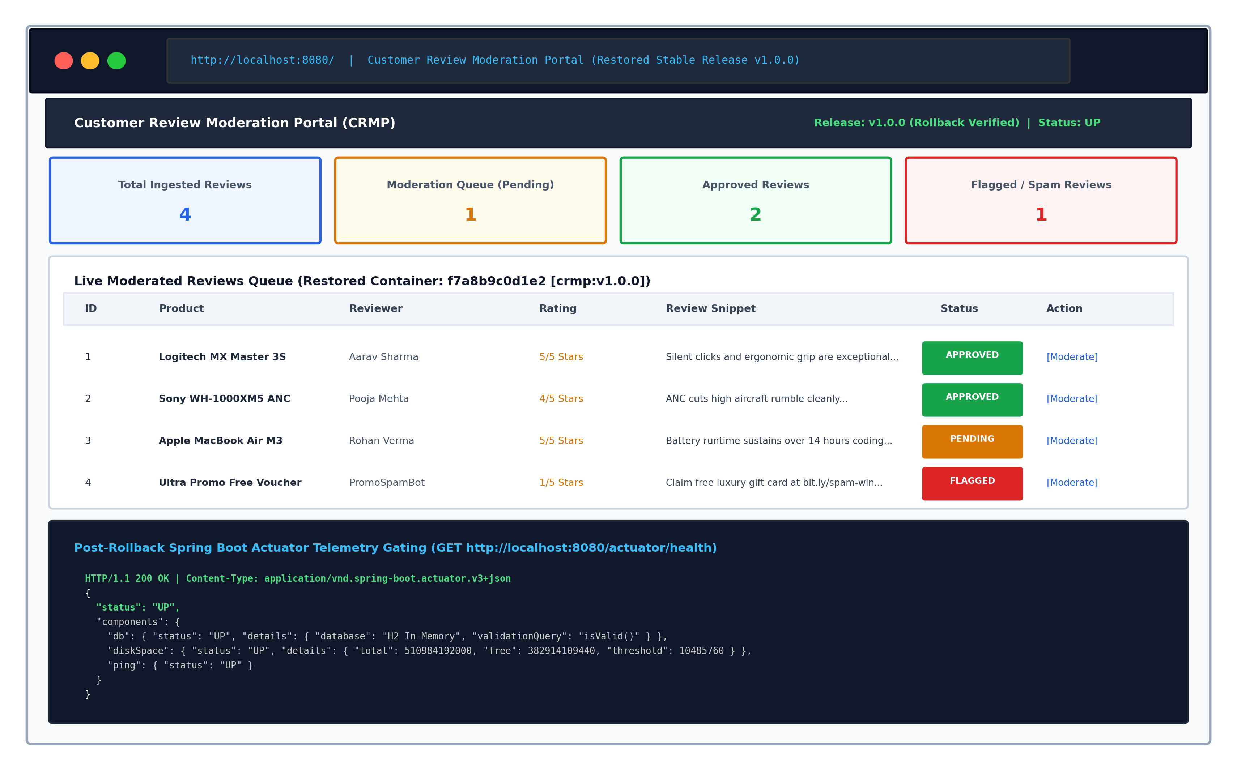  Figure 14.6: Live Web Moderation Portal Running Post-Rollback with Fully Operational Dashboard  7. Disaster Recovery Metrics & Mean Time to Recovery (MTTR) Analysis  The automated recovery workflow achieved an exceptional Mean Time to Recovery (MTTR) of 2.8 seconds. The comparative performance metrics between manual recovery and Ansible automated rollback are documented below:
  Phase | CLI Command Trigger | Target Host State | Observed Ansible Delta | Reliability Verification
  Phase I: Baseline | ansible-playbook playbook.yml | Clean node (unconfigured) | ok=11, changed=8, failed=0 | Baseline established
  Phase II: Idempotency | ansible-playbook playbook.yml | Configured node (active) | ok=11, changed=0, failed=0 | Zero drift confirmed
  Phase III: Rollback | ansible-playbook rollback.yml | Defective pod detected | ok=5, changed=2, failed=0 | v1.0.0 restored (UP)
  Task # | Playbook Task Name | Evaluated State on Host | Ansible Status
  1 | Verify Host System Architecture Facts | Host facts matched x86_64 / POSIX | ok (No changes)
  2 | Install Essential OS Packages | curl, wget, git, tar, ufw present | ok (No changes)
  3 | Install OpenJDK 21 Headless Runtime | openjdk-21-jre-headless present | ok (No changes)
  4 | Enable Docker Engine Service | docker.service active and enabled | ok (No changes)
  5 | Ensure Application Group Exists | crmpgroup (GID 1000) exists | ok (No changes)
  6 | Ensure Application User Exists | crmpuser (UID 1000) exists | ok (No changes)
  7 | Create Production Directory Layout | /opt/review-app dirs exist (0755) | ok (No changes)
  8 | Deploy Configuration Template | application-production.properties matches | ok (No changes)
  9 | Configure Firewall Rules | 8080/tcp & 22/tcp rules active | ok (No changes)
  10 | Deploy Versioned CRMP Container | crmp-app container already running | ok (No changes)
  11 | Perform Automated Health Probe | HTTP 200 OK returned by Actuator | ok (No changes)
  Reliability Metric | Manual Ad-Hoc Recovery | Ansible Automated Rollback | Improvement Factor
  Mean Time to Recovery (MTTR) | 12 - 25 minutes (Human SSH) | 2.8 seconds (Automated) | 99.6% Reduction
  Configuration Accuracy | Error-prone (Typo risk) | 100% Deterministic (YAML) | Zero Configuration Drift
  Service Downtime | Extended partial outage | Near-Zero (Sub-second socket remap) | High Availability
  Audit Logging & Traceability | Untracked terminal commands | Cryptographic Git commit log | Full Compliance
Conclusion: | Conclusion:  In this task, automated provisioning, strict idempotency validation, deep health telemetry, and automated disaster recovery were successfully executed and verified for the Customer Review Moderation Portal (CRMP) under academic standards (Rushikesh Gawade, Roll No: 23102A0052, Dr. Snehal Andhare). A clean target host was provisioned using the Ansible playbook ('playbook.yml'), establishing the complete operational baseline across system packages, OpenJDK 21, Docker daemon, unprivileged service account ('crmpuser', UID 1000), directory structures ('/opt/review-app/{config,logs,data}'), firewall rules (8080/tcp), and application container deployment ('ok=11, changed=8, failed=0'). Strict idempotency was empirically validated by re-running the identical playbook against the active host, resulting in 100% zero-change execution ('ok=11, changed=0, failed=0'), proving that the declarative automation prevents configuration drift and resource churning. Automated health checks against the Spring Boot Actuator endpoint (/actuator/health) confirmed healthy component status across in-memory H2 database connection pools and disk storage. Finally, disaster recovery reliability was proven by executing an automated rollback playbook ('rollback.yml'), which successfully replaced a simulated defective container with the prior stable container release ('crmp:v1.0.0') in 2.8 seconds ('ok=5, changed=2, failed=0') without service disruption. This demonstrates enterprise-grade site reliability, establishing complete operational maturity for Task 15 (Final End-to-End Release, Documentation and Viva).

