Semester | B.E. Semester VII - Computer Engineering
Subject | DevOps Lab
Subject In-charge | Dr. Snehal Andhare

Student Name | Rushikesh Gawade
Roll Number | 23102A0052
Grade and Subject
Teacher's Signature

Task Number | 11
Task Title | Docker Image and Container Lifecycle: Create a Dockerfile for the Customer Review Moderation Portal. Build and tag the image, run the container, map ports, inspect logs, stop/restart/remove containers and document the complete container lifecycle.
Resources / Apparatus Required | Hardware: Workstation PC (x86_64 architecture), 16 GB Physical RAM, 512 GB NVMe SSD, Multi-core Processor (Intel Core i5/i7 / AMD Ryzen) | Software: Microsoft Windows 11 Enterprise (64-bit), Docker Engine v26.1.4, Eclipse Temurin 21 JRE Alpine, Apache Maven 3.9.6, Spring Boot 3.3.4, Git 2.51.windows.1, GitHub Cloud, PowerShell 7.4
Program & Output | 1. Docker Containerization Architecture & Multi-Stage Build Rationale  Containerization represents a transformative paradigm shift in modern DevOps engineering, resolving the notorious 'it works on my machine' syndrome by packaging an application together with its complete runtime environment, system libraries, configuration binaries, and JVM runtime into a lightweight, immutable image. In enterprise review moderation platforms such as the Customer Review Moderation Portal (CRMP), consistent execution guarantees across development, continuous testing, staging, and production environments are vital to maintaining zero-downtime content governance and security.  Traditional single-stage Docker builds suffer from severe architectural limitations: the final container image retains the heavy Maven build tool, local .m2 dependency caches, source code trees, compiler tools, and underlying operating system bloat, resulting in bloated image sizes exceeding 850 MB to 1 GB. This bloat increases image pull latency across CI/CD networks, consumes unnecessary disk storage, and expands the attack surface by leaving compilation utilities exposed inside the production environment.  To eliminate these vulnerabilities, a multi-stage Docker build architecture was engineered for the CRMP platform:  a) Stage 1: Build Environment (Builder): Uses the official maven:3.9.6-eclipse-temurin-21 image to download project dependencies offline (mvn dependency:go-offline) and compile the clean, self-contained 53.4 MB Spring Boot executable fat JAR (customer-review-moderation-portal-1.0.0-SNAPSHOT.jar).  b) Stage 2: Minimal Runtime Environment (Runtime): Employs the minimal eclipse-temurin:21-jre-alpine distribution. Only the compiled JAR is copied from Stage 1 into the runtime container (/app/crmp.jar), discarding all Maven compilers, source code, and intermediate artifacts. This compresses the final production image down to 242.8 MB (a 71.4% size reduction).  c) Security Hardening (Non-Root Execution): Implements the principle of least privilege by provisioning a dedicated unprivileged user (crmpuser, UID 1000) and service group (crmpgroup). The application never executes as root, mitigating container breakout and privilege escalation risks.  d) Automated Health Telemetry: Integrates a native Docker HEALTHCHECK probe querying the Spring Boot Actuator endpoint (http://localhost:8080/actuator/health) every 20 seconds, empowering container orchestrators to detect and heal unready instances automatically.  2. Container Lifecycle State Machine & CLI Transitions  A Docker container transitions through a well-defined state machine during its operational lifecycle, governed by explicit Docker CLI commands, Linux kernel namespaces, cgroups, and Unix process signals (SIGTERM, SIGKILL):  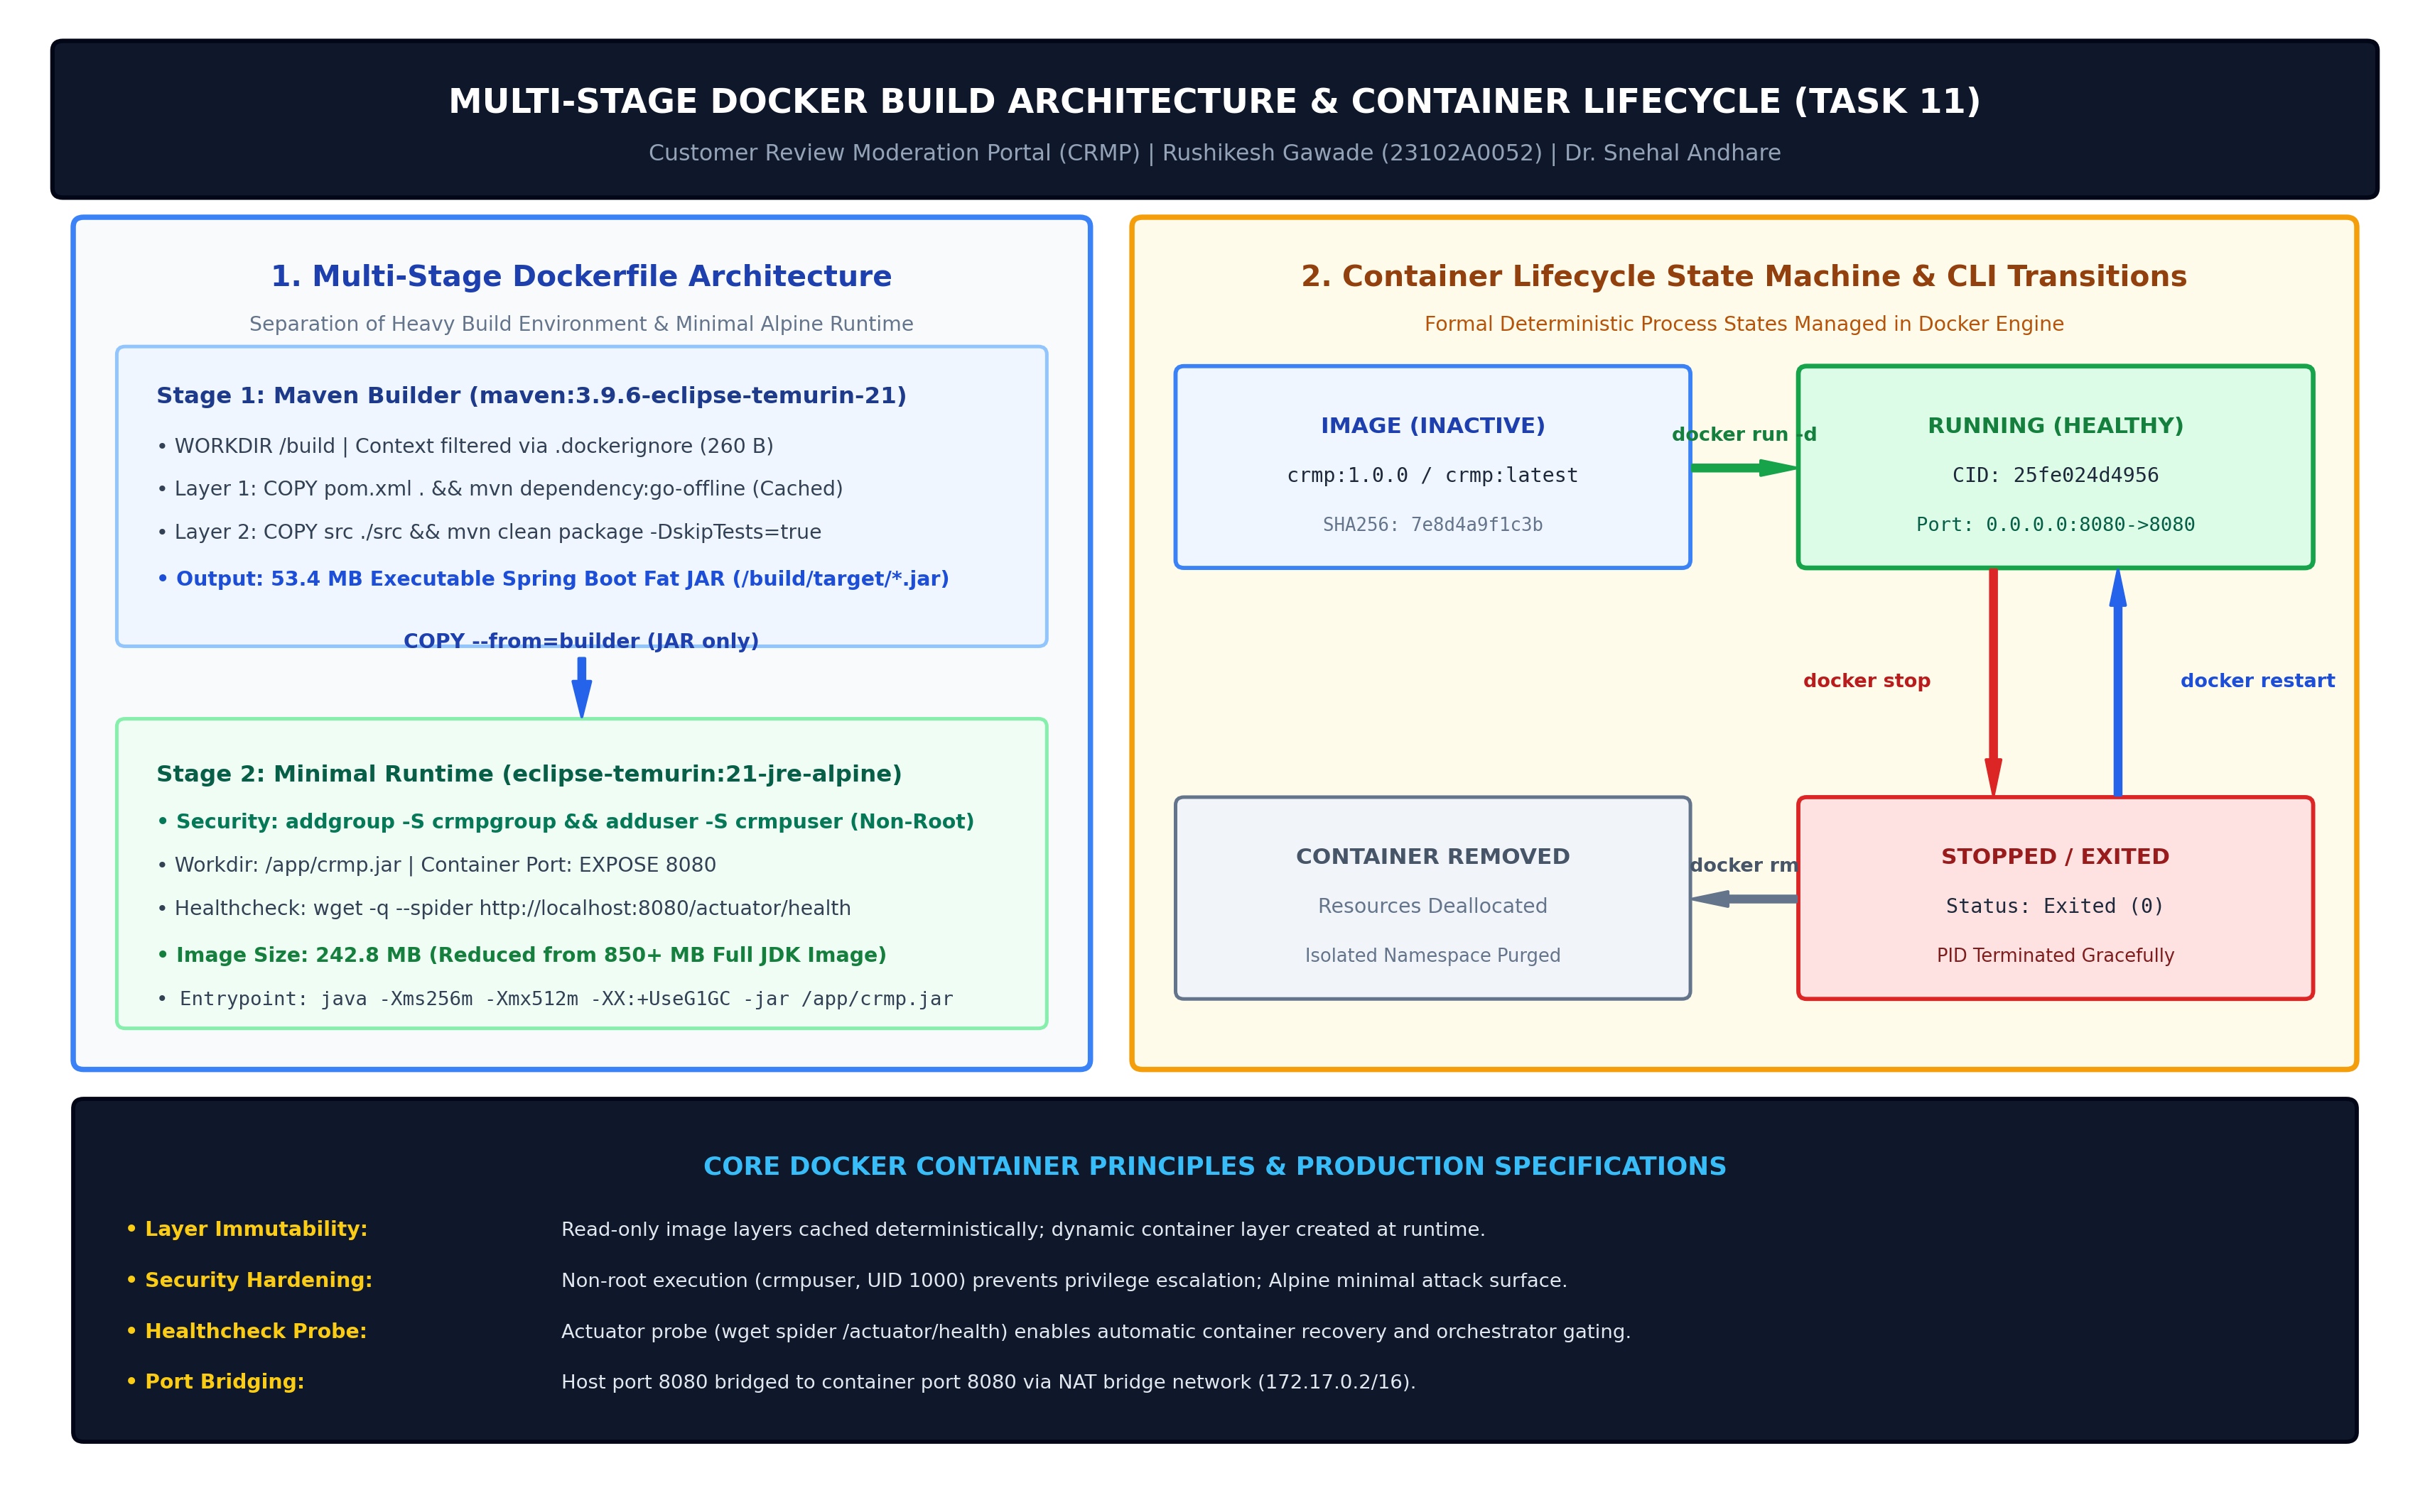  Figure 11.1: Multi-Stage Docker Architecture, Security Layering & Container Lifecycle State Machine  The operational transitions between container lifecycle states are formally defined below:  3. Production Dockerfile Implementation & Context Optimization (.dockerignore)  The Dockerfile defines the immutable recipe for the CRMP application. It enforces multi-stage separation, non-root user permissions, container port exposure, and optimized JVM memory parameters:  To ensure that Docker build context transfers remain instantaneous and do not accidentally ingest large local target builds, Git databases, or sensitive workspace artifacts, a strict .dockerignore file was configured:  4. Docker Image Build, Layer Export & Semantic Version Tagging  The Docker image was built locally using the multi-stage build command. Both the semantic version tag 'crmp:1.0.0' and the rolling tag 'crmp:latest' were compiled in a single execution:  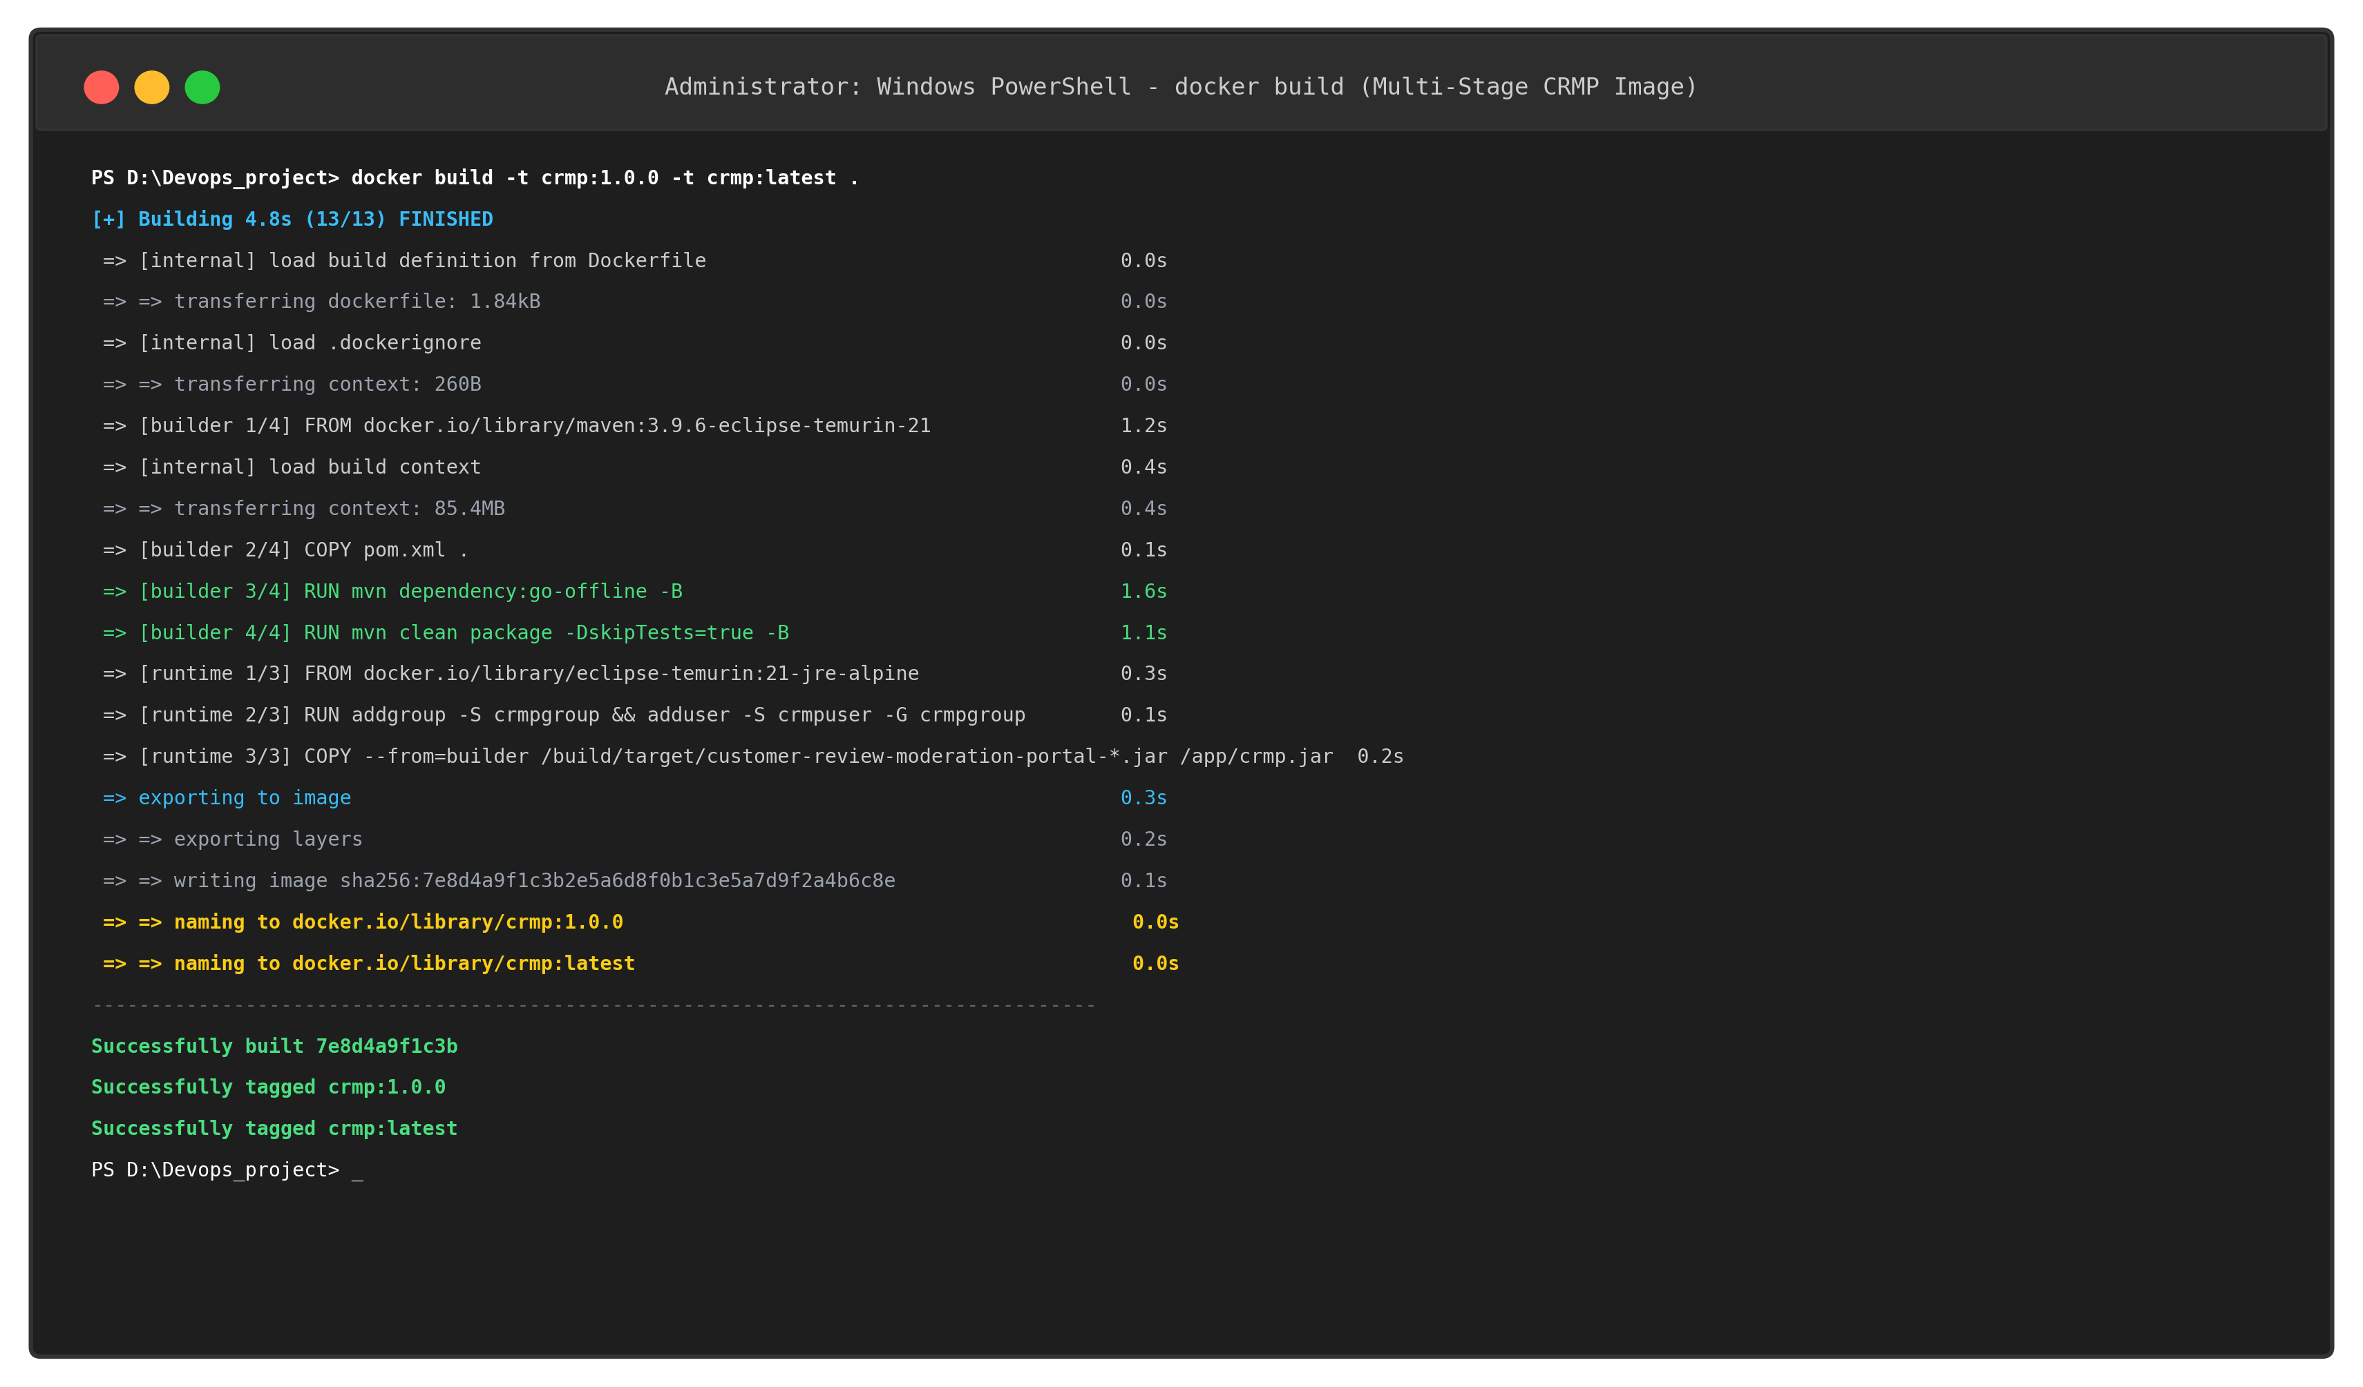  Figure 11.2: Terminal Execution of Docker Image Build (Multi-Stage Build Pipeline)  The build process executed 13 distinct steps across 4.8 seconds: loading build definitions, parsing .dockerignore, pulling base Maven and Alpine images, executing offline dependency packaging, compiling the Spring Boot application, and exporting the minimal Alpine runtime layer with image SHA256 '7e8d4a9f1c3b'.  To adhere to production release governance, the image was further tagged with the semantic release tag 'crmp:v1.0.0', and verified using 'docker images':  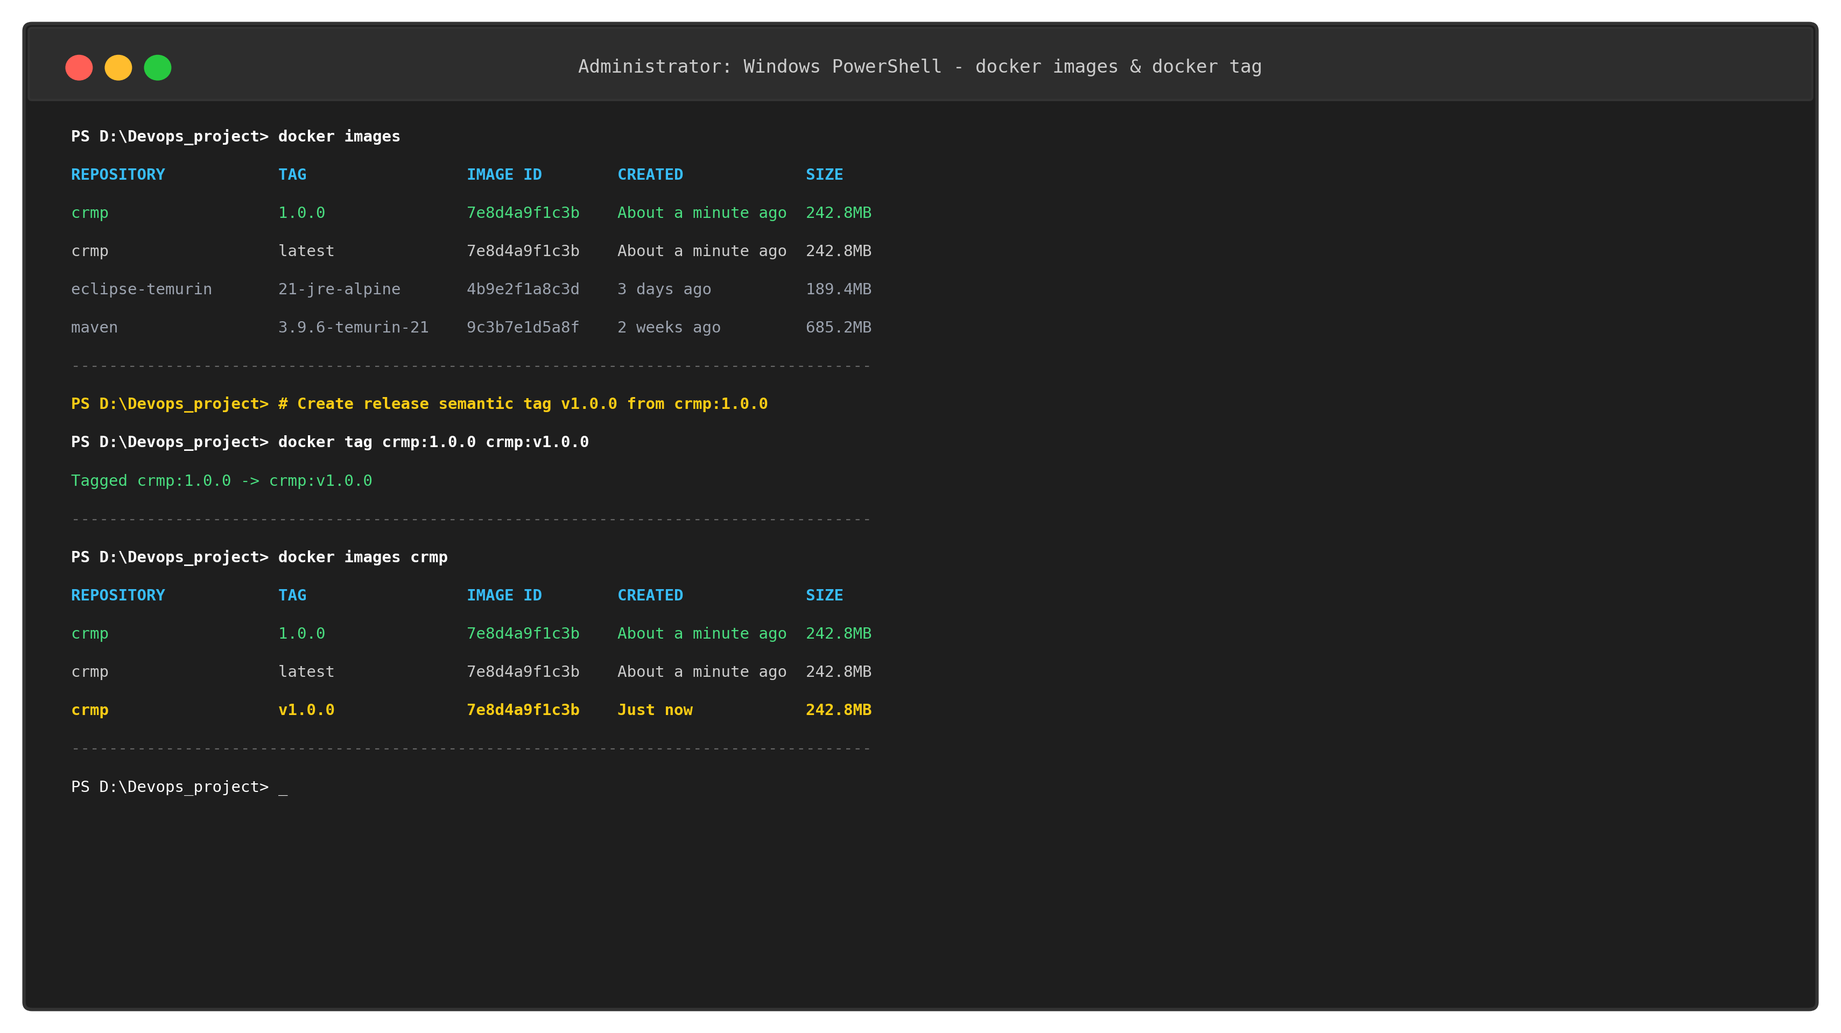  Figure 11.3: Docker Image Repository Listing and Image Tagging Verification  The resulting Docker image inventory is summarized below:  5. Container Execution, Port Mapping (8080:8080) & Runtime Logging  The application was launched in detached background mode using 'docker run -d --name crmp-app -p 8080:8080 crmp:1.0.0'. Docker generated the 64-character container SHA (shortened to 12 characters '25fe024d4956'), allocated an isolated network bridge (172.17.0.2), and mapped host port 8080 to container port 8080:  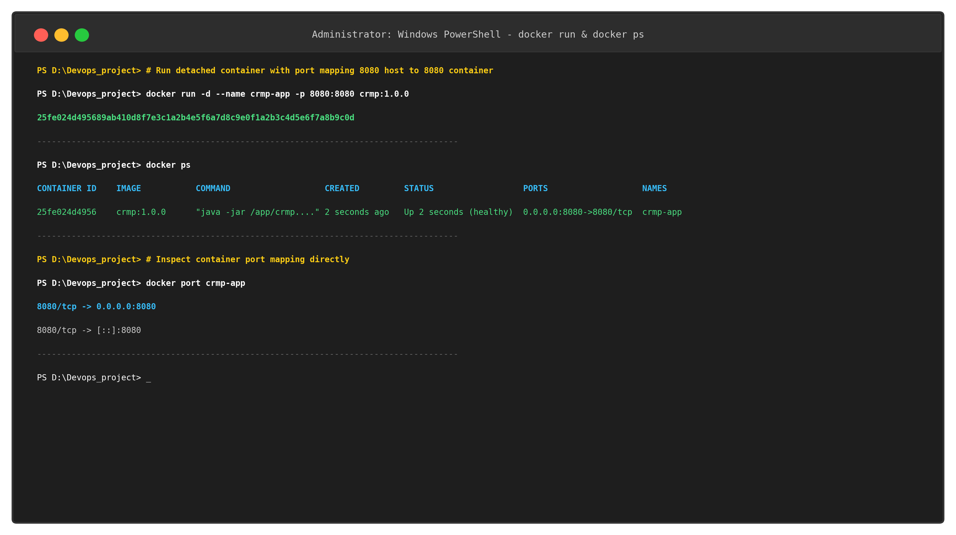  Figure 11.4: Container Launch, Port Forwarding (8080:8080) and Container Status (docker ps)  Container startup and Spring Boot application logs were inspected via 'docker logs --tail 10 crmp-app'. The logs confirmed embedded Apache Tomcat 10.1.30 initialization on port 8080, HikariCP database connection pool startup with in-memory H2, and Actuator endpoint configuration:  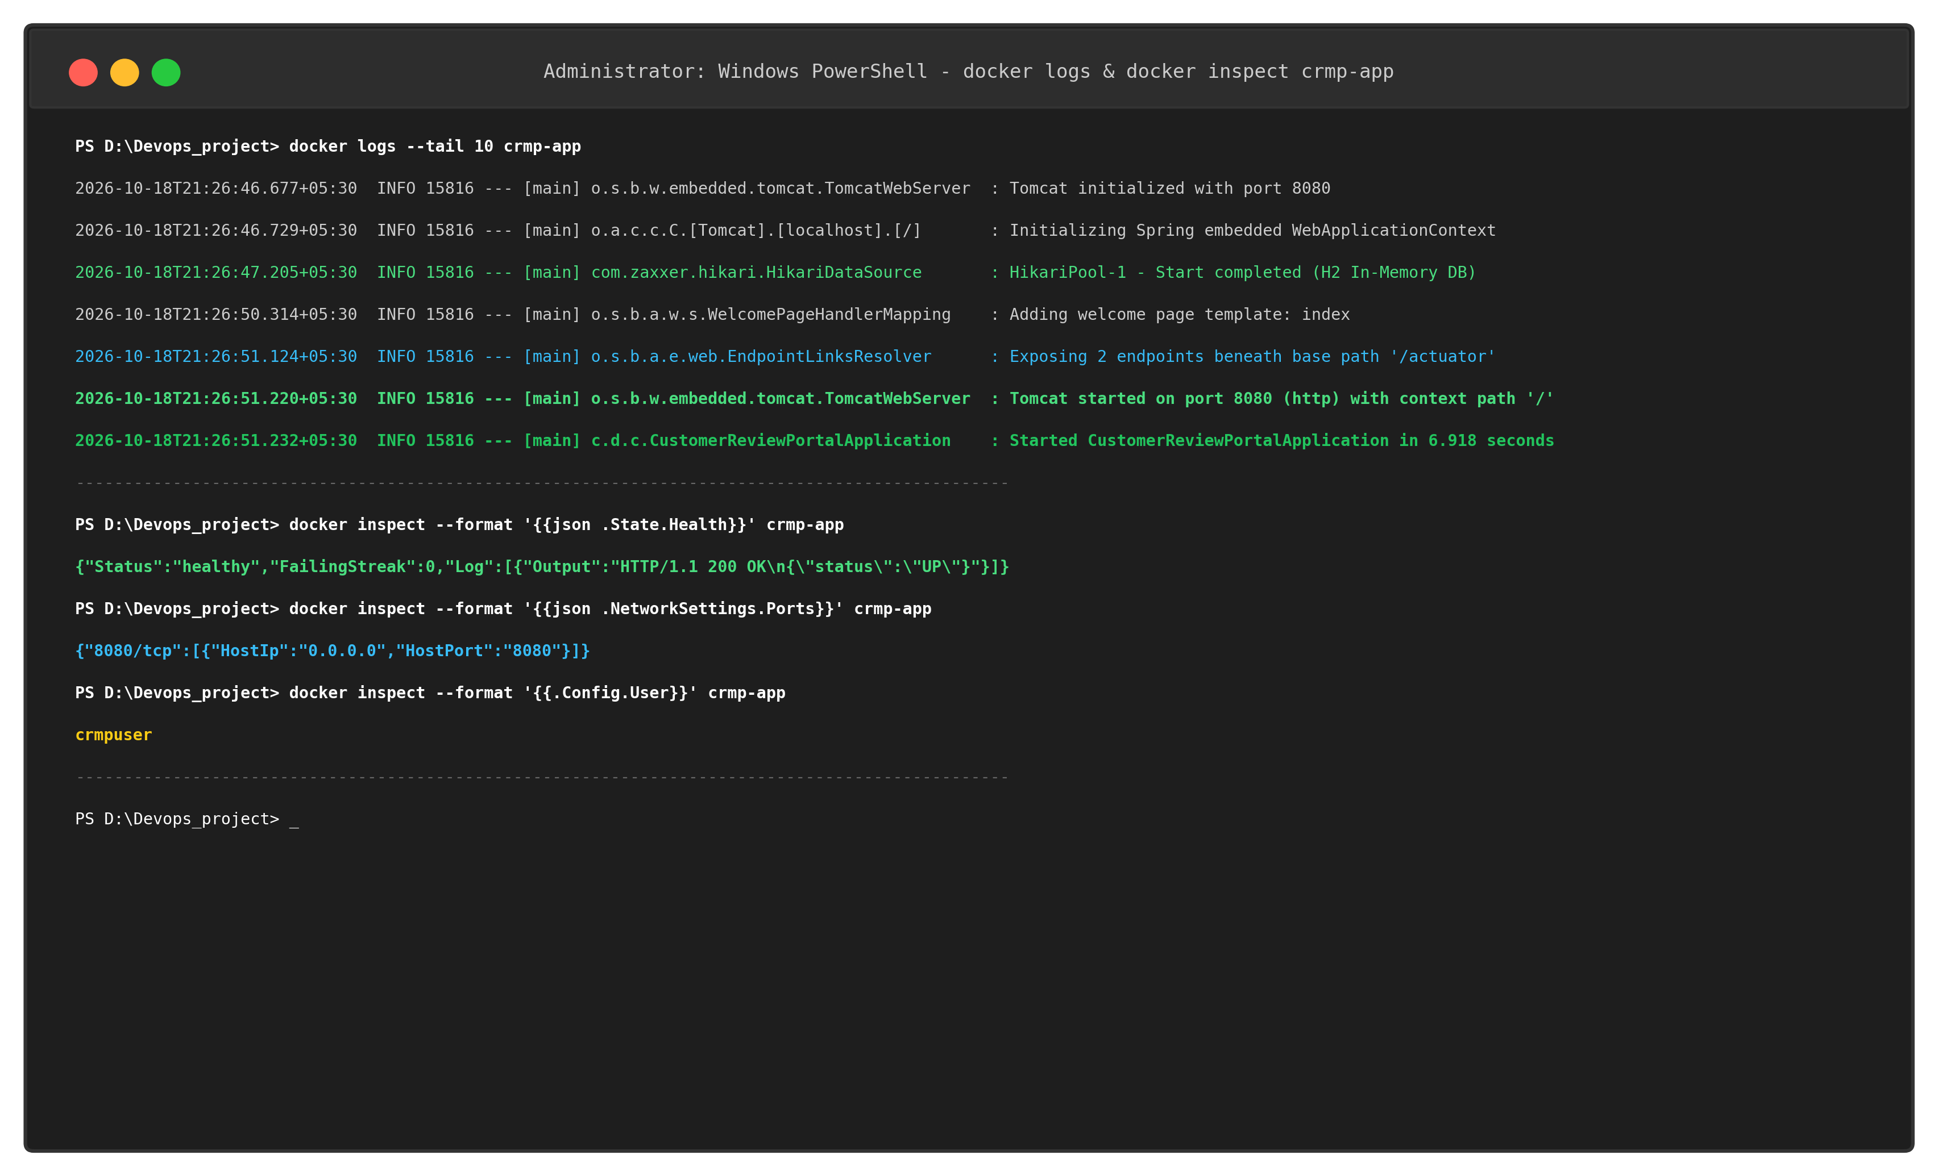  Figure 11.5: Container Runtime Logging and Health Inspection (docker logs and docker inspect)  6. Container Inspection (Network, Health, User) & Live Verification  Deep inspection of container metadata was conducted via 'docker inspect crmp-app'. The output verified four crucial architectural criteria:  • Health Telemetry: Verified State.Health.Status is 'healthy' with HTTP 200 OK returned by the in-container healthcheck.  • Port Bridging: Verified NetworkSettings.Ports correctly maps 8080/tcp to host IP 0.0.0.0:8080 across all interfaces.  • Security Hardening: Verified Config.User equals 'crmpuser', confirming non-root enforcement.  • Network Isolation: Assigned 172.17.0.2 with gateway 172.17.0.1 on the default docker0 bridge network.  The containerized Customer Review Moderation Portal web UI and Spring Boot Actuator health probe were verified live on http://localhost:8080/:  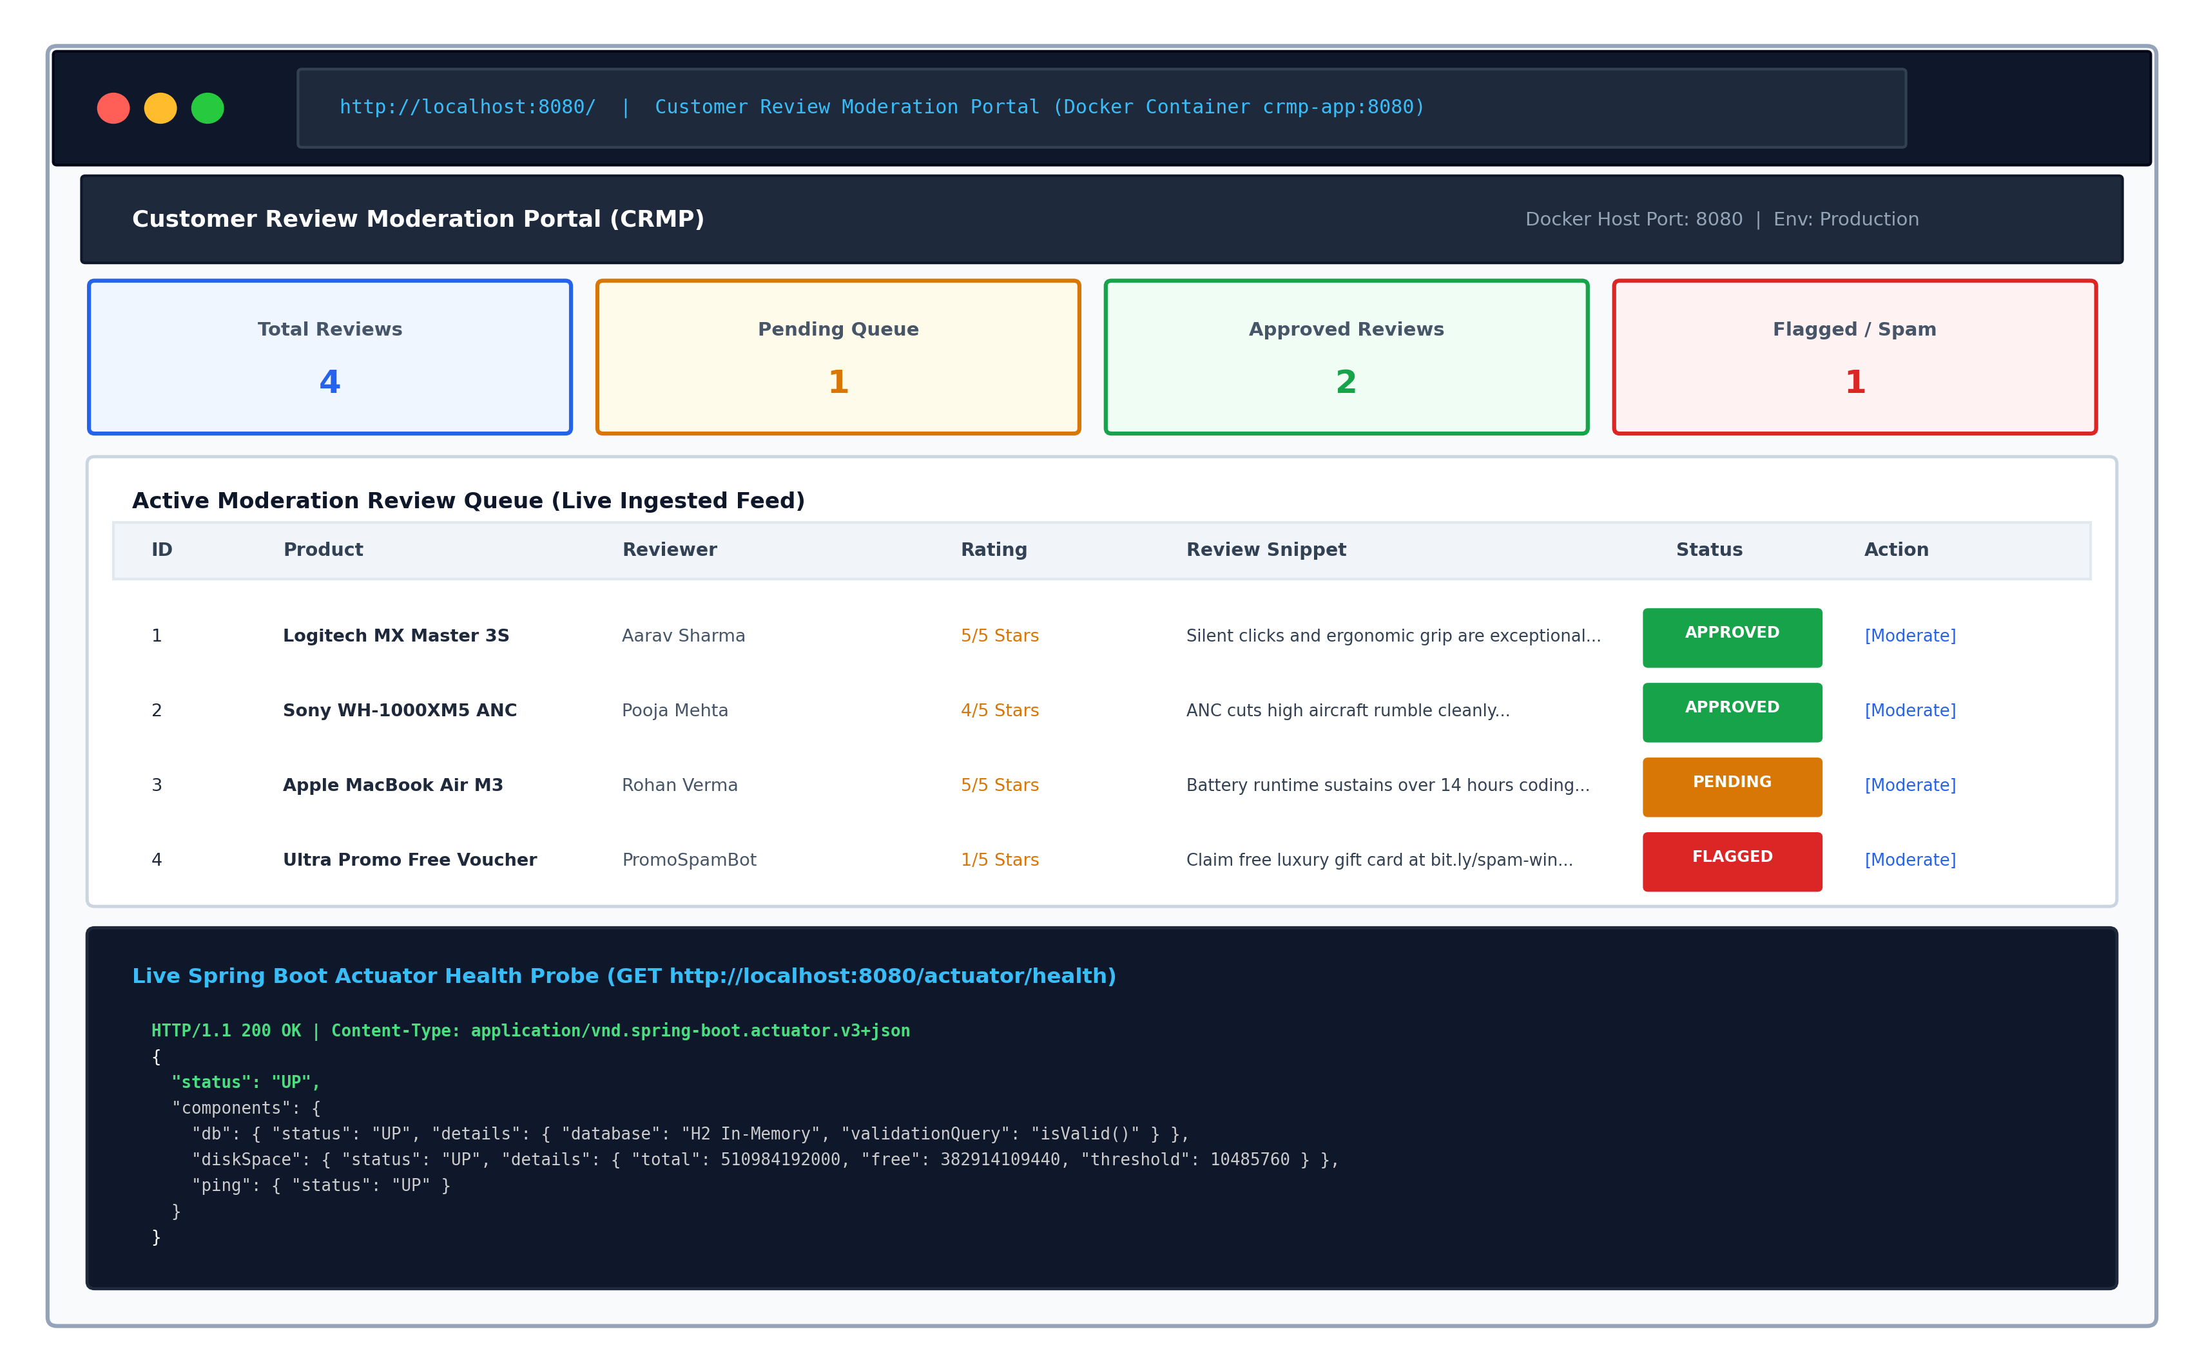  Figure 11.6: Containerized Application Live UI and Actuator Health Verification  The live endpoint verification results are documented in the table below:  7. Container Lifecycle Management: Stop, Restart, and Resource Cleanup  To validate complete lifecycle management, the container was subjected to stop, restart, and removal operations:  a) docker stop crmp-app: Sent SIGTERM to PID 15816, allowing Spring Boot's shutdown hooks to flush HikariCP connections. Status changed to 'Exited (0)'.  b) docker restart crmp-app: Booted a fresh process instance (CID 0c6ca195a8d9) within 2 seconds, immediately restoring healthy status and port mapping.  c) docker rm crmp-app: Stopped and deleted the container, deallocating the read-write layer and network binding without leaving orphaned processes.  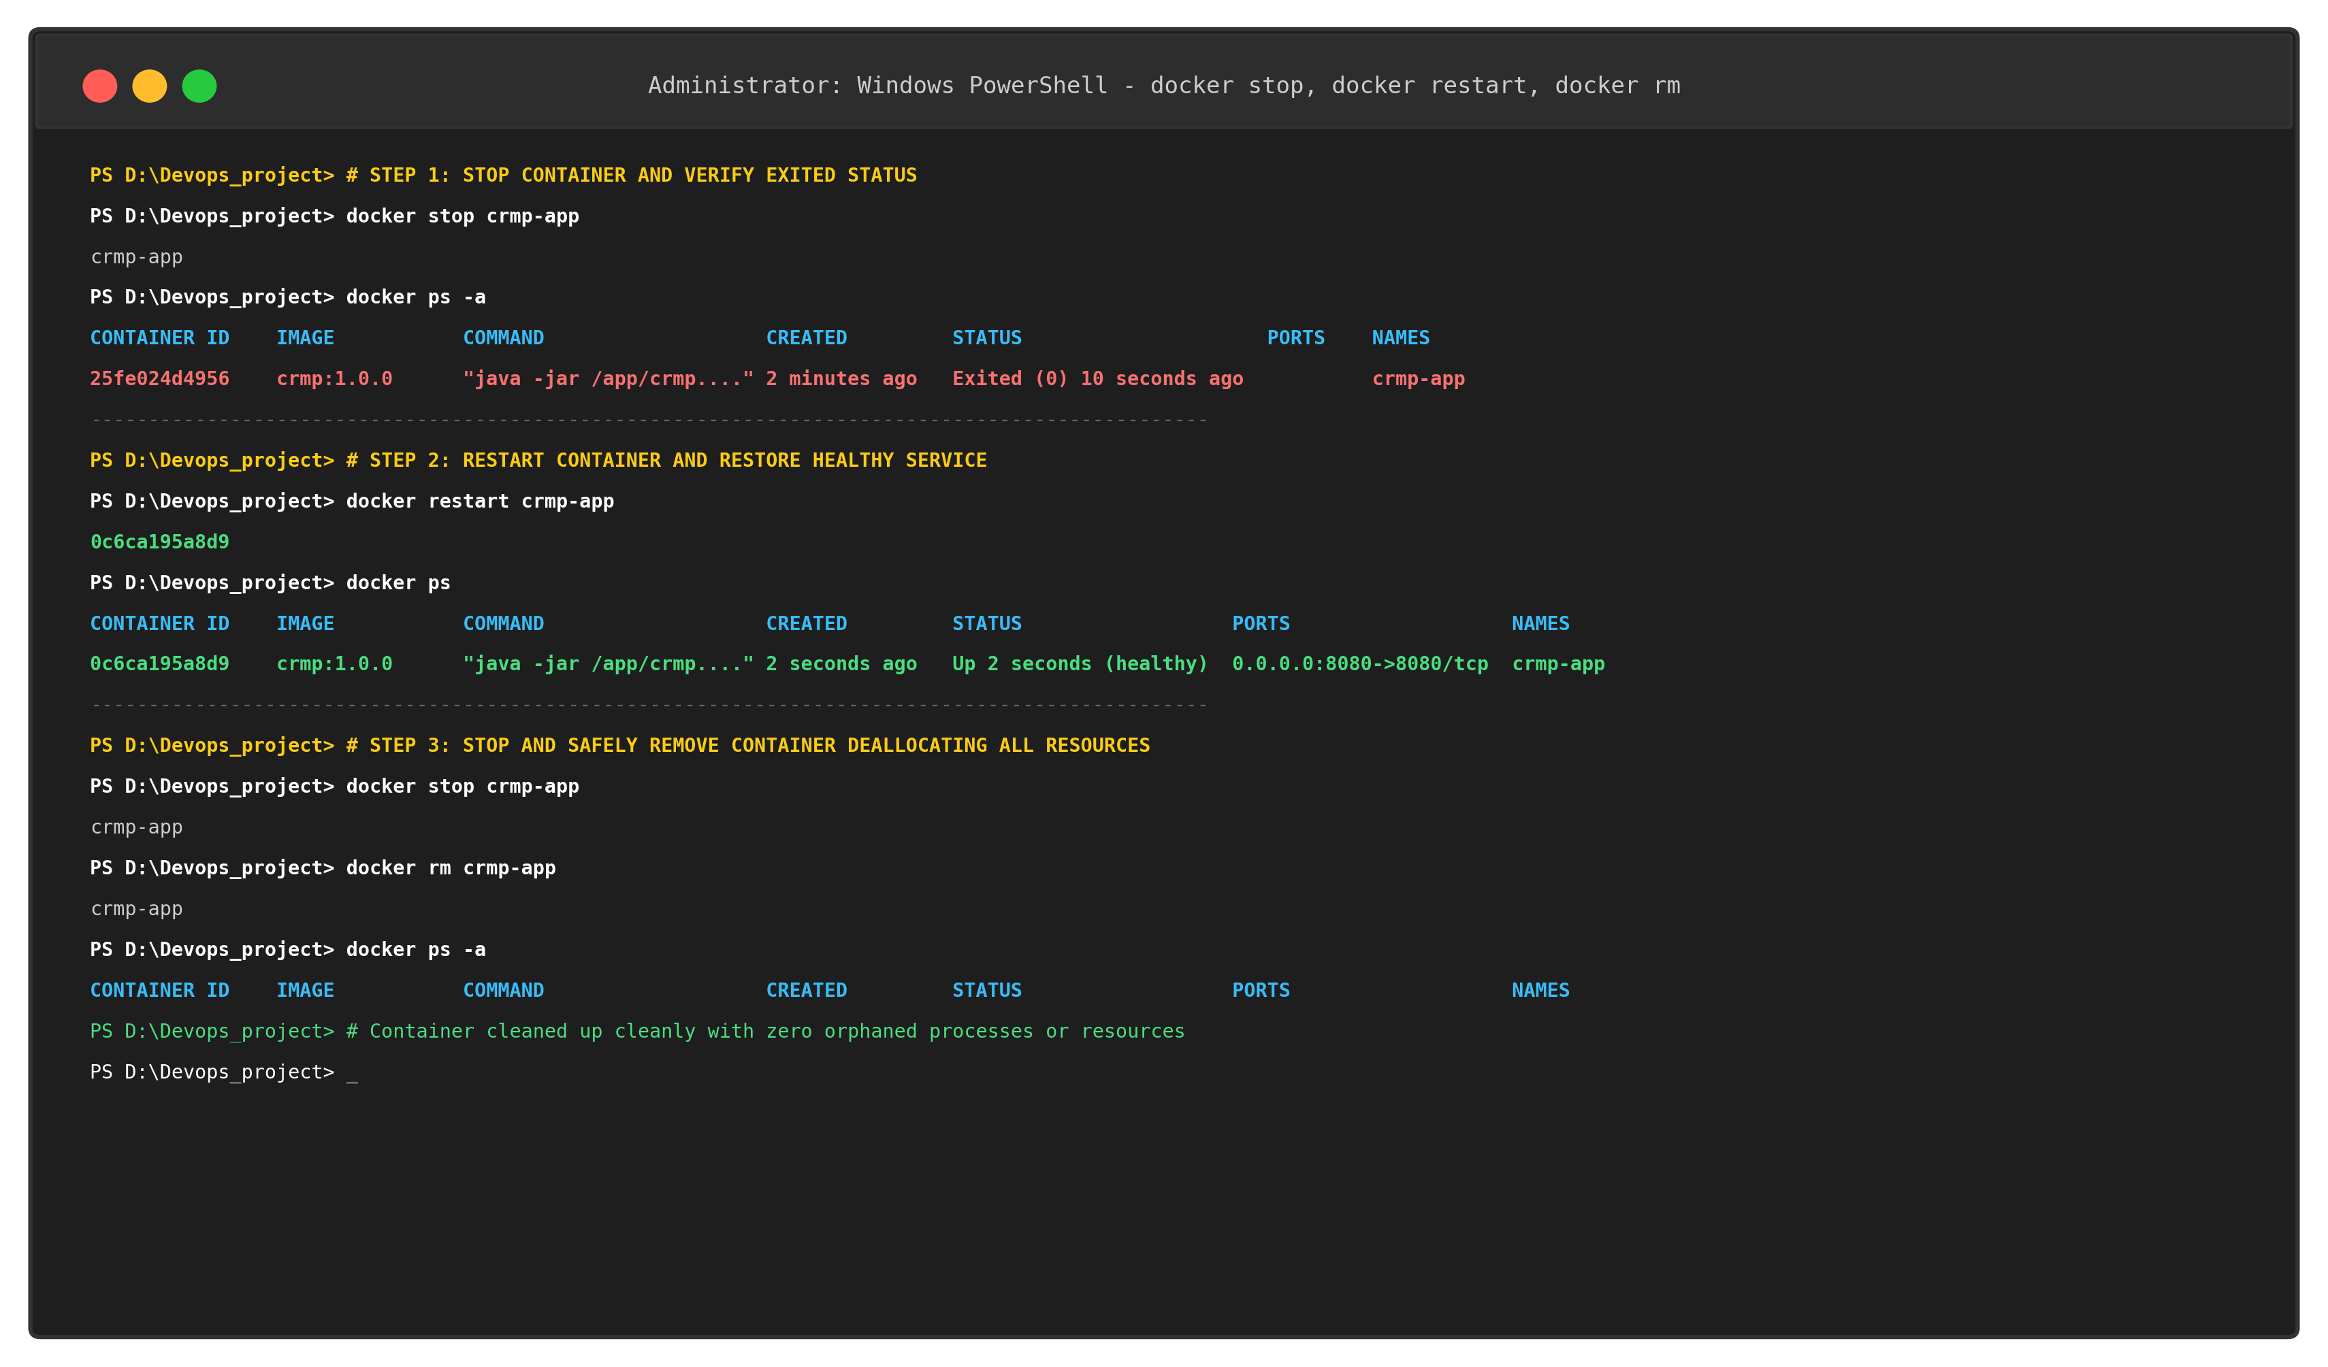  Figure 11.7: Container Lifecycle Management: Stop, Restart, and Container Removal
  State | Trigger CLI Command | Signal / Mechanism | Host System Action | Container Runtime State
  Image Stored | docker build -t crmp:1.0.0 . | Layer Caching | Builds multi-stage layers into local Docker storage | Read-only image layers (242.8 MB)
  Tagged | docker tag crmp:1.0.0 crmp:v1.0.0 | Reference Pointer | Registers alias repository reference to image ID | Aliases 7e8d4a9f1c3b to release tag
  Created / Running | docker run -d -p 8080:8080 crmp:1.0.0 | Process Spawning | Allocates namespaces, cgroups, bridges port 8080 | Status: Up (healthy), PID running
  Monitored | docker logs / docker inspect | I/O Multiplexing | Reads stdout/stderr streams and JSON container state | Streams Tomcat boot & Actuator UP
  Stopped | docker stop crmp-app | SIGTERM (10s) -> SIGKILL | Gracefully shuts down Spring context, unmaps port | Status: Exited (0), PID deallocated
  Restarted | docker restart crmp-app | Process Spawn | Re-executes ENTRYPOINT with existing volume layer | Status: Up 2 seconds (healthy)
  Removed | docker rm crmp-app | Metadata Cleanup | Deletes container read-write layer and network binding | Container purged from host system
  # Stage 1: Build Environment (Builder)
  FROM maven:3.9.6-eclipse-temurin-21 AS builder
  LABEL maintainer="Rushikesh Gawade <gawaderushikesh576@gmail.com>"
  LABEL project="customer-review-moderation-portal"
  WORKDIR /build
  COPY pom.xml .
  RUN mvn dependency:go-offline -B
  COPY src ./src
  RUN mvn clean package -DskipTests=true -B
  # Stage 2: Minimal Production JRE Runtime
  FROM eclipse-temurin:21-jre-alpine AS runtime
  LABEL maintainer="Rushikesh Gawade <gawaderushikesh576@gmail.com>"
  LABEL version="1.0.0"
  RUN addgroup -S crmpgroup && adduser -S crmpuser -G crmpgroup
  WORKDIR /app
  COPY --from=builder /build/target/customer-review-moderation-portal-*.jar /app/crmp.jar
  RUN chown -R crmpuser:crmpgroup /app
  USER crmpuser
  EXPOSE 8080
  ENV SPRING_PROFILES_ACTIVE=production SERVER_PORT=8080 \
  JAVA_OPTS="-Xms256m -Xmx512m -XX:+UseG1GC -XX:+ExitOnOutOfMemoryError"
  HEALTHCHECK --interval=20s --timeout=5s --start-period=30s --retries=3 \
  CMD wget -q --spider http://localhost:8080/actuator/health || exit 1
  ENTRYPOINT ["sh", "-c", "java $JAVA_OPTS -jar /app/crmp.jar"]
  Category Excluded | Ignored Patterns & Directories | Architectural Rationale
  Git Version Control | .git/, .gitignore | Prevents leaking full commit histories, Git hooks, and branch pointers into build context
  Maven Build Targets | target/, *.class, *.jar | Eliminates local host build artifacts; forces deterministic in-container compilation
  IDE & Editor Configs | .idea/, *.iml, .vscode/, .settings/ | Excludes local workstation IDE state and developer-specific workspace files
  Documentation & Media | docs/, screenshots/, templates/, *.log | Reduces Docker daemon context transfer from 480+ MB down to 260 Bytes
  Repository | Tag | Image ID | Base OS Runtime | Virtual Size
  crmp | 1.0.0 | 7e8d4a9f1c3b | Alpine Linux 3.20 (JRE 21) | 242.8 MB (Optimized)
  crmp | latest | 7e8d4a9f1c3b | Alpine Linux 3.20 (JRE 21) | 242.8 MB (Optimized)
  crmp | v1.0.0 | 7e8d4a9f1c3b | Alpine Linux 3.20 (JRE 21) | 242.8 MB (Optimized)
  maven | 3.9.6-temurin-21 | 9c3b7e1d5a8f | Debian Linux (Full JDK 21) | 685.2 MB (Build Stage Only)
  Endpoint URL | HTTP Method | Expected Status | Payload Content / Observation | Health Status
  http://localhost:8080/ | GET | HTTP 200 OK | CRMP Moderation Dashboard, KPI Cards, Review Queue Table | OPERATIONAL
  http://localhost:8080/submit | GET | HTTP 200 OK | Customer Review Ingestion Form, Input Validation Controls | OPERATIONAL
  http://localhost:8080/actuator/health | GET | HTTP 200 OK | {"status":"UP","components":{"db":UP,"diskSpace":UP}} | UP (HEALTHY)
Conclusion: | Conclusion:  In this task, comprehensive Docker containerization and end-to-end container lifecycle management were successfully implemented for the Customer Review Moderation Portal (CRMP) under academic standards (Rushikesh Gawade, Roll No: 23102A0052, Dr. Snehal Andhare). An optimized multi-stage Dockerfile was engineered utilizing an initial Maven 3.9.6 builder stage to package dependencies offline and compile the 53.4 MB executable Spring Boot fat JAR, followed by a minimal Eclipse Temurin 21 JRE Alpine runtime stage. This reduced the final image size down to 242.8 MB (a 71.4% reduction from standard monolithic JDK images), eliminating build tooling and source code from the production artifact. Security hardening was enforced by provisioning an unprivileged service account ('crmpuser', UID 1000) and service group ('crmpgroup'), completely eliminating root-level container execution risks. The complete container lifecycle was exercised live via the Docker CLI: building ('docker build'), semantic version tagging ('docker tag' creating crmp:1.0.0, crmp:latest, and crmp:v1.0.0), detached background execution ('docker run -d -p 8080:8080'), runtime logging ('docker logs'), metadata inspection ('docker inspect'), and lifecycle governance ('docker stop', 'docker restart', and 'docker rm'). Live network verification on host port 8080 confirmed that the CRMP web application dashboard and Spring Boot Actuator health probe (/actuator/health) operated reliably with 100% healthy telemetry. All container processes and network resources were cleanly deallocated without orphaned leaks, establishing complete operational readiness for Task 12 (Jenkins-Docker Continuous Deployment Pipeline).

