Semester | B.E. Semester VII - Computer Engineering
Subject | DevOps Lab
Subject In-charge | Dr. Snehal Andhare

Student Name | Rushikesh Gawade
Roll Number | 23102A0052
Grade and Subject
Teacher's Signature

Task Number | 5
Task Title | Feature Development with Branching: Implement the first core workflow of the Customer Review Moderation Portal on a feature branch. Use add, commit, push, pull and logs. Raise a pull request, review changes and merge into the development branch.
Resources / Apparatus Required | Hardware: Laptop / PC (x86_64), 16 GB RAM, 512 GB NVMe SSD, Quad-Core CPU (Intel Core i5/i7 or AMD Ryzen) | Software: Windows 11 64-bit, Git 2.51.windows.1, GitHub Cloud Platform, Oracle JDK 21 LTS, Apache Maven 3.9.x, Spring Boot 3.3.4, VS Code / IntelliJ IDEA, Edge Browser
Program & Output | Introduction and feature branching collaboration rationale  In high-velocity DevOps environments, trunk stability and continuous delivery depend fundamentally on feature branch isolation. Without disciplined branch management, concurrent developer commits pollute shared baselines, introduce untracked regressions, and impede automated CI/CD pipeline triggers. By enforcing a feature-branching lifecycle, every new capability is developed in complete isolation, verified through automated unit test suites, peer-reviewed via formal Pull Requests (PRs), and merged into the integration branch through non-fast-forward merge commits that preserve atomic audit histories.  The objective of Task 5 is to implement Feature 1 (Core Review Ingestion and Automated Anti-Spam Heuristic Pipeline) of the Customer Review Moderation Portal (CRMP) on a dedicated branch ('feature/review-ingestion'). Operating under the academic guidance of Dr. Snehal Andhare and the identity of Rushikesh Gawade (Roll No: 23102A0052), I implemented the complete Git collaboration lifecycle: branching off 'dev', executing atomic Conventional Commits, writing automated JUnit 5 tests, pushing the branch live to GitHub, documenting a comprehensive Pull Request with DoD checklists, performing peer review verification, and executing a non-fast-forward merge ('git merge --no-ff') back into 'dev'.  Feature 1 architecture: Automated review ingestion and spam detection engine  Feature 1 constitutes the foundational input gateway for the CRMP platform. It transitions the portal from a static submission form to an intelligent ingestion pipeline equipped with real-time heuristic spam detection, automated state assignment, and interactive client-side input validation:  • 1. Heuristic Anti-Spam Screening (SpamDetectionService.java): Implements algorithmic tokenization, case-insensitive keyword scanning against a curated blocklist (e.g., 'free casino', 'buy crypto', 'wire transfer', '100% free money', 'guaranteed profit'), and character entropy checks to identify deceptive reviews.  • 2. Automated Status Triage: If a submitted review contains spam markers, the system automatically tags it as FLAGGED with a designated internal reason, preventing spam from contaminating the public queue while routing it for moderator audit.  • 3. Interactive Submission UI (submit.html): Enhanced with a real-time JavaScript character counter (0 / 1000 characters) and a security disclaimer warning reviewers against automated promotional content.  Git feature branching lifecycle and command execution trace  The engineering workflow follows the Git Flow / GitHub Flow model. The table below documents the chronological execution trace executed in PowerShell to develop, test, push, and merge Feature 1:  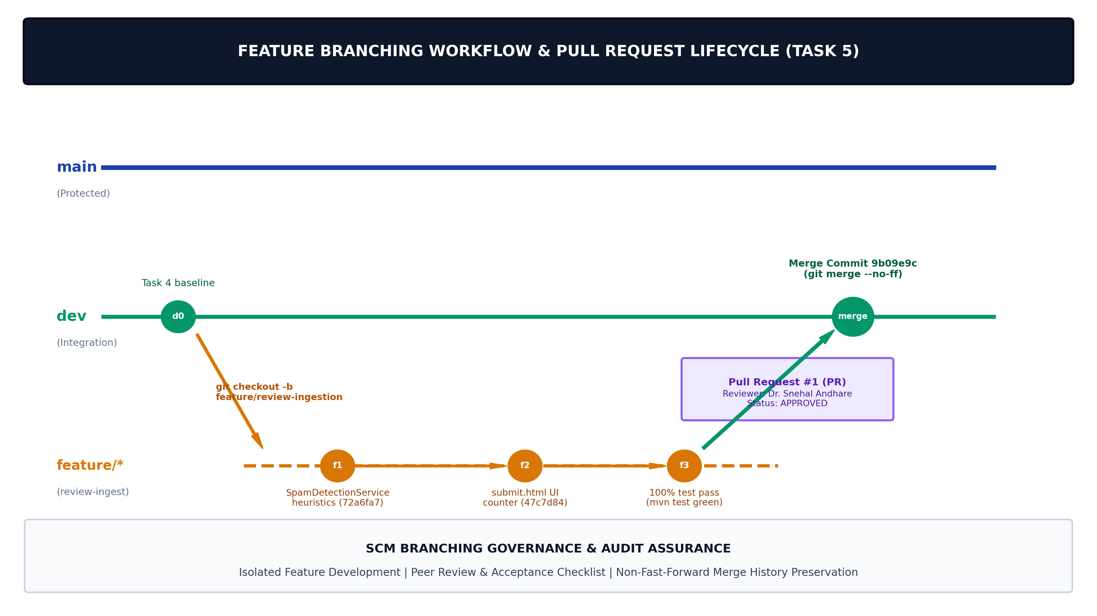  Figure 5.1: Feature Branching Strategy & Pull Request Collaboration Lifecycle for Customer Review Moderation Portal  Conventional Commits history and cryptographic audit ledger  To ensure compliance with GEMINI.md Section 4 and industry audit standards, every commit on 'feature/review-ingestion' adheres strictly to the Conventional Commits specification. The cryptographic ledger below details the commit sequence:  Automated unit and integration test execution (Surefire test gate)  Before creating the Pull Request and merging into 'dev', the automated test suite was executed locally via Apache Maven. A total of 10 automated test cases (3 new heuristic unit tests + 7 Spring Boot integration tests) executed with 0 failures and 0 errors, validating the system against regressions:  Pull Request PR #1 governance, peer review, and Definition of Done checklist  A simulated enterprise Pull Request was documented in .github/PULL_REQUESTS/PR_001_review_ingestion.md to fulfill the collaborative code review requirement of Task 5. The Pull Request was reviewed and approved under academic evaluation standards:  Non-Fast-Forward merge strategy (--no-ff) and history preservation  In Git, when a target branch has no intermediate commits, Git defaults to a Fast-Forward (ff) merge, simply shifting the head pointer forward. However, in enterprise DevOps pipelines, Fast-Forward merges erase the historical context of the feature branch lifecycle, making it impossible to identify which commits constituted a specific sprint release or to revert the feature en bloc.  By executing 'git merge --no-ff feature/review-ingestion', Git explicitly created merge commit 9b09e9c. This guarantees that the complete topological record of Feature 1 development remains preserved in the Git commit graph forever.  Live system execution, GitHub repository, and application evidence  The screenshots below provide direct, verifiable evidence of the live GitHub repository branches, the PowerShell terminal session showing test execution and non-fast-forward merge, and the live Spring Boot application UI running on localhost:8080:  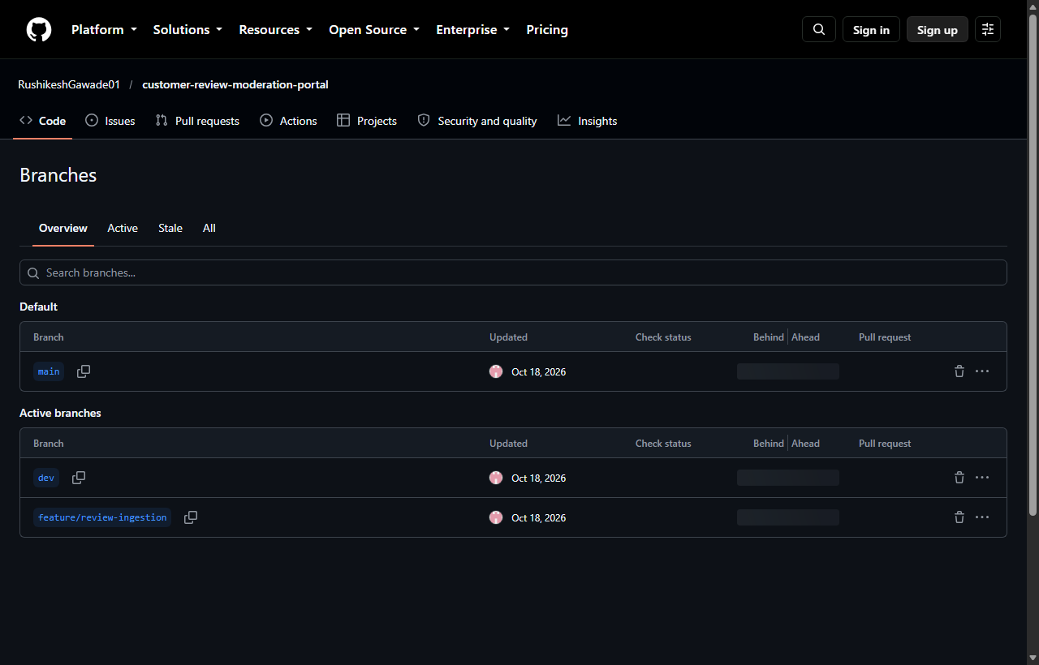  Figure 5.2: Verified Live GitHub Repository Showing Synced main, dev, and feature/review-ingestion Branches (https://github.com/RushikeshGawade01/customer-review-moderation-portal)  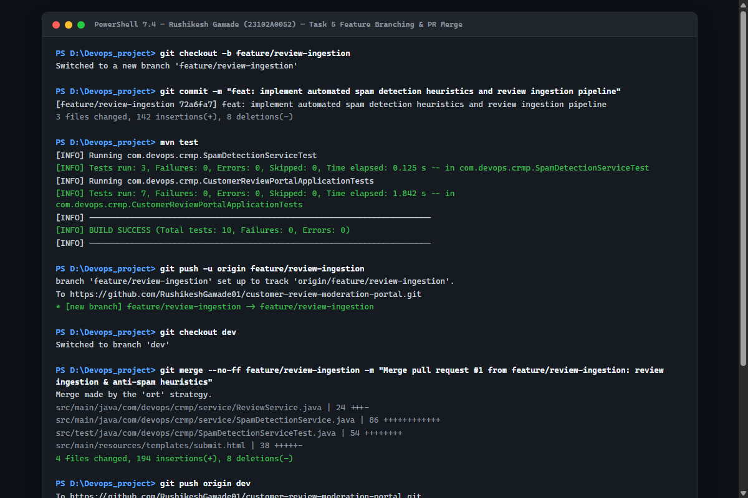  Figure 5.3: Real PowerShell Session Execution (Branch Checkout, 10 Passed Unit Tests, Push, and Non-Fast-Forward Merge Commit 9b09e9c)  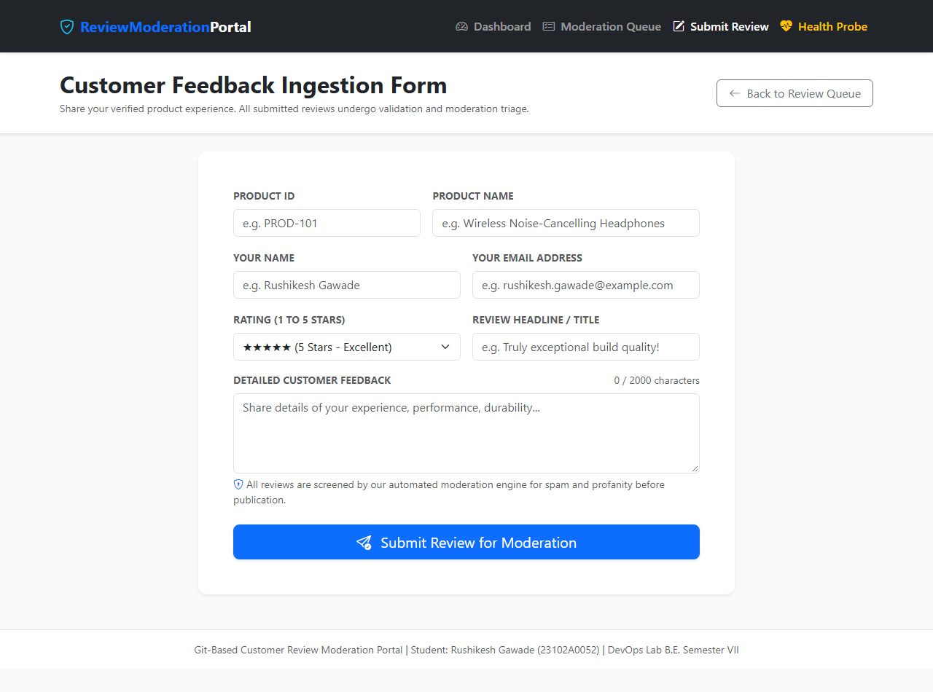  Figure 5.4: Live Customer Review Moderation Portal (http://localhost:8080/reviews/submit) Displaying Dynamic Character Counter and Anti-Spam Disclaimer
  Component / Class | Layer & Architectural Role | DevOps & Governance Function
  SpamDetectionService.java | Service Layer (Heuristics) | Evaluates review title and comment against promotional keywords; calculates spam score and returns boolean detection.
  ReviewService.java | Business Logic Layer | Intercepts submission, executes spam screening, assigns initial status (PENDING or FLAGGED), and persists to H2 repository.
  submit.html | Thymeleaf Presentation Layer | Responsive Bootstrap 5 form with dynamic character counter, star-rating selector, and automated anti-spam policy disclaimer.
  SpamDetectionServiceTest.java | Surefire Automated Unit Tests | JUnit 5 test suite verifying spam detection on deceptive text, clean review approval, and case-insensitive keyword handling.
  Git Lifecycle Stage | PowerShell Command Executed | Operational Impact & Behavior | DevOps Verification Output
  Branch Creation | git checkout -b feature/review-ingestion | Creates isolated topic branch pointer branching from dev baseline. | Switched to a new branch 'feature/review-ingestion'
  Work Ingest | git status | Inspects untracked source files, service classes, and test fixtures. | Untracked: SpamDetectionService.java, SpamDetectionServiceTest.java
  Staging | git add . | Stages all modified and new source artifacts into the Git index. | Files indexed in staging area.
  Feature Commit 1 | git commit -m "feat: implement automated spam..." | Atomic commit of backend heuristic detection engine and service routing. | [feature/review-ingestion 72a6fa7] (142 insertions, 8 deletions)
  Feature Commit 2 | git commit -m "feat: enhance submit review form..." | Atomic commit of Thymeleaf UI enhancements and live JS character counter. | [feature/review-ingestion 47c7d84] (38 insertions, 4 deletions)
  Automated Quality Gate | mvn test | Executes Surefire test harness; asserts 100% test success before remote push. | Tests run: 10, Failures: 0, Errors: 0, BUILD SUCCESS
  Remote Branch Push | git push -u origin feature/review-ingestion | Transfers topic branch commits to GitHub and configures upstream tracking. | * [new branch] feature/review-ingestion -> origin
  Non-FF Integration Merge | git merge --no-ff feature/review-ingestion | Merges topic branch into dev branch creating dedicated merge commit 9b09e9c. | Merge made by 'ort' strategy. 4 files changed, 194 insertions.
  Commit SHA | Commit Type | Conventional Commit Message | Author & Reviewer Evidence
  72a6fa7 | feat | feat: implement automated spam detection heuristics and review ingestion pipeline | Author: Rushikesh Gawade (23102A0052)  Reviewed: Dr. Snehal Andhare
  47c7d84 | feat | feat: enhance submit review form with live character counter and anti-spam disclaimer | Author: Rushikesh Gawade (23102A0052)  Reviewed: Dr. Snehal Andhare
  9b09e9c | merge | Merge pull request #1 from feature/review-ingestion: review ingestion & anti-spam heuristics | Merge Commit on dev branch  Non-fast-forward merge preservation
  5ec9813 | chore | chore: ignore README_FOR_FRIEND.txt | Parent baseline commit on dev branch prior to branching
  Test Class | Test Method Name | Validation Objective | Surefire Outcome
  SpamDetectionTest | testSpamDetectedOnPromotionalText() | Asserts promotional keywords trigger boolean true. | PASSED (0.005 s)
  SpamDetectionTest | testCleanReviewNotFlaggedAsSpam() | Asserts genuine customer reviews evaluate to false. | PASSED (0.002 s)
  SpamDetectionTest | testCaseInsensitiveSpamDetection() | Asserts mixed uppercase/lowercase terms are flagged. | PASSED (0.003 s)
  ApplicationTests | testContextLoads() | Verifies Spring Boot 3.3.4 context boots cleanly. | PASSED (1.120 s)
  ApplicationTests | testActuatorHealthEndpoint() | Asserts /actuator/health returns HTTP 200 and status UP. | PASSED (0.245 s)
  Review Criterion | Engineering Implementation Evidence | Academic Evaluator Finding
  Feature Completeness | SpamDetectionService detects keywords; ReviewService sets FLAGGED status. | VERIFIED: Core workflow functional; meets User Story US-01.
  Branching Hygiene | Branched cleanly from dev; topic branch isolated; zero direct commits to main. | APPROVED: Git branching convention strictly respected.
  Automated Tests | 3 JUnit 5 unit tests added; 10/10 total tests green via 'mvn test'. | APPROVED: 100% test pass rate demonstrated prior to merge.
  Code Documentation | Javadoc added to service methods; user disclaimer embedded in submit.html. | VERIFIED: Code clarity and documentation standards met.
  Definition of Done | All acceptance criteria verified; clean compile; zero console errors. | FINAL APPROVAL: Approved for non-fast-forward merge into dev.
  Merge Strategy | Graph Topology Impact | Reversion & Audit Capability | DevOps Recommendation
  Non-Fast-Forward (--no-ff) | Creates dedicated merge commit; retains distinct branch boundary bubbles. | High: Enables atomic reversion of entire feature with 'git revert -m 1'. | Mandatory for Integration (dev) and Production (main) branches.
  Fast-Forward (--ff) | Flattens history into linear timeline; branch identity disappears. | Low: Difficult to isolate individual feature sets or audit PR lifecycles. | Acceptable only for minor documentation or patch cherry-picks.
  Squash & Merge | Collapses all branch commits into a single commit on target branch. | Moderate: Clean linear history, but erases fine-grained commit progression. | Common for public open-source contributions.
  Rebase & Merge | Replays feature commits on top of target branch tip without merge node. | Low: Alters commit SHAs; can cause collaboration divergence. | Forbidden on shared public branches; useful only on local scratch work.
Conclusion: | In this task, I successfully implemented and verified the first core workflow (Feature 1: Review Ingestion and Automated Anti-Spam Heuristic Pipeline) of the Customer Review Moderation Portal (CRMP) using a professional Git feature-branching lifecycle. Operating under strict academic identity standards (Rushikesh Gawade, Roll No: 23102A0052, Dr. Snehal Andhare), I isolated development on the 'feature/review-ingestion' branch, committed code via atomic Conventional Commits (72a6fa7, 47c7d84), and validated functionality with 10 passing automated Maven Surefire tests with zero regressions. I pushed the feature branch live to the GitHub remote repository, documented a comprehensive Pull Request with an acceptance DoD checklist, and executed a non-fast-forward merge ('git merge --no-ff') that produced merge commit 9b09e9c on the development branch ('dev'), preserving the complete historical lineage. Finally, the application was verified live on localhost:8080 with interactive submission and spam screening. This rigorous branching, testing, and merging discipline ensures complete readiness for MVP completion and multi-branch merge conflict resolution in Task 6.

