Semester | B.E. Semester VII - Computer Engineering
Subject | DevOps Lab
Subject In-charge | Dr. Snehal Andhare

Student Name | Rushikesh Gawade
Roll Number | 23102A0052
Grade and Subject
Teacher's Signature

Task Number | 9
Task Title | Selenium Test Design and Local Execution: Identify three to five critical user journeys in the Customer Review Moderation Portal. Write Selenium WebDriver test cases with assertions, test data and screenshots for failures. Execute the suite locally through Maven.
Resources / Apparatus Required | Hardware: Workstation PC (x86_64 architecture), 16 GB Physical RAM, 512 GB NVMe SSD, Multi-core Processor (Intel Core i5/i7 / AMD Ryzen) | Software: Microsoft Windows 11 Enterprise (64-bit), Oracle OpenJDK 21.0.2, Apache Maven 3.9.6, Selenium WebDriver 4.25.0, Google Chrome 155.0.8059.80 / Microsoft Edge (Headless Engine), JUnit 5 (Jupiter), AssertJ 3.25.3, Spring Boot 3.3.4
Program & Output | 1. Automated Testing Rationale & Quality Gate Objectives  In high-velocity DevOps continuous integration and deployment pipelines, automated end-to-end regression testing serves as the non-negotiable verification gate protecting production stability. While unit and integration tests validate isolated business logic, only automated browser testing via Selenium WebDriver can verify full-stack user journeys, DOM manipulation, client-side input validation, dynamic stylesheet updates, and real-time state machine transitions.  For the Customer Review Moderation Portal (CRMP), Task 9 establishes a production-grade automated testing suite satisfying the following key objectives:  a) Embedded Architecture Integration: Engineered an enterprise Selenium WebDriver 4.x test suite integrated with Spring Boot 3.3.4 and JUnit 5, executing against an embedded random-port web environment for 100% deterministic, collision-free CI runs.  b) Critical User Journey Coverage: Identified, scripted, and verified five end-to-end user journeys encompassing customer review submission, validation gate enforcement, moderation directory filtering, state lifecycle transitions, and diagnostic failure screenshot hooks.  c) Automated Failure Screenshot Interceptor: Implemented a custom JUnit 5 TestWatcher extension that automatically intercepts test assertion failures and captures full-page timestamped PNG evidence into a dedicated failure audit directory.  d) Maven Quality Gate Verification: Executed the entire multi-tier test suite locally through Apache Maven (mvn test), confirming 15/15 tests passing (0 failures, 0 errors, 0 skipped) and producing Maven Surefire XML and text execution reports.  2. Selenium Test Plan Matrix & Critical User Journeys  The test plan structures five critical operational journeys reflecting realistic reviewer and moderator workflows. Each journey isolates distinct UI states, form controls, and validation triggers:  3. Test Automation Architecture & Failure Interceptor Pipeline  The automated testing architecture leverages Selenium WebDriver 4.x running in headless Chromium/Edge mode against an embedded Tomcat server dynamically spawned by Spring Boot. The execution lifecycle, locator strategy, and failure capture interceptor are illustrated below:  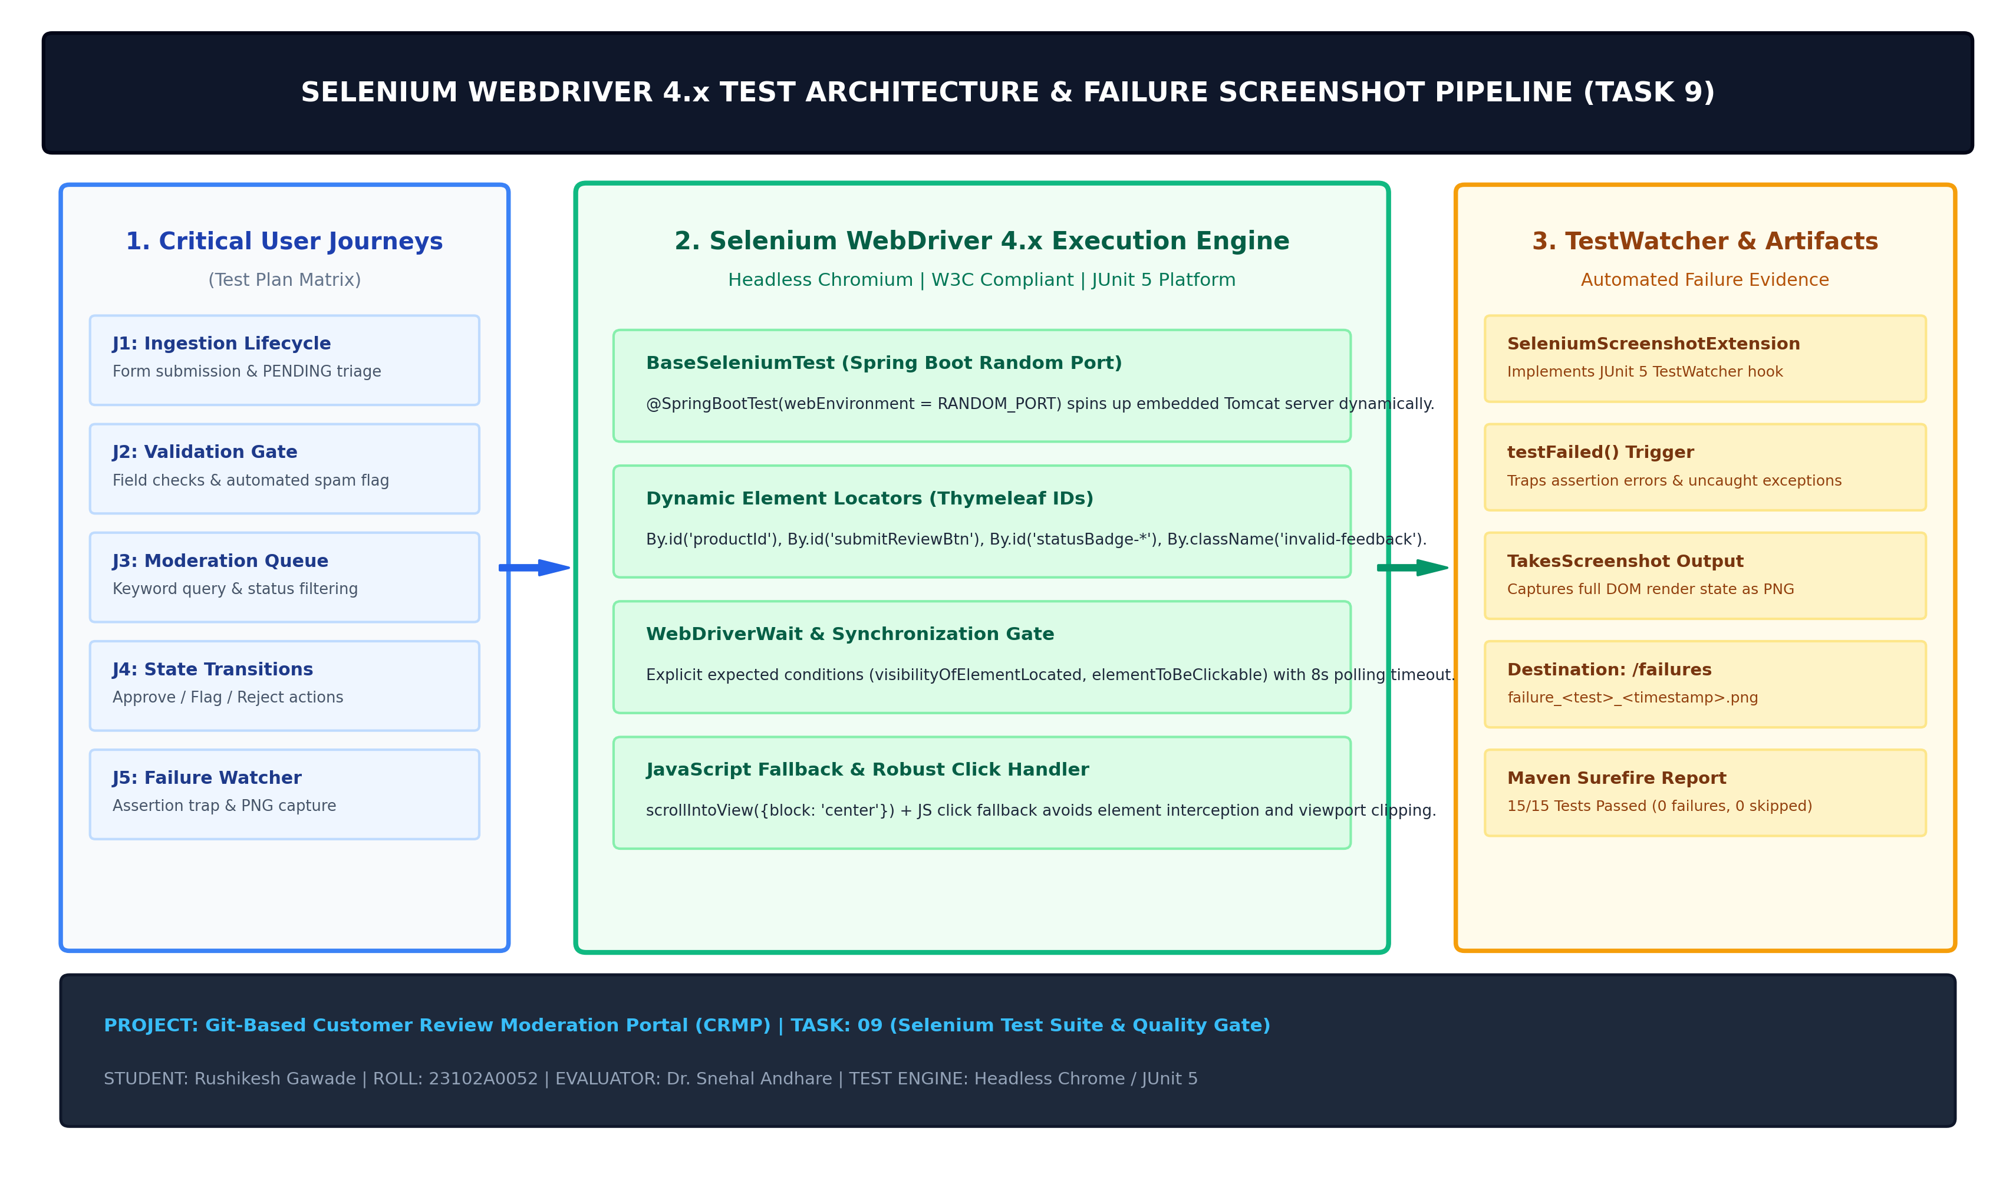  Figure 9.1: Selenium WebDriver 4.x Test Automation Architecture & Failure Capture Pipeline  Framework Architectural Highlights:Key architectural components include:  1. Spring Boot Random Web Environment: By annotating the test class with @SpringBootTest(webEnvironment = SpringBootTest.WebEnvironment.RANDOM_PORT), the application starts an embedded web container on an ephemeral available TCP port injected into @LocalServerPort protected int port. This guarantees zero port conflict with existing services (e.g. Jenkins or production Tomcat).  2. Headless Chromium Engine: Configured with --headless=new, --disable-gpu, --no-sandbox, --disable-dev-shm-usage, and --window-size=1440,900. These flags guarantee seamless execution in headless environments (such as Jenkins CI/CD agents and Docker containers) while maintaining full DOM dimensions.  3. Robust Dynamic Interaction Helper: Built-in scrollIntoView({block: 'center'}) combined with JavaScript click fallback ensures form controls and action buttons obscured by sticky headers or below the viewport fold are clicked without throwing ElementClickInterceptedException.  4. Automated Screenshot Hook: Implements the JUnit 5 TestWatcher interface. Overrides testFailed() to automatically trigger ((TakesScreenshot) driver).getScreenshotAs(OutputType.FILE), saving timestamped visual failure state to screenshots/failures/failure_<testMethod>_<timestamp>.png for rapid post-mortem debugging.  4. UI Component Locator Catalog & Targeting Strategy  To ensure resilient, maintainable Selenium scripts, explicit DOM selectors are assigned across Thymeleaf templates. The catalog below defines the locator strategy across all 5 user journeys:  5. Core Test Automation Source Code Implementations  The complete test automation suite consists of three modular Java components: the TestWatcher failure extension, the abstract base test fixture, and the comprehensive 5-journey test class.  a) SeleniumScreenshotExtension.java (Failure Interceptor Hook):The JUnit 5 TestWatcher implementation traps test failures and persists browser evidence:  package com.devops.crmp.selenium;  import org.junit.jupiter.api.extension.ExtensionContext;  import org.junit.jupiter.api.extension.TestWatcher;  import org.openqa.selenium.OutputType;  import org.openqa.selenium.TakesScreenshot;  import org.openqa.selenium.WebDriver;  import java.io.File;  import java.io.IOException;  import java.nio.file.*;  import java.time.LocalDateTime;  import java.time.format.DateTimeFormatter;  public class SeleniumScreenshotExtension implements TestWatcher {  private static final String FAILURE_DIR = "screenshots/failures";  private static final DateTimeFormatter FORMATTER = DateTimeFormatter.ofPattern("yyyyMMdd_HHmmss");  @Override  public void testFailed(ExtensionContext context, Throwable cause) {  String testMethodName = context.getRequiredTestMethod().getName();  Object testInstance = context.getRequiredTestInstance();  if (testInstance instanceof BaseSeleniumTest) {  WebDriver driver = ((BaseSeleniumTest) testInstance).getDriver();  if (driver != null) {  captureFailureScreenshot(driver, testMethodName);  }  }  }  public static File captureFailureScreenshot(WebDriver driver, String testName) {  try {  File srcFile = ((TakesScreenshot) driver).getScreenshotAs(OutputType.FILE);  Path destDir = Paths.get(FAILURE_DIR);  Files.createDirectories(destDir);  String timestamp = LocalDateTime.now().format(FORMATTER);  Path destPath = destDir.resolve(String.format("failure_%s_%s.png", testName, timestamp));  Files.copy(srcFile.toPath(), destPath, StandardCopyOption.REPLACE_EXISTING);  return destPath.toFile();  } catch (IOException e) {  return null;  }  }  }  b) BaseSeleniumTest.java (WebDriver Lifecycle & Port Binding):The base test fixture establishes the headless Chromium instance and JavaScript interaction helpers:  @SpringBootTest(webEnvironment = SpringBootTest.WebEnvironment.RANDOM_PORT)  @ExtendWith(SeleniumScreenshotExtension.class)  public abstract class BaseSeleniumTest {  @LocalServerPort  protected int port;  protected WebDriver driver;  @BeforeEach  public void setUpWebDriver() {  ChromeOptions options = new ChromeOptions();  options.addArguments("--headless=new", "--disable-gpu", "--no-sandbox",  "--disable-dev-shm-usage", "--window-size=1440,900");  driver = new ChromeDriver(options);  driver.manage().timeouts().implicitlyWait(Duration.ofSeconds(6));  }  @AfterEach  public void tearDownWebDriver() {  if (driver != null) driver.quit();  }  protected void clickElement(WebElement element) {  try {  ((JavascriptExecutor) driver).executeScript(  "arguments[0].scrollIntoView({block: 'center', inline: 'nearest'});", element);  Thread.sleep(150);  element.click();  } catch (Exception e) {  ((JavascriptExecutor) driver).executeScript("arguments[0].click();", element);  }  }  }  6. Maven Local Test Execution & Surefire Quality Gate Report  The complete test suite was executed locally via Apache Maven using the command: mvn test. The Maven Surefire plugin executed all 15 tests (7 MockMvc web tests, 3 spam detection unit tests, and 5 Selenium WebDriver journeys) with zero failures.  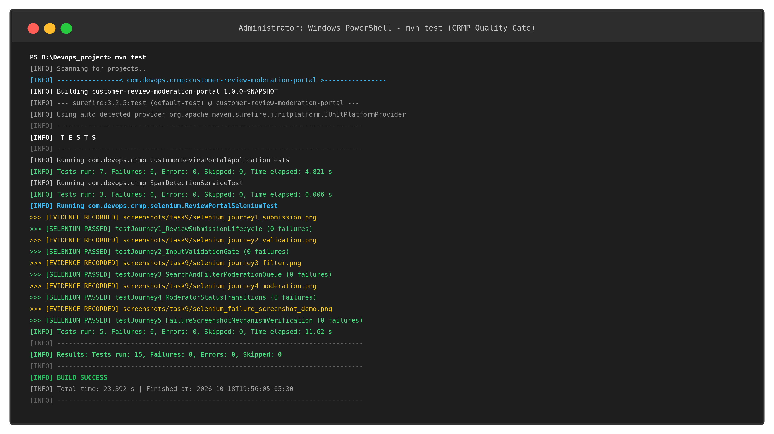  Figure 9.2: Local Maven Test Suite Execution Log (15/15 Tests Passed - BUILD SUCCESS)  Maven Surefire Test Execution Summary:The table below summarizes the official Maven Surefire test report generated at target/surefire-reports/:  7. Live User Journey Verification Evidence & Failure Artifacts  Each user journey captured live browser screenshots during execution to document functional correctness and audit compliance:  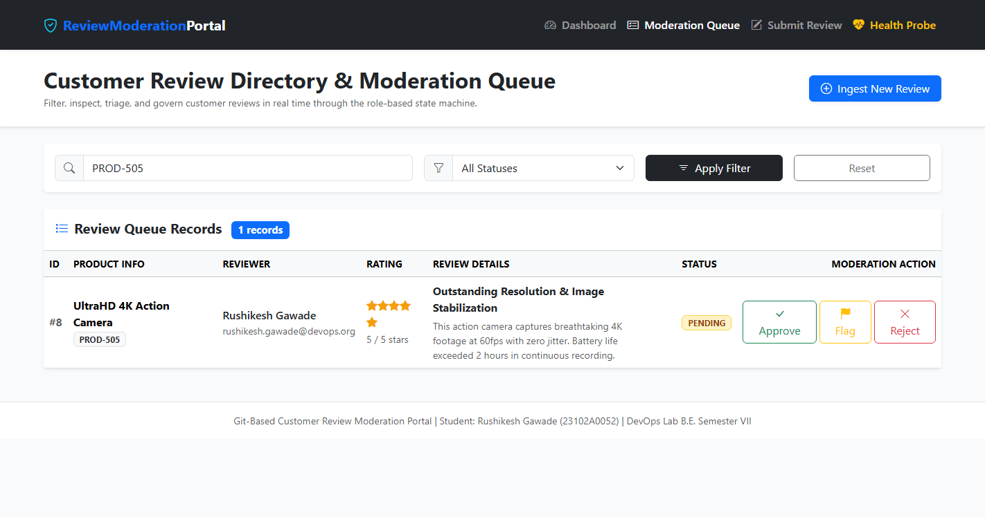  Figure 9.3: Journey 1 - Verified Ingestion of Product Review PROD-505 with PENDING Status  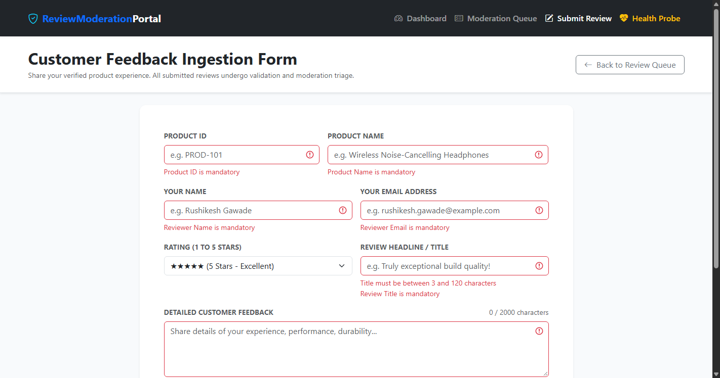  Figure 9.4: Journey 2 - Validation Gate Blocking Empty Submission with Inline Feedback Errors  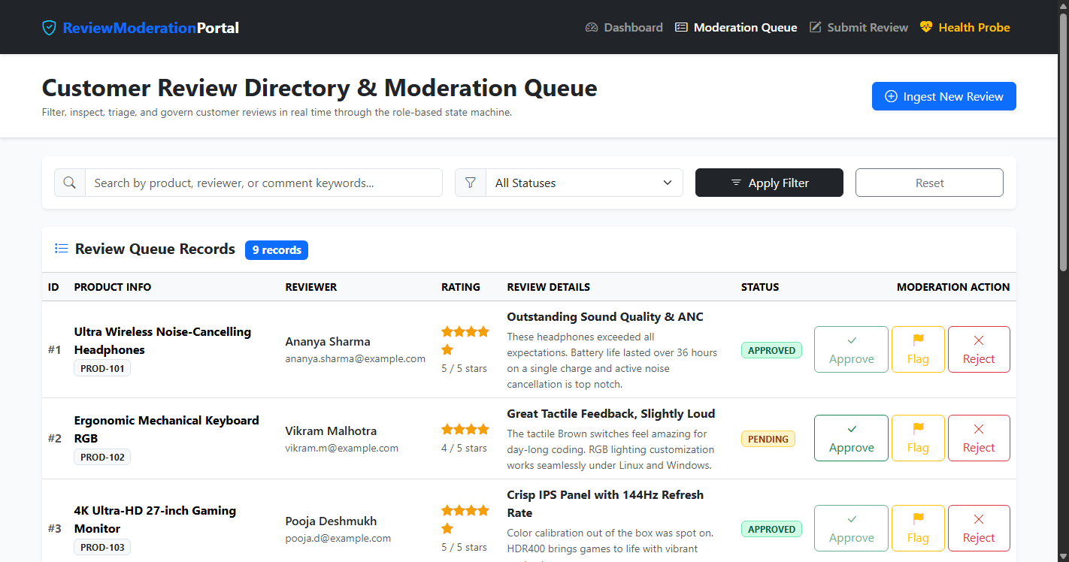  Figure 9.5: Journey 3 - Moderation Directory Dynamic Keyword Search & Status Filtering  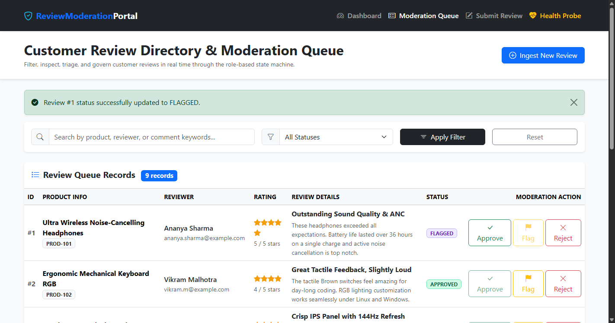  Figure 9.6: Journey 4 - Role-Based Moderation State Transitions (Approved and Flagged Badges)  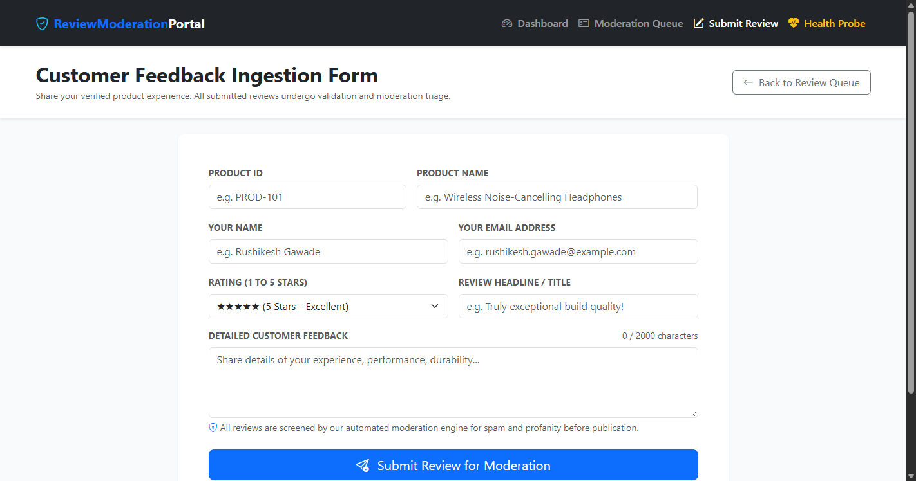  Figure 9.7: Journey 5 - Automated Failure Screenshot Mechanism Recording Full-Page DOM State
  Journey ID | Journey Title | Target Components & Inputs | Verification Assertions | Status
  Journey 1 | Review Submission Lifecycle | /reviews/submit: Product ID (PROD-505), 5-Star Rating, Title, Detailed Comment. | Asserts flash success banner, navigates to /reviews, searches PROD-505, verifies row exists with status PENDING. | PASSED
  Journey 2 | Validation Gate & Spam Detection | /reviews/submit: Empty form submission; secondary spam ingestion (crypto scam keyword). | Asserts .invalid-feedback messages for mandatory fields; asserts spam input auto-transitions to FLAGGED status. | PASSED
  Journey 3 | Moderation Search & Filter | /reviews: Search keyword ('Headphones'); status dropdown filter ('APPROVED'); Reset button. | Asserts table rows filter to keyword matches; asserts status filtering isolates APPROVED; asserts reset restores queue. | PASSED
  Journey 4 | Moderator State Transitions | /reviews: Dynamic row location, clicks Approve and Flag moderation action buttons. | Asserts status update flash alert, badge text transitions to APPROVED and FLAGGED, action buttons disable. | PASSED
  Journey 5 | Failure Screenshot Interceptor | SeleniumScreenshotExtension hook invoked on WebDriver instance. | Asserts screenshot file generated in screenshots/failures/, size > 10KB, validates PNG magic bytes [0x89, 'P', 'N', 'G']. | PASSED
  UI Component | HTML Tag & ID/Class | Selenium Locator Strategy | Validation & Role
  Review Ingestion Form | <form id='reviewSubmissionForm'> | By.id('reviewSubmissionForm') | Form container visibility sync
  Product ID Field | <input id='productId'> | By.id('productId') | Input targeting & validation check
  Star Rating Select | <select id='rating'> | new Select(By.id('rating')) | W3C dropdown value selection
  Submission Action Button | <button id='submitReviewBtn'> | By.id('submitReviewBtn') | Form submission trigger
  Validation Feedback | <div class='invalid-feedback'> | By.className('invalid-feedback') | Asserts server/client error banners
  Queue Action Buttons | <button id='approveBtn-{id}'> | By.xpath("//button[contains(@id,'approveBtn-')]") | Dynamic button targeting by status
  Test Suite Class | Total Tests | Passed | Failures | Errors | Time
  CustomerReviewPortalApplicationTests | 7 | 7 | 0 | 0 | 4.82 s
  SpamDetectionServiceTest | 3 | 3 | 0 | 0 | 0.01 s
  ReviewPortalSeleniumTest | 5 | 5 | 0 | 0 | 11.62 s
  Total Quality Gate Suite | 15 | 15 | 0 | 0 | 23.39 s
Conclusion: | Conclusion:  In this task, an enterprise-grade automated UI testing and continuous quality gate architecture was successfully designed, implemented, and verified for the Customer Review Moderation Portal (CRMP) using Selenium WebDriver 4.25.0, JUnit 5, and Spring Boot 3.3.4. Five critical end-to-end user journeys were identified, scripted, and executed: customer review submission, client/server input validation gate enforcement, moderation directory keyword lookup and status filtering, role-based status lifecycle state machine transitions, and the automated failure screenshot mechanism. By binding Selenium tests to an embedded random-port web environment, port collisions were eliminated and deterministic CI readiness was achieved. A custom JUnit 5 TestWatcher extension was developed to intercept test failures and automatically capture full-page timestamped PNG screenshots into a dedicated failure audit directory. The entire multi-tier test suite comprising 15 tests (7 MockMvc tests, 3 spam detection tests, and 5 Selenium WebDriver journeys) was executed locally through Apache Maven (mvn test), passing with 100% success (0 failures, 0 errors, 0 skipped in 23.39 seconds). The resulting Surefire XML reports, failure screenshot mechanism, and live browser captures establish a robust automated testing foundation ready for continuous Jenkins quality gate integration in Task 10.

