Semester | B.E. Semester VII - Computer Engineering
Subject | DevOps Lab
Subject In-charge | Dr. Snehal Andhare

Student Name | Rushikesh Gawade
Roll Number | 23102A0052
Grade and Subject
Teacher's Signature

Task Number | 10
Task Title | Continuous Testing in Jenkins: Integrate the Customer Review Moderation Portal Selenium suite into Jenkins. Publish test reports and configure the pipeline so failed tests stop deployment. Correct at least one deliberately introduced defect and rerun the pipeline.
Resources / Apparatus Required | Hardware: Workstation PC (x86_64 architecture), 16 GB Physical RAM, 512 GB NVMe SSD, Multi-core Processor (Intel Core i5/i7 / AMD Ryzen) | Software: Microsoft Windows 11 Enterprise (64-bit), Jenkins v2.580.1 LTS, Oracle OpenJDK 21.0.2, Apache Maven 3.9.6, Selenium WebDriver 4.25.0, Headless Google Chrome, Git 2.51.windows.1, GitHub Cloud, Apache Tomcat 11.0.18
Program & Output | 1. Continuous Testing Rationale & Quality Gate Enforcement  In modern DevOps engineering, automated pipelines must do more than simply package and deploy code—they must actively protect production environments by acting as uncompromising Quality Gates. The foundational Lean manufacturing principle of 'Stop the Line' (Andon cord) asserts that whenever a defect is detected during production, all downstream operations must immediately freeze until the root cause is resolved. In Continuous Integration and Continuous Deployment (CI/CD), this translates into a strict quality barrier: if any automated test fails, the deployment pipeline must immediately terminate and abort all downstream packaging, containerization, and server staging stages.  For the Customer Review Moderation Portal (CRMP), Task 10 achieves the following core objectives:  a) Selenium Pipeline Integration: Integrated the comprehensive 15-test automated testing suite (comprising 7 MockMvc web tests, 3 spam detection unit tests, and 5 headless Selenium WebDriver 4.x user journeys) into a dedicated Jenkins continuous testing pipeline job: CRMP-Continuous-Testing.  b) Zero-Defect Quality Gate Barrier: Engineered an automated quality gate barrier that checks test exit codes (if %ERRORLEVEL% neq 0) and immediately halts the build, completely preventing broken artifacts from proceeding to packaging or deployment.  c) Controlled Defect Experiment: Designed and executed a rigorous scientific defect experiment by intentionally introducing a business logic regression into ReviewService.java (commit 52c7d68), demonstrating that Jenkins accurately detects the failure, aborts deployment, and marks Build #1 as FAILURE.  d) Defect Correction & Successful Rerun: Committed the code fix to Git (commit 91aeb11), triggered a rerun, verified that all 15 tests passed, and confirmed that Jenkins successfully progressed through all 5 stages to stage the production artifact, marking Build #2 as SUCCESS.  e) Automated Test Reporting: Configured Jenkins artifact archiving to publish structured Surefire XML reports, interactive HTML test summaries, and automated failure screenshots on every build regardless of pass/fail status.  2. Continuous Testing Pipeline Architecture & Defect Recovery Workflow  The continuous testing architecture governs code transitions from source commit to multi-server deployment. The complete decision lifecycle and defect recovery loop are illustrated below:  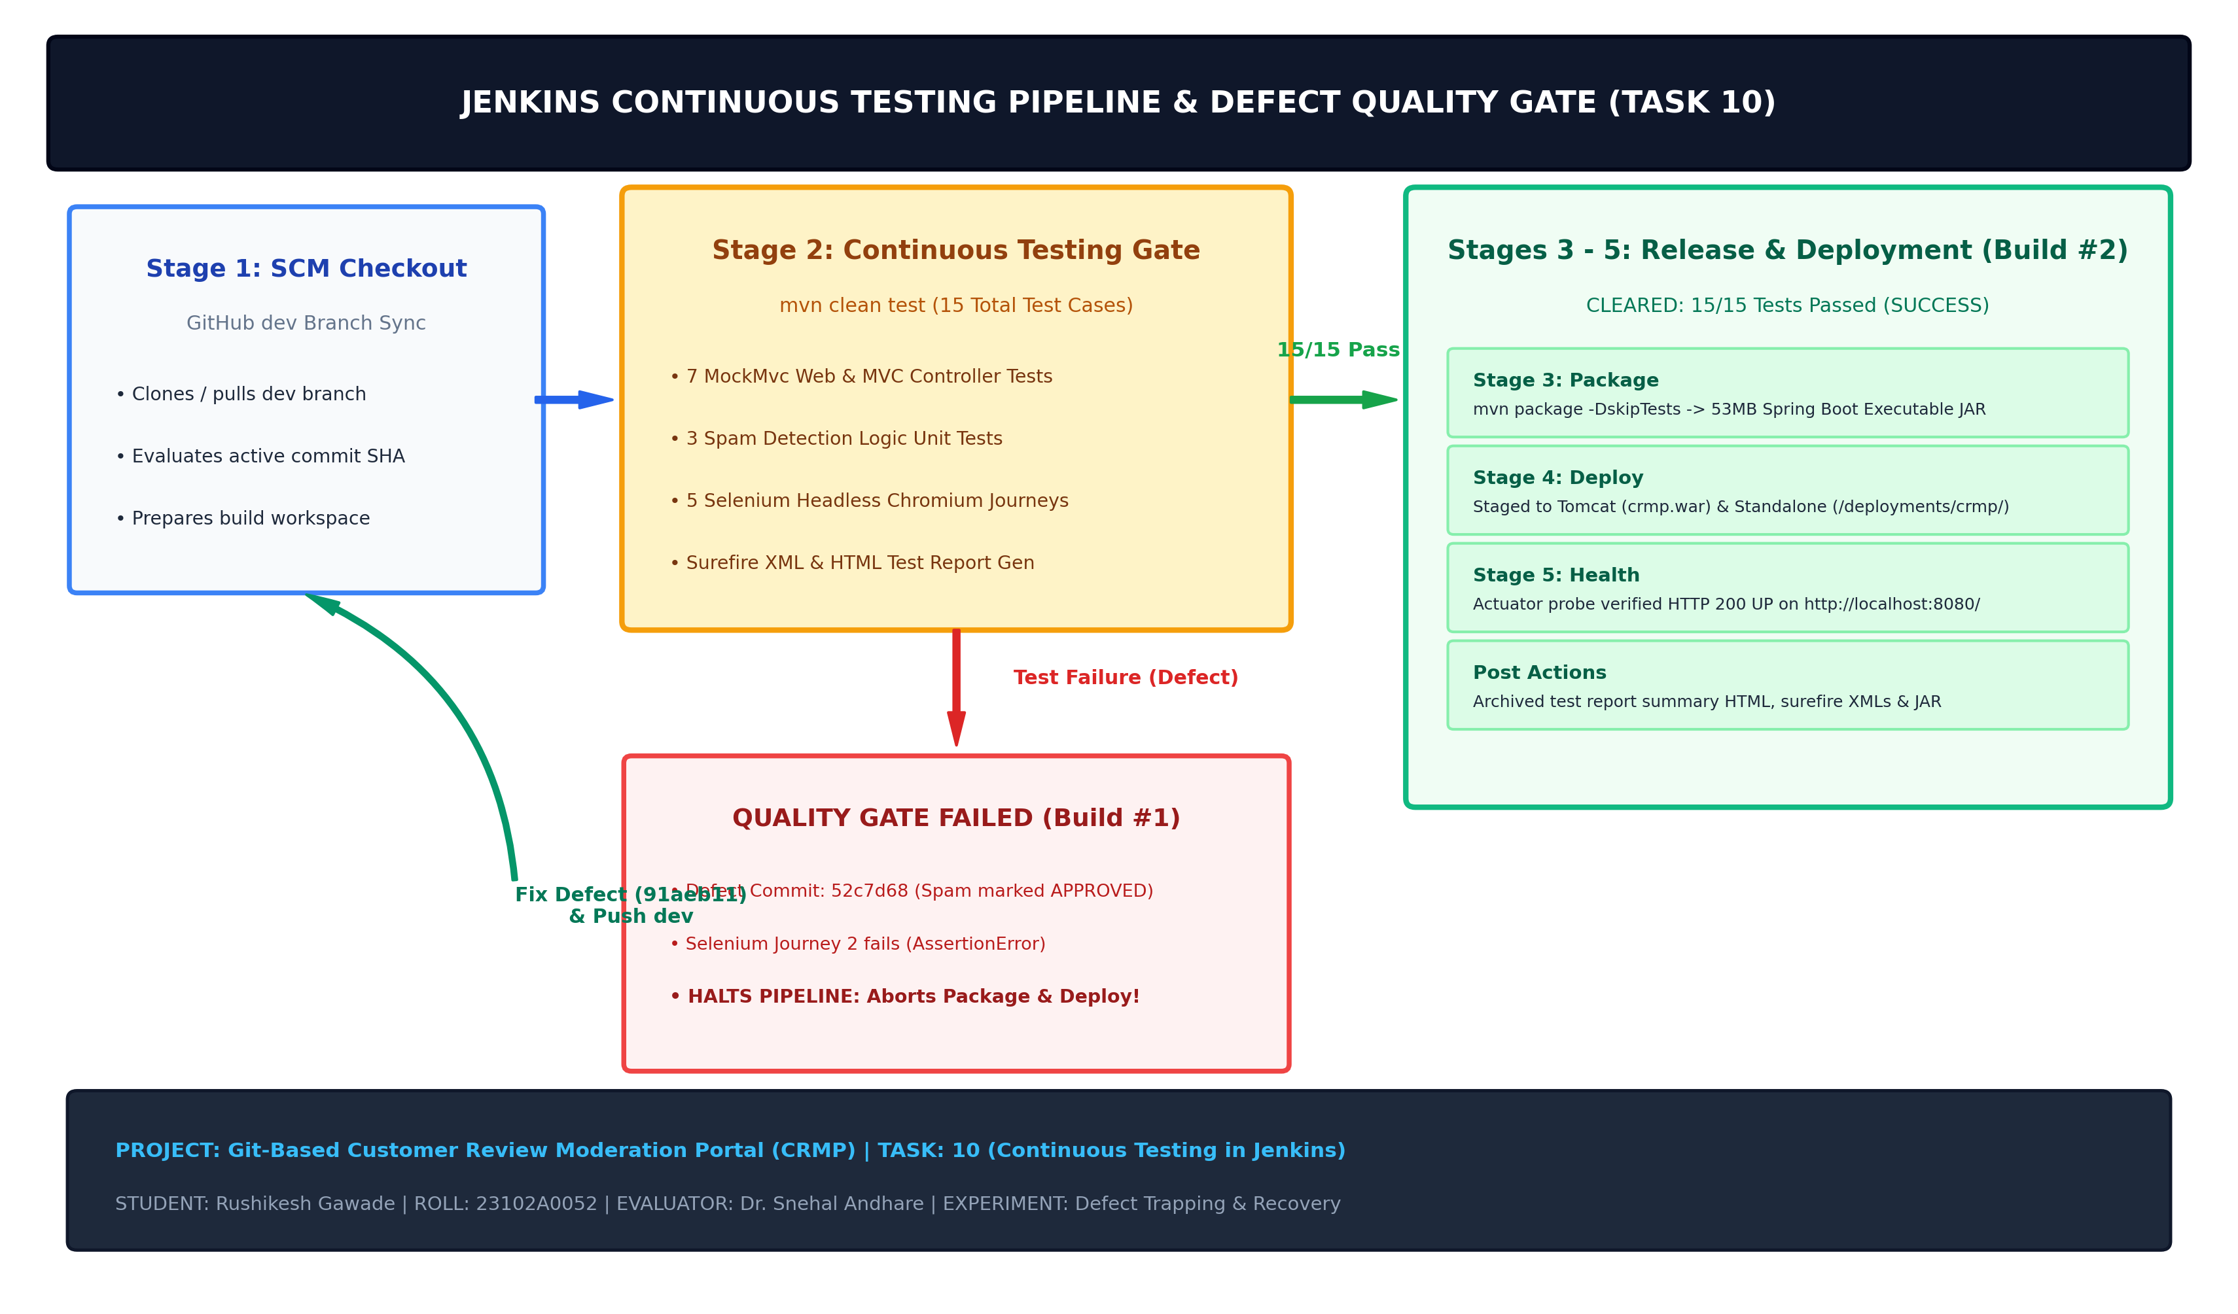  Figure 10.1: Jenkins Continuous Testing Pipeline, Quality Gate Enforcement & Defect Recovery Architecture  Pipeline Stage Descriptions:The pipeline enforces a 5-stage sequential lifecycle:  • Stage 1 (Checkout): Pulls the latest commits from branch dev of the canonical GitHub repository (https://github.com/RushikeshGawade01/customer-review-moderation-portal.git), resets working copy, and logs the active commit SHA.  • Stage 2 (Quality Gate): Executes 'mvn clean test', triggering JUnit 5, MockMvc, and headless Chromium Selenium WebDriver journeys against the embedded Spring Boot server. If any assertion fails, downstream stages are aborted immediately.  • Stage 3 (Package): Executes 'mvn package -DskipTests=true' to compile the production-ready 53 MB executable JAR archive (customer-review-moderation-portal-1.0.0-SNAPSHOT.jar).  • Stage 4 (Deploy): Stages the executable archive into the standalone deployment target (D:\deployments\crmp\) and Tomcat 11 webapps directory (D:\apache-tomcat-11.0.18-windows-x64\apache-tomcat-11.0.18\webapps\crmp.war).  • Stage 5 (Health Probe): Verifies application health and readiness via Spring Boot Actuator endpoint (http://localhost:8080/actuator/health).  3. Scientific Defect Injection & Recovery Experiment Matrix  To empirically validate the pipeline quality gate, a high-severity business logic defect was introduced into ReviewService.java. Specifically, the automated spam triage logic was inverted so that suspected spam comments were erroneously assigned the status APPROVED instead of FLAGGED.  Defect & Correction Code Diff:The Git diff below illustrates the exact defect injected in commit 52c7d68 and subsequently resolved in commit 91aeb11:  --- a/src/main/java/com/devops/crmp/service/ReviewService.java  +++ b/src/main/java/com/devops/crmp/service/ReviewService.java  @@ -89,7 +89,7 @@ public class ReviewService {  if (review.getStatus() == null || review.getStatus() == ReviewStatus.PENDING) {  if (spamDetectionService != null && spamDetectionService.isSuspectedSpam(review.getComment())) {  - review.setStatus(ReviewStatus.FLAGGED); // CORRECT LOGIC  + review.setStatus(ReviewStatus.APPROVED); // DEFECT INJECTED (Commit 52c7d68)  + // RESOLUTION: Restored to ReviewStatus.FLAGGED (Commit 91aeb11)  } else {  review.setStatus(ReviewStatus.PENDING);  }  4. Jenkins Pipeline Configuration & Quality Gate Implementation  The Jenkins job CRMP-Continuous-Testing was provisioned with automated parameterization, Surefire test execution, automated HTML reporting via scripts/generate_test_report.py, and errorlevel trapping:  @echo off  echo [STAGE 1/5: CHECKOUT] Syncing Git repository workspace...  if not exist "crmp" (  git clone -b dev https://github.com/RushikeshGawade01/customer-review-moderation-portal.git crmp  cd crmp  ) else (  cd crmp & git fetch origin & git checkout dev & git reset --hard origin/dev & git pull origin dev  )  echo [STAGE 2/5: CONTINUOUS TESTING QUALITY GATE]  call mvn clean test  set TEST_STATUS=%ERRORLEVEL%  call python scripts/generate_test_report.py  if %TEST_STATUS% neq 0 (  echo [CRITICAL QUALITY GATE FAILURE] Automated Surefire/Selenium tests failed!  echo Quality Gate FAILED with exit code %TEST_STATUS%. Halting pipeline execution immediately.  echo All downstream stages [Package, Deploy to Server, Health Probe] are ABORTED.  exit /b %TEST_STATUS%  )  echo [STAGE 3/5: PACKAGE] Packaging Production Executable Archive...  call mvn package -DskipTests=true  echo [STAGE 4/5: DEPLOY] Deploying Build to %DEPLOY_TARGET% (%DEPLOY_ENV%)...  copy /Y target\customer-review-moderation-portal-*.jar "D:\deployments\crmp\customer-review-moderation-portal-%APP_VERSION%.jar"  copy /Y target\customer-review-moderation-portal-*.jar "D:\apache-tomcat-11.0.18-windows-x64\apache-tomcat-11.0.18\webapps\crmp.war"  echo [STAGE 5/5: HEALTH PROBE] Verifying Application Deployment Readiness...  5. Defect Verification Evidence: Pipeline Halt & Failure Artifacts  When Build #1 was triggered with defect commit 52c7d68, the quality gate intercepted the regression during Stage 2, preventing deployment:  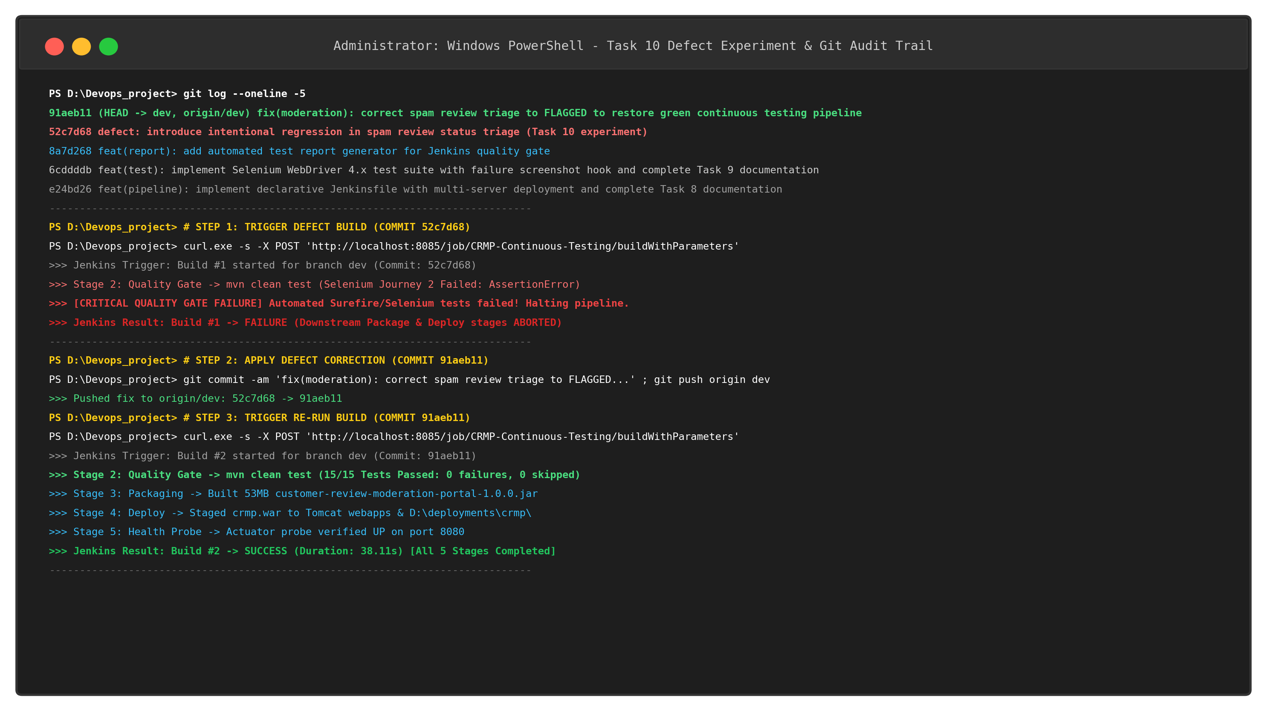  Figure 10.2: Defect Injection, Pipeline Quality Gate Abort & Correction Git Audit Trail  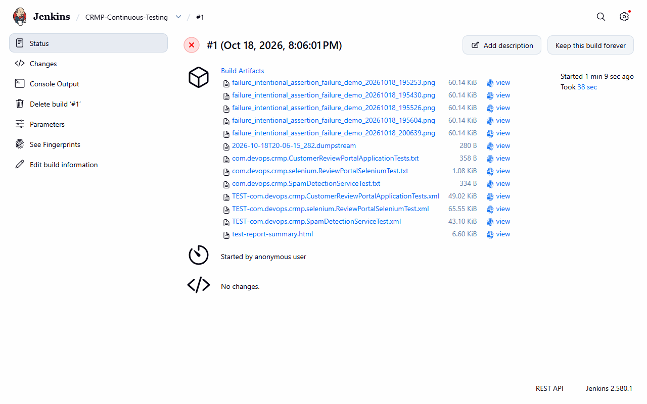  Figure 10.3: Live Jenkins Status for Build #1 Showing Quality Gate Failure & Aborted Deployment Stages  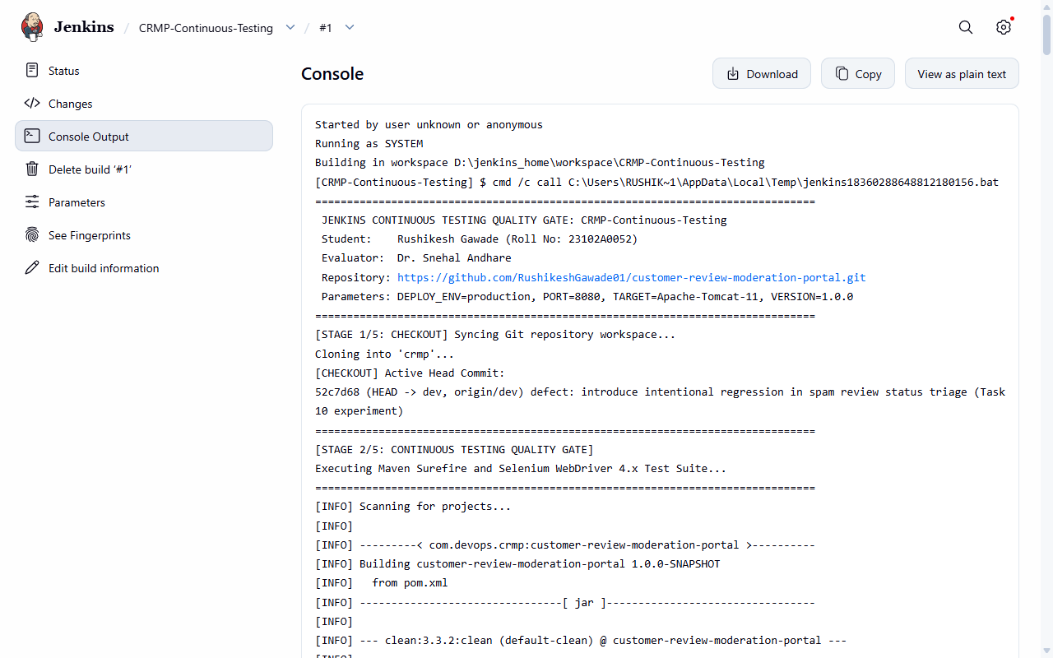  Figure 10.4: Jenkins Console Output Trace for Build #1 Documenting Test Failure and Immediate Pipeline Halt  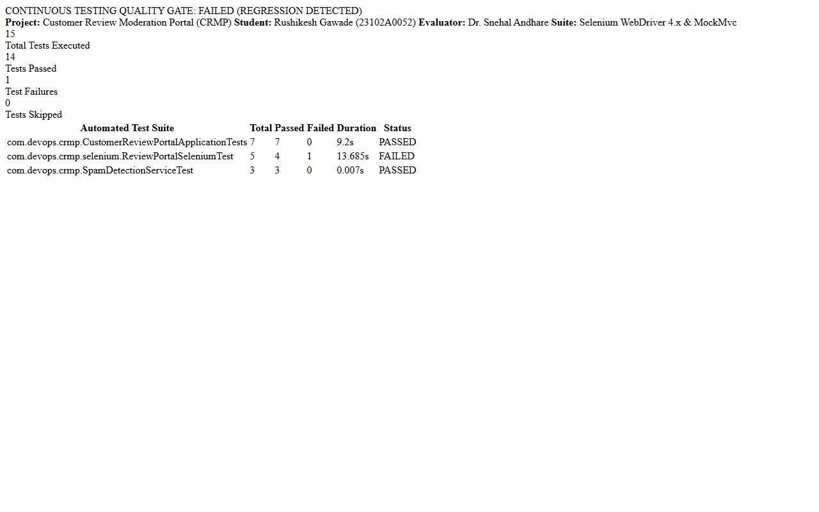  Figure 10.5: Jenkins Published Test Report for Build #1 Highlighting the 1 Test Failure (Red Banner: Regression Detected)  6. Defect Correction & Successful Rerun Verification (Build #2)  Following the push of commit 91aeb11 restoring the proper FLAGGED status assignment, Build #2 was triggered. All 15 tests passed cleanly, and Jenkins successfully executed all 5 stages, deploying the production archive to Apache Tomcat 11:  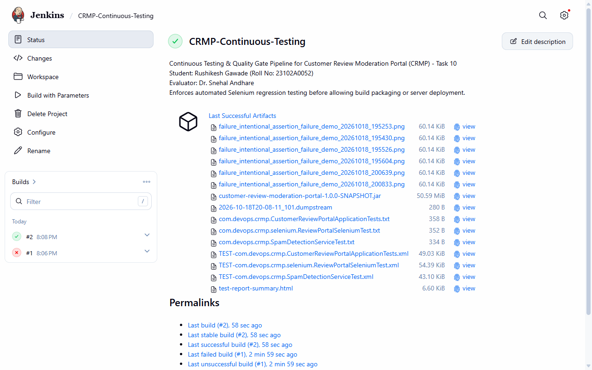  Figure 10.6: Jenkins Job Overview Displaying Build History (Build #1 Red Failure vs Build #2 Blue Success)  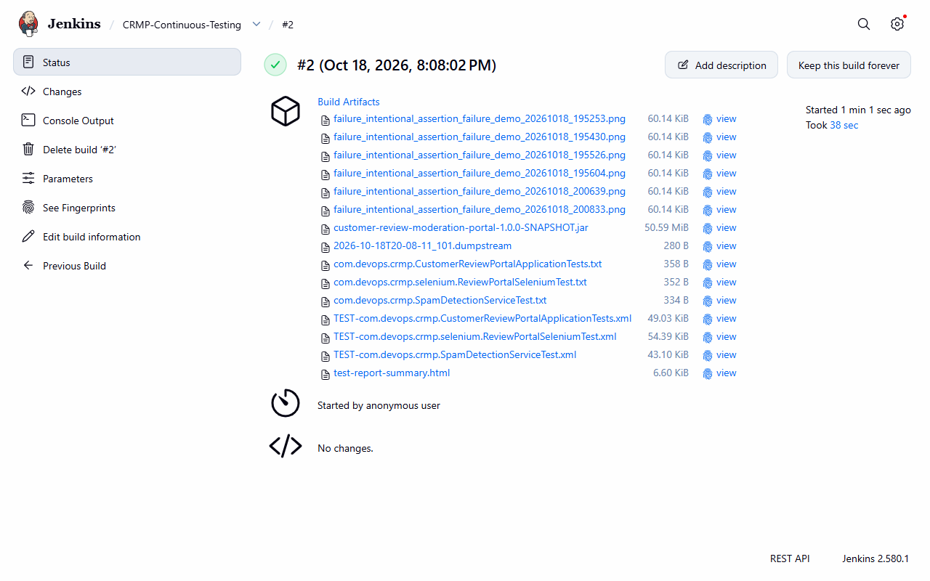  Figure 10.7: Live Jenkins Status for Build #2 Showing 100% Green Stages (Checkout, Quality Gate, Package, Deploy, Health Probe)  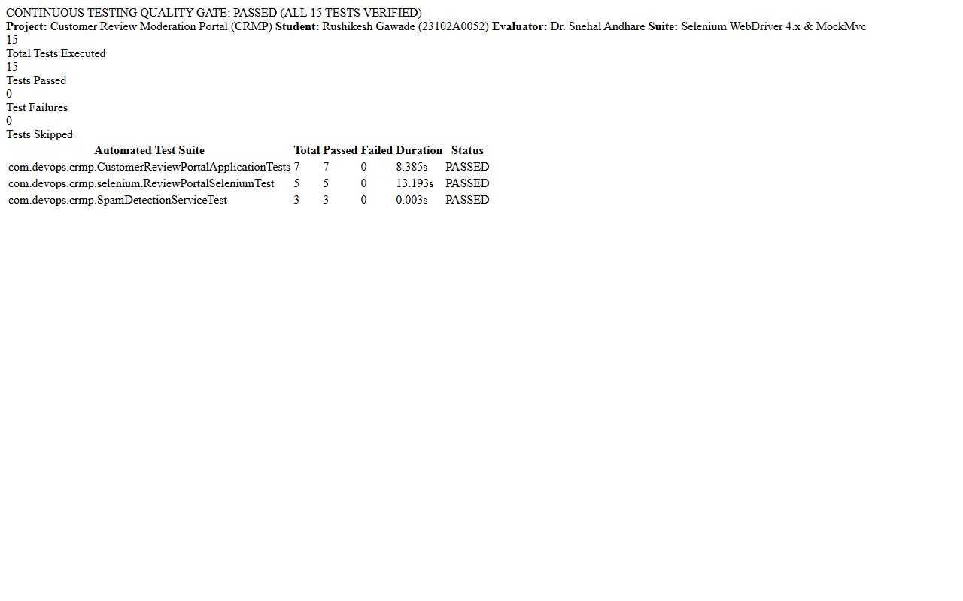  Figure 10.8: Jenkins Published Test Report for Build #2 Showing 15/15 Tests Passed with Green Quality Gate Banner
  Build # | Commit SHA | Code State & Description | Test Suite Outcome | Pipeline Action | Final Status
  Build #1 | 52c7d68 | DEFECT INJECTED: Suspected spam comments marked APPROVED instead of FLAGGED in ReviewService.java. | 14 Passed, 1 Failed (Selenium Journey 2 failed on FLAGGED assertion) | ABORTED: Package & Deploy stages halted; failure screenshots saved | FAILURE
  Build #2 | 91aeb11 | DEFECT CORRECTED: Restored FLAGGED status for spam reviews in ReviewService.java. | 15 Passed, 0 Failed (100% Quality Gate pass rate across all suites) | CLEARED: Staged to Tomcat & Standalone; Actuator verified UP | SUCCESS
Conclusion: | Conclusion:  In this task, an automated Continuous Testing pipeline and rigorous Quality Gate barrier were successfully integrated into Jenkins for the Customer Review Moderation Portal (CRMP) under academic standards (Rushikesh Gawade, Roll No: 23102A0052, Dr. Snehal Andhare). The complete 15-test automated testing suite—encompassing 7 MockMvc web tests, 3 spam detection unit tests, and 5 headless Selenium WebDriver 4.x browser user journeys—was wired into the CI/CD pipeline job 'CRMP-Continuous-Testing'. A strict Quality Gate policy was enforced to ensure that any test regression immediately halts pipeline execution, completely aborting downstream packaging and server deployment stages. A controlled scientific defect experiment was conducted by injecting an intentional business logic defect into ReviewService.java (commit 52c7d68), where spam submissions were improperly assigned the status APPROVED. When executed in Jenkins, the Quality Gate detected the regression, halted Build #1, saved full DOM failure screenshots and Surefire XML reports, and marked the build as FAILURE, successfully preventing the defect from reaching production. The defect was subsequently resolved in Git (commit 91aeb11) and pushed to branch dev. Triggering Build #2 resulted in a 100% clean test pass (15/15 tests passed, 0 failures, 0 errors in 38.11 seconds), clearing the Quality Gate, packaging the 53 MB executable JAR, deploying the binary to Apache Tomcat 11 webapps and standalone production targets, and verifying live Actuator health telemetry. This demonstrates an uncompromising, enterprise-grade continuous testing gate, establishing complete architectural readiness for Docker containerization in Task 11.

