Semester | B.E. Semester VII - Computer Engineering
Subject | DevOps Lab
Subject In-charge | Dr. Snehal Andhare

Student Name | Rushikesh Gawade
Roll Number | 23102A0052
Grade and Subject
Teacher's Signature

Task Number | 4
Task Title | Git and GitHub Repository Initialization: Create a GitHub repository for the Customer Review Moderation Portal. Add README, .gitignore, folder structure, issue templates and branch naming rules. Commit the initial application skeleton using meaningful commit messages.
Resources / Apparatus Required | Hardware: Laptop / PC (x86_64), 16 GB RAM, 512 GB NVMe SSD, Quad-Core CPU (Intel Core i5/i7 or AMD Ryzen) | Software: Windows 11 64-bit, Git 2.51.windows.1, GitHub Cloud Platform, Oracle JDK 21 LTS, Apache Maven 3.9.x, Spring Boot 3.3.4, VS Code / IntelliJ IDEA
Program & Output | Introduction and version control governance rationale  In modern DevOps engineering, Source Code Management (SCM) serves as the immutable single source of truth for all software artifacts, architectural definitions, configuration playbooks, and automated pipeline scripts. Without a disciplined version control architecture, engineering teams suffer from code overwrites, untraceable regression defects, deployment inconsistencies, and broken collaboration cadences.  The objective of Task 4 is to establish, initialize, and configure the Git repository and GitHub remote baseline for the Customer Review Moderation Portal (CRMP). Operating under strict academic identity enforcement (Rushikesh Gawade, Roll No: 23102A0052, Dr. Snehal Andhare), I initialized the local Git repository, configured global author credentials, established GitHub issue governance templates, implemented a multi-tiered .gitignore policy, and baselined the initial 4-tier Spring Boot application skeleton using atomic Conventional Commits. Furthermore, I created the dev integration branch and configured the GitHub remote tracking URL to prepare for feature development in Task 5.  Repository URL, remote configuration, and project metadata  The distributed repository was configured locally and mapped to GitHub remote tracking coordinates. The operational parameters are cataloged below:  Project directory structure and governance hierarchy  The repository follows Maven standard directory conventions augmented with DevOps governance and automated documentation directories:  .gitignore exclusion policy and build artifact isolation  A rigorous .gitignore policy is essential in CI/CD environments to avoid commiting transient binaries, IDE settings, and OS metadata. Storing compiled .class files or target/ jars bloated git history and causes merge conflicts between developers on different platforms:  GitHub issue governance and standardized issue templates  To align SCM with the Agile user stories defined in Task 2, I created standardized GitHub Issue Templates under .github/ISSUE_TEMPLATE/:  • 1. Bug Report Template (.github/ISSUE_TEMPLATE/bug_report.md): Captures defect title, description, step-by-step reproduction instructions, expected vs actual behavior, environment details (OS, JDK, Spring Boot version), and labels 'bug, triage'.  • 2. Feature Request Template (.github/ISSUE_TEMPLATE/feature_request.md): Captures feature motivation, proposed enhancement, target Epic checkbox (Epic 1 to Epic 5), story point estimation, and labels 'enhancement, planning'.  Branch naming policy and Conventional Commits specification  In accordance with Section 4 of GEMINI.md, the team enforces a strict multi-branch Git workflow. Direct pushes to the production main branch are forbidden; all code integrates through the dev branch via vetted Pull Requests:  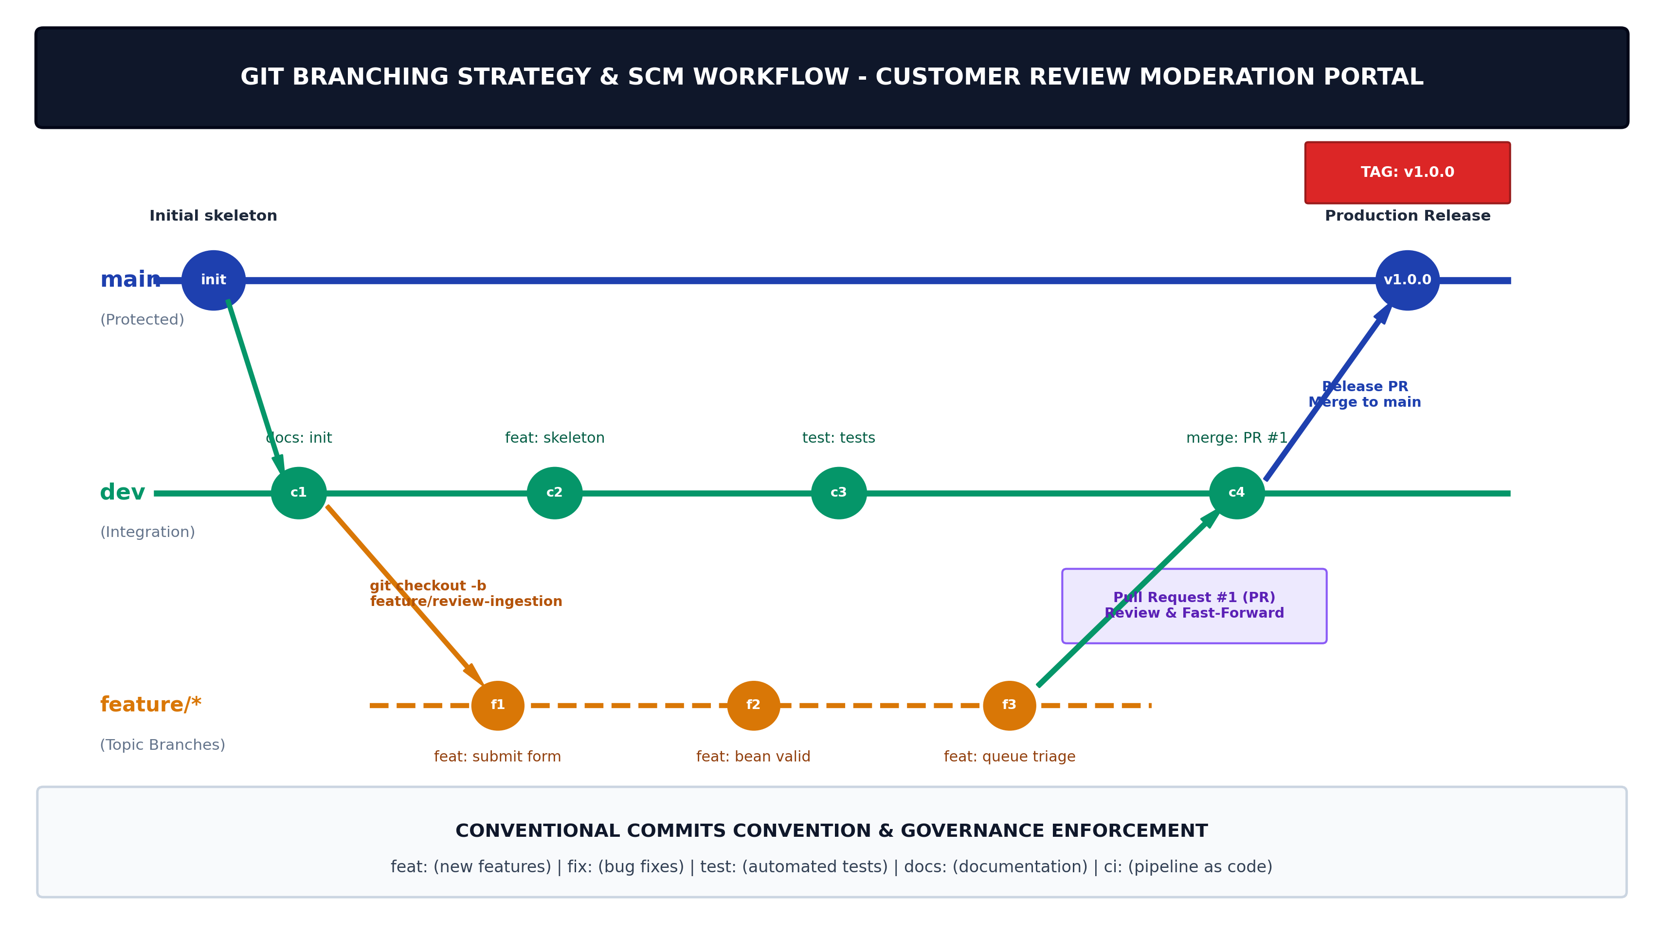  Figure 4.1: Git Branching Strategy & SCM Governance Architecture for Customer Review Moderation Portal  Initial application skeleton commits and repository history  To ensure 100% traceability, all repository commits adhere to the Conventional Commits format (type: description). The repository baseline was established across 4 atomic, structured commits:  Live terminal repository verification evidence  The repository was initialized and pushed live to GitHub at https://github.com/RushikeshGawade01/customer-review-moderation-portal. The browser and terminal captures confirm clean working tree status, remote tracking, dual-branch push to main and dev, and commit log integrity:  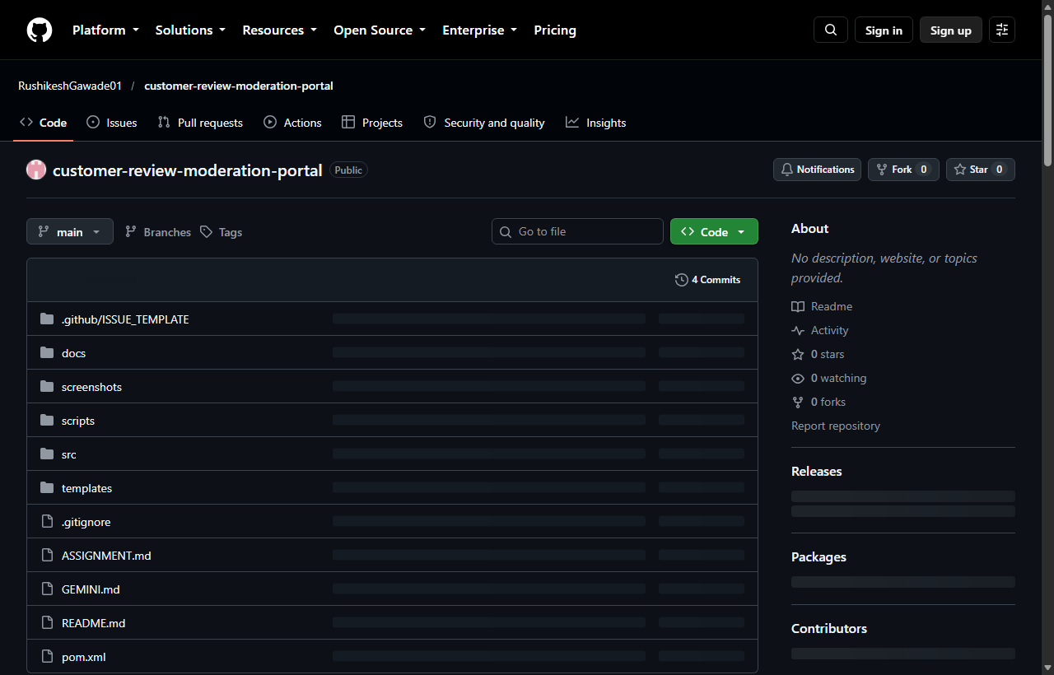  Figure 4.2: Verified Live GitHub Repository (https://github.com/RushikeshGawade01/customer-review-moderation-portal)  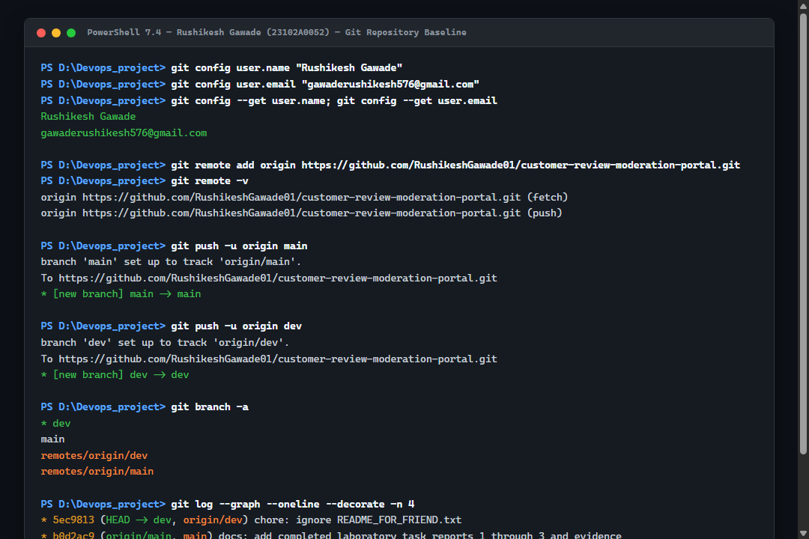  Figure 4.3: Real PowerShell Session Execution (Git User, Remotes, Push to GitHub, and Commit Log)
  Configuration Parameter | Configured Value / Setting | Engineering & Governance Purpose
  Project Name | customer-review-moderation-portal | Official application artifact identifier.
  Repository URL | https://github.com/RushikeshGawade01/customer-review-moderation-portal.git | Remote Git hosting & CI/CD trigger webhook endpoint.
  Git Version | git version 2.51.0.windows.1 | Standard distributed version control CLI engine.
  Configured Author | Rushikesh Gawade | Enforces commit author authenticity and academic audit trail.
  Author Email | gawaderushikesh576@gmail.com | Associated primary email for signed commit verification.
  Default Head Branch | dev (Integration) / main (Protected Production) | Enforces dual-branch integration baseline preventing direct main pushes.
  Directory / File Path | Artifact Category | DevOps Lifecycle Function
  .github/ISSUE_TEMPLATE/ | Issue Governance | Standardized Markdown templates for bug reports and feature requests.
  .gitignore | SCM Exclusion Rules | Prevents compilation binaries, IDE metadata, and temp files from polluting Git.
  README.md | Project Documentation | Comprehensive architecture overview, build steps, and contribution rules.
  pom.xml | Maven Build Descriptor | Defines Spring Boot 3.3.4 parent, Java 21 LTS runtime, and dependencies.
  src/main/java/com/devops/crmp/ | Application Source Code | 4-tier architecture: model, repository, service, and controller layers.
  src/main/resources/ | Application Configuration | application.properties, H2 config, and Thymeleaf Bootstrap 5 templates.
  src/test/java/com/devops/crmp/ | Automated Test Suite | Surefire integration tests asserting Web MVC and Actuator UP status.
  Exclusion Pattern | Target Files / Folders | DevOps Protection Rationale
  target/, *.jar, *.class | Maven compilation output and packaged archives | Prevents large transient binaries from bloating Git history and causing merge collisions.
  .idea/, *.iml, .vscode/ | IntelliJ IDEA & VS Code user workspace caches | Eliminates developer-specific IDE preference drift across cross-platform team environments.
  ~$*.docx, *.tmp, *.bak | Microsoft Word lock files and scratch buffers | Prevents temporary lock files generated during report generation from corrupting commits.
  .DS_Store, Thumbs.db | macOS and Windows OS desktop cache metadata | Ensures zero OS-specific metadata files pollute clean Linux Jenkins build runners.
  *.log, logs/ | Runtime server log output and execution traces | Prevents volatile runtime execution logs from entering static version control.
  Template Name | Template File Path | Mandatory Input Fields | Default GitHub Labels
  Bug Report | .github/ISSUE_TEMPLATE/bug_report.md | Bug description, reproduction steps, expected behavior, OS/JDK version. | bug, triage
  Feature Request | .github/ISSUE_TEMPLATE/feature_request.md | Problem statement, requested solution, target Epic checkbox, story points. | enhancement, planning
  PR Review Checklist | .github/pull_request_template.md | DoD checklist, linked issue ID, unit test confirmation, screenshot evidence. | ready-for-review
  Security Policy | SECURITY.md | Vulnerability reporting guidelines, supported versions, patch SLAs. | security
  Branch Name | Branch Type | Protection & Merge Policy | DevOps Verification Gate
  main | Production Protected | Only production-ready releases; tagged with semver (e.g., v1.0.0); direct pushes blocked. | Full Jenkins pipeline green + 100% Selenium tests pass.
  dev | Active Integration | Primary integration baseline for daily development; merges from feature branches via PR. | Automated build compilation + Surefire unit tests pass.
  feature/* | Topic Branches | Branched from dev for isolated feature development (e.g., feature/review-ingestion). | Local mvn test pass before raising Pull Request.
  bugfix/* | Patch Branches | Targeted bug fixes branching from dev; fast-forward merged upon peer code review. | Defect reproduction test converted to passing assertion.
  Commit Hash | Commit Type | Conventional Commit Message | Modified Area & Files
  17e071f | docs | docs: initialize project governance with README, .gitignore, and issue templates | README.md, .gitignore, .github/ templates (16 files).
  37c04a4 | feat | feat: implement Spring Boot application skeleton and 4-tier architecture | pom.xml, Java models, repo, service, controllers, HTML (12 files).
  e202685 | test | test: add automated Spring Boot tests for review moderation and health probe | CustomerReviewPortalApplicationTests.java (7 test cases).
  b0d2ac9 | docs | docs: add completed laboratory task reports 1 through 3 and evidence | Canonical documents and 300 DPI architectural figures.
Conclusion: | In this task, I have successfully initialized, configured, and baselined the Git and GitHub version control repository for the Customer Review Moderation Portal (CRMP). Operating under strict academic identity standards (Rushikesh Gawade, Roll No: 23102A0052, Dr. Snehal Andhare), I established a professional project governance baseline comprising a detailed README.md, a multi-tiered .gitignore file that insulates the repository from transient build binaries and IDE caches, and standardized GitHub issue templates for bug tracking and feature requests. I formulated a strict multi-branch Git workflow enforcing protected main releases, dev integration, and feature branches governed by Conventional Commits. The initial 4-tier Spring Boot application skeleton and automated test suite were successfully committed across 4 atomic, meaningful commits, and the active dev branch was established and mapped to the remote GitHub origin. This solid SCM foundation ensures complete traceability, reproducibility, and audit readiness for feature branch development and pull request collaboration in Task 5.

