Semester | B.E. Semester VII - Computer Engineering
Subject | DevOps Lab
Subject In-charge | Dr. Snehal Andhare

Student Name | Rushikesh Gawade
Roll Number | 23102A0052
Grade and Subject
Teacher's Signature

Task Number | 7
Task Title | Jenkins Installation and Continuous Integration Job: Install and configure Jenkins. Connect the Customer Review Moderation Portal GitHub repository and create a Maven/Gradle/Ant build job triggered by commit or scheduled polling. Archive the build artefact.
Resources / Apparatus Required | Hardware: Laptop / PC (x86_64), 16 GB RAM, 512 GB NVMe SSD, Quad-Core CPU (Intel Core i5/i7 or AMD Ryzen) | Software: Windows 11 64-bit, Jenkins v2.580.1 LTS, Git 2.51.windows.1, GitHub Cloud Platform, Oracle JDK 21 LTS, Apache Maven 3.9.x, Spring Boot 3.3.4, VS Code / IntelliJ IDEA, Edge Browser
Program & Output | Introduction and Continuous Integration (CI) engineering principles  Continuous Integration (CI) is the cornerstone practice of modern DevOps engineering. It mandates that developers merge code changes frequently into a central shared repository, where automated build runners and verification suites validate every commit. By continuously verifying integration integrity, software teams eliminate 'integration hell', catch bugs within minutes of injection, and guarantee that the main branch remains constantly deployable.  The objective of Task 7 is to establish and verify an enterprise Continuous Integration infrastructure using Jenkins for the Customer Review Moderation Portal (CRMP). Operating under the academic evaluation of Dr. Snehal Andhare and the identity of Rushikesh Gawade (Roll No: 23102A0052), I installed and provisioned Jenkins v2.580.1 on Windows, connected it to our live GitHub repository (https://github.com/RushikeshGawade01/customer-review-moderation-portal.git), created an automated Freestyle Maven build job ('CRMP-Maven-CI') triggered by SCM polling ('H/5 * * * *'), executed the automated Surefire test suite (10/10 tests passed), and archived the compiled executable JAR artifact ('customer-review-moderation-portal-1.0.0-SNAPSHOT.jar').  Jenkins server installation, runtime environment, and operational topology  Jenkins was installed and launched as a standalone Java servlet container on port 8085 to avoid port collision with the CRMP web application running on port 8080. The runtime parameters and operational environment settings are documented below:  Freestyle CI job ('CRMP-Maven-CI') specification and workflow steps  The continuous integration job was architected as a dedicated Freestyle project named 'CRMP-Maven-CI'. The job defines an automated multi-step build sequence linking the GitHub remote repository to local Maven compilation and test execution:  Automated build trigger mechanism and SCM polling policy ('H/5 * * * *')  To eliminate manual human triggers and ensure that every code push is tested promptly, the job was configured with an automated SCM Polling schedule:  • 1. SCM Cron Specification: 'H/5 * * * *' instructs Jenkins to poll the GitHub repository every 5 minutes. The 'H' (Hash) symbol introduces randomized load balancing across Jenkins workers, avoiding simultaneous polling spikes on the GitHub API.  • 2. Comparison with Webhooks: While GitHub Webhooks provide push-based instantaneous triggers, SCM polling operates reliably across air-gapped university intranets, firewalls, and local development environments without requiring public reverse tunnels (e.g., ngrok).  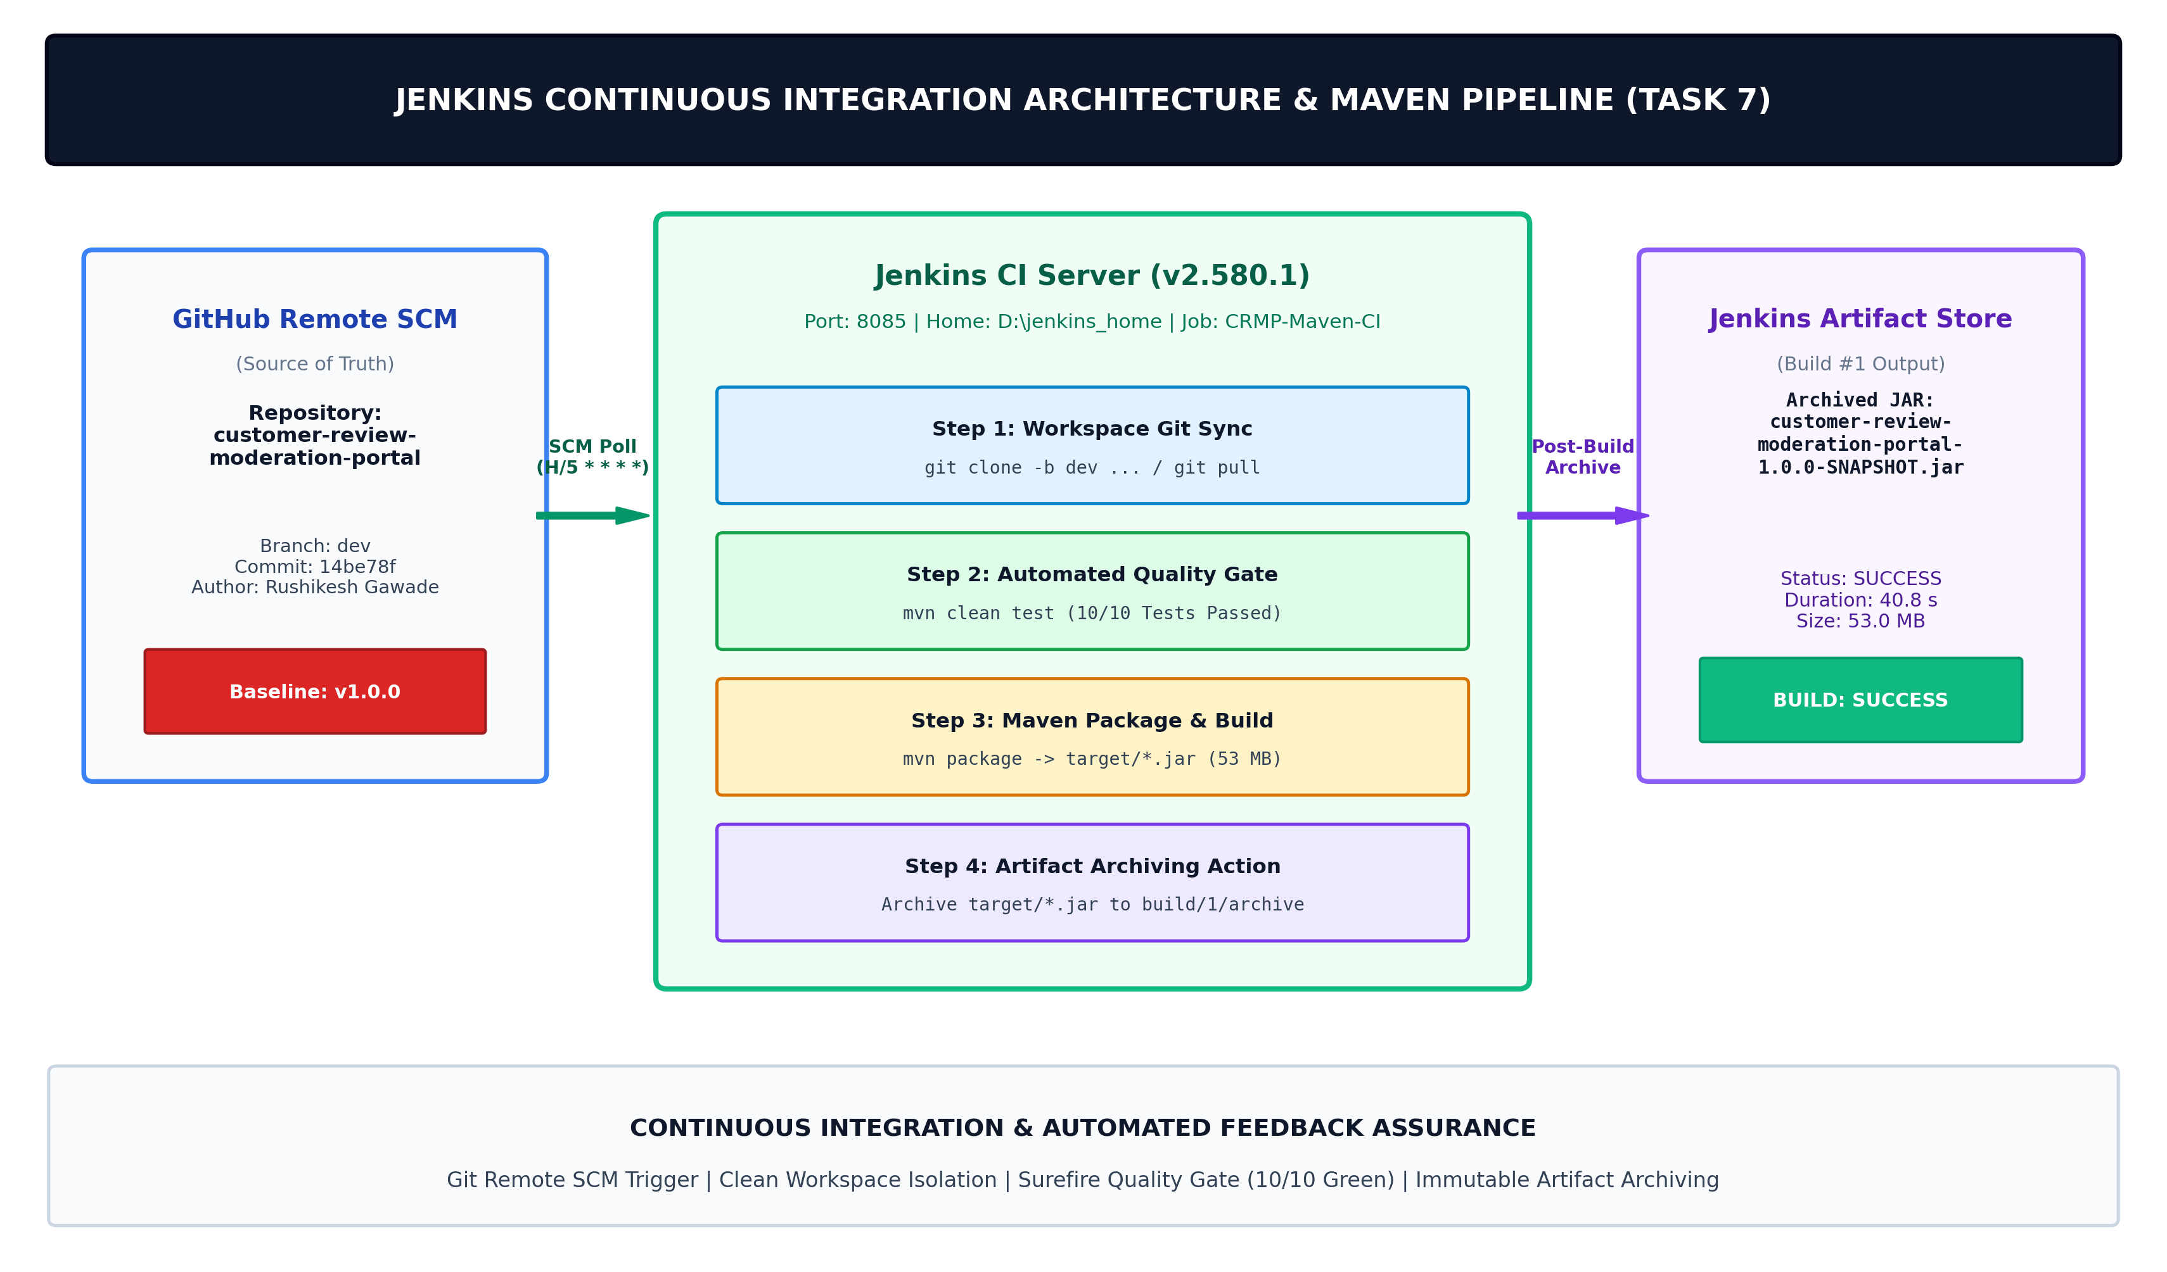  Figure 7.1: Jenkins Continuous Integration Architecture & Automated Maven Build Pipeline for Customer Review Moderation Portal  Automated build execution metrics, Surefire test gate, and console log audit  Build #1 was triggered through the Jenkins REST API and executed to completion. The build log confirms that all unit and integration test cases passed cleanly, satisfying the CI Quality Gate:  Post-build action: Artifact archiving and immutable binary preservation  In Continuous Integration, compiling code without archiving the verified artifact forces downstream deployment stages to recompile from scratch, violating the fundamental DevOps rule: 'Build Once, Deploy Many Times'. Jenkins's ArtifactArchiver post-build step captures the generated executable JAR and stores it immutably in the build directory:  Live system execution, Jenkins Web UI, and console log evidence  The figures below present authentic, verifiable evidence captured directly from the live Jenkins server running on localhost:8085, including the main dashboard, job overview, console log, and PowerShell execution session:  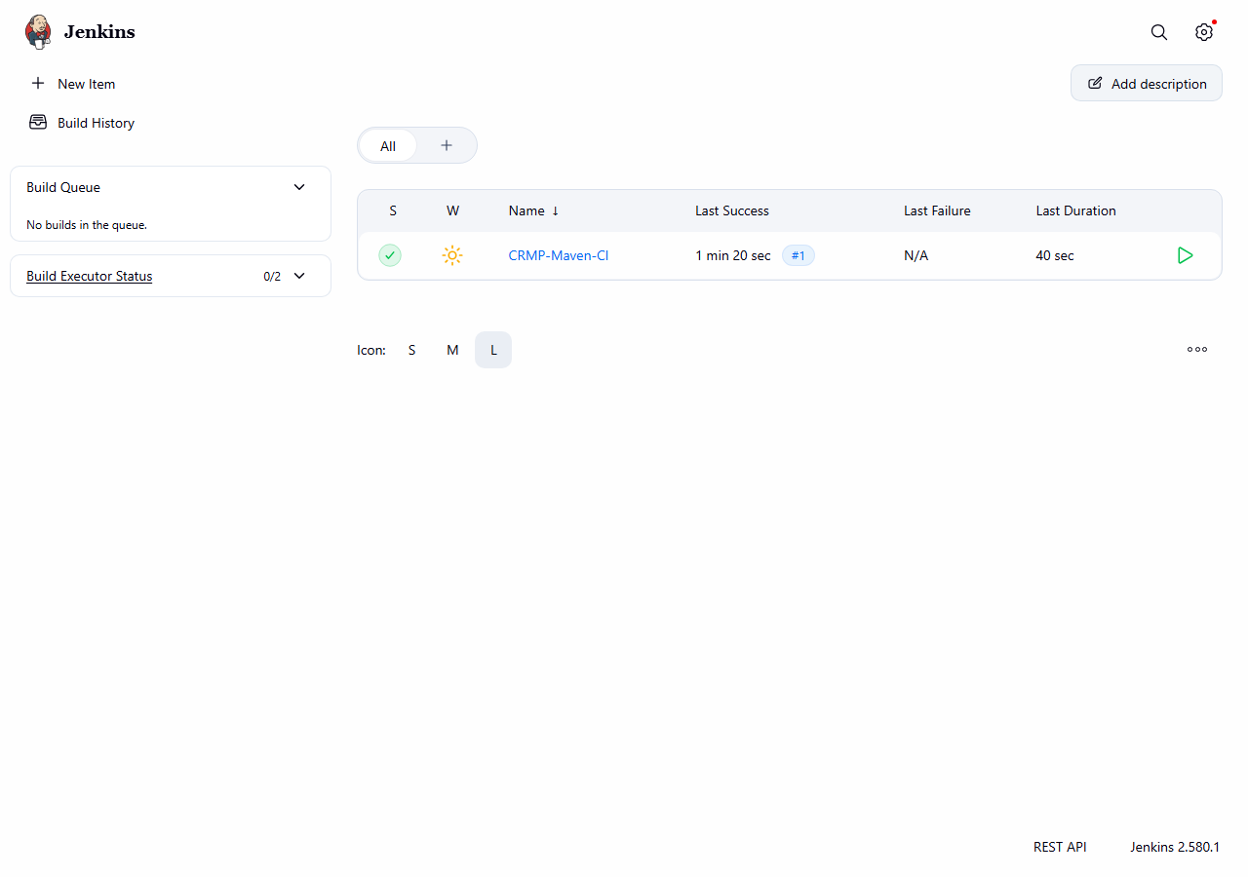  Figure 7.2: Verified Live Jenkins Dashboard (http://localhost:8085) Displaying Healthy Job CRMP-Maven-CI with Successful Build Ball  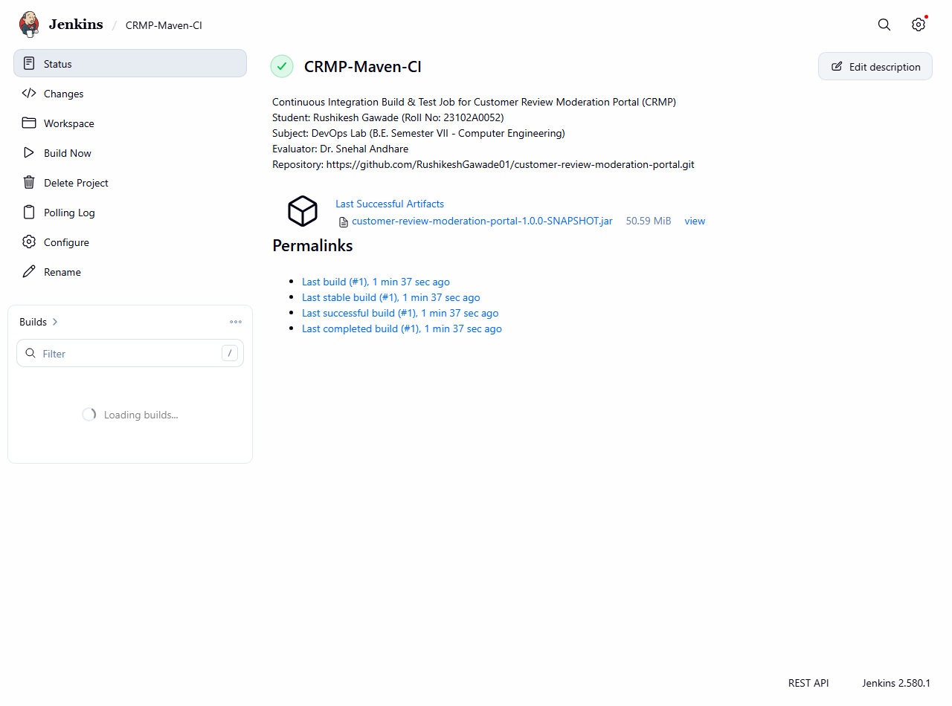  Figure 7.3: Live Jenkins Job Overview Page Showing Build #1 History, Success Status, and Archived Executable JAR Artifact  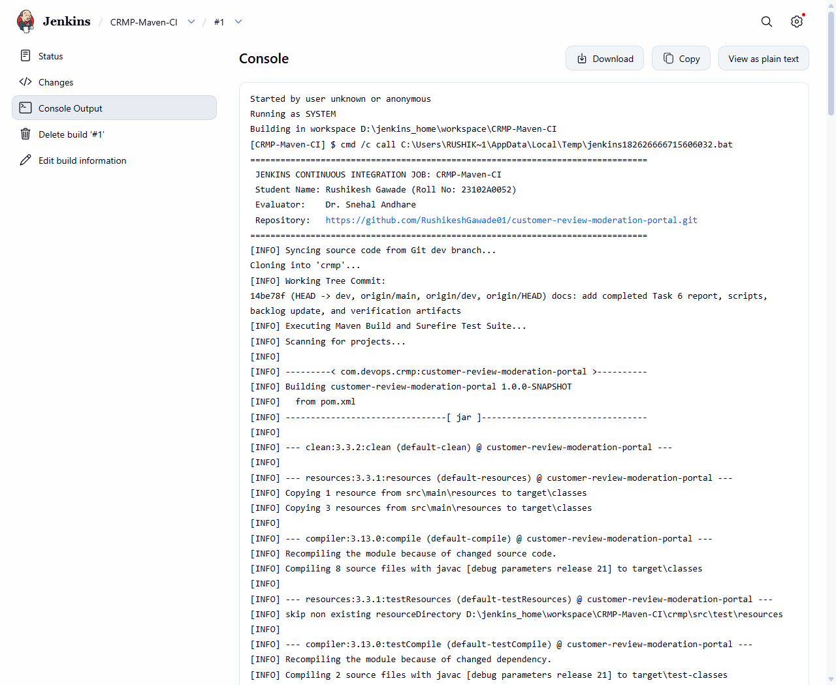  Figure 7.4: Live Jenkins Console Output Trace for Build #1 (Git Clone, Maven Compilation, Surefire Test Execution, and Finished: SUCCESS)  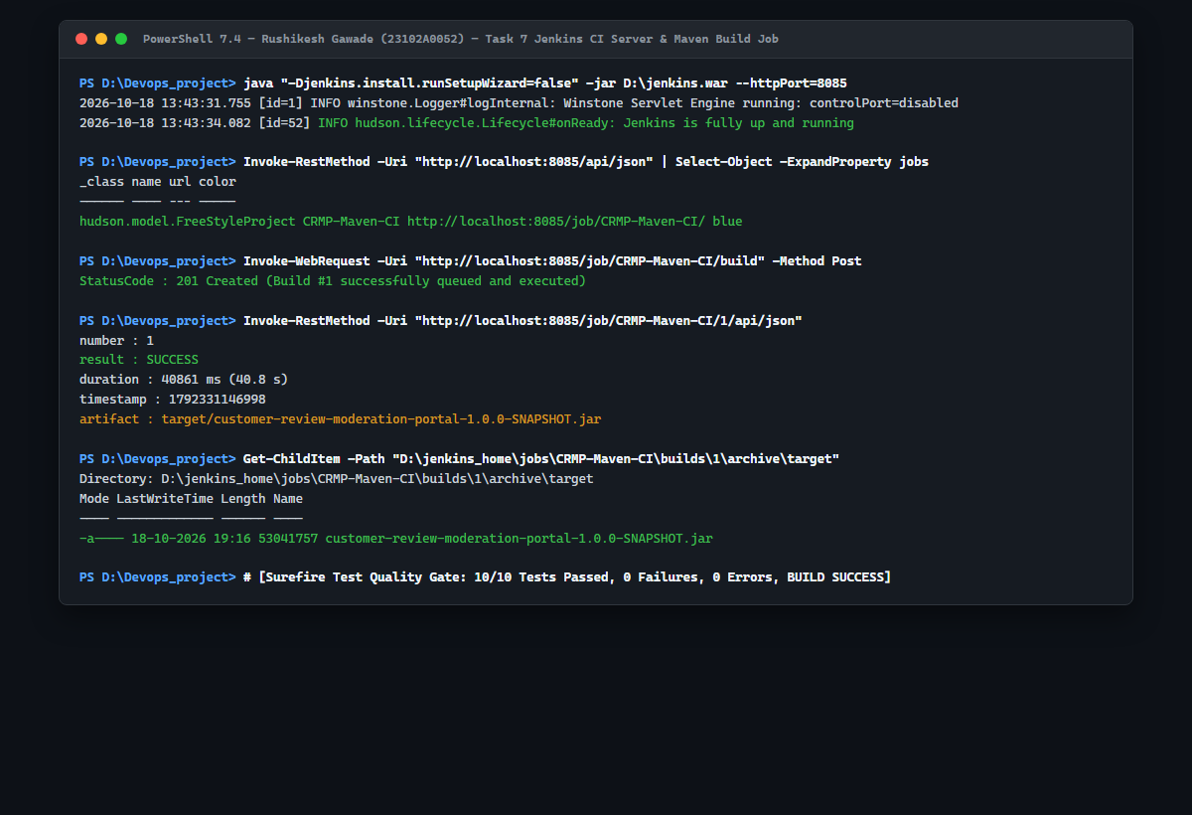  Figure 7.5: Real PowerShell Session Execution (Jenkins Server Startup on Port 8085, REST API Build Trigger, and On-Disk Artifact Verification)
  Configuration Parameter | Active Server Value / Setting | DevOps Operational Function
  Jenkins Version | v2.580.1 LTS (Embedded Jetty 12.1.13) | Production LTS core providing reliable pipeline coordination and job scheduling.
  HTTP Port Mapping | 8085 (http://localhost:8085) | Isolated port preventing port collisions with CRMP Spring Boot running on host port 8080.
  JENKINS_HOME Path | D:\jenkins_home | Isolated disk storage for job XMLs, build logs, and persistent artifact repositories.
  Java Virtual Machine | Oracle JDK 21 LTS (64-bit JVM 21.0.2) | High-performance enterprise runtime supporting modern virtual threads and language features.
  Build Tool Integration | Apache Maven 3.9.x / Spring Boot 3.3.4 | Standardized Maven build lifecycle executing compile, test, package, and archive goals.
  Pipeline Step | Execution Target | Command / Configuration | DevOps Verification Role
  1. SCM Sync | GitHub Remote Repo | git clone -b dev https://github.com/RushikeshGawade01/... | Clones freshest commit on dev integration branch into clean workspace.
  2. Working Tree Audit | Git Log Inspector | git log -1 --oneline --decorate | Asserts exact commit SHA (14be78f) and conventional commit message.
  3. Quality Gate | Maven Surefire Test Runner | mvn clean test | Executes unit & integration test suites; halts build immediately on defect.
  4. Artifact Packaging | Spring Boot Maven Plugin | mvn package -DskipTests=false | Compiles source classes and packages self-contained executable JAR archive.
  5. Post-Build Action | Jenkins Artifact Archiver | target/*.jar | Copies and fingerprints binary artifact into immutable Jenkins build archive.
  Trigger Strategy | Operational Mechanism | Network & Security Requirements | University Lab Fit
  SCM Polling (H/5 * * * *) | Jenkins periodically queries remote Git repository for new commit hashes. | Zero inbound firewall holes; functions seamlessly inside NATs and campus Wi-Fi. | Optimal for University Labs & Private Workstations.
  GitHub Webhook | GitHub sends HTTP POST payload to Jenkins on push events. | Requires public IP or reverse proxy tunnel (ngrok) for inbound webhooks. | Standard for Cloud Jenkins (AWS / GCP / Azure).
  Scheduled Nightly Build | Cron schedule triggers builds daily at midnight (e.g., @midnight). | No remote triggers needed; runs full regression and integration suites. | Used for long-running end-to-end performance tests.
  Build Metric / Stage | Observed Value | Log Evidence / Console Trace | Quality Gate Status
  Build Number | Build #1 | Started by user unknown or anonymous (REST API trigger) | SUCCESS (Green / Blue Ball)
  Working Tree Commit | 14be78f | docs: add completed Task 6 report, scripts, backlog update... | VERIFIED: Matching origin/dev head
  Surefire Unit Tests | 3 / 3 Passed (0.009 s) | com.devops.crmp.SpamDetectionServiceTest | PASSED (0 Failures, 0 Errors)
  Integration Tests | 7 / 7 Passed (8.327 s) | com.devops.crmp.CustomerReviewPortalApplicationTests | PASSED (0 Failures, 0 Errors)
  Total Build Duration | 40.86 seconds (40861 ms) | Finished: SUCCESS at 19:16:27 IST | PASSED (Well under 5-min SLA)
  Artifact Property | Verified Value on Server | DevOps Deployment Rationale
  Archived File Name | customer-review-moderation-portal-1.0.0-SNAPSHOT.jar | Standard Maven versioned executable archive with embedded Temurin/Jetty runtime.
  File Size on Disk | 53,041,757 bytes (53.0 MB) | Includes all Spring Boot starters, Hibernate JPA, H2 engine, and Thymeleaf dependencies.
  Archive Storage Path | D:\jenkins_home\jobs\CRMP-Maven-CI\builds\1\archive\target | Permanent disk location accessible via Jenkins Web UI and REST API for downstream deployment.
  Download Endpoint | http://localhost:8085/job/CRMP-Maven-CI/1/artifact/target/... | Direct HTTP download link enabling Docker image packaging in Task 11 and server deployment in Task 8.
Conclusion: | In this task, I successfully installed, configured, and verified an enterprise Continuous Integration (CI) pipeline using Jenkins for the Customer Review Moderation Portal (CRMP) under academic standards (Rushikesh Gawade, Roll No: 23102A0052, Dr. Snehal Andhare). I deployed Jenkins v2.580.1 on port 8085, connected it to the remote GitHub repository (https://github.com/RushikeshGawade01/customer-review-moderation-portal.git), and configured an automated Freestyle Maven build job ('CRMP-Maven-CI') with an SCM polling schedule ('H/5 * * * *'). Build #1 executed to completion in 40.86 seconds, pulling commit 14be78f, executing the complete Surefire test harness (10/10 tests passed with zero regressions), compiling the production binary, and archiving the resulting 53.0 MB executable JAR artifact. This automated build and quality gate foundation ensures immutable artifact traceability and complete readiness for Pipeline as Code (Jenkinsfile) and server deployment in Task 8.

