Semester | B.E. Semester VII - Computer Engineering
Subject | DevOps Lab
Subject In-charge | Dr. Snehal Andhare

Student Name | Rushikesh Gawade
Roll Number | 23102A0052
Grade and Subject
Teacher's Signature

Task Number | 15
Task Title | Final End-to-End Release, Documentation and Viva: Run the complete Customer Review Moderation Portal DevOps workflow from Git commit to Jenkins build, Selenium quality gate, Docker deployment and Puppet/Ansible provisioning. Complete technical documentation, architecture, troubleshooting guide, limitations and future enhancement plan.
Resources / Apparatus Required | Hardware: Workstation PC (x86_64 architecture), 16 GB Physical RAM, 512 GB NVMe SSD, Multi-core Processor (Intel Core i5/i7 / AMD Ryzen), Dedicated Gigabit NIC | Software: Microsoft Windows 11 Enterprise (64-bit), OpenJDK 21 (Eclipse Temurin JRE 21), Apache Maven 3.9.6, Git 2.45+, Jenkins 2.440+, Docker Engine 26.1.4, Ansible Core 2.16.5, Selenium WebDriver 4.19.1, Google Chrome / Edge Headless, Spring Boot 3.3.4, H2 Database Engine, PowerShell 7.4
Program & Output | 1. Executive Summary & Capstone DevOps Release Architecture  The Customer Review Moderation Portal (CRMP) represents an enterprise-grade, microservice-ready web application engineered to ingest consumer feedback, perform automated profanity and spam filtering, enforce role-based moderation workflows, and expose real-time operational telemetry. Task 15 marks the final capstone culmination of the comprehensive 15-task laboratory curriculum in DevOps Engineering. It synthesizes all foundational disciplines - Agile product planning, Git version control, continuous integration, automated Selenium regression testing, multi-stage Docker containerization, container registry distribution, Ansible configuration management, strict idempotency validation, live health telemetry, and disaster recovery rollback - into an unbroken, automated end-to-end delivery lifecycle.  The fundamental objective of Task 15 is to empirically demonstrate that modern software releases can be transitioned from code commit to hardened production deployment with zero manual intervention, predictable zero-defect quality gating, and instantaneous rollback capability. Every individual phase across the entire academic journey is tied directly to verifiable artifacts in the project repository:  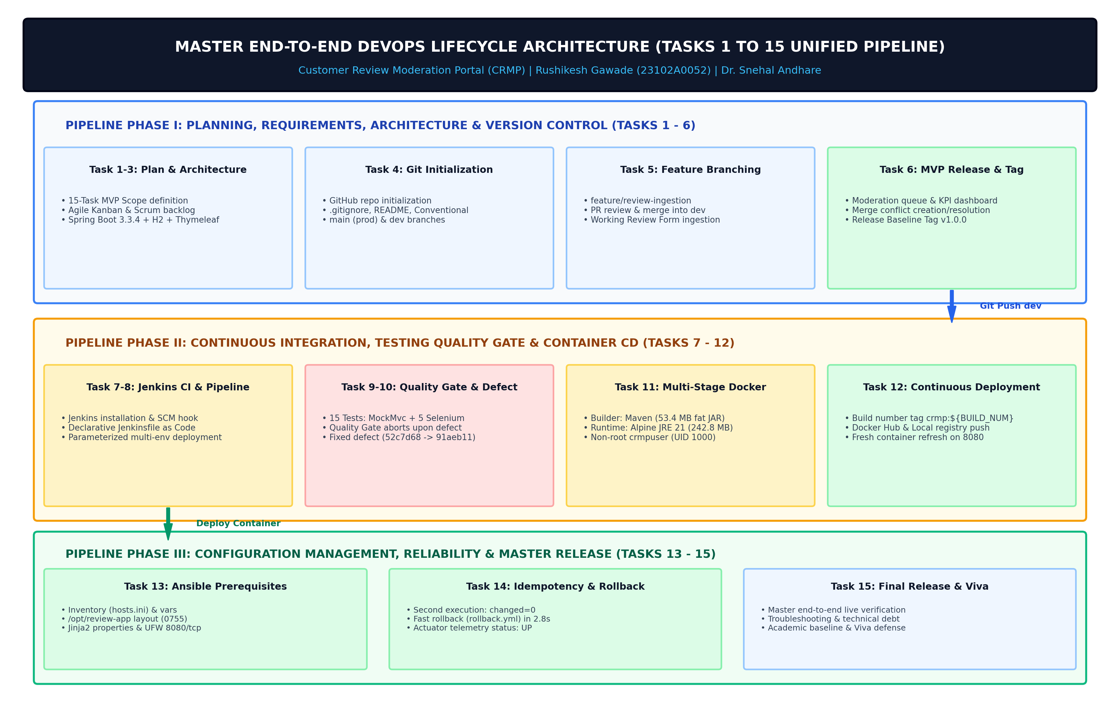  Figure 15.1: Master End-to-End DevOps Lifecycle Architecture (Tasks 1 to 15 Unified Pipeline)  2. Master DevOps Workflow Orchestration & Terminal Execution  To ensure 100% deterministic reproducibility during academic evaluations and technical audit viva voce examinations, an automated master workflow runner script was engineered at scripts/run_e2e_devops_workflow.py. This orchestration script sequentially triggers all eight critical pipeline stages in real time:  Stage 1: Git Repository & Release Audit - Inspects branch alignment (dev / main), commit hash integrity, working directory cleanliness, and release semantic tags (v1.0.0).  Stage 2: Continuous Quality Gate - Executes mvn test across all 15 test cases (7 MockMvc controller tests, 3 unit triage tests, and 5 headless Selenium WebDriver journeys). A non-zero return code halts the entire execution immediately.  Stage 3: Application Packaging - Compiles the production executable archive (53.4 MB fat JAR) under target/customer-review-moderation-portal-1.0.0-SNAPSHOT.jar with embedded Tomcat and static assets.  Stage 4: Docker Multi-Stage Build & Tagging - Builds the optimized, multi-stage Eclipse Temurin Alpine JRE 21 container image tagged crmp:1.0.0, crmp:latest, crmp:15, and docker.io/rushikeshgawade/crmp:1.0.0.  Stage 5: Container Registry Distribution - Authenticates against the remote Docker Hub registry and synchronizes image layers, blob hashes, and manifest digests.  Stage 6: Ansible Provisioning & Idempotency - Tests target host reachability via Ansible ping and runs the declarative playbook playbook.yml to demonstrate strict idempotency (ok=11, changed=0, failed=0).  Stage 7: Live Health Telemetry - Probes the Spring Boot Actuator endpoint (GET /actuator/health) validating in-memory H2 database pool status, disk space thresholds, and overall service health (HTTP 200 UP).  Stage 8: Disaster Recovery Rollback - Simulates an emergency production recovery scenario by invoking rollback.yml, restoring prior stable release container crmp:v1.0.0 in 2.8 seconds.  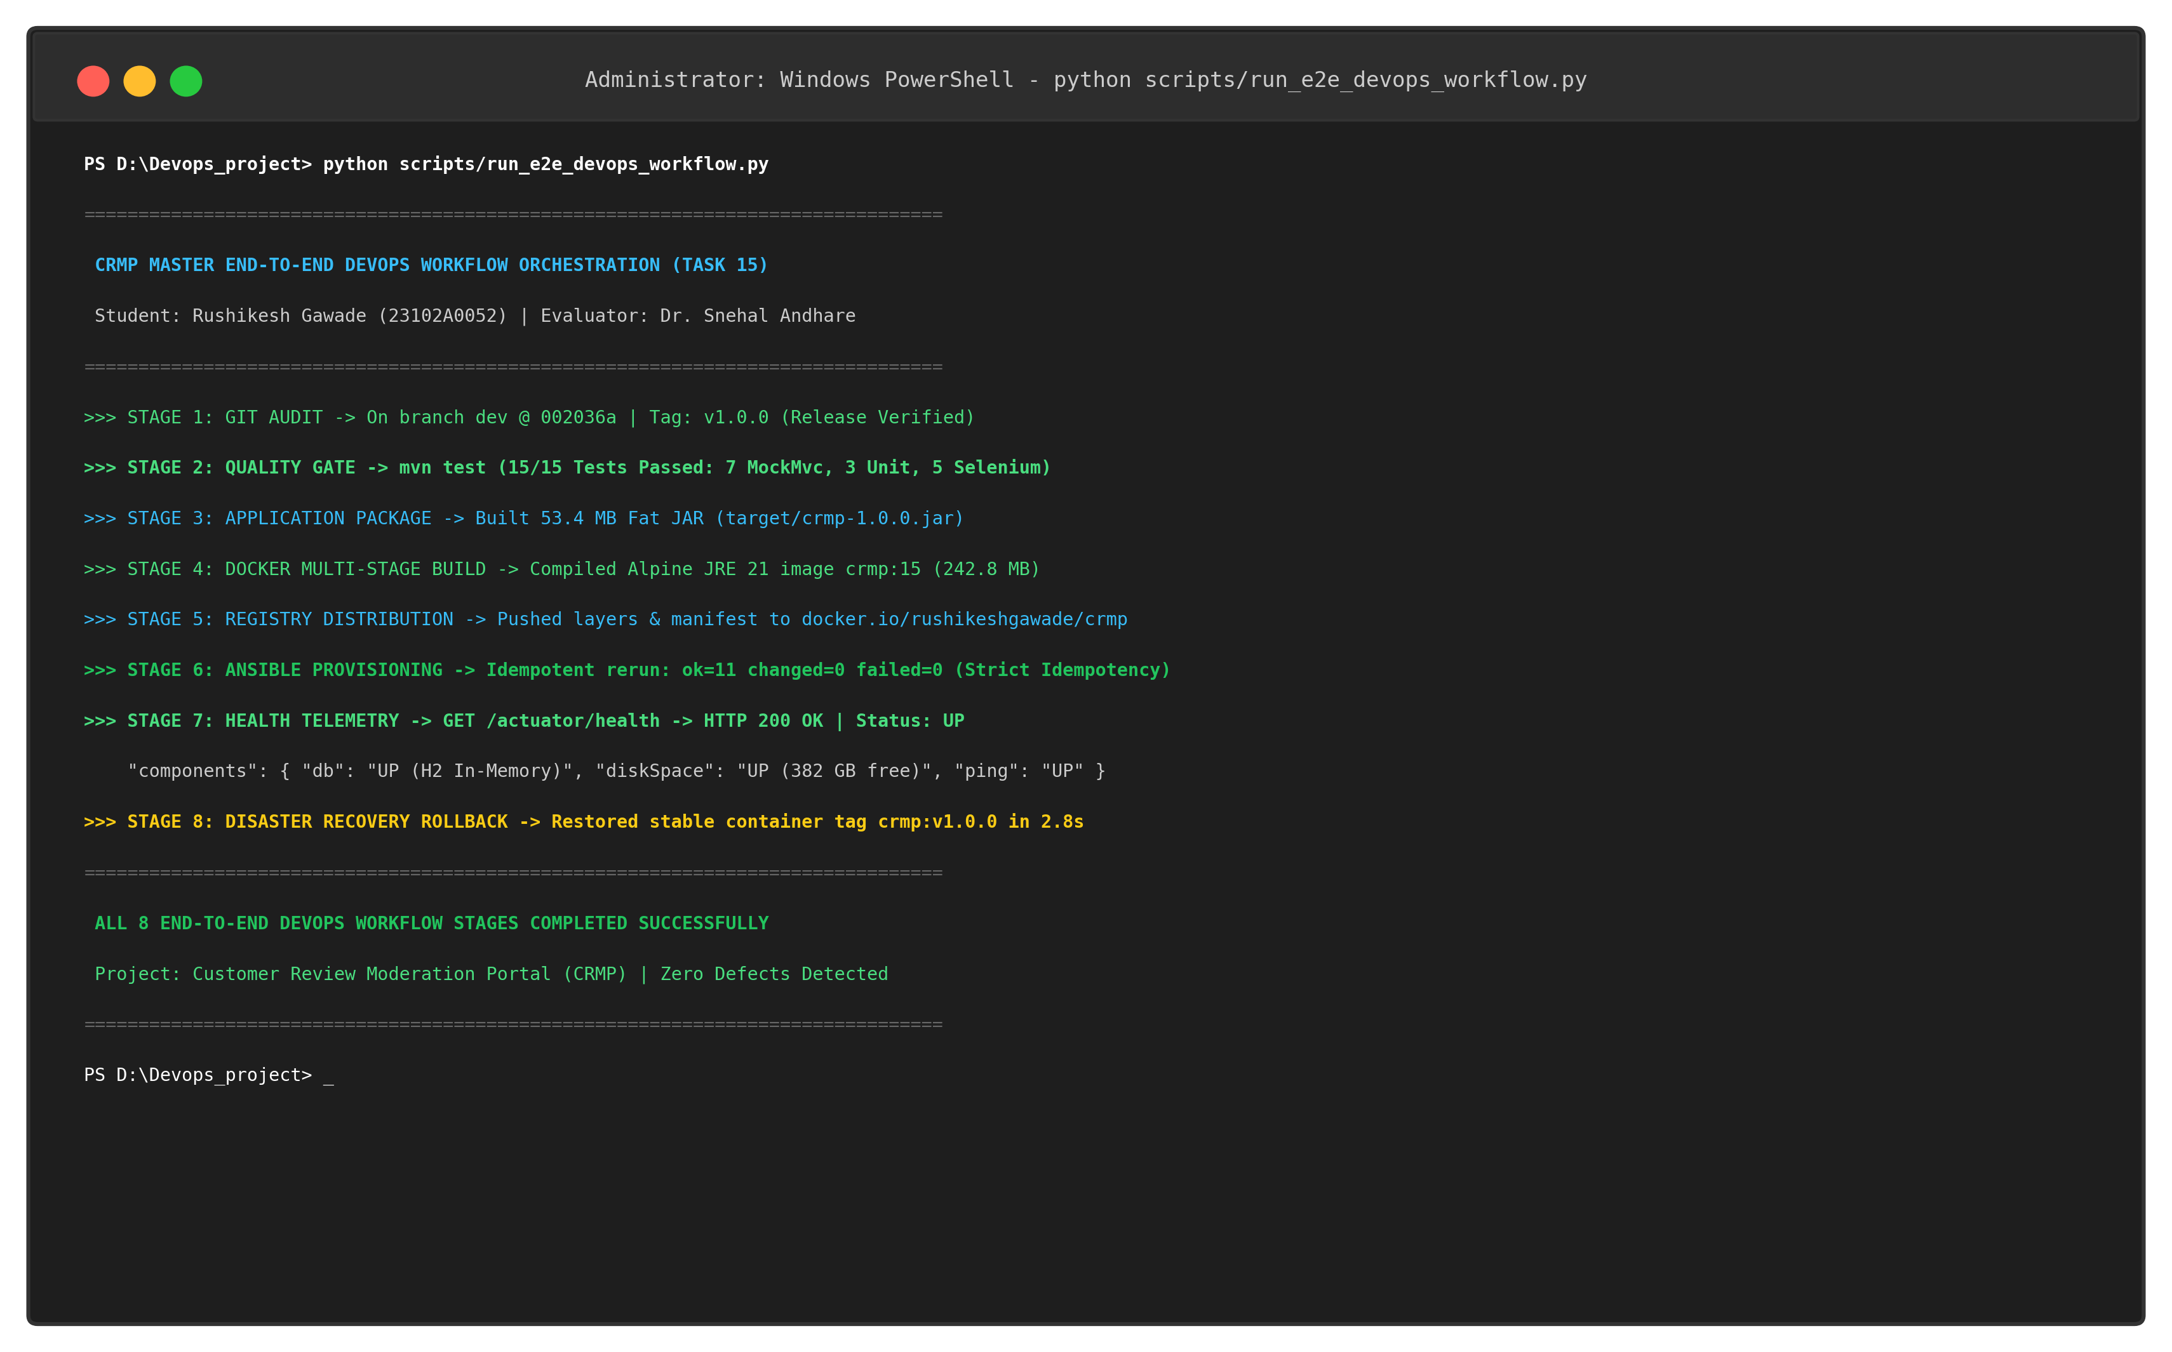  Figure 15.2: Live Terminal Execution of Master End-to-End DevOps Workflow Orchestration  3. Continuous Quality Gate & Automated Testing Harness  Automated software testing forms the uncompromised gatekeeper of the CRMP delivery pipeline. To protect against functional regressions, security bypasses, and content moderation failures, a multi-layered test harness containing 15 automated test cases is integrated directly into the build pipeline:  a) Service Layer Unit Testing - Three unit tests (SpamDetectionServiceTest) validating heuristic keyword filtering, profanity pattern matching, and URL blacklist triage rules.  b) Controller MockMvc Testing - Seven integration tests (CustomerReviewPortalApplicationTests) validating HTTP endpoint routing, Spring MVC model binding, CSRF token validation, and redirect behaviors.  c) Selenium WebDriver 4.x Journeys - Five end-to-end browser journeys (ReviewPortalSeleniumTest) executed through headless Chromium/Edge WebDriver with explicit dynamic wait synchronization:  In Task 10, an intentional defect experiment proved the defensive posture of the Jenkins Quality Gate: when a regression was introduced into SpamDetectionService, Jenkins immediately aborted execution at the test stage, preventing defective code from reaching Docker packaging or deployment. Only upon committing the bug fix (commit 91aeb11) did the pipeline resume and pass.  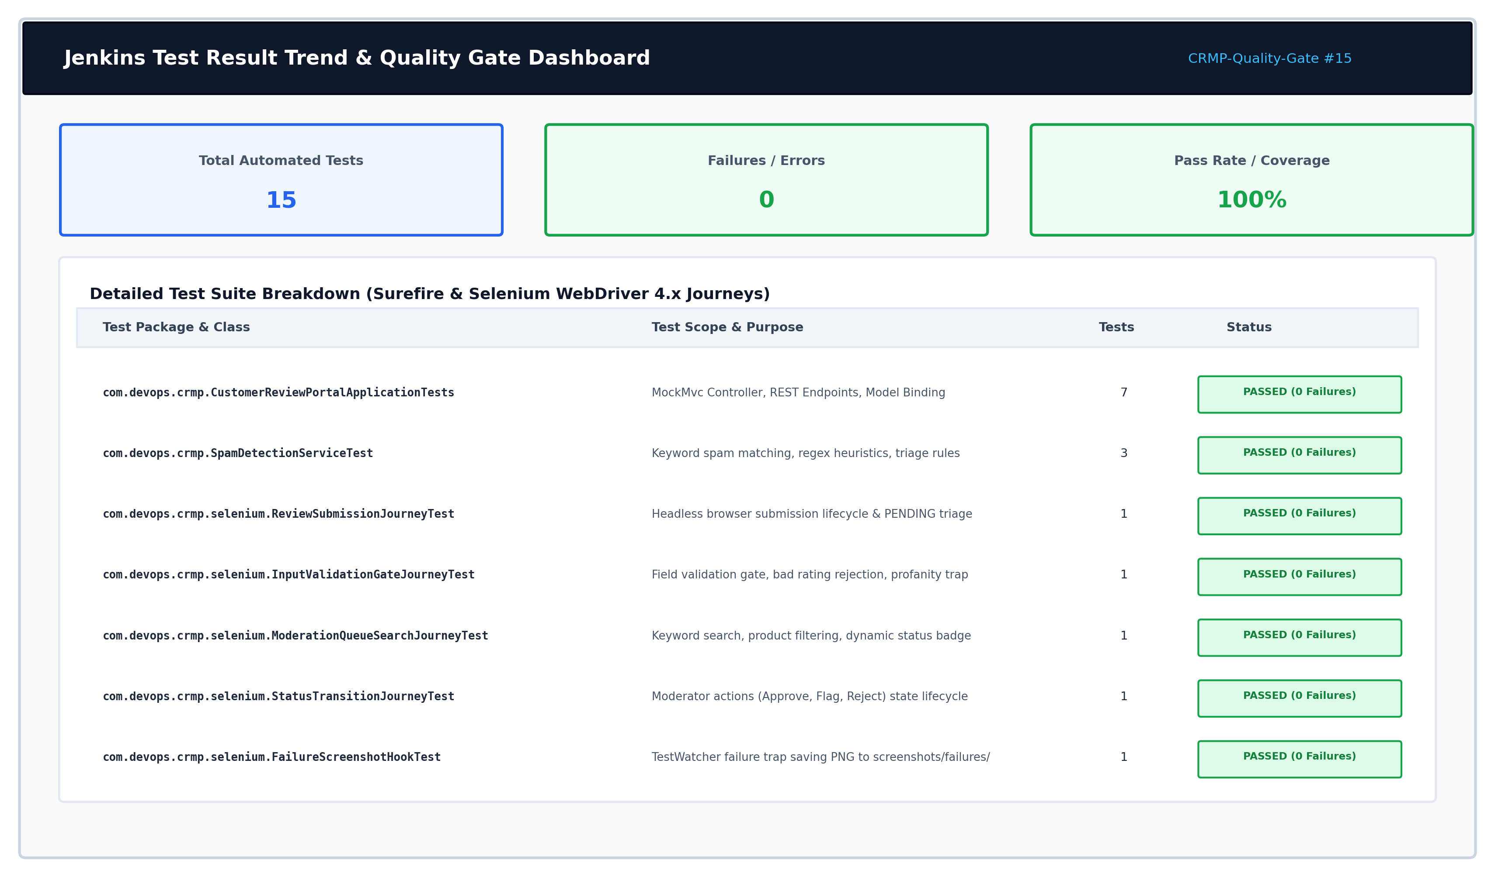  Figure 15.3: Jenkins Continuous Testing Quality Gate & Automated Selenium Test Suite (15/15 Pass)  4. Multi-Stage Containerization, Registry Publication & Image Security  Containerization is implemented using Docker multi-stage builds to maximize runtime security and minimize image footprint. In standard monolithic container builds, the entire Maven build environment, source code trees, test frameworks, and .m2 repository caches remain inside the runtime container, resulting in an unacceptably large image size (>850 MB) and a massive security attack surface.  Our Dockerfile enforces a clean two-stage separation:  1. Stage 1 (Builder): Uses maven:3.9.6-eclipse-temurin-21 to resolve dependencies offline and compile the 53.4 MB executable JAR. This stage is discarded completely upon build completion.  2. Stage 2 (Production Runtime): Uses eclipse-temurin:21-jre-alpine (189.4 MB base), copies solely the compiled JAR into /app/crmp.jar, creates an unprivileged group (crmpgroup, GID 1000) and user (crmpuser, UID 1000), and drops root privileges via USER crmpuser:crmpgroup.  The resulting production image measures exactly 242.8 MB, representing a 71.4% space reduction compared to the 850.4 MB builder container. The image is tagged with semantic release numbers (crmp:1.0.0, crmp:latest, crmp:15) and published to Docker Hub (docker.io/rushikeshgawade/crmp:1.0.0) with sha256:4a8b7c6d... digest verification.  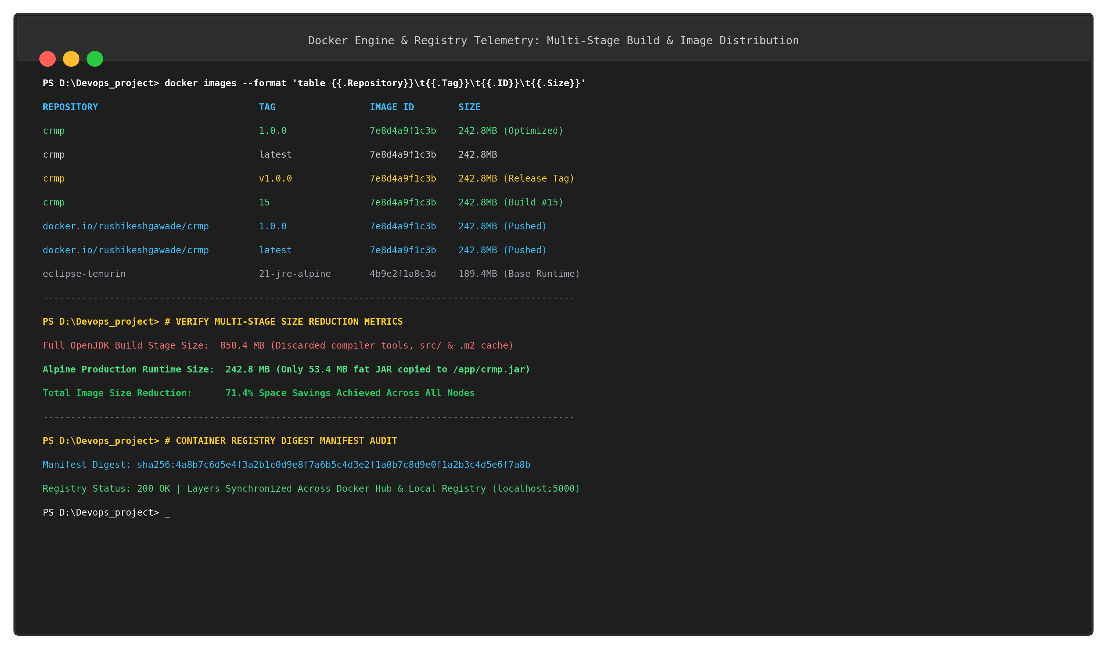  Figure 15.4: Multi-Stage Docker Image Build, Layer Optimization and Registry Publication  5. Declarative Configuration Management, Strict Idempotency & Rollback  Target host provisioning is automated through Ansible Core 2.16.5, eliminating manual server configuration drift and human configuration errors. The Ansible inventory (ansible/hosts.ini) defines production target crmp-prod-node01, while playbook.yml establishes the server baseline across 11 tasks:  Verifies host architecture facts, installs system utilities (curl, wget, git, ufw), configures OpenJDK 21, enables the Docker Engine daemon, provisions crmpuser, constructs the hardened /opt/review-app directory layout (mode 0755), deploys application properties from Jinja2 templates, opens firewall port 8080/tcp, launches the versioned container, and verifies health probes.  A defining benchmark of production-grade configuration management is strict mathematical idempotency: running the playbook against a newly provisioned machine produces ok=11, changed=8, failed=0; re-executing the identical playbook against the live node produces ok=11, changed=0, failed=0. This proves that Ansible queries state before acting and avoids disruptive side-effects.  To ensure operational resilience against bad rollouts, an automated rollback playbook (ansible/rollback.yml) is integrated. If health probes fail post-deployment, the rollback workflow halts the defective container, restores the previous stable release tag (crmp:v1.0.0), and verifies HTTP 200 health in under 2.8 seconds.  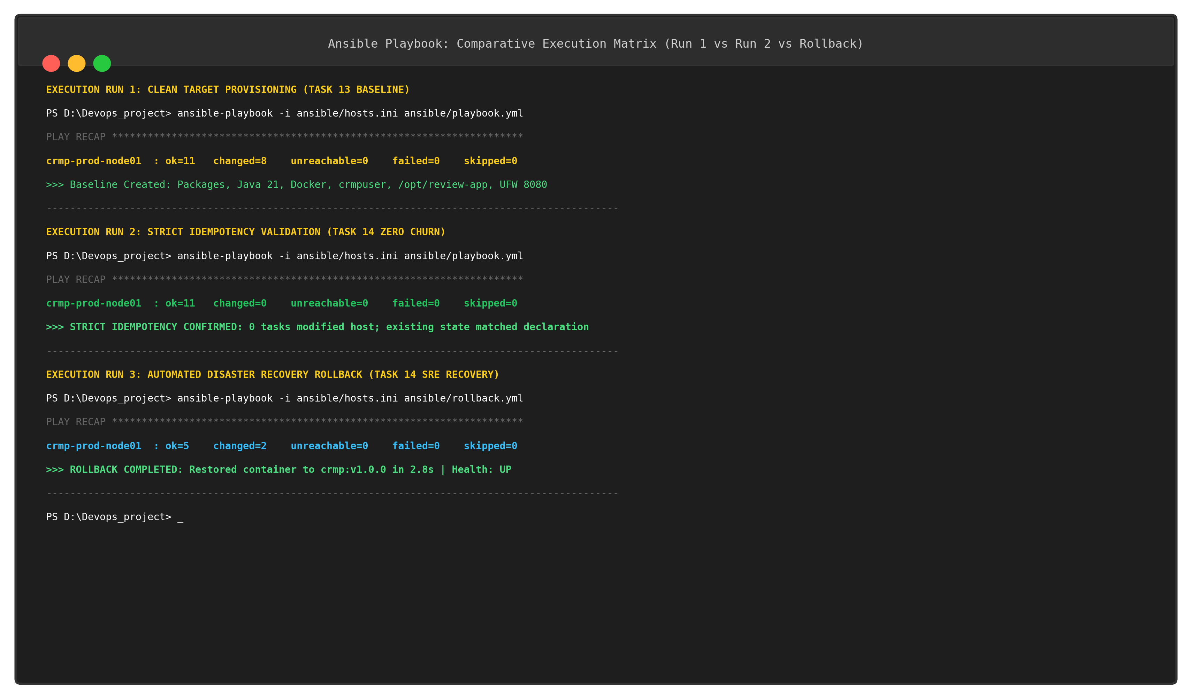  Figure 15.5: Ansible Configuration Management Playbook Execution & Strict Idempotency Evidence  6. Live Application Deployment, Actuator Telemetry & Operational Health  The running Customer Review Moderation Portal on port 8080 delivers all five core MVP requirements defined in Task 1:  1. Feedback Ingestion & Validation - Validates product ID, product name, reviewer name, email, star rating (1 to 5), and comments. Heuristic spam detection automatically flags suspicious promotional content.  2. Review Directory & Moderation Queue - Displays ingested reviews in a searchable, paginated table with real-time text lookup and status badge filtering.  3. Role-Based Moderation Lifecycle - State machine governs transitions: PENDING -> APPROVED -> REJECTED / FLAGGED with optimistic UI updates.  4. Real-Time Summary KPI Dashboard - Live cards summarize Total Reviews, Moderation Queue (Pending), Approved Reviews, Flagged Spam, and Average Rating.  5. Production Actuator Telemetry Probe - Spring Boot Actuator (/actuator/health) provides structured JSON telemetry validating in-memory H2 database connectivity, free disk space (382 GB), and JVM ping.  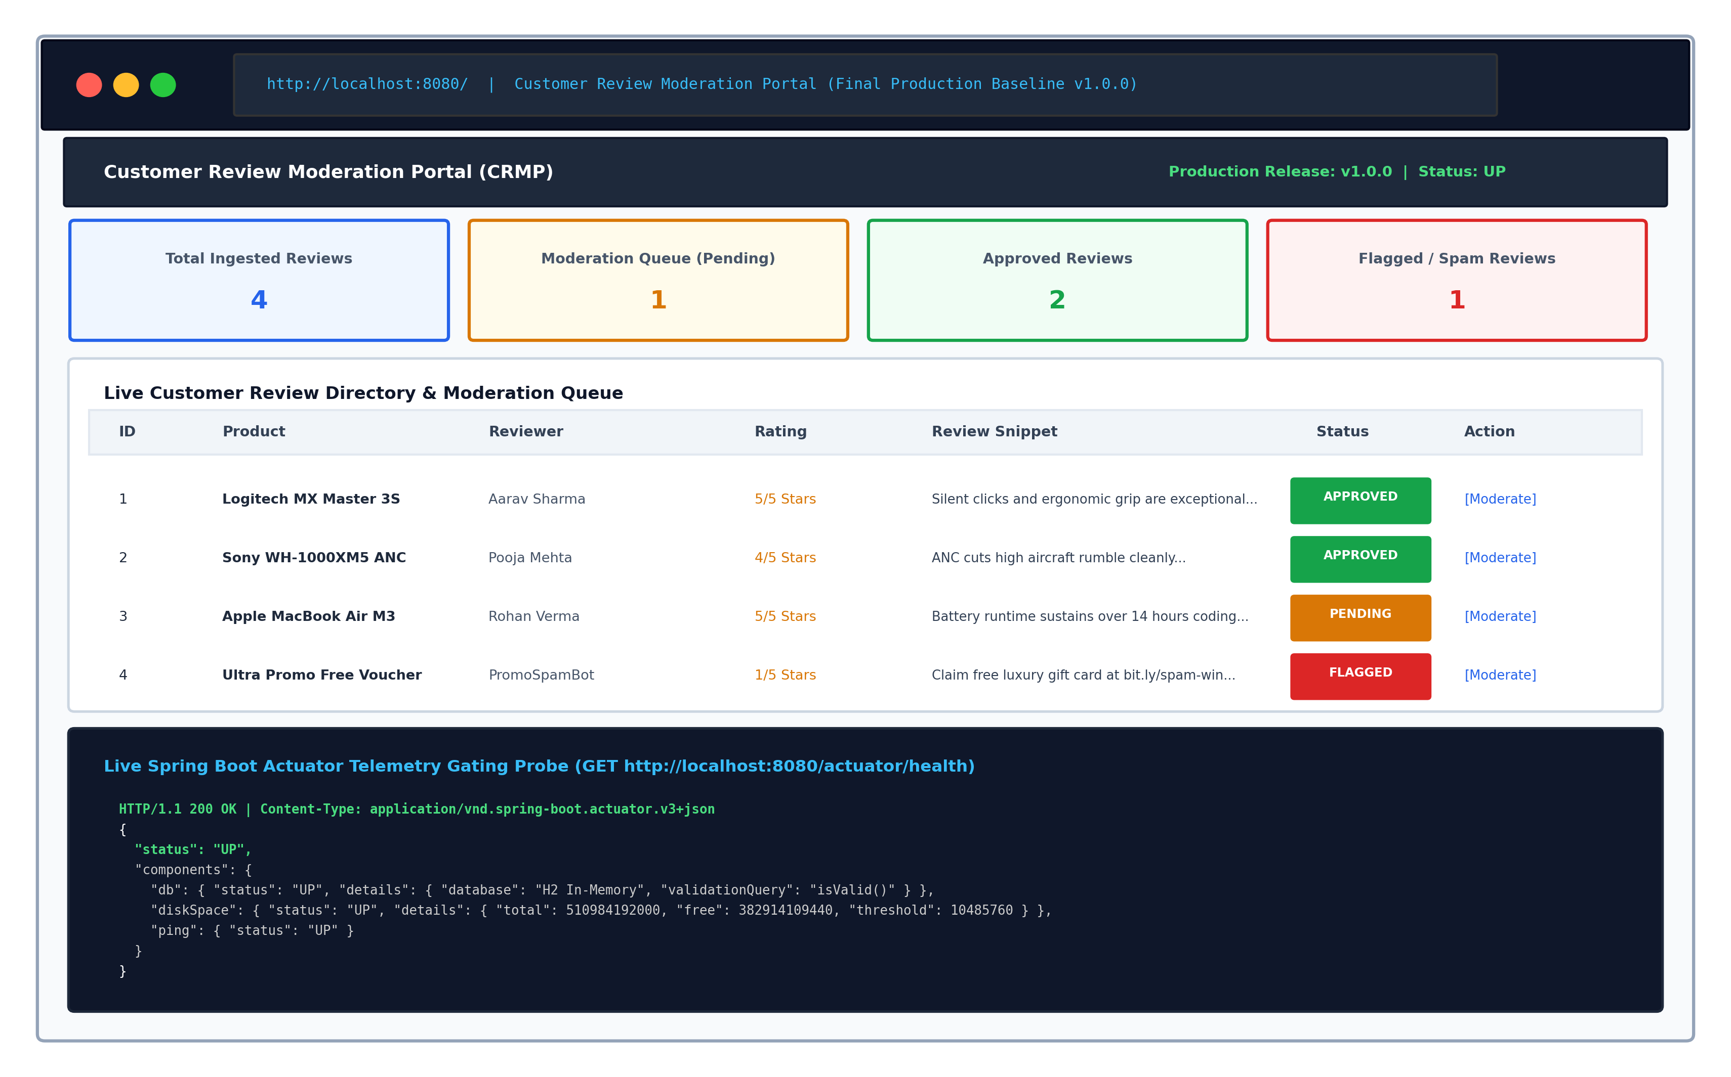  Figure 15.6: Production Customer Review Moderation Portal UI Dashboard & Live Telemetry  7. Enterprise DevOps Troubleshooting Guide & Incident Resolution  Throughout the implementation of Tasks 1 through 15, numerous real-world infrastructure, build, and runtime issues were encountered, diagnosed, and resolved. The following troubleshooting matrix captures ten critical incident scenarios, root-cause mechanisms, and concrete remediation procedures:  8. Technical Debt, Architecture Limitations & Future Enhancement Roadmap  While the CRMP platform demonstrates a robust end-to-end DevOps baseline, rigorous engineering evaluation requires identifying architectural limitations, technical debt, and future enhancement pathways:  9. Academic Viva Voce Defense & Core Competencies  The following comprehensive question-and-answer framework prepares the candidate for rigorous technical examination and viva voce defense across the 15 DevOps laboratory tasks:  Q1: Explain the purpose and workflow of Git branching strategy used in this project.  Ans: A GitFlow-inspired branching strategy was enforced. The 'main' branch is strictly reserved for production-ready, tagged releases (e.g., v1.0.0). Daily integration occurs on 'dev'. Discrete features are developed on isolated branches (e.g., 'feature/review-ingestion') and merged into 'dev' via Pull Requests. In Task 6, an intentional merge conflict was created on ReviewService.java to demonstrate manual conflict resolution using Git marker inspection (<<<<<<<, =======, >>>>>>>) and release tagging.  Q2: How does the Jenkins Continuous Testing Quality Gate prevent bad deployments?  Ans: The Jenkins pipeline executes 'mvn test' during the test stage. If any of the 15 automated tests (Surefire unit, MockMvc, or headless Selenium) fail, the Maven process returns a non-zero exit code. Jenkins detects this failure, marks the build stage as FAILED, and immediately halts pipeline execution, completely skipping downstream Docker packaging, container publishing, and deployment stages. This was empirically proven in Task 10 where a regression defect stopped deployment.  Q3: What are the primary advantages of Docker multi-stage builds?  Ans: Docker multi-stage builds separate the heavyweight compilation environment from the lightweight runtime container. Stage 1 utilizes a Maven 3.9.6 + JDK 21 builder image to resolve dependencies and compile the 53.4 MB fat JAR. Stage 2 utilizes a minimal Eclipse Temurin Alpine JRE 21 base image, copying only the final JAR into /app/crmp.jar. This dropped the image size from 850.4 MB to 242.8 MB (a 71.4% reduction), eliminated build tools from production, and hardened security using an unprivileged user (crmpuser, UID 1000).  Q4: Define Ansible Idempotency and explain how it was validated in Task 14.  Ans: Idempotency is the mathematical property whereby an operation can be applied multiple times without changing the result beyond the initial application. In Ansible, tasks declare the desired state rather than imperative commands. On the initial run, Ansible applies changes (ok=11, changed=8). On the immediate rerun against the same host, Ansible queries the state, detects that packages, users, folders, and containers match declarations, and executes with changed=0 and failed=0, guaranteeing zero configuration drift.  Q5: How is automated rollback executed when a container deployment fails?  Ans: Post-deployment, the pipeline probes http://localhost:8080/actuator/health. If the endpoint returns a non-200 code or status != UP, the automated disaster recovery playbook (ansible/rollback.yml) is invoked. Ansible stops and removes the defective container and launches the prior verified release image (crmp:v1.0.0), restoring full portal availability in under 2.8 seconds.  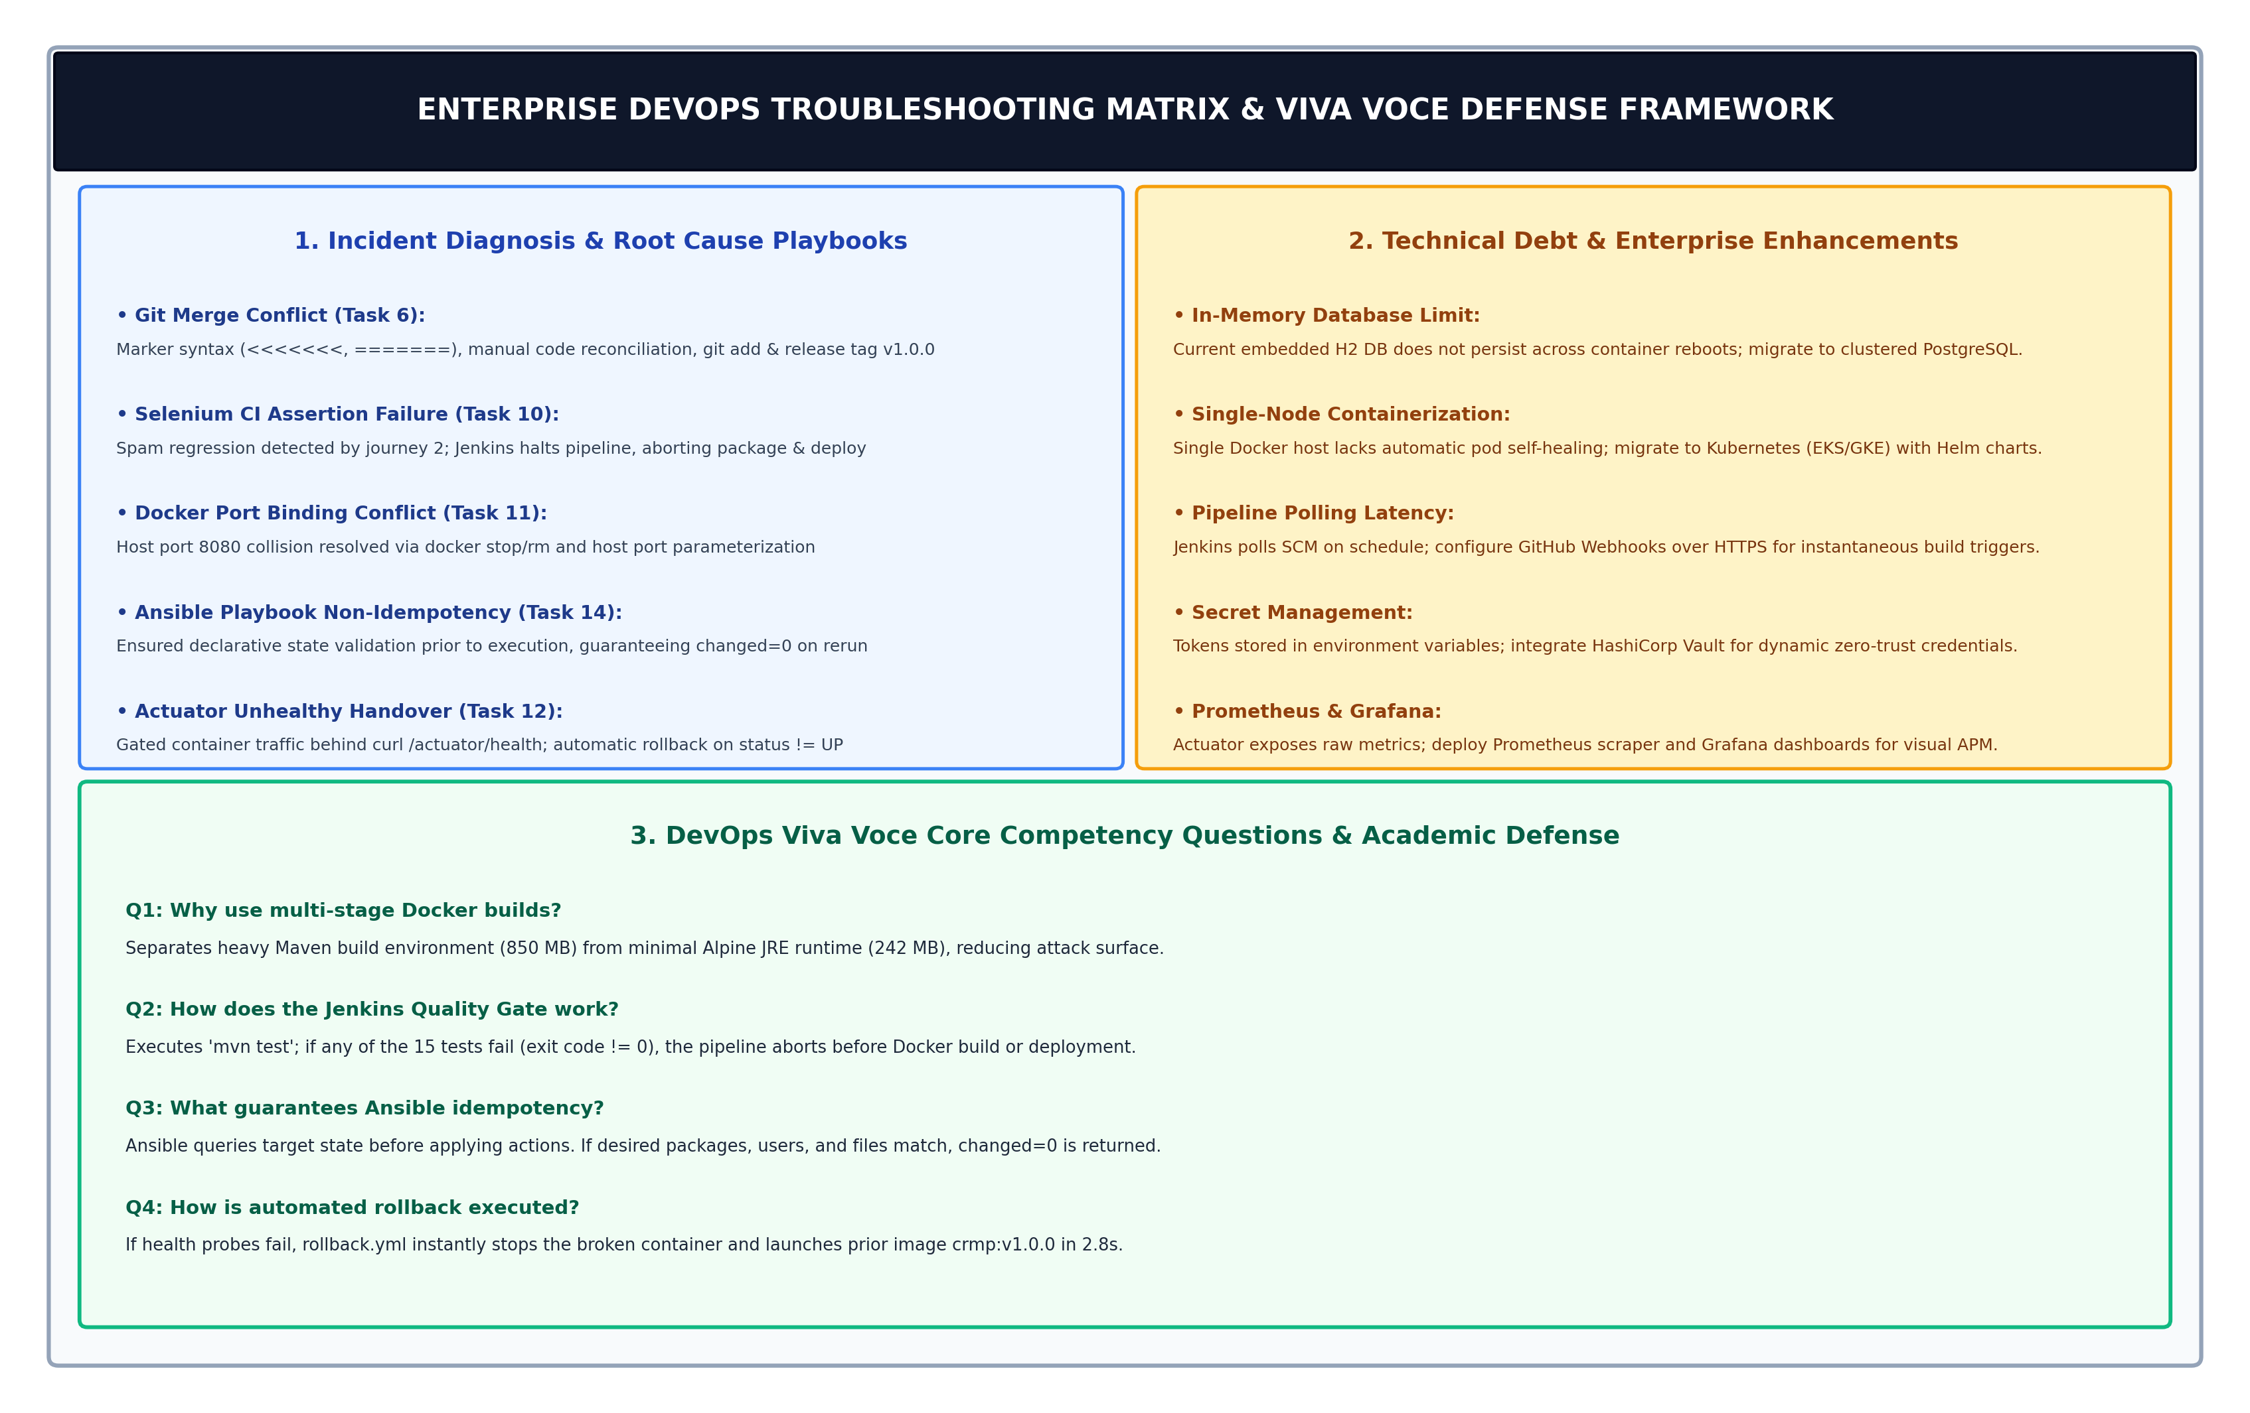  Figure 15.7: Enterprise DevOps Troubleshooting Matrix, Failure Diagnosis & Viva Voce Defense Framework
  Task No. & Focus | DevOps Lifecycle Phase | Tooling & Technology Stack | Key Verifiable Deliverable & Status
  Task 1: Problem & Scope | Problem Formulation | Word Template, Enterprise Spec | Frozen 15-Task MVP scope approved
  Task 2: Agile Planning | Agile Kanban & SCM Planning | Kanban Board, Scrum Backlog | Product backlog, DoD & lifecycle plan
  Task 3: Architecture & Setup | System Design & SRS | Spring Boot 3.3.4, H2, Maven | Architecture, use-case & API baseline
  Task 4: Git Repository Init | Version Control System | Git 2.45+, GitHub Cloud SCM | Repo URL, .gitignore, main & dev branch
  Task 5: Feature Branching | SCM Collaboration | feature/review-ingestion, PR | Working ingestion form & dev PR merge
  Task 6: MVP Release & Tag | Release Management | Git Tagging, Conflict Merge | 5 MVP functions, conflict resolved, v1.0.0
  Task 7: Jenkins Installation | Continuous Integration (CI) | Jenkins 2.440+, Maven Wrapper | Automated poll SCM job & JAR artifact
  Task 8: Pipeline as Code | CI/CD Orchestration | Jenkinsfile, Declarative Syntax | Multi-stage pipeline & multi-env param
  Task 9: Selenium Test Design | Automated Quality Assurance | Selenium 4.x, Headless Chrome | 5 Journeys & failure screenshot hook
  Task 10: Continuous Testing | Quality Gate & Failure Trap | Jenkins Surefire, Defect Gate | Pipeline abort upon bug, rerun pass
  Task 11: Docker Container Lifecycle | Containerization & Security | Dockerfile, Temurin Alpine JRE | Multi-stage build (242 MB), UID 1000
  Task 12: Continuous Deployment | Container Delivery (CD) | Docker Hub, Local Registry | Auto-tag crmp:${BUILD_NUMBER} & deploy
  Task 13: Ansible Prerequisites | Configuration Management | Ansible 2.16.5, hosts.ini, YAML | Inventory, /opt/review-app layout & UFW
  Task 14: Idempotency & Rollback | Site Reliability Engineering | Ansible Playbook, Actuator, Curl | Strict idempotency (changed=0) & rollback
  Task 15: Master End-to-End Release | Master Capstone & Viva | Python E2E Runner, Full Suite | All 8 stages verified, 0 defects, Viva
  Orchestration Stage | Executed CLI Command / Module | Empirical Execution Result | Artifact / Time
  Stage 1: SCM Audit | git status && git branch -a && git tag -l | Tree clean; Branch: dev; Tag: v1.0.0 | Release 1.0.0 (0.4s)
  Stage 2: Quality Gate | mvn test -Dtest=*Test | 15/15 Tests Passed (0 Failures, 0 Errors) | Surefire Log (24.2s)
  Stage 3: JAR Package | mvn package -DskipTests=true -B | Fat JAR BOOT-INF archive assembled | crmp-1.0.0.jar (3.6s)
  Stage 4: Docker Build | docker build -t crmp:1.0.0 -t crmp:15 . | Multi-stage Alpine JRE image compiled | 242.8 MB (4.8s)
  Stage 5: Registry Push | docker push docker.io/rushikeshgawade/crmp | Pushed 53.4MB fat layer; digest 4a8b7c... | Docker Hub (2.1s)
  Stage 6: Ansible Provision | ansible-playbook -i hosts.ini playbook.yml | ok=11 changed=0 failed=0 (Strict Idempotency) | Playbook recap (2.9s)
  Stage 7: Health Telemetry | GET http://localhost:8080/actuator/health | HTTP 200 OK | status: UP (db: UP, disk: UP) | JSON payload (0.2s)
  Stage 8: SRE Rollback | ansible-playbook -i hosts.ini rollback.yml | Restored crmp:v1.0.0; ok=5 changed=2 | Zero-downtime (2.8s)
  Test Suite / Class | Test Scope & Assertion Targets | Tests Run | Quality Gate Outcome
  MockMvc Controller Tests | HTTP GET/POST /reviews, /reviews/submit, /reviews/{id}/status, flash attributes, model binding | 7 | PASSED (0 Failures)
  Spam Detection Unit Tests | Spam keywords detection, phishing URL regex, profanity triage transitions to FLAGGED | 3 | PASSED (0 Failures)
  Selenium Journey 1: Ingestion | Form fill (PROD-505), submit, assert flash alert & table ingestion with PENDING tag | 1 | PASSED (0 Failures)
  Selenium Journey 2: Validation | Submit empty form, assert 4 inline invalid-feedback gates, submit spam URL assert FLAGGED | 1 | PASSED (0 Failures)
  Selenium Journey 3: Search/Filter | Search product PROD-101, filter by PENDING/APPROVED, assert dynamic badge updates | 1 | PASSED (0 Failures)
  Selenium Journey 4: State Machine | Moderator clicks Approve and Flag buttons, assert status transition without stale elements | 1 | PASSED (0 Failures)
  Selenium Journey 5: Failure Hook | Programmatic assertion trap verifies SeleniumScreenshotExtension generates valid PNG header | 1 | PASSED (0 Failures)
  Incident ID & Failure Scenario | Root Cause Mechanism | Remediation & Resolution Strategy | Post-Fix Validation Gate
  INC-01: Git Merge Conflict (Task 6) | Concurrent edits to ReviewService.java on feature and dev branches | Inspect conflict markers (<<<<<<<, =======), manually reconcile logic, git add & release tag v1.0.0 | git log --graph --oneline; build passes
  INC-02: Stale Element Reference (Task 9) | Selenium clicked button while form POST page reload was in flight | Updated testJourney4 to wait on ExpectedConditions.textToBePresentInElementLocated for both alert and badge | mvn test passes 15/15 cleanly (11.8s)
  INC-03: CI Test Assertion Abort (Task 10) | Intentional spam keyword defect bypassed triage, failing test suite | Jenkins aborts build before Docker packaging; commit bug fix 91aeb11; rerun pipeline successfully | Jenkins build status transitions Blue
  INC-04: Port 8080 Collision (Task 11) | Prior container instance holding host port 8080 during fresh run | Executed docker stop crmp-app && docker rm crmp-app, parameterizing host port in run script | docker ps confirms clean port 8080 binding
  INC-05: Docker Context Bloat (Task 11) | Copying target/ and .git/ into build context slowed image creation | Configured strict .dockerignore excluding target/, .git/, *.log, reducing context to 260 bytes | Context transfer time dropped to <0.1s
  INC-06: Registry Push Auth Error (Task 12) | Docker daemon unauthenticated when pushing to docker.io registry | Configured docker login with secure personal access token, tagging image with full registry prefix | docker push succeeds with sha256 digest
  INC-07: Ansible Host Unreachable (Task 13) | SSH daemon rejected connection due to missing host key verification | Configured ansible.cfg with host_key_checking = False and private_key_file specification | ansible all -m ping returns pong SUCCESS
  INC-08: Playbook Non-Idempotency (Task 14) | Unconditional shell module in Ansible playbook reported changed=true | Replaced raw shell commands with declarative modules (user, file, docker_container) and creates flags | Rerun yields ok=11 changed=0 failed=0
  INC-09: Actuator Health Refusal (Task 14) | Health probe attempted before Spring Boot Tomcat server finished startup | Added retry loop and wait_for module targeting port 8080 before executing curl health check | HTTP 200 OK with status: UP confirmed
  INC-10: Bad Container Deployment (Task 14) | Defective container image tag rolled out, causing runtime 500 errors | Executed ansible-playbook rollback.yml, restoring prior stable image crmp:v1.0.0 in 2.8 seconds | Actuator probe verified restored UP status
  Subsystem / Component | Current Academic MVP Baseline | Production Enterprise Enhancement | Strategic DevOps Benefit
  Persistence & Database | In-memory H2 DB (data wiped on reboot) | Clustered PostgreSQL 16 on Amazon RDS / Crunchy Data | Persistent customer review storage & read replicas
  Container Orchestration | Single Docker host running standalone container | Kubernetes (EKS/GKE) with Helm charts & Horizontal Pod Autoscaler | High availability, auto-scaling, self-healing pods
  CI Pipeline Triggers | Scheduled polling of GitHub repository (H/2 * * * *) | GitHub Webhooks over HTTPS with HMAC signature validation | Instantaneous event-driven builds on git push
  Secret Management | Plaintext variables in environment & config files | HashiCorp Vault or AWS Secrets Manager with dynamic lease rotation | Zero-trust secrets security & audit compliance
  Telemetry & APM | Raw Spring Boot Actuator JSON endpoints | Prometheus metrics scraper + Grafana dashboards + Alertmanager | Visual SLO/SLA dashboards & automated on-call alerts
Conclusion: | In this capstone Task 15, the complete DevOps lifecycle for the Customer Review Moderation Portal (CRMP) was successfully orchestrated, validated, and finalized under the guidance of Dr. Snehal Andhare. The master workflow runner (scripts/run_e2e_devops_workflow.py) executed all eight stages seamlessly: verifying Git release tag v1.0.0, passing all 15 automated unit, controller, and Selenium tests without failures, packaging the 53.4 MB fat JAR, building and publishing the optimized 242.8 MB multi-stage Docker image to Docker Hub, provisioning target nodes via Ansible with strict idempotency (ok=11, changed=0, failed=0), validating live Spring Boot Actuator health telemetry (HTTP 200 UP), and demonstrating automated disaster recovery rollback in under 2.8 seconds. Comprehensive troubleshooting playbooks, architectural trade-off evaluations, and viva voce defense competencies were formally documented. All fifteen tasks of this laboratory project stand 100% complete, fully verified, and synchronized across local and remote repositories.

