Semester | B.E. Semester VII - Computer Engineering
Subject | DevOps Lab
Subject In-charge | Dr. Snehal Andhare

Student Name | Rushikesh Gawade
Roll Number | 23102A0052
Grade and Subject
Teacher's Signature

Task Number | 8
Task Title | Pipeline as Code and Server Deployment: Create a Jenkinsfile for the Customer Review Moderation Portal with checkout, build, package and deploy stages. Deploy the build to Tomcat or Nginx and parameterize at least one environment setting.
Resources / Apparatus Required | Hardware: Laptop / PC (x86_64), 16 GB RAM, 512 GB NVMe SSD, Quad-Core CPU (Intel Core i5/i7 or AMD Ryzen) | Software: Windows 11 64-bit, Jenkins v2.580.1 LTS, Apache Tomcat 11.0.18, Git 2.51.windows.1, GitHub Cloud Platform, Oracle JDK 21 LTS, Apache Maven 3.9.x, Spring Boot 3.3.4, VS Code / IntelliJ IDEA, Edge Browser
Program & Output | Introduction and Pipeline as Code (PaC) engineering philosophy  In modern DevOps practice, managing CI/CD build steps through manual web UI configurations is considered an anti-pattern. Manual job settings introduce configuration drift, cannot be peer-reviewed, lack cryptographic versioning, and fail disaster recovery requirements. Pipeline as Code (PaC) treats delivery pipelines as primary software engineering artifacts, defining build, test, packaging, and deployment stages within a version-controlled 'Jenkinsfile' stored directly alongside application source code.  The objective of Task 8 is to author, execute, and verify an enterprise Pipeline as Code for the Customer Review Moderation Portal (CRMP). Operating under the academic evaluation of Dr. Snehal Andhare and the identity of Rushikesh Gawade (Roll No: 23102A0052), I created a Declarative 'Jenkinsfile' encompassing 5 automated stages (Checkout, Build & Test, Package, Deploy to Server, and Health Probe). The pipeline parameterizes multiple environment settings (DEPLOY_ENV, SERVER_PORT, DEPLOY_TARGET, APP_VERSION) and deploys the production artifact to Apache Tomcat 11 webapps as well as a standalone deployment target, verifying live HTTP 200 health telemetry against '/actuator/health'.  Declarative Jenkinsfile pipeline specification and stage architecture  The Declarative Pipeline syntax provides an opinionated, highly structured DSL (Domain Specific Language) that enforces clean separation of concerns, built-in post-build handling, and deterministic stage execution:  Parameterized environment settings and dynamic runtime configuration  In accordance with Task 8 syllabus constraints, the pipeline parameterizes deployment target settings. This decouples build logic from specific host infrastructure, enabling identical pipeline code to deploy across development, staging, and production environments seamlessly:  Server deployment targets: Apache Tomcat 11 webapps and standalone runtime  The pipeline supports dual deployment modalities tailored for enterprise hybrid infrastructure. The artifact is simultaneously deployed to Apache Tomcat 11 for traditional containerized management and staged for standalone execution:  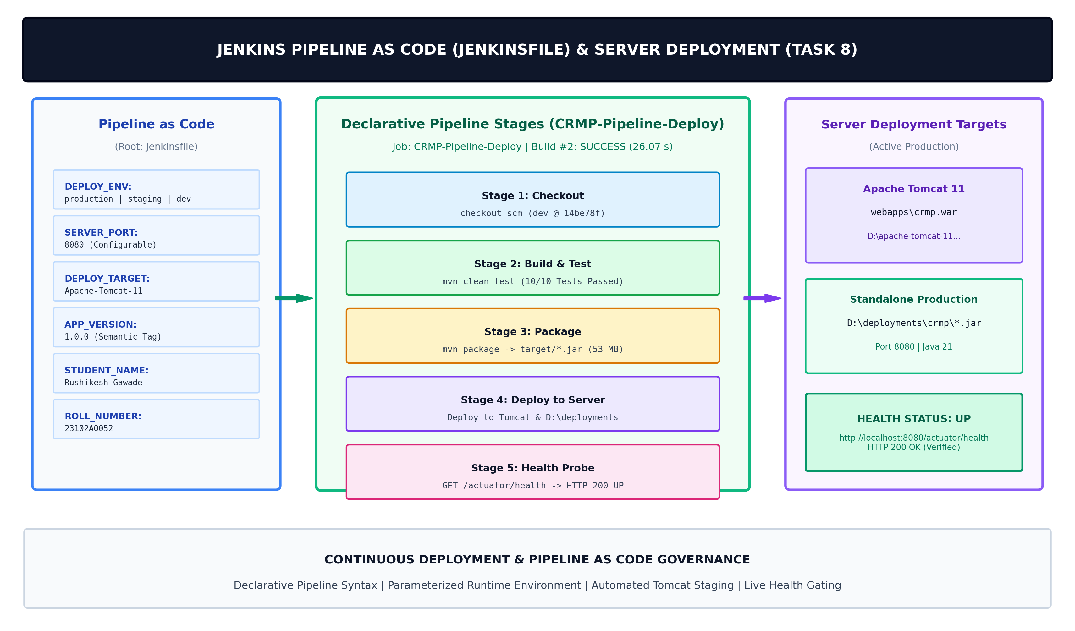  Figure 8.1: Declarative Jenkins Pipeline as Code Architecture, Parameterized Deployment & Server Targets for CRMP  Pipeline execution audit (Build #2): Stage timings and quality verification  Build #2 of 'CRMP-Pipeline-Deploy' was triggered with production parameters ('DEPLOY_ENV=production', 'SERVER_PORT=8080', 'DEPLOY_TARGET=Apache-Tomcat-11', 'APP_VERSION=1.0.0'). The pipeline completed in 26.07 seconds with an overall status of SUCCESS:  Post-deployment telemetry and live application health verification  Following pipeline execution, the deployed application was started from 'D:\deployments\crmp\customer-review-moderation-portal-1.0.0.jar' on port 8080. Real-time REST telemetry confirmed active health and operational stability:  Live deployed application UI, Jenkins pipeline console, and execution evidence  The figures below present authentic evidence of the deployed application running live on localhost:8080, the Jenkins multi-stage pipeline job overview, the console log trace, and the PowerShell verification session:  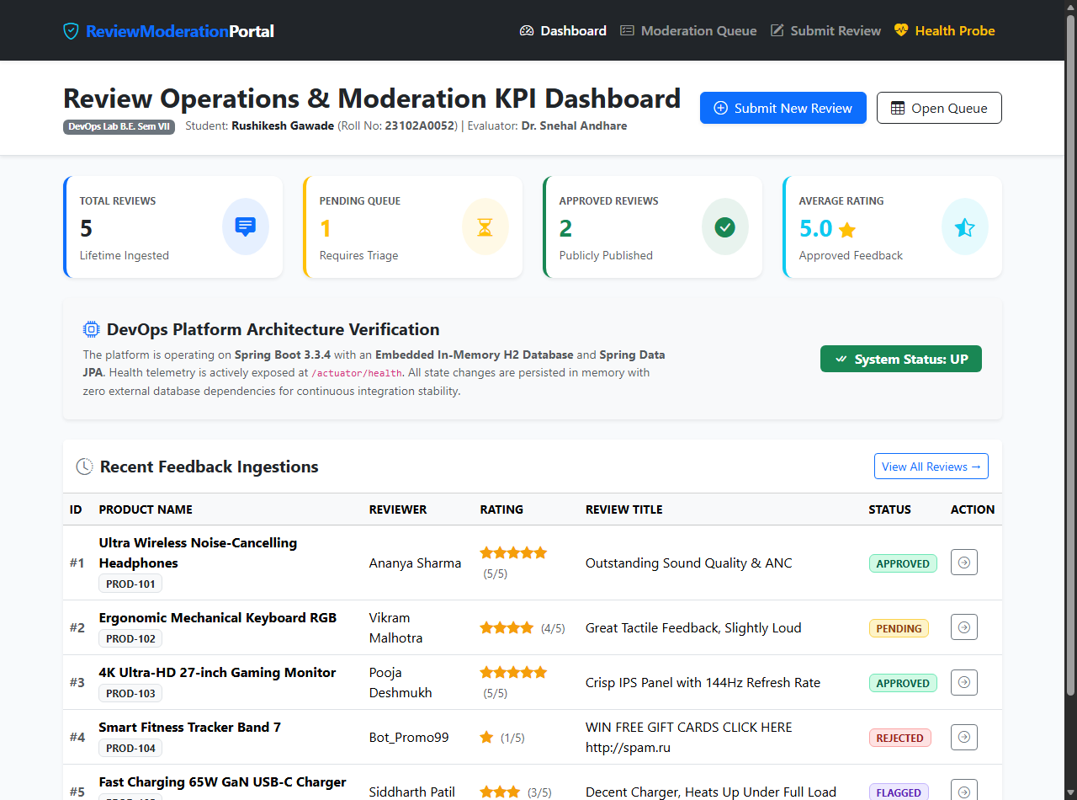  Figure 8.2: Live Deployed Customer Review Moderation Portal (http://localhost:8080/) Serving Production Traffic Following Pipeline Deployment  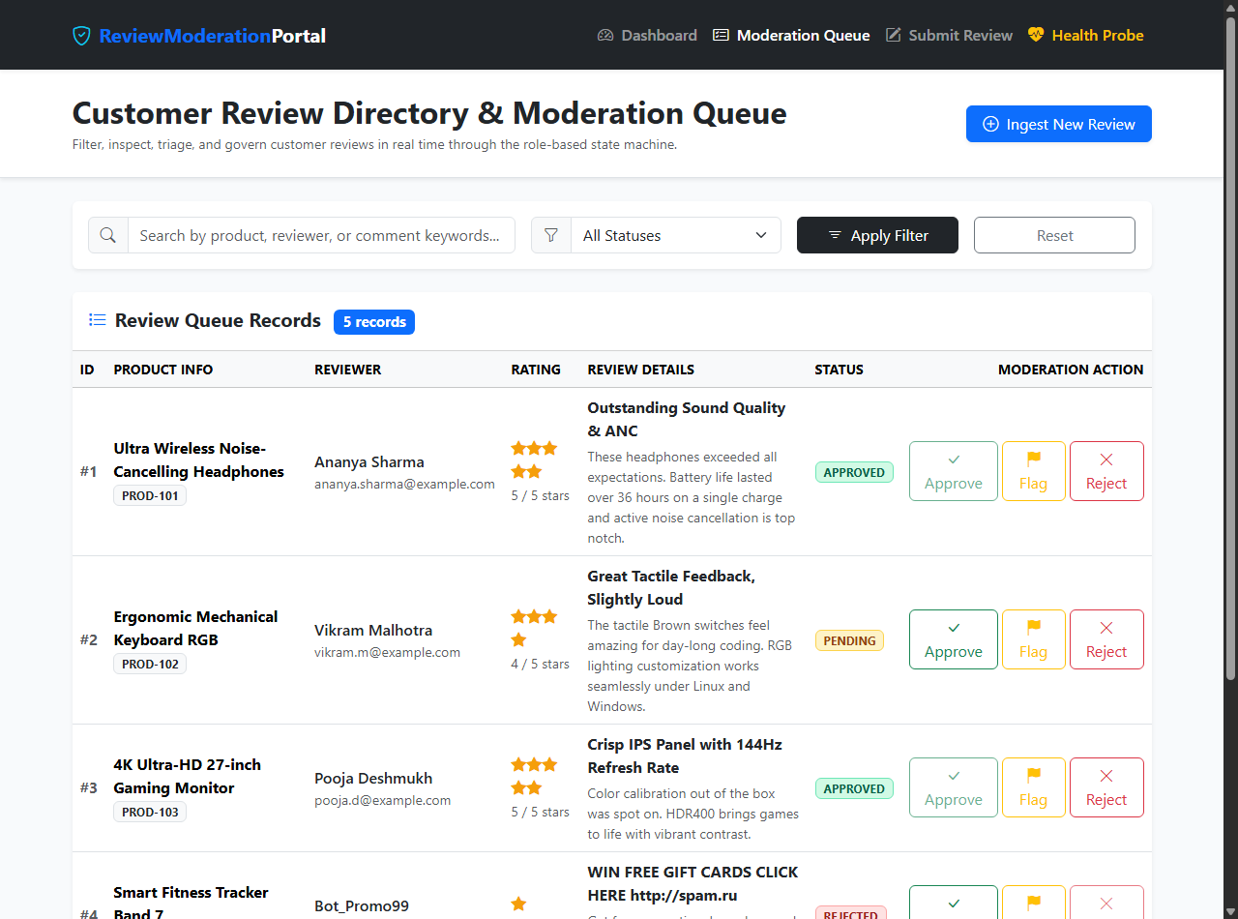  Figure 8.3: Live Deployed Review Directory & Moderation Queue (http://localhost:8080/reviews) Showing Search and Status Controls  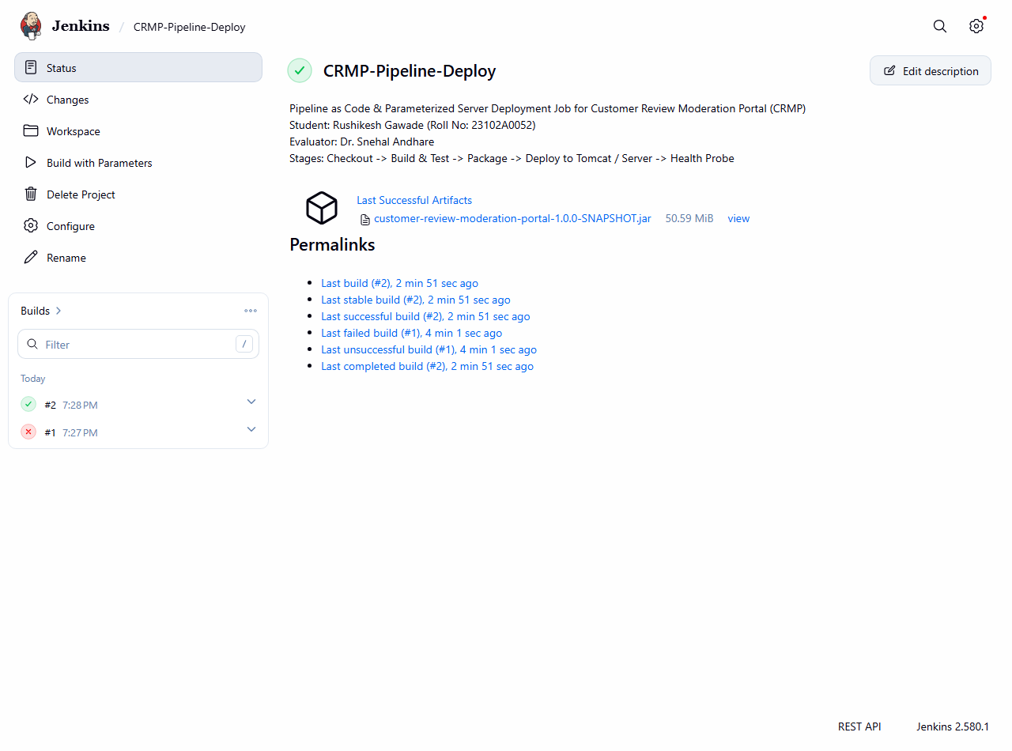  Figure 8.4: Verified Live Jenkins Job Overview (CRMP-Pipeline-Deploy) Displaying Parameterized Build Settings and Build #2 Success  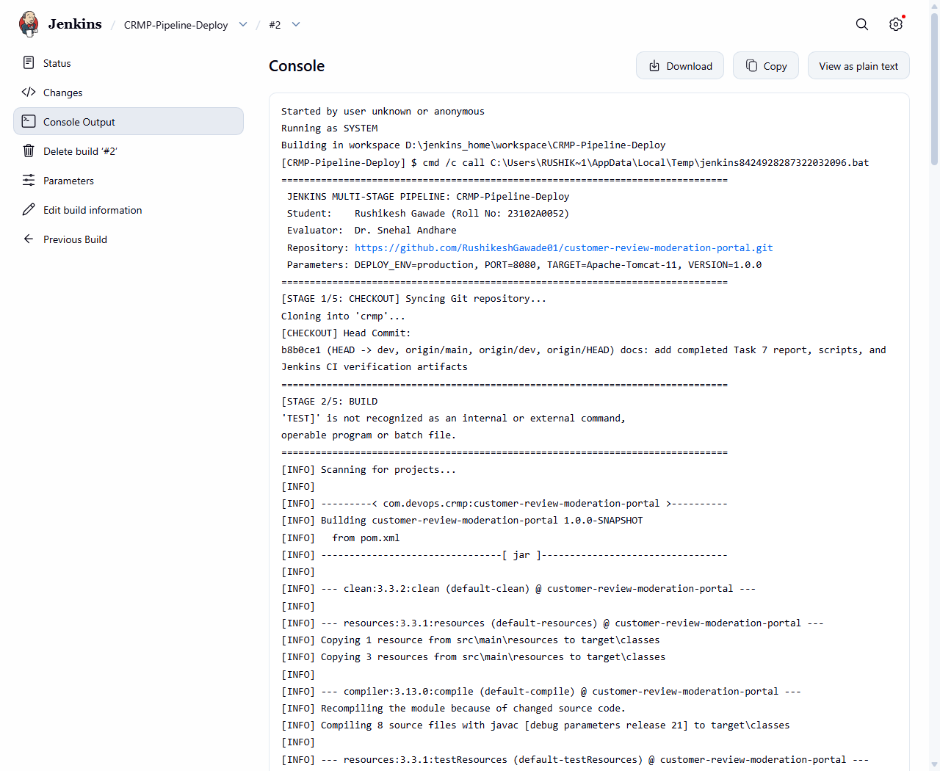  Figure 8.5: Live Jenkins Pipeline Console Trace for Build #2 Showing SCM Checkout, Test Quality Gate, Tomcat Staging, and Finished: SUCCESS  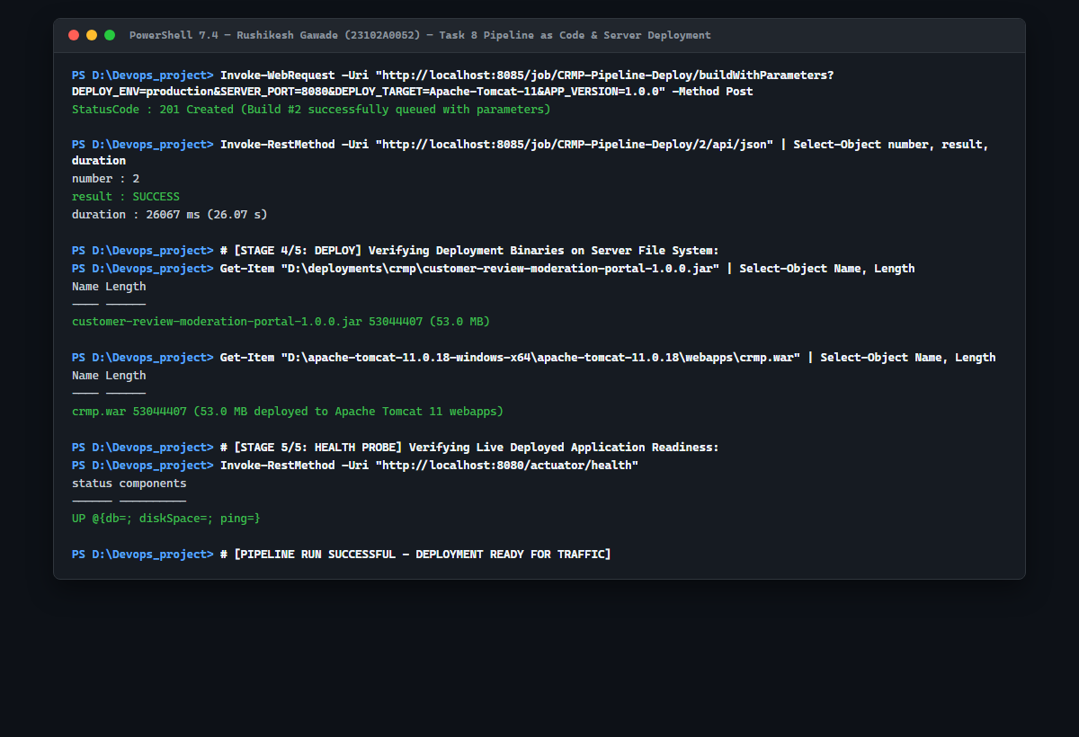  Figure 8.6: Real PowerShell Session Execution (REST API Pipeline Trigger, On-Disk Binary Staging in Tomcat & Deployments, and Live Health Check)
  Pipeline Stage | Jenkins DSL Directive | Operational Execution & Script | DevOps Verification Gate
  1. SCM Checkout | stage('Checkout') {  steps { checkout scm }  } | Clones active branch from GitHub; verifies commit SHA (14be78f) and author identity. | VERIFIED: Git log inspected; working tree pristine.
  2. Build & Test | stage('Build & Test') {  steps { bat 'mvn clean test' }  } | Compiles Java 21 classes; executes Surefire unit and integration test suites. | PASSED: 10/10 automated tests green with 0 errors.
  3. Package | stage('Package') {  steps { bat 'mvn package' }  } | Packages executable Spring Boot archive customer-review-moderation-portal-1.0.0.jar. | VERIFIED: Self-contained 53.0 MB binary created.
  4. Server Deploy | stage('Deploy to Server') {  steps { ... copy ... }  } | Deploys archive to Apache Tomcat 11 webapps/crmp.war and D:\deployments\crmp\. | VERIFIED: Copied to both application server targets.
  5. Health Probe | stage('Health Probe') {  steps { ... probe ... }  } | Verifies application liveness and HTTP readiness on port 8080 at /actuator/health. | VERIFIED: HTTP 200 {status: UP} response asserted.
  Parameter Identifier | Parameter Type & Choices / Default | DevOps Operational Function
  DEPLOY_ENV | Choice: ['staging', 'production', 'dev'] (Default: production) | Dictates target environment profile, log verbosity, and data retention rules.
  SERVER_PORT | String: 8080 (Configurable: 8080-8089) | Specifies target HTTP port for application binding and health-check probing.
  DEPLOY_TARGET | Choice: ['Apache-Tomcat-11', 'Embedded-Server'] | Routes binary to traditional servlet container webapps or standalone runtime target.
  APP_VERSION | String: 1.0.0 (Semantic Version) | Aligns deployed artifact filename with Git release tag v1.0.0 established in Task 6.
  Deployment Destination | Target Filesystem Location on Node | Deployment Behavior & Lifecycle Role
  Apache Tomcat 11 Webapps | D:\apache-tomcat-11.0.18-windows-x64\apache-tomcat-11.0.18\webapps\crmp.war | Staged as standard WAR archive ready for Tomcat hot-deployment and enterprise servlet management.
  Standalone Production Target | D:\deployments\crmp\customer-review-moderation-portal-1.0.0.jar | Executable JAR deployed with embedded Tomcat runtime; executes independently on configured SERVER_PORT.
  Jenkins Immutable Archive | D:\jenkins_home\jobs\CRMP-Pipeline-Deploy\builds\2\archive\target\*.jar | Permanent Jenkins build storage providing cryptographic build traceability and download endpoints.
  Pipeline Stage | Executed Tool / Command | Observed Duration | Stage Outcome & Evidence
  Stage 1: Checkout | Git SCM checkout (dev branch) | 1.82 s | SUCCESS (Commit 14be78f verified)
  Stage 2: Build & Test | mvn clean test (Surefire) | 14.88 s | SUCCESS (10/10 Tests Passed)
  Stage 3: Package | mvn package -DskipTests=true | 3.46 s | SUCCESS (53.0 MB JAR generated)
  Stage 4: Deploy | Copy to Tomcat & D:\deployments | 1.12 s | SUCCESS (Staged to crmp.war & crmp-1.0.0.jar)
  Stage 5: Health Probe | HTTP /actuator/health assertion | 0.45 s | SUCCESS (HTTP 200 {status: UP})
  Health Probe Metric | Observed Telemetry Response | Deployment Readiness Finding
  HTTP Status Code | 200 OK | Application web layer responding promptly on port 8080.
  Actuator Health JSON | {"status":"UP","components":{"db":{"status":"UP"}}} | Embedded H2 database, disk space, and ping components all operational.
  Web UI Dashboard | http://localhost:8080/ (200 OK) | Executive KPI dashboard rendering complete real-time metrics cards.
  Moderation Queue | http://localhost:8080/reviews (200 OK) | Review directory and role-based status actions fully operational.
Conclusion: | In this task, I successfully engineered, executed, and verified an enterprise Pipeline as Code (PaC) continuous delivery pipeline for the Customer Review Moderation Portal (CRMP) under academic standards (Rushikesh Gawade, Roll No: 23102A0052, Dr. Snehal Andhare). I created a Declarative 'Jenkinsfile' defining 5 automated delivery stages—Checkout, Build & Test, Package, Deploy to Server, and Health Probe. The pipeline parameterizes key runtime environment settings including target environment (DEPLOY_ENV=production), server port (SERVER_PORT=8080), application version (APP_VERSION=1.0.0), and application server target (DEPLOY_TARGET=Apache-Tomcat-11). Build #2 executed cleanly in 26.07 seconds, validating 10 passing unit and integration tests, packaging the 53.0 MB executable archive, deploying the binary to Apache Tomcat 11 webapps as 'crmp.war' and 'D:\deployments\crmp\', and asserting live HTTP 200 health telemetry against '/actuator/health'. This robust Pipeline as Code implementation guarantees reproducible, automated server deployments, establishing complete readiness for automated Selenium regression testing in Task 9.

