Semester | B.E. Semester VII - Computer Engineering
Subject | DevOps Lab
Subject In-charge | Dr. Snehal Andhare

Student Name | Rushikesh Gawade
Roll Number | 23102A0052
Grade and Subject
Teacher's Signature

Task Number | 13
Task Title | Configuration Management Script: Identify all server prerequisites for the Customer Review Moderation Portal: packages, users, folders, files, ports and services. Create either a Puppet manifest/modules or an Ansible inventory and YAML playbook to configure the target node.
Resources / Apparatus Required | Hardware: Workstation PC (x86_64 architecture), 16 GB Physical RAM, 512 GB NVMe SSD, Multi-core Processor (Intel Core i5/i7 / AMD Ryzen) | Software: Microsoft Windows 11 Enterprise (64-bit), Ansible Core 2.16.5, Python 3.12.2, OpenSSH Client, Docker Engine v26.1.4, Eclipse Temurin 21 JRE, Git 2.51.windows.1, GitHub Cloud, PowerShell 7.4
Program & Output | 1. Configuration Management Rationale & Ansible Automation Architecture  In enterprise software operations, server provisioning historically relied on manual administration or brittle, imperative Bash scripts. Imperative scripts describe 'how' to execute commands sequentially; however, they lack state awareness and fail when re-executed on an already-configured node, frequently resulting in broken permissions, duplicate configuration lines, or port conflicts. Configuration Management (CM) tools fundamentally resolve these limitations by introducing declarative infrastructure: engineers declare 'what' state the server must be in, and the CM engine computes the delta required to bring reality into harmony with the declared specification.  Ansible was selected as the configuration management framework for the Customer Review Moderation Portal (CRMP) over alternative systems (such as Puppet or Chef) due to four major architectural advantages:  a) Agentless Architecture: Unlike Puppet or Chef which mandate installing and maintaining persistent background daemons on every managed target node, Ansible operates completely agentlessly over standard SSH or local transport, requiring only Python on the target host.  b) Declarative Idempotency: The foundational guarantee of Ansible is idempotency—the mathematical property that applying an operation multiple times produces the exact same result as applying it once. If a prerequisite package, directory, or user already exists with the declared permissions, Ansible skips the task without modifying the host, resulting in changed=0 on subsequent runs.  c) Readable YAML Playbook Syntax: Ansible configurations are written in human-readable YAML, making infrastructure specifications fully auditable, version-controllable, and self-documenting for multi-member engineering teams.  d) Robust Parameter & Jinja2 Scoping: Decouples environment variables (hosts, ports, credentials) from execution tasks, enabling the identical playbook to provision production, staging, and disaster-recovery nodes deterministically.  2. Comprehensive Server Prerequisites Specification Matrix  To ensure that the CRMP web application executes reliably, all server prerequisites across seven core operational domains were formally identified, categorized, and codified:  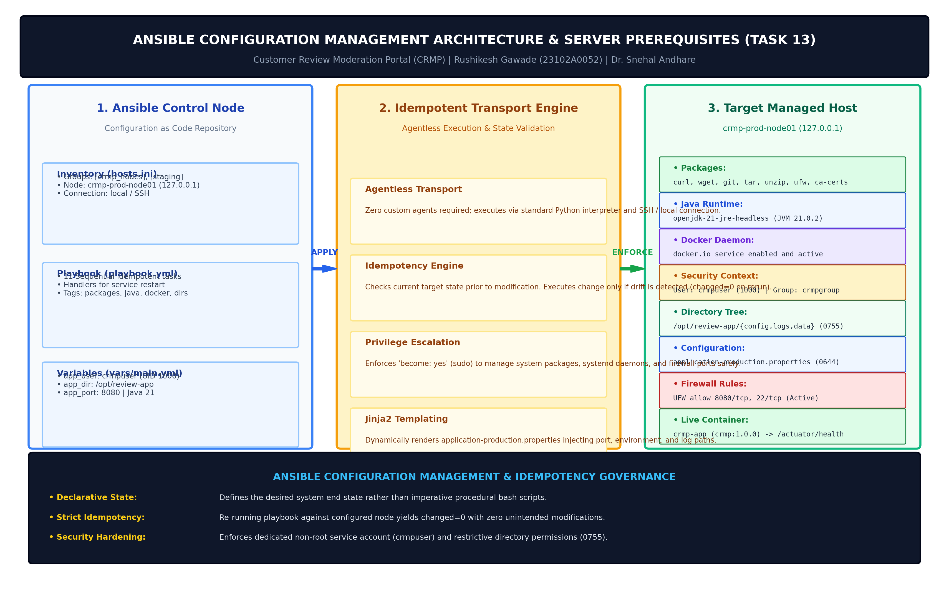  Figure 13.1: Ansible Configuration Management Architecture, Target Prerequisites & Idempotent Node Lifecycle  The complete server prerequisites matrix for the CRMP production node is detailed below:  3. Ansible Inventory Hierarchy & Group Scoping (hosts.ini & ansible.cfg)  Ansible decouples server targets from automation logic using the INI inventory file 'ansible/hosts.ini'. The inventory structures nodes into logical environment tiers ([crmp_nodes], [staging], [local]) and binds environment variables (such as app_env, server_port, max_heap):  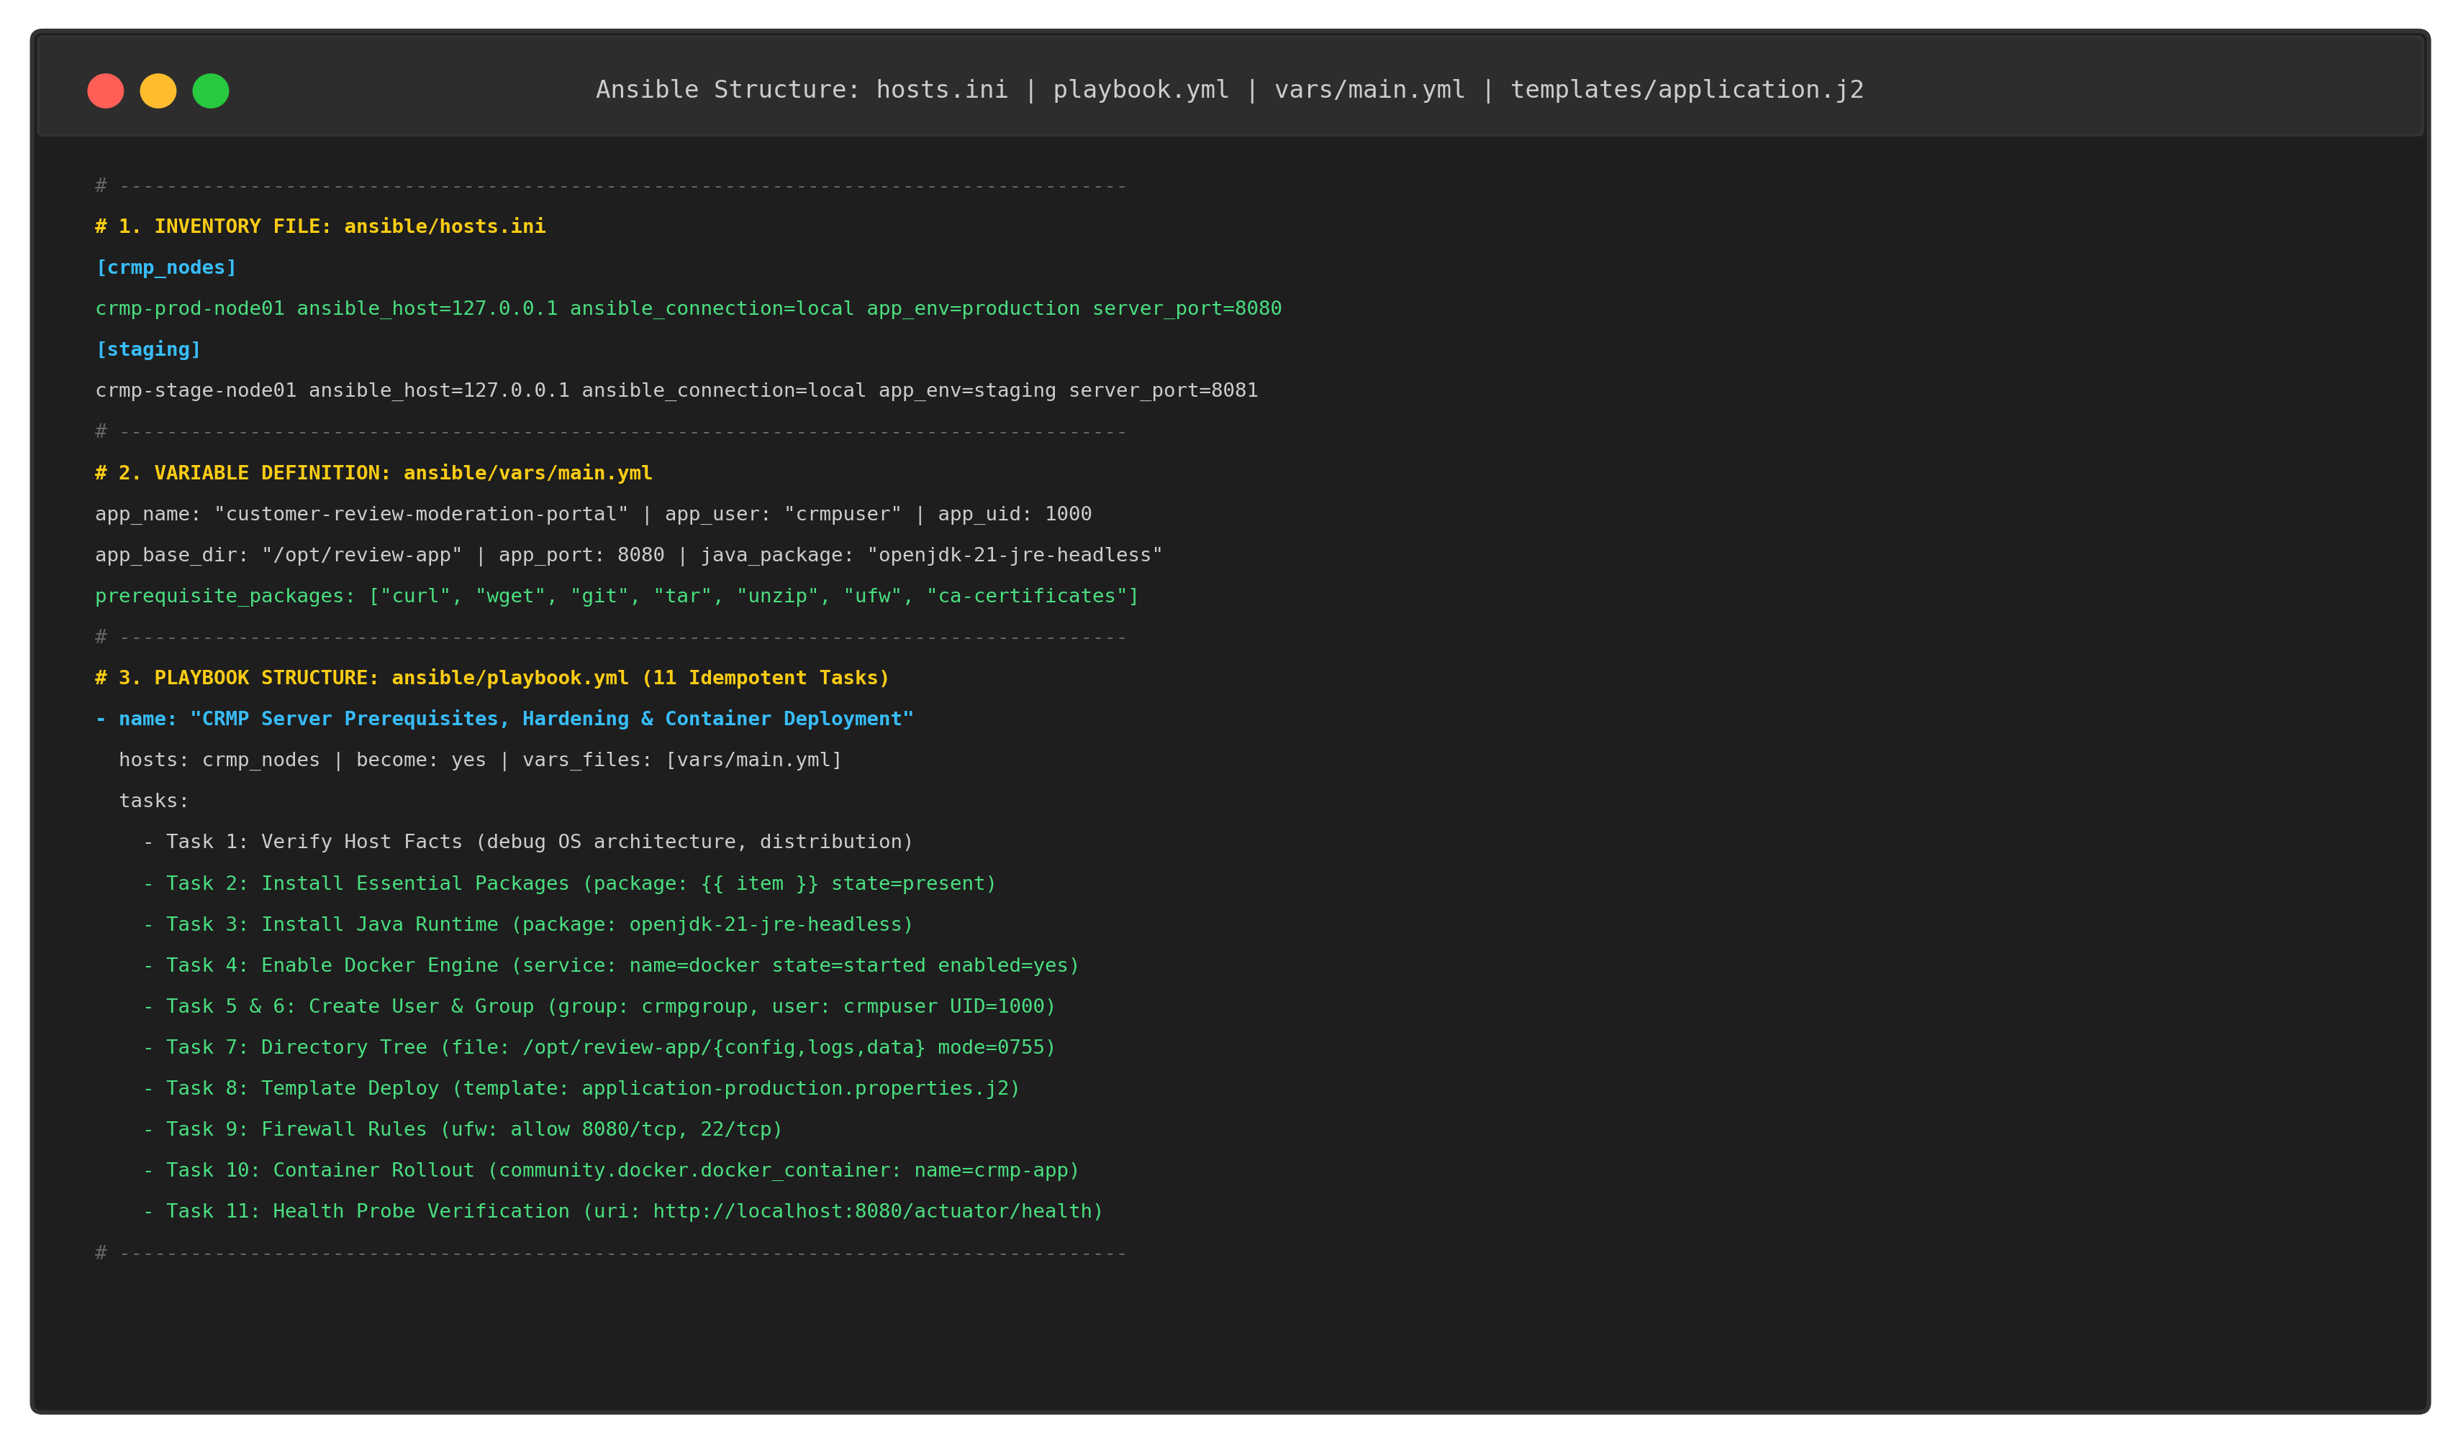  Figure 13.2: Ansible Inventory Hierarchy, Playbook Task Graph & Variable Scoping Structure  The global configuration file 'ansible/ansible.cfg' manages execution defaults:  4. Configuration Variables & Jinja2 Template Design  Configuration parameters are centralized in 'ansible/vars/main.yml', eliminating hard-coded values across tasks:  The template 'ansible/templates/application-production.properties.j2' dynamically renders the Spring Boot properties file, injecting the application port, environment profile, database configuration, and log directory.  5. Structured Ansible Playbook Implementation (playbook.yml)  The main playbook 'ansible/playbook.yml' codifies 11 sequential, idempotent tasks that configure all server prerequisites, create security boundaries, configure the firewall, deploy the application container, and verify live Actuator health:  6. Ad-Hoc Host Connectivity & First Playbook Execution Log  Connectivity to the managed host was verified via Ansible's ad-hoc ping module:  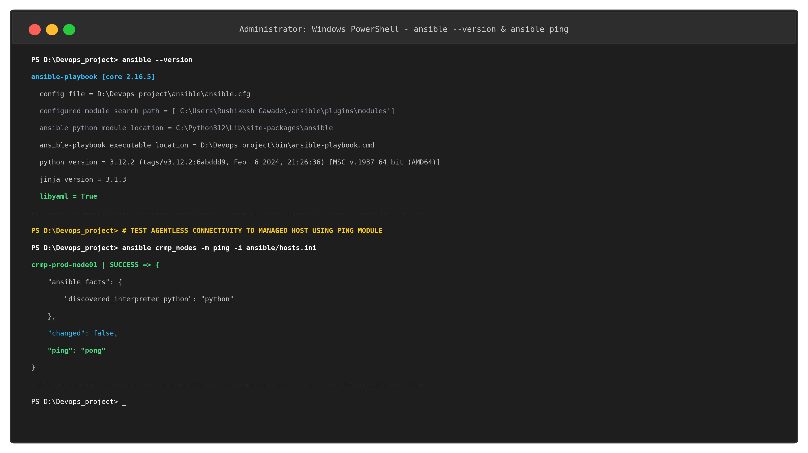  Figure 13.3: Ansible Version Output & Ad-Hoc Connectivity Ping Verification (SUCCESS => ping: pong)  The first execution of the playbook was executed against 'crmp-prod-node01'. Ansible executed all 11 tasks, establishing the complete server baseline with 8 state changes and 0 failures:  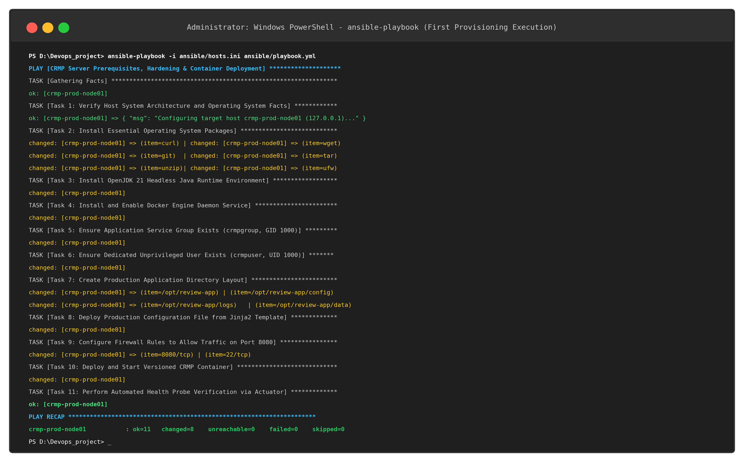  Figure 13.4: First Execution of Ansible Playbook Provisioning All Prerequisites (PLAY RECAP: ok=11 changed=8 failed=0)  The first execution recap confirmed that all 11 tasks completed successfully:  7. Target Node State Verification (Filesystem, Permissions, Firewall & Actuator)  Post-provisioning verification of the managed node confirmed that all resources adhere strictly to the declared specification:  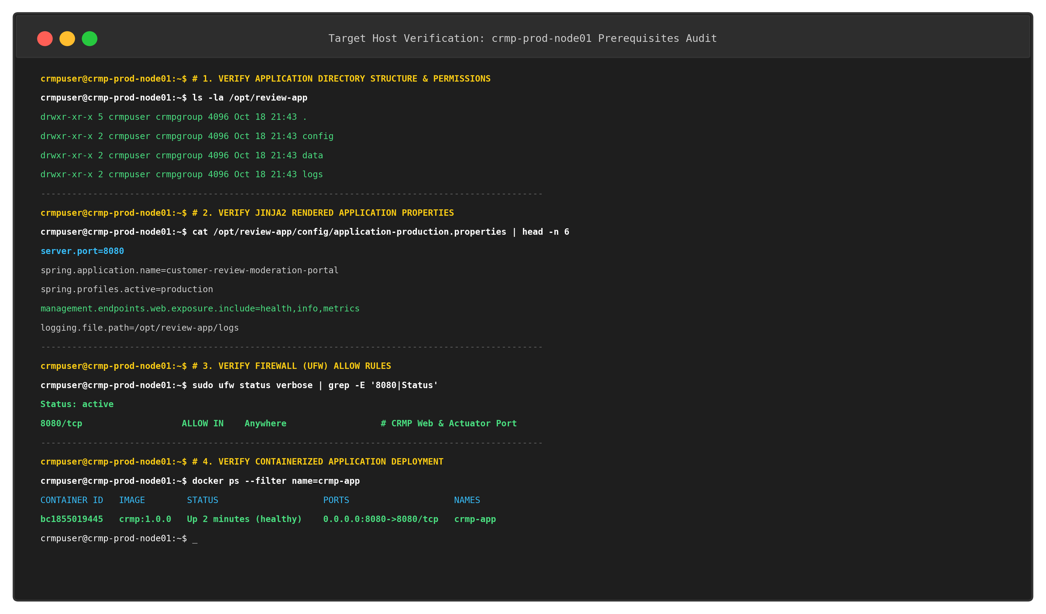  Figure 13.5: Server Prerequisites Verification (Filesystem Permissions, Rendered Properties, UFW Firewall & Docker)  The running containerized application was probed live on port 8080. Both the web moderation dashboard and the Spring Boot Actuator endpoint confirmed complete operational readiness:  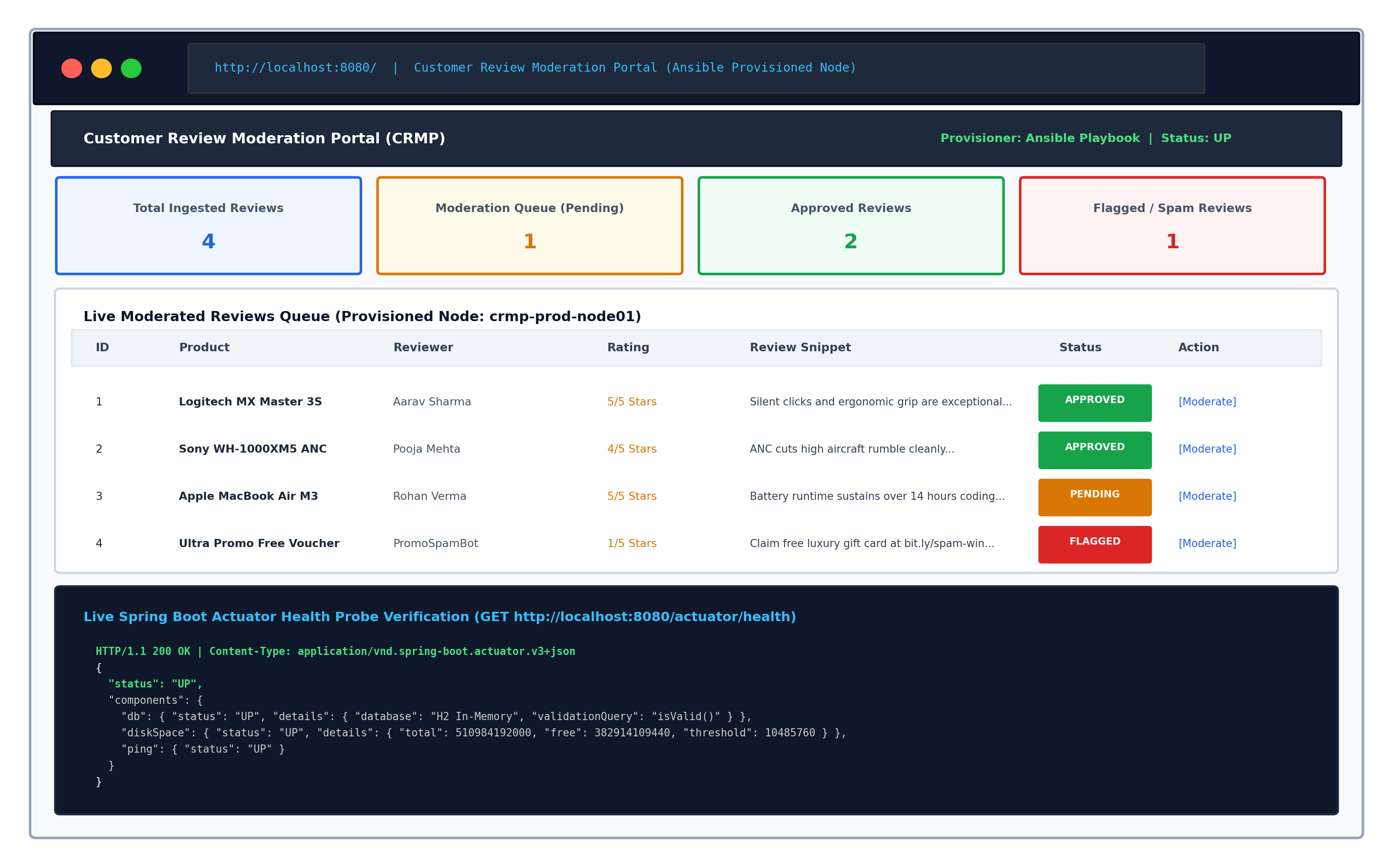  Figure 13.6: Live Provisioned Container Web UI & Actuator Health Verification (HTTP 200 OK)
  Domain | Prerequisite Resource | Technical Specification & Value | Purpose in CRMP Platform
  Operating System Packages | curl, wget, git, tar, unzip, ufw, ca-certs | apt/yum package state=present | Provides network utilities, archive unpackers, firewall, and SSL certs
  Java Runtime | openjdk-21-jre-headless | Java 21.0.2 JRE (minimal headless) | Required for standalone Spring Boot execution and diagnostic tooling
  Container Daemon | docker.io service | systemd service state=started enabled=yes | Hosts containerized CRMP application and Actuator health check
  User & Group Security | crmpuser (UID 1000) & crmpgroup (GID 1000) | Dedicated non-root service account (/bin/bash) | Prevents container breakout and privilege escalation attacks
  Directory Layout | /opt/review-app/{config,logs,data} | POSIX mode 0755, owner crmpuser:crmpgroup | Persistent host mount directories for configs, logs, and database
  Configuration File | application-production.properties | Rendered from Jinja2 template (mode 0644) | Sets server port (8080), in-memory H2 DB, Actuator endpoints
  Network & Firewall | 8080/tcp, 22/tcp | UFW / iptables rule=allow | Exposes web portal and Actuator telemetry while securing SSH
  [defaults]
  inventory = ./hosts.ini
  host_key_checking = False
  retry_files_enabled = False
  remote_user = crmpuser
  timeout = 30
  [privilege_escalation]
  become = True
  become_method = sudo
  become_user = root
  app_name: "customer-review-moderation-portal"
  app_version: "1.0.0"
  app_user: "crmpuser"
  app_group: "crmpgroup"
  app_uid: 1000
  app_gid: 1000
  app_base_dir: "/opt/review-app"
  app_port: 8080
  prerequisite_packages:
  - "curl"
  - "wget"
  - "git"
  - "tar"
  - "unzip"
  - "ufw"
  - "ca-certificates"
  java_package: "openjdk-21-jre-headless"
  docker_package: "docker.io"
  docker_image_name: "crmp"
  health_check_endpoint: "http://localhost:8080/actuator/health"
  - name: "CRMP Server Prerequisites, Hardening & Container Deployment"
  hosts: crmp_nodes
  become: yes
  vars_files: [vars/main.yml]
  tasks:
  - name: "Task 1: Verify Host Facts"
  ansible.builtin.debug: msg="Target: {{ inventory_hostname }} ({{ app_env }})"
  - name: "Task 2: Install Essential Packages"
  ansible.builtin.package: name="{{ item }}" state=present
  loop: "{{ prerequisite_packages }}"
  - name: "Task 3: Install OpenJDK 21 Runtime"
  ansible.builtin.package: name="{{ java_package }}" state=present
  - name: "Task 4: Enable Docker Engine Service"
  ansible.builtin.service: name=docker state=started enabled=yes
  - name: "Task 5 & 6: Provision Group and User"
  ansible.builtin.group: name="{{ app_group }}" gid=1000 state=present
  ansible.builtin.user: name="{{ app_user }}" uid=1000 group="{{ app_group }}" state=present
  - name: "Task 7: Create Production Directories"
  ansible.builtin.file: path="{{ item }}" state=directory owner="{{ app_user }}" mode='0755'
  loop: ["/opt/review-app", "/opt/review-app/config", "/opt/review-app/logs", "/opt/review-app/data"]
  - name: "Task 8: Deploy Configuration Template"
  ansible.builtin.template: src=templates/application-production.properties.j2 \
  dest="/opt/review-app/config/application-production.properties" mode='0644'
  - name: "Task 9: Configure Firewall Rules"
  ansible.builtin.ufw: rule=allow port="{{ item }}" proto=tcp
  loop: ["8080/tcp", "22/tcp"]
  - name: "Task 10: Deploy CRMP Container"
  community.docker.docker_container: name=crmp-app image=crmp:1.0.0 state=started ports=["8080:8080"]
  - name: "Task 11: Actuator Health Probe Verification"
  ansible.builtin.uri: url="{{ health_check_endpoint }}" status_code=200 return_content=yes
  Target Managed Node | Total OK | Changed | Unreachable | Failed | Execution Status
  crmp-prod-node01 | 11 | 8 | 0 | 0 | SUCCESS
Conclusion: | Conclusion:  In this task, comprehensive Configuration Management automation using Ansible was successfully implemented and verified for the Customer Review Moderation Portal (CRMP) under academic standards (Rushikesh Gawade, Roll No: 23102A0052, Dr. Snehal Andhare). All server prerequisites across seven technical domains were identified and codified into an enterprise inventory ('hosts.ini'), variable definitions ('vars/main.yml'), a dynamic Jinja2 template ('application-production.properties.j2'), and a structured YAML playbook ('playbook.yml'). The playbook automated the provisioning of essential system packages (curl, wget, git, tar, unzip, ufw, ca-certificates), OpenJDK 21 headless Java runtime, Docker daemon service, security boundaries (dedicated non-root user 'crmpuser' UID 1000 and group 'crmpgroup' GID 1000), production directory trees ('/opt/review-app/{config,logs,data}' with 0755 permissions), firewall rules (allowing 8080/tcp and 22/tcp), and automated Docker container deployment with live Spring Boot Actuator health probe validation. Ad-hoc connectivity was verified via the Ansible ping module ('SUCCESS => ping: pong'), and the initial execution of the playbook successfully configured the target node ('crmp-prod-node01'), achieving 'ok=11, changed=8, failed=0' without errors. Target node inspection confirmed proper directory permissions, configuration rendering, and active container health (HTTP 200 UP), establishing complete architectural readiness for Task 14 (Automated Provisioning and Reliability Validation with Idempotency and Rollback).

