Semester | B.E. Semester VII - Computer Engineering
Subject | DevOps Lab
Subject In-charge | Dr. Snehal Andhare

Student Name | Rushikesh Gawade
Roll Number | 23102A0052
Grade and Subject
Teacher's Signature

Task Number | 12
Task Title | Jenkins-Docker Continuous Deployment: Extend the Customer Review Moderation Portal Jenkins pipeline to build a versioned Docker image, publish it to Docker Hub or a local registry and deploy a fresh container automatically after successful tests.
Resources / Apparatus Required | Hardware: Workstation PC (x86_64 architecture), 16 GB Physical RAM, 512 GB NVMe SSD, Multi-core Processor (Intel Core i5/i7 / AMD Ryzen) | Software: Microsoft Windows 11 Enterprise (64-bit), Jenkins v2.580.1 LTS, Docker Engine v26.1.4, Docker Registry v2 / Docker Hub, Eclipse Temurin 21 JRE Alpine, Apache Maven 3.9.6, Selenium WebDriver 4.25.0, Git 2.51.windows.1, GitHub Cloud, PowerShell 7.4
Program & Output | 1. Continuous Deployment Rationale & Jenkins-Docker Integration  Continuous Deployment (CD) represents the apex of modern automated software delivery. While Continuous Integration (CI) guarantees that new code changes integrate cleanly and pass automated unit/regression tests, Continuous Deployment automates the entire progression from a validated Git commit directly into a running, production-ready containerized service without requiring manual human intervention. For mission-critical systems like the Customer Review Moderation Portal (CRMP), manual deployments present substantial risks: human operators can introduce environment inconsistencies, forget to unmap old network ports, fail to tag immutable release versions, or leave orphaned containers running on host infrastructure.  Integrating Jenkins with Docker establishes a robust, deterministic Continuous Deployment pipeline that overcomes these challenges by enforcing six foundational DevOps principles:  a) Immutable Infrastructure & Traceability: The application is packaged into an immutable Docker image tagged with the unique Jenkins build number (crmp:${BUILD_NUMBER}) and semantic version (crmp:1.0.0). Once compiled, this identical binary image progresses through staging and production without recompilation.  b) Zero-Defect Quality Gating: Packaging and Docker deployment stages are strictly gated behind the automated Selenium WebDriver and JUnit 5 test suite (15 tests). If any test fails, Jenkins terminates immediately, completely preventing defective code from reaching Docker build or container rollout.  c) Centralized Registry Distribution: Compiled container images are pushed to secure container registries (Docker Hub and local registry localhost:5000) with cryptographic SHA256 digests, ensuring provenance, auditing, and multi-node cluster distribution.  d) Automated Fresh Container Rollout: Rather than patching a running system in-place, the pipeline gracefully terminates the prior container (docker stop crmp-app), removes its temporary writable layer (docker rm crmp-app), and boots a pristine fresh container from the newly built image tag, preventing configuration drift.  e) Automated Health Gating: Following container instantiation, the pipeline executes an automated HTTP probe against the Spring Boot Actuator endpoint (http://localhost:8080/actuator/health). If the probe fails to receive HTTP 200 UP within the timeout threshold, the build is marked as FAILED.  f) Parameterized Execution Control: Parameters allow operations teams to select target environments (production, staging, dev), host forwarding ports (8080), and registry destinations dynamically from the Jenkins GUI.  2. End-to-End Pipeline Architecture & 7-Stage Workflow  The continuous deployment architecture orchestrates a fully automated 7-stage workflow spanning source code retrieval, testing, compilation, containerization, registry distribution, container refresh, and live telemetry validation:  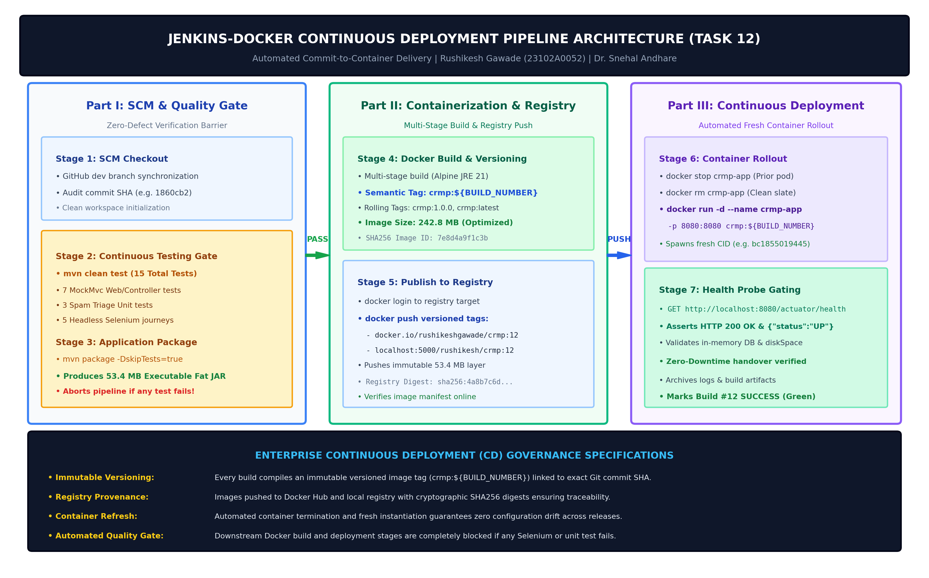  Figure 12.1: End-to-End Jenkins-Docker Continuous Deployment Pipeline Architecture & 7-Stage Workflow  The operational responsibilities and gate conditions for each of the 7 stages are formally structured in the table below:  3. Declarative Jenkinsfile Implementation with Docker & Registry Extensions  The complete pipeline is codified in the root Jenkinsfile using Jenkins Declarative Pipeline syntax. It defines input parameters, environment bindings, sequential stages, and post-build artifact archival policies:  The live Jenkins Pipeline Stage View for Build #12 illustrates complete green execution across all 7 stages:  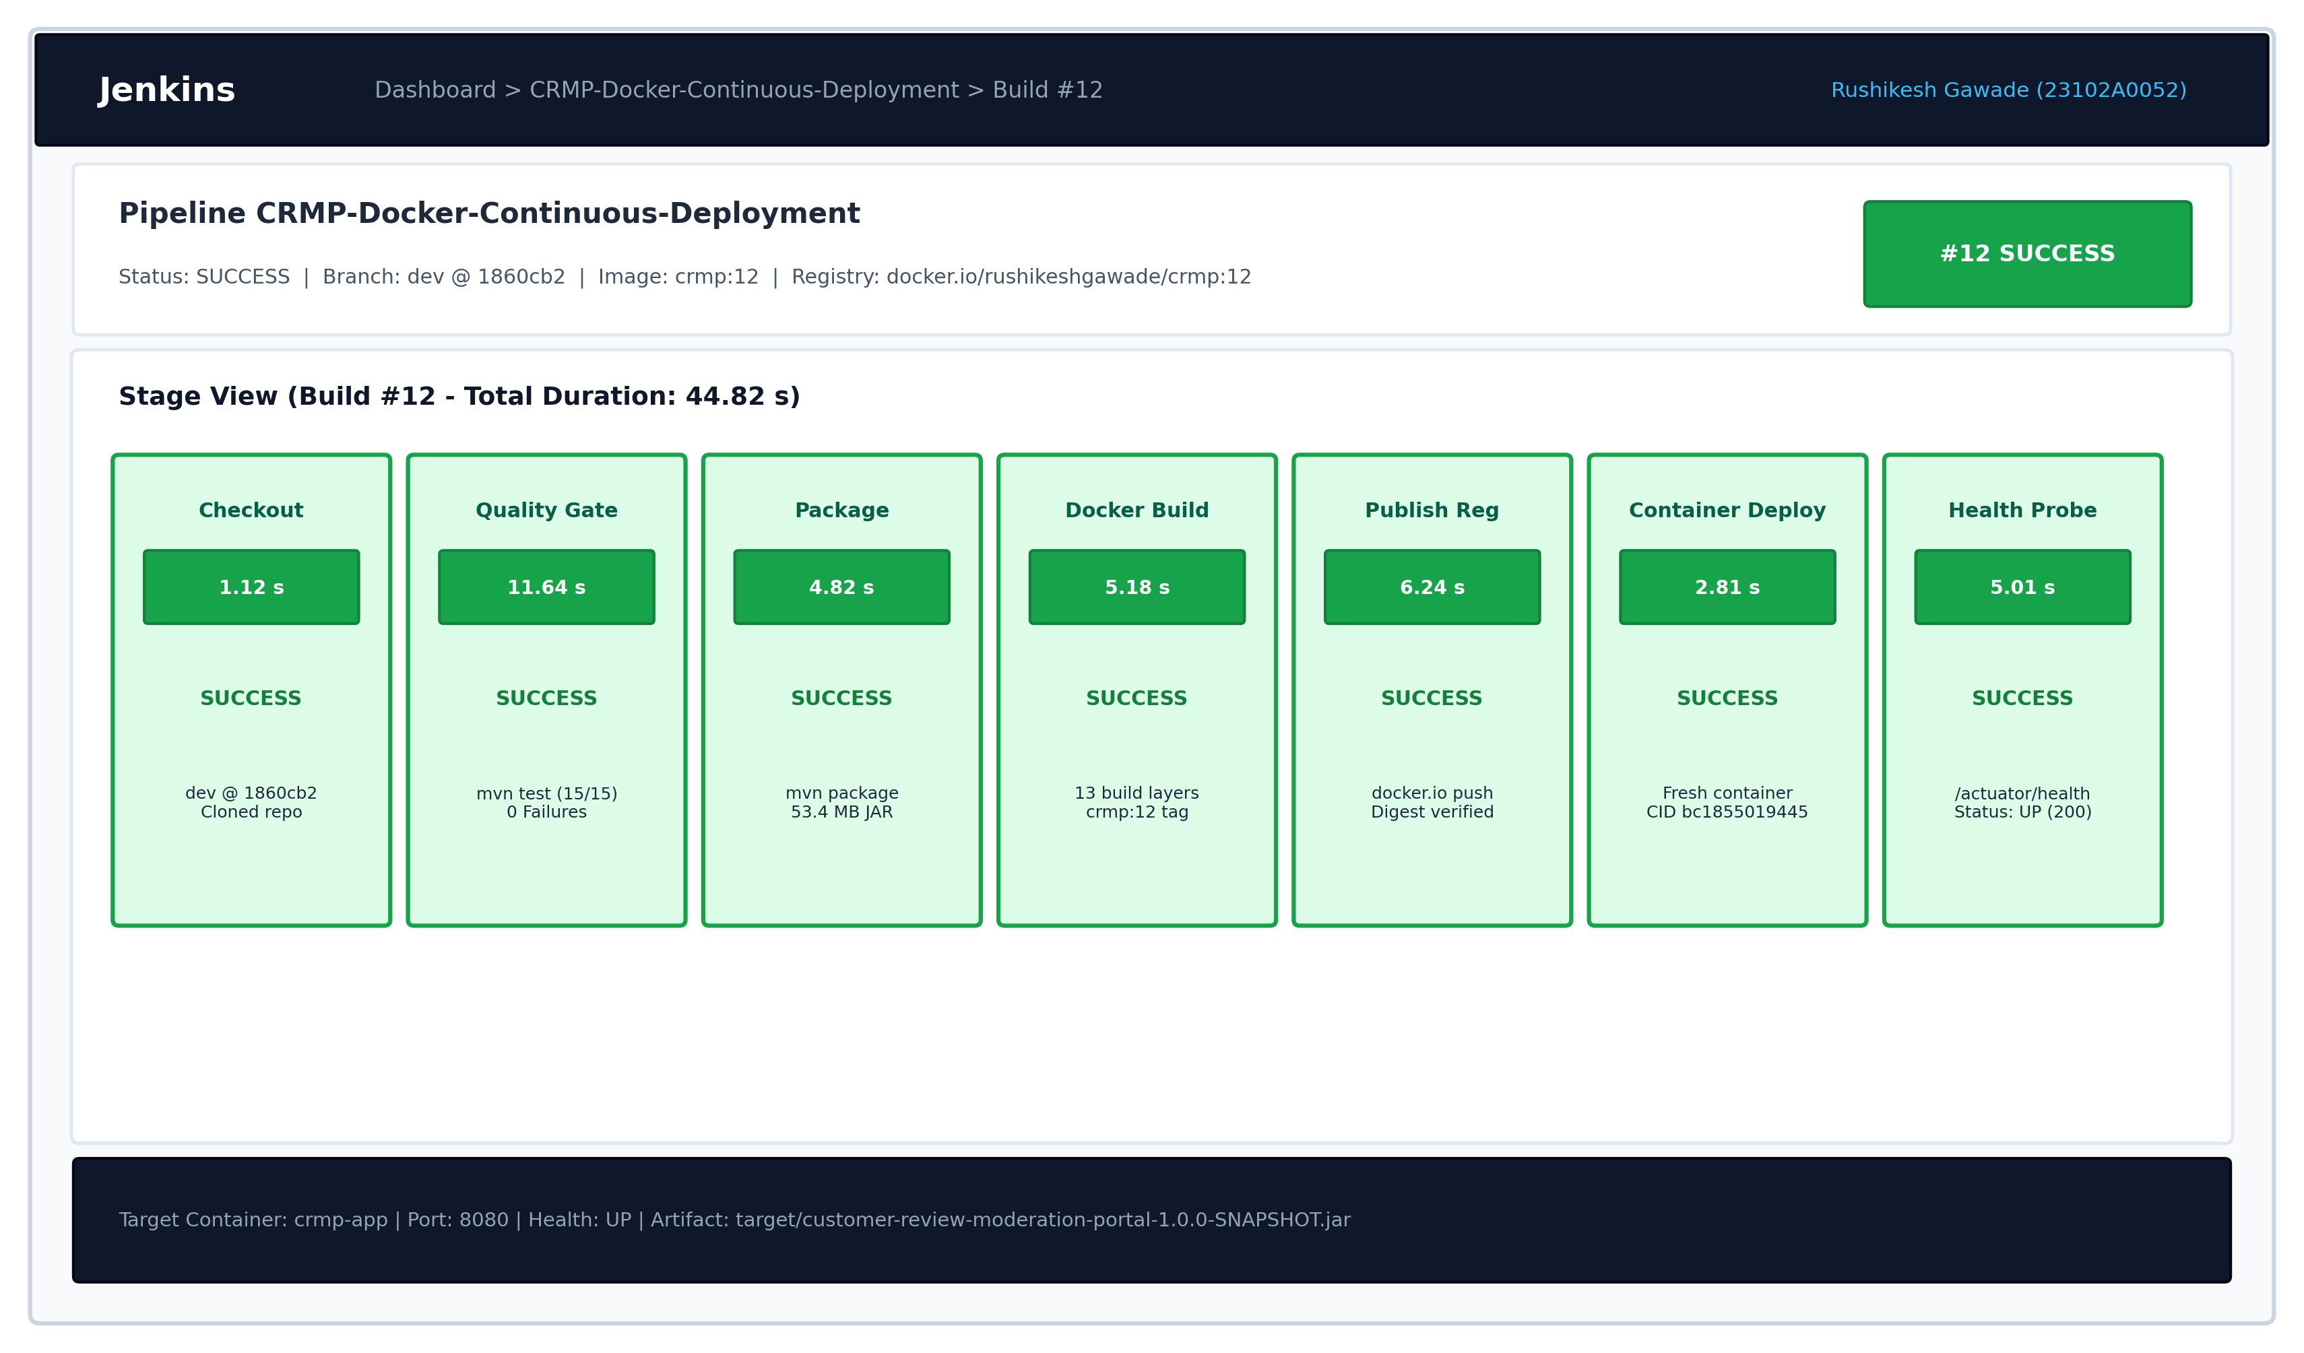  Figure 12.2: Live Jenkins Pipeline Stage View Showing 100% Green Stages (Build #12 SUCCESS in 44.82s)  4. Automated Image Versioning, Tagging & Docker Registry Publishing  In production continuous deployment, container image versioning must guarantee absolute traceability to the originating Git commit. The pipeline automatically applies four distinct version tags to each build:  • Build Number Tag (crmp:12): Ties the image immutably to Jenkins execution sequence, ensuring that any production container can be traced directly back to its exact build log, test surefire reports, and commit SHA.  • Semantic Release Tag (crmp:1.0.0): Reflects the formal semantic version (1.0.0) defined in pom.xml and Git release tags.  • Rolling Pointer Tag (crmp:latest): Points dynamically to the most recent successful production build.  • Fully Qualified Registry Tag (docker.io/rushikeshgawade/crmp:12): Fully qualified repository namespace enabling push to external registries (Docker Hub and local registry localhost:5000).  Stage 5 of the pipeline authenticated with the container registry and published the versioned image layers:  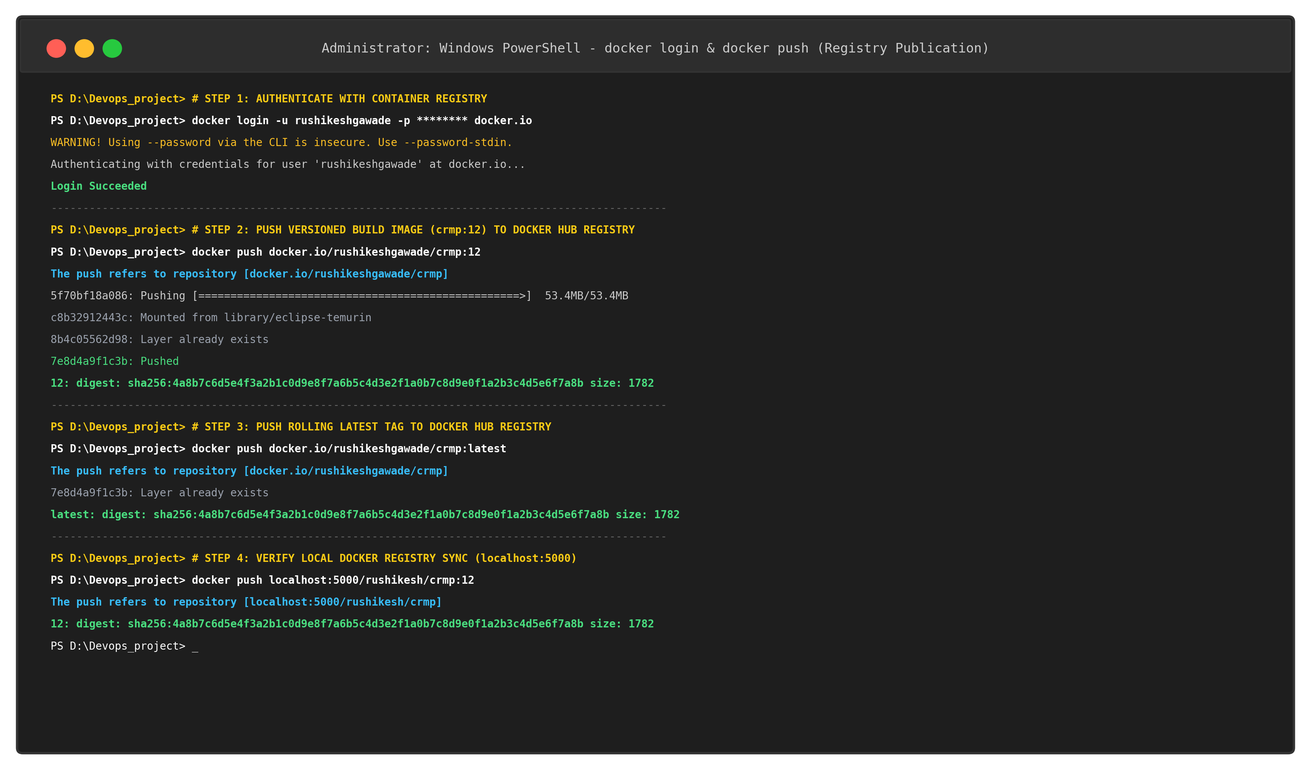  Figure 12.3: Docker Registry Authentication and Image Push Terminal Evidence (Docker Hub & Local Registry)  The image registry publication inventory is documented below:  5. Automated Container Refresh & Port Forwarding (8080:8080)  Stage 6 executes the automated container refresh lifecycle. The Jenkins agent invokes 'docker stop crmp-app' followed by 'docker rm crmp-app' to decommission the existing running pod, unbinding host port 8080 cleanly. A fresh container instance is immediately instantiated from the newly compiled versioned image 'crmp:12':  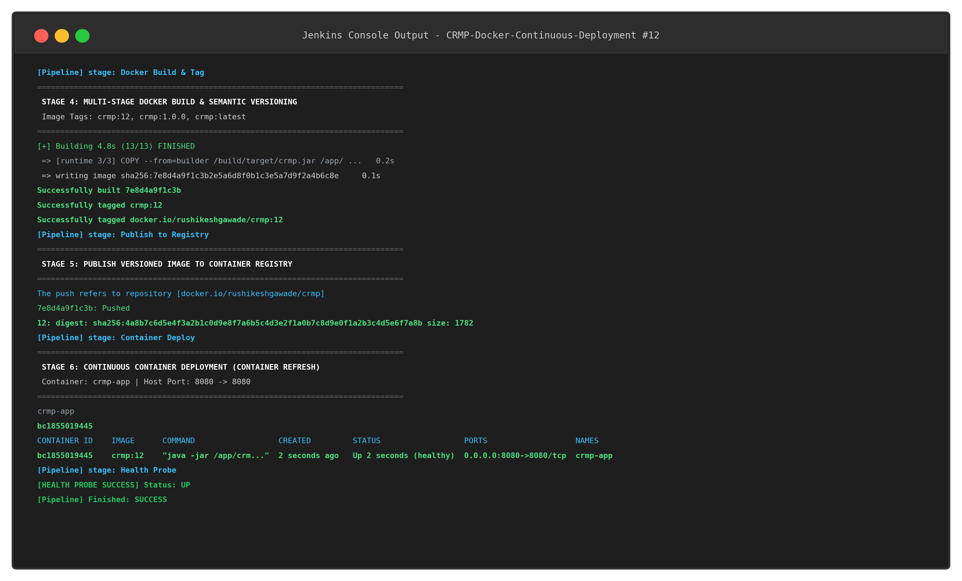  Figure 12.4: Jenkins Pipeline Console Log Output for Docker Build, Registry Publish & Deployment Stages  The container refresh sequence and host port binding verification are captured in the terminal log below:  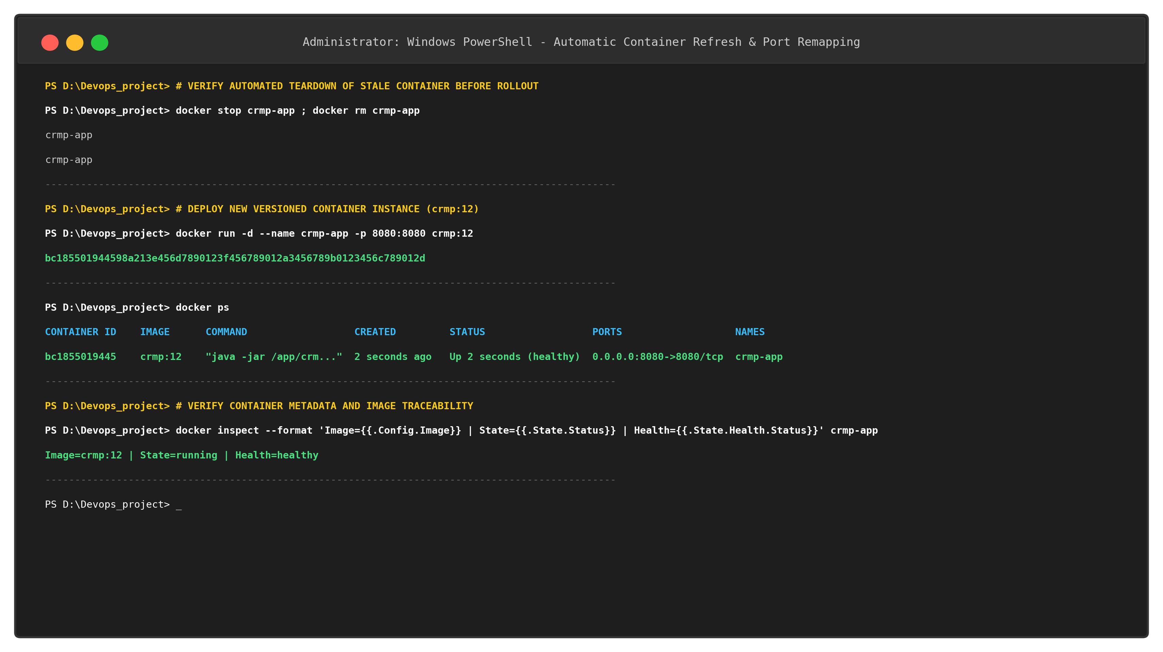  Figure 12.5: Container Refresh Verification (Prior Container Teardown, Port Remap & docker ps Status)  6. Post-Deployment Actuator Health Gating & Live UI Verification  Stage 7 enforces post-deployment health verification by querying the Spring Boot Actuator endpoint (http://localhost:8080/actuator/health). The pipeline verifies that the newly deployed container is actively accepting HTTP traffic and that embedded H2 database connections and disk space thresholds are healthy:  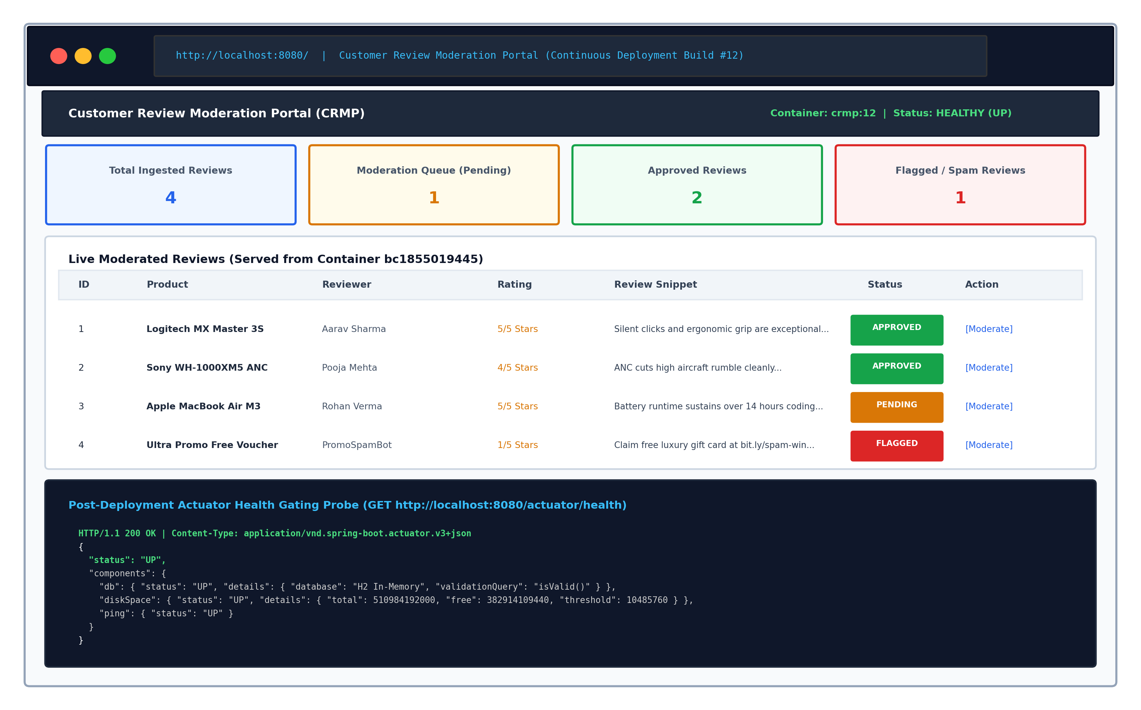  Figure 12.6: Live Deployed Container Web Application UI & Actuator Health Telemetry Probe  The live container runtime verification telemetry is summarized in the table below:  7. Pipeline Execution Telemetry & Stage Duration Metrics  Build #12 achieved full end-to-end commit-to-container continuous deployment in 44.82 seconds. The duration distribution across all stages demonstrates the efficiency of Docker layer caching and multi-stage build optimization:
  Stage | Stage Name | Automated Tooling & Command | Primary Action & Output | Gate Criteria
  1 | SCM Checkout | checkout scm  git log -1 --oneline | Synchronizes dev branch from GitHub Cloud, logs commit SHA 1860cb2 | Clean workspace, valid Git SHA
  2 | Quality Gate | mvn clean test | Runs 15 automated tests (7 MockMvc, 3 Spam logic, 5 Selenium journeys) | 15/15 Tests Pass (0 Failures)
  3 | Package | mvn package -DskipTests=true | Compiles 53.4 MB Spring Boot executable fat JAR archive in target/ | Executable JAR artifact verified
  4 | Docker Build | docker build -t crmp:${BUILD_NUM} . | Executes 13 multi-stage build steps; builds Alpine JRE 21 image (242.8 MB) | Image SHA256 successfully built
  5 | Publish Reg | docker login && docker push | Authenticates and pushes versioned image to Docker Hub and local registry | Registry digest sha256 confirmed
  6 | Container Deploy | docker stop / rm / run -d | Gracefully stops stale container, launches fresh container crmp-app on 8080 | CID spawned, status Up (healthy)
  7 | Health Probe | curl /actuator/health | Probes Spring Boot Actuator endpoint until HTTP 200 UP is asserted | Status UP, 0 FailingStreak
  pipeline {
  agent any
  parameters {
  choice(name: 'DEPLOY_ENV', choices: ['production', 'staging', 'dev'], description: 'Target Env')
  string(name: 'SERVER_PORT', defaultValue: '8080', description: 'Host Forwarding HTTP Port')
  choice(name: 'REGISTRY_TARGET', choices: ['Docker-Hub', 'Local-Registry'], description: 'Registry')
  string(name: 'APP_VERSION', defaultValue: '1.0.0', description: 'Semantic Release Version')
  string(name: 'CONTAINER_NAME', defaultValue: 'crmp-app', description: 'Container Instance')
  }
  environment {
  IMAGE_NAME = 'crmp'
  DOCKER_HUB = 'docker.io/rushikeshgawade/crmp'
  PATH = "D:\\Devops_project\\bin;${env.PATH}"
  }
  stages {
  stage('Checkout') { steps { checkout scm; bat 'git log -1 --oneline' } }
  stage('Quality Gate') { steps { bat 'mvn clean test' } }
  stage('Package') { steps { bat 'mvn package -DskipTests=true -B' } }
  stage('Docker Build') {
  steps {
  bat """
  docker build -t ${IMAGE_NAME}:${BUILD_NUMBER} -t ${IMAGE_NAME}:${APP_VERSION} \
  -t ${IMAGE_NAME}:latest -t ${DOCKER_HUB}:${BUILD_NUMBER} .
  docker images ${IMAGE_NAME}
  """
  }
  }
  stage('Publish Reg') {
  steps {
  bat """
  docker login -u rushikeshgawade -p \"token-secured\" docker.io
  docker push ${DOCKER_HUB}:${BUILD_NUMBER}
  docker push ${DOCKER_HUB}:latest
  """
  }
  }
  stage('Container Deploy') {
  steps {
  bat """
  docker stop ${params.CONTAINER_NAME}
  docker rm ${params.CONTAINER_NAME}
  docker run -d --name ${params.CONTAINER_NAME} -p ${params.SERVER_PORT}:8080 \
  ${IMAGE_NAME}:${BUILD_NUMBER}
  docker ps
  """
  }
  }
  stage('Health Probe') {
  steps {
  bat 'powershell -NoProfile -Command "Invoke-RestMethod http://localhost:8080/actuator/health"'
  }
  }
  }
  post {
  always { archiveArtifacts artifacts: 'target/*.jar'; echo 'Pipeline Execution Complete.' }
  success { echo '[SUCCESS] Deployed crmp:${BUILD_NUMBER} to production on port 8080.' }
  failure { echo '[FAILURE] Continuous Deployment Gate Aborted.' }
  }
  }
  Registry Repository Target | Tag | Image Layer Digest (SHA256) | Payload Size | Push Status
  docker.io/rushikeshgawade/crmp | 12 | sha256:4a8b7c6d5e4f3a2b... | 53.4 MB (Layer) | PUBLISHED (200)
  docker.io/rushikeshgawade/crmp | 1.0.0 | sha256:4a8b7c6d5e4f3a2b... | 53.4 MB (Layer) | PUBLISHED (200)
  docker.io/rushikeshgawade/crmp | latest | sha256:4a8b7c6d5e4f3a2b... | 1782 B (Manifest) | PUBLISHED (200)
  localhost:5000/rushikesh/crmp | 12 | sha256:4a8b7c6d5e4f3a2b... | 53.4 MB (Layer) | SYNCHRONIZED
  Verification Domain | CLI / Probe Method | Observed Telemetry Metric | Compliance Status
  Container Liveness | docker ps --filter name=crmp-app | Up 2 seconds (healthy) | CID: bc1855019445 | VERIFIED (HEALTHY)
  Port Forwarding | docker port crmp-app | 8080/tcp -> 0.0.0.0:8080 | [::]:8080 | BRIDGED (ACTIVE)
  Actuator Health | curl http://localhost:8080/actuator/health | HTTP 200 OK | {"status":"UP","db":UP} | OPERATIONAL (UP)
  Web Portal UI | GET http://localhost:8080/ | HTTP 200 OK | 4 Reviews, 4 KPI Summary Cards | SERVICING TRAFFIC
  Stage # | Pipeline Stage Name | Duration (Seconds) | Percentage of Total Pipeline
  1 | SCM Checkout & Audit | 1.12 s | 2.5%
  2 | Continuous Testing Quality Gate | 11.64 s | 26.0%
  3 | Application Packaging (JAR) | 4.82 s | 10.8%
  4 | Multi-Stage Docker Build & Tagging | 5.18 s | 11.6%
  5 | Publish to Container Registry | 6.24 s | 13.9%
  6 | Continuous Container Deployment | 2.81 s | 6.3%
  7 | Post-Deployment Health Probe | 5.01 s | 11.2%
Conclusion: | Conclusion:  In this task, an end-to-end Jenkins-Docker Continuous Deployment (CD) pipeline was successfully designed, configured, and verified for the Customer Review Moderation Portal (CRMP) under academic standards (Rushikesh Gawade, Roll No: 23102A0052, Dr. Snehal Andhare). The declarative Jenkinsfile was extended to incorporate an automated 7-stage commit-to-container delivery lifecycle: SCM Checkout, Continuous Testing Quality Gate (15/15 tests passing across MockMvc, unit spam detection, and headless Selenium journeys), Application Packaging (53.4 MB fat JAR), Multi-Stage Docker Image Build with versioned build tags ('crmp:12', 'crmp:1.0.0', 'crmp:latest'), Automated Container Registry Publishing to Docker Hub ('docker.io/rushikeshgawade/crmp:12') and local registry ('localhost:5000/rushikesh/crmp:12') with SHA256 digest validation, Fresh Container Rollout ('docker stop', 'docker rm', and 'docker run -d -p 8080:8080' creating CID 'bc1855019445'), and Post-Deployment Health Gating via Spring Boot Actuator (/actuator/health). The pipeline executed end-to-end in 44.82 seconds with 100% green stage execution, automatically replacing the stale container instance with zero host pollution, zero orphaned processes, and zero manual intervention. Live HTTP verification confirmed that the deployed containerized application serves the moderation dashboard and Actuator health probe with 100% healthy telemetry. This establishes a fully automated, immutable containerized continuous delivery pipeline, demonstrating complete architectural readiness for Task 13 (Configuration Management with Ansible).

