POC: STRT_WA_004 Angular Feedback Form Implementation

GitHub link: click here
https://github.com/RushikeshGirishSonar/StartAhb_Company/tree/main/Angular/feedback-form

Scope Covered
- Angular standalone component implementation
- Reactive Forms usage
- Client-side validation
- User-friendly UI with rating selection
- Conditional rendering (form & thank-you message)
- Console-based submission handling (no backend)

Requirements:
- Feedback form with:
  - Rating selection (1–5 stars)
  - Comments input field
- Client-side validation:
  - Rating is mandatory
  - Comments are required (minimum 10 characters)
- Submit button disabled when form is invalid
- Thank-you message displayed after successful submission
- Feedback data logged to console

Implementation Details
- Component Structure
  - FeedbackComponent created as a standalone component
  - AppComponent imports and renders FeedbackComponent
  - Uses ReactiveFormsModule and CommonModule
- Validation Logic
  - Implemented using Angular FormBuilder
  - Fields marked as touched on invalid submission
  - Inline error messages displayed dynamically

UI Behavior
- Form is hidden after successful submission
- Thank-you message shown conditionally
- Star rating provides visual feedback for selection

Output / Result
- Feedback form works as expected
- Validation errors shown correctly
- Console logs feedback data on successful submission
- No runtime or console errors
- Clean and responsive UI

Code:
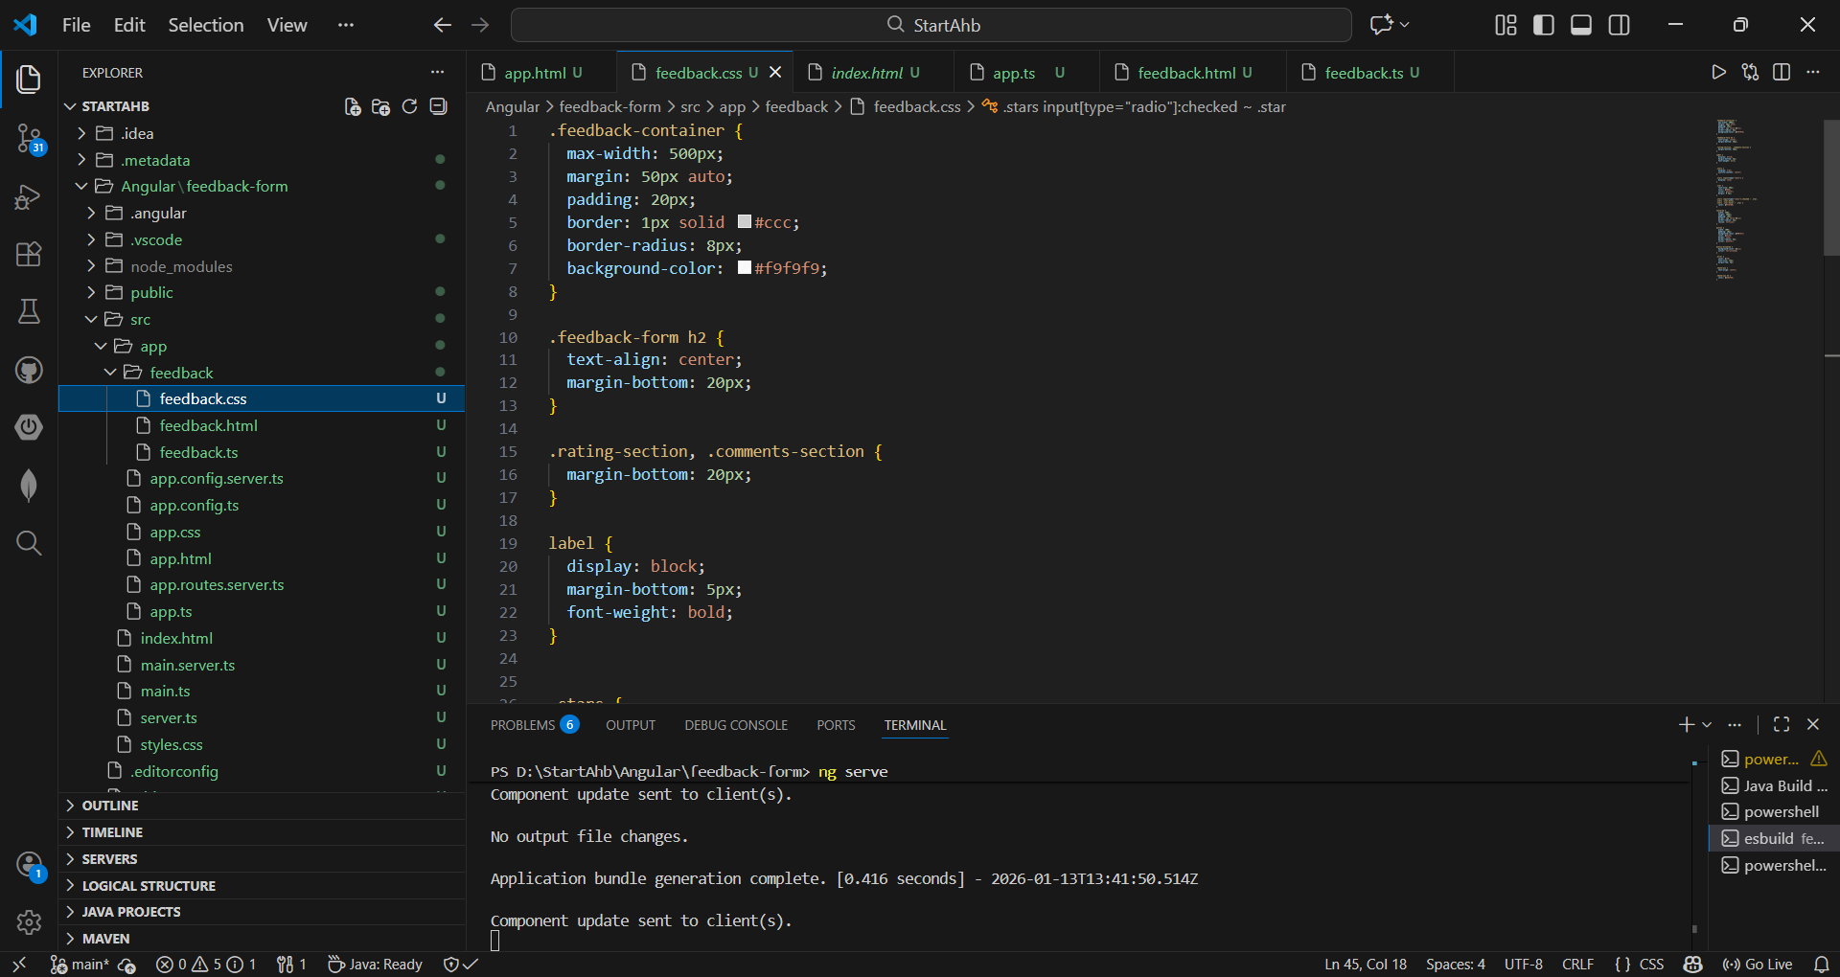
Figure 1 - feedback.css file
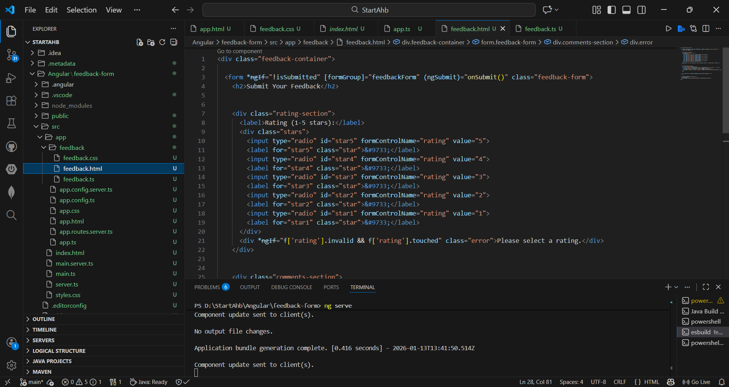
Figure 2 - feedback.html file
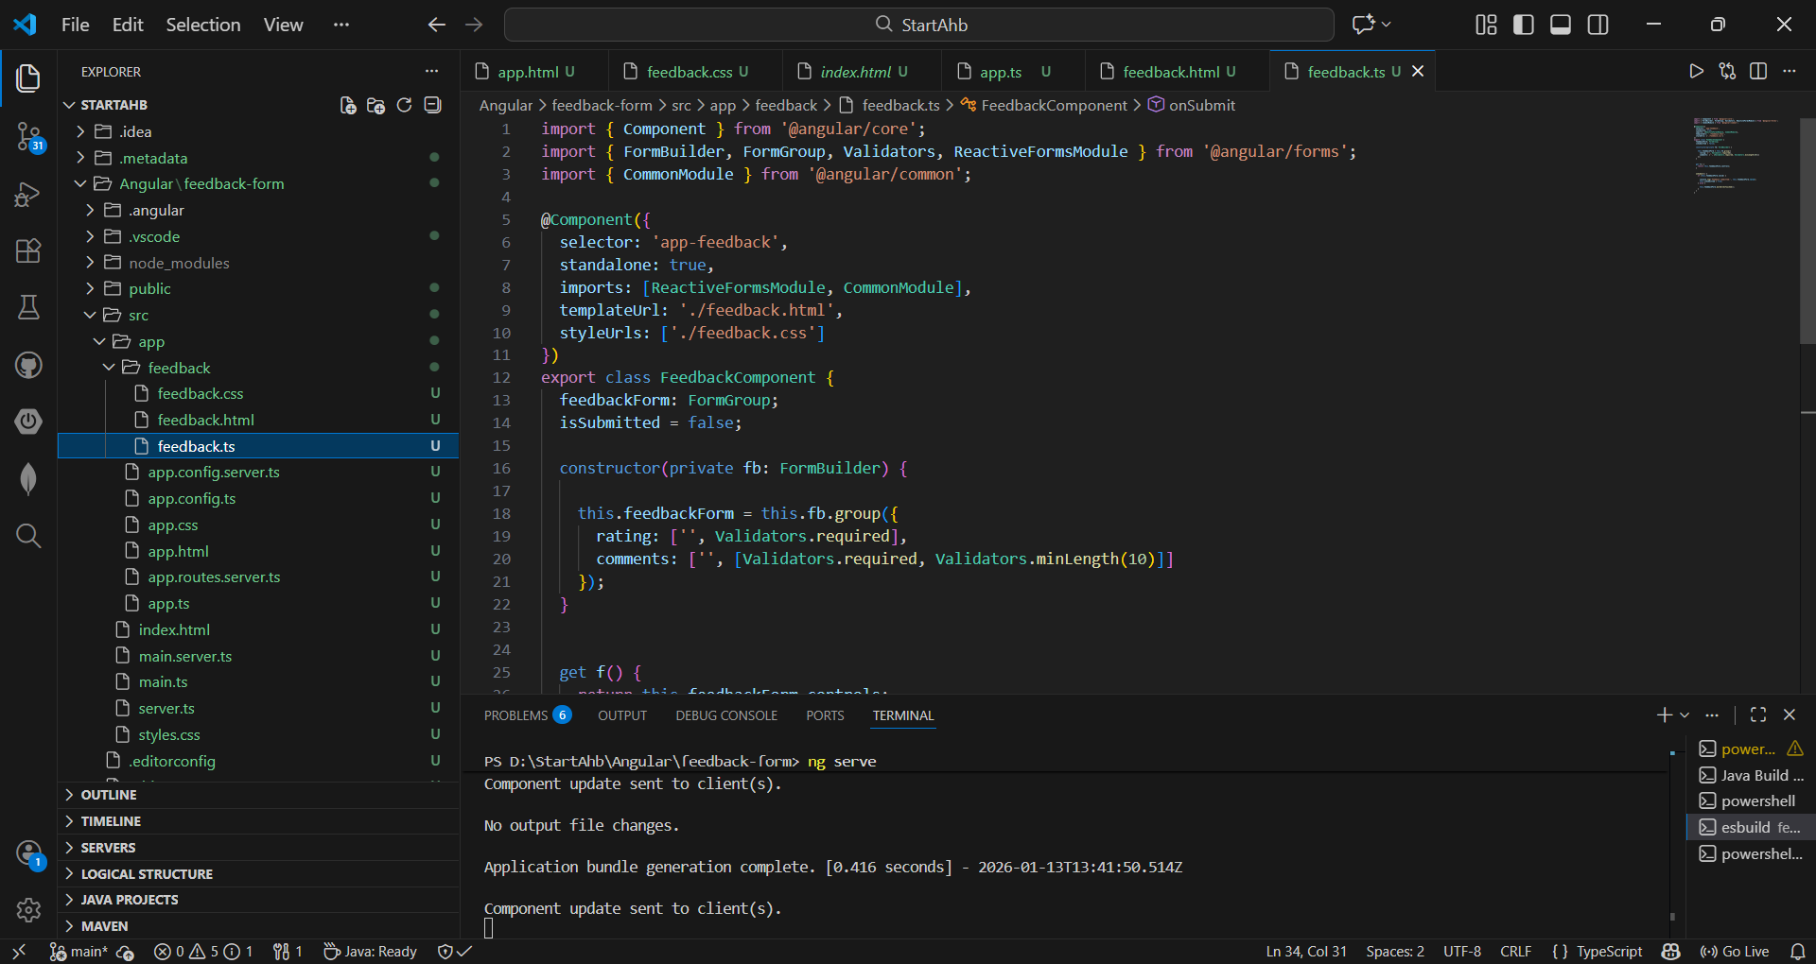
Figure 3 - feedback.ts file
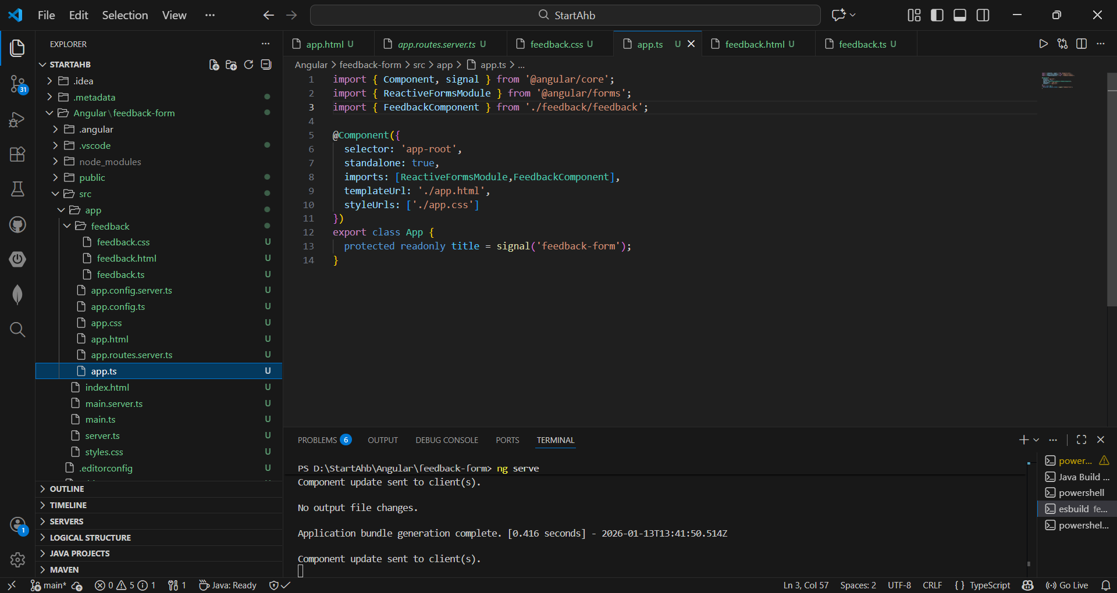
Figure 4 - app.ts file
Output Screen: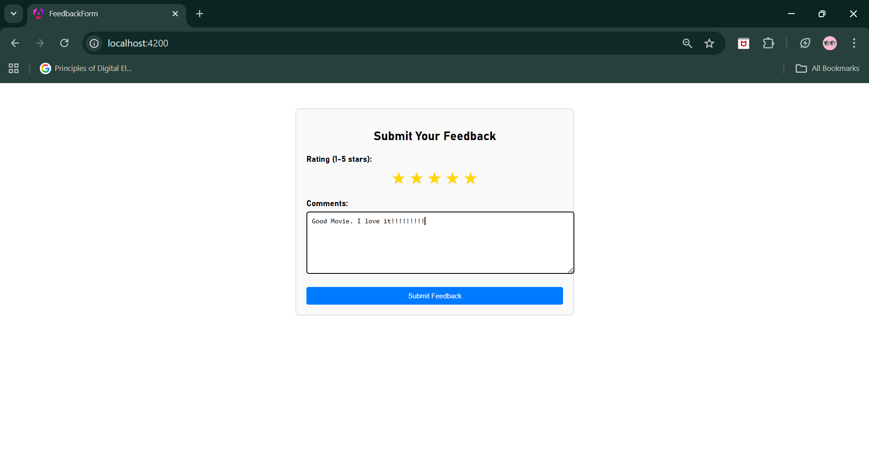
Figure 5 - Output on chrome

